# Forelesning 1: Introduction

«the emergence of **platform ecosystems** is relocating the locus of **innovation** from the firm to a **massive network** of outside firms” – Tiwana, 2013

#### Multisidedness of platforms

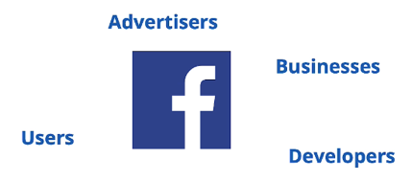A platform without at least two distinct groups or “sides” is not a platform at all (Tiwana,2013)

#### Digital platforms: Two archetypes

Transaction platforms:

* **Facilitate transactions** between different groups (e.g. social media, marketplaces, music, gaming & sharing economy)

Innovation platforms / software platforms

* A **foundation** on top of which other actors develop **complementary** technologies, products or services (e.g. Microsoft, Intel, SAP & Salesforce)

#### A diagram of software platforms AI-generated content may be incorrect.Economic view & technical view

* We also have **Hybrid platforms**
* This course is about **innovation platforms** where **complementors** contribute to the functionality & capabilities of the platform
* An extensible software product or services that serves as a **foundation** on which **independent outside parties** can build **complementary products or services** (“Apps”) that interoperate through the platforms **interfaces –** Tiwana, 2013
  + Almost all successful software platforms started out as **standalone products or services**. Only after wide adoption did they add a second side – **developers -** & transform into platforms

#### Platform ecosystems are complex systems

Complex systems are beyond intuitive understanding & **cannot be fully controlled**

Complicated => **orderly structure** is built into the minute details, if you understand the details, you will understand the system

#### Platforms manage complexity through architecture

Stable interfaces support development of apps that extend core functionality

Platform architecture allows for distributed design & innovation

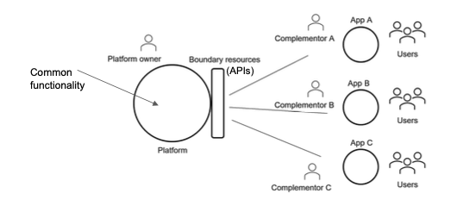

## The DHIS2 platform & the HISP community

HISP: Implementation & research network since 1994

DHIS2: open-source web-based platform for data collection, storage, analysis, visualization & sharing of data

#### DHIS2 as a software platform

* The DHIS2 core remains stable, while providing support for local innovation
* DHIS2 Web API allows developers to access & shared platform recources