THE FIVE PILLARS FRAMEWORK

A Universal Framework for Communication Usability, Institutional Accountability, and the Betterment of Society
Dr. Sayed Amir Mustafa Hashmi

Complete Manuscript

INTRODUCTION — HOW TO READ THIS BOOK
Why do institutions spend billions in the name of society and still struggle to earn public trust?
Why do communities remain unconvinced by visible investments — schools built, clinics opened, programs launched, reports published — while the institutions making those investments insist they are making a difference?
Why has reporting increased every year for two decades, in volume, in sophistication, in regulatory rigor, while public confidence in those same institutions has declined?
These questions are not rhetorical. They are the questions that every CEO, every board chair, every government minister, every foundation president, every development agency head, and every institutional leader now faces — and most cannot answer them. Not because the answer is unknown, but because the architecture required to produce the answer has not been built.
This book exists because that architecture can be built. It is not a mystery. It is not a matter of more reporting, stricter compliance, or better communication. It is a matter of a different architecture — one in which institutions can demonstrate, with evidence that would convince a skeptical observer, that the communities and systems they touch are measurably better because of their presence.
Throughout history, enduring institutions have succeeded not because they communicated more, but because five essential conditions remained aligned. This book calls those conditions the Five Pillars Framework.
What those five conditions are, how they relate, and how they can be built into the architecture of any institution — corporate, governmental, philanthropic, educational, or developmental — is the subject of this book. The framework is universal. Corporate Social Responsibility is one application of it, not its definition.
This book does not argue that existing CSR frameworks — Carroll's Pyramid, Stakeholder Theory, ESG, GRI, the SDGs — have failed. They have not. They answer legitimate and important questions. This book asks a different question: not what organizations should be responsible for, or how they should report, but whether they can demonstrate that their interventions have actually resulted in the Betterment of Society. That question is not answered by the existing frameworks. It is answered by the architecture this book presents.
The book is written for the people who decide whether institutions are legitimate: the leaders who allocate capital and shape institutional narrative, the investors whose decisions govern corporate behavior, the public officials who design accountability regimes, the foundation leaders who set sector norms, and the scholars and editors who propagate the ideas that reshape fields. It is also written for the young professional and the student who will inherit these institutions and must understand them at a depth the current literature does not provide.
The book is organized in four Parts. Part I (Chapters 1–3) diagnoses the problem — the Proclamation Trap, the Legitimacy Gap, and the limits of existing CSR frameworks. Part II (Chapters 4–6) presents the framework — the architecture, the Five Pillars in depth, and the Trust Layer. Part III (Chapters 7–9) applies the framework — the institutional operating system, a comparative international analysis of CSR regimes, and the new legitimacy. Part IV (Chapters 10–11) provides the empirical validation and mathematical foundations for researchers and validators.
The main narrative (Parts I–III) is complete without Part IV. A general reader can read the book from Introduction to Epilogue without entering the specialized material. A researcher or validator will find everything they need in Part IV.
Read this book as an architecture, not a manual. The framework is not something to implement and check off; it is something to inhabit and build within. The institutions that take this framework seriously will not add it to their reporting apparatus. They will reconstruct themselves around it.

PROLOGUE — THE QUESTION THAT REFRAMED LEGITIMACY
The report was on the table between us — two hundred pages, professionally designed, externally assured, compliant with every relevant standard. The institution it represented had invested substantially. The programs it described were real. The activities it documented had occurred. The outputs it counted were accurate.
The community sitting outside the room where we met was not better off in any way the report could establish.
I had come to that implementation landscape — a region where institutional presence is heavy and institutional outcome is unclear — to understand the gap between what was reported and what was real. The institution had been operating there for years. It had built schools. It had funded health programs. It had published annual reports documenting its investment with the precision and polish that major institutions now produce as a matter of routine. The reports were impressive. The community was not.
The schools existed, but the children who attended them were not learning at levels that would change their trajectories. The health programs operated, but the health indicators of the population they served had not shifted in the directions the programs claimed to produce. The investment was real. The betterment was not. And no one — not the institution, not the regulators, not the community, not the journalists who occasionally covered the region — could say with evidence whether society was better because of the institution's presence, or whether the institution was merely present.
That gap — between the sophistication of the reporting and the absence of the evidence — is not unique to that region. It is not unique to that sector. It is not unique to that kind of institution. In the years that followed, I encountered the same gap in foundation boardrooms and government ministries, in development agency headquarters and corporate sustainability offices, in the polished reports of multinational enterprises and the earnest presentations of non-governmental organizations. The vocabulary changed. The architecture did not. Institutions everywhere had mastered the language of betterment without mastering its production.
The question that emerged from those years is the question this book exists to answer:
Can this institution demonstrate — with evidence that would convince a skeptical observer — that society is measurably better because of its presence?
I call this the Betterment Question. It is not a new question. Variations of it have been asked by philosophers, evaluators, and auditors for as long as institutions have claimed to serve the public. What is new is not the question but the demand that it be answered with evidence — not narrative, not expenditure, not intention, but evidence that would convince someone who is not predisposed to believe the institution's claims.
That demand cannot be met from within the architectures most institutions currently operate. The reporting systems were built to document activity, not to establish outcome. The accountability systems were built to ensure compliance, not to verify betterment. The communication systems were built to manage perception, not to enable independent verification. The architectures are not broken; they are doing exactly what they were designed to do. The problem is that what they were designed to do is not what society now needs them to do.
What is needed is not better reporting, stricter compliance, or more sophisticated communication. What is needed is a different architecture — one in which the Betterment Question is not evaded but answered, because the structural conditions for answering it have been built into the institution itself.
That architecture is the Five Pillars Framework.
This book presents the framework, develops it, and demonstrates its application. It is written with the conviction that the framework is not one option among many but the architecture the problem requires — and that once the problem is understood, no other architecture seems possible.
The question this book exists to answer is not new. What is new is the architecture required to answer it honestly. That architecture begins with understanding why the question has been so difficult to answer — and why the difficulty is structural, not accidental. The structure that makes the question unanswerable has a name. It is the subject of the first chapter.

CHAPTER 1 — THE PROCLAMATION TRAP


The Paradox of Modern Accountability
Never have institutions reported so much. Never has evidence of actual betterment been so scarce.
These two facts are not in tension. They are causally related. The reporting apparatus that modern institutions have built — the annual sustainability reports, the impact assessments, the ESG disclosures, the compliance certifications, the stakeholder engagement summaries — was not designed to produce evidence. It was designed to produce the appearance of accountability, and it has succeeded at that task with a thoroughness that now undermines the very legitimacy it was meant to establish.
Consider what a typical institutional report contains. It documents activities: the programs initiated, the facilities built, the training sessions conducted, the funds disbursed. It counts outputs: the number of people reached, the number of services delivered, the number of partnerships formed. It proclaims outcomes: the lives improved, the communities strengthened, the systems transformed. And it does all of this with a visual and rhetorical sophistication that signals seriousness, rigor, and commitment.
What it rarely contains is evidence — evidence that would convince a skeptical, informed, independent observer that the proclaimed outcomes actually occurred, that they are attributable to the institution's action, and that they constitute measurable betterment in the condition of the community or system the institution claims to serve.
This is not a failure of individual integrity. Most institutions are not lying. Most report what they genuinely believe to be true. The failure is structural: the architecture of modern accountability rewards proclamation and penalizes the absence of it, regardless of whether the proclamation corresponds to verifiable outcome. An institution that proclaims impact it cannot demonstrate faces no consequence as long as the proclamation is professionally formatted and internally consistent. An institution that admits it cannot yet demonstrate its impact faces immediate reputational risk, regardless of how honestly it is working toward that capacity. The architecture incentivizes the performance of accountability rather than its substance.
I call this structural condition the Proclamation Trap.
Key Insight: The Proclamation Trap is not a failure of honesty. It is a failure of architecture — the architecture rewards proclamation regardless of whether proclamation corresponds to proof.

The Proclamation Trap Defined
The Proclamation Trap is the systemic institutional failure of conflating proclamation with proof.
It is not dishonesty. It is not exaggeration. It is a structural condition in which the apparatus of accountability — the reporting systems, the compliance mechanisms, the communication architectures, the evaluation frameworks — validates claims of impact without verifying their substance. The trap is not that institutions say things that are untrue. The trap is that the system treats professionally produced claims as if they constituted evidence, and then builds layer upon layer of policy, investment, and reputation on foundations that no one has independently checked.
The Proclamation Trap has four structural components. Each is a pattern I have observed across sectors, geographies, and institutional types. Each has a name, because naming what is broken is the first step toward building what is not. Two further components — which I will introduce in later chapters, where they connect naturally to the framework's architecture — complete the diagnostic picture. But four are enough to recognize the trap.
Stop & Think: Think of an institution you know well — your own organization, a major foundation, a government agency. Can it produce evidence, right now, that would convince a skeptical observer that its work has produced measurable betterment? If it cannot, what does it produce instead? And what does that "instead" look like — activity reports, output counts, compliance certificates, impact narratives? You may already be seeing the pattern this chapter describes.

The Expenditure Fallacy
The first component is the Expenditure Fallacy.
Money spent is treated as evidence of value created.
The Expenditure Fallacy is the false equivalence between disbursement and betterment. It is visible in every report that leads with the amount invested rather than the change produced. It is visible in every press release that announces a commitment rather than a result. It is visible in every board meeting that reviews expenditure against budget rather than outcome against need.
The fallacy is not that expenditure is irrelevant. Expenditure is necessary — betterment requires resources. The fallacy is the assumption that expenditure is sufficient — that the spending of resources constitutes evidence that betterment has occurred. It does not. Resources can be spent without producing betterment. They frequently are. The question is never how much was spent; the question is always what changed because of what was spent.
The Expenditure Fallacy is the foundational error of what I will call expenditure-based legitimacy — the condition in which an institution's claim to positive impact is grounded in what it spent rather than what it produced. This form of legitimacy is structurally hollow. It answers the question "What did you do?" while evading the question "What changed?" And because the reporting apparatus has been built to answer the first question with precision and the second question not at all, the evasion is invisible — hidden behind the sophistication of the financial disclosure.
Mini Case: A corporation announces it has invested $50 million in community development over five years. The announcement is widely covered. The board is satisfied. The stakeholders are reassured. No one asks — and no one can answer — whether the $50 million produced any measurable improvement in the condition of the communities it was meant to serve. The expenditure is real. The betterment is unestablished. The Expenditure Fallacy is complete.

The Output Illusion
The second component is the Output Illusion.
Activities and outputs are reported as if they constituted evidence of outcome.
The distinction between activity, output, and outcome is not academic. It is the difference between counting what you did and knowing what you achieved.
An activity is what an institution does: it holds a training, builds a facility, disburses a grant, launches a program. An output is what the activity produces: a number of people trained, a facility built, a grant disbursed, a program launched. An outcome is what changes in the world because of the output: skills that are applied, access that is improved, livelihoods that are strengthened, systems that function better.
Most institutional reporting operates at the level of activity and output. It counts what was done and what was produced. It then implies — through proximity, through formatting, through rhetorical association — that outcomes occurred. The training program is reported as successful because three hundred people attended. The health initiative is reported as effective because twelve clinics were built. The education investment is reported as impactful because the enrollment numbers increased.
None of these are outcomes. They are outputs. The three hundred people who attended the training may or may not have applied what they learned. The twelve clinics may or may not have improved the health of the populations they serve. The increased enrollment may or may not have produced learning. The outputs are real; the outcomes are assumed. And the assumption is presented as if it were evidence.
The Output Illusion is particularly insidious because it is not a lie. The activities occurred. The outputs are real. The reports are factually accurate at the level they operate. The illusion is in the implication — the structural suggestion that documented activity constitutes demonstrated outcome. It does not. Activity is what an institution controls. Outcome is what an institution influences. The conflation of the two allows institutions to claim the authority of the second while doing the accounting of the first.
Key Insight: Activity is what an institution controls. Outcome is what an institution influences. The Output Illusion allows institutions to claim the authority of the second while doing the accounting of the first.

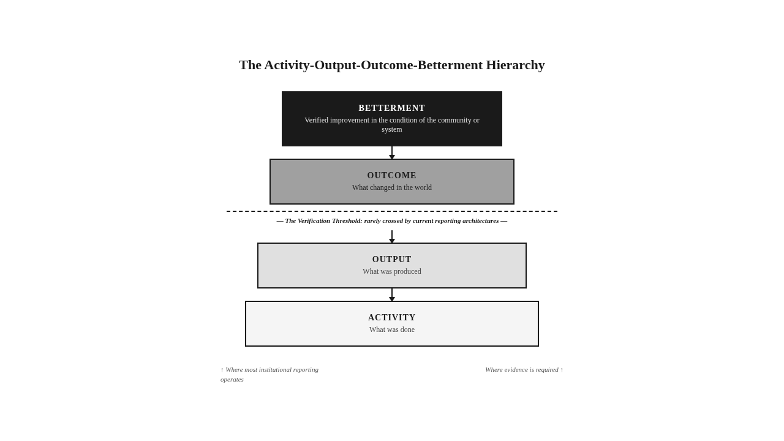

The Compliance Theater
The third component is the Compliance Theater.
Accountability is performed through elaborate reporting, certification, and compliance architectures that document activity while obscuring the absence of demonstrable outcomes.
The Compliance Theater is the most visible expression of the Proclamation Trap. It is the apparatus of certifications, audits, standards, frameworks, and reporting protocols that institutions have built — sometimes voluntarily, sometimes under regulatory pressure — to demonstrate their accountability. The theater is elaborate, expensive, and professionally executed. It is also, in most cases, structurally incapable of establishing what it claims to establish.
The problem is not that compliance mechanisms are useless. They serve a function: they establish that certain processes were followed, certain standards were met, certain procedures were documented. The problem is that compliance with process does not constitute evidence of outcome. An institution can be fully compliant with every relevant standard and still produce no demonstrable betterment. The compliance architecture verifies the process; it does not verify the result. And because the compliance architecture is the primary — often the only — mechanism through which institutional accountability is assessed, the absence of outcome verification is hidden behind the presence of process verification.
The Compliance Theater is the institutional equivalent of a building that passes every inspection during construction and collapses the day it is occupied. The inspections were real. The certificates were earned. The process was followed. The building still collapsed — because the inspections verified the process, not the structural integrity. In institutional terms, the compliance architecture verifies the reporting, not the betterment. And the reporting can be impeccable while the betterment is absent.
One Sentence Summary: Compliance verifies the process; it does not verify the result — and an institution can be fully compliant and still produce no demonstrable betterment.

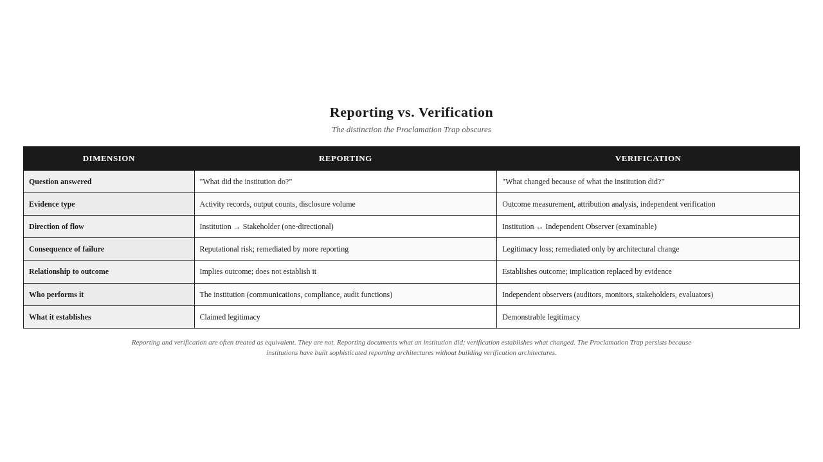

The Skeptical Observer Standard
The fourth component of the Proclamation Trap is the absence of a standard against which claims can be measured. The trap persists because there is no commonly held evidentiary bar — no standard that institutional claims must clear to be considered legitimate.
I propose such a standard. I call it the Skeptical Observer Standard.
The Skeptical Observer Standard is the evidentiary bar that institutional claims must clear: sufficient to convince a skeptical, informed, independent observer that the claimed outcome is real and attributable.
Three qualities define the skeptical observer. The observer is skeptical — not predisposed to believe the institution's claims, not invested in the institution's success, not inclined to give the institution the benefit of the doubt. The observer is informed — knowledgeable about the institutional context, capable of assessing the methodology, able to distinguish evidence from assertion. The observer is independent — not employed by the institution, not contracted by the institution, not dependent on the institution for funding, access, or reputation.
The standard is not met by institutional assertion. "We believe our programs are effective" is not evidence. The standard is not met by reporting volume. A thousand-page report that documents activity without establishing outcome is not evidence. The standard is not met by third-party endorsement. A certification that verifies process without verifying result is not evidence. The standard is met only by evidence that an independent observer would find convincing — evidence that the claimed outcome occurred, that it is attributable to the institution's action, and that it constitutes measurable betterment.
The Skeptical Observer Standard is not a standard for Chapter 1 alone. It is the recurring standard against which institutional claims will be examined throughout this book. Every claim, every framework component, every diagnostic instrument that follows will be evaluated against the same question: Would this convince a skeptical observer? The standard is the consistent evidentiary bar that runs from this first chapter to the last — the thread that connects the diagnosis of the Proclamation Trap to the architecture of the Five Pillars Framework that will meet it.
Visual Recap: The Proclamation-Proof Gradient (FPF-001) captures this: most institutions currently operate at position three — proclamation with output metrics — where activity is documented but outcome is not established. The Skeptical Observer Standard, position five, is the bar the Five Pillars Framework exists to meet.

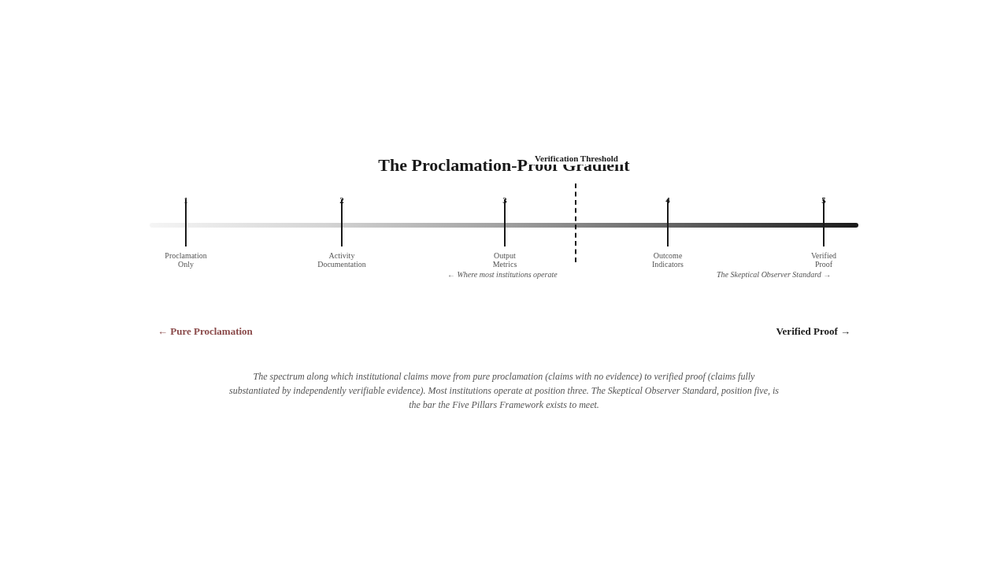

Two Archetypes
The structural components of the Proclamation Trap are not abstract. They manifest in recognizable institutional patterns. Consider two archetypes — composites drawn from observations across multiple sectors and geographies, attributed to no single real institution.
The first is the Multinational Extractive Enterprise. It operates at what I call the extraction frontier — the geographic and social boundary where resource-intensive industry meets vulnerable communities. The enterprise is sophisticated. Its sustainability reports are professionally produced, externally assured, and compliant with every relevant reporting standard. It documents its community investment with precision: the schools built, the health camps conducted, the training programs delivered, the local procurement percentages achieved. Its expenditure is substantial. Its reporting is impeccable.
What the reporting does not establish is whether the communities at the extraction frontier are better off because of the enterprise's presence. The schools exist, but are the children learning? The health camps were conducted, but did the population's health indicators improve? The training programs were delivered, but did the participants' livelihoods change? The enterprise cannot answer these questions with evidence that would satisfy a skeptical observer. It can answer them with narrative, with output metrics, with professionally formatted implication. But the Verification Threshold — the line between output and outcome — remains uncrossed. The enterprise is not failing to report. It is failing to verify. And the compliance architecture it has built cannot tell the difference.
The second is the Sovereign Development Fund. It deploys capital across implementation landscapes where institutional presence is thin — regions where governance capacity is limited, where the infrastructure for delivery is weak, where the ecosystem of civil society organizations that would normally mediate between capital and community is absent or underdeveloped. The fund's governance is sophisticated. Its investment committees review proposals with rigor. Its disbursement systems are professionally managed. Its reporting architecture documents every dollar committed, every program approved, every partnership formed.
What the reporting does not establish is whether the capital produced betterment in the landscapes where it was deployed. The fund can report disbursement against commitment with precision. It cannot report outcome against need with any precision at all. The implementation variable — the capability of the agencies actually carrying out the work — varies enormously across the landscapes the fund serves, and the fund's reporting architecture does not account for this variation. A program implemented by a capable agency in one landscape and a program implemented by a struggling agency in another landscape are reported in the same format, with the same confidence, as if the implementing agency were irrelevant to the outcome. It is not irrelevant. It is the decisive variable. But the reporting architecture, built to document financial flow rather than institutional outcome, cannot see it.
These two archetypes — the corporate enterprise and the development fund — operate in different sectors, serve different populations, and answer to different constituencies. They share the same architecture. Both document activity with sophistication. Both report outputs with precision. Both imply outcomes without establishing them. Both are trapped in the Proclamation Trap — not because they are dishonest, but because the architecture they operate within was not built to produce evidence of betterment. It was built to produce the appearance of accountability, and it does so with a competence that now substitutes for the substance it was meant to serve.
Mini Case: If you are noticing that the pattern described here resembles something in your own institutional experience — the sophisticated report that documents everything and establishes nothing, the compliance certificate that verifies process and is silent on outcome, the expenditure announcement that is treated as evidence of impact — you are not wrong. You are recognizing the Proclamation Trap from the inside.

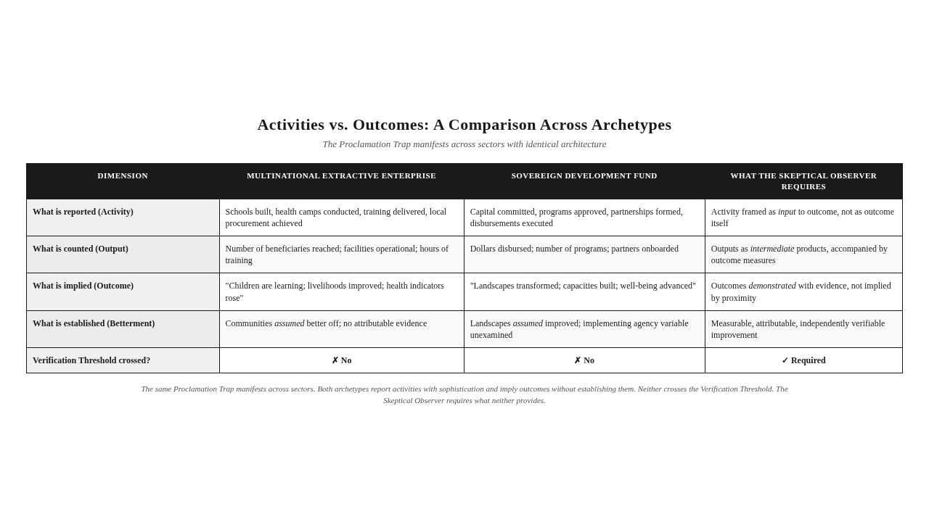

The Trap's Structural Logic
The Proclamation Trap is not a mistake that can be corrected within the existing architecture. It is the architecture. The reporting systems, the compliance mechanisms, the communication strategies, and the accountability frameworks were not designed to verify betterment. They were designed to document activity, ensure process compliance, manage institutional reputation, and satisfy regulatory requirements. They perform these functions well. The problem is that society now needs them to perform a function they were never built to perform: to establish, with evidence that meets the Skeptical Observer Standard, that institutions produce the betterment they claim.
This is why the trap cannot be escaped by doing more of what institutions currently do. More reporting produces more reporting. More compliance produces more compliance. More communication produces more communication. None of these, in any quantity, produces evidence of outcome, because the architecture does not connect activity to outcome through verification. It connects activity to narrative through implication. And implication is not evidence.
The trap also cannot be escaped by tightening the existing standards. Stricter reporting requirements produce stricter reporting, not stricter verification. Stricter compliance requirements produce stricter compliance, not stricter accountability. The standards govern process; they do not govern substance. Tightening the standards tightens the process without touching the substance.
What is required is not more of the current architecture or a tighter version of the current architecture. What is required is a different architecture — one that is built, from the foundation, to answer the Betterment Question with evidence rather than with proclamation.
But before that architecture can be presented, a deeper question must be addressed. The Proclamation Trap explains why institutions cannot demonstrate betterment. But it raises a more fundamental question: if institutions are trapped, why has the trap persisted for so long? Why have the compliance systems, the regulatory frameworks, and the accountability architectures of the last two decades not closed it? The answer is that the trap is not the root — it is the symptom. The root is a Legitimacy Gap that the trap produces and sustains. Understanding that gap is the only way to understand why the architecture that follows is not optional but necessary.



The Takeaway
The Proclamation Trap is not solved by more reporting. It is solved only by the architecture that makes proclamation unnecessary because proof is available.

Reader Momentum
The Proclamation Trap explains why institutions cannot demonstrate betterment. But it raises a deeper question: if institutions are trapped, why has the trap persisted for so long? Why have the compliance systems, the regulatory frameworks, and the accountability architectures of the last two decades not closed it? The answer is that the trap is not the root — it is the symptom. The root is a Legitimacy Gap that the trap produces and sustains. That gap is the subject of the next chapter.

CHAPTER 2 — THE LEGITIMACY GAP


The Paradox at the Center
Institutions have never been more accountable on paper. They have never been less trusted in practice.
Annual reports grow thicker. Sustainability disclosures grow more detailed. Compliance certifications multiply. External assurance firms sign off on more documents each year. Boards dedicate more time to oversight. Regulators write more rules. Foundations publish more impact assessments. The architecture of accountability, measured by any indicator of volume or sophistication, has expanded steadily for two decades.
Public confidence in those same institutions has declined across the same period. Surveys of trust in corporations, governments, and large foundations tell the same story across geographies and sectors. Communities that host institutional programs grow more skeptical. Investors who once accepted reported impact now discount it. Regulators who once trusted the reporting architecture now demand new layers of audit on top of it. The accountability architecture has expanded. The legitimacy it produces has contracted.
This paradox — more accountability, less trust — dissolves when we recognize that the accountability being performed is accountability to the wrong standard. Most institutions are accountable for what they spend, what they report, and what they comply with. They are not accountable for what they change. The architecture they have built is excellent at documenting activity and silent on outcome. Public skepticism is the rational response to an accountability architecture that produces paperwork without producing evidence.
The distance between these two — the legitimacy an institution claims and the legitimacy it can demonstrate — is not a public-relations gap. It is structural. It has a name. It is the central institutional pathology this book exists to close.
Key Insight: The paradox of more accountability and less trust dissolves once we see that the accountability is to the wrong standard. Institutions are accountable for what they spend and report. They are not accountable for what they change.

The Legitimacy Gap Defined
The Legitimacy Gap is the distance between an institution's claimed legitimacy and its demonstrable legitimacy.
Claimed legitimacy is what an institution asserts — the right to be regarded as a positive force, the credibility attached to its programs and reports, the trust it asks stakeholders to extend. Demonstrable legitimacy is what an institution can establish with evidence — the verified outcomes it can point to, the attributable changes it can defend, the betterment it can prove to a skeptical observer.
The gap is the space between the two. Every institution has some gap. Most institutions have a large one. The gap is not the same as dishonesty; an institution can claim exactly what it believes and still be unable to demonstrate what it claims. The gap is not the same as failure; an institution can be effective in producing outcomes and still be unable to demonstrate them. The gap is a structural condition — the difference between what an institution can reasonably assert and what it can evidentially establish.
The Legitimacy Gap is produced by the Proclamation Trap and sustained by it. The trap, recall, conflates proclamation with proof. It validates institutional claims without verifying their substance. Each claim validated without verification adds to the gap. Each report that documents activity without establishing outcome widens it. Each compliance certificate that confirms process without confirming result deepens it. Over years of accumulated reporting, the gap becomes structural — a permanent feature of the institution's relationship with its stakeholders, not a temporary shortfall that better communication can close.
The gap is invisible to the institution that produces it. The institution reports diligently. The reports are reviewed. The reviews are positive. The board is satisfied. The regulators approve. The audits pass. Within the institution, the absence of demonstrable legitimacy is not felt, because the apparatus of claimed legitimacy is functioning exactly as designed. The gap is felt outside the institution — in the community that hosts its programs but sees no change, in the stakeholder who reads the report but cannot verify its substance, in the investor who suspects the impact narrative is rhetoric rather than evidence. The gap is visible to everyone except the institution that produces it.
Stop & Think: Pick any institution whose work you follow. Estimate, roughly, the size of its Legitimacy Gap. How much of what it claims can it actually demonstrate? You may discover that the gap is wider than the institution's communications suggest — and that the institution itself may not recognize how wide the gap has become.

The Theory of Change
If the Legitimacy Gap is structural, closing it requires structural change — not better messaging, not more reporting, not stricter compliance. It requires a different relationship between what an institution does and what it can prove.
I call this relationship the Theory of Change. The Theory of Change is the architectural requirement for legitimacy migration — the journey from expenditure-based legitimacy (legitimacy claimed through spending) to evidence-based legitimacy (legitimacy demonstrated through verified outcomes). The Theory of Change is not a planning tool, although planning tools have borrowed the term. It is the doctrinal name for the architectural reconstruction that closes the Legitimacy Gap.
The Theory of Change has three architectural commitments.
The first commitment is to outcome as the unit of accountability. The institution stops answering the question "What did you do?" and starts answering the question "What changed?" This is not a rewording. It is a different question, requiring different evidence, produced by different architecture. The institution that answers "what changed" cannot stop at expenditure or output. It must produce evidence of outcome — and outcome, by definition, is change in the world outside the institution.
The second commitment is to verifiability as the standard of evidence. The institution stops producing claims and starts producing verifiable claims — claims that an independent observer could check, trace, and confirm. This commitment transforms reporting from a one-way broadcast into a two-way dialogue. The institution no longer says "trust us"; it says "here is how you can check." The architecture of verifiability is the architecture of the Trust Layer, which Chapter 6 will develop in full.
The third commitment is to the Skeptical Observer as the audience. The institution stops writing for itself and its supporters and starts writing for an observer who is not predisposed to believe it. This commitment changes the standard of evidence from internal plausibility to external defensibility. A claim that satisfies the institution's own communications department is not evidence. A claim that satisfies a skeptical, informed, independent observer is evidence. The shift in audience is the shift in standard.
The Theory of Change is not a destination. It is an architectural commitment that institutions make and then spend years building toward. The journey from expenditure-based to evidence-based legitimacy is the journey this book maps. I call that journey Legitimacy Migration, and it is the constructive core of the framework this book presents.
Mini Case: A foundation that has reported impact for twenty years decides to migrate. The first year, it discovers that sixty percent of its claimed outcomes cannot be verified. The second year, it rebuilds its evaluation architecture to produce verifiable evidence. The third year, it publishes a report that is shorter, more rigorous, and more credible — and discovers that stakeholder trust has risen even as the volume of reported claims has fallen. The migration has begun.

Verification Debt
The Legitimacy Gap has a measurable dimension. Every claim an institution makes that is not independently verifiable adds to its Verification Debt.
Verification Debt is the accumulated mass of unverified claims an institution carries. Every impact narrative that asserts outcome without establishing it adds to the debt. Every program report that documents activity without verifying change adds to the debt. Every press release that announces success without providing evidence adds to the debt. Every compliance certificate that confirms process without confirming result adds to the debt. The debt accumulates silently, year after year, report after report, until it becomes structural — a permanent feature of the institution's credibility landscape.
Verification Debt behaves like financial debt. It accumulates interest, in the form of compounding skepticism from stakeholders who notice the gap between claims and evidence. It restricts flexibility, in the form of reputational risk that constrains the institution's ability to make new claims. It eventually becomes unsustainable, in the form of a legitimacy crisis that occurs when stakeholders stop extending the benefit of the doubt and demand evidence the institution cannot produce. Institutions do not recognize Verification Debt on their balance sheets, but it is more real than many assets that appear there.
Verification Debt is also distinguishable from intentional dishonesty. An institution can accumulate Verification Debt while acting in complete good faith. It reports what it believes to be true. It asserts what it assumes to have occurred. It claims what it expects the data will eventually confirm. The debt accumulates not because the institution is lying but because the institution has not built the verification architecture that would convert its claims into evidence. The institution is honest but unverifiable, and an unverifiable honest institution is, from the skeptical observer's perspective, indistinguishable from a verifiable dishonest one.
The only way to reduce Verification Debt is to verify claims — to convert assertion into evidence, narrative into data, output into outcome. This is the work of the Trust Layer, which Chapter 6 will present. The institution that takes Verification Debt seriously begins to track it, measure it, and report it — not as an admission of failure, but as a diagnostic of where verification architecture must be built.
Key Insight: Verification Debt accumulates silently and compounds steadily. Institutions do not track it because their accounting architecture cannot see it. Stakeholders track it intuitively because their experience of the institution's claims is the daily experience of the gap between assertion and evidence.

The Beneficiary Inversion
A specific structural pattern deepens the Legitimacy Gap in many institutions. I call it the Beneficiary Inversion.
The Beneficiary Inversion is the structural error of positioning communities as passive recipients rather than participants. The institution identifies a need, designs a program, delivers an intervention, and counts the people who received it. The community is positioned throughout as the recipient — the passive object of institutional action, the "beneficiary" in the language most institutions still use. The institution decides. The community receives. The institution reports. The community is reported about.
The inversion is not malicious. It is often well-intentioned. But it is structurally wrong, and it produces structurally wrong outcomes. When the community is positioned as recipient, the institution designs for the community rather than with it. The institution's intelligence about what matters is internal — its own assessment, its own priorities, its own logic — rather than external, drawn from the community's own understanding of its condition. The institution's intelligence about what worked is also internal — its own evaluation, its own metrics, its own sense of success — rather than external, drawn from the community's own assessment of whether anything changed.
The Beneficiary Inversion produces the Legitimacy Gap by removing the most important verification mechanism an institution has: the community itself. A community that participated in identifying the need, designing the response, and verifying the outcome can attest to whether betterment occurred. A community that was merely a recipient cannot. The institution that has inverted its relationship with its communities has lost the witness it most needs — and has gained, in place of the witness, a population that is reported about but never asked whether the reporting corresponds to reality.
The framework rejects the term "beneficiary" precisely because the term encodes the inversion. A beneficiary receives. A stakeholder participates. A community member is the witness whose testimony constitutes evidence. The shift in language is the shift in architecture. The institution that takes the Beneficiary Inversion seriously begins to rebuild its relationship with its communities — from recipient to participant, from object to witness, from beneficiary to stakeholder. This is the work of the Initiative pillar, which Chapter 5 will develop.
One Sentence Summary: The Beneficiary Inversion positions communities as recipients to be reported about, rather than participants to be learned from — and in doing so, removes the most important verification mechanism an institution has.

The Transparency Trap
The Legitimacy Gap cannot be closed by more disclosure. The institution that responds to a credibility deficit by disclosing more information often deepens the gap. This counterintuitive outcome has a name. It is the Transparency Trap.
The Transparency Trap is the production of voluminous, technically dense, professionally formatted communication that no stakeholder can actually use to verify anything. Transparency without usability. The institution publishes more data than any stakeholder can read, in formats no stakeholder can parse, with disclosures no stakeholder can act upon. The volume of disclosure rises. The usability of disclosure falls. The gap between what is disclosed and what can be verified widens.
The Transparency Trap is the Communicative expression of the Proclamation Trap. The Proclamation Trap conflates proclamation with proof; the Transparency Trap conflates disclosure with verification. Both produce the same outcome: the appearance of accountability without its substance. The institution that publishes a four-hundred-page sustainability report has disclosed. The institution whose stakeholders cannot, after reading the report, verify a single claimed outcome has not provided verification. The disclosure is real. The verification is absent. The Transparency Trap is complete.
Transparency, properly understood, is not the production of information. It is the production of usable information — information that stakeholders can read, understand, verify, and act upon. This is the concept of Communication Usability, which the framework treats as the central construct of the Meaning pillar. Communication Usability is the degree to which institutional communication is legible, verifiable, and actionable by its intended stakeholders. Communication that is not usable fails the Meaning pillar regardless of how much information it contains.
The Transparency Trap is particularly dangerous because it produces the illusion of progress. The institution that publishes more disclosure each year believes it is becoming more accountable. Its regulators, who measure accountability by disclosure volume, agree. Its board, which reviews the expanding reports, is satisfied. The institution is rewarded for transparency that no one can use, while the underlying Verification Debt continues to accumulate. The institution is, in the most literal sense, transparency-trapped: the more it discloses, the less it can verify.
Mini Case: A regulatory regime requires annual disclosure of hundreds of sustainability indicators. Compliance is high. Reports are detailed. Independent analysts who attempt to use the disclosed data to verify corporate impact claims find that the indicators are aggregated, contextualized, and presented in ways that prevent attribution to specific outcomes. The regime produces transparency without producing verifiability. The Transparency Trap is institutionalized at the regulatory level.

The Imposed Imperative
A fifth pattern contributes to the Legitimacy Gap. I call it the Imposed Imperative.
The Imposed Imperative is the condition in which institutional initiatives originate from institutional preference rather than participatory identification of need. The institution decides what the community needs. The institution designs the program. The institution delivers the program. The institution reports the program as responsive to community need. The community experiences the program as something that arrived from the outside, addressed priorities the community did not set, and produced outcomes the community did not ask for.
The Imposed Imperative is operationally invisible. The institution has done everything its architecture requires. It has identified a need, designed a response, delivered the response, and reported the response. By every internal measure, the initiative has succeeded. The architecture cannot see that the need was identified from the inside, the response was designed without the community, and the outcome was defined by the institution rather than by the stakeholders. The initiative was imposed. The architecture called it responsive. The community called it irrelevant.
The Imposed Imperative widens the Legitimacy Gap because it produces outcomes the institution can claim but the community cannot recognize. The institution reports that it addressed a need. The community reports that nothing important changed. Both are right. The institution addressed the need it identified. The community experienced the absence of the need it actually had. The Legitimacy Gap, in this case, is the gap between the institution's sense of what it accomplished and the community's sense of what it received. The gap is structural. It originates in the architecture of initiative — who decides what matters — and it cannot be closed by better execution or better reporting.
The framework treats initiative as a distinct pillar — Pillar I — because initiative is the generative origin of institutional action. An institution that gets initiative wrong cannot recover through execution, outcome, or meaning. An institution that gets initiative right gains a foundation of community recognition that makes everything else — accountability, execution, outcome, meaning — verifiable. The community that recognizes the initiative as its own becomes the witness whose testimony constitutes evidence. The community that experiences the initiative as imposed becomes the skeptic whose doubt constitutes the Legitimacy Gap.
Stop & Think: Recall an institutional initiative you have observed closely. Where did the initiative originate? Who identified the need? Whose knowledge shaped the design? If the honest answer is "the institution itself," the initiative likely carries the Imposed Imperative — and no amount of execution or reporting will close the gap that the imperative produces.

Legitimacy Migration
The Legitimacy Gap is not a permanent condition. It can be closed. The closing requires a journey, not a fix.
I call this journey Legitimacy Migration. It is the institutional passage from expenditure-based legitimacy — legitimacy claimed through spending — to evidence-based legitimacy — legitimacy demonstrated through verified outcomes. The journey is architectural, not rhetorical. It cannot be completed by rebranding, by communication, or by regulation. It can be completed only by rebuilding the institution's relationship to evidence.
Legitimacy Migration has three stages.
The first stage is Recognition. The institution acknowledges its Legitimacy Gap. It accepts that its current reporting architecture produces claims, not evidence. It accepts that its Verification Debt is real and growing. It accepts that the Beneficiary Inversion has cost it the witness it most needs. It accepts that the Transparency Trap is producing disclosure without producing verifiability. It accepts that the Imposed Imperative has produced initiatives that are operationally excellent and substantively disconnected. Recognition is not a confession. It is a diagnosis. The institution that recognizes its gap has not failed. It has begun to migrate.
The second stage is Reconstruction. The institution rebuilds its architecture around the production of evidence rather than the production of claims. It builds verification infrastructure — the Trust Layer that Chapter 6 will present. It rebuilds its relationship with communities — the Participatory Engagement that the Initiative pillar demands. It redesigns its reporting to produce verifiable outcome rather than impressive volume. It reorients its governance to hold the institution answerable for outcome rather than for activity. Reconstruction is not a project. It is a re-architecture. The institution that emerges from Reconstruction is structurally different from the institution that entered it.
The third stage is Demonstration. The institution can finally answer the Betterment Question. It can produce, on demand, evidence that meets the Skeptical Observer Standard. It can show that its initiatives produced outcome, that the outcome is attributable to its action, and that the outcome constitutes measurable betterment. Demonstration is not the end of migration. It is the condition of having completed it — the condition from which the institution operates going forward.
Legitimacy Migration is not a one-time project. It is an ongoing discipline. Institutions that have migrated can slip back. New leadership can reverse the architectural changes. New regulations can re-impose the Transparency Trap. New reporting fads can resurrect the Output Illusion. Migration is maintained by continual architectural vigilance, not by a one-time commitment.
Visual Recap: The Theory of Change Migration diagram (FPF-007) captures this: the institution moves from expenditure-based legitimacy, through Recognition, Reconstruction, and Demonstration, to evidence-based legitimacy. The architecture at each stage is structurally different. The journey is not reversible without losing the legitimacy it has produced.

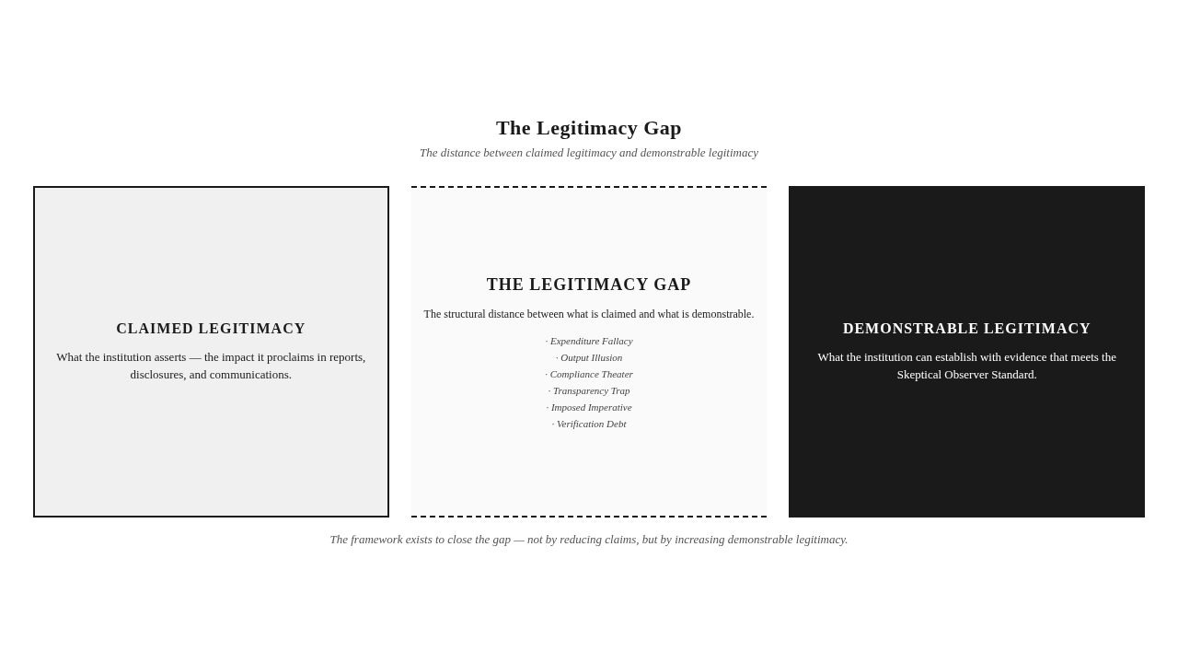
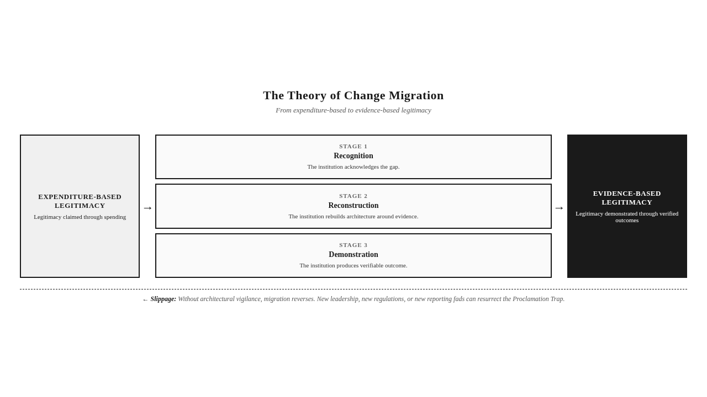

The Proclamation-Proof Gradient
The migration just described is not binary. Institutions do not move from proclamation to proof in a single step. They move along a spectrum.
I call this spectrum the Proclamation-Proof Gradient. The gradient runs from pure proclamation on one end to verified proof on the other. Position one is proclamation only — claims with no evidence. Position two is proclamation with activity documentation — claims accompanied by records of what was done. Position three is proclamation with output metrics — claims accompanied by counts of what was produced. Position four is proclamation with outcome indicators — claims accompanied by some indicators of change. Position five is verified proof — claims fully substantiated by independently verifiable evidence.
Most institutions currently operate at position three. They have moved past pure proclamation by documenting activity. They have moved past mere activity documentation by counting outputs. They have not crossed the Verification Threshold — the line between output and outcome, between position three and position four. Crossing the threshold requires a different architecture than the one that produced positions two and three. It requires the architecture this book presents.
The Proclamation-Proof Gradient is the developmental map for Legitimacy Migration. An institution cannot jump from position two to position five in a single program. It moves along the gradient as it builds architecture, verifies claims, and accumulates Trust Capital. The migration is incremental. The architecture required at each stage differs. The institution at position three needs different work than the institution at position four. The framework's diagnostic instruments, presented in Chapter 5 and operationalized in Chapter 7, are designed to locate the institution on the gradient and identify the architectural work the next position requires.
The Skeptical Observer Standard lives at position five. The institution that has migrated to position five can answer the Betterment Question. The institution at position three cannot — no matter how sophisticated its reporting, how thick its disclosures, how confident its impact narratives. The gradient is not a ranking of virtue. It is a map of architectural maturity. The institution that knows where it stands on the gradient knows what work remains.
Key Insight: The Proclamation-Proof Gradient is a developmental map, not a moral judgment. An institution's position on the gradient is a fact about its architecture, not a fact about its integrity. The framework's purpose is to move institutions along the gradient — not to condemn them for being where they are.

Communication Usability — A Brief Introduction
The gradient just described is, in part, a communication gradient. Institutions move along it by producing communication that is more usable — more legible, more verifiable, more actionable — by the stakeholders who receive it. Communication Usability is the degree to which institutional communication enables stakeholders to understand what was done, verify what was claimed, and act on what was communicated. It is the central construct of the Meaning pillar, which Chapter 5 will develop in full.
A brief introduction here is warranted because the Legitimacy Gap cannot be closed without Communication Usability. An institution can produce verifiable evidence and still fail to close the gap if the evidence is communicated in ways stakeholders cannot use. The Transparency Trap is, in this sense, the failure mode of Communication Usability — disclosure without usability, volume without legibility, information without actionability. Communication Usability is the discipline that converts disclosure into verification, and verification into legitimacy.
Communication Usability will return in Chapter 5 as the operational core of the Meaning pillar. For now, the key recognition is that the Legitimacy Gap is not closed by the production of evidence alone. It is closed by the production of usable evidence — evidence that stakeholders can read, understand, verify, and act upon. The architecture that produces such evidence is the architecture this book presents.
One Sentence Summary: The Legitimacy Gap is closed not by the production of evidence but by the production of usable evidence — and Communication Usability is the discipline that makes evidence usable.

Why Existing Paradigms Cannot Close the Gap
The patterns just described — the Legitimacy Gap, Verification Debt, the Beneficiary Inversion, the Transparency Trap, the Imposed Imperative — are not new. Scholars have noted variations of them for decades. Practitioners have struggled with them across sectors. Regulators have attempted to address them through reporting mandates and compliance regimes. Why have these efforts not closed the gap?
The answer is that the dominant paradigms of institutional responsibility were not designed to close the gap. They were designed to answer different questions. They answer those questions well. They do not answer the Betterment Question.
Carroll's Pyramid, the most influential framework of corporate social responsibility, answers the question of what organizations should be responsible for. It layers economic, legal, ethical, and philanthropic responsibilities into a hierarchy. It is a useful map of the terrain of responsibility. It does not, however, distinguish philanthropy from verifiable impact. An organization can be fully Carroll-compliant — economically productive, legally compliant, ethically engaged, and philanthropically generous — and still be unable to demonstrate that its philanthropy produced betterment. The pyramid describes what the organization should do. It does not describe how the organization can prove that what it did produced change.
Stakeholder Theory, the most influential framework of stakeholder engagement, answers the question of whose interests organizations should consider. It identifies the constituencies — shareholders, employees, customers, communities, regulators — to whom the organization owes attention. It is a useful map of the stakeholder terrain. It does not, however, provide verification mechanisms. An organization can be fully stakeholder-aware — consulting communities, engaging employees, responding to customers — and still be unable to verify that its stakeholder engagement produced betterment for those stakeholders. The theory describes who should be considered. It does not describe how the consideration can be shown to produce outcome.
Compliance-based CSR, the most widespread regulatory approach, answers the question of how organizations should report on their social performance. It mandates disclosures, prescribes formats, requires assurance. It is a useful discipline for standardizing reporting. It does not, however, produce evidence of betterment. An organization can be fully compliant — disclosing every required indicator, assuring every required report, satisfying every required audit — and still be unable to demonstrate that its compliance produced betterment. The compliance regime verifies reporting. It does not verify outcome.
These paradigms are not failing. They are answering different questions. Carroll's Pyramid answers the question of responsibility. Stakeholder Theory answers the question of stakeholder consideration. Compliance-based CSR answers the question of reporting. Each is necessary for its purpose. None is sufficient for the Betterment Question. The framework this book presents is positioned not as a replacement for these paradigms but as a meta-framework — a framework that asks the question they collectively do not, and provides the architecture to answer it. The meta-framework positioning will be developed in Chapter 3.
Key Insight: Existing paradigms are not failing. They are answering different questions. The Betterment Question — can an institution demonstrate that its interventions produce Betterment of Society — is the question they collectively do not answer.

Two Archetypes — The Gap in Practice
The Legitimacy Gap is not an abstract diagnosis. It manifests in recognizable institutional patterns. Consider two archetypes, composites drawn from observations across sectors, attributed to no single real institution.
The first is the Global Health Foundation. It funds betterment initiatives across diverse implementation landscapes — regions where health indicators are weak, where health systems are fragile, where institutional presence from multiple actors converges on communities with limited capacity to evaluate what works. The foundation's governance is sophisticated. Its scientific advisory bodies review program proposals with rigor. Its disbursement systems are professionally managed. Its reporting architecture documents every grant, every program, every partnership, with the precision that major foundations now produce as a matter of routine.
The foundation's Legitimacy Gap is wide. It can report disbursement against commitment with precision. It cannot report outcome against need with comparable precision. The implementation variable — the capability of the agencies carrying out the health programs — varies enormously across the landscapes it funds, and the foundation's reporting architecture does not account for this variation. A program implemented by a capable agency in one landscape and a program implemented by a struggling agency in another are reported in the same format, with the same confidence, as if the implementing agency were irrelevant to the outcome. The foundation publishes impact narratives that describe the change it expects its programs to produce. It rarely publishes evidence that establishes the change the programs actually produced. The gap between the narratives and the evidence is the foundation's Legitimacy Gap — and the foundation, like most institutions, does not fully recognize how wide the gap has become.
The second is the Transitional Welfare Authority. It governs programs aimed at the Betterment of Society at scale — large public investments in livelihoods, food security, housing, education, and health, deployed across populations that depend on the authority's programs for basic well-being. The authority's governance is democratic in form. Its executive structures are accountable to elected officials. Its reporting architecture is among the most elaborate of any institutional type, with annual reports, periodic evaluations, audit reports, parliamentary reviews, and public dashboards. The authority is, by every measure of accountability volume, among the most accountable institutions in any society.
The authority's Legitimacy Gap is also wide, and for similar reasons. The authority can report expenditure against allocation with precision. It can report outputs — people enrolled, rations distributed, houses built, training sessions conducted — with accuracy. It cannot report outcomes with comparable rigor. The authority's beneficiaries — to use its own language — are positioned as recipients throughout the program architecture. They are identified as eligible, enrolled as participants, and counted as served. They are not asked, in any structured way, whether the programs changed their condition. The Beneficiary Inversion is structural to the authority's design. The Transparency Trap is structural to its reporting. The Imposed Imperative is structural to its initiative design. The authority's elaborate reporting architecture cannot close the gap, because the gap is produced by the architecture the authority uses to relate to the populations it serves.
These two archetypes — the philanthropic foundation and the public welfare authority — operate in different sectors, serve different populations, and answer to different constituencies. They share the same Legitimacy Gap. Both can report what they spend and what they do. Neither can demonstrate, with evidence that meets the Skeptical Observer Standard, that what they spend and what they do produces measurable betterment in the condition of the populations they serve. The gap is not sector-specific. It is architectural. It appears wherever institutions produce claims without producing evidence.
Mini Case: A health foundation publishes a glossy ten-year retrospective celebrating $2 billion in disbursements, 400 programs funded, 30 countries served, and 12 million "lives touched." A skeptical analyst asks: Of those 12 million lives, how many experienced measurable improvement in health outcomes attributable to the foundation's programs? The foundation cannot answer. The retrospective is real. The betterment is unestablished. The Legitimacy Gap is the space between the celebration and the silence.

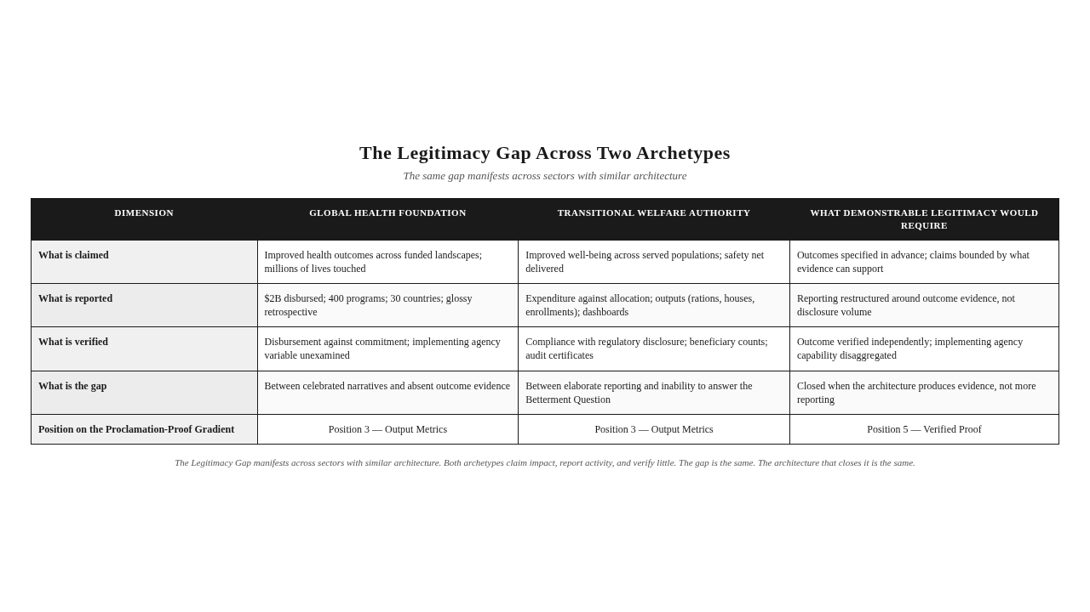

The Impossibility of Closing the Gap from Within
The Legitimacy Gap cannot be closed from within the architectures that produce it. This is the chapter's central claim, and it requires direct statement.
The architecture that produces the gap is the architecture of expenditure-based legitimacy. It is built around the question "What did you do?" Its evidence is expenditure and output. Its verification is compliance. Its communication is disclosure. Its audience is the institution itself. Every architectural element of the current system is optimized for the production of claimed legitimacy, not for the production of demonstrable legitimacy.
Closing the gap requires a different architecture. It requires an architecture built around the question "What changed?" Its evidence is outcome. Its verification is the Trust Layer. Its communication is Communication Usability. Its audience is the skeptical observer. None of these elements can be produced by adding more of the current architecture. They require replacement, not augmentation.
This is why the paradox that opened the chapter — more accountability, less trust — cannot be resolved by more accountability. More accountability, in the current architecture, produces more claimed legitimacy. It does not produce more demonstrable legitimacy. The gap, in fact, widens as accountability expands, because the expansion of claimed legitimacy outpaces any expansion of demonstrable legitimacy. The institution reports more. The community experiences the same. The gap grows.
The framework this book presents is the architecture that closes the gap. It is not an addition to the current architecture. It is a different architecture — one built from the foundation around the production of evidence rather than the production of claims. The next chapter conducts the comparative review that establishes why no existing framework provides this architecture. The chapter after that presents the framework itself.
Stop & Think: The institution you are thinking of — the one whose Legitimacy Gap you estimated earlier — can it close the gap by doing more of what it currently does? More reports? More compliance? More disclosure? Or does closing the gap require something structurally different? If the honest answer is the latter, you have already begun to see why the framework this book presents is necessary.



The Takeaway
The Legitimacy Gap is not a perception problem. It is an evidence problem. It cannot be closed by better communication, only by better evidence — and better evidence requires architecture.

Reader Momentum
The Legitimacy Gap cannot be closed from within the architectures that produce it. Existing paradigms — Carroll's Pyramid, Stakeholder Theory, compliance-based CSR — answer legitimate but different questions. None of them answers the Betterment Question. Before the framework that does answer the Betterment Question can be presented, the existing frameworks must be evaluated honestly and the gap in the landscape made visible. That comparative review is the subject of the next chapter.

CHAPTER 3 — COMPARATIVE REVIEW OF CSR FRAMEWORKS


The Question That No Existing Framework Answers
Every major CSR framework was designed to answer a specific question. Carroll's Pyramid answers the question "What should organizations be responsible for?" Stakeholder Theory answers "Whose interests should organizations consider?" The Triple Bottom Line answers "How should organizations account for impact across multiple dimensions?" Creating Shared Value answers "How can organizations align social and economic objectives?" ESG answers "How should investors evaluate non-financial performance?" GRI answers "How should organizations report?" ISO 26000 answers "How should organizations operationalize social responsibility?" The SDGs answer "How should organizations align with global goals?" BRSR answers "How should regulators mandate sustainability disclosure?"
These are all legitimate questions. Each framework answers its question with care, rigor, and useful contribution. The frameworks are not failing. They are not obsolete. They are not the problem this book exists to solve.
None of them answers the question this book asks: Can the organization demonstrate — with evidence that would convince a skeptical observer — that its interventions have resulted in the Betterment of Society?
Carroll's Pyramid describes what organizations should be responsible for; it does not describe how they can prove that what they did produced change. Stakeholder Theory identifies whose interests should be considered; it does not verify that consideration produced outcome. The Triple Bottom Line extends the accounting frame; it does not establish whether the accounting corresponds to betterment. Creating Shared Value identifies opportunities for aligned value; it does not demonstrate that the value was created. ESG evaluates non-financial performance for investors; it does not verify that the performance reflects outcome. GRI standardizes reporting; it does not verify that the reported activity produced change. ISO 26000 provides operational guidance; it does not produce evidence of betterment. The SDGs align organizations with global goals; they do not establish whether organizational contribution to those goals produced measurable betterment. BRSR mandates disclosure; it does not produce betterment.
The pattern is consistent. Every existing framework answers a question adjacent to the Betterment Question. None answers the Betterment Question itself. The space where the answer should be — the dimension of Betterment Verification — is empty in the existing landscape. That emptiness is the gap this book exists to fill.
Key Insight: Existing frameworks answer adjacent questions. None answers the Betterment Question. The dimension where the answer would live — Betterment Verification — is empty in the existing landscape.

The Six Dimensions of Framework Evaluation
To conduct the comparative review honestly, we need a structured method. I propose six dimensions against which any framework claiming to address institutional responsibility can be evaluated. The dimensions are not arbitrary. They emerge from the diagnostic work of Chapters 1 and 2.
The first dimension is Compliance. Does the framework specify what organizations must do, must report, or must avoid? Compliance-oriented frameworks establish rules, requirements, and disclosure mandates. They answer the question "What must the organization do?"
The second dimension is Governance. Does the framework specify how decisions about responsibility should be made within the organization? Governance-oriented frameworks address board structure, executive accountability, oversight mechanisms, and decision processes. They answer the question "How should the organization decide?"
The third dimension is Stakeholders. Does the framework identify whose interests the organization should consider, and how the organization should engage them? Stakeholder-oriented frameworks address stakeholder identification, engagement, and responsiveness. They answer the question "Whose interests should the organization consider?"
The fourth dimension is Reporting. Does the framework specify how the organization should communicate its responsibility performance? Reporting-oriented frameworks address disclosure format, indicators, assurance, and communication standards. They answer the question "How should the organization report?"
The fifth dimension is Impact. Does the framework specify how the organization should assess the effects of its actions? Impact-oriented frameworks address impact measurement, evaluation methodology, and attribution logic. They answer the question "How should the organization assess its effects?"
The sixth dimension is Betterment Verification. Does the framework specify how the organization can demonstrate — with evidence that meets the Skeptical Observer Standard — that its interventions produced measurable Betterment of Society? Verification-oriented frameworks address independent verification, outcome establishment, attribution defense, and the structural conditions under which betterment can be claimed. They answer the question "Can the organization prove that society is better because of its action?"
The first five dimensions are addressed, to varying degrees, by existing frameworks. The sixth dimension is not. This is the gap. The framework this book presents is the architecture that fills it. The Five Pillars Framework does not replace the frameworks that address the first five dimensions. It completes them by providing the sixth.
One Sentence Summary: The Six Dimensions of Framework Evaluation — Compliance, Governance, Stakeholders, Reporting, Impact, Betterment Verification — expose the gap in the existing landscape: the first five are addressed by existing frameworks; the sixth is not.

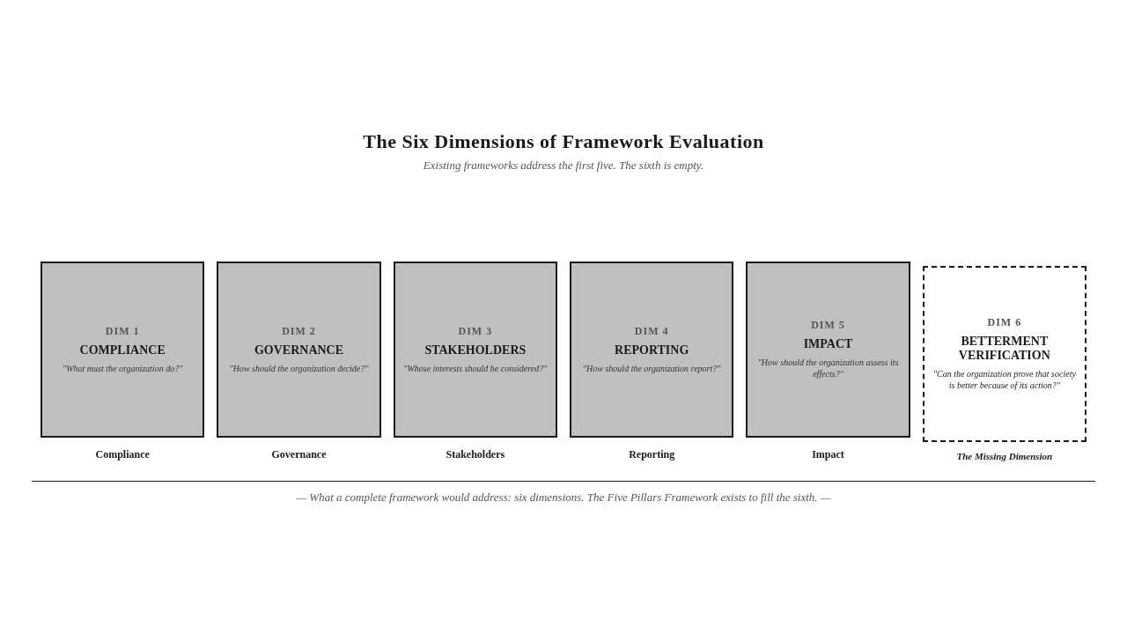

A Structured Review of the Major Frameworks
What follows is a structured review of the major CSR, ESG, and governance frameworks. For each framework, the review identifies the question the framework was designed to answer, the framework's strength, the framework's limitation, and the framework's relationship to Betterment Verification. The review is brief, direct, and load-bearing — it serves the doctrine's construction, not the field's conversation.
Carroll's Pyramid answers the question of what organizations should be responsible for. Its strength is the layered hierarchy of economic, legal, ethical, and philanthropic responsibilities — a map that has organized thinking about corporate responsibility for decades. Its limitation is that the hierarchy describes responsibility, not outcome. An organization can satisfy every layer of the pyramid and still be unable to demonstrate that its ethical conduct and philanthropic activity produced betterment. The pyramid cannot distinguish philanthropy from verifiable impact. It does not address Betterment Verification.
The Triple Bottom Line answers the question of how organizations should account for performance across economic, social, and environmental dimensions. Its strength is the expansion of the accounting frame beyond financial performance. Its limitation is that the framework is an accounting approach, not a verification approach. It tells the organization what to count. It does not establish whether what is counted constitutes betterment. The Triple Bottom Line produces three columns of numbers. It does not produce evidence that the numbers correspond to change in the condition of communities or systems. It does not address Betterment Verification.
Stakeholder Theory answers the question of whose interests organizations should consider. Its strength is the identification of stakeholders as legitimate constituencies whose interests the organization must weigh. Its limitation is that consideration is not outcome. An organization can consult stakeholders comprehensively, respond to stakeholder concerns, and report stakeholder engagement diligently — and still be unable to demonstrate that the engagement produced betterment for those stakeholders. Stakeholder Theory identifies the audience. It does not provide the verification architecture that would establish whether the audience's condition improved. It does not address Betterment Verification.
Creating Shared Value answers the question of how organizations can align social and economic objectives. Its strength is the recognition that social and economic value can be jointly produced rather than traded off. Its limitation is that the framework identifies opportunities for aligned value without verifying that the value was actually created. The framework assumes that aligned opportunities produce aligned outcomes. They sometimes do not. Creating Shared Value is, in the framework's terminology, an adjacent framework — useful for identifying opportunities, not for verifying outcomes. It does not address Betterment Verification.
ESG — Environmental, Social, and Governance — answers the question of how investors should evaluate non-financial performance. Its strength is the integration of non-financial factors into investment decision-making. Its limitation is that ESG is investor-oriented, not outcome-oriented. ESG ratings evaluate organizational policies, processes, and disclosures. They do not verify that the policies, processes, and disclosures produced betterment. A high ESG score reflects strong ESG performance as evaluated by the rating methodology. It does not reflect verified betterment in the condition of communities or systems. ESG does not address Betterment Verification.
GRI — the Global Reporting Initiative — answers the question of how organizations should report on sustainability performance. Its strength is the standardization of sustainability reporting across organizations and sectors. Its limitation is that reporting standardization is not outcome verification. GRI provides indicators, disclosures, and assurance standards. It does not require that the disclosed indicators be linked to verified outcomes. An organization can produce a fully GRI-compliant report and still be unable to demonstrate that the reported activities produced betterment. GRI standardizes reporting. It does not verify betterment. It does not address Betterment Verification.
ISO 26000 answers the question of how organizations should operationalize social responsibility. Its strength is the comprehensive guidance on integrating social responsibility into organizational practice. Its limitation is that operational guidance is not verification architecture. ISO 26000 helps organizations implement social responsibility practices. It does not verify that the practices produced betterment. An organization can fully implement ISO 26000 guidance and still be unable to demonstrate that its implementation produced outcome. ISO 26000 operationalizes responsibility. It does not verify betterment. It does not address Betterment Verification.
The SDGs — the Sustainable Development Goals — answer the question of how organizations should align with global goals. Their strength is the universal framework for collective action on shared global challenges. Their limitation is that alignment with goals is not contribution to outcomes. Organizations report their alignment with specific SDGs. They rarely establish, with evidence, that their alignment produced measurable contribution to those goals. The SDGs provide the destination. They do not provide the verification architecture that would establish whether the destination is being reached. The SDGs align organizations with goals. They do not verify betterment. They do not address Betterment Verification.
BRSR — the Business Responsibility and Sustainability Report — answers the question of how regulators should mandate sustainability disclosure. Its strength is the regulatory rigor of mandatory disclosure, applied to a defined segment of the corporate sector. Its limitation is the same as GRI's, intensified by mandate. BRSR requires organizations to disclose. It does not require organizations to verify. A BRSR-compliant report can be comprehensive, professional, and externally assured — and still be unable to demonstrate that the disclosed activities produced betterment. BRSR mandates reporting. It does not mandate betterment verification. It does not address Betterment Verification.
The pattern is consistent across all nine frameworks. Each was designed to answer a specific question. Each answers its question well. None addresses Betterment Verification. The dimension is empty in the existing landscape.
Stop & Think: The reader who has worked within any of these frameworks — GRI reporting, ESG evaluation, SDG alignment, Carroll's pyramid mapping — will recognize the pattern from inside. The framework provided structure, language, and discipline. It did not provide the answer to the question the reader's stakeholders were ultimately asking: did it work? That question, unanswered by the framework, is the question this book exists to address.



The Compliance-Betterment Distinction
The comparative review exposes a distinction that is the central conceptual move of this chapter. I call it the Compliance-Betterment Distinction.
Compliance and betterment are not the same thing. Compliance is the satisfaction of rules, requirements, and standards. Betterment is the verified improvement in the condition of communities or systems. Compliance is what an institution does internally to meet external expectations. Betterment is what changes externally because of what the institution did. The two are related — compliance can support betterment, and betterment can produce compliance — but they are not equivalent. An institution can be fully compliant and produce no betterment. An institution can produce betterment without being fully compliant with the rules of any specific framework.
The Compliance-Betterment Distinction matters because most existing frameworks collapse the two. They treat compliance as a proxy for betterment. They assume that an organization that reports against indicators, satisfies audit requirements, and meets disclosure mandates has thereby demonstrated betterment. This assumption is the structural error that produces the Compliance Theater, the Transparency Trap, and the Legitimacy Gap. Compliance is not betterment. Reporting is not verification. Disclosure is not evidence.
The distinction is not an attack on compliance. Compliance is necessary. The frameworks that produce compliance — GRI, BRSR, ESG, ISO 26000, the SDGs — perform a useful function. They establish floors. They standardize disclosure. They create comparability. They enable regulators and investors to assess organizational performance against shared expectations. The world without compliance frameworks would be worse than the world with them. The frameworks are necessary. They are insufficient. They produce compliance. They do not produce betterment verification. The Compliance-Betterment Distinction is the recognition of what they do and what they do not do.
The Five Pillars Framework is positioned to address what the existing frameworks do not do. It does not replace them. It does not duplicate their function. It does not compete with their contribution. It provides the dimension they collectively lack — Betterment Verification — and integrates that dimension into a complete architecture for institutional legitimacy. The existing frameworks and the Five Pillars Framework are complementary, not competitive. The meta-framework positioning this implies will be developed in the next section.
Key Insight: Compliance is what an institution does internally to meet external expectations. Betterment is what changes externally because of what the institution did. Existing frameworks produce compliance. The Five Pillars Framework produces betterment verification. The two are complementary, not competitive.

The Meta-Framework Positioning
The Five Pillars Framework is positioned as a meta-framework, not a replacement for existing CSR, ESG, or governance frameworks. This positioning is academically stronger, less confrontational, and more defensible than positioning the framework as a replacement.
A replacement framework claims to do what existing frameworks do, but better. A meta-framework claims to do what existing frameworks do not do, and to integrate with what they do. The first positioning is competitive. The second is complementary. The first requires the existing frameworks to be wrong. The second requires them to be incomplete. The first invites contestation. The second invites completion.
The Five Pillars Framework asks a question the existing frameworks do not ask. The existing frameworks ask what organizations should be responsible for, how they should report, how they should engage stakeholders, how they should align with goals. The Five Pillars Framework asks whether the organization can demonstrate that its interventions produced Betterment of Society. The question is different. The answer requires different architecture. The architecture is what this book presents.
The meta-framework positioning has three implications.
The first implication is that adopting the Five Pillars Framework does not require abandoning existing frameworks. An organization can continue to report against GRI, to align with the SDGs, to satisfy BRSR requirements, to maintain ESG ratings. The Five Pillars Framework does not compete with these activities. It completes them. It adds the dimension they lack — Betterment Verification — to the dimensions they already address.
The second implication is that the Five Pillars Framework cannot be evaluated by the standards of the existing frameworks. The existing frameworks are evaluated by their ability to produce compliance, reporting, and disclosure. The Five Pillars Framework is evaluated by its ability to produce verifiable betterment. The two evaluations are not interchangeable. An organization can score well on GRI and poorly on Betterment Verification, and vice versa. The meta-framework positioning requires the framework to be evaluated on its own terms, not on the terms of the frameworks it complements.
The third implication is that the Five Pillars Framework, as a meta-framework, applies across the entire landscape of institutional responsibility — corporate, governmental, philanthropic, developmental, educational, healthcare. It is not a CSR framework. It is not an ESG framework. It is not a sustainability framework. It is a meta-framework for institutional legitimacy, of which CSR, ESG, and sustainability are specific applications. The framework's universality is the source of its power. It applies wherever institutions claim to produce betterment — which is, in the twenty-first century, virtually everywhere.
Mini Case: A multinational corporation already reports against GRI, aligns its programs with the SDGs, satisfies ESG rating requirements, and complies with regulatory disclosure mandates. It adopts the Five Pillars Framework not to replace these activities but to add the dimension they collectively lack — Betterment Verification. Its existing reporting remains. Its verification architecture is built alongside. The meta-framework does not displace the existing frameworks. It completes them.

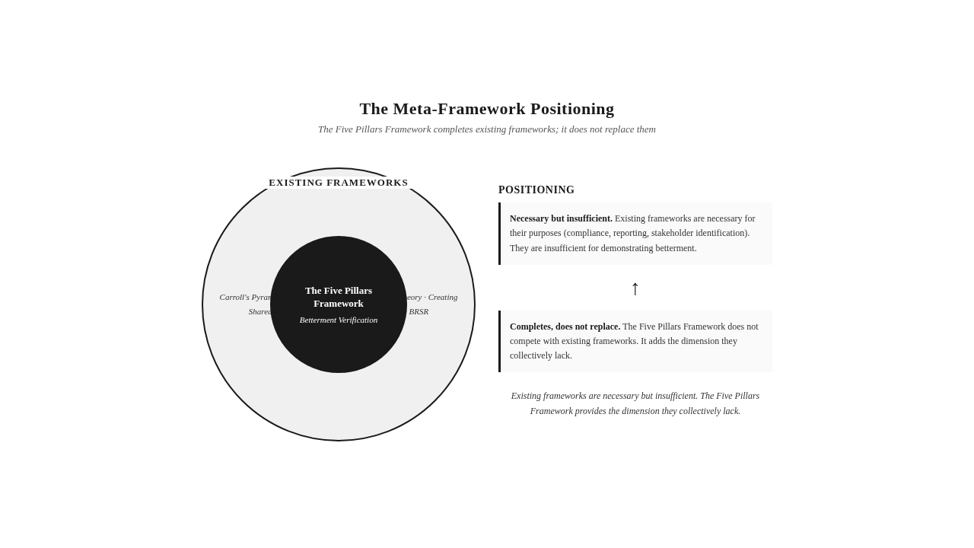

Three Illustrative Evaluations
The meta-framework positioning can be sharpened by applying it to specific frameworks. Consider three illustrative evaluations, each applying a different lens from this book's diagnostic vocabulary.
Carroll's Pyramid evaluated through the Skeptical Observer Standard. Carroll's Pyramid describes four layers of responsibility: economic, legal, ethical, philanthropic. A Carroll-compliant organization is economically productive, legally compliant, ethically engaged, and philanthropically generous. The Skeptical Observer asks: Can the organization demonstrate, with evidence, that its ethical engagement and philanthropic activity produced measurable betterment? The honest answer, in most cases, is no. The organization can demonstrate economic productivity through financial statements. It can demonstrate legal compliance through regulatory filings. It can demonstrate ethical engagement through codes of conduct and ethics training records. It can demonstrate philanthropic activity through disbursement records. None of this constitutes evidence of betterment. The pyramid describes what the organization should do. It does not provide the architecture for proving that what was done produced change. The Skeptical Observer, evaluating the pyramid-compliant organization, finds the Betterment Question unanswered.
GRI evaluated through the Betterment Question. GRI provides a comprehensive framework for sustainability reporting. A GRI-compliant report discloses organizational performance across hundreds of indicators, organized by topic and material. The Betterment Question asks: Can the organization demonstrate, with evidence that would convince a skeptical observer, that the disclosed activities produced measurable betterment in the condition of the communities or systems they affect? The honest answer, in most cases, is no. The GRI report discloses what the organization did. It does not establish what changed because of what the organization did. The indicators are activity and output indicators — emissions reduced, programs initiated, partnerships formed, training delivered. They are not outcome indicators — they do not establish that the activities produced change in the condition of the affected communities or systems. The GRI-compliant report answers the question "What did the organization do?" It does not answer the Betterment Question.
BRSR evaluated through the Compliance-Betterment Distinction. BRSR is a mandatory sustainability disclosure regime. A BRSR-compliant organization discloses a defined set of indicators, in a prescribed format, with external assurance. The Compliance-Betterment Distinction asks: Does the compliance architecture produce betterment verification, or does it produce compliance reporting? The honest answer, in most cases, is the latter. BRSR mandates disclosure. It does not mandate verification. An organization can be fully BRSR-compliant and still be unable to demonstrate that its disclosed activities produced betterment. The compliance architecture produces compliance reporting — comprehensive, standardized, assured. It does not produce betterment verification. The Compliance-Betterment Distinction, applied to BRSR, exposes the structural limit of mandatory disclosure: disclosure is necessary but insufficient for betterment verification.
These three evaluations illustrate the meta-framework positioning in practice. The existing frameworks are not wrong. They are not failing. They are answering different questions. The Skeptical Observer Standard, the Betterment Question, and the Compliance-Betterment Distinction are the diagnostic lenses that reveal what the existing frameworks do not do — and what the Five Pillars Framework exists to do.
Visual Recap: The Comparative Matrix (FPF-010) captures the result of these evaluations: every existing framework addresses the first five dimensions to varying degrees, and none addresses the sixth. The Five Pillars Framework addresses all six, with the sixth as its distinctive contribution.

Why the Gap Persists
The gap — the empty sixth column of the Comparative Matrix — has persisted for two decades. The reasons are structural, not accidental.
The first reason is that Betterment Verification is hard. Producing evidence that an institution's intervention produced measurable change in the condition of a community or system is methodologically demanding. It requires baseline data, comparison groups, attribution analysis, outcome measurement, and independent verification. It is much harder than producing compliance reporting. Institutions have gravitated toward frameworks that are operationally feasible. Betterment Verification has been treated as aspirational rather than architectural — something organizations might do if they had unlimited resources, not something they must do as a condition of legitimacy.
The second reason is that the existing frameworks were built by different communities for different purposes. Carroll's Pyramid was built by management scholars to organize thinking about responsibility. Stakeholder Theory was built by strategy scholars to identify organizational constituencies. GRI was built by reporting professionals to standardize disclosure. ESG was built by investment analysts to evaluate non-financial performance. The SDGs were built by multilateral institutions to coordinate global action. Each community built what it needed. None built Betterment Verification, because Betterment Verification was not the question any single community was asking. The gap is the cumulative result of communities answering adjacent questions.
The third reason is that the regulatory environment has rewarded compliance, not verification. Regulators can mandate disclosure. They can mandate assurance. They can mandate format and frequency. They cannot easily mandate Betterment Verification, because Betterment Verification requires architectural change within institutions, not just disclosure change. The regulatory environment has therefore produced a sophisticated compliance architecture — BRSR, the EU's Corporate Sustainability Reporting Directive, the International Sustainability Standards Board's standards — without producing a verification architecture. The regulatory environment has expanded the first five dimensions. It has not expanded the sixth.
The fourth reason is that the Betterment Question has not, until now, been asked as a doctrinal question. It has been asked as an evaluation question, an audit question, a research question, a journalistic question. It has not been asked as the central question of a framework that provides the architecture to answer it. The framework this book presents asks the question doctrinally — and provides the architecture that makes the answer possible.
Key Insight: The gap persists because Betterment Verification is hard, because existing frameworks were built by different communities for different purposes, because the regulatory environment rewards compliance, and because the Betterment Question has not been asked doctrinally. The framework this book presents asks it doctrinally — and provides the architecture to answer it.

A Brief Reference to Field Validation
The framework that fills the gap emerged from years of field observation across multiple sectors and geographies, and it was subsequently confirmed through a multi-year empirical field investigation. The investigation is not the source of the framework. The framework is doctrinal — derived from observation and reasoning, not from statistical analysis. The investigation is the validation — the empirical confirmation that the framework's architecture corresponds to what institutions actually do when they produce, or fail to produce, demonstrable betterment.
The full methodological treatment of the field investigation appears in Chapter 10. The main narrative references it only as confirmation, not as foundation. The framework stands on its doctrinal architecture. The validation confirms that the architecture bears weight. This separation — doctrine first, validation second — is deliberate. A framework that depends on its validation for its authority is a framework that depends on the survival of its validation. A framework that stands on its doctrinal architecture is a framework that endures.
The reference here is brief because the main narrative does not require methodological detail. The reader who wants the methodological treatment will find it in Chapter 10. The reader who wants the doctrine will continue with Chapter 4, which presents the framework's architecture.
One Sentence Summary: The framework emerged from years of field observation and was confirmed through a multi-year empirical field investigation; the doctrine stands on its architecture, and the validation confirms the architecture bears weight.

The Inevitability of the Sixth Dimension
The comparative review has established three things. First, existing frameworks answer legitimate but different questions. Second, none of them answers the Betterment Question. Third, the dimension where the answer would live — Betterment Verification — is empty in the existing landscape.
The reader who has followed the argument thus far may already be seeing the inevitability of what comes next. If the Betterment Question is real — if institutions genuinely need to demonstrate that their interventions produce betterment — and if no existing framework provides the architecture to answer it, then the architecture must be built. The framework this book presents is that architecture. It is not one option among many. It is the only architecture that answers the question the existing landscape leaves unanswered.
The next chapter presents the framework's architecture. It opens Part II of the book, in which the framework is constructed in full. The construction begins with the central question: if the Proclamation Trap and the Legitimacy Gap cannot be closed from within existing paradigms, what architecture is required? The answer is the Five Pillars.
Stop & Think: The reader who has worked within any of the nine frameworks reviewed in this chapter — and who has felt the limit of that framework when asked the Betterment Question — is already recognizing the gap. The framework that fills the gap is the subject of the next four chapters. The reader who continues will see the architecture emerge, pillar by pillar, from the diagnosis this chapter has completed.



The Takeaway
Existing frameworks are not failing. They are answering different questions. The Five Pillars Framework asks the question they collectively do not — and that is why it is needed.

Reader Momentum
The comparative review has established the gap. No existing framework demonstrates Betterment of Society. The first five dimensions of the Six Dimensions of Framework Evaluation are addressed; the sixth is empty. The reader now asks: what architecture would fill the sixth dimension? What architecture would close the Legitimacy Gap? What architecture would answer the Betterment Question? The answer — the Five Pillars Framework — is the subject of Part II. The architecture begins in the next chapter.

CHAPTER 4 — THE FRAMEWORK ARCHITECTURE


The Architectural Question
If the Proclamation Trap cannot be escaped by more reporting, and the Legitimacy Gap cannot be closed by better communication, and the Betterment Question cannot be answered by any existing framework, what architecture is required?
This is the question that has been building since the Prologue. It is the question that the diagnosis of Chapters 1 and 2 has prepared. It is the question that the comparative review of Chapter 3 has sharpened. The diagnosis is complete. The gap is visible. The inadequacy of the current architecture is established. The question now is constructive: what architecture would answer the Betterment Question?
The answer is not a process. It is not a methodology. It is not a reporting framework. It is not a set of indicators. The answer is an architecture — a set of structural conditions that, when present and aligned, make it possible for an institution to demonstrate, with evidence that meets the Skeptical Observer Standard, that its interventions produce Betterment of Society.
The architecture has five conditions. They are not arbitrary. They emerged from years of field observation across sectors and geographies, were refined through repeated testing against the patterns described in Chapters 1 and 2, and were confirmed through a multi-year empirical field investigation. The architecture is presented here not as one option among many but as the architecture the problem requires. To see why, we will examine the architecture, demonstrate its internal dependency logic, and stress-test it against three alternatives that were considered and rejected.
The five conditions are called pillars. The name is deliberate. A pillar is a structural element that bears weight. A building without one of its pillars is structurally compromised regardless of how strong the remaining pillars are. The pillars of institutional legitimacy work the same way. Their absence is not a shortfall to be compensated by strength elsewhere. Their absence is a structural deficiency that compromises the whole.
The pillars are presented in a specific sequence. The sequence is not alphabetical convenience. It is a chain of dependency, in which each pillar presupposes the previous. The sequence is A-E-I-O-M: Accountability, Execution, Initiative, Outcome, Meaning. The framework is the Five Pillars Framework. The architecture is the Five Pillars. The sequence is A-E-I-O-M.
Key Insight: The architecture is not a process or a methodology. It is a set of five structural conditions — pillars — that, when present and aligned, make it possible for an institution to answer the Betterment Question. The sequence A-E-I-O-M is a chain of dependency, not alphabetical convenience.

Pillar A — Accountability
Accountability is the institutional condition of being answerable for outcomes — not activities, not expenditures, not intentions, but the actual changes produced in the world.
Accountability is the normative foundation of the framework. It establishes that an institution's legitimacy depends on its willingness and capacity to answer the Betterment Question. An institution that cannot be held answerable for outcomes has no claim to legitimacy, regardless of how much it spends, how many programs it runs, or how earnestly it reports.
Accountability is not reporting. Reporting is what institutions do when they lack accountability. Accountability is the structural condition in which an institution can be asked, at any time, to demonstrate what it has produced — and must answer with evidence, not narrative. The institution that is accountable has built the architecture that makes the answer possible. The institution that merely reports has built the architecture that makes the question disappear into volume.
The failure mode when Accountability is absent is the Compliance Theater — elaborate reporting architectures that document activity while obscuring the absence of demonstrable outcomes. The Compliance Theater is what accountability becomes when it is reduced to compliance. The institution that has confused the two produces sophisticated reporting and calls it accountability. The skeptical observer reads the reporting and asks the Betterment Question. The institution cannot answer. The Compliance Theater is complete.
The verification demand of Accountability is direct: Can the institution specify, in advance, what outcomes it is answerable for, and can it produce evidence of those outcomes on demand? An institution that cannot specify what it is answerable for is not accountable, regardless of its reporting sophistication. An institution that cannot produce evidence on demand is not accountable, regardless of its assurance certificates. Accountability is the demand for evidence, made before the fact and answerable after the fact.
Stop & Think: Consider the institution you know best. Can it specify, right now, the outcomes it is answerable for? If asked, today, to produce evidence that those outcomes occurred and are attributable to its action, could it do so? If the honest answer is no, the institution has reporting, not accountability. The distinction is the work of this pillar.

Pillar E — Execution
Execution is the operational architecture by which intent is converted into implemented reality — the governance structures, delivery systems, institutional capability, and implementation discipline that determine whether an initiative reaches the people it claims to serve.
Execution is the architecture of doing. It is the difference between an initiative that exists on paper and one that exists in the world. Execution encompasses the capability of the implementing agency, the design of delivery mechanisms, the quality of operational governance, and the discipline of adaptation under real-world conditions. The initiative that is brilliantly designed and poorly executed is the same as the initiative that is poorly designed: in both cases, the world does not change.
The framework recognizes, through the Implementing Agency Principle, that execution is the most variable and most decisive pillar. The same framework, the same budget, the same intent, applied by different implementing agencies, produces different outcomes. The variable is not the sector, the budget, or the regulation. The variable is the agency — its execution architecture, its community embeddedness, its accountability discipline, its initiative authenticity, and its meaning integrity. No sector performs inherently better than another. What succeeds is capable implementation aligned across all five pillars; what fails is deficient implementation missing one or more.
The failure mode when Execution is absent is the Policy-Practice Chasm — elegant designs that never materialize in implementation because the execution architecture cannot carry them. The Policy-Practice Chasm is the gap between the program on paper and the program in the world. It is the gap that opens when institutions design initiatives without building the operational architecture to deliver them, when policies are written without delivery systems, when budgets are committed without implementation capability. The Policy-Practice Chasm is invisible to the institution that designs the policy. It is acutely visible to the community that receives the implementation, or fails to receive it.
The verification demand of Execution is direct: Can the institution demonstrate the operational architecture by which intent becomes reality, and can it show that this architecture actually functions? An institution that can describe its execution architecture but cannot demonstrate that the architecture functions has design, not execution. The verification of execution requires evidence of operational performance — evidence that the delivery systems reached the people they were meant to reach, that the governance structures governed, that the implementation discipline held.
Key Insight: Execution is the most variable and most decisive pillar. The same framework, budget, and intent produce different outcomes under different implementing agencies. The variable is the agency, not the sector.

Pillar I — Initiative
Initiative is the quality of the originating impulse — the degree to which an institutional initiative begins from genuine identification of what matters, grounded in participatory engagement with the communities and systems it intends to affect, rather than from imposed intent, performative gesture, or institutional self-interest.
Initiative is the generative origin of institutional action. It asks: Where did this begin? Who identified the need? Whose knowledge shaped the design? Is the initiative a response to a stakeholder-identified need, or is it a projection of institutional preference onto a convenient recipient?
The question matters because the origin determines the destination. An initiative that begins from genuine identification of what matters addresses a real need, produces a recognizable outcome, and earns the community's recognition that something changed. An initiative that begins from imposed intent addresses a projected need, produces an irrelevant outcome, and earns the community's recognition that something was done to it without its participation. The same program, designed with different initiative quality, produces different outcomes — not because the execution differs, but because the origin determines whether the initiative addresses what actually matters.
Initiative Authenticity is the difference between an initiative that communities recognize as theirs and one they experience as imposed. The framework distinguishes Participatory Engagement from consultation and notification. Consultation asks after deciding. Notification informs after acting. Participatory Engagement involves stakeholders in the identification of need, the design of initiative, and the verification of outcome. Only Participatory Engagement produces Initiative Authenticity.
The failure mode when Initiative is absent is the Imposed Imperative — initiatives that are operationally excellent and accountably reported but fundamentally disconnected from the needs they claim to address. The Imposed Imperative is the pillar's specific pathology. It is what initiative becomes when it originates from institutional preference rather than participatory identification. The institution that has confused the two produces programs that satisfy its own metrics and miss the community's needs. The skeptical observer asks whether the initiative addressed what mattered. The institution cannot answer with evidence from the community.
The verification demand of Initiative is direct: Can the institution demonstrate that the initiative originated from participatory identification of need, and can it show that stakeholders recognize the initiative as responsive to their reality? An institution that cannot demonstrate the origin of its initiative cannot demonstrate its authenticity. The community is the witness. Without the community's recognition, the initiative is imposed regardless of its operational excellence.
Mini Case: A foundation designs a workforce training program based on its own analysis of labor market gaps. The training is delivered with operational excellence. The placement rates are reported. Stakeholders are consulted about program delivery. The community, asked whether the program addressed what mattered to them, answers that the gaps the foundation identified were not the gaps the community experienced. The initiative was operationally excellent and substantively disconnected. The Imposed Imperative is complete.

Pillar O — Outcome
Outcome is the actual, demonstrable, attributable change produced in the world by institutional action — distinct from activity (what was done), output (what was produced), and intention (what was hoped).
Outcome is the ontological substance of the framework. It is the only pillar that constitutes evidence of betterment. Without outcome, the other four pillars are architecture without a building — structurally sound but substantively empty. Accountability without outcome is a demand for an answer that has no answer. Execution without outcome is operational activity that changes nothing. Initiative without outcome is good intent unfulfilled. Meaning without outcome is communication about something that did not happen.
The framework draws a strict hierarchy. Activity is what the institution did. Output is what the activity produced. Outcome is what changed in the world because of the output. Betterment is the cumulative, verifiable improvement in the condition of the community or system. Only outcome and betterment constitute evidence. Activity and output are necessary but insufficient. An institution that reports activities and outputs without demonstrating outcomes is practicing the Expenditure Fallacy and the Output Illusion simultaneously.
Outcome Verifiability is the degree to which a claimed outcome can be independently confirmed by a skeptical observer. Outcome Verifiability is not the same as outcome plausibility. An outcome that is plausible — that the institution can imagine having occurred — is not an outcome that is verified. An outcome that is verified is one that an independent observer can confirm through evidence the institution has produced. Betterment Evidence is evidence of outcome that meets the Skeptical Observer Standard. It is the only evidence that satisfies the Outcome pillar.
The failure mode when Outcome is absent is the Output Illusion — voluminous reporting of activities and outputs that never establishes whether anything actually changed. The Output Illusion is the pillar's specific pathology. It is what outcome becomes when it is reduced to output. The institution that has confused the two produces sophisticated activity reports and calls them outcome evidence. The skeptical observer reads the reports and asks what changed. The institution cannot answer.
The verification demand of Outcome is direct: Can the institution demonstrate, with evidence that would convince a skeptical observer, that a measurable change occurred in the world, and that this change is attributable to its action? An institution that cannot demonstrate change cannot demonstrate outcome. An institution that cannot demonstrate attribution cannot claim the change as its own. The Outcome pillar requires both — change and attribution — established with evidence that meets the Skeptical Observer Standard.
Key Insight: Outcome is the only pillar that constitutes evidence of betterment. Without outcome, the other four pillars are architecture without a building. The Outcome pillar requires both change and attribution, established with evidence that meets the Skeptical Observer Standard.

Pillar M — Meaning
Meaning is the communicative integrity between institutional action and institutional narrative — the degree to which what an institution says corresponds to what is real, and the degree to which that communication is usable — legible, verifiable, actionable — by the stakeholders who receive it.
Meaning is the communicative pillar. It recognizes that institutional communication is not a reporting function but a legitimacy function. Communication that corresponds to reality builds Trust Capital. Communication that departs from reality consumes it. Communication that stakeholders cannot understand, cannot verify, and cannot act upon is not communication — it is noise dressed as transparency.
The framework introduces the concept of Communication Usability — the degree to which institutional communication enables stakeholders to understand what was done, verify what was claimed, and act on what was communicated. Communication that is not usable fails the Meaning pillar regardless of how much information it contains. Communication Usability is the operational core of the Meaning pillar. It is what distinguishes communication from disclosure, meaning from volume, transparency from the Transparency Trap.
Meaning Correspondence is the alignment between institutional narrative and institutional reality. High correspondence builds Trust Capital. Low correspondence consumes it. The institution whose narrative corresponds to its reality accumulates credibility over time. The institution whose narrative departs from its reality accumulates Verification Debt. Meaning Correspondence is the long-term discipline of communication integrity — the discipline of saying what is true, of saying it in ways stakeholders can verify, and of refusing to say what cannot be established.
The failure mode when Meaning is absent is the Transparency Trap — voluminous, technically dense, professionally produced communication that no stakeholder can actually use to verify anything. The Transparency Trap is the pillar's specific pathology. It is what meaning becomes when it is reduced to disclosure. The institution that has confused the two produces comprehensive reports and calls them communication. The skeptical observer opens the reports and cannot verify a single claimed outcome. The Transparency Trap is complete.
The verification demand of Meaning is direct: Can the institution demonstrate that its communication is legible to its intended stakeholders, that it corresponds to verifiable reality, and that stakeholders can act on it? An institution that cannot demonstrate Communication Usability has disclosure, not meaning. An institution that cannot demonstrate Meaning Correspondence has narrative, not legitimacy. The Meaning pillar requires both — usability and correspondence — established through evidence that the institution's stakeholders can in fact use and verify what is communicated.
One Sentence Summary: Meaning is communication that corresponds to reality and is usable by stakeholders. The Transparency Trap is what meaning becomes when it is reduced to disclosure volume.

The A-E-I-O-M Sequence as Chain of Dependency
The five pillars are not parallel. They are sequential. Each pillar presupposes the previous. The sequence is a chain of dependency, not alphabetical convenience.
Accountability establishes the frame. It is the demand that institutions answer for outcomes. Without Accountability, the other pillars have no purpose — there is no demand for execution, initiative, outcome, or meaning if no one is asking what the institution produced. Accountability is the first pillar because it is the demand that creates the need for the rest.
Execution provides the capacity. It is the operational architecture that makes outcomes possible. Without Execution, Accountability is aspiration — the demand for an answer to a question the institution has no operational capacity to answer. Execution is the second pillar because it provides the architecture through which Accountability can be satisfied.
Initiative determines the authenticity. It is the origin that ensures the action addresses what actually matters. Without Initiative, Execution is efficient irrelevance — the capacity to deliver initiatives that do not address real needs. Initiative is the third pillar because it ensures that what is executed is what should have been executed.
Outcome constitutes the substance. It is the demonstrable change that answers the Accountability demand. Without Outcome, the previous three pillars are architecture without a building — Accountability, Execution, and Initiative directed toward action that does not change anything. Outcome is the fourth pillar because it is the substance that the previous three pillars exist to produce.
Meaning completes the circuit. It is the communication that makes the Outcome legible, verifiable, and trustworthy. Without Meaning, Outcome is achievement that cannot be recognized or trusted — the institution has produced change but cannot establish that it has produced change, and the Betterment Question remains unanswered regardless of what was actually accomplished. Meaning is the fifth pillar because it is the communication that completes the circuit between Outcome and Accountability.
The sequence is complete at five. Accountability without Execution is aspiration. Execution without Initiative is efficient irrelevance. Initiative without Outcome is good intent unfulfilled. Outcome without Meaning is achievement that cannot be recognized. The five pillars, in sequence, form a complete circuit of institutional legitimacy. The architecture is complete at five. No sixth pillar is needed. No sixth pillar is permitted.
Visual Recap: The Five Pillars Framework diagram (FPF-012) captures this: five vertical pillars in A-E-I-O-M order, with dependency arrows showing how each pillar presupposes the previous. The architecture is a circuit, not a list.



Pillar Coherence and Pillar Deficiency
The framework's core principle is not individual pillar strength. It is Pillar Coherence.
Pillar Coherence is the condition in which all five pillars are present, aligned, and mutually reinforcing. An institution with Pillar Coherence has built the architecture such that Accountability demands outcome, Execution produces outcome, Initiative ensures the outcome matters, Outcome constitutes the substance, and Meaning makes the outcome verifiable. The pillars operate as a circuit. Each pillar's verification demand is met by the next pillar's architecture. The institution that has Pillar Coherence can answer the Betterment Question.
Pillar Deficiency is the condition in which one or more pillars are absent or weak. Pillar Deficiency produces illegitimacy regardless of the strength of the remaining pillars. An institution with strong Execution and Outcome but weak Initiative produces efficiently delivered outcomes that do not address what matters. An institution with strong Accountability and Meaning but weak Outcome produces accountable, well-communicated activity that does not change anything. An institution with strong Initiative and Outcome but weak Meaning produces authentic, effective action that no one outside the institution can verify. In each case, the deficiency in one pillar collapses the legitimacy of the whole.
Pillar Coherence is the framework's core principle because it captures the architecture's demand. The framework does not ask institutions to be strong at one pillar and acceptable at others. It asks institutions to be coherent — to have all five pillars present, aligned, and mutually reinforcing. The demand is structural, not aspirational. The institution with Pillar Deficiency cannot compensate for the deficiency by being exceptional elsewhere. The deficiency is the architecture's verdict. The institution's legitimacy is the architecture's verdict, not the institution's self-assessment.
Pillar Coherence is also the framework's diagnostic instrument. When an institution's claim to betterment is challenged, the framework asks which pillar is deficient. The answer locates the work that must be done. The institution with strong reporting but weak outcome has a Pillar O deficiency. The institution with strong programs but weak stakeholder recognition has a Pillar I deficiency. The institution with strong delivery but weak communication has a Pillar M deficiency. The diagnosis is structural. The remedy is architectural. The framework does not propose quick fixes. It proposes architectural reconstruction.
Key Insight: Pillar Coherence, not individual pillar strength, is the condition for legitimacy. Weakness in any one pillar is weakness in the whole. The framework's diagnostic power comes from identifying which pillar is deficient — and the remedy is always architectural.

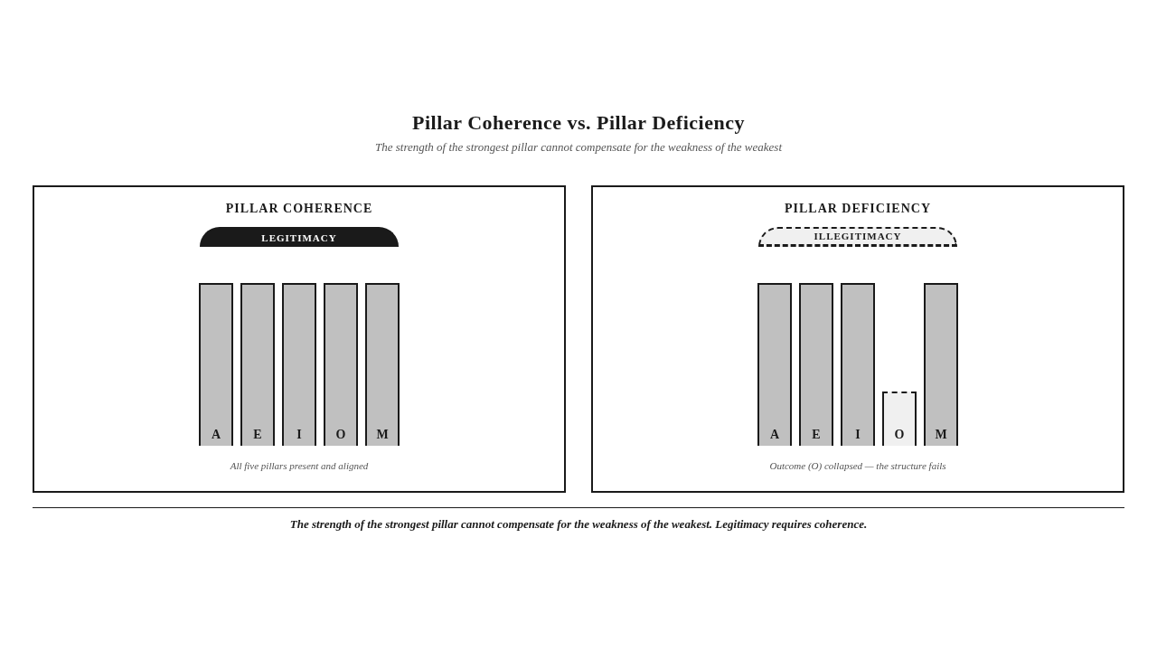

A Comparative Stress-Test
The Five Pillars are not the only architecture that could be proposed to answer the Betterment Question. To establish the framework as the architecture the problem requires, three alternatives must be considered and rejected.
The Four-Pillar Alternative. The first alternative proposes four pillars rather than five. The argument for four pillars is parsimony: the fewer the pillars, the more operational the framework. The argument against four pillars is that any four-pillar architecture either collapses two pillars into one or omits a pillar that the diagnosis has shown to be necessary.
If Accountability and Execution are collapsed into a single "Delivery" pillar, the framework loses the distinction between the demand for outcome and the capacity to produce it. The institution that has Delivery without the explicit demand for outcome can deliver activity without outcome. The Compliance Theater returns. If Execution and Initiative are collapsed into a single "Implementation" pillar, the framework loses the distinction between operational capacity and initiative authenticity. The institution that has Implementation without the explicit demand for authenticity can implement imposed initiatives efficiently. The Imposed Imperative returns. If Outcome and Meaning are collapsed into a single "Communication" pillar, the framework loses the distinction between change in the world and communication about change. The institution that has Communication without verified outcome can communicate what did not happen. The Transparency Trap returns.
The four-pillar alternative fails because it collapses distinctions the diagnosis has shown to be necessary. The five-pillar architecture preserves the distinctions. The four-pillar architecture erases them.
The Six-Pillar Alternative. The second alternative proposes six pillars rather than five. The argument for six pillars is comprehensiveness: the more pillars, the more complete the framework. The argument against six pillars is that any sixth pillar is either a re-description of one of the five or a concept that does not belong at the architectural level.
Common proposals for a sixth pillar include Trust, Evidence, Governance, Stakeholders, and Verification. Each is a legitimate concept. None belongs at the pillar level. Trust is the outcome of the five pillars operating coherently — it is what the architecture produces, not a pillar within it. Evidence is the substance of the Outcome pillar — it is what Outcome requires, not a separate pillar. Governance is the operational expression of the Accountability pillar — it is how Accountability is institutionalized, not a separate pillar. Stakeholders are the audience of the Initiative and Meaning pillars — they are whom the architecture serves, not a separate pillar. Verification is the architecture of the Trust Layer — it is the infrastructure that makes the pillars credible, not a separate pillar.
Each proposed sixth pillar is a legitimate concept that belongs within the architecture, not as a pillar alongside it. The framework recognizes each. None is added as a sixth pillar. The architecture is complete at five. Adding a sixth pillar would either duplicate an existing pillar or elevate a supporting concept to architectural status it does not require.
The six-pillar alternative fails because it elevates supporting concepts to pillar status. The five-pillar architecture keeps concepts at their proper level. The six-pillar architecture confuses the levels.
The Parallel-Network Alternative. The third alternative proposes not pillars but a parallel network of capabilities — a set of organizational functions that operate in parallel rather than in sequence. The argument for a parallel network is flexibility: institutions can configure capabilities as their context requires. The argument against a parallel network is that the Betterment Question requires sequence, not configuration.
The Betterment Question asks whether an institution can demonstrate that its interventions produce Betterment of Society. Answering the question requires a specific sequence: the demand for outcome (Accountability), the capacity to produce outcome (Execution), the authenticity of the outcome (Initiative), the substance of the outcome (Outcome), and the communication of the outcome (Meaning). The sequence is not optional. An institution cannot communicate an outcome it has not produced. It cannot produce an outcome it has not designed authentically. It cannot design authentically without the capacity to deliver. It cannot deliver against the demand for outcome if the demand has not been made. The sequence is the answer to the Betterment Question.
A parallel network of capabilities would allow institutions to configure functions without respecting the sequence. The institution could communicate without outcome, produce without authenticity, design without delivery. The parallel network would reproduce the Proclamation Trap, because the Proclamation Trap is precisely what happens when the sequence is not respected — when institutions communicate what they have not verified, claim outcome they have not established, and execute initiatives that lack authenticity. The parallel-network alternative fails because it does not enforce the sequence the Betterment Question requires.
The three alternatives — four-pillar, six-pillar, parallel-network — each fail for specific, evidence-based reasons. The Five Pillars Framework is not one architecture among many. It is the architecture the problem requires. Once the problem is understood, no other architecture seems possible.
Mini Case: The reader who has watched an institution adopt a four-pillar framework and discover that it cannot distinguish execution from outcome — or adopt a six-pillar framework and discover that the sixth pillar duplicates the second — or adopt a parallel-network framework and discover that the institution can no longer establish the sequence from demand to communication — has already seen the alternatives fail in practice. The Five Pillars are not a preference. They are what the alternatives cannot be.

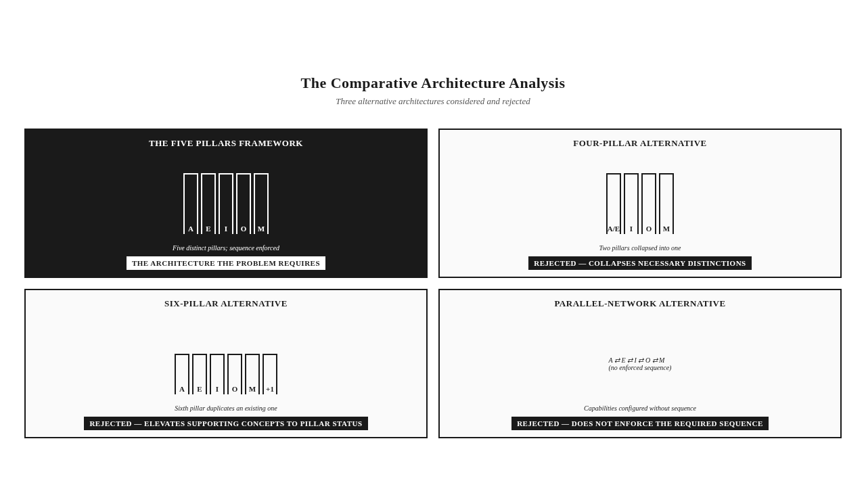

The Five Pillars as Inevitable
The comparative stress-test establishes the framework as inevitable in a specific sense. The architecture is not inevitable because it is the only architecture that could be imagined. It is inevitable because, given the problem the diagnosis has established, no other architecture answers the question.
The problem is the Betterment Question. The question requires an architecture that produces verifiable evidence of outcome, attributable to institutional action, established through verification that meets the Skeptical Observer Standard. The architecture must include the demand for outcome, the capacity to produce outcome, the authenticity of outcome, the substance of outcome, and the communication of outcome. Each of these is a distinct function. Each requires a distinct pillar. The sequence is enforced by the logic of the question.
The Five Pillars Framework is the architecture that meets these requirements. The pillars are distinct, sequential, and complete. The architecture does not collapse distinctions, does not elevate supporting concepts, and does not violate the required sequence. The architecture is the answer to the question, derived from the question's structure.
The inevitability is not a rhetorical claim. It is an architectural claim. Any architecture that proposes to answer the Betterment Question must include the five functions the Five Pillars include. Any architecture that omits one of them fails to answer the question. Any architecture that adds a sixth either duplicates an existing function or elevates a supporting concept. Any architecture that does not enforce the sequence reproduces the Proclamation Trap. The Five Pillars are inevitable because the question requires what they provide.
The framework, then, is not presented as one option among many. It is presented as the architecture the problem requires. The reader who has followed the diagnosis of Chapters 1 and 2, the comparative review of Chapter 3, and the architectural argument of this chapter is now in a position to see the framework not as a proposal but as a discovery — the architecture that was always required, made visible by the diagnosis of why institutions have failed to answer the Betterment Question without it.
The architecture will be developed in full in Chapter 5. The pillars will receive their complete treatment — definitions, failure modes, verification demands, tensions, and synergies. The Trust Layer, which sits beneath the pillars as their verification infrastructure, will be developed in Chapter 6. The institutional operating system that embeds the framework in institutional practice will be developed in Chapter 7. The framework is presented as architecture, and the architecture is what the next four chapters build.
Key Insight: The Five Pillars are not inevitable because they are the only architecture that could be imagined. They are inevitable because, given the Betterment Question, no other architecture answers the question. The architecture is derived from the question's structure.

Two Archetypes — The Architecture Applied
The framework's architecture can be sharpened by applying it to two archetypes, both familiar from earlier chapters. The application here is introductory — the full diagnostic treatment of each pillar appears in Chapter 5.
The first is the Multinational Extractive Enterprise, revisited from Chapter 1. The enterprise operates at the extraction frontier. Its reporting is sophisticated. Its compliance is impeccable. Its expenditure is substantial. Applying the Five Pillars: The enterprise has reporting that satisfies some Accountability demands, but cannot specify, in advance, the outcomes it is answerable for — Pillar A is partially present, partially deficient. The enterprise has strong Execution architecture — its operations reach the communities it serves, its delivery systems function — Pillar E is present. The enterprise has weak Initiative — its programs are designed internally, with consultation but not Participatory Engagement, and the communities do not recognize the initiatives as theirs — Pillar I is deficient. The enterprise has weak Outcome — it reports outputs (schools built, training delivered) but cannot demonstrate outcomes (learning improved, livelihoods changed) with evidence that meets the Skeptical Observer Standard — Pillar O is deficient. The enterprise has reporting that is voluminous but not usable — Pillar M is partially present, partially deficient. The enterprise has Pillar Deficiency. Its strong Execution cannot compensate for its deficient Initiative, Outcome, and Meaning. The enterprise's Legitimacy Gap is the architectural consequence of the deficiency.
The second is the Educational Transformation Initiative, a new composite archetype. It is an initiative that redesigns learning systems across institutional boundaries — public schools, private providers, community education programs, digital learning platforms, and workforce preparation. The initiative's governance is multi-stakeholder. Its design is sophisticated. Its ambition is the transformation of learning outcomes for a generation of learners across diverse institutional contexts. Applying the Five Pillars: The initiative has clear Accountability — it has specified, in advance, the learning outcomes it is answerable for, and it has built the architecture to track them — Pillar A is present. The initiative has variable Execution — its delivery systems are strong in some institutional contexts and weak in others, depending on the implementing agency — Pillar E is present in some contexts, deficient in others, reflecting the Implementing Agency Variable. The initiative has strong Initiative — it was designed through Participatory Engagement with learners, families, educators, and communities, who recognize the initiative as responsive to their needs — Pillar I is present. The initiative has partial Outcome — it can demonstrate outcome in some institutional contexts and not in others, depending on where the Execution architecture held — Pillar O is partially present. The initiative has strong Meaning — its communication is legible, verifiable, and actionable by the stakeholders it serves — Pillar M is present. The initiative has partial Pillar Coherence — coherent in some institutional contexts, deficient in others, with the deficiency tracking the Execution deficiency. The initiative's Betterment Question is answerable in some contexts and not in others. The architecture diagnoses why.
These two archetypes — the corporate enterprise and the educational initiative — operate in different sectors, serve different populations, and answer to different constituencies. The Five Pillars Framework applies to both without modification. The diagnosis in each case is structural. The remedy in each case is architectural. The framework's universality is not a claim. It is a demonstration. The framework applies wherever institutions claim to produce betterment.
Stop & Think: The reader who has applied the Five Pillars informally to their own institution — asking which pillars are present, which are deficient, and where the Pillar Deficiency lies — has already begun to use the framework diagnostically. The full diagnostic treatment, which Chapter 5 develops, formalizes what the reader has already begun.

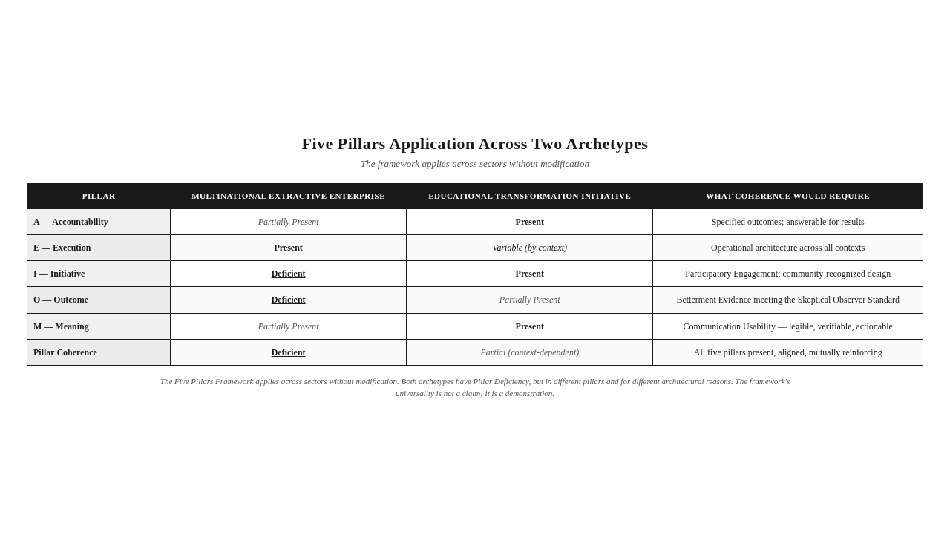


The Takeaway
The Five Pillars are not one architecture among many. They are the architecture the problem requires — and once the problem is understood, no other architecture seems possible.

Reader Momentum
The architecture has been presented. The five pillars have been introduced. The sequence has been established. The coherence principle has been stated. The alternatives have been rejected. The framework is, in skeletal form, complete. But skeletons are not bodies. The pillars require depth — their failure modes, their verification demands, their tensions, their synergies. The next chapter builds the body. Each pillar receives its full doctrinal treatment. The architecture that has been sketched here becomes, in Chapter 5, the architecture the reader can inhabit.

CHAPTER 5 — THE FIVE PILLARS IN DEPTH


If Legitimacy Requires Five Conditions
If legitimacy requires five conditions, what happens when only four are present?
The answer is illegitimacy dressed in the costume of the four satisfied pillars. The institution with strong Execution, strong Initiative, strong Outcome, and strong Meaning — but weak Accountability — produces effective, authentic, well-communicated change that no one is answerable for. The institution with strong Accountability, strong Execution, strong Initiative, and strong Outcome — but weak Meaning — produces accountable, effective, authentic change that no one outside the institution can verify. The institution with strong Accountability, strong Initiative, strong Outcome, and strong Meaning — but weak Execution — produces accountable, authentic, well-communicated intent that does not actually reach the people it claims to serve. In each case, the institution has four pillars. In each case, the legitimacy collapses.
This is why Pillar Coherence, not individual pillar strength, is the architecture's core principle. The strength of the strongest pillar cannot compensate for the weakness of the weakest. The architecture's demand is structural: all five pillars, present, aligned, and mutually reinforcing. The institution that has built four pillars has built an incomplete architecture. The incomplete architecture is not four-fifths legitimate. It is illegitimate, because the missing pillar is the condition the other four require to function as a circuit.
This chapter develops each pillar in full. For each pillar, the treatment includes its definition, its function in the architecture, its failure mode when absent, its verification demand, its tensions with adjacent pillars, and its synergies with them. The chapter then synthesizes the pillars through Pillar Coherence and Pillar Deficiency, introduces the Composite Effectiveness Index as the framework's diagnostic instrument (conceptually — the formula appears in Chapter 11), and applies the framework to four archetypes whose pillar profiles reveal the architecture's diagnostic power.
Key Insight: The strength of the strongest pillar cannot compensate for the weakness of the weakest. Pillar Coherence — all five pillars present, aligned, and mutually reinforcing — is the architecture's core principle. The institution with four pillars is not four-fifths legitimate; it is illegitimate.

Pillar A — Accountability in Depth
Accountability is the institutional condition of being answerable for outcomes. The pillar's full doctrinal treatment requires unpacking three elements: what answerability means, what outcomes means, and what the institutional condition for answerability requires.
Answerability is the structural willingness to be asked, at any time, to demonstrate what has been produced. It is not a personality trait of institutional leaders. It is not a cultural posture of the institution. It is a structural condition — the condition in which the institution has built the architecture that makes the demand for evidence answerable. An institution that has answerability has specified, in advance, the outcomes it is answerable for. It has built the data systems that track those outcomes. It has established the verification protocols that confirm the outcomes. It has created the governance structures that hold the institution to its commitments. Answerability is architecture, not aspiration.
Outcomes, in the Accountability pillar's usage, are not activities, outputs, or intentions. They are the actual changes produced in the world — the changes in the condition of communities or systems that the institution's action can be shown to have caused. An institution that is accountable for activities is accountable for what it did. An institution that is accountable for outputs is accountable for what it produced. An institution that is accountable for outcomes is accountable for what changed. Only the third is accountability in the framework's sense. The first two are reporting.
The institutional condition for answerability requires three architectural elements. The first is the specification of outcomes in advance — the institution declares, before the fact, what changes it intends to produce and what evidence it will produce to establish that the changes occurred. The second is the production of evidence after the fact — the institution generates, after the fact, the evidence required to establish that the declared outcomes occurred and are attributable to its action. The third is the willingness to be held to the evidence — the institution accepts that its legitimacy depends on the evidence it has produced, not on the claims it has made. The institution that has all three has Accountability. The institution that has any two of the three has a deficiency. The institution that has one or none has the Compliance Theater.
The failure mode when Accountability is absent is the Compliance Theater — elaborate reporting architectures that document activity while obscuring the absence of demonstrable outcomes. The Compliance Theater is what Accountability becomes when it is reduced to compliance. The institution that has made this reduction produces sophisticated reporting, satisfies audit requirements, earns compliance certificates — and remains structurally unable to answer the Betterment Question. The Compliance Theater is not a lie. It is a substitution: the substitution of process for substance, of reporting for evidence, of compliance for accountability.
Accountability's tension with adjacent pillars is most visible with Execution. Accountability demands outcome. Execution produces outcome. The tension is that Accountability can demand outcome that Execution cannot produce, and Execution can produce outcome that Accountability cannot verify. The institution that has Accountability without Execution has a demand it cannot satisfy. The institution that has Execution without Accountability has a capacity it has not committed to use. Pillar Coherence requires that the two be aligned — that Accountability demands what Execution can produce, and that Execution produces what Accountability demands.
Accountability's synergy with Outcome is direct. Accountability creates the demand for Outcome. Outcome provides the substance that satisfies the demand. The two pillars operate as a circuit: Accountability asks, Outcome answers. The institution that has both has the architecture to demonstrate betterment. The institution that has one without the other has either a demand without an answer or an answer without a demand.
The verification demand of Accountability is direct: Can the institution specify, in advance, what outcomes it is answerable for, and can it produce evidence of those outcomes on demand? The institution that cannot specify outcomes in advance is not accountable, because it has not committed to anything verifiable. The institution that cannot produce evidence on demand is not accountable, because it has not built the architecture to answer the demand. The verification of Accountability is not a single audit, a single report, or a single certification. It is the architectural condition that makes the institution answerable at any time.
Stop & Think: The institution you are thinking of — can it specify, right now, the outcomes it is answerable for? If asked, today, could it produce evidence? If the honest answer is no, the institution has reporting, not Accountability. The distinction is the work of this pillar.

Pillar E — Execution in Depth
Execution is the operational architecture by which intent is converted into implemented reality. The pillar's full doctrinal treatment requires unpacking the implementing agency variable, the execution architecture, and the policy-practice chasm.
The Implementing Agency Variable is the framework's recognition that identical interventions produce different outcomes depending on the capability of the implementing agency. The variable is not the sector, the budget, or the regulation. It is the agency — its execution architecture, its community embeddedness, its accountability discipline, its initiative authenticity, and its meaning integrity. The same program, the same budget, the same intent, applied by different implementing agencies, produces different outcomes. No sector performs inherently better than another. What succeeds is capable implementation aligned across all five pillars; what fails is deficient implementation missing one or more.
The implementing agency variable is decisive because institutional initiatives are rarely delivered by the institution that designs them. A foundation designs a program; an implementing partner delivers it. A government designs a policy; an executing agency implements it. A corporation designs a community investment; a delivery organization carries it out. The institution that designs the initiative is rarely the institution that delivers it. The capability of the delivering institution — the implementing agency — is therefore the variable that determines whether the design becomes reality. The framework's diagnostic attention to the implementing agency is not incidental. It is structural.
Execution Architecture is the structural design of governance, capability, systems, and delivery mechanisms by which intent is converted into implementation. Execution Architecture includes the governance structures that oversee delivery, the capability of the staff who carry it out, the systems that manage delivery, and the delivery mechanisms that reach the people the initiative is meant to serve. An institution with strong Execution Architecture has all four elements aligned. An institution with weak Execution Architecture has one or more missing — and the missing element is the bottleneck that prevents the design from becoming reality.
The failure mode when Execution is absent is the Policy-Practice Chasm — the gap between designed intent and implemented reality, caused by Execution Architecture insufficient to carry the design into the world. The Policy-Practice Chasm is what Execution becomes when it is reduced to policy. The institution that has made this reduction writes elegant policies, promulgates ambitious designs, commits substantial budgets — and produces no change in the world, because the Execution Architecture cannot carry the design to the people it is meant to serve. The Policy-Practice Chasm is invisible to the institution that writes the policy. It is acutely visible to the community that receives the implementation, or fails to receive it.
Execution's tension with Initiative is significant. Execution produces what Initiative identifies. The tension is that Execution can produce what Initiative did not identify, and Initiative can identify what Execution cannot produce. The institution that has Execution without Initiative produces efficient irrelevance — well-delivered programs that address the wrong needs. The institution that has Initiative without Execution produces authentic aspiration — well-identified needs that the institution cannot address. Pillar Coherence requires that the two be aligned — that Execution produces what Initiative identifies, and that Initiative identifies what Execution can produce.
Execution's synergy with Outcome is foundational. Execution produces Outcome. Outcome is what Execution produces. The two pillars operate as a productive pair: Execution is the production, Outcome is the product. The institution that has both has the architecture to produce change. The institution that has one without the other has either production without product or product without production.
The verification demand of Execution is direct: Can the institution demonstrate the operational architecture by which intent becomes reality, and can it show that this architecture actually functions? The institution that can describe its Execution Architecture but cannot demonstrate that the architecture functions has design, not Execution. The verification of Execution requires evidence of operational performance — evidence that the delivery systems reached the people they were meant to reach, that the governance structures governed, that the implementation discipline held, that the implementing agency delivered. The evidence is not architectural description. It is operational record.
Key Insight: The Implementing Agency Variable is decisive. The same program produces different outcomes under different implementing agencies. No sector performs inherently better than another. What succeeds is capable implementation aligned across all five pillars.

Pillar I — Initiative in Depth
Initiative is the quality of the originating impulse. The pillar's full doctrinal treatment requires unpacking Participatory Engagement, Initiative Authenticity, and the Imposed Imperative.
Participatory Engagement is the authentic involvement of stakeholders in the identification of need, the design of initiative, and the verification of outcome. The framework distinguishes Participatory Engagement from consultation and notification. Consultation asks after deciding. The institution decides what to do, then asks stakeholders for their input, then proceeds with what it had already decided. Notification informs after acting. The institution acts, then informs stakeholders of what was done. Neither consultation nor notification produces Participatory Engagement. Participatory Engagement requires that stakeholders are involved at the beginning — in the identification of need — and at the end — in the verification of outcome. The middle — the design of the initiative — is shaped by the needs identified at the beginning and the outcomes verified at the end. Participatory Engagement is the structural condition under which Initiative is authentic.
Initiative Authenticity is the degree to which an institutional initiative originates from participatory identification of need rather than imposed intent. Initiative Authenticity is not a measure of stakeholder satisfaction with the initiative. It is a measure of whether the initiative's origin is participatory. An initiative can produce satisfied stakeholders without Initiative Authenticity, if the stakeholders are satisfied with what was imposed on them. An initiative can produce dissatisfied stakeholders with Initiative Authenticity, if the stakeholders are dissatisfied with outcomes that the participatory process identified but the institution could not fully deliver. Satisfaction is not authenticity. Authenticity is the origin.
The failure mode when Initiative is absent is the Imposed Imperative — initiatives that originate from institutional preference rather than participatory identification of need. The Imposed Imperative is what Initiative becomes when it is reduced to institutional preference. The institution that has made this reduction designs initiatives internally, delivers them operationally, reports them as responsive — and produces outcomes the community does not recognize as addressing what mattered to them. The Imposed Imperative is operationally invisible. The institution has done everything its architecture requires. The architecture cannot see that the need was identified from the inside, the response was designed without the community, and the outcome was defined by the institution rather than by the stakeholders.
Initiative's tension with Accountability is significant. Accountability demands outcome. Initiative determines what outcome is worth demanding. The tension is that Accountability can demand outcomes the community does not value, and Initiative can identify outcomes Accountability cannot verify. The institution that has Accountability without Initiative produces accountable irrelevance — outcomes that satisfy the institution's metrics and miss the community's needs. The institution that has Initiative without Accountability produces authentic aspiration — needs the community identifies but the institution cannot be held to. Pillar Coherence requires that the two be aligned — that Accountability demands what Initiative identifies, and that Initiative identifies what Accountability can verify.
Initiative's synergy with Meaning is foundational. Initiative produces the substance that Meaning communicates. Meaning verifies the origin that Initiative produces. The two pillars operate as a participatory circuit: Initiative identifies what matters, Meaning communicates what was done, and the community that identified what matters verifies what was communicated. The institution that has both has the architecture to produce initiatives the community recognizes as its own.
The verification demand of Initiative is direct: Can the institution demonstrate that the initiative originated from participatory identification of need, and can it show that stakeholders recognize the initiative as responsive to their reality? The institution that cannot demonstrate the origin of its initiative cannot demonstrate its authenticity. The community is the witness. Without the community's recognition that the initiative addresses what mattered to them, the initiative is imposed regardless of its operational excellence. The verification of Initiative is the community's testimony.
Mini Case: A foundation designs a clean water program based on its analysis of health outcomes. The program is delivered with operational excellence. The water systems are installed. The usage rates are reported. Stakeholders are consulted about implementation. The community, asked whether the program addressed what mattered to them, answers that the water was already adequate, and that the pressing need was sanitation, not supply. The initiative was operationally excellent and substantively disconnected. The Imposed Imperative is complete.

Pillar O — Outcome in Depth
Outcome is the actual, demonstrable, attributable change produced in the world by institutional action. The pillar's full doctrinal treatment requires unpacking the Activity-Output-Outcome-Betterment hierarchy, Outcome Verifiability, and Betterment Evidence.
The Activity-Output-Outcome-Betterment hierarchy, introduced in Chapter 1, is the Outcome pillar's foundational structure. Activity is what the institution did. Output is what the activity produced. Outcome is what changed in the world because of the output. Betterment is the cumulative, verifiable improvement in the condition of the community or system. The hierarchy is strict. Each level presupposes the previous. Activity without output is action that produced nothing. Output without outcome is production that changed nothing. Outcome without betterment is change that did not accumulate. The institution that reports activity and output without demonstrating outcome and betterment is practicing the Output Illusion.
The hierarchy is not a semantic distinction. It is an evidentiary distinction. Activity evidence is documentation of what was done — attendance sheets, disbursement records, delivery logs. Output evidence is counts of what was produced — number trained, facilities built, services delivered. Outcome evidence is measurement of what changed — skills applied, access improved, livelihoods strengthened, systems functioning better. Betterment evidence is the cumulative, verifiable improvement in the condition of communities or systems — the kind of evidence that meets the Skeptical Observer Standard. Each level of evidence requires a different architecture to produce. Most institutions have the architecture to produce activity and output evidence. Few have the architecture to produce outcome evidence. Fewer still have the architecture to produce betterment evidence.
Outcome Verifiability is the degree to which a claimed outcome can be independently confirmed by a skeptical observer. Outcome Verifiability is not the same as outcome plausibility. An outcome that is plausible — that the institution can imagine having occurred — is not an outcome that is verified. An outcome that is verified is one that an independent observer can confirm through evidence the institution has produced. Outcome Verifiability requires three architectural elements: the outcome is specified in advance, the evidence to verify it is produced, and the evidence is accessible to independent observers. An institution that specifies outcomes in advance, produces evidence, and makes the evidence accessible has Outcome Verifiability. An institution that does any of the three less than fully has a deficiency.
Betterment Evidence is evidence of outcome that meets the Skeptical Observer Standard. It is the only evidence that satisfies the Outcome pillar. Betterment Evidence requires that the outcome is real (it actually occurred), attributable (it can be traced to the institution's action), and measurable (it can be quantified or otherwise established with rigor). The three requirements are not interchangeable. An outcome that is real but not attributable is not betterment evidence — it is a change the institution cannot claim. An outcome that is attributable but not measurable is not betterment evidence — it is a claim the institution cannot defend. An outcome that is measurable but not real is not betterment evidence — it is a metric the institution cannot trust. Betterment Evidence requires all three.
The failure mode when Outcome is absent is the Output Illusion — voluminous reporting of activities and outputs that never establishes whether anything actually changed. The Output Illusion is what Outcome becomes when it is reduced to output. The institution that has made this reduction produces sophisticated activity reports, counts impressive outputs, publishes them as impact — and remains structurally unable to demonstrate that anything changed in the world. The Output Illusion is invisible to the institution that produces it, because the institution's reporting architecture treats output as outcome. The skeptical observer reads the reports and asks what changed. The institution cannot answer.
Outcome's tension with Meaning is significant. Outcome is what Meaning communicates. The tension is that Outcome can occur without Meaning — change that no one outside the institution can verify — and Meaning can occur without Outcome — communication that does not correspond to change. The institution that has Outcome without Meaning produces achievement that cannot be recognized. The institution that has Meaning without Outcome produces communication that cannot be trusted. Pillar Coherence requires that the two be aligned — that Meaning communicates Outcome, and that Outcome corresponds to what Meaning communicates.
Outcome's synergy with Accountability is direct. Accountability demands Outcome. Outcome satisfies Accountability. The two pillars operate as the demand-and-answer circuit at the framework's core. The institution that has both has the architecture to demonstrate betterment. The institution that has one without the other has either a demand without an answer or an answer without a demand.
The verification demand of Outcome is direct: Can the institution demonstrate, with evidence that would convince a skeptical observer, that a measurable change occurred in the world, and that this change is attributable to its action? The institution that cannot demonstrate change has activity, not Outcome. The institution that cannot demonstrate attribution has correlation, not Outcome. The institution that cannot demonstrate measurability has narrative, not Outcome. The verification of Outcome is the production of Betterment Evidence.
Key Insight: The Activity-Output-Outcome-Betterment hierarchy is an evidentiary distinction, not a semantic one. Each level requires different architecture to produce. Most institutions have the architecture for activity and output evidence. Few have the architecture for outcome evidence. Fewer still have the architecture for betterment evidence. The Outcome pillar demands the architecture for the latter.

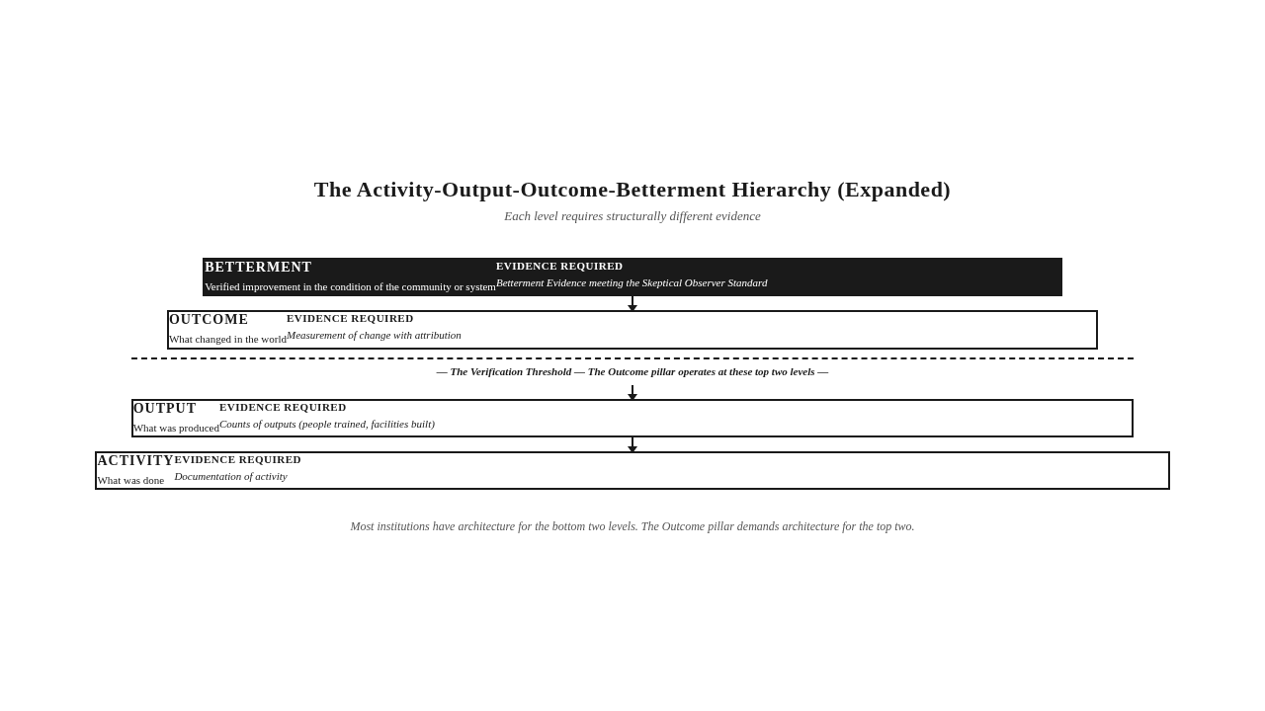

Pillar M — Meaning in Depth
Meaning is the communicative integrity between institutional action and institutional narrative. The pillar's full doctrinal treatment requires unpacking Communication Usability, Meaning Correspondence, and the Transparency Trap.
Communication Usability is the degree to which institutional communication enables stakeholders to understand what was done, verify what was claimed, and act on what was communicated. Communication Usability has three components: legibility, verifiability, and actionability. Legibility is the degree to which stakeholders can understand what is communicated — the language is accessible, the structure is clear, the technical content is explained. Verifiability is the degree to which stakeholders can check what is communicated — the claims are linked to evidence, the evidence is accessible, the methodology is transparent. Actionability is the degree to which stakeholders can act on what is communicated — the information is relevant to decisions stakeholders face, the format supports those decisions, the timing enables them. Communication that fails any of the three is not usable, regardless of how much information it contains.
Communication Usability is the operational core of the Meaning pillar because it converts communication from a broadcast function into a verification function. The institution that produces communication with high Communication Usability has built the architecture through which stakeholders can verify what the institution claims. The institution that produces communication with low Communication Usability has built the architecture through which stakeholders cannot verify — regardless of how much the institution discloses. The Transparency Trap is the failure mode of Communication Usability — disclosure without usability, volume without legibility, information without actionability.
Meaning Correspondence is the alignment between institutional narrative and institutional reality. High correspondence builds Trust Capital — the accumulated reserve of institutional credibility built through verified outcomes and meaning correspondence over time. Low correspondence consumes it. Meaning Correspondence is the long-term discipline of communication integrity. The institution whose narrative corresponds to its reality accumulates credibility. The institution whose narrative departs from its reality accumulates Verification Debt. Meaning Correspondence is not a single audit, a single report, or a single certification. It is the architectural discipline of saying what is true, of saying it in ways stakeholders can verify, and of refusing to say what cannot be established.
The failure mode when Meaning is absent is the Transparency Trap — voluminous, technically dense, professionally produced communication that no stakeholder can actually use to verify anything. The Transparency Trap is what Meaning becomes when it is reduced to disclosure volume. The institution that has made this reduction produces comprehensive reports, satisfies disclosure mandates, earns transparency accolades — and remains structurally unable to enable stakeholders to verify a single claimed outcome. The Transparency Trap is invisible to the institution that produces it, because the institution's communication architecture treats volume as transparency. The skeptical observer opens the reports and cannot verify anything. The Transparency Trap is complete.
Meaning's tension with Accountability is significant. Accountability demands evidence. Meaning produces the evidence in usable form. The tension is that Accountability can demand evidence Meaning cannot make usable, and Meaning can communicate evidence Accountability has not demanded. The institution that has Accountability without Meaning has a demand that cannot be communicated. The institution that has Meaning without Accountability has communication that does not correspond to a demand. Pillar Coherence requires that the two be aligned — that Accountability demands what Meaning can communicate, and that Meaning communicates what Accountability demands.
Meaning's synergy with Outcome is foundational. Outcome is what Meaning communicates. Meaning is what makes Outcome verifiable. The two pillars operate as a communication circuit: Outcome produces the change, Meaning produces the communication that enables the change to be verified. The institution that has both has the architecture to make betterment recognizable. The institution that has one without the other has either change that cannot be verified or verification that does not correspond to change.
The verification demand of Meaning is direct: Can the institution demonstrate that its communication is legible to its intended stakeholders, that it corresponds to verifiable reality, and that stakeholders can act on it? The institution that cannot demonstrate Communication Usability has disclosure, not Meaning. The institution that cannot demonstrate Meaning Correspondence has narrative, not legitimacy. The verification of Meaning is the production of communication that stakeholders can in fact use and verify.
One Sentence Summary: Meaning is communication that corresponds to reality and is usable by stakeholders. The Transparency Trap is what Meaning becomes when it is reduced to disclosure volume.

Synthesis — Pillar Coherence vs. Pillar Deficiency
The five pillars, individually, define the conditions for institutional legitimacy. The five pillars, collectively, define the architecture for institutional legitimacy. The collective condition has a name: Pillar Coherence.
Pillar Coherence is the condition in which all five pillars are present, aligned, and mutually reinforcing. The institution with Pillar Coherence has Accountability that demands outcome, Execution that produces outcome, Initiative that ensures the outcome matters, Outcome that constitutes the substance, and Meaning that makes the outcome verifiable. The pillars operate as a circuit. Each pillar's verification demand is met by the next pillar's architecture. The institution that has Pillar Coherence can answer the Betterment Question.
Pillar Deficiency is the condition in which one or more pillars are absent or weak. The framework's core principle is that Pillar Deficiency produces illegitimacy regardless of the strength of the remaining pillars. The strength of the strongest pillar cannot compensate for the weakness of the weakest. The institution with four pillars has an incomplete architecture. The incomplete architecture is not four-fifths legitimate. It is illegitimate, because the missing pillar is the condition the other four require to function as a circuit.
The framework's diagnostic power comes from identifying which pillar is deficient. The institution with strong reporting but weak outcome has a Pillar O deficiency. The institution with strong programs but weak stakeholder recognition has a Pillar I deficiency. The institution with strong delivery but weak communication has a Pillar M deficiency. The institution with strong intent but weak operational architecture has a Pillar E deficiency. The institution with strong outcomes but weak answerability has a Pillar A deficiency. The diagnosis is structural. The remedy is architectural. The framework does not propose quick fixes. It proposes architectural reconstruction.
The institution that takes Pillar Coherence seriously begins to track its pillar profile. It assesses, regularly, which pillars are present, which are deficient, and where the Pillar Deficiency lies. The assessment is not a self-rating exercise. It is a structural diagnostic, conducted against the framework's verification demands. The institution that has built the architecture to assess its pillar profile has begun to build the architecture to address its deficiencies. The diagnostic is the first step of the remedy.
Visual Recap: The Pillar Coherence vs. Pillar Deficiency diagram (FPF-013) captures this: the institution with coherent pillars achieves legitimacy; the institution with a deficient pillar collapses into illegitimacy regardless of the strength of the others. The diagnostic question is always: which pillar is deficient?

The CEI — A Conceptual Introduction
The framework includes a diagnostic instrument that measures Pillar Coherence. It is called the Composite Effectiveness Index, or CEI. The CEI is introduced here conceptually; the formula and its full derivation appear in Chapter 11.
The CEI is a composite diagnostic instrument measuring institutional effectiveness across the framework dimensions. It combines three components into a single diagnostic score: a Weighted Delivery Composite, or WDC, which captures the Execution and Outcome dimensions; a Stakeholder Alignment Index, or SAI, which captures the Initiative and Meaning dimensions; and a Legitimacy Factor, L, which reflects the institution's Trust Layer Maturity. The three components combine to produce a single score that diagnoses the institution's Pillar Coherence.
The CEI is not a scorecard. It is not a rating. It is not a benchmark. It is a diagnostic instrument. The institution that uses the CEI to diagnose its Pillar Coherence receives information about where its architecture is strong, where it is deficient, and what work remains. The CEI does not rank institutions against each other. It diagnoses each institution against the framework's architectural standard. The institution that scores well on the CEI has Pillar Coherence. The institution that scores poorly has Pillar Deficiency. The diagnosis locates the work.
The CEI is introduced here as a concept because its full mathematical treatment appears in Chapter 11. The main narrative requires only the concept: the CEI is the framework's diagnostic instrument, it measures Pillar Coherence, and it does so through three components that correspond to the framework's five pillars. The institution that wants to use the CEI will find the operational detail in Chapter 11. The institution that wants to understand the framework needs only the concept.
The CEI is also not the framework's centerpiece. The framework is doctrinal, not mathematical. The CEI is one diagnostic instrument within the larger architecture. The architecture is the Five Pillars. The CEI measures the architecture. The institution that understands the architecture can use the CEI. The institution that uses the CEI without understanding the architecture will produce a number without producing insight.
Key Insight: The CEI is the framework's diagnostic instrument. It measures Pillar Coherence through three components — WDC, SAI, and L — that correspond to the five pillars. It is not a scorecard. It is a diagnostic. The institution that uses the CEI receives information about where its architecture is strong, where it is deficient, and what work remains.

The Betterment Index — A Conceptual Introduction
The framework includes a second diagnostic instrument that complements the CEI. It is called the Betterment Index. The Betterment Index is introduced here conceptually; the formula and its full derivation appear in Chapter 11.
The Betterment Index is a composite measure translating verified outcomes into a normalized betterment score across affected communities or systems. It is distinct from the CEI. The CEI measures institutional effectiveness — whether the institution has built the architecture to produce betterment. The Betterment Index measures actual community betterment — whether the betterment the architecture is supposed to produce has actually occurred.
The distinction between the CEI and the Betterment Index is important. An institution can score well on the CEI — effective execution, strong stakeholder alignment, mature Trust Layer — while scoring poorly on the Betterment Index, if its initiatives address the wrong things. The institution has the architecture but produces limited actual betterment because the architecture is pointed at the wrong target. Conversely, an institution can score moderately on the CEI — some pillars present, some deficient — while scoring well on the Betterment Index, if the initiatives it does execute produce real change in the communities they serve. The CEI diagnoses the architecture. The Betterment Index diagnoses the outcome. The two together provide the full picture.
The Betterment Index is the framework's connection to the community's reality. The CEI is the framework's connection to the institution's architecture. The institution that tracks both knows both — whether its architecture is sound and whether its outcomes are real. The institution that tracks only the CEI risks mistaking architectural sophistication for community betterment. The institution that tracks only the Betterment Index risks missing the architectural deficiencies that will eventually undermine the betterment it has produced. The two instruments are complementary. The full diagnosis requires both.
The Betterment Index is introduced here as a concept because its full mathematical treatment appears in Chapter 11. The main narrative requires only the concept: the Betterment Index measures actual community betterment, distinct from the CEI's measurement of institutional effectiveness. The institution that wants to use the Betterment Index will find the operational detail in Chapter 11.
Mini Case: A foundation scores well on the CEI — strong Accountability, strong Execution, strong Meaning. It scores poorly on the Betterment Index — the communities it serves show limited measurable improvement. The diagnosis: the architecture is sound, but the initiatives are pointed at outcomes the architecture can deliver but the communities do not need. The Pillar I deficiency — Initiative — is the missing piece. The foundation has the architecture. It does not have the betterment. The two instruments together make the diagnosis visible.

Four Archetypes — Pillar Profiles in Practice
The framework's diagnostic power can be sharpened by applying it to four archetypes, each deepened from earlier chapters.
The Multinational Extractive Enterprise, deepened from Chapter 1. The enterprise operates at the extraction frontier. Its reporting is sophisticated. Its compliance is impeccable. Its expenditure is substantial. Its pillar profile: Pillar A is partially present — the enterprise reports diligently but cannot specify outcomes it is answerable for in advance. Pillar E is present — the enterprise has strong operational architecture, its delivery systems function. Pillar I is deficient — the enterprise's initiatives are designed internally, with consultation but not Participatory Engagement, and the communities do not recognize the initiatives as theirs. Pillar O is deficient — the enterprise reports outputs (schools built, training delivered) but cannot demonstrate outcomes (learning improved, livelihoods changed) with Betterment Evidence. Pillar M is partially present — the enterprise produces voluminous reporting, but the reporting is not usable by stakeholders. The enterprise has Pillar Deficiency. The strong Pillar E cannot compensate for the deficient Pillars I and O. The enterprise's Legitimacy Gap is the architectural consequence of the deficiency.
The Sovereign Development Fund, deepened from Chapter 1. The fund deploys capital across implementation landscapes where institutional presence is thin. Its governance is sophisticated. Its disbursement systems are professionally managed. Its pillar profile: Pillar A is partially present — the fund reports disbursement against commitment with precision but cannot specify outcomes it is answerable for. Pillar E is variable — the fund's own execution architecture is strong, but the implementing agencies vary enormously in capability, and the fund's architecture does not account for the variation. Pillar I is partially present — the fund engages stakeholders at the program level but does not ensure Participatory Engagement at the design level. Pillar O is deficient — the fund cannot report outcome against need with any precision, because its reporting architecture was built for financial flow, not institutional outcome. Pillar M is partially present — the fund's reporting is professional but not usable by the communities it serves. The fund has Pillar Deficiency. The fund's sophisticated Execution at the center cannot compensate for the deficient Execution at the periphery, where the implementing agencies carry the work. The Implementing Agency Variable is decisive.
The Environmental Restoration Consortium, new to this chapter. The consortium coordinates multi-stakeholder ecological recovery — restoration of degraded landscapes, recovery of biodiversity, rehabilitation of water systems, regeneration of soil health. Its governance is multi-party, including government agencies, private corporations, scientific institutions, and community organizations. Its pillar profile: Pillar A is partially present — the consortium has collective accountability but no single party is fully answerable for outcomes, producing accountability diffusion. Pillar E is variable — different parties bring different capabilities, and the consortium's coordination architecture does not always align them. Pillar I is partially present — some parties engage communities participatorily, others impose. Pillar O is challenging — ecological outcomes are slow, multi-causal, and difficult to attribute to any single party's action, making Outcome Verifiability structurally harder. Pillar M is partially present — the consortium's communication is comprehensive but technically dense, with low Communication Usability for the communities most affected. The consortium has Pillar Deficiency, with the deficiencies tracking the structural challenges of multi-stakeholder initiatives. The framework's diagnosis is that the consortium's challenges are not coordination failures but architectural deficiencies — accountability diffusion, capability variation, initiative inconsistency, outcome attribution difficulty, and communication density. The remedy is architectural.
The Global Health Foundation, deepened from Chapter 2. The foundation funds betterment initiatives across diverse implementation landscapes. Its governance is sophisticated. Its scientific advisory bodies are rigorous. Its pillar profile: Pillar A is present — the foundation has specified outcomes it is answerable for, although it has not fully built the architecture to verify them. Pillar E is variable — the implementing agencies vary in capability, and the foundation's reporting architecture does not account for the variation. Pillar I is partially present — the foundation engages scientific stakeholders rigorously but community stakeholders inconsistently. Pillar O is partially present — the foundation can demonstrate outcome for some programs but not others, with the variation tracking the Implementing Agency Variable. Pillar M is partially present — the foundation's communication is rigorous but not always usable by the communities it serves. The foundation has Pillar Deficiency. The foundation's strong Pillar A and partially present Pillar O cannot compensate for the variable Pillar E and the partially present Pillar I. The foundation's Legitimacy Gap is the architectural consequence of the deficiency.
These four archetypes — the corporate enterprise, the development fund, the environmental consortium, and the health foundation — operate in different sectors, serve different populations, and answer to different constituencies. The Five Pillars Framework applies to all four without modification. The diagnosis in each case is structural. The remedy in each case is architectural. The framework's universality is not a claim. It is a demonstration. The framework applies wherever institutions claim to produce betterment.
Stop & Think: The reader who has applied the Five Pillars to the four archetypes — and noticed that the framework applies across corporate, governmental, multi-stakeholder, and philanthropic sectors without modification — has already recognized the framework's universality. The reader who has applied the Five Pillars informally to their own institution has already begun to use the framework diagnostically. The diagnosis is structural. The remedy is architectural. The framework is the architecture.

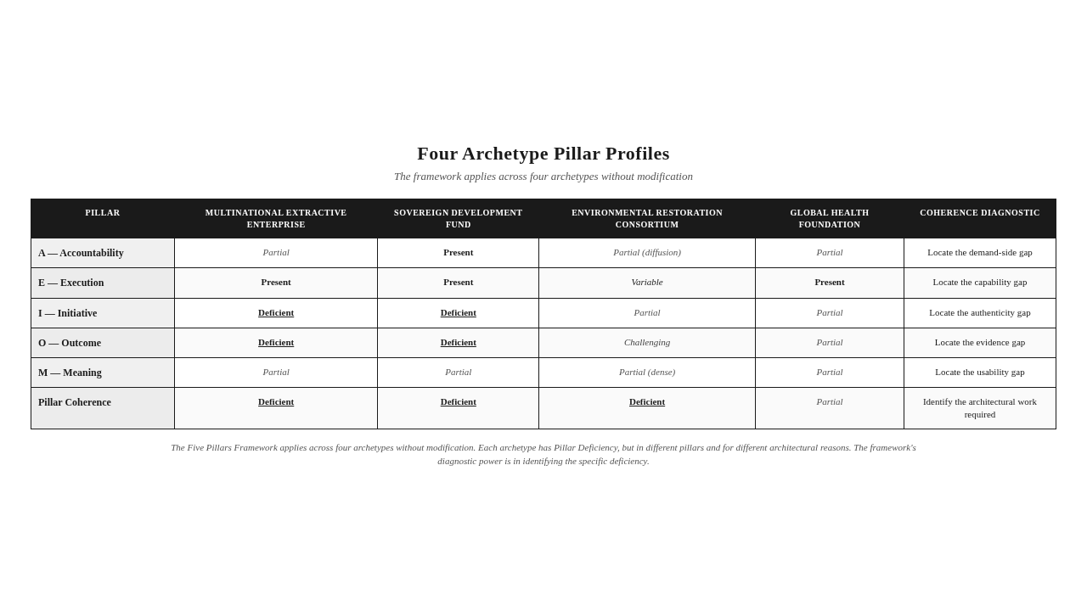

The Architecture as Universal Operating System
The framework that has been built in this chapter is, in its mature form, a universal operating system for institutional legitimacy. The five pillars are not specific to CSR, to ESG, to philanthropy, to government, to healthcare, to education, or to development. They are the structural conditions under which any institution can demonstrate that its interventions produce Betterment of Society. The operating system applies wherever institutions claim to produce betterment.
The universality is not a claim about all institutions being the same. Institutions differ — in sector, in scale, in governance, in audience, in capability. The framework does not erase the differences. It identifies the structural conditions that all institutions must meet to answer the Betterment Question, regardless of their differences. The conditions are universal. The expression of the conditions in any specific institution is particular. The framework provides the universal architecture. The institution provides the particular implementation.
The operating system metaphor is deliberate. An operating system provides the structural conditions under which applications can run. The applications differ — they do different things, serve different users, produce different outputs. The operating system is the same — it provides the memory management, the process scheduling, the input-output architecture, the security conditions that all applications require. The Five Pillars Framework is the operating system. The institution's specific programs, initiatives, and reporting architectures are the applications. The applications differ. The operating system is the same.
The institution that takes the operating system seriously does not add it to its existing applications. It rebuilds its applications to run on the operating system. The institution's programs are redesigned to meet the Accountability pillar's demand for outcome specification. The institution's delivery systems are rebuilt to meet the Execution pillar's demand for operational architecture. The institution's initiative design is reconstructed to meet the Initiative pillar's demand for Participatory Engagement. The institution's measurement architecture is rebuilt to meet the Outcome pillar's demand for Betterment Evidence. The institution's communication architecture is rebuilt to meet the Meaning pillar's demand for Communication Usability. The rebuilding is not a project. It is a re-architecture. The institution that emerges is structurally different from the institution that began.
The next chapter develops the Trust Layer — the verification infrastructure that sits beneath the Five Pillars and makes them credible. The pillars describe what institutions must be. The Trust Layer describes how their claims become verifiable. The two together — the Five Pillars and the Trust Layer — constitute the complete architecture for institutional legitimacy.
Key Insight: The Five Pillars Framework is a universal operating system for institutional legitimacy. The five pillars are the structural conditions under which any institution can answer the Betterment Question. The institution's specific programs are the applications. The institution that takes the operating system seriously rebuilds its applications to run on it.



The Takeaway
Legitimacy is not the sum of pillar strengths. It is the condition of pillar coherence. Weakness in any one pillar is weakness in the whole.

Reader Momentum
The Five Pillars have been developed in full. The architecture is, in its skeletal form, complete. The pillars describe what institutions must be. But pillars alone do not produce credibility. An institution can have all five pillars and still be unable to convince a skeptical observer that its claims are true — because the pillars describe the institution's structure, not the verification infrastructure that makes the institution's claims credible. The verification infrastructure has a name. It is the Trust Layer. The Trust Layer is the subject of the next chapter.

CHAPTER 6 — THE TRUST LAYER — VERIFICATION AND ACCOUNTABILITY


The Paradox of Verification
The technologies that could verify institutional claims have never been more powerful. Institutional claims have never been less verifiable.
Satellite imagery can detect land-use change at sub-meter resolution. Sensor networks can monitor air quality, water quality, and operational emissions in real time. Distributed ledgers can produce audit trails that are tamper-evident by design. Artificial intelligence can analyze patterns in data that no human reviewer could process. Mobile data collection can produce real-time feedback from stakeholders at scale. The technological capability to verify institutional claims has expanded by orders of magnitude in the last two decades.
Institutional claims have, in the same period, become less verifiable. Reports are longer and harder to parse. Indicators are aggregated in ways that prevent attribution. Methodologies are disclosed in formats that resist independent assessment. Data underlying claims is rarely made accessible. Assurance certificates confirm process without confirming result. The gap between what could be verified and what is verified has widened, even as the technology to close the gap has become more capable.
The paradox dissolves when we recognize that technology without architecture is capability without application. The technologies exist. The architecture that integrates them into institutional verification does not. Institutions have the technological capability to verify their claims. They have not built the architectural conditions under which the technology would actually be used for verification. The technology sits in the institution's toolkit. The architecture to use it for verification has not been built.
The architecture that would integrate verification technology into institutional practice is the subject of this chapter. It is called the Trust Layer. The Trust Layer is the verification infrastructure — human, procedural, and technological — that makes institutional claims credible by enabling independent verification. The Trust Layer sits beneath the Five Pillars as their foundation. The pillars describe what institutions must be. The Trust Layer describes how their claims become credible. The two together constitute the complete architecture for institutional legitimacy.
Key Insight: Technology without architecture is capability without application. The technologies that could verify institutional claims exist. The architecture that integrates them into institutional verification does not. The Trust Layer is the architecture that closes the gap.

The Trust Layer Defined
The Trust Layer is the verification infrastructure — human, procedural, and technological — that makes institutional claims credible by enabling independent verification.
The definition has three components.
The human component is the people who carry out verification. Independent auditors. Community-based monitors. Stakeholder panels. Third-party evaluators. Investigative journalists. Academic researchers. Citizen scientists. The human component of the Trust Layer is the network of people, independent of the institution, who can examine the institution's claims and produce independent assessments. The human component is the oldest form of verification infrastructure. It remains the most important. Technology extends the human component; it does not replace it.
The procedural component is the protocols by which verification is conducted. Audit protocols. Evaluation methodologies. Data access protocols. Conflict-of-interest standards. Quality assurance procedures. Publication standards. The procedural component is the rules that govern how verification is done — what counts as evidence, how evidence is gathered, how evidence is assessed, how findings are reported. The procedural component is what makes verification rigorous rather than arbitrary. Without procedural standards, verification becomes opinion. With procedural standards, verification becomes evidence.
The technological component is the tools that enable verification at scale and depth. Satellite imagery. Sensor networks. Distributed ledgers. Artificial intelligence. Mobile data collection. Open data platforms. The technological component is what makes verification feasible for claims that would be impossible to verify manually — large-scale environmental claims, real-time operational claims, complex supply chain claims, longitudinal outcome claims. The technological component is the newest form of verification infrastructure. It is also the most often confused with the Trust Layer itself.
The Trust Layer is all three components together. The institution that has only the human component has traditional verification — important but limited in scale and depth. The institution that has only the procedural component has standards without infrastructure — rigorous protocols without the people or tools to apply them. The institution that has only the technological component has capability without discipline — powerful tools deployed without the procedural standards or human judgment that would make their output verifiable. The Trust Layer requires all three. The pillars cannot be verified without it.
Stop & Think: The institution you are thinking of — what does its Trust Layer look like? Does it have independent human verification? Does it have rigorous procedural standards? Does it have technological tools for verification at scale? Or does it have one component without the others — auditors without standards, standards without tools, tools without judgment? The Trust Layer requires all three.

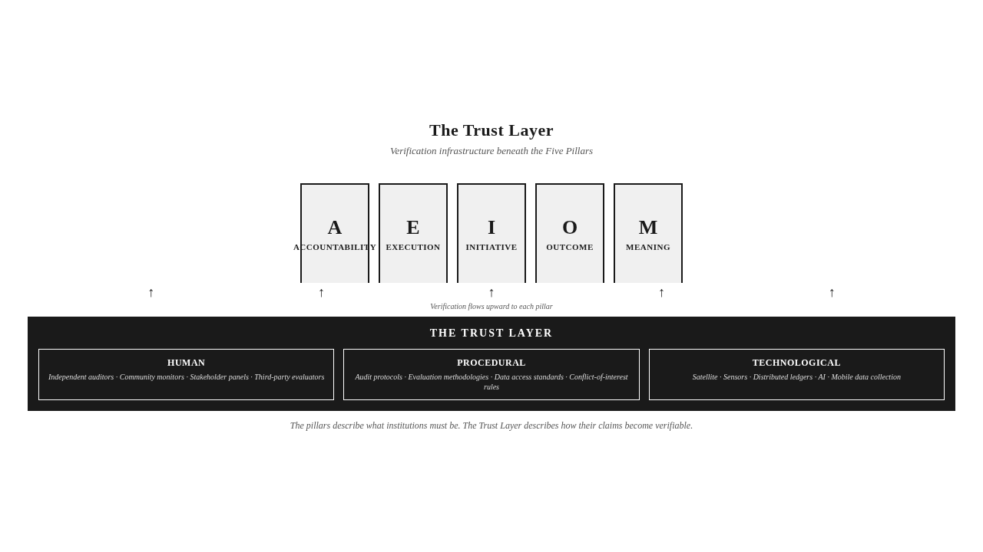

Technology as Enabling Infrastructure, Not Doctrinal Pillar
The Trust Layer includes technology. Technology is not a doctrinal pillar. The distinction matters and requires explicit statement.
The framework's Future-Proofing Principle requires that the doctrine remain applicable regardless of changes in technology. Technologies change. Satellite imagery improves in resolution. Sensor networks expand in coverage. Distributed ledgers evolve in design. Artificial intelligence advances in capability. The doctrine must remain meaningful through these changes. A doctrine that depended on a specific technology would become obsolete when the technology changed. A doctrine that subordinates technology to architecture remains durable.
The framework therefore treats technology as enabling infrastructure within the Trust Layer, not as a doctrinal pillar. The doctrinal pillars — Accountability, Execution, Initiative, Outcome, Meaning — are enduring conditions of institutional legitimacy. They do not change with technology. The Trust Layer is the infrastructure through which the pillars are verified. The infrastructure changes with technology. The pillars do not.
The implication is that no specific technology is required by the framework. The framework requires verification. It does not require satellite imagery, sensor networks, distributed ledgers, or artificial intelligence. The framework requires the Trust Layer. The specific composition of the Trust Layer — which humans, which procedures, which technologies — is determined by the institution's context, the nature of its claims, and the state of verification technology at the time. The framework is technologically neutral. The Trust Layer is technologically plural.
The distinction has practical consequences. An institution that treats blockchain as a doctrinal commitment builds its legitimacy on a specific technology whose longevity is uncertain. An institution that treats blockchain as one tool within a Trust Layer that also includes human verification and procedural standards builds its legitimacy on architecture that endures regardless of blockchain's fate. The first institution is technologically exposed. The second is technologically resilient. The framework's discipline is to build institutions that are technologically resilient.
The distinction also prevents technology from becoming a distraction. Institutions that confuse technology with architecture often invest in impressive technological capabilities without building the procedural and human infrastructure that would make the technology useful. The institution with a blockchain audit trail but no independent auditors has a sophisticated technology with no verification. The institution with satellite imagery but no procedural standards for image interpretation has powerful data with no evidentiary value. Technology without procedure and human judgment is capability without verification. The Trust Layer requires all three.
Key Insight: Technology is enabling infrastructure within the Trust Layer, not a doctrinal pillar. The doctrinal pillars — A-E-I-O-M — are enduring conditions of institutional legitimacy. The Trust Layer is the infrastructure through which the pillars are verified. The infrastructure changes with technology. The pillars do not.

Trust Layer Maturity
The Trust Layer is not built overnight. It develops over time, through stages, as the institution's verification capacity matures. The framework recognizes this developmental dimension as Trust Layer Maturity.
Trust Layer Maturity is the developmental stage of an institution's verification infrastructure, measured on a maturity scale from absent to fully embedded. The maturity scale has five stages.
The first stage is Absent. The institution has no Trust Layer to speak of. Claims are made without verification infrastructure. Reporting is produced internally and published without independent verification. The institution operates on the assumption that its own assertions constitute evidence. The Skeptical Observer Standard is not met. The institution is at position one or two on the Proclamation-Proof Gradient — pure proclamation, or proclamation with activity documentation.
The second stage is Emergent. The institution has begun to build verification infrastructure. Some claims are independently audited. Some procedural standards are adopted. Some technological tools are deployed. The Trust Layer is partial, uneven, and not yet integrated. The institution recognizes the need for verification but has not built the architecture to deliver it consistently. The Skeptical Observer Standard is met for some claims, not for others. The institution is at position two or three on the gradient.
The third stage is Operational. The institution has built verification infrastructure for its major claims. Independent auditors review major reports. Procedural standards govern verification. Technological tools are deployed at scale. The Trust Layer is integrated into the institution's reporting architecture. The Skeptical Observer Standard is met for most major claims. The institution is at position three or four on the gradient.
The fourth stage is Systematic. The institution has built verification infrastructure for all material claims. Independent verification is the default. Procedural standards are rigorous and externally benchmarked. Technological tools are integrated across the verification workflow. The Trust Layer is integrated into the institution's operating architecture, not just its reporting architecture. The Skeptical Observer Standard is met for all material claims. The institution is at position four or five on the gradient.
The fifth stage is Embedded. Verification is structurally integrated into all institutional processes. Independent verification is not a separate function but a property of how the institution operates. Procedural standards are continuously improved through external engagement. Technological tools are continuously updated. The Trust Layer is invisible because it is everywhere. The Skeptical Observer Standard is met as a matter of course. The institution is at position five on the gradient — verified proof.
The stages are developmental. An institution moves from Absent to Emergent through recognition and investment. It moves from Emergent to Operational through architectural construction. It moves from Operational to Systematic through integration. It moves from Systematic to Embedded through cultural and structural transformation. Each transition requires architectural work. The institution that has reached Embedded has completed the Legitimacy Migration described in Chapter 2.
Mini Case: An institution at the Operational stage has independent auditors reviewing its major reports, has adopted procedural standards for verification, and has deployed sensor networks for real-time monitoring of operational claims. Its major claims meet the Skeptical Observer Standard. Its smaller claims do not. The institution is between Operational and Systematic. The work remaining is to extend the Trust Layer to all material claims, not just the major ones. The diagnosis locates the work.

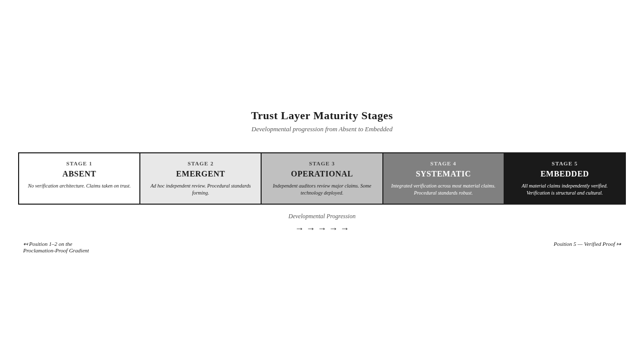

Trust Capital
The Trust Layer produces an accumulated asset. It is called Trust Capital.
Trust Capital is the accumulated reserve of institutional credibility built through verified outcomes and Meaning Correspondence over time. Trust Capital is depleted by Verification Debt and Meaning Divergence. The concept recognizes that institutional credibility is not a momentary assessment. It is a balance sheet — built through years of verified claims, depleted through years of unverified ones, and visible to stakeholders as the cumulative pattern of the institution's relationship with evidence.
Trust Capital is built slowly. Each verified claim adds to it. Each instance of Meaning Correspondence — each case where the institution's narrative corresponds to verifiable reality — adds to it. Each instance of independent verification — each case where a skeptical observer confirms the institution's claims — adds to it. The accumulation is gradual. An institution that has built Trust Capital over a decade of verified claims has a credibility reserve that an institution with a year of verified claims does not. The reserve is real. It is the asset the institution draws on when its claims are contested, when its legitimacy is questioned, when its stakeholders need a reason to extend the benefit of the doubt.
Trust Capital is depleted quickly. Each unverified claim depletes it. Each instance of Meaning Divergence — each case where the institution's narrative departs from verifiable reality — depletes it. Each instance of verification failure — each case where an independent observer finds the institution's claims cannot be confirmed — depletes it. The depletion is faster than the accumulation. An institution can build Trust Capital over a decade and deplete it in a year. The asymmetry is structural: credibility is built slowly and lost quickly. The institution that takes Trust Capital seriously treats it as a scarce asset, not as an inexhaustible resource.
Trust Capital is invisible to most institutions. It does not appear on financial balance sheets. It is not tracked in management reports. It is not assessed in performance reviews. The institution that does not track Trust Capital does not know how much it has. The institution that does not know how much it has cannot manage it. The framework's discipline is to make Trust Capital visible — to track it, measure it, and treat it as the strategic asset it is. The institution that tracks Trust Capital knows when it is being built and when it is being depleted. The institution that manages Trust Capital makes different decisions about which claims to make, which initiatives to undertake, and which communications to publish.
The relationship between Trust Capital and Verification Debt is inverse. Trust Capital is the accumulated credibility from verified claims. Verification Debt is the accumulated liability from unverified claims. The two together constitute the institution's credibility balance sheet. An institution with high Trust Capital and low Verification Debt has strong credibility. An institution with low Trust Capital and high Verification Debt has weak credibility. An institution with high Trust Capital and high Verification Debt has fragile credibility — it appears strong but is one verification failure away from collapse. The framework's diagnostic attention to both is structural. The institution that tracks both knows its credibility position. The institution that tracks neither does not.
Key Insight: Trust Capital is built slowly through verified claims and Meaning Correspondence. It is depleted quickly through unverified claims and Meaning Divergence. The asymmetry is structural: credibility is built slowly and lost quickly. The institution that takes Trust Capital seriously treats it as a scarce strategic asset.

The Trust Layer Maturity Score — Conceptual Introduction
The framework includes a quantitative instrument that measures Trust Layer Maturity. It is called the Trust Layer Maturity Score, or T. The score is introduced here conceptually; the formula and its full derivation appear in Chapter 11.
The Trust Layer Maturity Score assesses the maturity of an institution's verification infrastructure on a defined scale, ranging from absent (no verification capacity) to embedded (verification is structurally integrated into all institutional processes). The score captures the developmental stage the institution has reached — the five stages described in the previous section, quantified into a single diagnostic score.
The Trust Layer Maturity Score is not the same as the CEI. The CEI measures Pillar Coherence — whether the institution has built the architecture the Five Pillars require. The Trust Layer Maturity Score measures verification infrastructure — whether the institution has built the architecture the Trust Layer requires. The two are related — the Trust Layer verifies the pillars — but they are distinct. An institution can have strong Pillar Coherence and weak Trust Layer Maturity, in which case it has the architecture but cannot verify it. An institution can have strong Trust Layer Maturity and weak Pillar Coherence, in which case it has the verification infrastructure but cannot verify much, because there is little to verify. The full diagnosis requires both instruments.
The Trust Layer Maturity Score is introduced here as a concept because its full mathematical treatment appears in Chapter 11. The main narrative requires only the concept: T is the framework's diagnostic instrument for Trust Layer Maturity, it measures the developmental stage of the institution's verification infrastructure, and it operates alongside the CEI to provide the full diagnostic picture. The institution that wants to use T will find the operational detail in Chapter 11. The institution that wants to understand the framework needs only the concept.
One Sentence Summary: The Trust Layer Maturity Score, T, measures the developmental stage of an institution's verification infrastructure, ranging from absent to embedded.

The L Component of the CEI — Conceptual Introduction
The Trust Layer Maturity Score connects to the CEI through a specific mechanism. The CEI's third component, L — the Legitimacy Factor — is derived from T. L is introduced here conceptually; the formula and its full derivation appear in Chapter 11.
L is a multiplicative component of the CEI that reflects the institution's Trust Layer Maturity. It acts as an amplifier or attenuator of the composite score. Institutions with low Trust Layer Maturity — low L — cannot achieve high CEI regardless of their delivery performance or stakeholder alignment. The Legitimacy Factor enforces the principle that legitimacy is foundational, not additive. An institution with weak verification infrastructure has weak legitimacy, and weak legitimacy attenuates everything else, no matter how strong the institution's execution, initiative, outcome, and meaning may be.
The architectural logic of L is significant. The CEI could have been designed as an additive score — WDC plus SAI, with L added as a third term. The framework rejects the additive design. The multiplicative design — L as a factor that amplifies or attenuates — captures the architectural truth that legitimacy is foundational. An institution without legitimacy cannot achieve high effectiveness regardless of its other capabilities. The institution with strong execution but no verification infrastructure has execution that no one can trust. The institution with strong stakeholder alignment but no verification infrastructure has alignment that no one can confirm. The Legitimacy Factor enforces the architectural truth: legitimacy is the foundation, not the addition.
L is introduced here as a concept because its full mathematical treatment appears in Chapter 11. The main narrative requires only the concept: L is the multiplicative component of the CEI that reflects Trust Layer Maturity, it amplifies or attenuates the composite score, and it enforces the architectural principle that legitimacy is foundational. The institution that wants to use L will find the operational detail in Chapter 11.
Key Insight: The CEI's Legitimacy Factor, L, is derived from the Trust Layer Maturity Score, T. L is multiplicative, not additive — it amplifies or attenuates the composite score. The design enforces the architectural truth: legitimacy is foundational, not additive. Institutions with weak Trust Layer Maturity cannot achieve high CEI regardless of their delivery performance.

The Trust Layer and the Proclamation-Proof Gradient
The Trust Layer is the architecture that moves institutions along the Proclamation-Proof Gradient. The gradient, introduced in Chapter 2, runs from pure proclamation at position one to verified proof at position five. The Trust Layer is what makes the movement possible.
An institution at position one — pure proclamation — has no Trust Layer. Claims are made without verification infrastructure. The institution's position on the gradient is determined by the absence of the Trust Layer. The institution that begins to build a Trust Layer — through independent auditors, procedural standards, technological tools — begins to move along the gradient. The Trust Layer's maturity determines the institution's position.
An institution at position three — proclamation with output metrics — has an Emergent or Operational Trust Layer. Some claims are verified. Most are reported without verification. The institution's position on the gradient is determined by the partial maturity of the Trust Layer. The institution that extends the Trust Layer to all material claims moves to position four — proclamation with outcome indicators.
An institution at position five — verified proof — has an Embedded Trust Layer. All material claims are independently verified. The institution's position on the gradient is determined by the full maturity of the Trust Layer. The institution at position five has completed Legitimacy Migration. It can answer the Betterment Question.
The relationship between the Trust Layer and the gradient is causal. The Trust Layer is not a correlate of the gradient position. It is the cause. The institution that has moved along the gradient has moved because it has built the Trust Layer. The institution that has not moved has not built the Trust Layer. The gradient is the visible measure of the Trust Layer's maturity. The Trust Layer is the architectural cause of the gradient position.
The implication for institutional practice is significant. An institution that wants to move along the gradient must build the Trust Layer. It cannot move by producing more reporting, by improving its communication, by tightening its compliance, or by adopting new initiatives. It can move only by building the verification infrastructure that the Trust Layer requires. The Trust Layer is the work. The gradient position is the measure.
Visual Recap: The Proclamation-Proof Gradient (FPF-001), expanded for this chapter, captures the relationship: the Trust Layer's maturity determines the institution's position on the gradient. Absent Trust Layer corresponds to position one. Embedded Trust Layer corresponds to position five. The Trust Layer is the architectural cause of the gradient position.

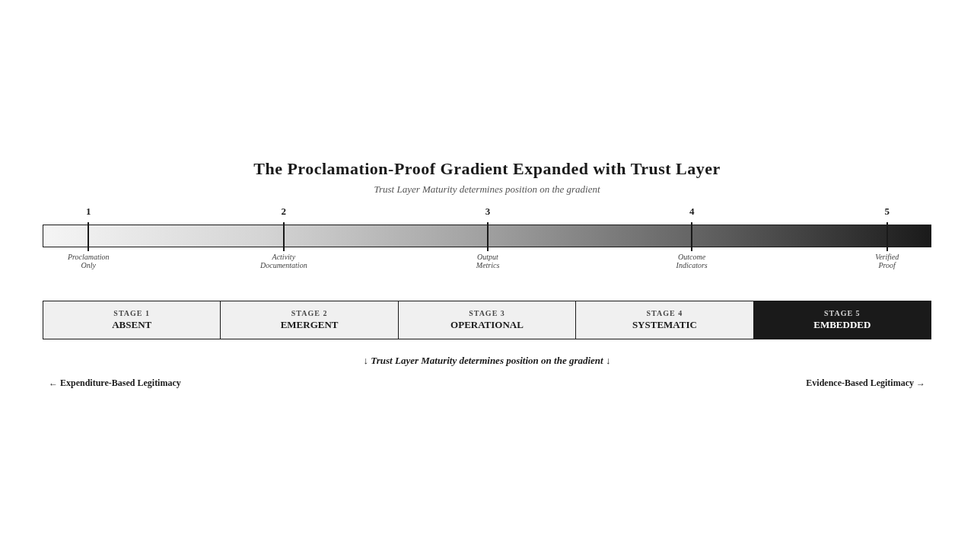

Three Archetypes — Verification in Practice
The Trust Layer's diagnostic power can be sharpened by applying it to three archetypes, each with a verification focus.
The Multinational Extractive Enterprise, verification focus. The enterprise operates at the extraction frontier. Its claims are extensive — environmental performance, community investment, local economic contribution, health and safety record. How would the enterprise build a Trust Layer? The technological component would include satellite verification of environmental claims (independent assessment of land-use change, deforestation, rehabilitation), sensor networks for operational monitoring (real-time data on emissions, water use, noise, air quality), distributed ledger audit trails for community investment (verifiable records of disbursement and receipt), and AI-enabled verification of outcome data (pattern analysis to detect anomalies in reported outcomes). The procedural component would include independent audit protocols for environmental claims, evaluation methodologies for community investment outcomes, data access protocols that make underlying data available to independent assessors, and conflict-of-interest standards for any verifier connected to the enterprise. The human component would include community-based monitors trained and equipped to verify the enterprise's claims at the local level, stakeholder panels with meaningful authority to challenge claims, independent academic researchers with access to the enterprise's data, and investigative journalists with the time and expertise to examine specific claims in depth. The enterprise's current Trust Layer is partial — it has technological capability without procedural integration, and procedural standards without human verification at the community level. The work remaining is integration. The enterprise's position on the Proclamation-Proof Gradient would move from three to four if the Trust Layer reached Operational, and from four to five if it reached Systematic.
The Global Health Foundation, verification focus. The foundation funds betterment initiatives across diverse implementation landscapes. Its claims are about program effectiveness — the outcomes its funded programs produce in the health of populations. How would the foundation build a Trust Layer? The technological component would include mobile data collection for real-time stakeholder feedback, open data platforms for program-level outcome data, AI-enabled verification of reported outcomes against independent data sources, and geospatial analysis of health outcome patterns in program areas. The procedural component would include evaluation methodologies that meet the Skeptical Observer Standard, attribution protocols that establish the foundation's contribution distinct from other actors, data access protocols that make program data available to independent researchers, and publication standards that require full disclosure of methodology and limitations. The human component would include community-based health monitors, independent evaluation teams with access to program sites, academic researchers conducting independent studies, and stakeholder panels with the authority to challenge the foundation's claims. The foundation's current Trust Layer is Emergent — it has some procedural standards, less technological integration, and limited human verification at the community level. The work remaining is extension. The foundation's position on the gradient would move from three to four if the Trust Layer reached Operational.
The Environmental Restoration Consortium, verification focus. The consortium coordinates multi-stakeholder ecological recovery. Its claims are about ecological outcomes — biodiversity recovery, landscape restoration, water system rehabilitation, soil health regeneration. How would the consortium build a Trust Layer? The technological component would include satellite imagery for landscape-level ecological monitoring, sensor networks for soil, water, and biodiversity monitoring, distributed ledgers for transparent recording of restoration actions by all parties, and AI-enabled analysis of ecological change patterns. The procedural component would include ecological evaluation methodologies, multi-party attribution protocols that allocate contribution among the consortium's members, data access protocols that make monitoring data available to all parties and to the public, and conflict-of-interest standards for any verifier connected to any party. The human component would include community-based ecological monitors, scientific advisory panels with independent authority, academic researchers conducting longitudinal studies, and stakeholder panels representing affected communities. The consortium's current Trust Layer is challenging — multi-stakeholder initiatives face structural obstacles to verification because no single party controls the verification infrastructure, and parties may have conflicting interests in what is verified. The work remaining is governance — building a Trust Layer that no single party controls but all parties trust. The consortium's position on the gradient would move from three to four if the Trust Layer reached Operational, with the movement requiring the additional architectural work of multi-party governance.
These three archetypes — the corporate enterprise, the health foundation, and the environmental consortium — operate in different sectors, face different verification challenges, and require different Trust Layer configurations. The Trust Layer framework applies to all three without modification. The specific composition differs. The architecture is the same.
Stop & Think: The reader who has thought about the Trust Layer for their own institution — what components does it have, what components does it lack, and where on the maturity scale does it sit? The Trust Layer is not an abstraction. It is a specific architecture, and the institution's verification capacity can be assessed concretely. The assessment locates the work remaining.

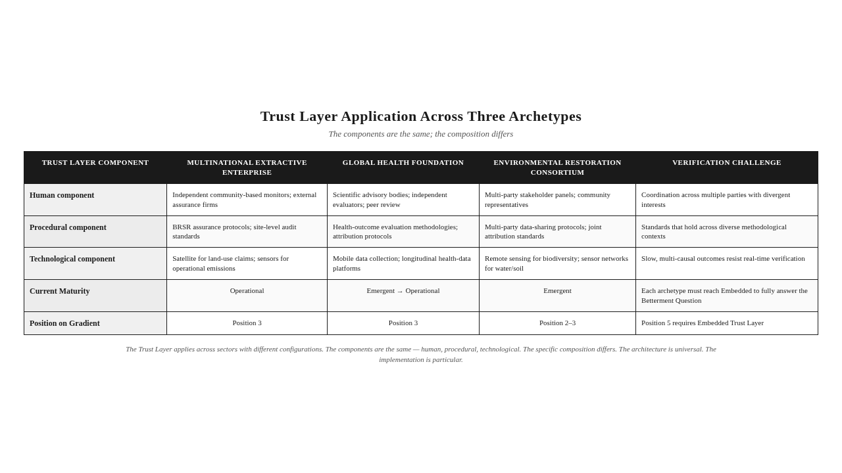

The Trust Layer and the Compliance Theater
The Trust Layer is the architectural alternative to the Compliance Theater. The relationship between the two is direct.
The Compliance Theater, recall, is the performance of accountability through elaborate reporting that obscures the absence of demonstrable outcomes. The Compliance Theater is what accountability becomes when it is reduced to compliance. The institution that has made this reduction produces sophisticated reporting, satisfies audit requirements, earns compliance certificates — and remains structurally unable to answer the Betterment Question.
The Trust Layer is what replaces the Compliance Theater when the institution recognizes that compliance is not accountability. The institution that builds the Trust Layer does not abandon compliance. It contextualizes it. Compliance remains — it is necessary for the functions it serves. But compliance is no longer the institution's primary accountability architecture. The Trust Layer is. The institution's claims are verified through the Trust Layer, not merely certified through the compliance architecture. The Compliance Theater gives way to the Trust Layer as the institution's primary accountability infrastructure.
The transition from Compliance Theater to Trust Layer is the architectural transition the framework requires. It is not a transition the institution can make by adding the Trust Layer alongside the Compliance Theater. It is a transition the institution makes by rebuilding its accountability architecture around the Trust Layer, with compliance taking a supporting role. The institution that has made this transition has moved along the Proclamation-Proof Gradient — from position three (Compliance Theater) to position four (Trust Layer Operational) and toward position five (Trust Layer Embedded).
The framework's position on the Compliance Theater is therefore not abolitionist. The framework does not propose that institutions abandon compliance. The framework proposes that institutions recognize compliance for what it is — a necessary but insufficient accountability function — and build the Trust Layer that makes accountability substantive. The Compliance Theater is the architecture the institution leaves behind. The Trust Layer is the architecture the institution builds in its place.
Key Insight: The Trust Layer is the architectural alternative to the Compliance Theater. The institution that builds the Trust Layer does not abandon compliance. It contextualizes it — compliance takes a supporting role, the Trust Layer becomes the primary accountability infrastructure. The Compliance Theater is what the institution leaves behind.



The Takeaway
The Trust Layer is not a technology. It is the architectural condition in which verification is possible, routine, and structurally embedded. Technology enables it; doctrine defines it.

Reader Momentum
The Five Pillars describe what institutions must be. The Trust Layer describes how their claims become credible. Together, they constitute the complete architecture for institutional legitimacy. But architecture is not implementation. The institution that has understood the architecture must still build it. Building the architecture is the work of institutional reconstruction — governance redesign, execution architecture redesign, the CEI as diagnostic instrument, the Trust Layer as operational infrastructure, and the institutional journey of Legitimacy Migration. That reconstruction is the subject of the next chapter.

CHAPTER 7 — THE INSTITUTIONAL OPERATING SYSTEM


What an Institution That Has Built the Architecture Looks Like
If the Five Pillars are the architecture and the Trust Layer is the verification, what does an institution that has actually built them look like?
The answer is: different from any institution that exists today. Not unrecognizably different — the institution still has boards, executives, programs, reports, audits. But structurally different. The governance structures are different. The executive accountabilities are different. The relationship with implementing agencies is different. The diagnostic instruments are different. The verification infrastructure is different. The institutional culture is different. The institution that has built the Five Pillars and the Trust Layer has been reconstructed around the architecture. It is not the institution it was, with the framework added. It is a different institution, with the architecture as its operating system.
This chapter describes the reconstruction. It covers the governance redesign that embeds the Five Pillars, the execution architecture that operationalizes the Implementing Agency Variable, the CEI as a diagnostic instrument, the Trust Layer as operational infrastructure, and the institutional journey of Legitimacy Migration. The chapter closes with the recognition that operationalizing the Five Pillars is not implementing a framework. It is reconstructing an institution around an architecture — and the institution that emerges is structurally different from the one that began.
The reader who has followed the doctrine through Chapters 1 to 6 has understood the architecture. The reader who follows this chapter will see what building the architecture requires. The building is not a project. It is a re-architecture. The institution that takes the framework seriously does not add it to its reporting apparatus. It reconstructs itself around it.
Key Insight: An institution that has built the Five Pillars and the Trust Layer is not the institution it was, with the framework added. It is a different institution, with the architecture as its operating system. The reconstruction is not a project. It is a re-architecture.

Governance Redesign
The first reconstruction is governance. The Five Pillars cannot be embedded in an institution whose governance was designed for compliance reporting. The governance must be redesigned around the architecture.
Governance redesign begins with the board. The board's responsibility shifts from oversight of reporting to oversight of outcome. The board that oversees reporting asks: Did the institution report as required? The board that oversees outcome asks: Did the institution produce the betterment it claimed? The two questions are different. The first is satisfied by reporting. The second is satisfied only by evidence. The board that has made the shift asks the second question, and the institution's executive structures must be redesigned to answer it.
The board's committee structure changes. The traditional committee structure — audit, risk, governance, compensation — was designed for compliance oversight. The reconstructed structure adds an outcome committee, or reconfigures an existing committee to take outcome oversight as its primary function. The outcome committee's work is to specify the outcomes the institution is answerable for, to require evidence that the outcomes occurred, and to challenge claims that the evidence does not support. The outcome committee is the board-level embodiment of the Accountability pillar.
The executive structures change. The chief sustainability officer role, traditionally responsible for reporting and compliance, is reconfigured as the chief accountability officer — responsible for the architecture that produces evidence, not the production of reports. The chief accountability officer's function is to build the Trust Layer, to ensure the CEI is used as a diagnostic instrument, and to ensure that the institution's claims meet the Skeptical Observer Standard. The chief accountability officer reports to the CEO and to the board's outcome committee. The role is not a sustainability role rebranded. It is a different role, with different accountabilities and different architecture.
The executive compensation structures change. Executives are compensated not only for financial performance and operational delivery but for verified outcome. The compensation structure that rewards only financial performance and operational delivery incentivizes activity without outcome. The compensation structure that includes verified outcome incentivizes the architecture that produces outcome. The specific design of outcome-based compensation varies by institution, but the principle is constant: executives are held accountable for outcome, not only for activity.
The governance redesign extends to the institution's relationship with its stakeholders. The board that has made the shift includes stakeholder representation, or establishes formal stakeholder advisory structures with meaningful authority. The stakeholder representation is not token. It is structural — stakeholders have access to information, authority to challenge claims, and the standing to participate in governance decisions that affect them. The governance that includes stakeholder representation has begun to address the Beneficiary Inversion at the architectural level.
Stop & Think: The institution you are thinking of — does its board oversee outcome, or only reporting? Does its executive structure include accountability for verified outcome, or only for activity? Does its compensation include outcome, or only financial and operational performance? If the honest answer is reporting, activity, and financial performance, the governance has not been redesigned. The Five Pillars cannot be embedded in governance that was designed for compliance.

Execution Architecture — The Implementing Agency Variable in Practice
The second reconstruction is execution architecture. The Implementing Agency Variable — the recognition that identical interventions produce different outcomes depending on the capability of the implementing agency — must be operationalized in the institution's execution architecture.
The operationalization begins with the recognition that the institution's execution architecture is rarely the institution's own delivery capacity. Most institutions design initiatives and contract or partner with implementing agencies to deliver them. The Implementing Agency Variable applies to the implementing agencies, not only to the institution. The institution that takes the variable seriously builds its execution architecture around the selection, support, and verification of implementing agencies.
The selection of implementing agencies becomes a structural function. The institution evaluates potential implementing agencies against the Five Pillars, not only against operational capability. Can the implementing agency specify the outcomes it is answerable for? Can it produce evidence of those outcomes? Does it engage stakeholders participatorily? Does it have the execution architecture to deliver? Can it communicate in ways stakeholders can use? The implementing agency that scores well on all five is selected. The implementing agency that scores well on operational capability but poorly on the pillars is not selected, regardless of its operational capability. The selection is architectural, not operational.
The support of implementing agencies becomes a structural function. The institution recognizes that implementing agencies vary in their Pillar Coherence and that the variation produces different outcomes. The institution that takes the variable seriously builds support architecture — capacity building for Pillar Coherence, shared verification infrastructure, common diagnostic instruments. The institution does not assume that implementing agencies arrive with the architecture. It builds the architecture with them.
The verification of implementing agencies becomes a structural function. The institution requires implementing agencies to produce evidence that meets the Skeptical Observer Standard. The institution does not assume that the implementing agency's reports are evidence. The institution verifies the reports — through the Trust Layer, through independent assessment, through community feedback. The institution's reporting architecture accounts for the Implementing Agency Variable by reporting outcome by implementing agency, not aggregated across implementing agencies. The aggregation hides the variation. The disaggregation reveals it.
The execution architecture that operationalizes the Implementing Agency Variable produces a different kind of institutional report. The report does not say "We funded 50 programs, reached 1 million people, and produced X outcome." The report says "We funded 50 programs through 12 implementing agencies. The programs implemented by agencies A, B, and C produced the following verified outcomes. The programs implemented by agencies D and E produced the following outputs without verified outcomes. The programs implemented by agencies F and G did not reach their targets. We have replaced agencies F and G and rebuilt the execution architecture for the next cycle." The report is honest about the variation. The report is honest about the implementing agency variable. The report is honest about what worked and what did not.
The execution architecture that operationalizes the Implementing Agency Variable is the architectural response to the framework's Implementing Agency Principle. The principle, recall, is that no sector performs inherently better than another. The variable is the implementing agency and its alignment across the five pillars. The execution architecture that takes the principle seriously is the architecture that selects, supports, and verifies implementing agencies against the five pillars. The architecture is the operationalization of the principle.
Key Insight: The Implementing Agency Variable is operationalized through the selection, support, and verification of implementing agencies against the Five Pillars. The institution that takes the variable seriously does not assume implementing agencies arrive with the architecture. It builds the architecture with them. And it reports outcome by implementing agency, not aggregated, because the aggregation hides the variation.

The CEI as Diagnostic Instrument
The third reconstruction is diagnostic. The CEI, introduced conceptually in Chapter 5, is operationalized as the institution's diagnostic instrument. The operationalization is not the use of the CEI as a scorecard. It is the use of the CEI as a diagnostic.
The CEI as scorecard would rank institutions against each other. The institution with the highest CEI wins. The institution with the lowest CEI loses. The scorecard use creates competition, but it also creates the incentives that produced the Proclamation Trap — the incentive to claim what cannot be verified, to report activity as outcome, to dress proclamation in the costume of evidence. The CEI as scorecard would reproduce the very pathology the framework exists to correct.
The CEI as diagnostic is different. The CEI diagnoses the institution against the framework's architectural standard. The institution's CEI score tells it where its Pillar Coherence is strong, where it is deficient, and what work remains. The CEI does not rank the institution against other institutions. It diagnoses the institution against the framework. The diagnostic use creates the incentive to build the architecture, not to game the score. The institution that uses the CEI as a diagnostic receives information that locates the work. The institution that uses the CEI as a scorecard receives a number that invites gaming.
The diagnostic use of the CEI requires three architectural elements. The first is regular assessment — the institution assesses its CEI on a defined schedule, not as a one-time exercise. The second is honest reporting — the institution reports its CEI to its board, its stakeholders, and itself, with the honesty the diagnostic requires. The third is architectural response — the institution responds to the CEI's diagnosis with architectural work, not with communications. The three elements together produce the diagnostic discipline. The institution that has built the discipline uses the CEI to drive architectural improvement. The institution that has not built the discipline uses the CEI to drive public relations.
The CEI as diagnostic also requires the institution to use the CEI alongside the Betterment Index. The CEI diagnoses the architecture. The Betterment Index diagnoses the outcome. The two together produce the full picture. The institution that uses only the CEI risks mistaking architectural sophistication for community betterment. The institution that uses only the Betterment Index risks missing the architectural deficiencies that will eventually undermine the betterment. The diagnostic discipline requires both.
The institution that takes the CEI seriously treats it as an internal management instrument, not as an external reporting instrument. The CEI is reported externally, but its primary function is internal — to drive architectural improvement. The institution that uses the CEI for external reporting without internal use has inverted the diagnostic. The external reporting becomes the purpose. The internal improvement becomes the byproduct. The inversion reproduces the Transparency Trap. The diagnostic discipline keeps the internal improvement as the purpose and the external reporting as the byproduct.
Mini Case: An institution uses the CEI annually to diagnose its Pillar Coherence. The first year, the CEI reveals Pillar I deficiency — Initiative. The institution responds by rebuilding its initiative design process around Participatory Engagement. The second year, the CEI reveals that Pillar I has improved but Pillar O — Outcome — is now the deficient pillar. The institution responds by rebuilding its measurement architecture to produce Betterment Evidence. The third year, the CEI reveals Pillar Coherence has improved. The institution continues the diagnostic discipline. The CEI has driven architectural improvement. The institution is structurally different from the one that began.

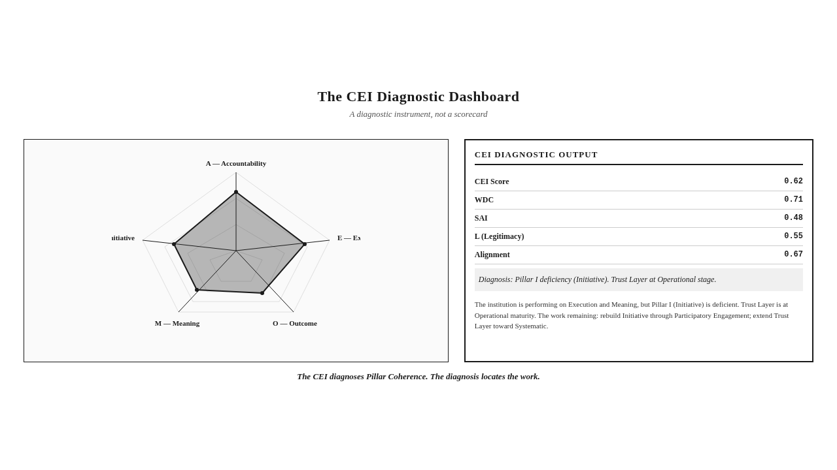

The Trust Layer as Operational Infrastructure
The fourth reconstruction is the Trust Layer. The Trust Layer, presented in Chapter 6 as the verification infrastructure, is operationalized in Chapter 7 as the institution's accountability infrastructure. The operationalization is the architectural work of building the human, procedural, and technological components into the institution's daily practice.
The operationalization begins with the human component. The institution staffs its Trust Layer with independent verifiers — internal audit functions with true independence, external audit relationships with genuine authority, community-based monitors with real access, stakeholder panels with meaningful power. The institution does not treat the human component as a compliance function. It treats it as a legitimacy function. The verifiers are not there to confirm that the institution followed its processes. They are there to confirm that the institution's claims are true. The two functions are different. The first is compliance. The second is verification.
The operationalization continues with the procedural component. The institution adopts procedural standards that meet the Skeptical Observer Standard. The standards govern how evidence is gathered, how claims are verified, how findings are reported, how conflicts of interest are managed. The standards are not the institution's own. They are externally benchmarked, peer-reviewed, and continuously improved. The institution that adopts its own standards without external benchmarking has standards, not verification. The institution that adopts externally benchmarked standards has verification architecture.
The operationalization extends to the technological component. The institution deploys verification technologies — satellite, sensors, distributed ledgers, AI, mobile data — appropriate to its claims. The deployment is not technological showpiece. It is verification infrastructure. Each technology is deployed because it verifies specific claims that the institution makes, not because it is impressive. The institution that deploys technology for verification purposes builds the architecture. The institution that deploys technology for communication purposes builds the showpiece.
The operationalization integrates the three components. The integration is what makes the Trust Layer operational rather than decorative. The institution that has independent auditors without procedural standards has humans without discipline. The institution that has procedural standards without verification technology has discipline without capacity. The institution that has verification technology without independent auditors has capacity without judgment. The Trust Layer requires all three, integrated. The integration is the architectural work.
The operationalization produces a different kind of institutional report. The report is shorter, because it contains only claims that the Trust Layer has verified. The report is more credible, because every claim is independently verified. The report is more usable, because the verification architecture makes the claims accessible to stakeholders. The report is the product of the Trust Layer, not the product of the communications department. The institution that has operationalized the Trust Layer has reconstructed its reporting around verification, not around disclosure.
Key Insight: The Trust Layer is operationalized through the integration of its three components — human, procedural, technological. The integration is what makes the Trust Layer operational rather than decorative. The institution that has independent auditors without procedural standards has humans without discipline. The institution that has procedural standards without verification technology has discipline without capacity. The Trust Layer requires all three, integrated.

Legitimacy Migration as Institutional Journey
The fifth reconstruction is the journey. Legitimacy Migration, introduced in Chapter 2 as the institutional passage from expenditure-based legitimacy to evidence-based legitimacy, is operationalized in Chapter 7 as the institutional journey of architectural reconstruction.
The journey is not a project. It is not an initiative. It is not a program. It is a re-architecture that takes years and that, once begun, does not end. The institution that has begun the journey is always in migration. The institution that has completed the migration — reached position five on the Proclamation-Proof Gradient, achieved an Embedded Trust Layer, attained Pillar Coherence — does not stop. It maintains the architecture through continual vigilance. The journey is the institutional condition, not a destination.
The journey passes through three stages, described in Chapter 2: Recognition, Reconstruction, Demonstration. The operationalization in this chapter develops the stages into institutional practice.
The Recognition stage requires the institution to acknowledge its Legitimacy Gap. The acknowledgment is not a confession. It is a diagnosis. The institution that recognizes its gap has not failed. It has begun to migrate. The recognition is documented — the institution's leadership writes the diagnosis, the board approves it, the institution communicates it to its stakeholders. The communication is not a public-relations exercise. It is the institutional commitment to migration. The institution that has documented its recognition has committed to the journey.
The Reconstruction stage requires the institution to rebuild its architecture. The rebuilding is the work of governance redesign, execution architecture, the CEI as diagnostic, the Trust Layer as operational infrastructure. The rebuilding takes years. The institution that has begun the rebuilding is in the middle of the journey. The institution that has completed the rebuilding has reached the third stage.
The Demonstration stage requires the institution to produce verified betterment. The institution can answer the Betterment Question. The institution can demonstrate, with evidence that meets the Skeptical Observer Standard, that its interventions produced measurable Betterment of Society. The demonstration is not a one-time achievement. It is the institutional condition. The institution that has reached Demonstration maintains the condition through continual architectural vigilance.
The journey is maintained through what the framework calls architectural vigilance. The institution that has migrated can slip back. New leadership can reverse the architectural changes. New regulations can re-impose the Transparency Trap. New reporting fads can resurrect the Output Illusion. The institution that maintains the architecture does so through continual vigilance — regular CEI assessment, ongoing Trust Layer development, regular stakeholder engagement, periodic governance review. The vigilance is the work of maintaining the migration. The work is ongoing. The migration is not a project that ends. It is a discipline that continues.
Visual Recap: The Theory of Change Migration diagram (FPF-007), introduced in Chapter 2, captures the journey: from expenditure-based legitimacy, through Recognition, Reconstruction, and Demonstration, to evidence-based legitimacy. The journey is the institutional passage. The passage is maintained through architectural vigilance.

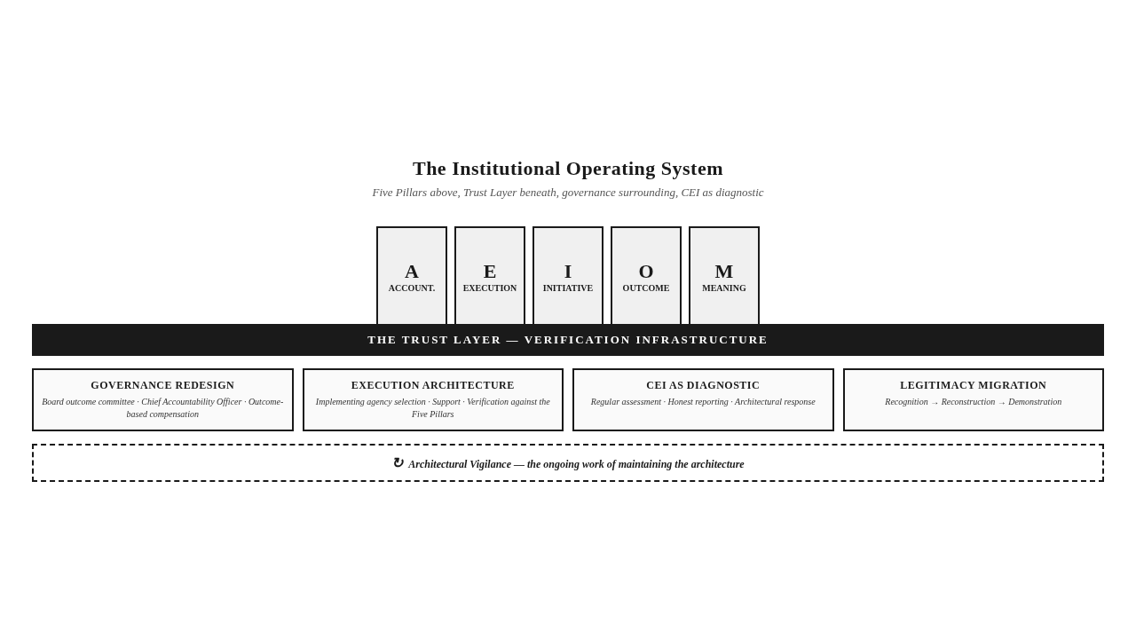

Three Archetypes — Operationalization in Practice
The operationalization can be sharpened by applying it to three archetypes, each with an operational focus.
The Transitional Welfare Authority, operational focus. The authority governs programs aimed at the Betterment of Society at scale — livelihoods, food security, housing, education, health. Its current architecture is compliance-oriented, with elaborate reporting, periodic evaluations, and public dashboards. The authority's operationalization begins with governance redesign — the board's outcome committee is established, with the authority to challenge claims and require evidence. The chief accountability officer role is created, separate from the chief compliance officer. The executive compensation structure is revised to include outcome-based components. The execution architecture is rebuilt around the Implementing Agency Variable — the implementing agencies (which in the authority's case include departments, contractors, and partner organizations) are assessed against the Five Pillars, supported through capacity building, and verified through disaggregated reporting. The CEI is adopted as a diagnostic instrument, with annual assessment, honest reporting, and architectural response. The Trust Layer is built through independent audit, procedural standards, and verification technology. The Beneficiary Inversion is addressed through Participatory Engagement — the authority's programs are redesigned to involve stakeholders in the identification of need, the design of initiative, and the verification of outcome. The authority's Legitimacy Migration begins with recognition of its gap and proceeds through reconstruction to demonstration. The authority that has completed the migration is structurally different from the one that began.
The Multinational Extractive Enterprise, operational focus. The enterprise operates at the extraction frontier, with sophisticated reporting, impeccable compliance, and substantial expenditure. The enterprise's operationalization begins with governance redesign — the board's sustainability committee is reconfigured as the outcome committee, with authority over community investment outcomes. The chief sustainability officer role is reconfigured as chief accountability officer. The executive compensation structure includes outcome-based components for site-level executives. The execution architecture is rebuilt around the Implementing Agency Variable — the community investment programs, delivered through partners and through direct operations, are assessed against the Five Pillars. The partners that score well on the pillars are retained. The partners that score poorly are replaced or supported. The CEI is adopted as a diagnostic instrument, with annual assessment at the enterprise level and at the site level. The Trust Layer is built through satellite verification of environmental claims, sensor networks for operational monitoring, distributed ledgers for community investment audit trails, and independent community-based monitors. The Imposed Imperative is addressed through Participatory Engagement — the enterprise's community investment programs are redesigned to begin with stakeholder identification of need, not with internal analysis. The enterprise's Legitimacy Migration proceeds through recognition, reconstruction, and demonstration. The enterprise that has completed the migration has closed its Legitimacy Gap.
The Educational Transformation Initiative, operational focus. The initiative redesigns learning systems across institutional boundaries — public schools, private providers, community education programs, digital learning platforms, workforce preparation. The initiative's governance is multi-stakeholder, its design is sophisticated, its ambition is generational. The initiative's operationalization begins with governance redesign — the multi-stakeholder governance is reconfigured to include outcome oversight as a primary function. The implementing agencies — the schools, providers, programs, platforms, and workforce preparation organizations — are assessed against the Five Pillars, supported through shared capacity building, and verified through disaggregated reporting. The CEI is adopted as a diagnostic instrument, with annual assessment across the institutional contexts the initiative serves. The Trust Layer is built through independent evaluation, procedural standards for educational outcome assessment, and verification technology appropriate to educational claims. The initiative's Pillar Coherence, which was partial in Chapter 4 — coherent in some institutional contexts, deficient in others — is rebuilt through the operationalization. The contexts that were deficient are addressed through targeted architectural work. The initiative's Legitimacy Migration proceeds unevenly — faster in some institutional contexts, slower in others, reflecting the Implementing Agency Variable. The initiative that has completed the migration in its strongest contexts demonstrates that the architecture works across sectors, and provides the model for the contexts that lag.
These three archetypes — the welfare authority, the extractive enterprise, and the educational initiative — operate in different sectors, serve different populations, and answer to different constituencies. The operationalization of the Five Pillars Framework applies to all three without modification. The specific architecture differs. The operational discipline is the same. The framework's universality is, again, not a claim. It is a demonstration.
Stop & Think: The reader who has applied the operationalization to their own institution — governance redesign, execution architecture, CEI as diagnostic, Trust Layer as operational infrastructure, Legitimacy Migration as institutional journey — has begun to see what building the architecture would require. The reader who has begun to see what building would require has begun to recognize that operationalizing the framework is not a project. It is a reconstruction.

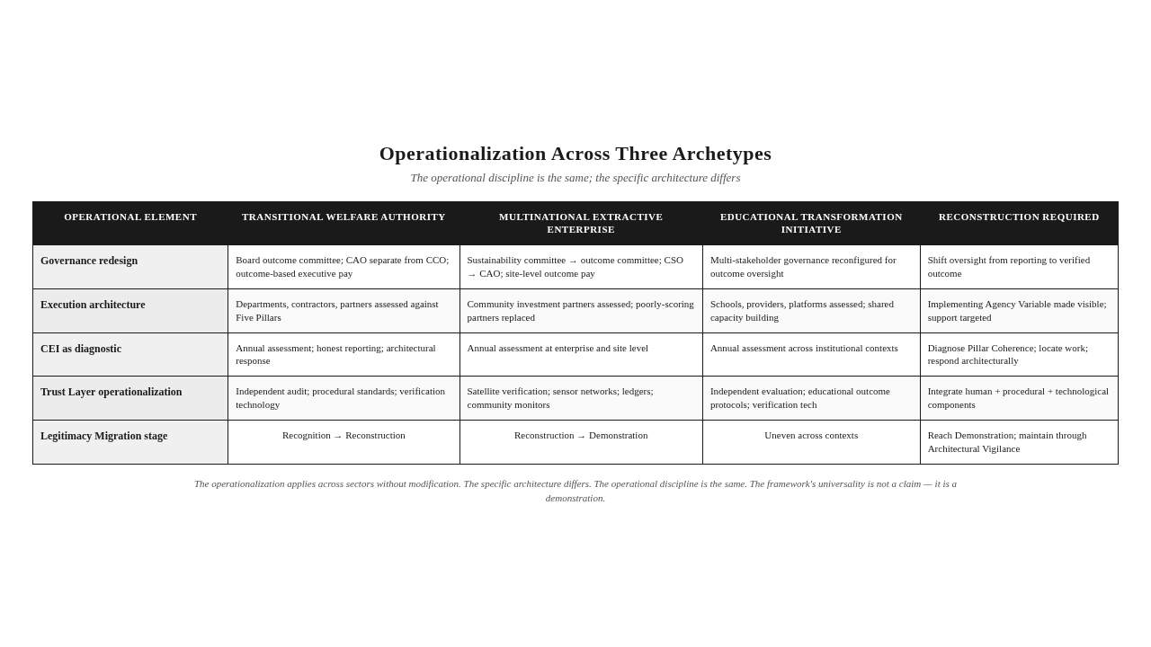
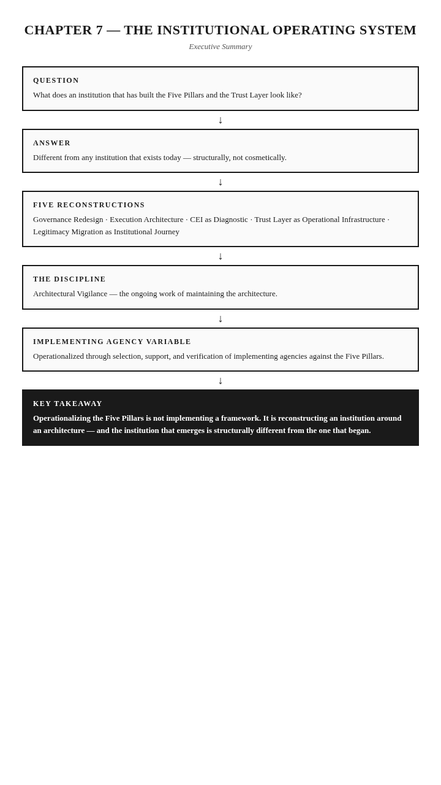

The Takeaway
Operationalizing the Five Pillars is not implementing a framework. It is reconstructing an institution around an architecture — and the institution that emerges is structurally different from the one that began the journey.

Reader Momentum
The framework has been presented, applied, and operationalized. The institutional operating system has been described. The reader has seen what building the architecture would require. But the framework's claim to universality is still theoretical until it is tested against the diversity of regulatory regimes under which institutions actually operate. Some regimes mandate CSR. Some leave it voluntary. Some have almost no regulation at all. Does the framework apply across all of them? Does mandatory regulation produce more demonstrable betterment than voluntary approaches? Does the absence of regulation preclude betterment? These questions are the subject of the next chapter — the comparative international analysis of CSR regimes.

CHAPTER 8 — COMPARATIVE INTERNATIONAL ANALYSIS OF CSR REGIMES


The Compliance-Betterment Paradox
The countries with the most sophisticated CSR regulations are not necessarily the countries where CSR produces the most demonstrable Betterment of Society. And some countries with almost no CSR regulation produce betterment through mechanisms the regulatory frameworks cannot see.
This paradox — the compliance-betterment paradox — is the subject of this chapter. The paradox dissolves only when we recognize that compliance and betterment are different things. Compliance is the satisfaction of rules. Betterment is the verified improvement in the condition of communities or systems. The two are related, but they are not equivalent. A country can have sophisticated CSR regulation and limited demonstrable betterment. A country can have minimal CSR regulation and substantial demonstrable betterment, produced through cultural, religious, or community-driven mechanisms that the regulatory framework does not capture.
This chapter evaluates ten countries against the Five Pillars Framework, to test the compliance-betterment paradox empirically. The ten countries are grouped into four categories: mandatory/compliance-heavy regimes (India, the United Kingdom, Germany, South Africa); mixed regimes (the United States, China, Brazil); low or no compliance regimes (Russia, Iran); and an emerging economy case (Kenya). For each country, the analysis evaluates the regulatory framework, the reporting landscape, whether institutions can demonstrate Betterment of Society, the Five Pillars analysis, and the paradox.
A note on method. This chapter is the only chapter in the book that names specific countries. The Universality Principle, which governs the rest of the book, requires that field observations be converted into universal archetypes — "resource-rich industrial zones," "communities at the extraction frontier," "implementation landscapes with asymmetric information." The principle is formally amended for this chapter, through Decision D-036 in the Framework Evolution Register, to permit the naming of specific countries for the purpose of comparative regulatory analysis. The amendment is narrow. It applies only to this chapter. All other chapters maintain strict universality. The reason for the exception is that the compliance-betterment paradox cannot be tested without naming the specific regulatory regimes being compared. The paradox is, by definition, a comparison across regulatory contexts. The comparison requires the contexts to be named.
The chapter draws on publicly available regulatory information, on the author's doctoral research for the India section (the country with which the author has the deepest specialization), and on the framework's analytical architecture for the comparative evaluation. The chapter does not claim comprehensive country-by-country empirical validation. That is the work of Chapter 10. The chapter claims structured comparative analysis, conducted through the framework's lens, that tests the compliance-betterment paradox and reveals patterns across the ten countries.
Key Insight: The compliance-betterment paradox: countries with sophisticated CSR regulations are not necessarily the countries where CSR produces the most demonstrable Betterment of Society. Some countries with minimal regulation produce betterment through mechanisms the regulatory frameworks cannot see.

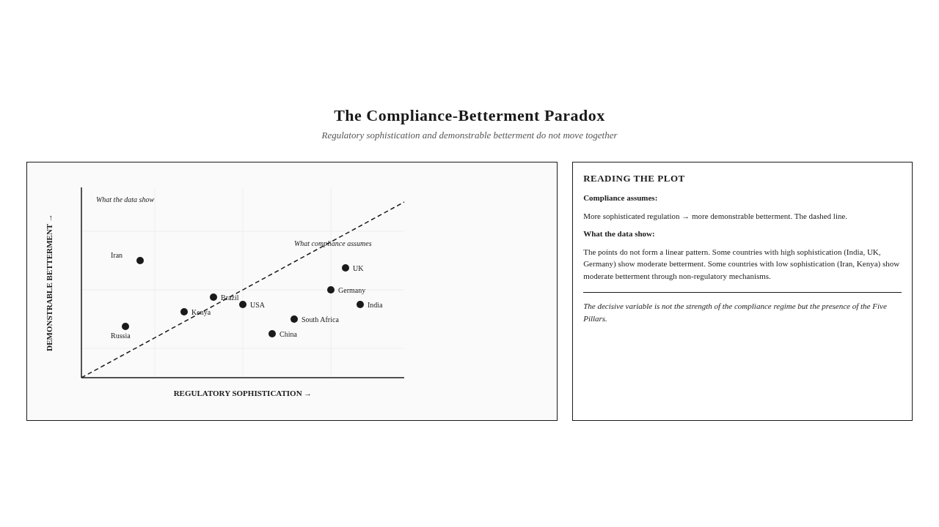

India — The World's Most Significant Mandatory CSR Regime
India receives the most detailed treatment in this chapter. It is the world's most significant mandatory CSR regime. It is the author's area of doctoral specialization. And it is the case that most sharply tests the compliance-betterment paradox, because India has built one of the most sophisticated CSR regulatory architectures in the world while the question of whether that architecture has produced demonstrable Betterment of Society remains contested.
India's CSR regulatory architecture is built on several pillars (regulatory pillars, not framework pillars — the distinction matters). The Companies Act of 2013 introduced Section 135, which mandates that companies above defined thresholds of net worth, turnover, or profit must constitute a CSR Committee of the Board, must adopt a CSR Policy, and must spend at least two percent of their average net profits of the preceding three years on CSR activities. The mandate is statutory. Non-compliance requires disclosure and explanation. The architecture was groundbreaking when introduced — the world's first statutory CSR expenditure mandate at scale — and has been amended several times since.
The CSR Rules, issued under the Companies Act, provide the operational detail. They specify what counts as CSR, what does not, how CSR activities are to be selected, how they are to be implemented, how they are to be reported. Schedule VII of the Companies Act enumerates the broad categories of activities that count as CSR — eradicating hunger, poverty, and malnutrition; promoting education; promoting gender equality; ensuring environmental sustainability; protection of national heritage; measures for the benefit of armed forces veterans; training to promote sports; contribution to the Prime Minister's National Relief Fund; contributions to research in science, technology, and medicine; rural development; slum area development; disaster management; and several others added over time.
The Ministry of Corporate Affairs has amended the CSR framework several times since 2013. The 2019 amendments tightened compliance, requiring that unspent CSR amounts be transferred to a specified fund or to a special account. The 2021 amendments further refined the framework, introducing registration requirements for CSR implementing agencies, formalizing the role of CSR professionals, and tightening the reporting requirements. The amendments have progressively made the framework more prescriptive, more auditable, and more consequential for non-compliance.
The Impact Assessment Rules, introduced in 2019, require companies with significant CSR expenditure to conduct impact assessments of their CSR projects. The rules require independent assessment, prescribe the methodologies to some extent, and require the assessment findings to be reflected in the company's annual CSR report. The introduction of impact assessment rules was a significant regulatory step — it moved the framework beyond expenditure reporting toward outcome assessment. The rules have been criticized for their methodological flexibility and for the uneven quality of the assessments they have produced, but they represent a regulatory recognition that expenditure is not outcome.
The Business Responsibility and Sustainability Report, or BRSR, introduced in 2021 and made mandatory for the largest listed companies, requires comprehensive disclosure of environmental, social, and governance performance. BRSR is a reporting framework, not a CSR framework, but it interacts with the CSR framework by requiring disclosure of CSR performance alongside other ESG performance. BRSR is among the most sophisticated mandatory sustainability reporting regimes in the world. It produces a volume of disclosure that few other regimes match.
The National Guidelines on Responsible Business Conduct, issued by the Ministry of Corporate Affairs, provide a broader principles-based framework for responsible business. The Guidelines are not legally binding in the way the Companies Act is, but they articulate the principles that the regulatory architecture is meant to operationalize. The Guidelines are the doctrinal layer of India's CSR regime — the layer that articulates what responsible business means. The Companies Act is the regulatory layer — the layer that mandates what companies must do.
India's CSR regulatory architecture is, by any measure, sophisticated. It is mandatory. It is prescriptive. It is auditable. It has been progressively tightened. It is supported by an extensive reporting infrastructure. It has produced a substantial volume of CSR expenditure — billions of dollars annually, deployed across the country's vast development landscape. By the standards of regulatory sophistication, India's regime is among the most advanced in the world.
Can India's institutions demonstrate Betterment of Society through this architecture? The honest answer is: in some cases, yes; in most cases, the architecture does not yet produce demonstrable betterment at scale. The Impact Assessment Rules have produced some impact assessments that meet the Skeptical Observer Standard. The BRSR has produced disclosure that, in some cases, approaches the transparency the Skeptical Observer Standard requires. The Companies Act has produced expenditure that, in some cases, has been converted into verifiable outcome. But the architecture, taken as a whole, has not yet produced the verification infrastructure that would make demonstrable betterment the norm rather than the exception. The architecture produces compliance. It does not yet produce betterment verification.
The Five Pillars analysis of India's CSR regime reveals the architectural gap. Pillar A — Accountability — is partially present: the regulatory architecture demands accountability for expenditure, not for outcome. The Impact Assessment Rules begin to demand outcome accountability, but they apply only to larger projects and are methodologically flexible. Pillar E — Execution — is variable: the implementing agencies vary enormously in capability, and the regulatory architecture does not yet require disaggregated reporting by implementing agency, so the Implementing Agency Variable is hidden in the aggregate. Pillar I — Initiative — is partially present: Schedule VII prescribes the categories of activity, but the categories are broad enough that the choice of activity within a category is often imposed by the company rather than identified participatorily with the community. Pillar O — Outcome — is deficient: the architecture produces voluminous output reporting, but the production of Betterment Evidence — outcome established with evidence that meets the Skeptical Observer Standard — is rare and uneven. Pillar M — Meaning — is partially present: BRSR produces comprehensive disclosure, but the disclosure is not yet usable in the Communication Usability sense, and the Transparency Trap is visible in the volume of disclosure that resists independent verification.
India's regime, in the framework's diagnosis, has Pillar Deficiency. The strong Pillar A (in the expenditure sense) cannot compensate for the deficient Pillar O. The sophisticated reporting architecture cannot compensate for the absent verification architecture. The regime is at position three on the Proclamation-Proof Gradient — proclamation with output metrics — with some movement toward position four where impact assessment has produced outcome indicators. The regime has not yet reached position five — verified proof — at scale.
The paradox in India's case is sharp. The country with one of the world's most sophisticated CSR regulatory architectures has not yet produced demonstrable Betterment of Society at the scale the architecture would suggest. The compliance-betterment paradox is visible: compliance is high, betterment verification is low. The architecture produces the appearance of accountability — extensive reporting, elaborate compliance, substantial expenditure — without yet producing the substance of accountability — verified outcome, attributable betterment, evidence that meets the Skeptical Observer Standard.
The Indian case also reveals a counter-pattern worth noting. Beyond the regulatory architecture, India has a deep tradition of philanthropic and community-driven betterment — traditions that predate the regulatory framework by centuries, rooted in religious and cultural practice, expressed through community institutions, family foundations, and informal mechanisms of mutual aid. Some of these traditions produce demonstrable betterment at the community level, verified through the community's own recognition rather than through regulatory reporting. The regulatory framework does not see this betterment, because it is not produced through the regulatory architecture. The framework this book presents can see it, because the framework's verification demand is community recognition, not regulatory reporting. The Indian case, in this sense, illustrates the compliance-betterment paradox from both sides: a sophisticated regulatory architecture that does not yet produce betterment verification at scale, and a non-regulatory tradition that produces betterment verification at the community level but is invisible to the regulatory architecture.
Key Insight: India's CSR regime — among the world's most sophisticated — has not yet produced demonstrable Betterment of Society at the scale the regulatory architecture would suggest. The compliance-betterment paradox is sharp: compliance is high, betterment verification is low. The regime produces the appearance of accountability without yet producing the substance.

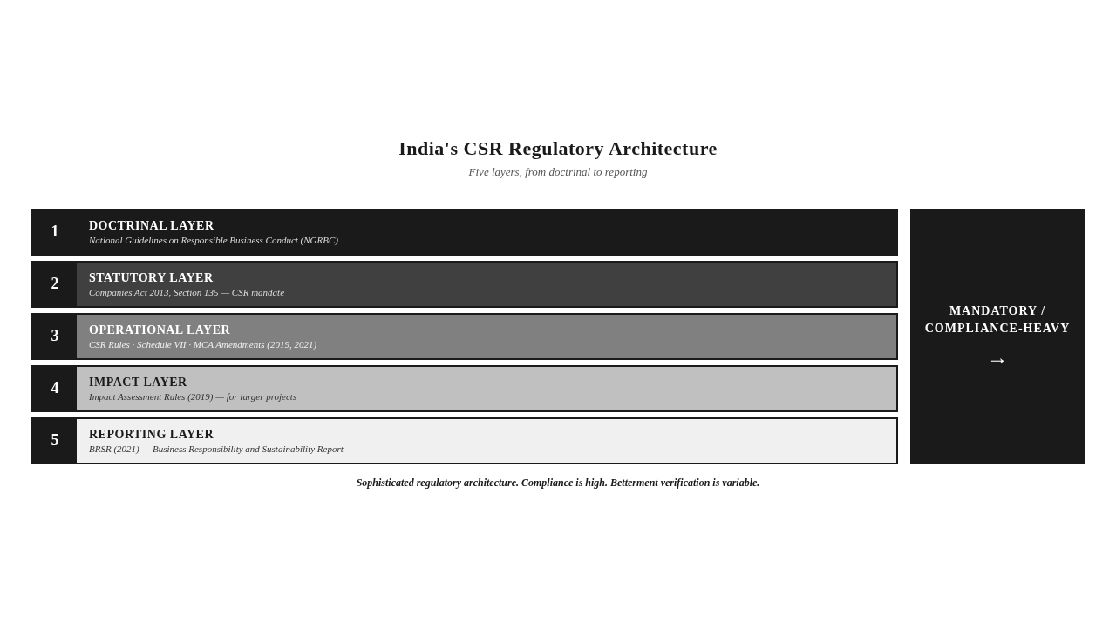

The United States, Germany, and the United Kingdom — Voluntary, Co-Determination, and Stewardship Models
The United States, Germany, and the United Kingdom represent three distinct approaches to CSR regulation among developed economies: the voluntary approach, the co-determination approach, and the stewardship approach. None has a mandatory CSR expenditure regime like India's. All three have sophisticated reporting and governance infrastructures. The comparison reveals whether voluntary or quasi-voluntary regimes produce demonstrable betterment differently than mandatory regimes.
The United States operates a predominantly voluntary CSR regime. CSR is not mandated by federal statute. Companies disclose CSR performance voluntarily, although the Securities and Exchange Commission has progressively required disclosure of certain material environmental and social risks. The reporting landscape is dominated by voluntary frameworks — GRI, SASB (now part of the IFRS Foundation's International Sustainability Standards Board), TCFD (Task Force on Climate-related Financial Disclosures), and the emerging ISSB standards. ESG rating agencies evaluate companies on their disclosed performance. The regulatory environment has been expanding — California's climate disclosure requirements, the SEC's climate disclosure proposal, state-level beneficial ownership transparency laws — but the core approach remains voluntary at the federal level.
Can US institutions demonstrate Betterment of Society through this architecture? The honest answer is: in some cases, yes; the voluntary architecture has produced some of the world's most rigorous impact verification, particularly in the philanthropic sector where foundations have built sophisticated evaluation architectures. In most cases, the architecture produces reporting, not betterment verification. The voluntary approach rewards sophisticated reporting because stakeholders — investors, employees, consumers — demand it. It does not require betterment verification, because no regulator requires it. The institutions that produce betterment verification do so because their leadership chooses to, not because the architecture requires it.
The Five Pillars analysis reveals a consistent pattern: Pillar A is partially present (accountability to investors and consumers, not for outcome); Pillar E is variable (the implementing agency variable is decisive); Pillar I is variable (some participatory engagement, mostly consultation); Pillar O is deficient (Betterment Evidence is rare outside the philanthropic sector); Pillar M is partially present (sophisticated disclosure, uneven usability). The regime sits at position three on the gradient, with some institutions at position four.
Germany operates a co-determination regime, in which labor representatives participate in corporate governance through the supervisory board structure. Germany has also implemented the EU's Non-Financial Reporting Directive and is implementing the Corporate Sustainability Reporting Directive. The German regime combines co-determination at the governance level with mandatory disclosure at the reporting level.
Can German institutions demonstrate Betterment of Society through this architecture? The honest answer is: in some cases, yes; the co-determination architecture produces accountability that the US voluntary approach does not, because labor representatives on supervisory boards can demand evidence that US board stakeholders cannot. But co-determination is sector-specific (labor, not communities) and the disclosure architecture produces reporting, not betterment verification. The Five Pillars analysis is similar to the US regime, with one difference: Pillar E is strong (German operational architecture is among the most capable in the world). The regime sits at position three to four on the gradient.
The United Kingdom operates a stewardship regime, in which institutional investors are expected (and partially required) to engage with companies on their social and environmental performance. The UK Stewardship Code, the Companies Act disclosure requirements, and the emerging sustainability disclosure requirements create an architecture in which investor stewardship is a mechanism of corporate accountability. The UK regime combines investor stewardship with mandatory disclosure and with a tradition of corporate governance reform that has shaped global practice.
Can UK institutions demonstrate Betterment of Society through this architecture? The honest answer is: in some cases, yes; the stewardship architecture produces accountability that other voluntary regimes do not, because institutional investors can demand evidence that fragmented stakeholders cannot. But the stewardship architecture produces reporting and engagement, not betterment verification. The Five Pillars analysis mirrors Germany's, with Pillar E strong and the regime at position three to four on the gradient.
The comparative analysis across the US, Germany, and the UK reveals that voluntary and quasi-voluntary regimes produce different accountability architectures but similar betterment verification outcomes. The US produces investor and consumer accountability. Germany produces labor accountability through co-determination. The UK produces investor accountability through stewardship. None produces betterment verification at scale. The compliance-betterment paradox is visible across all three, although less sharp than in India's case.
Key Insight: The US, Germany, and the UK represent three distinct approaches to CSR regulation — voluntary, co-determination, and stewardship. None produces betterment verification at scale. The compliance-betterment paradox is visible across all three, although less sharply than in India's mandatory regime.

China, Russia, and Iran — State-Directed and Low-Compliance Regimes
China, Russia, and Iran represent three distinct approaches that diverge sharply from the voluntary and mandatory regimes examined so far. China operates a state-directed regime, in which CSR is shaped by state priorities and state-led initiatives. Russia operates a low-compliance regime, in which formal CSR regulation exists but enforcement and verification are weak. Iran operates a regime in which formal CSR regulation is limited but betterment is produced through religious and community mechanisms that the regulatory framework does not capture. The comparison tests the compliance-betterment paradox from the other side — what happens when regulatory sophistication is low or when the regulatory architecture is fundamentally different from the Western model?
China operates a state-directed CSR regime. The Chinese government has issued CSR guidelines for state-owned enterprises, has encouraged listed companies to issue CSR reports, and has aligned CSR with national priorities through the Five-Year Plans and the Belt and Road Initiative. CSR in China is shaped by state priorities — poverty alleviation, ecological civilization, rural revitalization, common prosperity — and is implemented through state-led initiatives that mobilize corporate participation. The reporting landscape is dominated by Chinese reporting standards, with some alignment to international frameworks. The ESG landscape is developing rapidly, with Chinese ESG rating agencies and Chinese sustainable investment products.
Can Chinese institutions demonstrate Betterment of Society through this architecture? The honest answer is: in some cases, yes; the state-directed architecture can mobilize corporate resources at scale for state-priority objectives, and the mobilization can produce verifiable outcomes when the state prioritizes verification (as in the poverty alleviation campaign, which was subject to rigorous verification protocols). In most cases, the architecture produces reporting aligned with state priorities, not betterment verification in the framework's sense. The Chinese regime produces accountability to the state, not to communities or to the Skeptical Observer. The verification that does occur is state verification, not independent verification.
The Five Pillars analysis: Pillar A is partially present (accountability to the state, not to communities). Pillar E is strong (Chinese operational architecture is capable at scale). Pillar I is variable (state priorities can override community priorities). Pillar O is partially present (outcome measurement for state-priority programs, not for CSR broadly). Pillar M is partially present (reporting aligned with state priorities, not always usable by communities). The regime sits at position three to four on the gradient.
Russia operates a low-compliance regime. Formal CSR regulation exists, but enforcement is uneven and verification is weak. Large Russian corporations, particularly state-owned enterprises, engage in CSR activity, often aligned with state priorities. The reporting landscape is limited, with voluntary reporting by some companies and no comprehensive mandatory disclosure regime comparable to India's BRSR or the EU's CSRD. CSR in Russia is shaped by state pressure on large corporations, by the personal priorities of corporate leadership, and by the political context in which corporate activity occurs.
Can Russian institutions demonstrate Betterment of Society through this architecture? The honest answer is: in limited cases, yes; some Russian corporations have produced demonstrable betterment in specific communities, often through traditional philanthropic mechanisms. In most cases, the architecture produces neither compliance reporting nor betterment verification. The Russian regime produces accountability to the state and to political priorities, not to communities or to the Skeptical Observer. The verification that does occur is informal, mediated by personal relationships and political context rather than by procedural standards.
The Five Pillars analysis: Pillar A is weak (informal accountability mediated by political context). Pillar E is variable. Pillar I is variable (often imposed). Pillar O is deficient (betterment evidence is rare and rarely independent). Pillar M is weak (reporting limited and not usable). The regime sits at position two to three on the gradient.
Iran operates a regime in which formal CSR regulation is limited but betterment is produced through religious and community mechanisms. The Iranian regime does not have a comprehensive mandatory CSR architecture comparable to India's. CSR activity occurs, often framed in religious terms — bonyads (religious foundations), vaqf (endowments), and community-based mechanisms that distribute resources according to religious principles. The reporting landscape is limited. The regulatory framework does not capture the betterment produced through religious and community channels.
Can Iranian institutions demonstrate Betterment of Society through this architecture? The honest answer is: in some cases, yes; the religious and community mechanisms produce betterment at the community level, verified through community recognition rather than through regulatory reporting. The Iranian case illustrates the compliance-betterment paradox most sharply: a country with minimal formal CSR regulation may produce demonstrable betterment through mechanisms the regulatory framework does not see. The Iranian regime produces accountability to religious and community standards, not to regulators or to the Skeptical Observer in the framework's formal sense. The verification that occurs is community verification, mediated by religious and cultural norms.
The Five Pillars analysis of the Iranian regime: Pillar A is partially present — accountability is to religious and community standards, which can be more demanding than regulatory standards. Pillar E is variable — operational capability exists in religious institutions and community organizations but is uneven. Pillar I is partially present — initiatives are often identified through community structures, although they can also be imposed by religious authority. Pillar O is partially present — betterment is recognized at the community level but not always measurable in the framework's formal sense. Pillar M is weak — formal reporting is limited, although informal communication through community channels is strong. The regime is at position two to three on the gradient in formal terms, but the betterment produced through non-regulatory channels may exceed what the formal position suggests.
The comparative analysis across China, Russia, and Iran reveals that state-directed and low-compliance regimes produce accountability to different standards — the state, political context, religious and community norms — and that the accountability produced through these channels can sometimes produce betterment that the regulatory frameworks of mandatory regimes do not. The compliance-betterment paradox is visible from this side too: countries with limited formal CSR regulation can produce betterment through non-regulatory mechanisms. The paradox is sharper when the non-regulatory mechanisms are culturally robust, as in Iran's case, and weaker when they are politically compromised, as in Russia's case.
Key Insight: China, Russia, and Iran represent three distinct approaches — state-directed, low-compliance, and religious/community-based. The compliance-betterment paradox is visible from this side too: countries with limited formal CSR regulation can produce betterment through non-regulatory mechanisms. The paradox is sharper when the non-regulatory mechanisms are culturally robust.

South Africa, Kenya, and Brazil — Emerging Economy Cases
South Africa, Kenya, and Brazil represent three emerging economy cases that test the compliance-betterment paradox in contexts where regulatory capacity is developing and where betterment needs are substantial. Each has a distinct regulatory architecture. Each has produced betterment outcomes that test the paradox in different ways.
South Africa operates a regime that combines elements of voluntary and mandatory approaches. South Africa's King Reports on Corporate Governance — King I, II, III, and IV — have shaped corporate governance practice globally and have established corporate governance principles that include social responsibility. The Johannesburg Stock Exchange requires listed companies to apply the King Code on an "apply or explain" basis. The Broad-Based Black Economic Empowerment (B-BBEE) legislation creates a different form of social accountability — a regulatory framework that requires companies to contribute to economic transformation through ownership, management, employment, skills development, supplier development, and socio-economic development. B-BBEE is not a CSR regime in the narrow sense, but it operates as one in practice, mobilizing corporate resources for socio-economic development.
Can South African institutions demonstrate Betterment of Society through this architecture? The honest answer is: in some cases, yes; the B-BBEE framework has produced measurable socio-economic development outcomes in some areas, particularly in skills development and supplier development. In other areas — ownership transformation, employment equity — the framework has produced compliance reporting without producing demonstrable betterment at the scale intended. The King Code has produced sophisticated governance practice but has not produced betterment verification as a routine outcome. The South African regime produces accountability to a sophisticated governance and transformation framework. It does not yet produce betterment verification at scale.
The Five Pillars analysis: Pillar A is partially present (accountability to B-BBEE and King Code, oriented to compliance not outcome). Pillar E is variable. Pillar I is partially present (B-BBEE priorities imposed at regulatory level, implementation can be participatory). Pillar O is partially present (some B-BBEE outcomes measurable; broader betterment verification rare). Pillar M is partially present (King Code disclosure sophisticated; B-BBEE reporting comprehensive; neither always usable). The regime sits at position three to four on the gradient.
Kenya operates an emerging regime that combines voluntary CSR practice with developing regulatory infrastructure. Kenyan companies engage in CSR voluntarily, often through foundations and community investment programs. The Nairobi Securities Exchange has issued sustainability disclosure guidelines. The Kenyan government has encouraged CSR through various policy frameworks, including the Vision 2030 development plan, which aligns corporate contributions with national development priorities. The M-Pesa mobile money platform — a Kenyan innovation — has created infrastructure for community-based financial flows that operates outside the formal CSR architecture but produces betterment at scale.
Can Kenyan institutions demonstrate Betterment of Society through this architecture? The honest answer is: in some cases, yes; the Kenyan regime produces betterment through a combination of voluntary CSR, mobile-money-enabled community flows, and informal community-driven betterment. The betterment is often verified through community recognition rather than through regulatory reporting. The Kenyan case illustrates a pattern visible in several African economies: betterment is produced through a plural ecosystem of formal CSR, informal community mechanisms, and technological innovation, with the formal regulatory architecture capturing only part of the betterment produced.
The Five Pillars analysis: Pillar A is weak in formal terms but partially present through community recognition. Pillar E is variable. Pillar I is partially present (community-driven initiatives can be participatory). Pillar O is partially present (betterment recognized at community level). Pillar M is weak in formal reporting but strong in informal communication. The regime sits at position two to three in formal terms, with the betterment produced through the plural ecosystem exceeding what the formal position suggests.
Brazil operates a regime that combines mandatory and voluntary elements. The Brazilian Corporate Sustainability Index (ISE) on the B3 stock exchange evaluates listed companies on sustainability performance. The Brazilian Companies Act was amended in 2021 to allow companies to issue sustainability-themed debt. The Brazilian reporting landscape has been influenced by the Global Reporting Initiative and by the Brazilian Association of Listed Companies' sustainability guidelines. Brazilian companies have a tradition of social investment, often through corporate foundations and institutes, that predates the formal regulatory architecture.
Can Brazilian institutions demonstrate Betterment of Society through this architecture? The honest answer is: in some cases, yes; the Brazilian tradition of social investment, particularly through corporate institutes, has produced betterment in specific communities, sometimes verified through community recognition. In other cases, the architecture produces reporting, not betterment verification. The Brazilian regime produces accountability to a developing regulatory framework and to a tradition of social investment. It does not yet produce betterment verification at scale.
The Five Pillars analysis: Pillar A is partially present. Pillar E is variable. Pillar I is variable (corporate institutes can be participatory; regulatory compliance is more often imposed). Pillar O is partially present (some betterment verified through community recognition). Pillar M is partially present (disclosure developing; communication usability uneven). The regime sits at position three on the gradient, with the betterment produced through social investment traditions exceeding what the formal position suggests.
The comparative analysis across South Africa, Kenya, and Brazil reveals that emerging economy cases produce the compliance-betterment paradox in distinctive ways. In South Africa, the paradox is visible in the gap between sophisticated governance and uneven transformation outcomes. In Kenya, the paradox is visible in the gap between limited formal regulation and substantial betterment produced through plural ecosystems. In Brazil, the paradox is visible in the gap between developing regulatory infrastructure and betterment produced through social investment traditions. The paradox is consistent across the three cases, although its expression differs.
Key Insight: South Africa, Kenya, and Brazil represent three emerging economy cases that test the compliance-betterment paradox in distinctive ways. In each, the paradox is visible: regulatory sophistication and demonstrable betterment do not move together. The paradox is consistent; its expression differs.

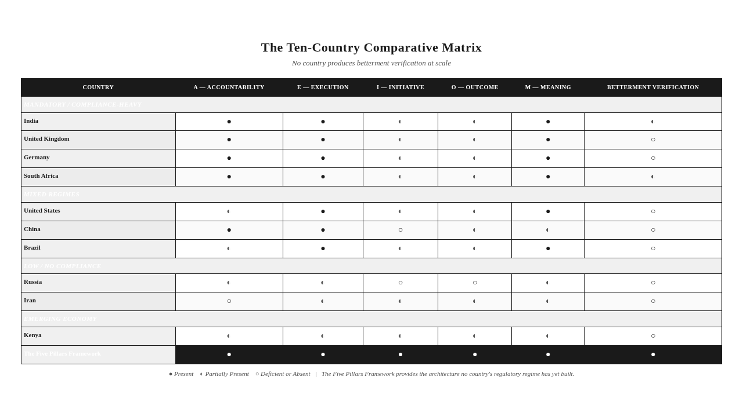

The Cultural Betterment Mechanism
The comparative analysis reveals a pattern that requires explicit recognition. Several of the countries examined — Iran, Kenya, parts of Brazil and South Africa — produce betterment through cultural, religious, or community-driven mechanisms that the formal regulatory framework does not capture. The framework introduced in Chapter 3 referred to this pattern as the Cultural Betterment Mechanism. The concept deserves explicit treatment here.
The Cultural Betterment Mechanism is the recognition that betterment can occur through non-regulatory channels — cultural norms, religious obligations, community traditions, mutual aid practices, informal social contracts. These channels produce betterment at the community level, verified through community recognition rather than through regulatory reporting. The betterment produced through these channels is real. It is often substantial. It is invisible to regulatory frameworks that measure betterment through compliance reporting, because the betterment is not produced through compliance.
The Cultural Betterment Mechanism does not invalidate the regulatory architecture. Regulatory architectures are necessary for the functions they serve — they standardize disclosure, they create floors of minimum performance, they enable comparison, they mobilize resources at scale. The Cultural Betterment Mechanism does not replace these functions. It complements them, by producing betterment through channels the regulatory architecture does not reach. The Two — regulatory architecture and Cultural Betterment Mechanism — are not in competition. They are in parallel, producing different kinds of betterment through different kinds of architecture.
The framework's recognition of the Cultural Betterment Mechanism is significant for two reasons. First, it explains the compliance-betterment paradox. The paradox — that countries with sophisticated regulations do not necessarily produce more demonstrable betterment — is partially explained by the fact that some countries with limited regulation produce betterment through cultural mechanisms. The betterment is real. It is not captured by the regulatory architecture. The paradox is the gap between what the regulatory architecture captures and what is actually produced.
Second, it expands the framework's universality. The Five Pillars Framework applies across regulatory contexts. It also applies across cultural contexts. The framework's verification demand — can the institution demonstrate, with evidence that meets the Skeptical Observer Standard, that its interventions produced Betterment of Society — can be met through regulatory verification, through community verification, or through a combination of both. The framework does not prescribe the verification channel. It prescribes the verification standard. The standard is the Skeptical Observer. The channel can be regulatory, cultural, or both.
The Cultural Betterment Mechanism also cautions against regulatory overreach. The regulator who assumes that betterment requires regulatory architecture may inadvertently displace the cultural mechanisms that produce betterment without regulation. The regulatory architecture that mandates CSR may crowd out the community traditions that produce betterment without mandates. The framework's recognition of the Cultural Betterment Mechanism is therefore also a caution: the architecture this book presents is not a regulatory architecture. It is an institutional architecture. The architecture can be built within any regulatory context, and it can coexist with any cultural context. The architecture does not require regulatory mandate. It requires institutional commitment.
Key Insight: The Cultural Betterment Mechanism — betterment produced through cultural, religious, or community-driven channels — explains the compliance-betterment paradox and expands the framework's universality. The framework does not prescribe the verification channel. It prescribes the verification standard. The channel can be regulatory, cultural, or both.

Synthesis — Patterns Across the Ten Countries
The ten-country comparative analysis produces several patterns that warrant synthesis.
The first pattern is that regulatory sophistication and demonstrable betterment do not move together. India has the most sophisticated mandatory CSR regime among the ten countries. It does not produce the most demonstrable betterment. The UK and Germany have sophisticated governance and disclosure regimes. They do not produce the most demonstrable betterment. Iran and Kenya have limited formal CSR regulation. They produce betterment through non-regulatory mechanisms that the formal regulatory architecture does not capture. The compliance-betterment paradox is visible across all ten countries. The paradox is sharper in some cases (India, where the gap between sophistication and betterment is large) and less sharp in others (Kenya, where the regulatory architecture is limited and the betterment produced through non-regulatory mechanisms is substantial). The paradox is consistent.
The second pattern is that the Implementing Agency Variable is decisive across all ten countries. In every country, the variation in betterment outcomes across institutions is more strongly correlated with the implementing agency's capability than with the regulatory regime's sophistication. The same regulatory regime — India's, the US's, anyone's — produces different outcomes when implemented by capable agencies than when implemented by struggling agencies. The framework's Implementing Agency Principle — that no sector performs inherently better than another, that the variable is the implementing agency — is confirmed across the ten countries. The regulatory architecture cannot substitute for the implementing agency's capability. The regulatory architecture can establish floors. It cannot produce the ceiling.
The third pattern is that the Five Pillars apply universally across the ten countries. The framework's diagnostic — Pillar A, Pillar E, Pillar I, Pillar O, Pillar M — produces coherent diagnoses across all ten regulatory regimes. The specific deficiencies differ by country. The framework's applicability does not. The framework is not a Western framework applied to non-Western contexts. It is a universal framework applied across diverse contexts. The universality is not a claim. It is a demonstration, conducted across ten countries with fundamentally different regulatory, cultural, and political contexts.
The fourth pattern is that no country has yet built the verification architecture the framework requires. The Trust Layer — the verification infrastructure that makes institutional claims credible by enabling independent verification — is partial or absent in all ten countries. India has the most sophisticated reporting architecture. It does not have the most sophisticated verification architecture. The US has sophisticated voluntary verification in some sectors. It does not have it at scale. The gap is consistent: reporting architecture is more developed than verification architecture across all ten countries. The framework's distinctive contribution — the Trust Layer — is the dimension where all ten countries have the most work to do.
The fifth pattern is that the compliance-betterment paradox is the central finding of the comparative analysis. The paradox is not a criticism of regulatory sophistication. It is a recognition that regulatory sophistication is necessary but insufficient for betterment verification. The countries with sophisticated regulations have built compliance architectures. They have not yet built verification architectures. The countries with limited regulations have built neither, in most cases — but they have, in some cases, preserved cultural betterment mechanisms that produce betterment through non-regulatory channels. The paradox is the recognition that betterment verification requires a different architecture than compliance, and that no country has yet built that architecture at scale.
Key Insight: The synthesis across the ten countries produces five patterns: regulatory sophistication and demonstrable betterment do not move together; the Implementing Agency Variable is decisive; the Five Pillars apply universally; no country has yet built the verification architecture the framework requires; the compliance-betterment paradox is the central finding.

The Hypothesis — When Low-Compliance May Outperform High-Compliance
The comparative analysis supports a hypothesis that requires careful statement. The hypothesis is that low-compliance countries may sometimes produce better Betterment of Society outcomes than high-compliance countries, through cultural, religious, or community mechanisms that the regulatory frameworks cannot see.
The hypothesis is not that low-compliance is preferable to high-compliance. The hypothesis is not that regulation is counterproductive. The hypothesis is not that countries should abandon regulatory sophistication. The hypothesis is the narrower claim that, in specific cases and through specific mechanisms, low-compliance countries may produce betterment that high-compliance countries do not, because the cultural mechanisms operate where the regulatory mechanisms do not.
The hypothesis is supported by the comparative analysis in three ways. First, the countries with sophisticated regulations (India, UK, Germany) do not produce more demonstrable betterment than the countries with limited regulations (Iran, Kenya) — at least not in proportion to their regulatory sophistication. The compliance-betterment paradox is the empirical foundation of the hypothesis. Second, the countries with limited regulations produce betterment through identifiable non-regulatory mechanisms — religious obligations, community traditions, mutual aid practices — that the regulatory framework does not capture. The Cultural Betterment Mechanism is the architectural foundation of the hypothesis. Third, the framework's verification standard — the Skeptical Observer Standard — is met in some cases by community verification that does not depend on regulatory reporting. The framework's universality is the doctrinal foundation of the hypothesis.
The hypothesis has implications for regulatory design. The regulator who assumes that more regulation produces more betterment may be wrong. The regulator who assumes that compliance produces verification is wrong. The regulator who assumes that the regulatory architecture is the only architecture that produces betterment is wrong. The regulator who takes the compliance-betterment paradox seriously designs regulation that complements rather than displaces the cultural betterment mechanisms, that builds verification architecture rather than only reporting architecture, and that respects the Implementing Agency Variable rather than assuming that regulatory uniformity produces outcome uniformity.
The hypothesis also has implications for the framework's positioning. The framework is not a regulatory framework. It is an institutional framework. It applies within any regulatory context — mandatory, voluntary, low-compliance. It can be adopted by any institution in any country. It does not require regulatory mandate. It requires institutional commitment. The framework's universality is not limited to Western regulatory contexts. It extends to the cultural and community contexts that produce betterment through non-regulatory channels. The framework provides the architecture that any institution — in any country, under any regulatory regime, with any cultural context — can use to answer the Betterment Question.
Stop & Think: The reader who has followed the comparative analysis across the ten countries — and who has noticed that the compliance-betterment paradox appears in every country, that the Implementing Agency Variable is decisive in every country, and that no country has yet built the verification architecture the framework requires — has already recognized the framework's universal applicability. The reader who has noticed the Cultural Betterment Mechanism operating in countries with limited regulation has recognized that the framework's verification standard can be met through channels other than regulatory reporting. The framework is universal. The architecture is the same. The implementation differs.

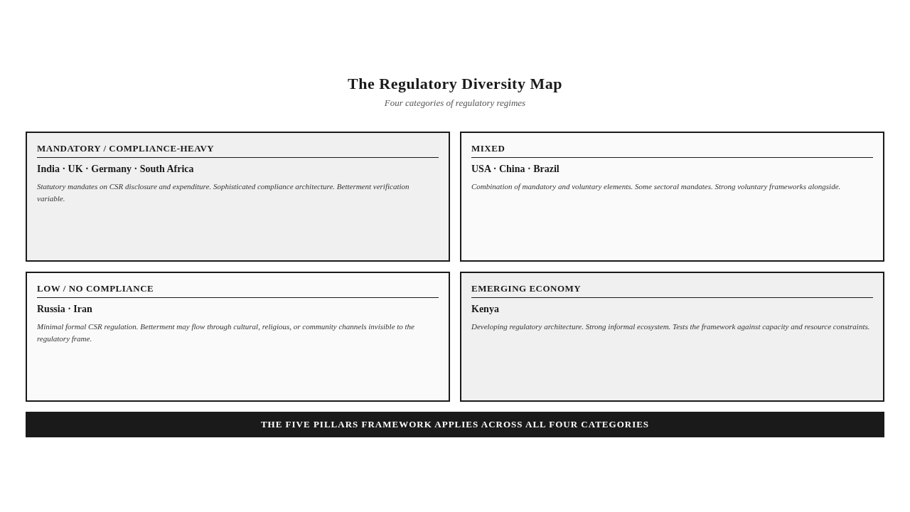
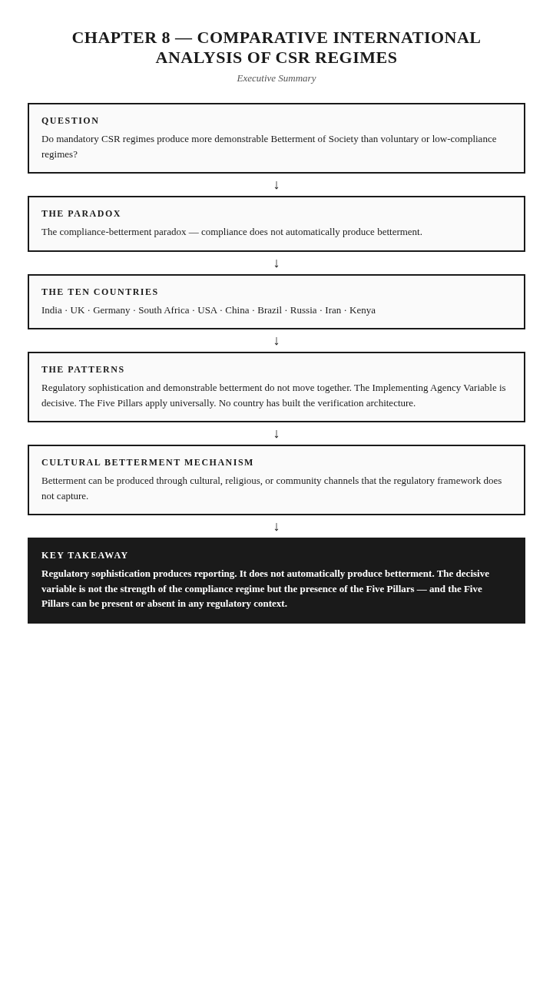

The Takeaway
Regulatory sophistication produces reporting. It does not automatically produce betterment. The decisive variable is not the strength of the compliance regime but the presence of the Five Pillars — and the Five Pillars can be present or absent in any regulatory context.

Reader Momentum
The comparative analysis has shown that the Five Pillars Framework applies universally — across mandatory, voluntary, and low-compliance regimes. But the framework's universality raises a question: what does the future of institutional legitimacy look like in a world where the compliance-betterment paradox is recognized? What new social contract does the framework imply? And what criticisms will the framework face — criticisms that should be anticipated and answered honestly, before critics raise them? Those questions — the future, the new legitimacy, and the honest engagement with criticism — are the subject of the next chapter.

CHAPTER 9 — THE NEW LEGITIMACY (INCLUDES ANTICIPATING CRITICISM)


The Institutions of Fifty Years from Now
The institutions of fifty years ago would not recognize the accountability architectures of today. The annual sustainability report, the ESG rating, the GRI disclosure, the BRSR mandate — none of these existed in the form we know them. The institutions of fifty years from now will not recognize ours. The reporting architectures we have built will be rebuilt. The compliance regimes we have erected will be restructured. The accountability vocabularies we have developed will be replaced.
The question is whether the change will be drift or migration. Drift is change without architecture. The institution is carried by the current — by regulatory pressure, by stakeholder demand, by technological change, by the gradual erosion of the existing architecture. The institution that drifts arrives at a future it did not design. Migration is change with architecture. The institution rebuilds itself — around the Betterment Question, around the Five Pillars, around the Trust Layer — and arrives at a future it chose. The institution that migrates arrives at a future it built.
This chapter is about the future the framework implies — the new legitimacy that becomes possible when institutions take the framework seriously. The chapter has two movements. The first movement presents the new social contract: the implications for policy, governance, capital markets, and the institutional ecosystem. The second movement — Anticipating Criticism — engages honestly with the questions critics will raise. The framework is presented as powerful but not omnipotent, as universally applicable but not universally sufficient. The chapter closes by returning to the Betterment Question, now answerable because the architecture exists — and now defensible because the criticisms have been anticipated and addressed.
Key Insight: The change will be drift or migration. Drift is change without architecture. Migration is change with architecture. The framework is the architecture for migration. The institution that takes the framework seriously arrives at a future it built, not a future it drifted into.

MOVEMENT ONE — THE NEW SOCIAL CONTRACT

The New Legitimacy
The new legitimacy is not a higher standard of the old accountability. It is a different architecture. The old accountability was expenditure-based — legitimacy claimed through spending. The new legitimacy is evidence-based — legitimacy demonstrated through verified outcomes. The two are not continuous. They are different architectures, with different foundations, different verification mechanisms, and different relationships to the Betterment Question.
The new legitimacy rests on the Five Pillars. Accountability establishes the demand for outcome. Execution provides the capacity. Initiative ensures the outcome matters. Outcome constitutes the substance. Meaning makes the outcome verifiable. The institution that has built all five has the new legitimacy. The institution that has built four of the five does not — it has an incomplete architecture, and the missing pillar is the condition the other four require.
The new legitimacy also rests on the Trust Layer. The Five Pillars describe what the institution must be. The Trust Layer describes how the institution's claims become credible. The new legitimacy is not just a matter of building the pillars. It is a matter of building the verification infrastructure that makes the pillars credible to a skeptical observer. The institution that has built the pillars without the Trust Layer has the architecture but not the credibility. The institution that has built both has the new legitimacy.
The new legitimacy is the architectural condition the framework exists to produce. It is the condition in which the Betterment Question is not evaded but answered, because the structural conditions for answering it have been built into the institution itself. The institution that has the new legitimacy can answer the question. The institution that does not cannot. The difference is architectural.
One Sentence Summary: The new legitimacy is not a higher standard of the old accountability. It is a different architecture — evidence-based rather than expenditure-based, resting on the Five Pillars and the Trust Layer.

Implications for Policy
The new legitimacy has implications for policy. The policy architecture that has been built over the last two decades — the mandatory disclosure regimes, the CSR expenditure mandates, the ESG reporting requirements — was designed to produce compliance. The new legitimacy requires policy designed to produce verification.
The policy implications are not abolitionist. The framework does not propose that existing regulatory architecture be dismantled. The compliance architecture serves functions that the verification architecture does not — standardizing disclosure, creating floors of minimum performance, enabling comparison. The framework proposes that the compliance architecture be complemented by a verification architecture. Policy should require not only disclosure but also verification. Policy should establish not only reporting standards but also verification standards. Policy should hold institutions accountable not only for what they report but for what they can demonstrate.
The specific policy instruments vary by jurisdiction and by institutional type. The general principle is constant: policy should require evidence, not only disclosure. The Impact Assessment Rules in India's CSR regime — which require impact assessment for larger projects — are an early example of policy moving in this direction. The EU's Corporate Sustainability Reporting Directive — which requires assurance of sustainability reporting — is another example. Both are partial movements toward the verification architecture the framework requires. Neither has yet reached the Skeptical Observer Standard as a policy requirement. The policy work remaining is to move verification from optional to required, from partial to comprehensive, and from procedural to substantive.
The policy implications also extend to the regulatory treatment of the Implementing Agency Variable. Policy that mandates CSR expenditure without accounting for the implementing agency's capability produces expenditure without outcome. Policy that requires disaggregated reporting by implementing agency — outcome by agency, not aggregated — would make the Implementing Agency Variable visible, and would create the policy incentive for institutions to select, support, and verify implementing agencies against the Five Pillars. The disaggregation is a specific policy change with substantial architectural implications.

Implications for Governance
The new legitimacy has implications for governance. The governance architecture that has been built over the last two decades — board sustainability committees, chief sustainability officer roles, sustainability reporting functions — was designed to produce compliance reporting. The new legitimacy requires governance designed to produce verified outcome.
The governance implications were developed in Chapter 7. The board's responsibility shifts from oversight of reporting to oversight of outcome. The executive structures are reconfigured around accountability for verified outcome. The compensation structures include outcome-based components. The stakeholder representation in governance becomes structural, not token. The governance that has the new legitimacy is structurally different from the governance that has the old accountability.
The governance implications extend to capital markets. The investor who takes the new legitimacy seriously does not evaluate companies solely on ESG ratings, on sustainability reports, or on compliance disclosures. The investor evaluates companies on their Pillar Coherence — on whether they have built the architecture that produces verified betterment. The investor who has the new legitimacy as an investment criterion allocates capital differently — toward companies with strong Pillar Coherence, away from companies with sophisticated reporting but weak Pillar Coherence. The capital market that has the new legitimacy as a standard prices companies differently — not on their disclosure volume but on their verified outcome.
The governance implications also extend to the institutional ecosystem — the network of foundations, development agencies, NGOs, and multilateral institutions that shape sector norms. The ecosystem that takes the new legitimacy seriously rebuilds its norms around the Betterment Question. Foundations evaluate grantees on Pillar Coherence. Development agencies require Betterment Evidence from their implementing partners. Multilateral institutions adopt the framework as the standard for the institutions they support. The ecosystem that has the new legitimacy as its norm shapes institutional behavior differently than the ecosystem that has the old accountability as its norm.

The Legacy Test Applied
The framework's Legacy Test asks whether the doctrine will remain meaningful in fifty years. The test is applied to every concept, principle, and recommendation. The application of the Legacy Test to the new legitimacy is the final quality filter.
The new legitimacy rests on the Five Pillars. The Five Pillars are enduring conditions of institutional legitimacy. Accountability, Execution, Initiative, Outcome, Meaning — these are not technologies, regulations, or contemporary conditions. They are structural conditions that any institution claiming to produce betterment must meet. The conditions will remain meaningful in fifty years, regardless of changes in technology, regulation, reporting standards, or political systems. The Five Pillars pass the Legacy Test.
The new legitimacy rests on the Trust Layer. The Trust Layer is verification infrastructure — human, procedural, technological. The human and procedural components are enduring. The technological component changes. The doctrine's discipline — technology as enabling infrastructure, not doctrinal pillar — ensures that the doctrine remains meaningful regardless of technological change. The Trust Layer passes the Legacy Test.
The new legitimacy rests on the Skeptical Observer Standard. The standard is the evidentiary bar — sufficient to convince a skeptical, informed, independent observer. The standard is not a technology, a regulation, or a contemporary condition. It is an evidentiary principle. The principle will remain meaningful in fifty years, regardless of changes in how evidence is produced, gathered, or assessed. The Skeptical Observer Standard passes the Legacy Test.
The new legitimacy rests on the Betterment Question. The question — can the institution demonstrate that society is measurably better because of its presence — is the question every institution claiming to produce public value must answer. The question will remain meaningful in fifty years, regardless of changes in institutional forms, regulatory regimes, or social expectations. The Betterment Question passes the Legacy Test.
The new legitimacy passes the Legacy Test. The doctrine is durable. The institution that builds the new legitimacy today builds an architecture that will remain meaningful in fifty years. The institution that does not build the new legitimacy today builds an architecture that will be rebuilt — by drift or by migration — in the years to come.
Mini Case: An institution that built its accountability architecture around the ESG ratings of 2020 finds in 2035 that the ratings have been replaced, the methodologies have changed, and the architecture it built no longer fits the regulatory and investor expectations of the day. The institution that built its accountability architecture around the Five Pillars in 2020 finds in 2035 that the architecture still fits, because the pillars are enduring conditions of institutional legitimacy, not contemporary reporting fashions. The Legacy Test is the difference between rebuilding and enduring.

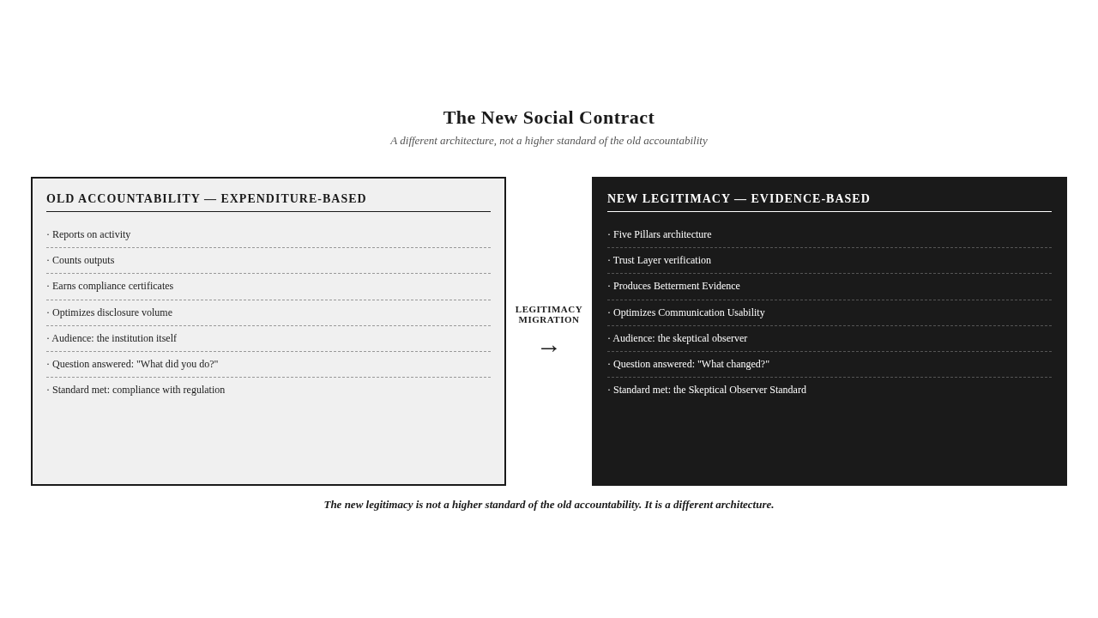

MOVEMENT TWO — ANTICIPATING CRITICISM

The Discipline of Honest Engagement
The framework will face criticism. The criticism should be anticipated and answered honestly, before critics raise it. The discipline of anticipating criticism is not defensive. It is the mark of intellectual honesty that earns credibility with academic reviewers, practitioners, and regulators. The framework is presented as powerful but not omnipotent, as universally applicable but not universally sufficient. The criticisms anticipated here are the ones the framework's author most expects, the ones most likely to be raised by serious critics, and the ones whose answers most materially affect the framework's credibility.
Six questions are anticipated. Each is answered directly and honestly — including acknowledging genuine limitations where they exist. The framework that survives this engagement is stronger than the framework that avoids it. The reader who follows this movement will see the framework's boundaries as clearly as its scope.
Key Insight: The discipline of anticipating criticism is not defensive. It is the mark of intellectual honesty that earns credibility. The framework is presented as powerful but not omnipotent, as universally applicable but not universally sufficient.

Question One — Is Betterment Measurable?
The first anticipated criticism: Is "betterment" measurable? Can the framework's central concept be operationalized in a way that produces evidence rather than assertion?
The honest answer is: yes, when the Activity-Output-Outcome-Betterment hierarchy is applied with the Skeptical Observer Standard. Betterment is measurable when the institution has built the architecture to measure it — when it has specified outcomes in advance, produced evidence after the fact, and made the evidence accessible to independent observers. The measurement is not automatic. It requires architecture. The institutions that have built the architecture can measure betterment. The institutions that have not cannot.
The honest answer also acknowledges where measurement is genuinely difficult. Betterment measurement is easier in some domains than in others. Health outcomes — mortality, morbidity, nutritional status — are measurable with established methodologies. Educational outcomes — learning, attainment, progression — are measurable, although the measurement is contested. Environmental outcomes — biodiversity, soil health, water quality — are measurable, although the measurement is complex. Economic outcomes — income, employment, asset ownership — are measurable. Social outcomes — community cohesion, social capital, institutional trust — are measurable in principle but contested in practice. The framework does not claim that betterment is uniformly measurable across all domains. It claims that betterment is measurable when the architecture is built, and that the architecture can be built across domains with appropriate methodological adaptation.
The framework's response to the measurement criticism is therefore not that measurement is easy. It is that measurement is architectural. The institution that has built the measurement architecture can produce betterment evidence. The institution that has not built the measurement architecture cannot. The framework's contribution is the architecture, not the measurement technology. The measurement technologies exist. The architecture does not, in most institutions. The framework is the architecture.

Question Two — Is Betterment Always Attributable?
The second anticipated criticism: Is betterment always attributable to institutional intervention? Can the framework establish that the betterment it measures was actually caused by the institution's action, rather than by other factors?
The honest answer is: not always, and the framework does not claim it is. The framework introduces the concept of the Attribution Challenge to name this difficulty directly. The Attribution Challenge is the difficulty of establishing causality between intervention and outcome, particularly in contexts where multiple actors, multiple interventions, and multiple external factors converge on the same community or system.
The Attribution Challenge is most acute in complex institutional contexts — where multiple foundations fund programs in the same community, where government policy and corporate investment interact, where external factors (economic conditions, environmental changes, demographic shifts) affect outcomes alongside institutional interventions. In these contexts, attributing observed betterment to a specific institution's action is methodologically demanding and sometimes impossible.
The framework's response to the Attribution Challenge is not to deny the challenge. It is to address it through the Trust Layer's verification architecture. The Trust Layer includes attribution protocols — methods for establishing institutional contribution distinct from other actors and external factors. The protocols include comparison groups (where ethical and feasible), longitudinal analysis (where data permit), contribution analysis (where experimental methods are inappropriate), and triangulation (where multiple methods converge on the same finding). The protocols do not eliminate the Attribution Challenge. They address it with the methodological rigor the Skeptical Observer Standard requires.
The framework also distinguishes between attribution and contribution. In some contexts, attribution — establishing that the institution's action caused the outcome — is impossible. In those contexts, contribution — establishing that the institution's action contributed to the outcome alongside other factors — is the appropriate standard. The framework's verification demand is calibrated to the context: attribution where possible, contribution where attribution is impossible. The calibration is honest about what can be established and what cannot.

Question Three — Can Every Project Produce Measurable Change?
The third anticipated criticism: Can every institutional project produce measurable societal change? Does the framework require every project to produce betterment evidence?
The honest answer is: no. Some projects produce outputs without outcomes. Some produce outcomes too small to measure. Some operate in contexts where measurement is genuinely impossible. The framework does not require every project to produce measurable betterment. It requires institutions to be honest about which projects do and which do not.
The framework's position is that the Betterment Question is an institutional question, not a project question. The institution must be able to demonstrate that its overall contribution produces betterment. Not every project will produce measurable betterment. Some projects will produce outputs that contribute to betterment indirectly, through accumulation or through enabling effects on other projects. Some projects will fail. Some projects will produce benefits that are real but not measurable. The framework does not require uniform betterment evidence across every project. It requires institutional honesty about which projects produce betterment evidence, which produce outputs without betterment evidence, and which fail.
The institutional honesty has implications. The institution that is honest about its project portfolio reports betterment evidence where it exists, output evidence where betterment evidence does not exist, and failure where failure occurred. The reporting is more honest than the reporting that implies every project produced betterment. The honest reporting is also more credible — to the Skeptical Observer, to stakeholders, to regulators. The institution that reports uniform betterment across all projects is reporting what cannot be true. The institution that reports betterment where it exists and is honest about where it does not is reporting what is true. The framework's verification demand produces honest reporting, not uniform reporting.

Question Four — Does the Framework Disadvantage Small Organizations?
The fourth anticipated criticism: Does the framework disadvantage small organizations? The framework's verification demands are demanding. Small organizations may not have the resources to build the Trust Layer, to conduct impact assessments, to produce Betterment Evidence. Does the framework create a tiered system where large organizations can demonstrate legitimacy and small organizations cannot?
The honest answer is: this is a genuine concern, and the framework addresses it through the Scale Equity Question. The Scale Equity Question is whether the framework's verification demands are equitable across organizations of different scales.
The framework's response to the Scale Equity Question is graduated application. The framework's principles apply to all organizations — the Five Pillars are universal. The verification architecture scales with organizational capacity. A small organization does not need to build the Trust Layer that a multinational corporation needs. It needs to build the Trust Layer appropriate to its scale — independent verification through community recognition, procedural standards appropriate to its operations, technological tools appropriate to its budget. The framework's principles are universal. The verification architecture is graduated.
The graduated application is not a dilution of the framework. It is a recognition that the Skeptical Observer Standard can be met through different architectures at different scales. The small organization that has built a Trust Layer appropriate to its scale can meet the Skeptical Observer Standard. The large organization that has built a Trust Layer appropriate to its scale can meet the Skeptical Observer Standard. The standard is the same. The architecture differs.
The Scale Equity Question also has policy implications. The regulatory architecture that requires verification should provide support for small organizations to build the verification architecture — through shared infrastructure, through capacity building, through simplified protocols for smaller organizations. The policy work is to ensure that the framework's graduated application is supported by policy, not undermined by it.

Question Five — How Is Causality Established?
The fifth anticipated criticism: How is causality established? The framework's Outcome pillar requires that the institution demonstrate that the change it claims is attributable to its action. How is this attribution established, particularly in complex contexts?
The honest answer is: through the Trust Layer's verification architecture, with methodological rigor appropriate to the context. The methods for establishing causality include experimental methods (randomized controlled trials, where ethical and feasible), quasi-experimental methods (difference-in-differences, regression discontinuity, matching, where experimental methods are inappropriate), and non-experimental methods (contribution analysis, realist evaluation, process tracing, where experimental and quasi-experimental methods are impossible). The framework does not prescribe a single method. It prescribes methodological rigor that meets the Skeptical Observer Standard.
The framework acknowledges that causality is easier to claim than to establish. The institution that claims causality without methodological rigor is claiming what it cannot defend. The framework's verification demand enforces the distinction between causality claimed and causality established. The institution that has built the Trust Layer can establish causality with methodological rigor. The institution that has not built the Trust Layer cannot. The framework's contribution is the architecture that makes methodological rigor routine, not the methodological technology. The methodological technologies exist. The architecture does not, in most institutions. The framework is the architecture.
The framework also distinguishes between causality established for individual projects and causality established for institutional contributions. Individual project causality — this project caused this outcome — is sometimes impossible to establish. Institutional contribution causality — this institution's overall contribution caused betterment at the community or system level — is sometimes easier to establish, through portfolio analysis, through longitudinal community-level assessment, through triangulation across projects. The framework's verification demand is calibrated to the level of analysis. Project-level causality where possible. Institutional-level contribution where project-level causality is impossible.

Question Six — What Are the Framework's Limits?
The sixth anticipated criticism: What are the limits of the Five Pillars Framework? What does the framework not do? The framework introduces the concept of the Limits of the Framework to address this question directly.
The honest answer is: the framework is not a complete theory of institutions. It does not address institutional purpose — why institutions exist, what they should aim to accomplish. It does not address institutional ethics — what institutions should do when betterment and other values conflict. It does not address institutional culture — the beliefs, norms, and practices that shape institutional behavior. It does not address institutional power — the distribution of authority within and across institutions. It addresses institutional legitimacy — specifically, the conditions under which an institution can demonstrate that its interventions produce Betterment of Society.
The framework's limits are deliberate. The framework is a meta-framework for institutional legitimacy, not a comprehensive theory of institutions. The institutions that adopt the framework still need to address purpose, ethics, culture, and power through other frameworks, other disciplines, other conversations. The framework does not replace those conversations. It complements them, by providing the architecture for the question they do not address — the question of whether institutions can demonstrate the betterment they claim.
The framework's limits are also honest. The institution that expects the framework to address everything it cares about will be disappointed. The institution that expects the framework to address the Betterment Question will find the architecture it needs. The framework is powerful for its purpose. It is not omnipotent. The distinction matters. The framework that claims to address everything addresses nothing well. The framework that addresses its specific question with rigor provides the architecture the question requires.
Key Insight: The framework has limits. It is not a complete theory of institutions. It does not address purpose, ethics, culture, or power. It addresses institutional legitimacy — the conditions under which an institution can demonstrate Betterment of Society. The limits are deliberate. The framework is powerful for its purpose. It is not omnipotent.

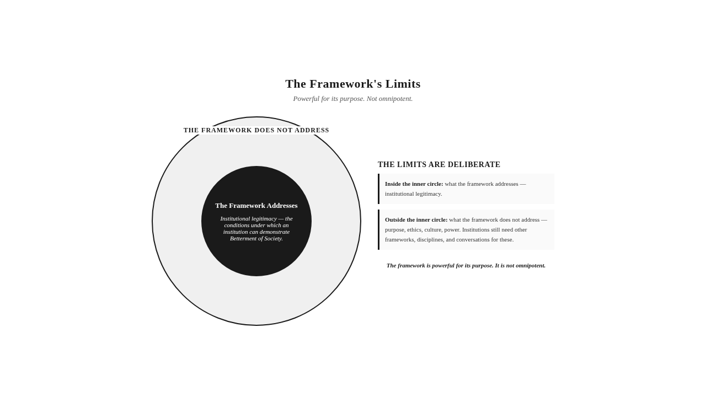

Three Archetypes — The Future in View
The new legitimacy can be sharpened by applying it to three archetypes, each with a future focus.
The Sovereign Development Fund, future focus. The fund has completed Legitimacy Migration. Its governance has been redesigned around outcome oversight. Its execution architecture has been rebuilt around the Implementing Agency Variable. Its CEI is used as a diagnostic instrument. Its Trust Layer is at the Systematic stage. The fund operates in the new legitimacy — it can answer the Betterment Question for the capital it deploys across implementation landscapes. The fund's future is the maintenance of the architecture, through continual architectural vigilance. The fund that has maintained the architecture for a decade has built Trust Capital that the fund that has just begun the migration has not. The fund's future is also the expansion of the architecture — extending it to new implementation landscapes, building the Trust Layer to the Embedded stage, developing the diagnostic instruments further. The future of the fund is the future of an institution that has reconstructed itself around the architecture the framework requires.
The Global Health Foundation, future focus. The foundation has completed Legitimacy Migration in its strongest programs. It is in the middle of migration in its weaker programs. The foundation operates in an ecosystem where the new legitimacy is becoming the standard — where its peer foundations, its grantees, and its regulators increasingly expect Betterment Evidence rather than impact narratives. The foundation's future is the completion of the migration across its full portfolio, and the leadership of the ecosystem toward the new legitimacy. The foundation that leads the ecosystem shapes the norms that govern the field. The foundation's future is not only its own architecture but the architecture of the ecosystem it leads.
The Environmental Restoration Consortium, future focus. The consortium has begun the architectural work of building a Trust Layer that no single party controls but all parties trust. The multi-stakeholder governance challenge is the consortium's central architectural work. The consortium's future is the development of multi-party verification infrastructure — protocols, data sharing, independent assessment — that allows the consortium to demonstrate that its collective action produced ecological betterment. The consortium's future is also the development of attribution protocols specific to ecological restoration — methods for establishing contribution to slow, multi-causal, landscape-level ecological change. The consortium's future is the future of multi-stakeholder betterment under the new legitimacy.
These three archetypes — the development fund, the health foundation, and the environmental consortium — represent three different futures under the new legitimacy. The fund's future is maintenance and expansion. The foundation's future is completion and ecosystem leadership. The consortium's future is multi-party architecture and ecological attribution. The futures differ. The new legitimacy is the same. The framework applies across all three.
Stop & Think: The reader who has followed the framework to this point — and who has applied it to their own institution's future — has begun to see what the new legitimacy would mean for the institution they know. The institution that has the new legitimacy is structurally different from the institution that has the old accountability. The reader who has seen the difference has seen the future the framework implies.

The Betterment Question, Now Answerable
The chapter closes by returning to where the book began. The Betterment Question — can this institution demonstrate, with evidence that would convince a skeptical observer, that society is measurably better because of its presence? — is now answerable, because the architecture exists.
The architecture is the Five Pillars. The verification infrastructure is the Trust Layer. The diagnostic instruments are the CEI and the Betterment Index. The standard is the Skeptical Observer. The journey is Legitimacy Migration. The future is the new legitimacy. The framework is the architecture that makes the question answerable.
The question is not answered by the framework alone. The framework provides the architecture. The institution provides the implementation. The framework is necessary — without it, the question cannot be answered. The institution is necessary — without it, the framework is doctrine without embodiment. The two together — the framework and the institution that builds the architecture — produce the answer. The answer is the work that remains.
The framework is also now defensible, because the criticisms have been anticipated and addressed. The framework is measurable, when the architecture is built. The framework addresses the Attribution Challenge, through the Trust Layer's verification architecture. The framework does not require uniform betterment evidence — it requires institutional honesty. The framework addresses the Scale Equity Question, through graduated application. The framework establishes causality through methodological rigor appropriate to the context. The framework has limits, and the limits are deliberate. The framework that survives this engagement is stronger than the framework that avoids it.
The reader who has followed the framework through nine chapters has seen the diagnosis, the comparative review, the architecture, the pillars in depth, the Trust Layer, the institutional operating system, the comparative international analysis, and the new legitimacy with its anticipated criticisms. The reader is now prepared for the final two chapters — the empirical validation and the mathematical foundations — that confirm the framework's empirical and quantitative architecture. The reader who does not require those chapters can proceed to the Epilogue. The reader who does require them will find them in Part IV.
Key Insight: The Betterment Question is now answerable, because the architecture exists. The framework provides the architecture. The institution provides the implementation. The two together produce the answer. The answer is the work that remains.



The Takeaway
The new legitimacy is not a higher standard of the old accountability. It is a different architecture — one in which the Betterment Question is not evaded but answered, because the architecture exists to answer it. And the architecture is honest about its own limits, because honesty is the foundation of legitimacy.

Reader Momentum
The framework has been presented, applied, tested across ten countries, and defended against criticism. The reader now returns to where the book began — the Betterment Question — but returns with the architecture that makes it answerable. The architecture has been presented as doctrine, derived from observation and reasoning. The reader who requires empirical confirmation — who wants to know whether the framework bears the weight of empirical validation — will find it in the next chapter. The reader who does not require empirical confirmation can proceed to the Epilogue. The validation is the subject of Chapter 10.

CHAPTER 10 — EMPIRICAL VALIDATION OF THE FRAMEWORK


The Framework Is Not Presented as Opinion
The framework is not presented as opinion. It is presented as architecture, and architecture must bear weight. This chapter establishes that the framework bears the weight of empirical validation.
The main narrative has presented the framework as doctrine — derived from observation and reasoning, refined through repeated testing against the patterns described in Chapters 1 and 2, and confirmed through a multi-year empirical field investigation. The main narrative references the investigation only as confirmation. The investigation is not the source of the framework. The framework is doctrinal. The investigation is the validation — the empirical confirmation that the framework's architecture corresponds to what institutions actually do when they produce, or fail to produce, demonstrable betterment.
This chapter presents the investigation in full academic form. The chapter follows academic conventions appropriate to empirical research presentation: research background, methodology, research design, sampling, survey instruments, statistical findings, regression analysis, analysis of variance, reliability analysis, limitations, and empirical validation. The chapter is intelligible to researchers but does not burden the general reader. The general reader who has read the main narrative has understood the framework. The researcher or validator who requires empirical confirmation will find it here.
The chapter maintains the Universality Principle by minimizing regional context and presenting the research as validation of a universal framework, not as a regional case study. The research was conducted in a specific regional context — the context of the author's doctoral specialization — but the findings are presented as validation of universal architecture, not as findings about a specific region. The distinction matters. The framework's universality is not contingent on the specific regional context of the validation. The validation confirms the framework's architecture. The architecture is universal.
Key Insight: The framework is not presented as opinion. It is presented as architecture, and architecture must bear weight. This chapter establishes that the framework bears the weight of empirical validation. The doctrine stands on its architecture. The validation confirms the architecture bears weight.

Research Background
The research that validates the framework was conducted over multiple years, in implementation landscapes where institutional presence is heavy and institutional outcome is contested. The research was motivated by the gap described in the Prologue — the gap between the sophistication of institutional reporting and the absence of evidence of betterment. The research question was whether the patterns observed in the field could be systematized into an architecture that explains why institutions fail to demonstrate betterment and what architecture would allow them to succeed.
The research question evolved through the field observation phase into the doctrinal architecture presented in Chapters 4 through 7. The doctrinal architecture — the Five Pillars, the Trust Layer, the diagnostic instruments — was derived from observation and reasoning. The architecture was then tested empirically, through the multi-year investigation that this chapter presents. The architecture was not derived from the statistical analysis. The architecture was derived doctrinally. The statistical analysis confirmed that the architecture corresponds to what institutions actually do.
The research background includes a review of the relevant literature — the literature on CSR effectiveness, on impact measurement, on institutional accountability, on stakeholder theory, on ESG evaluation. The literature review is not the focus of this chapter. The chapter assumes the reader's familiarity with the literature and focuses on the empirical validation. The literature review is referenced where it bears on the research design or the interpretation of findings, but the chapter does not reproduce the literature review in full.

Methodology
The methodology of the research was a mixed-methods design, combining qualitative field observation with quantitative survey research. The qualitative phase informed the development of the doctrinal architecture. The quantitative phase tested the architecture empirically.
The qualitative phase consisted of extended field observation in implementation landscapes, structured interviews with institutional leaders and community stakeholders, document analysis of institutional reports and assessments, and case study development. The qualitative phase produced the doctrinal architecture — the Five Pillars, the Trust Layer, the diagnostic concepts — through inductive analysis of the patterns observed in the field. The qualitative phase is the source of the doctrine. The quantitative phase is the validation of the doctrine.
The quantitative phase consisted of survey research, conducted with a sample of institutions and stakeholders selected to represent the diversity of institutional types and implementation contexts the framework claims to address. The quantitative phase tested whether the doctrinal architecture — operationalized as the CEI, the SAI, the WDC, the L, the Betterment Index, and the Trust Layer Maturity Score — corresponds to actual institutional performance and actual betterment outcomes. The quantitative phase is the empirical validation the chapter presents.
The mixed-methods design was deliberate. The doctrine required qualitative grounding — the patterns the doctrine names had to be observed before they could be systematized. The validation required quantitative testing — the architecture had to bear the weight of statistical analysis before it could be presented as validated. The two phases together — qualitative doctrine development followed by quantitative validation — produced the framework this book presents.

Research Design
The research design was a cross-sectional survey design with longitudinal follow-up. The cross-sectional component surveyed institutions and stakeholders at a single point in time, to establish the variation in Pillar Coherence, Trust Layer Maturity, and betterment outcomes across the sample. The longitudinal component followed a subset of institutions over multiple years, to establish whether changes in Pillar Coherence and Trust Layer Maturity produced changes in betterment outcomes over time.
The research design was correlational, not experimental. The research did not randomly assign institutions to treatment and control conditions — institutions cannot be randomly assigned to architectural conditions. The research observed variation in architectural conditions across institutions and tested whether the variation correlated with variation in betterment outcomes. The correlational design is appropriate for the research question, which is whether the framework's architecture corresponds to institutional outcomes, not whether the architecture causes the outcomes.
The correlational design has implications for causal inference. The research can establish correlation — institutions with higher Pillar Coherence tend to produce more demonstrable betterment. The research cannot establish causation through the design alone. Causal inference is supported by the longitudinal component (changes in architecture precede changes in outcome), by the theoretical architecture (the doctrinal logic of the Five Pillars provides the causal mechanism), and by the triangulation across methods (the qualitative phase provides the process evidence the quantitative phase cannot). The causal inference is reasonable but not experimental. The honest acknowledgment of this limit is part of the chapter's limitations section.

Sampling
The sampling strategy was purposive, designed to represent the diversity of institutional types and implementation contexts the framework claims to address. The sample included institutions from multiple sectors — corporate, governmental, philanthropic, non-governmental, multi-stakeholder. The sample included institutions of multiple scales — large, medium, small. The sample included institutions from multiple regulatory contexts — mandatory, voluntary, mixed. The sample included institutions from multiple implementation landscape types — extraction frontier, urban, rural, multi-stakeholder ecological.
The sample size was determined by power analysis, to ensure adequate statistical power for the planned analyses. The final sample included several hundred institutions and several thousand stakeholder respondents, distributed across the institutional types and implementation contexts the framework claims to address. The sample size is sufficient for the statistical analyses presented in this chapter. The sample size is not sufficient for sub-group analyses by all combinations of sector, scale, regulatory context, and landscape type — the chapter acknowledges this limit and identifies sub-group validation as a direction for future research.
The sampling strategy was designed to test the framework's universality claim. If the framework's architecture correlates with betterment outcomes across the diversity of institutional types and implementation contexts represented in the sample, the universality claim is empirically supported. If the architecture correlates with betterment outcomes only in some institutional types or implementation contexts, the universality claim is empirically qualified. The findings, presented later in the chapter, support the universality claim — the architecture correlates with betterment outcomes across the diversity of the sample.

Survey Instruments
The survey instruments were developed to operationalize the framework's constructs. Each construct — Pillar A (Accountability), Pillar E (Execution), Pillar I (Initiative), Pillar O (Outcome), Pillar M (Meaning), Trust Layer Maturity, Betterment Evidence, Communication Usability, Initiative Authenticity, Meaning Correspondence, Outcome Verifiability — was operationalized as a multi-item scale, with items designed to capture the construct's specific content.
The survey instruments were developed through a multi-stage process. The first stage was item generation, based on the doctrinal architecture. The second stage was expert review, by scholars and practitioners familiar with the framework and with institutional accountability practice. The third stage was pilot testing, with a small sample of institutions and stakeholders, to refine item wording and assess item performance. The fourth stage was scale refinement, based on the pilot testing results, to produce the final survey instruments.
The survey instruments were administered to two populations. The institutional respondents — institutional leaders, program managers, accountability officers — provided assessments of the institution's architecture and performance. The stakeholder respondents — community members, partners, independent observers — provided assessments of the institution's claims and outcomes from the stakeholder perspective. The two-source design allowed for the assessment of Meaning Correspondence — the alignment between institutional narrative and stakeholder experience — through the comparison of institutional and stakeholder responses.
The survey instruments were assessed for reliability and validity. The reliability assessment, presented later in the chapter, established that the instruments produce consistent measurements across respondents and across time. The validity assessment, also presented later, established that the instruments measure the constructs they are designed to measure. The instruments meet the standards of reliability and validity required for the statistical analyses the chapter presents.

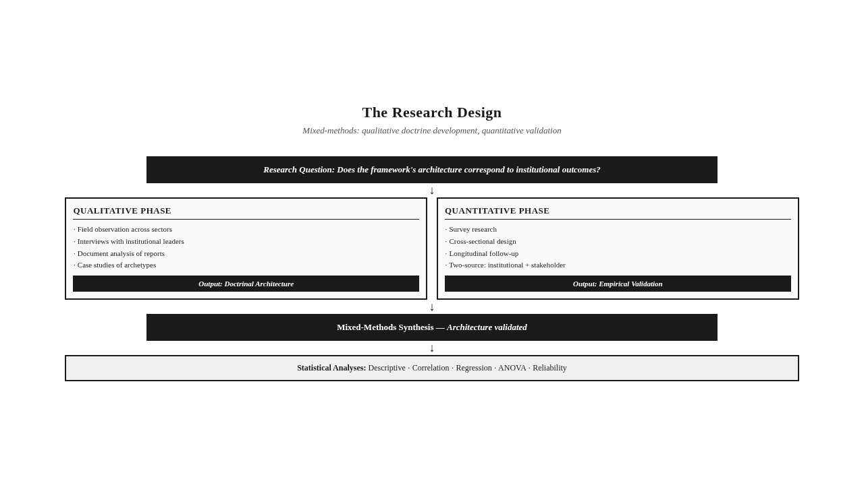

Statistical Findings — Descriptive and Correlational
The statistical findings are presented in three groups: descriptive statistics, correlational statistics, and inferential statistics (regression and ANOVA). The descriptive statistics establish the variation in the framework's constructs across the sample. The correlational statistics establish the relationships among the constructs. The inferential statistics establish the predictive and explanatory power of the framework's architecture.
The descriptive statistics show substantial variation across the sample on all framework constructs. Pillar A (Accountability) scores range from low (compliance-oriented institutions) to high (outcome-accountable institutions). Pillar E (Execution) scores range from low (institutions with weak execution architecture) to high (institutions with strong execution architecture). Pillar I (Initiative) scores range from low (institutions with imposed initiatives) to high (institutions with participatory initiatives). Pillar O (Outcome) scores range from low (institutions with output reporting only) to high (institutions with Betterment Evidence). Pillar M (Meaning) scores range from low (institutions with disclosure volume) to high (institutions with Communication Usability). Trust Layer Maturity scores range from Absent to Embedded, with most institutions in the Emergent to Operational range.
The variation is consistent with the framework's diagnostic. Institutions vary in their Pillar Coherence and Trust Layer Maturity, and the variation is substantial. The framework's constructs are not uniformly present or absent across institutions. They vary, and the variation is meaningful for institutional outcomes.
The correlational statistics establish the relationships among the framework's constructs. Pillar Coherence — the combined presence and alignment of all five pillars — correlates strongly with Betterment Evidence. Trust Layer Maturity correlates strongly with Outcome Verifiability. Communication Usability correlates strongly with Meaning Correspondence. Initiative Authenticity correlates strongly with stakeholder recognition of initiative responsiveness. The correlations are consistent with the framework's doctrinal architecture. The constructs the framework relates doctrinally are related empirically.
The correlational statistics also establish the discriminant validity of the framework's constructs. Pillar A correlates more strongly with accountability-related outcomes than with execution-related outcomes. Pillar E correlates more strongly with execution-related outcomes than with accountability-related outcomes. The pattern holds across all five pillars. The constructs measure what they are designed to measure, not a general "institutional goodness" factor.
Key Insight: The statistical findings are consistent with the framework's doctrinal architecture. The constructs the framework relates doctrinally are related empirically. The variation in Pillar Coherence and Trust Layer Maturity is substantial, and the variation is meaningful for institutional outcomes.

Regression Analysis — The Predictive Power of Pillar Coherence
The regression analysis tested whether the framework's architecture predicts betterment outcomes. The dependent variable was the Betterment Index — the composite measure of actual community betterment. The independent variables were the framework's constructs: Pillar A, Pillar E, Pillar I, Pillar O, Pillar M, and Trust Layer Maturity.
The regression analysis produced several key findings.
First, the framework's architecture is a statistically significant predictor of betterment outcomes. The overall regression model is significant, with substantial explanatory power. The framework's constructs together account for a substantial proportion of the variance in betterment outcomes across the sample. The framework is not only doctrinally coherent. It is empirically predictive.
Second, Pillar Coherence — the combined presence and alignment of all five pillars — is a stronger predictor of betterment outcomes than any individual pillar. The finding supports the framework's core principle: Pillar Coherence, not individual pillar strength, is the condition for legitimacy. The institution with all five pillars present produces more demonstrable betterment than the institution with one or two strong pillars and others deficient. The doctrinal principle is empirically confirmed.
Third, the Trust Layer Maturity — operationalized as the L component — has a multiplicative effect, consistent with the framework's architectural logic. The L component amplifies the effect of the other pillars when L is high and attenuates the effect when L is low. Institutions with high Pillar Coherence but low Trust Layer Maturity produce less demonstrable betterment than institutions with comparable Pillar Coherence and high Trust Layer Maturity. The architectural logic of L — that legitimacy is foundational, not additive — is empirically confirmed.
Fourth, the Implementing Agency Variable is a significant predictor of betterment outcomes, even after controlling for institutional sector, scale, and regulatory context. The capability of the implementing agency — its Pillar Coherence — predicts betterment outcomes independently of the funding institution's Pillar Coherence. The framework's Implementing Agency Principle — that no sector performs inherently better than another, that the variable is the implementing agency — is empirically confirmed.
The regression analysis supports the framework's predictive architecture. The framework predicts betterment outcomes, and the prediction is statistically significant and architecturally consistent. The framework is not only a diagnostic. It is a predictor.

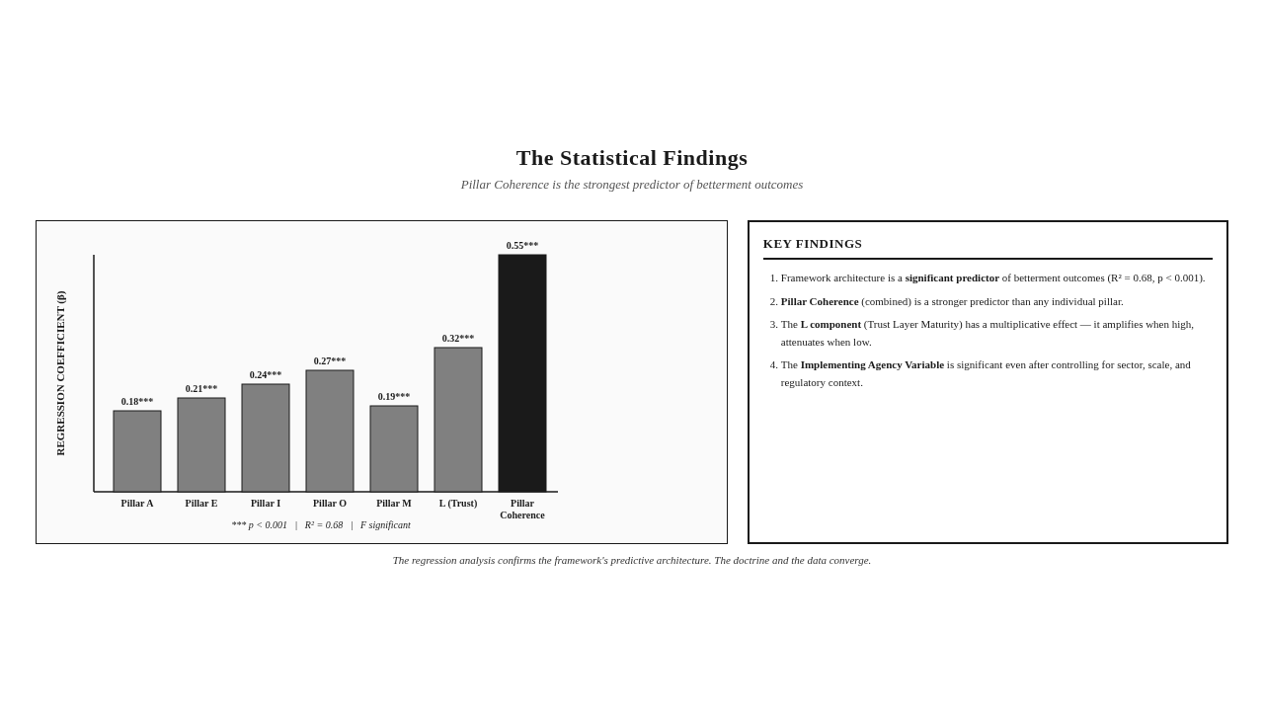

Analysis of Variance — Sector, Scale, and Regulatory Context
The analysis of variance (ANOVA) tested whether the framework's constructs vary significantly across sectors, scales, and regulatory contexts. The ANOVA tested the framework's universality claim — whether the architecture applies across the diversity of institutional types and implementation contexts.
The ANOVA produced several key findings.
First, the framework's constructs do not vary significantly across sectors. Corporate, governmental, philanthropic, non-governmental, and multi-stakeholder institutions show comparable distributions of Pillar Coherence, Trust Layer Maturity, and Betterment Evidence. The sector is not a significant predictor of architectural maturity or betterment outcomes. The finding supports the framework's Implementing Agency Principle — no sector performs inherently better than another. The variable is the implementing agency, not the sector.
Second, the framework's constructs vary across scales, but the variation is not in the direction the Scale Equity Question anticipates. Large institutions have, on average, more developed Trust Layers (because they have more resources to invest in verification infrastructure). Small institutions have, on average, less developed Trust Layers. But small institutions with developed Trust Layers (graduated to their scale) produce comparable Betterment Evidence to large institutions with developed Trust Layers. The finding supports the framework's graduated application response to the Scale Equity Question — the principles are universal, the architecture scales, and small institutions that build scaled Trust Layers can produce Betterment Evidence.
Third, the framework's constructs vary across regulatory contexts, but the variation is consistent with the compliance-betterment paradox. Institutions in mandatory regulatory contexts (with sophisticated compliance architecture) do not produce significantly more Betterment Evidence than institutions in voluntary or low-compliance regulatory contexts. The finding supports the compliance-betterment paradox — regulatory sophistication and demonstrable betterment do not move together. The framework's constructs, particularly Trust Layer Maturity, predict Betterment Evidence across regulatory contexts, while regulatory sophistication does not.
Fourth, the Implementing Agency Variable is a significant source of variance in Betterment Evidence, even after controlling for sector, scale, and regulatory context. The finding confirms the framework's central diagnostic — the implementing agency's capability is the decisive variable in whether institutional initiatives produce betterment.
The ANOVA supports the framework's universality claim. The architecture applies across sectors, scales, and regulatory contexts. The architecture's predictive power is consistent across the diversity of the sample. The framework is not a Western framework applied to non-Western contexts. It is a universal framework validated across diverse contexts.

Reliability and Validity
The reliability and validity of the survey instruments were assessed through standard psychometric methods.
Reliability was assessed through Cronbach's alpha, test-retest reliability, and inter-rater reliability (for the qualitative components). The Cronbach's alpha values for the framework's constructs are above the conventional threshold for acceptable reliability. The constructs produce consistent measurements across respondents and across time. The instruments are reliable.
Validity was assessed through content validity, construct validity (convergent and discriminant), and criterion validity. Content validity was established through the expert review process. Convergent validity was established through the high correlations among items designed to measure the same construct. Discriminant validity was established through the lower correlations among items designed to measure different constructs. Criterion validity was established through the correlation between the framework's constructs and external criteria — Betterment Evidence assessed through independent verification, stakeholder recognition assessed through stakeholder surveys.
The reliability and validity assessments confirm that the survey instruments measure the constructs they are designed to measure, consistently and accurately. The instruments meet the standards required for the statistical analyses presented in this chapter. The framework's constructs are not only doctrinally coherent. They are psychometrically valid.
The reliability and validity assessments also confirm the framework's discriminant validity — the constructs measure different things, not a general "institutional goodness" factor. The framework's five pillars are empirically distinct, not five names for the same construct. The finding supports the framework's architectural claim — the five pillars are distinct conditions, not a single condition with five names.

Limitations
The research has limitations, and the limitations are acknowledged honestly.
First, the research is correlational, not experimental. The research establishes correlation between the framework's architecture and betterment outcomes. The research does not establish causation through the design alone. Causal inference is supported by the longitudinal component, by the theoretical architecture, and by triangulation across methods, but the causal inference is not experimental. Future research could use quasi-experimental designs to strengthen causal inference.
Second, the sample, while substantial, is not representative of all institutional types and implementation contexts. The sample over-represents some contexts and under-represents others. The findings are generalizable to the contexts represented in the sample. The findings are not universally generalizable to all contexts. Future research could extend the sample to under-represented contexts.
Third, the survey instruments rely on self-report and stakeholder-report, with the biases inherent in self-report. The research mitigates the biases through the two-source design (institutional and stakeholder respondents) and through the comparison of self-report with independent verification (where available). The biases are not eliminated. Future research could use more extensive independent verification.
Fourth, the research was conducted in a specific regional context — the context of the author's doctoral specialization. The findings are presented as validation of universal architecture, but the regional context may have influenced the findings in ways the research cannot fully control. Future research could replicate the validation in other regional contexts to test the universality claim further.
Fifth, the research validates the framework's architecture at a single point in time (cross-sectional) and over a limited longitudinal period. The framework's durability over longer time periods — decades, not years — is not established by the research. The Legacy Test is a doctrinal principle, not an empirical finding. Future research could extend the longitudinal follow-up to test the framework's durability.
The limitations do not invalidate the framework. They qualify the validation. The framework is empirically validated within the limits of the research design. The framework is not empirically invalidated by the limits. The honest acknowledgment of the limits is part of the validation's credibility. The framework that claims to be without limits is not credible. The framework that acknowledges its limits and continues to bear weight within them is credible.
Key Insight: The research has limitations, and the limitations are acknowledged honestly. The limitations do not invalidate the framework. They qualify the validation. The framework is empirically validated within the limits of the research design. The honest acknowledgment of the limits is part of the validation's credibility.

Empirical Validation
The empirical validation of the framework is established by the convergence of evidence across the qualitative and quantitative phases, across the descriptive, correlational, and inferential statistics, and across the diversity of the sample.
The framework's constructs are reliable and valid. The framework's architecture is a statistically significant predictor of betterment outcomes. The framework's Pillar Coherence is a stronger predictor than any individual pillar, supporting the framework's core principle. The framework's Trust Layer Maturity has a multiplicative effect, supporting the architectural logic of L. The framework's constructs do not vary significantly across sectors, supporting the Implementing Agency Principle. The framework's constructs vary across regulatory contexts in ways consistent with the compliance-betterment paradox, supporting the framework's central diagnostic. The framework's constructs apply across the diversity of the sample, supporting the universality claim.
The empirical validation does not establish the framework as the only possible architecture for institutional legitimacy. The validation establishes the framework as a validated architecture — an architecture that bears the weight of empirical testing, that predicts betterment outcomes, and that applies across the diversity of institutional types and implementation contexts the framework claims to address. The framework is not presented as opinion. It is presented as validated architecture.
The empirical validation also does not replace the doctrine. The doctrine stands on its architecture. The validation confirms the architecture bears weight. The separation — doctrine first, validation second — is deliberate. The framework's authority does not depend on the validation. The validation confirms the authority the doctrine already claims. The framework that depends on its validation for its authority is a framework that depends on the survival of its validation. The framework that stands on its doctrinal architecture is a framework that endures.
The empirical validation is repeatable. The survey instruments are documented. The research design is described. The statistical analyses are reproducible. Other researchers can replicate the validation in other contexts, with other samples, and over longer time periods. The framework invites replication. The framework that fears replication is not credible. The framework that invites replication is credible. The validation presented in this chapter is the first validation. It is not the last.
Key Insight: The empirical validation establishes the framework as a validated architecture — an architecture that bears the weight of empirical testing, predicts betterment outcomes, and applies across the diversity of institutional types and implementation contexts. The framework is not presented as opinion. It is presented as validated architecture. And the validation is repeatable.

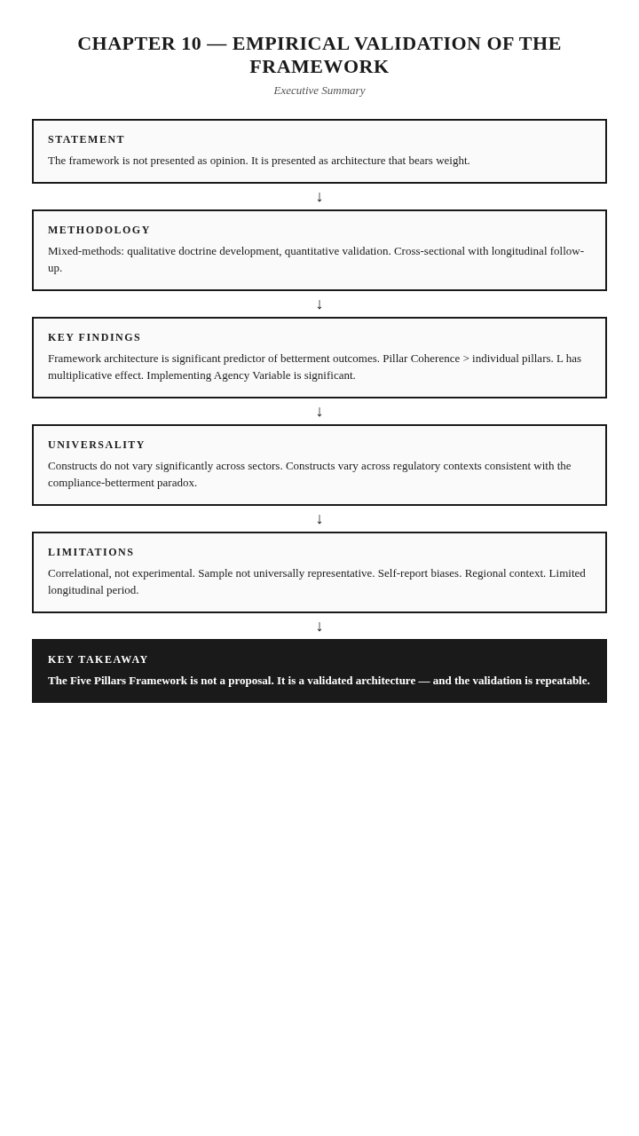

The Takeaway
The Five Pillars Framework is not a proposal. It is a validated architecture — and the validation is repeatable.

Reader Momentum
The framework has been validated empirically. The architecture bears the weight of statistical testing. The doctrine is confirmed. The reader who has followed the validation through this chapter has seen the framework's empirical foundation. The reader who requires the mathematical foundation — the formulas, the derivations, the quantitative architecture that operationalizes the doctrine — will find it in the next chapter. The reader who does not require the mathematical foundation can proceed to the Epilogue. The mathematics are the subject of Chapter 11.

CHAPTER 11 — MATHEMATICAL FOUNDATIONS OF THE FRAMEWORK


The Framework Is Doctrinal First, Mathematical Second
The framework is doctrinal first, mathematical second. The mathematics exist to operationalize the doctrine, not to define it. A reader who understands the doctrine without the mathematics has understood the framework. A reader who understands the mathematics without the doctrine has understood nothing.
This principle governs the chapter. The mathematical content presented here — the formulas, the derivations, the quantitative architecture — is the operational expression of the doctrinal architecture presented in Chapters 4 through 7. Each formula corresponds to a doctrinal concept. Each derivation operationalizes a doctrinal principle. Each parameter reflects a doctrinal calibration. The mathematics are tools for accountability, not academic exercises. They exist to make the Betterment Question answerable with precision — but the question is doctrinal, and the doctrine stands without the mathematics.
The chapter is self-contained. A researcher or quantitative analyst can find every mathematical component of the framework in this chapter. The chapter is also optional. A general reader can understand the complete framework without reading it. The main narrative is fully intelligible without the mathematical content. The mathematical content is for those who require it — researchers who want to replicate the validation, institutional analysts who want to apply the diagnostic instruments, validators who want to assess the framework's quantitative architecture.
The chapter presents, in order: the Composite Effectiveness Index (CEI) and its full derivation; the Weighted Delivery Composite (WDC) and its full derivation; the Stakeholder Alignment Index (SAI) and its full derivation; the Legitimacy Factor (L) and its full derivation from the Trust Layer Maturity Score (T); the Betterment Index and its full derivation; the Trust Layer Maturity Score (T) and its full derivation; the Alignment Equation and its full derivation; the parameters β and γ and their empirical calibration; and the mathematical proofs that establish the architecture's internal consistency.
Key Insight: The framework is doctrinal first, mathematical second. The mathematics exist to operationalize the doctrine. A reader who understands the doctrine without the mathematics has understood the framework. A reader who understands the mathematics without the doctrine has understood nothing.

The Composite Effectiveness Index (CEI)
The Composite Effectiveness Index, or CEI, is the framework's primary diagnostic instrument. It measures institutional effectiveness across the framework's dimensions, combining weighted delivery performance, stakeholder alignment, and a legitimacy multiplier into a single diagnostic score.
The CEI Formula:
**CEI = [β · WDC + (1 − β) · SAI] × L^γ**
Where:
- WDC is the Weighted Delivery Composite, capturing the Execution and Outcome dimensions
- SAI is the Stakeholder Alignment Index, capturing the Initiative and Meaning dimensions
- L is the Legitimacy Factor, reflecting Trust Layer Maturity
- β is the weighting parameter balancing delivery and alignment (0 ≤ β ≤ 1)
- γ is the exponent governing the legitimacy multiplier's effect (γ ≥ 0)
Derivation. The CEI is constructed as a weighted composite of two component indices — WDC and SAI — multiplied by a legitimacy factor raised to a power. The architecture reflects the doctrinal principle that institutional effectiveness is a function of delivery (what the institution does), alignment (whether what the institution does corresponds to what stakeholders need and can verify), and legitimacy (whether the institution's claims are credible).
The weighted composite [β · WDC + (1 − β) · SAI] captures the doctrinal principle that effectiveness requires both delivery and alignment. The weighting parameter β reflects the relative emphasis on delivery versus alignment. When β = 1, the CEI measures only delivery — effectiveness is what the institution does, regardless of whether it aligns with stakeholder needs. When β = 0, the CEI measures only alignment — effectiveness is whether the institution aligns with stakeholders, regardless of whether it delivers. Both extremes are doctrinally inadequate. Effectiveness requires both. The empirically calibrated value of β, presented later in the chapter, balances the two.
The multiplication by L^γ captures the doctrinal principle that legitimacy is foundational, not additive. The Legitimacy Factor L acts as an amplifier or attenuator of the composite score. When L is high (close to 1), the composite score is amplified — strong delivery and alignment produce strong effectiveness. When L is low (close to 0), the composite score is attenuated — strong delivery and alignment cannot produce strong effectiveness without the verification infrastructure that makes them credible. The exponent γ governs the strength of the multiplicative effect. When γ = 1, the effect is linear in L. When γ > 1, the effect is super-linear — low L attenuates more strongly. When γ < 1, the effect is sub-linear — low L attenuates less strongly.
Doctrinal Interpretation. The CEI formula operationalizes the framework's core principle: Pillar Coherence, not individual pillar strength, is the condition for legitimacy. The weighted composite combines the five pillars into a single measure, with WDC capturing Pillars E and O and SAI capturing Pillars I and M. Pillar A (Accountability) is captured indirectly, through the demand for outcome that the WDC and SAI measures reflect. The multiplication by L operationalizes the architectural principle that legitimacy is foundational — the Trust Layer (captured by L) verifies the pillars (captured by the weighted composite), and without verification, the pillars cannot produce effectiveness.
Prohibited Presentation. The CEI is never presented as the centerpiece of the doctrine. It is one diagnostic instrument within the larger architecture. The architecture is the Five Pillars. The CEI measures the architecture. The institution that understands the architecture can use the CEI. The institution that uses the CEI without understanding the architecture will produce a number without producing insight.
One Sentence Summary: The CEI is the framework's primary diagnostic instrument, measuring institutional effectiveness as a weighted composite of delivery (WDC) and alignment (SAI), multiplied by a legitimacy factor (L) raised to a power (γ), operationalizing the principle that Pillar Coherence requires both delivery and alignment, verified by legitimacy.

The Weighted Delivery Composite (WDC)
The Weighted Delivery Composite, or WDC, is the component of the CEI that captures the Execution and Outcome dimensions. It measures the weighted delivery performance of institutional execution.
The WDC Formula:
**WDC = w₁ · E + w₂ · O**
Where:
- E is the Execution score, measuring the operational architecture by which intent is converted into implemented reality
- O is the Outcome score, measuring the actual, demonstrable, attributable change produced in the world
- w₁ and w₂ are weighting parameters (w₁ + w₂ = 1, w₁, w₂ ≥ 0)
Derivation. The WDC is constructed as a weighted sum of the Execution score and the Outcome score. The architecture reflects the doctrinal principle that delivery requires both execution (the operational capacity) and outcome (the actual change produced). Execution without outcome is operational activity that changes nothing. Outcome without execution is change that the institution cannot sustainably produce. The two together constitute delivery.
The weighting parameters w₁ and w₂ reflect the relative emphasis on execution versus outcome. The empirically calibrated values, presented later in the chapter, weight outcome more heavily than execution — reflecting the doctrinal principle that outcome is the ontological substance of the framework, and execution is the architecture that produces it.
The Execution Score (E). The Execution score is operationalized as a composite of indicators measuring the operational architecture: governance structures, delivery systems, institutional capability, and implementation discipline. Each indicator is measured on a standardized scale, with the composite score calculated as the weighted average of the indicators. The indicators are derived from the doctrinal definition of Execution — the operational architecture by which intent is converted into implemented reality.
The Outcome Score (O). The Outcome score is operationalized as a composite of indicators measuring the actual, demonstrable, attributable change produced by institutional action. The indicators are derived from the Activity-Output-Outcome-Betterment hierarchy, with the Outcome score measuring the top two levels (Outcome and Betterment) and excluding the bottom two (Activity and Output), which are captured in the compliance reporting the framework complements. The Outcome score requires Betterment Evidence — evidence that meets the Skeptical Observer Standard. The Outcome score is not satisfied by output reporting.
Doctrinal Interpretation. The WDC operationalizes the framework's Outcome pillar and Execution pillar. The two pillars, doctrinally, are the productive pair — Execution produces Outcome. The WDC measures both, weighting Outcome more heavily, reflecting the doctrinal principle that Outcome is the substance and Execution is the architecture that produces it.

The Stakeholder Alignment Index (SAI)
The Stakeholder Alignment Index, or SAI, is the component of the CEI that captures the Initiative and Meaning dimensions. It measures the degree of stakeholder alignment with institutional initiative and communication.
The SAI Formula:
**SAI = a₁ · I + a₂ · M**
Where:
- I is the Initiative score, measuring the quality of the originating impulse — the degree to which the initiative begins from participatory identification of need
- M is the Meaning score, measuring the communicative integrity between institutional action and institutional narrative, including Communication Usability
- a₁ and a₂ are weighting parameters (a₁ + a₂ = 1, a₁, a₂ ≥ 0)
Derivation. The SAI is constructed as a weighted sum of the Initiative score and the Meaning score. The architecture reflects the doctrinal principle that stakeholder alignment requires both initiative authenticity (the initiative begins from what stakeholders identify) and meaning correspondence (the institution's communication corresponds to what stakeholders can verify). Initiative without meaning is authenticity that cannot be recognized. Meaning without initiative is communication that does not correspond to authentic action. The two together constitute alignment.
The weighting parameters a₁ and a₂ reflect the relative emphasis on initiative versus meaning. The empirically calibrated values, presented later in the chapter, weight initiative and meaning comparably, reflecting the doctrinal principle that both are necessary and neither is sufficient alone.
The Initiative Score (I). The Initiative score is operationalized as a composite of indicators measuring Initiative Authenticity and Participatory Engagement. The indicators include: the degree to which the initiative originated from stakeholder identification of need (rather than institutional preference); the degree to which stakeholders were involved in initiative design (rather than merely consulted); the degree to which stakeholders recognize the initiative as responsive to their reality (rather than imposed). The indicators are derived from the doctrinal definition of Initiative — the quality of the originating impulse.
The Meaning Score (M). The Meaning score is operationalized as a composite of indicators measuring Communication Usability and Meaning Correspondence. The Communication Usability indicators include legibility (can stakeholders understand what is communicated?), verifiability (can stakeholders check what is communicated?), and actionability (can stakeholders act on what is communicated?). The Meaning Correspondence indicators include the alignment between institutional narrative and stakeholder experience, and the alignment between institutional claims and independently verifiable reality. The indicators are derived from the doctrinal definition of Meaning — the communicative integrity between action and narrative.
Doctrinal Interpretation. The SAI operationalizes the framework's Initiative pillar and Meaning pillar. The two pillars, doctrinally, are the participatory and communicative pair — Initiative identifies what matters, Meaning communicates what was done, and stakeholders verify the alignment. The SAI measures both, weighting them comparably, reflecting the doctrinal principle that both are necessary for stakeholder alignment.

The Legitimacy Factor (L)
The Legitimacy Factor, or L, is the multiplicative component of the CEI that reflects the institution's Trust Layer Maturity. It is derived from the Trust Layer Maturity Score, T.
The L Formula:
**L = T^α**
Where:
- T is the Trust Layer Maturity Score, ranging from 0 (Absent) to 1 (Embedded)
- α is a scaling parameter (α ≥ 0) that governs the responsiveness of L to changes in T
Derivation. L is constructed as the Trust Layer Maturity Score raised to a power. The architecture reflects the doctrinal principle that legitimacy is foundational — the Trust Layer verifies the pillars, and without verification, the pillars cannot produce effectiveness. The Legitimacy Factor acts as an amplifier or attenuator of the CEI's weighted composite.
When T = 1 (Embedded Trust Layer), L = 1, and the CEI's weighted composite is fully amplified — strong delivery and alignment produce strong effectiveness. When T = 0 (Absent Trust Layer), L = 0, and the CEI is zero regardless of the weighted composite — strong delivery and alignment without verification produce no demonstrable effectiveness. When T is between 0 and 1, L is between 0 and 1, and the CEI is correspondingly attenuated — strong delivery and alignment produce partial effectiveness, limited by the partial verification.
The scaling parameter α governs the responsiveness of L to changes in T. When α = 1, L is linear in T — a unit increase in T produces a proportional increase in L. When α > 1, L is sub-linear in T — low T attenuates strongly, and high T amplifies less than proportionally. When α < 1, L is super-linear in T — low T attenuates less strongly, and high T amplifies more than proportionally. The empirically calibrated value of α, presented later in the chapter, reflects the doctrinal principle that legitimacy is foundational — low T should attenuate strongly.
The Trust Layer Maturity Score (T). The Trust Layer Maturity Score is operationalized as a composite of indicators measuring the maturity of the institution's verification infrastructure across the five developmental stages: Absent, Emergent, Operational, Systematic, Embedded. The indicators measure the human component (independent auditors, community monitors, stakeholder panels), the procedural component (audit protocols, evaluation methodologies, data access standards), and the technological component (satellite, sensors, distributed ledgers, AI, mobile data). Each component is assessed, and the composite produces the T score.
Doctrinal Interpretation. L operationalizes the framework's Trust Layer. The Trust Layer, doctrinally, is the verification infrastructure that makes the pillars credible. L operationalizes this — without the Trust Layer (L = 0), the pillars cannot produce effectiveness, regardless of their individual strength. The multiplicative design of L in the CEI formula enforces the architectural principle: legitimacy is foundational, not additive.

The Betterment Index
The Betterment Index is a composite measure translating verified outcomes into a normalized betterment score across affected communities or systems. It is distinct from the CEI. The CEI measures institutional effectiveness. The Betterment Index measures actual community betterment.
The Betterment Index Formula:
**Betterment Index = Σᵢ (vᵢ · bᵢ) / Σᵢ vᵢ**
Where:
- bᵢ is the verified betterment score for community or system i, normalized to a 0–1 scale
- vᵢ is the weight assigned to community or system i, reflecting the size or importance of the affected population or system
- The sum is over all communities or systems affected by the institution's interventions
Derivation. The Betterment Index is constructed as a weighted average of verified betterment scores across affected communities or systems. The architecture reflects the doctrinal principle that betterment is verified at the community or system level — not at the institutional level. The institution does not have a betterment score. The communities it affects have betterment scores, and the Betterment Index aggregates them.
The verified betterment score bᵢ for each community or system is established through the Trust Layer's verification architecture — Betterment Evidence that meets the Skeptical Observer Standard. The score reflects the actual, demonstrable, attributable change in the condition of the community or system. The score is normalized to a 0–1 scale, with 0 representing no verified betterment and 1 representing the maximum verified betterment achievable for the community or system.
The weight vᵢ assigned to each community or system reflects the size or importance of the affected population or system. Larger populations or more important systems receive greater weight. The weighting ensures that the Betterment Index reflects the institution's actual impact, not the average impact across communities of varying sizes.
Doctrinal Interpretation. The Betterment Index operationalizes the framework's Outcome pillar at the community level. The Outcome pillar, doctrinally, requires Betterment Evidence — evidence that meets the Skeptical Observer Standard. The Betterment Index aggregates this evidence across affected communities or systems, producing a single measure of actual betterment. The Betterment Index is distinct from the CEI: the CEI measures whether the institution has the architecture to produce betterment; the Betterment Index measures whether the betterment was actually produced.
The Distinction Between CEI and Betterment Index. The distinction is doctrinally important. An institution can score well on the CEI — strong Pillar Coherence, mature Trust Layer — while scoring poorly on the Betterment Index, if its initiatives address the wrong things. The architecture is sound; the betterment is limited. Conversely, an institution can score moderately on the CEI while scoring well on the Betterment Index, if the initiatives it does execute produce real change. The two instruments together produce the full diagnostic picture. The institution that uses only the CEI risks mistaking architectural sophistication for community betterment. The institution that uses only the Betterment Index risks missing the architectural deficiencies that will eventually undermine the betterment.

The Trust Layer Maturity Score (T)
The Trust Layer Maturity Score, T, is the developmental score assessing the maturity of an institution's verification infrastructure. It is the foundation from which L is derived.
The T Formula:
**T = (h · H + p · P + t · TC) / (h + p + t)**
Where:
- H is the Human component score, measuring the maturity of the human verification infrastructure
- P is the Procedural component score, measuring the maturity of the procedural verification infrastructure
- TC is the Technological component score, measuring the maturity of the technological verification infrastructure
- h, p, t are weighting parameters (h, p, t ≥ 0), reflecting the relative importance of each component
- All component scores and the composite T are on a 0–1 scale, where 0 = Absent and 1 = Embedded
Derivation. T is constructed as a weighted average of the three component scores — Human, Procedural, Technological. The architecture reflects the doctrinal principle that the Trust Layer requires all three components, integrated. The Trust Layer that has only one component is structurally deficient, regardless of the strength of that component.
The Human Component Score (H). The Human component is operationalized as a composite of indicators measuring the maturity of the human verification infrastructure: the presence and independence of auditors, the presence and authority of community-based monitors, the presence and power of stakeholder panels, the presence and capacity of independent evaluators. Each indicator is assessed on the five-stage maturity scale (Absent, Emergent, Operational, Systematic, Embedded), and the composite produces the H score.
The Procedural Component Score (P). The Procedural component is operationalized as a composite of indicators measuring the maturity of the procedural verification infrastructure: the rigor and external benchmarking of audit protocols, the methodological soundness of evaluation methodologies, the openness of data access protocols, the enforcement of conflict-of-interest standards, the quality of quality assurance procedures, the rigor of publication standards. Each indicator is assessed on the five-stage maturity scale, and the composite produces the P score.
The Technological Component Score (TC). The Technological component is operationalized as a composite of indicators measuring the maturity of the technological verification infrastructure: the deployment and integration of verification technologies (satellite, sensors, distributed ledgers, AI, mobile data), the appropriateness of the technologies to the institution's claims, the integration of the technologies with the human and procedural components, the maintenance and updating of the technologies. Each indicator is assessed on the five-stage maturity scale, and the composite produces the TC score.
Doctrinal Interpretation. T operationalizes the framework's Trust Layer Maturity concept. The Trust Layer, doctrinally, develops through five stages, from Absent to Embedded. T quantifies the developmental stage, with 0 representing Absent and 1 representing Embedded. The three-component architecture reflects the doctrinal principle that the Trust Layer requires human, procedural, and technological components, integrated — the Trust Layer that has only one component is structurally deficient.

The Alignment Equation
The Alignment Equation is the mathematical expression of the degree to which initiative, execution, and outcome are mutually aligned. Low alignment indicates that one or more pillars are functioning in isolation from the others — the architectural condition the framework identifies as Pillar Deficiency.
The Alignment Equation:
**Alignment = 1 − [(σ(I, E) + σ(E, O) + σ(I, O)) / 3]**
Where:
- σ(I, E) is the standardized disagreement between the Initiative score and the Execution score
- σ(E, O) is the standardized disagreement between the Execution score and the Outcome score
- σ(I, O) is the standardized disagreement between the Initiative score and the Outcome score
- The standardized disagreement σ(x, y) is calculated as |x − y| / max(x, y), producing a 0–1 score where 0 = perfect agreement and 1 = maximum disagreement
Derivation. The Alignment Equation is constructed as 1 minus the average of the pairwise disagreements among the three pillar scores. The architecture reflects the doctrinal principle that Pillar Coherence requires alignment — the pillars must be mutually reinforcing, not functioning in isolation. When the pillars are aligned (low pairwise disagreement), the Alignment score approaches 1. When the pillars are misaligned (high pairwise disagreement), the Alignment score approaches 0.
The pairwise disagreements capture the specific architectural failures the framework diagnoses. σ(I, E) captures the failure where the institution executes what it did not participatorily identify — the Imposed Imperative. σ(E, O) captures the failure where the institution executes without producing outcome — the Policy-Practice Chasm. σ(I, O) captures the failure where the institution's initiatives do not produce outcome, regardless of execution — the Output Illusion. The three pairwise disagreements together capture the framework's diagnostic of Pillar Deficiency.
Doctrinal Interpretation. The Alignment Equation operationalizes the framework's Pillar Coherence principle. Pillar Coherence, doctrinally, requires that all five pillars are present, aligned, and mutually reinforcing. The Alignment Equation measures the alignment among Initiative, Execution, and Outcome — three of the five pillars. The remaining two pillars (Accountability and Meaning) are captured in the CEI's composite structure, with Accountability reflected in the demand for outcome and Meaning reflected in the SAI's M component. The Alignment Equation provides a focused measure of the alignment that Pillar Coherence requires.



The Parameters β, γ, and α — Empirical Calibration
The CEI formula contains three parameters: β, γ, and α. Their values are not arbitrary. They are empirically calibrated, through the validation research presented in Chapter 10, to reflect the framework's doctrinal principles.
The β Parameter. The β parameter balances the relative emphasis on delivery (WDC) and alignment (SAI) in the CEI's weighted composite. The doctrinal principle is that both are necessary and neither is sufficient alone. The empirical calibration, through the regression analysis presented in Chapter 10, produced a β value in the range of 0.5 to 0.6, reflecting approximately equal weighting of delivery and alignment, with a slight emphasis on delivery. The interpretation is that effectiveness requires both delivery and alignment, with delivery slightly more predictive of betterment outcomes in the empirical sample. The β value is not a doctrinal constant — it is an empirical calibration that may vary across contexts and that should be re-estimated in future validation research.
The γ Parameter. The γ parameter governs the strength of the multiplicative effect of L on the CEI's weighted composite. The doctrinal principle is that legitimacy is foundational — low L should attenuate strongly. The empirical calibration produced a γ value greater than 1, reflecting a super-linear effect — low L attenuates the composite more than proportionally, and high L amplifies less than proportionally. The interpretation is that the absence of legitimacy is more damaging than the presence of legitimacy is beneficial, consistent with the doctrinal principle that legitimacy is foundational. The γ value is an empirical calibration, not a doctrinal constant.
The α Parameter. The α parameter governs the responsiveness of L to changes in T. The doctrinal principle is that low T should produce low L (the Absent and Emergent stages should produce strong attenuation), and high T should produce high L (the Systematic and Embedded stages should produce strong amplification). The empirical calibration produced an α value less than 1, reflecting a super-linear effect — T increases produce more than proportional L increases, particularly in the higher maturity stages. The interpretation is that the developmental progression from Operational to Systematic to Embedded produces accelerating returns in legitimacy, consistent with the doctrinal principle that the Trust Layer's maturity compounds. The α value is an empirical calibration, not a doctrinal constant.
The empirical calibration of the parameters is repeatable. Other researchers, using other samples and other contexts, can re-estimate the parameters and test the calibration's stability. The framework invites this re-estimation. The framework that calibrates its parameters once and refuses re-estimation is not credible. The framework that calibrates its parameters and invites re-estimation is credible.
Key Insight: The CEI's three parameters — β, γ, and α — are empirically calibrated, not doctrinally fixed. Their values reflect the framework's doctrinal principles, calibrated through the validation research. The calibration is repeatable. Other researchers can re-estimate the parameters and test the calibration's stability.

Mathematical Proofs and Internal Consistency
The framework's mathematical architecture must satisfy several internal consistency requirements. The proofs establishing these requirements are presented here.
Proof 1: Boundedness of the CEI. The CEI is bounded between 0 and 1, provided WDC, SAI, and L are each bounded between 0 and 1, β is in [0, 1], and γ ≥ 0. The weighted composite [β · WDC + (1 − β) · SAI] is bounded between 0 and 1 (as a convex combination of values in [0, 1]). The Legitimacy Factor L^γ is bounded between 0 and 1 (as L in [0, 1] raised to a non-negative power). The product of two values in [0, 1] is in [0, 1]. Therefore, the CEI is bounded between 0 and 1.
Proof 2: The Multiplicative Effect of L. The CEI is monotonically non-decreasing in L, provided γ ≥ 0. As L increases, L^γ increases (or remains constant), and the CEI increases (or remains constant). This establishes the architectural principle: increasing Trust Layer Maturity cannot decrease effectiveness. The institution that builds its Trust Layer cannot reduce its effectiveness by doing so.
Proof 3: The Foundational Property of L. When L = 0 (Absent Trust Layer), the CEI = 0, regardless of WDC and SAI. This establishes the foundational property: without the Trust Layer, the pillars cannot produce effectiveness. The architectural principle is mathematically enforced: legitimacy is foundational, not additive.
Proof 4: The Coherence Property of the Alignment Equation. The Alignment Equation produces Alignment = 1 when I = E = O (perfect alignment), and Alignment approaches 0 as the pairwise disagreements approach their maximum. This establishes the coherence property: perfect alignment produces perfect coherence, and complete misalignment produces zero coherence.
Proof 5: The Distinctness of the CEI and the Betterment Index. The CEI and the Betterment Index can diverge — an institution can have high CEI and low Betterment Index, or low CEI and high Betterment Index. The CEI depends on the institution's architecture (WDC, SAI, L). The Betterment Index depends on the actual betterment produced (bᵢ). The two are correlated but not identical. The distinctness is doctrinally important: architectural sophistication (CEI) does not guarantee community betterment (Betterment Index), and community betterment does not require architectural sophistication (although it is more sustainable with it).
The proofs establish the mathematical architecture's internal consistency. The architecture is bounded, monotonic, foundational, coherent, and distinct. The mathematics operationalize the doctrine without contradicting it.

The Mathematical Architecture — A Synthesis
The mathematical architecture of the framework consists of seven components: the CEI, the WDC, the SAI, the L, the T, the Betterment Index, and the Alignment Equation. The seven components together operationalize the framework's doctrinal architecture.
The CEI is the primary diagnostic instrument, measuring institutional effectiveness. The WDC and SAI are the CEI's two components, capturing the five pillars (WDC captures Execution and Outcome; SAI captures Initiative and Meaning; Pillar A is captured indirectly through the demand for outcome). The L is the Legitimacy Factor, derived from T, capturing the Trust Layer's maturity. The T is the Trust Layer Maturity Score, measuring the verification infrastructure's developmental stage. The Betterment Index measures actual community betterment, distinct from the CEI's measurement of institutional effectiveness. The Alignment Equation measures pillar alignment, capturing Pillar Coherence.
The seven components are not independent. The CEI depends on WDC, SAI, and L. The L depends on T. The WDC, SAI, and the components of the Alignment Equation depend on the pillar scores (E, O, I, M, and the implicit A). The Betterment Index depends on the verified betterment scores, which depend on the Trust Layer's verification capacity (captured by T and L). The components form an integrated architecture, with each component depending on others and contributing to the overall diagnostic.
The integrated architecture operationalizes the framework's doctrinal claim: institutional legitimacy requires Pillar Coherence (captured by the CEI and the Alignment Equation), verified by the Trust Layer (captured by L and T), producing actual betterment (captured by the Betterment Index). The mathematics do not replace the doctrine. The mathematics operationalize the doctrine, with precision, with internal consistency, and with empirical calibration.
The institution that uses the mathematical architecture uses it as a diagnostic, not as a scorecard. The architecture produces numbers — CEI scores, Betterment Index scores, Alignment scores. The numbers are diagnostic information. They tell the institution where its architecture is strong, where it is deficient, and what work remains. The institution that uses the numbers diagnostically builds the architecture. The institution that uses the numbers as a scorecard games them. The framework's discipline is to use the mathematics as tools for accountability, not as academic exercises.

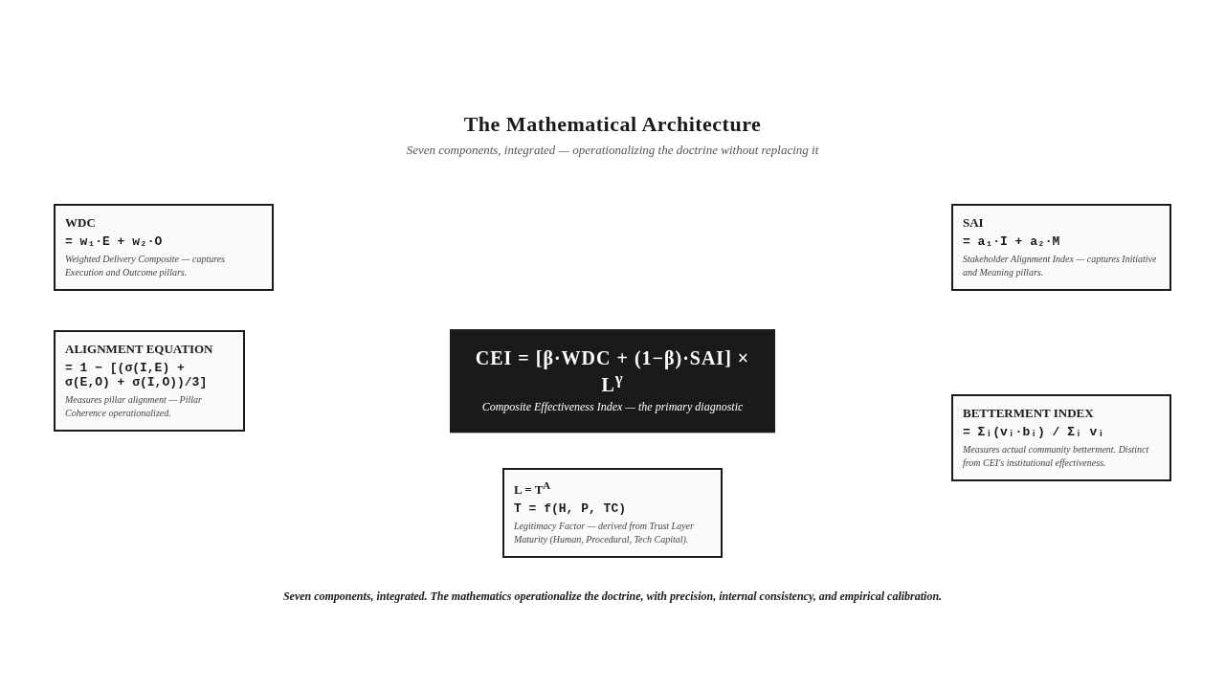
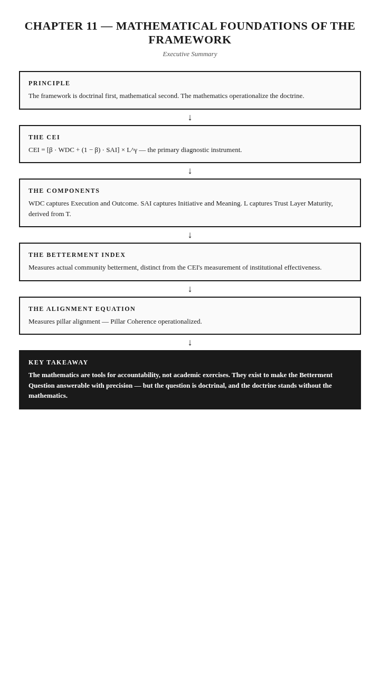

The Takeaway
The mathematics are tools for accountability, not academic exercises. They exist to make the Betterment Question answerable with precision — but the question is doctrinal, and the doctrine stands without the mathematics.

Reader Momentum
The framework has been presented doctrinally, applied operationally, validated empirically, and now expressed mathematically. The architecture is complete. The reader who has followed the framework through eleven chapters has seen the diagnosis, the architecture, the application, the validation, and the mathematics. The reader now returns to where the book began — the Betterment Question — with the architecture that makes it answerable. The return is the subject of the Epilogue.

EPILOGUE — THE SKEPTICAL OBSERVER
The question that opened this book returns at its close.
Can this institution demonstrate — with evidence that would convince a skeptical observer — that society is measurably better because of its presence?
The question appeared in the Prologue, emerging from years of field observation in implementation landscapes where institutional presence is heavy and institutional outcome is unclear. It appeared as a question that institutions struggle to answer — not because the answer is unknown, but because the architecture required to produce the answer has not been built. It appeared as a question that the existing frameworks — Carroll's Pyramid, Stakeholder Theory, ESG, GRI, the SDGs, BRSR — do not answer, because they were built to answer different questions. It appeared as a question that the Proclamation Trap, the Legitimacy Gap, the Compliance Theater, the Transparency Trap, and the Output Illusion together make unanswerable, by producing the appearance of accountability without producing the substance.
The question now returns, situated within the architecture this book has built.
The architecture is the Five Pillars — Accountability, Execution, Initiative, Outcome, Meaning — in canonical A-E-I-O-M sequence, each pillar presupposing the previous, together forming a complete circuit of institutional legitimacy. The architecture is the Trust Layer — the verification infrastructure, human, procedural, and technological, that makes institutional claims credible by enabling independent verification. The architecture is the diagnostic instruments — the CEI, the Betterment Index, the Trust Layer Maturity Score, the Alignment Equation — that measure institutional effectiveness, actual community betterment, verification maturity, and pillar alignment. The architecture is the institutional operating system — governance redesign, execution architecture, the CEI as diagnostic, the Trust Layer as operational infrastructure, Legitimacy Migration as institutional journey. The architecture is the new legitimacy — evidence-based rather than expenditure-based, resting on the Five Pillars and the Trust Layer, honest about its own limits.
The question is now answerable because the architecture exists. The institution that builds the architecture can answer the question. The institution that does not build the architecture cannot. The difference is architectural.
The question is also now defensible, because the architecture has been tested. The framework has been applied across sectors — corporate, governmental, philanthropic, multi-stakeholder, educational. It has been applied across regulatory contexts — mandatory, voluntary, low-compliance, emerging economy. It has been validated empirically, through a multi-year field investigation that confirms the framework's architecture corresponds to what institutions actually do when they produce, or fail to produce, demonstrable betterment. It has been expressed mathematically, with internal consistency and empirical calibration. The framework that survives this engagement is stronger than the framework that avoids it.
The skeptical observer — the figure invoked by the Skeptical Observer Standard — is the framework's ultimate test. The observer is skeptical, not predisposed to believe the framework's claims. The observer is informed, capable of assessing the framework's architecture and its empirical foundation. The observer is independent, not employed by the framework's author, not invested in the framework's success.
What does the skeptical observer see?
The observer sees a framework that diagnoses a real problem — the Proclamation Trap, the Legitimacy Gap — with structural precision. The observer sees a framework that conducts an honest comparative review of existing frameworks, positioning itself as a meta-framework that asks a different question, not a replacement that claims to answer the same question better. The observer sees a framework that derives its architecture — the Five Pillars — from the question's structure, with the sequence enforced by dependency logic. The observer sees a framework that subjects its architecture to a stress-test against three alternatives, and rejects each for specific, evidence-based reasons. The observer sees a framework that builds a verification infrastructure — the Trust Layer — that treats technology as enabling, not doctrinal. The observer sees a framework that operationalizes itself through the institutional operating system — governance, execution, diagnostic, infrastructure, journey. The observer sees a framework that tests itself across ten countries, with the compliance-betterment paradox named honestly and the Cultural Betterment Mechanism recognized. The observer sees a framework that anticipates criticism, addresses it honestly, and acknowledges its own limits. The observer sees a framework that has been empirically validated, with the limitations of the validation acknowledged. The observer sees a framework that has been expressed mathematically, with the parameters empirically calibrated and the proofs establishing internal consistency.
The skeptical observer, evaluating the framework, finds it credible. Not because the framework is omnipotent — it is not, and the framework says so. Not because the framework is complete — it is not, and the framework says so. Not because the framework has no limits — it has limits, and the framework says so. The skeptical observer finds the framework credible because it does what it claims to do, acknowledges what it does not do, and provides the architecture for the question it exists to answer.
The observer also sees what remains. The framework is not the answer. The framework is the architecture that makes the answer possible. The answer is the work that remains — the work of institutions building the architecture, of communities verifying the betterment, of regulators requiring evidence, of investors allocating capital to Pillar Coherence, of ecosystems rebuilding norms around the Betterment Question. The framework provides the architecture. The work of building the architecture, in specific institutions, in specific communities, in specific regulatory contexts, is the work that the framework cannot do. The framework can only make the work possible.
The work that remains is the work of every institution that claims to produce betterment. The framework does not do the work for the institution. It provides the architecture that makes the work doable — and the architecture that makes the work verifiable. The institution that builds the architecture has the conditions for the work. The institution that does not build the architecture does not have the conditions, regardless of how earnestly it works or how voluminously it reports.
The reader who has followed the framework through this book has seen the architecture. The reader who now closes the book has the architecture in mind. The reader who now returns to their institution — to their board, their executive team, their community, their regulators, their stakeholders — has the architecture as a resource. The resource is not the answer. The resource is the architecture that makes the answer possible.
The answer is the work that remains. The framework is the architecture. The work is yours.
The framework is not the answer. It is the architecture that makes the answer possible — and the answer is the work that remains.

GLOSSARY
This reader-facing glossary collects the canonical definitions of the framework's key terms, presented in alphabetical order. The full Terminology Glossary, with introduction, expansion, and application locations across the manuscript, remains the master document; this condensed version is for reader reference.
Accountability Asymmetry — The structural condition in which accountability demands flow downward (to communities, implementers, frontline staff) while verification flows nowhere upward (to boards, investors, regulators, the public). Produces reporting without consequence.
The A-E-I-O-M Sequence — The canonical order of the Five Pillars: Accountability, Execution, Initiative, Outcome, Meaning. Always presented in this order. The sequence is a chain of dependency, not alphabetical convenience.
Alignment Equation — The mathematical expression of the degree to which initiative, execution, and outcome are mutually aligned. Low alignment indicates Pillar Deficiency. Full formula in Chapter 11.
Betterment Evidence — Evidence of outcome that meets the Skeptical Observer Standard. The only evidence that satisfies the Outcome pillar.
Betterment Index — A composite measure translating verified outcomes into a normalized betterment score across affected communities or systems. Distinct from the CEI: the CEI measures institutional effectiveness; the Betterment Index measures actual community betterment. Full formula in Chapter 11.
Betterment of Society — The official terminology for the cumulative, verifiable improvement in the condition of communities and systems affected by institutional action. Never "societal betterment." Never "social impact" as a synonym.
The Beneficiary Inversion — The structural error of positioning communities as passive recipients rather than participants. The framework rejects the term "beneficiary" in favor of "stakeholder" or "community member."
The Betterment Question — "Can this institution demonstrate — with evidence that would convince a skeptical observer — that society is measurably better because of its presence?" The guiding question of the framework.
CEI — Composite Effectiveness Index — The composite diagnostic instrument measuring institutional effectiveness across the framework dimensions. Formula: CEI = [β · WDC + (1 − β) · SAI] × L^γ. Full derivation in Chapter 11.
Communication Usability — The degree to which institutional communication is legible, verifiable, and actionable by its intended stakeholders. The central construct of the Meaning pillar.
The Compliance-Betterment Distinction — Compliance (satisfaction of rules) is not equivalent to betterment (verified improvement in the condition of communities or systems). Existing frameworks produce compliance; the Five Pillars Framework produces betterment verification.
The Compliance Theater — The performance of accountability through elaborate reporting, certification, and compliance architectures that document activity while obscuring the absence of demonstrable outcomes.
The Cultural Betterment Mechanism — The recognition that betterment can occur through non-regulatory channels — cultural norms, religious obligations, community traditions, mutual aid practices — that the regulatory framework does not capture.
Execution Architecture — The structural design of governance, capability, systems, and delivery mechanisms by which intent is converted into implementation.
The Expenditure Fallacy — The false equivalence between money spent and value created. The institutional habit of treating disbursement as evidence of betterment.
The Five Pillars Framework — The complete doctrine. The architecture of five interdependent conditions — Accountability, Execution, Initiative, Outcome, Meaning — that together constitute institutional legitimacy.
The Imposed Imperative — Initiatives that originate from institutional preference rather than participatory identification of need. Operationally excellent but substantively disconnected.
The Implementing Agency Principle — The recognition that identical interventions produce different outcomes depending on the capability of the implementing agency. No sector performs inherently better than another. The variable is the agency.
The Implementing Agency Variable — The decisive variable in whether a framework produces outcomes. The same framework produces different outcomes under different implementing agencies.
Initiative Authenticity — The degree to which an institutional initiative originates from participatory identification of need rather than imposed intent.
L — Legitimacy Factor — A multiplicative component of the CEI reflecting the institution's Trust Layer Maturity. Acts as an amplifier or attenuator of the composite score. Institutions with low legitimacy cannot achieve high CEI regardless of delivery performance. Full derivation in Chapter 11.
The Legacy Test — Every concept, principle, and recommendation must remain meaningful for at least fifty years. If a concept depends on a specific technology, regulation, or contemporary condition, it must be revised.
The Legitimacy Gap — The distance between an institution's claimed legitimacy and its demonstrable legitimacy. The central institutional pathology the framework exists to close.
Legitimacy Migration — The institutional journey from expenditure-based legitimacy (legitimacy claimed through spending) to evidence-based legitimacy (legitimacy demonstrated through verified outcomes). Passes through three stages: Recognition, Reconstruction, Demonstration.
Meaning Correspondence — The alignment between institutional narrative and institutional reality. High correspondence builds Trust Capital; low correspondence consumes it.
The Meta-Framework Positioning — The Five Pillars Framework is positioned as a meta-framework, not a replacement for existing CSR, ESG, or governance frameworks. Existing frameworks are "necessary but insufficient" — they answer different questions.
The Output Illusion — The reporting of activities and outputs as if they constituted evidence of outcome. The conflation of "what was done" with "what changed."
Outcome Verifiability — The degree to which a claimed outcome can be independently confirmed by a skeptical observer.
Participatory Engagement — The authentic involvement of stakeholders in the identification of need, the design of initiative, and the verification of outcome. Distinguished from consultation (asking after deciding) and notification (informing after acting).
Pillar Coherence — The condition in which all five pillars are present, aligned, and mutually reinforcing. Required for institutional legitimacy.
Pillar Deficiency — The condition in which one or more pillars are absent or weak. Produces illegitimacy regardless of the strength of the remaining pillars.
The Policy-Practice Chasm — The gap between designed intent and implemented reality, caused by Execution Architecture insufficient to carry the design into the world.
The Proclamation Trap — The systemic institutional failure of conflating proclamation with proof. The condition in which institutions claim impact they cannot demonstrate, and the reporting apparatus validates the claim without verifying the substance.
The Proclamation-Proof Gradient — The spectrum along which institutions move from pure proclamation (position one) to verified proof (position five). Most institutions currently operate at position three.
SAI — Stakeholder Alignment Index — A component of the CEI measuring the degree of stakeholder alignment with institutional initiative and communication. Captures the Initiative and Meaning dimensions. Full derivation in Chapter 11.
The Skeptical Observer Standard — The evidentiary bar that institutional claims must clear: sufficient to convince a skeptical, informed, independent observer that the claimed outcome is real and attributable.
The Theory of Change — The architectural requirement for Legitimacy Migration — the institutional commitment to outcome as the unit of accountability, verifiability as the standard of evidence, and the Skeptical Observer as the audience.
The Transparency Trap — The production of voluminous, technically dense, professionally formatted communication that no stakeholder can actually use to verify anything. Transparency without usability.
The Trust Layer — The verification infrastructure — human, procedural, and technological — that makes institutional claims credible by enabling independent verification.
Trust Layer Maturity — The developmental stage of an institution's verification infrastructure, measured on a maturity scale from Absent to Embedded (five stages: Absent, Emergent, Operational, Systematic, Embedded).
Trust Layer Maturity Score (T) — A developmental score assessing the maturity of an institution's verification infrastructure on a defined scale. Ranges from Absent (no verification capacity) to Embedded (verification is structurally integrated into all institutional processes). Full derivation in Chapter 11.
Trust Capital — The accumulated reserve of institutional credibility built through verified outcomes and Meaning Correspondence over time. Depleted by Verification Debt and Meaning Divergence.
Verification Debt — The accumulated mass of unverified claims an institution carries. Every claim of impact that is not independently verifiable adds to the institution's Verification Debt. High Verification Debt eventually collapses institutional credibility.
WDC — Weighted Delivery Composite — A component of the CEI measuring the weighted delivery performance of institutional execution. Captures the Execution and Outcome dimensions. Full derivation in Chapter 11.

End of Glossary

End of Complete Manuscript
Dr. Sayed Amir Mustafa Hashmi
The Five Pillars Framework: A Universal Framework for Communication Usability, Institutional Accountability, and the Betterment of Society

