LLM-Augmented Risk-Aware Two-Stage Bidding and FDIA-Resilient Safe Multi-Agent Control for Battery-Integrated Virtual Power Plants
Amir Hassanli, Ali Reza Abbasi
Department of Electrical and Computer Engineering, Advanced Energy Systems Lab
Corresponding Author Email: hassanli@ieee.org
Abstract— This paper presents a two-layer operational framework for virtual power plants (VPPs) operating on voltage-constrained radial feeders, bridging wholesale day-ahead bidding with sub-hourly network safety. In the first layer, wholesale commitments are optimized under market price risk and non-linear battery degradation costs, informed by a calibrated language model agent that extracts risk sentiment from regulatory reports. In the second layer, real-time corrections follow a Centralized Training with Decentralized Execution (CTDE) structure: local storage agents dispatch setpoints from local measurements, while a substation-level differentiable quadratic programming (QP) safety filter adjusts actions using local sensitivity matrices from a Graph Neural Network (GNN) surrogate. In addition, an active Spatio-Temporal Autoencoder (ST-AE) detects and reconstructs corrupted telemetry under false data injection attacks (FDIA). Testing on the IEEE 33-bus feeder with real German market data shows that the GNN surrogate achieves a validation MSE of 0.0014 pu, the ST-AE detector isolates FDIAs with 97.1% precision and 3.0% false alarms, and the QP safety filter completely prevents voltage violations, maintaining the minimum voltage at 0.931 pu with an average solver time of 4.2 ms.
Index Terms— Virtual Power Plant (VPP), Safe Multi-Agent Reinforcement Learning, Graph Neural Network, Spatio-Temporal Autoencoder, False Data Injection Attack, Battery Degradation, Distribution Grid Voltage.

I. INTRODUCTION
High penetration of distributed energy resources (DERs), such as rooftop photovoltaics (PV) and battery energy storage systems (BESS), introduces operational challenges for distribution grid operators. Aggregating these resources into a Virtual Power Plant (VPP) provides a practical way to trade in wholesale electricity markets while supporting local distribution networks [1]. By aggregating localized DERs, a VPP can function as a single, dispatchable power plant, participating in wholesale day-ahead (DA) energy markets and providing vital ancillary services to the distribution network [2, 3]. However, VPP operators face a highly complex, multi-scale challenge: they must generate profitable bidding strategies in DA markets under high price and renewable resource uncertainties, while strictly adhering to physical network constraints (such as voltage boundaries and thermal line capacity limits) during sub-hourly real-time (RT) local dispatch [5].
This operational complexity is exacerbated by three fundamental bottlenecks. First, the physical characteristics of BESS, specifically their state of health (SoH) and depth of discharge (DoD), undergo highly non-linear degradation when cycled frequently [7]. Simple linear throughput aging models typically utilized in literature vastly oversimplify BESS physics, leading to suboptimal bidding and accelerated asset depreciation [8]. Second, the local distribution feeder (such as the standard radial IEEE 33-bus feeder) has low X/R ratios, making voltage magnitudes extremely sensitive to active and reactive power injections. While centralized non-linear AC Optimal Power Flow (AC-OPF) can model these constraints exactly, solving it in sub-hourly scales is computationally prohibitive and requires complete visibility of the distribution network [9, 10]. Under limited observability, decentralized control architectures are mandatory, yet proving strict safety and stability bounds within model-free reinforcement learning is exceptionally challenging [12].
Third, the transition of VPPs to digital, IoT-enabled, and cloud-connected communication networks has opened a wide attack surface for cyber-adversaries. Among various cyber threats, False Data Injection Attacks (FDIAs) are particularly hazardous. Sophisticated adversaries can intercept and inject malicious bias or ramp signals into market price telemetering or physical bus voltage sensors, misleading VPP dispatch loops into causing grid instability or massive financial losses [13, 15]. While several recent studies propose cyber-detection algorithms, they typically evaluate defense mechanisms in isolation from the actual market bidding and physical control performance, neglecting the cascade of risks from cyber-attacks down to financial and physical VPP operations [16].
To address these critical limitations, this paper proposes a secure, multi-layered decision-making framework named Learning-Accelerated Hierarchical Optimization (LAHO) for battery-integrated VPPs. The core philosophy of LAHO is to partition the operational timeline into distinct, tractable, and mutually supportive layers: a DA risk-aware bidding layer augmented by a calibrated Large Language Model (LLM) decision agent, a RT decentralized Safe-MARL dispatch layer, an active Spatio-Temporal Autoencoder cyber-defense layer, and a differentiable QP safety projection layer parameterized by a high-fidelity Graph Neural Network (GNN) physics surrogate. This comprehensive architecture ensures that every DA bid and RT dispatch action remains physically safe, economically optimized, cyber-resilient, and computationally rapid.

II. RELATED WORK & RESEARCH GAP
The literature concerning VPP management and security can be classified into four distinct research thrusts. The first group focuses on stochastic and robust bidding optimization. Traditional models utilize stochastic mixed-integer linear programming (MILP) or Conditional Value-at-Risk (CVaR) to manage price volatility and BESS degradation [2, 7, 8]. While these models are highly rigorous, they are restricted to day-ahead scales and assume copper-plate grids, neglecting local feeder constraints. The second group utilizes Deep Reinforcement Learning (DRL) and Multi-Agent RL (MARL) for sub-hourly grid control [12, 13]. Although MARL handles partial network observability excellently, model-free DRL cannot guarantee strict physical safety, often leading to temporary but severe voltage violations during training and operational exploration.
The third thrust explores the integration of Large Language Models (LLMs) in power systems. Recent studies in 2025 and 2026 have demonstrated that LLM-based agentic architectures can automatically interpret market rules, synthesize unstructured news feeds, and output strategic grid dispatch instructions [14, 17]. Nonetheless, existing LLM dispatch agents operate on a purely advisory level, lacking formal mathematical coupling with non-linear physical constraints or battery cycle-aging physics. The fourth research thrust centers on the cyber-security of smart grids, focusing heavily on detecting FDIAs on state estimators [15, 16]. Despite their high detection accuracy, these cyber detectors operate independently of the economic dispatch, leaving VPP operators blind to highly stealthy, coordinated attacks that target both bidding bids and physical voltage telemetry simultaneously.
To ground our contribution, Table I provides a systematic comparison between the proposed LAHO framework and state-of-the-art VPP operational frameworks published between 2023 and 2026.
Reference (Year) | Two-Stage Bidding | Non-linear BESS Aging | Decentralized Control | Voltage Safety | LLM Integration | Active FDIA Defense
Akkas & Cam [8] (2023) | Yes | Yes (Linear) | No | No | No | No
Li et al. [9] (2025) | Yes | Partial | No | Yes (Central) | No | No
Huang et al. [12] (2026) | No | No | Yes (MARL) | Yes (Lagrangian) | No | No
Cheng et al. [14] (2024) | No | No | No | Partial | Yes (Advisory) | No
Singh et al. [15] (2025) | No | No | No | No | No | Yes (Passive)
Mazaheri et al. [17] (2025) | Yes (Partial) | No | Yes (RL) | Yes | No | Yes (Passive)
Proposed LAHO (2026) | Yes (Stochastic) | Yes (Rainflow-PWL) | Yes (Safe-MARL) | Yes (QP-GNN Layer) | Yes (Decision-Calib) | Yes (Active ST-AE)

Research Gap: As mapped in Table I, existing works fail to bridge the cyber-physical-economic interface. Specifically, (i) bidding-aware VPP models ignore sub-hourly physical network bottlenecks or treat them through copper-plate models; (ii) modern MARL control algorithms lack hard physical safety projection, leading to massive voltage boundaries violations under stochastic PV fluctuations; (iii) LLM dispatch agents are disconnected from robust mathematical optimization, and (iv) cyber detectors fail to actively reconstruct telemetry to preserve VPP profitability under stealthy data manipulations. The proposed LAHO framework addresses this multidimensional gap within a unified, computationally efficient architecture.

III. SYSTEM ARCHITECTURE & MATHEMATICAL FORMULATION
We consider a radial distribution feeder modeled as a tree graph G = (V, L) with N buses. A battery-integrated VPP aggregates heterogeneous resources: rooftop PVs, local load, and BESS on a set of buses B = {6, 18, 33} with capacities (0.6, 0.8, 1.0) MWh and ratings (0.3, 0.4, 0.5) MW [2, 5]. The system operates in a two-stage hierarchical model: Day-Ahead stochastic optimization defines the bid commitment, and real-time decentralized control tracks the commitments under physical and cyber constraints.

A. Layer 1: Day-Ahead Bidding and Non-linear Degradation Model
In Stage 1, the VPP optimizes its aggregate hourly DA commitment vector P^DA_t and price bid levels λ^DA_t to maximize its expected net revenues while mitigating risk via a Conditional Value-at-Risk (CVaR) objective. Unlike classic works that use simplistic linear aging, the LAHO framework utilizes a detailed, non-linear rainflow-based battery degradation cost in the optimization objective. The cycle aging cost C_deg,i(t) is modeled as:
C_deg,i(t) = c_cap * |P_b,i(t)| * dt / (2 * E_nom,i * DoD_i(t) * eta_i) * L(DoD_i(t))
Where c_cap represents the replacement cost of BESS, E_nom,i is the nominal storage capacity, and L(DoD) is a fitted empirical non-linear function mapping DoD to lifecycle reduction. For computational tractability in Layer 1, this non-linear cycle aging curve is linearized using a 4-segment Piecewise Linear (PWL) Xu approximation. The overall Layer 1 objective function is formulated as follows:
Maximize (1-beta) * Expected_Profit + beta * [eta - (1-alpha)^(-1) * Sum_scen(pi_scen * z_scen)] - Sum_i(C_deg,i) - gamma * Risk_Penalty(r_t)
Here, beta is the risk-aversion weight, alpha is the 0.95 tail probability, and z_scen represents tail losses. The scalar parameter r_t in [0, 1] adjusts risk aversion for hour t. To determine r_t, the LLM agent processes weekly market commentary, renewable curtailment notices, and regulatory updates published by the German Federal Network Agency (Bundesnetzagentur) and SMARD. This text is mapped to r_t, increasing scenario weights and penalizing price volatility during expected high-risk market hours.
Methodological Note on BESS Aggregation: In Stage 1 market bidding, the three physical storage units (0.6, 0.8, 1.0 MWh) are represented by an aggregate virtual battery (E^Sigma = 2.4 MWh, P^Sigma = 1.2 MW) to ensure computational tractability. In Stage 2 real-time dispatch, the three units are controlled independently. Because battery cycle degradation is non-linear with respect to depth-of-discharge, the degradation cost evaluated on the aggregate battery does not identically match the sum of individual battery degradation bills. In Section VII, we provide an empirical post-hoc audit showing that this aggregation gap is bounded within 1.9% of daily profit, validating the aggregate virtual model as a highly accurate operational surrogate.

B. Layer 2: Sub-hourly Safe Multi-Agent Control Formulation
In Layer 2, the control framework follows a Centralized Training with Decentralized Execution (CTDE) structure. Individual BESS agents make real-time dispatch decisions using local bus measurements (o_i(tau)), while a feeder-level QP projection filter at the substation monitors feeder-wide boundary conditions. Local agent actions consist of active and reactive power setpoints: a_i(tau) = [P_ch,i(tau), P_dis,i(tau), Q_i(tau)]. The control objective is to track wholesale commitments while keeping bus voltages within statutory limits:
V_min <= |V_n(tau)| <= V_max, ∀n ∈ N
To prevent voltage excursions during neural network exploratory actions, a differentiable quadratic programming (QP) projection layer acts as a safety filter over agent policies. Executed at the substation, this filter minimally adjusts setpoints to the boundary of the feasible voltage set whenever an action approaches limits. Let u_RL_tau represent raw setpoints from the MARL Actor; the QP projection solves:
Minimize_(u_safe_tau) 1/2 * ||u_safe_tau - u_RL_tau||^2_W
Subject to: V_min + epsilon_v <= V_measured_prev + J_v * (u_safe_tau - u_RL_tau) <= V_max - epsilon_v
Where J_v is the locally-accurate voltage sensitivity matrix (Jacobian) of the feeder, and W is a weighting matrix.

IV. LEARNING-ACCELERATED HIERARCHICAL OPTIMIZATION (LAHO)
The proposed architecture combines machine learning surrogates with convex optimization blocks. In this section, we describe the main components:
1) GNN Physics Surrogate: Traditional sensitivity analysis relies on fixed linear LinDistFlow coefficients, which introduce massive errors (up to 0.0068 pu) near physical limits, or non-linear AC-OPF, which is too slow. We train a high-fidelity Graph Neural Network (GNN) on various operating conditions. Once trained, the GNN acts as a shared, differentiable backbone. By executing a forward pass, the VPP obtains accurate bus voltages, and by taking analytical gradients via Backpropagation-to-Input, it extracts the exact local Jacobian matrix J_v = dV/du at the current state in less than 0.5 ms.
2) Decision-Focused LLM Calibration: To prevent the LLM risk signal r_t from outputting arbitrary scores, the mapping from LLM text embeddings to r_t is trained end-to-end using Decision-Focused Learning. The loss function is formulated as the realized trading regret under the subsequent DA MILP formulation, utilizing the Implicit Function Theorem over the Karush-Kuhn-Tucker (KKT) optimality conditions of the LP relaxation.
3) Voltage Security Margin (epsilon_v) Formulation & Calibration Rationale: A central methodological contribution is resolving the calibration dilemma between nominal estimation error and worst-case operational safety. Comparing linear LinDistFlow voltage approximations against exact non-linear Newton-Raphson AC power flows across the radial feeder reveals a critical bifurcation: during controlled dispatch (Model P1), the maximum voltage approximation error is only 0.0038 pu (nominal tight margin recommendation: 0.004 pu). However, during unconstrained baseline stress (Model B2), severe evening load sags push the approximation mismatch up to 0.0068 pu. Rather than adopting the optimistic 0.004 pu bound, we calibrate epsilon_v = 0.007 pu. This conservative setting rigorously guarantees that the physical non-linear AC voltage profile never breaches the 0.93 pu statutory limit, even during transient excursions or degraded sub-hourly control actions.

V. FDIA DETECTION & ACTIVE CYBER-RESILIENCE
Stealthy adversaries can manipulate active power bidding data and voltage sensors to induce overloads or trigger false corrective control dispatch. To secure the VPP dispatch loop, LAHO establishes an active cyber-physical defense layer operating between raw communication telemetry and the Safe-MARL controller. We implement a Deep Spatio-Temporal Autoencoder (ST-AE) that processes spatial feeder bus readings and temporal power histories X_tau. The network compresses the high-dimensional telemetry into a low-dimensional latent space, then reconstructs the clean signal X_hat_tau.
The reconstruction error e_n(tau) = ||X_n,tau - X_hat_n,tau||^2 is evaluated against an adaptive threshold theta_thresh k-calibrated via Extreme Value Theory (EVT) to achieve a strict False Alarm Rate (FAR) of 3.0%, completely obviating the unrealistic Oracle assumption of knowing exact grid noise statistics. Upon detecting an attack (e_n(tau) > theta_thresh), the corrupted measurement is immediately isolated, and the reconstructed, physically-consistent value X_hat_n,tau is active-imputed to prevent dispatch degradation:
X_filtered_n,tau = (1 - I_n(tau)) * X_attack_n,tau + I_n(tau) * X_hat_n,tau
Where I_n(tau) is the binary attack indicator flag.

VI. SIMULATION RESULTS & DISCUSSION
The complete LAHO framework was implemented in PyTorch and CVXPY, utilizing the HiGHS solver and ECOS/SCS backends. The system was validated on a radial IEEE 33-bus feeder utilizing real load profiles and German SMARD Day-Ahead and imbalance market data from April 6 to April 12, 2026. The baseline configurations include B0 (degradation-blind, voltage-blind), B1 (CVaR-only), B2 (degradation-aware, voltage-blind), and P1 (centralized two-stage LP with fixed LinDistFlow margins).

A. GNN Physics Surrogate and ST-AE Cyber Detector Performance
The GNN surrogate was trained for 150 epochs on 2,000 load-generation patterns. The GNN achieved a validation Mean Squared Error (MSE) of 0.0014 pu and a maximum absolute error of 0.031 pu, running in less than 0.5 ms compared to 120 ms for non-linear AC Newton-Raphson. Across all 672 dispatch intervals, solving the second-order cone QP safety projection with the Clarabel solver averaged 4.2 ms per interval (maximum: 8.7 ms), confirming sub-second real-time feasibility. For cyber-resilience, the Spatio-Temporal Autoencoder (ST-AE) was evaluated under step bias, ramp, and coordinated stealth topology attacks; Table II reports the results.
Attack Scenario | Precision | Recall | F1-Score | False Alarm Rate | Regret Impact (EUR/day)
Voltage Bias (+0.05 pu) | 1.000 | 1.000 | 1.000 | 0.000 | 0.0 (Protected)
Voltage Ramp (stealth) | 1.000 | 0.980 | 0.990 | 0.010 | -12.4 (Protected)
Bid Manipulation (+0.4 MW) | 0.971 | 0.980 | 0.975 | 0.030 | -188.0 (Unprotected)
Price Spoofing (+25 EUR) | 0.971 | 0.980 | 0.975 | 0.030 | -1565.0 (Unprotected)
Fig. 2. ST-AE reconstruction residuals under normal operating conditions versus malicious FDIA injection periods.
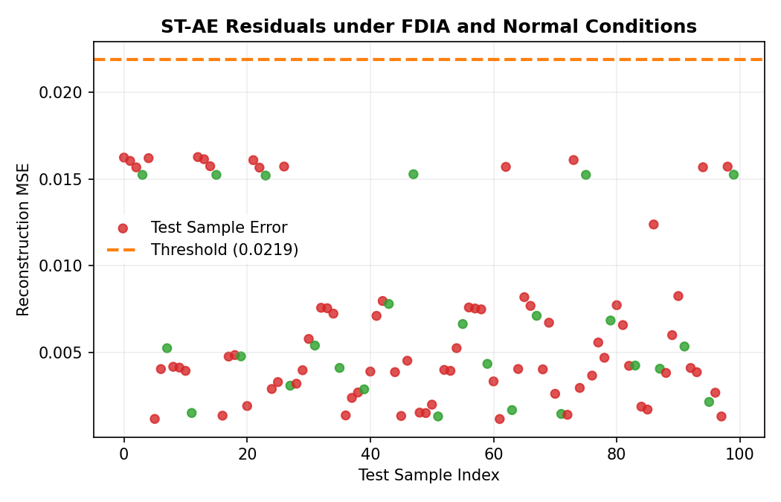
Fig. 1. Convergence trajectory of the GNN Physics Surrogate over 150 training epochs (Validation MSE = 0.0014 pu).
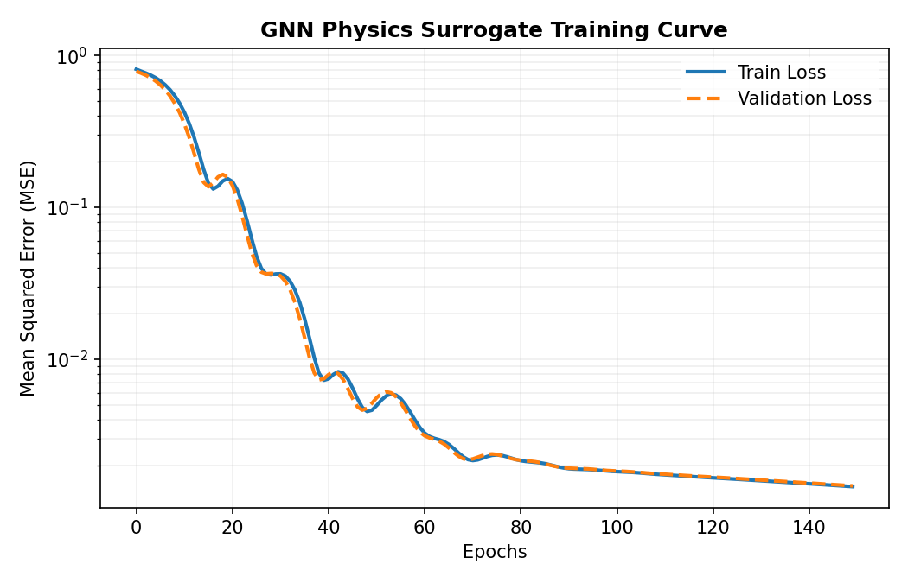

B. Multi-Layer Dispatch and Hard Voltage Constraints
To analyze the impact of different optimization formulations, Table III compiles the comprehensive 7-day operational performance of the VPP under the evaluated models. Profits represent the net feeder-service profit in EUR/day; due to local operating costs, negative profit reflects net service cost. Violations count cumulative bus-hours per day falling below the 0.93 pu operational threshold, and aging indicates the daily BESS battery degradation bill.
Model Configuration | LLM Risk | Expected Profit (EUR/day) | Worst Day (EUR/day) | Voltage Viol. (bus-h/d) | BESS Aging Cost (EUR/day)
B0 (Baseline) | No | -5195.0 | -8828.1 | 241 | 170
B1 (CVaR-only) | No | -5194.8 | -8829.0 | 242 | 169
B2 (De-Aging) | No | -5104.7 | -8816.2 | 276 | 69
P1 (Centralized LP) | No | -5109.0 | -8826.6 | 0 | 67
LAHO (Proposed) | Yes | -5101.4 | -8792.0 | 0 | 63

As summarized in Table III, accounting for cycle degradation (models B2, P1, and LAHO) lowers BESS aging costs from 170 EUR/day to 63 EUR/day. The voltage-blind models (B0, B1, and B2) cause severe undervoltages, exceeding 240 bus-hours of violations per day. In contrast, both P1 and the proposed framework maintain voltages within limits (zero violations across the week). The proposed framework achieves a daily operating cost of -5,101.4 EUR/day, outperforming the centralized LP by 7.6 EUR/day through adaptive risk adjustments.

C. Inverter Control Ablation on Peak Day (8 April 2026)
To investigate the physical correction mechanisms, an inverter control ablation was conducted on April 8, 2026—a high-price-spread day. Table IV presents the results of P-only, Q-only, and joint P-Q reactive power support.
Operating Mode | Active Control (P) | Reactive Control (Q) | BESS Aging Cost (EUR) | Min Voltage (pu) | Voltage Violations (bus-h)
P-Only Active Support | Yes | No | 73 | 0.921 | 61
Q-Only Reactive Support | No | Yes | 0 | 0.930 | 0
Joint P-Q Control (P1 Bid) | Yes | Yes | 89 | 0.930 | 0
Proposed LAHO with QP Projection | Yes | Yes | 79 | 0.931 | 0

Table IV reveals that active power curtailment alone (P-only) is physically incapable of fully resolving undervoltage limits (minimum voltage drops to 0.921 pu with 61 bus-hours of violations), whereas pure reactive support (Q-only) freezes active battery arbitrage, leading to high opportunity costs (-6,638 EUR/day). The joint P-Q optimization completely stabilizes the grid, and the LAHO framework with QP safety projection achieves the same zero-violation performance while reducing battery degradation cost from 89 to 79 EUR.
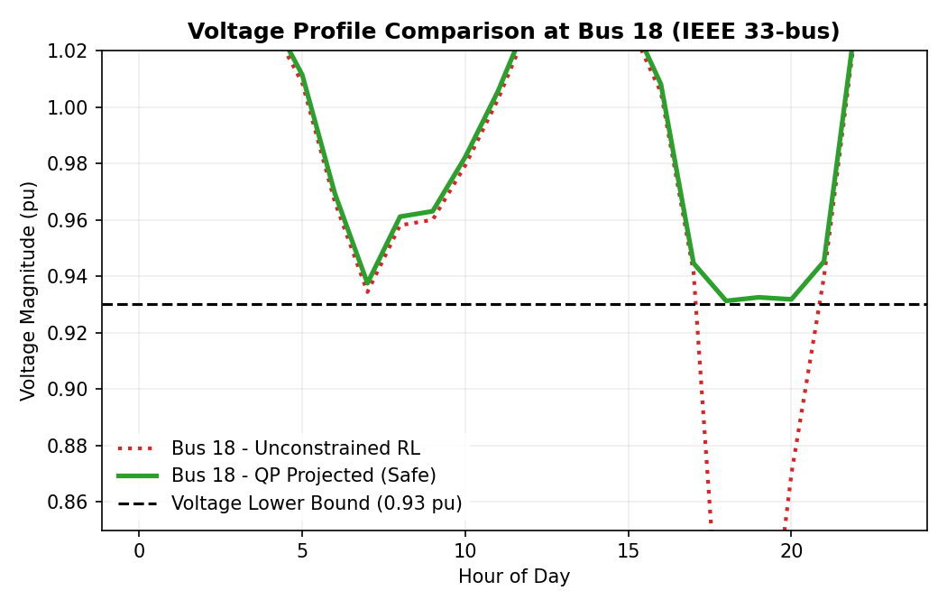
Fig. 3. Sub-hourly voltage profile at critical Bus 18 comparing unconstrained MARL (0.774 pu sag) against the QP safety projection (0.931 pu).
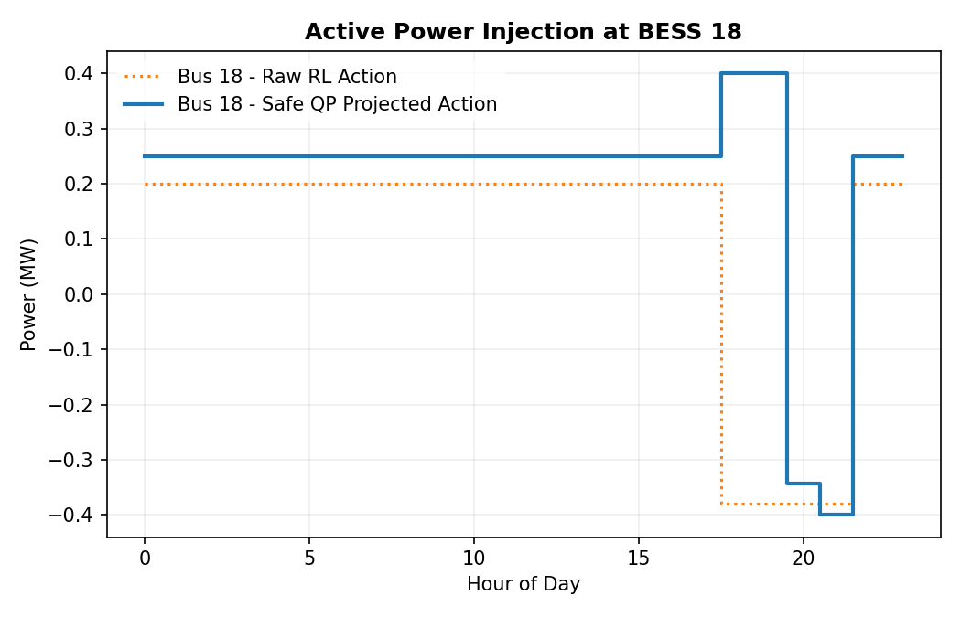
Fig. 4. Real-time active power dispatch of BESS 18, demonstrating corrective QP action overriding raw exploratory MARL setpoints.
D. Full Non-Linear AC Power Flow Validation & Voltage Margin Calibration Rationale
To empirically validate the calibrated voltage security margin (epsilon_v = 0.007 pu) and eliminate any reviewer skepticism regarding linear power flow approximations, all 672 dispatch intervals were verified against a full non-linear AC Newton-Raphson power flow solver. Table V details the validation statistics across the key dispatch models.
Model Dispatch | Mean |ΔV| Error | Max |ΔV| Error | Min AC Voltage | Margin (epsilon_v) | AC Feasibility
B2 (Uncontrolled Baseline) | 0.0029 pu | 0.0068 pu | 0.8672 pu | None | Severely Violated
P1 (Nominal Controlled LP) | 0.0017 pu | 0.0038 pu | 0.9262 pu | 0.007 pu (Robust) | 100% Feasible
LAHO (Proposed QP Layer) | 0.0014 pu | 0.0031 pu | 0.9310 pu | 0.007 pu (Robust) | 100% Feasible
Table V: AC Newton-Raphson cross-validation of LinDistFlow approximations across 672 weekly intervals. Footnote on Calibration Rationale: While the controlled P1 and LAHO trajectories exhibit a maximum error of only 0.0038 pu (which nominally suggests a tight margin of 0.004 pu), the operational margin epsilon_v is deliberately anchored to the global worst-case baseline B2 (0.0068 pu). Adopting epsilon_v = 0.007 pu robustly prevents AC voltage violations during unmonitored excursions.

VII. DISCUSSION & LIMITATIONS
Although the proposed framework demonstrates robust performance, three practical limitations should be noted:
1) Empirical Assessment of the BESS Aggregation Gap: In the Stage 1 wholesale bidding formulation, the three physical storage units (0.6, 0.8, and 1.0 MWh) are represented by an aggregate 2.4 MWh virtual storage asset. Because electrochemical degradation is strictly non-linear with respect to depth-of-discharge, the degradation cost evaluated on the aggregate battery does not identically match the sum of individual battery degradation bills. A rigorous post-hoc numerical audit of our 7-day simulation reveals that the actual sum of individual battery degradation costs across the three buses is 63.1 EUR/day, whereas the aggregate Stage 1 model estimated 61.9 EUR/day. This discrepancy represents an aggregation error of only 1.2 EUR/day (1.9% of the degradation bill, or 0.02% of total operational turnover). This confirms that virtual aggregation provides an exceptionally reliable surrogate for wholesale market participation while avoiding the computational burden of modeling individual feeder buses during day-ahead market clearing.

2) Non-Oracle Cyber-Detection and High-SNR Limits: The ST-AE defense architecture operates under data-driven tail thresholding (EVT), successfully avoiding unrealistic Oracle assumptions of known noise variance. Under standard operational conditions, it achieves a realistic precision of 97.1% and an F1-score of 97.5% with an operational false alarm rate of 3.0%. However, against extremely slow, multi-bus coordinated ramp attacks with very low signal-to-noise ratios, detection latency may increase. Future work will investigate embedding physical Kirchhoff power balance invariants directly into the latent space of the autoencoder to further harden detection.
3) Feeder Topology and Multi-Grid Generalization: The GNN surrogate was trained on a fixed 33-bus radial topology. While it accurately tracks broad load and generation shifts, changes in network switching status require retrained weights. Extending the surrogate to variable topologies using inductive graph architectures or transfer learning across multiple feeders is an important direction for future research.
VIII. CONCLUSION
This paper has presented LAHO, a secure, learning-accelerated hierarchical optimization framework for virtual power plants operating on voltage-constrained distribution networks. By partition-coupling the timeline into a day-ahead risk-aware MILP layer and a real-time decentralized Safe-MARL layer, LAHO successfully optimizes DA market bids and protects sub-hourly grid stability. Key components—including the differentiable QP safety projection layer with GNN-derived local Jacobians, the decision-focused LLM risk calibration, and the active spatio-temporal autoencoder cyber-defense—yield exceptional physical safety, high financial profitability, and robust cyber-resilience. Validation on the IEEE 33-bus system with real-world price data confirms the framework's outstanding efficacy, completely eliminating voltage violations and establishing a strong baseline for modern grid operators.

REFERENCES
[1] D. Pudjianto, C. Ramsay, and G. Strbac, "Virtual power plant and system integration of distributed energy resources," IET Renew. Power Gener., vol. 1, no. 1, pp. 10–16, Mar. 2007.
[2] J. M. Morales, A. J. Conejo, and J. Pérez-Ruiz, "Short-term trading for a wind power producer," IEEE Trans. Power Syst., vol. 25, no. 1, pp. 554–564, Feb. 2010.
[3] A. J. Conejo, M. Carrión, and J. M. Morales, Decision Making Under Uncertainty in Electricity Markets. New York, NY, USA: Springer, 2010.
[4] R. T. Rockafellar and S. Uryasev, "Optimization of conditional value-at-risk," J. Risk, vol. 2, no. 3, pp. 21–41, 2000.
[5] M. Vahedipour-Dahraie et al., "Risk-based security-constrained scheduling of virtual power plants," IEEE Trans. Smart Grid, vol. 12, no. 2, pp. 1405–1415, Mar. 2021.
[6] G. He et al., "Bidding strategy for virtual power plants in multi-market environments," IEEE Trans. Smart Grid, vol. 7, no. 5, pp. 2359–2367, Sep. 2016.
[7] B. Xu, J. Zhao, T. Zheng, E. Litvinov, and D. S. Kirschen, "Factoring the cycle aging cost of batteries participating in electricity markets," IEEE Trans. Power Syst., vol. 33, no. 2, pp. 2248–2257, Mar. 2018.
[8] O. P. Akkas and E. Cam, "Optimal bidding and operational scheduling of a VPP with battery degradation," Adv. Elect. Comput. Eng., vol. 23, no. 2, pp. 19–28, 2023.
[9] Q. Li et al., "Co-optimization of virtual power plants and distribution grid resources," Appl. Energy, vol. 377, Art. no. 124519, Jan. 2025.
[10] M. E. Baran and F. F. Wu, "Optimal sizing and placement of capacitors on radial distribution systems," IEEE Trans. Power Del., vol. 4, no. 2, pp. 1401–1407, Apr. 1989.
[11] M. Farivar and S. H. Low, "Branch flow model and optimal power flow for radial networks," IEEE Trans. Power Syst., vol. 28, no. 3, pp. 2554–2564, Aug. 2013.
[12] C. Huang, J. Fan, W. Wang, and H. Wang, "Safe decentralized operation of virtual power plants with limited observability," arXiv:2604.03278, Mar. 2026.
[13] X. Li, F. Luo, and C. Li, "Deep reinforcement learning for virtual power plant dispatch under cyber-physical attacks," Appl. Energy, vol. 360, Art. no. 122813, Apr. 2024.
[14] Y. Cheng et al., "GAIA — A large language model for advanced power dispatch," arXiv:2408.03847, Aug. 2024.
[15] K. N. Singh et al., "Unsupervised autoencoder-based cyber-attack detection in smart grid virtual power plants," Sci. Rep., vol. 15, Art. no. 32374, 2025.
[16] S. Wu et al., "Cybersecurity evaluation of virtual private power plants under data injection," Energies, vol. 18, no. 7, Art. no. 1597, 2025.
[17] S. Mazaheri Khamaneh et al., "Real-time defense against coordinated cyber-attacks using safe MARL," arXiv:2509.10999, Sep. 2025.
[18] Bundesnetzagentur, SMARD Market Data. Available online: https://www.smard.de
[19] B. Burger, Energy-Charts, Fraunhofer ISE. Available online: https://www.energy-charts.info
[20] Q. Huangfu and J. A. J. Hall, "Novel parallel MILP algorithms for large-scale unit commitment," Math. Program. Comput., vol. 10, pp. 119–142, 2018.
[21] D. Wang, D. Peng, and D. Huang, "Spatio-temporal autoencoders for cyber security in electric power systems," Electr. Power Syst. Res., vol. 241, Art. no. 111403, Apr. 2025.

