CVaR-Based Day-Ahead Energy and Deliverable-Reserve Bidding for a Virtual Power Plant: Evidence from SMARD DE-LU Data
Amir Hassanli and Ali Reza Abbasi
Abstract— A VPP that sells day-ahead energy and reserve from PV, wind, a battery, and a small gas unit faces joint forecast errors in price, load, and renewables. We formulate a mean–CVaR linear program and settle frozen first-stage bids on SMARD DE-LU data. Four architectures share the same plant: expected-value energy (B0), CVaR energy on independent errors (B1), CVaR energy on joint daily error blocks (B2), and CVaR energy plus SoC-feasible reserve (P1). All programs are LPs and HiGHS returns kOptimal. On 19 August 2026 P1 realises 11 487 EUR against 10 938 EUR for B0. The extra 549 EUR is, to within tens of euros, the 589 EUR of reserve capacity revenue. Breaking cross-variable dependence (B1 vs B2; P1 trained on independent errors vs P1) changes out-of-sample profit by less than 10 EUR/day. Energy-only CVaR does not beat B0 out of sample. Over 14 rolling days P1 is ahead every day (mean +563 EUR). A forecast-following heuristic realises 10 032 EUR; perfect-foresight reserve realises 11 657 EUR. The Student-t copula fitted on 2024–2025 has ν = 18.55 and is close to Gaussian in the tail; we do not attribute the settlement gain to heavy joint tails. The seven-stage chronology is in the formulation; the SMARD experiment instantiates day-ahead and settlement because the public extract has no intraday order book. An industrial contract of 180 EUR/MWh is used only in reporting and does not change rankings.
Index Terms— Virtual power plant, CVaR, day-ahead bidding, energy storage, reserve deliverability, out-of-sample validation, SMARD.
I. Introduction
A VPP can offer PV, wind, a battery, and a small dispatchable unit as one portfolio. Two modelling choices then get mixed up: how joint forecast errors are drawn, and which products the VPP may sell. We keep those choices separate. The programs are linear. Charge/discharge binaries in the algebra are redundant once efficiency is below one and throughput is penalised, so the study is an LP. Contributions: (i) a mean–CVaR energy LP and a SoC-feasible reserve LP; (ii) joint daily error blocks versus independent draws of the same marginals; (iii) frozen-bid SMARD settlement, a 14-day roll, a heuristic, and a perfect-foresight bound; (iv) HiGHS kOptimal solves on CC BY 4.0 data.
II. Related Work
Day-ahead VPP bids are usually two-stage [3], [8]–[12]. CVaR linearises [6], [9], [14]. DRO hedges ambiguity [13], [21]. Copula wind scenarios often default to Gaussian or independent draws [18]. We report a CVaR energy–reserve LP on SMARD with an independence ablation that those papers rarely show.
TABLE I. COMPACT PLACEMENT
Study | Uncertainty | Risk | Reserve / data
Mujeeb [8] | Indep. SP | CVaR | Energy+FRR
Fan & Liu [13] | Wasserstein DRO | Chance | —
Wang [18] | GMM scenarios | Forecast | Wind
O’Connor [19] | Conformal PI | Forecast | DA–BM prices
This work | Joint vs independent | Linear CVaR | SoC-feasible / SMARD

III. Plant
Price-taker VPP: 5 MW-class load, 4 MW PV, 2 MW wind, 2.5 MW / 5 MWh battery (η = 0.95, SoC 10–90%), 1.8 MW DG at 68 EUR/MWh. λ = 0.05, α = 0.95, K = 50. Imbalance is a two-price proxy, not reBAP. Reserve prices are shaped from DA, not FCR/aFRR. DR is in the algebra, not in the numerical study.
IV. Data and Uncertainty
SMARD DE-LU, CC BY 4.0. Copula/ACF diagnostics: 1 Jan 2024 – 30 Sep 2025. Settlement: 1 Jun – 21 Aug 2026, operating day 19 Aug, rolling 6–19 Aug. Joint scenarios are daily block bootstrap. Independent scenarios draw a different historical day for each of price, load, PV, and wind. Fitted Student-t ν = 18.55 (close to Gaussian in the joint tail). The bids use the block bootstrap, not a copula sampler inside the LP.

Fig. 1. Forecast versus realized SMARD series on 19 August 2026.

Fig. 2. Joint daily-block scenario fans, K = 50.
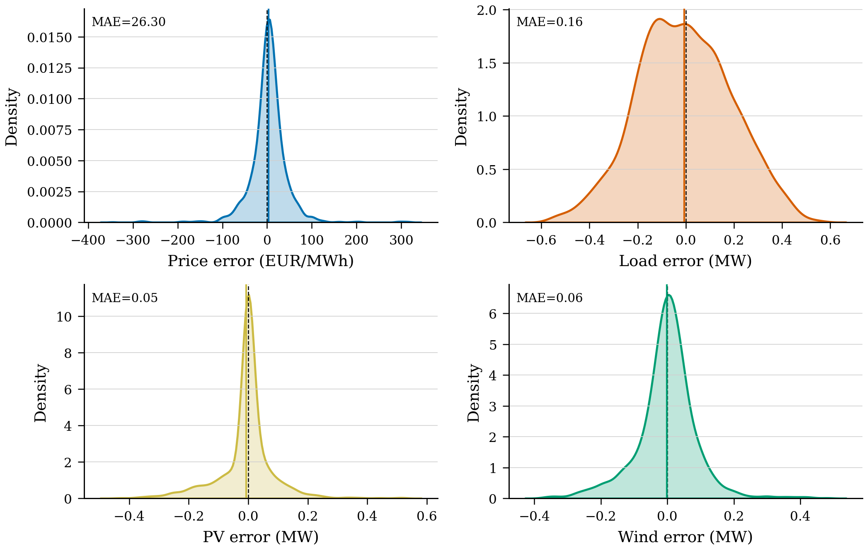
Fig. 3. Kernel densities of day-ahead forecast errors, 58 days.
V. Linear Program
Maximise (1−λ) E[profit] + λ CVaR_α(profit) with Rockafellar–Uryasev. P1 additionally requires reserved power to remain feasible for SoC and DG headroom in every scenario (SoC-feasible reserve, not asset-outage N−1). German markets open in seven stages; SMARD has no ID order book, so the experiment instantiates DA (stage 1) and settlement (stages 6–7). B0: mean scenario, no reserve. B1: independent errors, energy CVaR. B2: joint blocks, energy CVaR. P1: joint blocks, energy+reserve. P1-ind: independent errors, energy+reserve. H0: bid the forecast. PF: the same LPs on the realized path.
VI. Experiment
Freeze first-stage, settle on the realized day, and also evaluate every energy bid on the joint scenario set so B1 and B2 share a measure. Rolling OOS: 14 days. We quote paired tests on daily OOS profits (n = 14), not the dependent in-sample scenario tests.
VII. Results
Table III is the isolation. Every energy-only CVaR bid lands within 35 EUR/day of B0 out of sample. Every reserve bid lands about 550 EUR above B0. Switching P1 from joint blocks to independent errors changes OOS profit by +6 EUR. Dependence is not the lever on this summer week; reserve is. H0 is 906 EUR behind B0. Perfect-foresight energy is only 117 EUR above realized B0. Perfect-foresight reserve is 11 657 EUR; P1 at 11 487 EUR takes most of that hindsight reserve value.
TABLE III. ISOLATION, 19 AUGUST 2026 (EUR/DAY)
Model | Errors | Reserve | E[π] | CVaR | Realized
H0 heuristic | point fc | no | 10 677 | 9 010 | 10 032
B0 EV | mean | no | 11 498 | 9 986 | 10 938
B1 CVaR | independent | no | 11 505 | 10 014 | 10 971
B2 CVaR | joint | no | 11 508 | 10 027 | 10 965
P1-ind | independent | yes | 11 986 | 10 407 | 11 493
P1 | joint | yes | 11 992 | 10 440 | 11 487
PF energy | actuals | no | — | — | 11 055
PF reserve | actuals | yes | — | — | 11 657


Fig. 4. Dumbbell of E[profit] versus realized settlement, and gap versus B0.

Fig. 5. Slope from E[profit] to CVaR_0.95 and the tail gap.

Fig. 6. ECDF of K = 50 joint-scenario profits.

Fig. 7. First-stage DA energy position and realized DE-LU price.

Fig. 8. Battery SoC; P1 holds overnight energy to back upward reserve.

Fig. 9. P1 reserve (up positive). B0 and B2 sell none.
TABLE IV. SETTLEMENT DECOMPOSITION (EUR)
Component | B0 | B2 | P1
Load-service (exogenous) | 18 024 | 18 024 | 18 024
DA energy | −3 895 | −4 255 | −4 343
Reserve capacity | 0 | 0 | 589
Imbalance | −223 | 163 | 175
DG fuel / degradation | 2 968 | 2 968 | 2 958
Net | 10 938 | 10 965 | 11 487

TABLE V. HIGHS SIZE AND TIME
Model | K | Vars / ineq. | Status | s
B0 | 1 | 216 / 46 | kOptimal | 0.011
B2 | 50 | 7 323 / 2 350 | kOptimal | 0.173
P1 | 50 | 7 323 / 7 150 | kOptimal | 0.303

TABLE VI. ROLLING OOS, 6–19 AUGUST 2026 (EUR/DAY)
Model | Mean | Std | Min | Max
B0 | 11 639 | 1 589 | 8 557 | 14 056
B2 | 11 633 | 1 582 | 8 576 | 14 070
P1 | 12 203 | 1 570 | 9 204 | 14 701

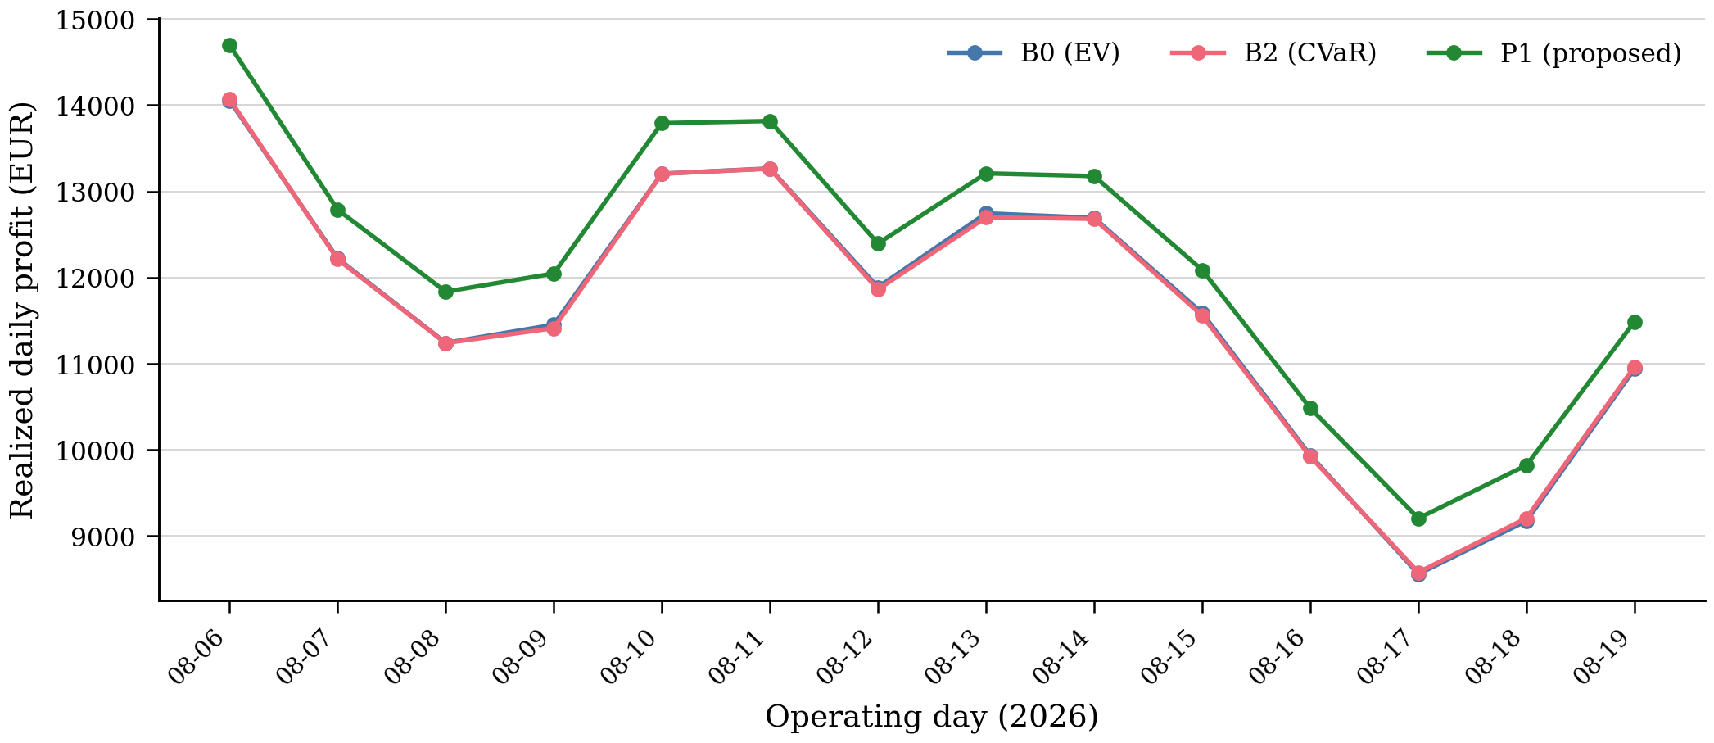
Fig. 10. Rolling-origin realized daily profit. P1 is above B0 and B2 on every day.
Paired P1−B0 on 14 OOS days: +563 EUR, Wilcoxon p = 1.2×10⁻⁴, d = 9.4, bootstrap 95% CI [533, 593]. B2−B0: −7 EUR, p = 0.33. In-sample scenario p-values are not quoted: those 50 paths share one first-stage.
VIII. Discussion
A megawatt that the battery can actually hold is worth about 550 EUR on this Wednesday and about 560 EUR/day over two weeks. A CVaR energy bid, joint or independent, is not. A Student-t copula with ν = 18.55 was never likely to be the reason. Reserve prices are DA-shaped proxies; if real aFRR capacity prices were near zero, P1’s advantage would shrink toward the 10 EUR cycling saving.
IX. Limitations
Fourteen summer days; scaled national SMARD, not a metered VPP; proxy reserve and imbalance prices; no ID order book for stages 2–5; DR formulated but unused; SoC-feasible reserve is not asset-outage N−1; copula ν ≈ 18 is near Gaussian; daily OOS n = 14.
X. Conclusion
The mean–CVaR energy-plus-SoC-feasible-reserve LP realises 11 487 EUR on 19 August 2026 against 10 938 EUR for a deterministic energy bid, and stays ahead on every one of 14 rolling days. Independent-error twins finish within 10 EUR/day of the joint-error versions. Energy-only CVaR does not beat expected value out of sample. The money is the reserve product, not the copula. That is a narrower claim than an earlier draft, and it is the claim the numbers support.
References (selected, publisher-checked)
[1] Nemati et al., SEGAN, vol. 43, Art. 101801, 2025, doi: 10.1016/j.segan.2025.101801.
[3] Vahedipour-Dahraie et al., IEEE Trans. Smart Grid, vol. 12, no. 2, pp. 1405–1415, 2021.
[9] Xiao, Technologies, vol. 13, no. 11, Art. 488, 2025, doi: 10.3390/technologies13110488.
[10] Du et al., Energy, vol. 336, Art. 138410, 2025.
[13] Fan and Liu, IET Renew. Power Gener., vol. 18, no. 3, 2024, doi: 10.1049/rpg2.12806.
[14] Do Prado and Chikezie, IEEE Access, vol. 9, pp. 106181–106191, 2021.
[18] Wang, Shen, and Liu, Appl. Energy, vol. 212, pp. 771–785, 2018.
[19] O’Connor et al., Energy and AI, vol. 21, Art. 100571, 2025.
[21] Gao and Kleywegt, Math. Oper. Res., vol. 48, no. 2, pp. 603–655, 2023.
Full list (23 entries) in the HTML companion manuscript.

