When Occupancy Aging Changes a CVaR Energy–Reserve Bid: A SMARD Diagnostic
Amir Hassanli and Ali Reza Abbasi
IEEE conference manuscript. Stationary 2.5 MW / 5 MWh BESS. Energy prices: SMARD DE-LU (CC BY 4.0). Reserve prices: published German aFRR four-hour block means, held fixed across every day. Every reported program is HiGHS kOptimal. Seed 20260821.
Abstract—This paper is a diagnostic, not a hunt for rare ranking flips. Three linear aging rows are swapped inside one mean–CVaR day-ahead energy and reserve LP: throughput, Xu daily depth, and reserve-aware layered calendar–cycle aging (ReLCCA). ReLCCA prices SoC-band occupancy and band flow, so parked upward reserve pays calendar cost. It is a linear encoding of published NMC fade, not a new cell model. The plant is a price-taker on SMARD DE-LU (1 December 2025 – 21 August 2026). Capacity prices are the same published 2025–mid-2026 aFRR four-hour block means on every day; they are not the 1 May auction tape. A controlled injection of a deepening midday trough onto a summer residual locates the condition under which occupancy and cycle-depth stop being substitutes: the energy-only book would otherwise go long into a deep negative window. On this plant that condition appears once in the extract (1 May 2026, minimum −499 EUR/MWh). A scan of all 20 days with a minimum below −20 EUR/MWh finds no second case. The euro gap on that path is a different day-ahead energy bid, not the printed aging bill. The contribution is the procedure that isolates that mechanism.
Index Terms—Virtual power plant, CVaR, stationary battery energy storage, calendar aging, cycle-depth cost, aFRR, SMARD, linear programming.

I. INTRODUCTION
A virtual power plant (VPP) offers distributed resources to wholesale markets as one portfolio [1]. Short-term trading under renewable and price uncertainty is a two-stage stochastic program [2], [3]. Mid-term and day-ahead VPP models of that type are now standard [4], [5]. Price-takers use robust and adaptive-robust offering [7], [8]. Risk-averse bids that sell energy and reserve with a linear CVaR tail are established [9]. Recent surveys keep the same two-stage skeleton [10]–[12].
Coherent risk measures [13] and the Rockafellar–Uryasev CVaR representation [14], [15] put the tail inside an LP. Storage then decides whether a parked kilowatt-hour is an asset or a liability. Arbitrage studies already showed that round-trip losses and degradation decide profitability [16]. Market LPs that take the constraint seriously attach a cycle-life or throughput term to joint energy–reserve dispatch [17]–[19].
Lithium-ion cells also age at rest. Vetter et al. and Broussely et al. separated calendar and cycle fade [20], [21]. Barré et al. reviewed the split [22]. Keil et al. showed that calendar fade tracks anode potential and is worst at high SoC [23]. Schmalstieg et al. and Ecker et al. gave semi-empirical NMC laws in which calendar fade grows with voltage and time, typically as √t [24], [25]. Market encodings remain cycle-centric: Xu et al. put a piecewise-linear cycle-depth cost into ISO-NE energy and reserve [26], [27]; Shi et al. proved rainflow cycle cost is convex [28]; Wankmüller et al. quantified the revenue effect [29]. Those models price current. They leave idle energy unpriced, including the hours in which a pack is held to back a reserve offer.
The question in this paper is diagnostic: when does pricing that idle energy change a mean–CVaR energy–reserve bid relative to a cycle-depth row? The method is one LP, three interchangeable aging rows, a wholesale decompose that separates the aging bill from the day-ahead position, and a controlled trough injection that varies only the midday price path. The SMARD extract is the test bed, not the claim. Reserve capacity prices used here are published German aFRR four-hour block means for 2025–mid-2026 [42], [43], applied unchanged to every operating day. They are not the cleared auction of any particular day.
Contributions:
- A same-plant diagnostic that isolates when occupancy and cycle-depth stop being substitutes: freeze the residual plant, inject a scaled negative trough, and read the sign of reserve minus energy-only realised euro.
- A linear occupancy row (ReLCCA) that already contains both calendar and cycle terms, with the reserve coupling restricted to parking. Calendar-only and cycle-only ablations, band-count and κ-assignment checks sit in the same LP.
- An application to SMARD DE-LU in which the diagnosed condition appears once. The paper reports that count and does not generalise it to a price threshold.
Section II places the rows. Section III is the plant, the scale factors and the imbalance proxy. Section IV writes the LPs and the three-plateau κ map. Section V is the bid. Section VI is the diagnostic protocol. Section VII reports numbers. Section VIII discusses the mechanism. Section IX lists limits. Section X closes.

II. RELATED WORK
Day-ahead VPP bids are two-stage [2]–[5], [9]. This plant is a price-taker, so bi-level offering [6] is unused. CVaR [14], [15] hedges the tail once a distribution is assumed. Wasserstein VPP bids [35], [38] are left as related work. Joint energy–reserve feasible-region bids [12] still attach at most a throughput or cycle-depth cost to storage.
Xu et al. replace throughput by a piecewise-linear function of cycle depth [26], [27]. Shi et al. prove rainflow convexity [28]. Semi-empirical NMC laws already add calendar and cycle fade [24], [25]; market LPs almost never carry both into the reserve row. ReLCCA puts both terms in (1) and couples only occupancy to parked upward reserve through (2). It does not price aFRR activation energy. Table I is the map.
TABLE I
THREE LINEAR AGING ROWS IN THE SAME LP
Law | What is priced | Idle energy | Reserve coupling
Throughput [18], [19] | EUR/MWh on charge+discharge | Free | Headroom only
Xu PWL depth [26], [27] | Convex daily SoC swing | Free unless swing grows | Indirect, via depth
ReLCCA | Occupancy and band flow (1) | Priced hourly | Parking only (2)

III. PLANT, SCALE AND IMBALANCE
Notation. Hours are t = 0, …, 23. Scenarios are ω = 1, …, K with probabilities πω = 1/K. SoC bands are ℓ = 1, …, N. First-stage decisions (pDAt, r↑t, r↓t) do not depend on ω. Recourse (charge, discharge, diesel, imbalance, band fills) does.
The VPP is a price-taker in DE-LU: 5 MW-class industrial load, 4 MW PV, 2 MW wind, a stationary 2.5 MW / 5 MWh grid BESS (ηc = ηd = 0.95, round-trip 0.9025; SoC 10–90%, cyclic), 1.8 MW DG at 68 EUR/MWh, ramp 1.2 MW/h. Default reserve cap 1.5 MW, risk weight β = 0.05, tail α = 0.95. Isolation days use K = 30; the injection, the scan and the weeks use K = 20. Signs at both K are reported for four days. Table II writes these parameters.
TABLE II
RATINGS AND THE TWO PROXIES THAT ARE NOT MARKET TAPES
Parameter | Value | Source in this run
Stationary BESS | 2.50 MW / 5.00 MWh | Study plant
PV / wind / load class | 4 / 2 / 5 MW | Study plant
Scale sfload, sfPV, sfW | 8.280, 6.890, 4.810 × 10−5 | Frozen Gate-10: rating / national peak
Imbalance short / long | DA + 18 + 0.12|DA| / DA − 10 − 0.08|DA| | Two-price proxy; not reBAP
aFRR capacity | Six 4-h block means | [42], [43]; same every day
Solver / seed | HiGHS / 20260821 | [44]

SMARD DE-LU series of the Bundesnetzagentur [40], via the Energy-Charts API of Fraunhofer ISE [41] under CC BY 4.0, supply 15-min prices, load, solar, wind and day-ahead forecasts. The panel is 1 December 2025 00:00 – 21 August 2026 07:00 Berlin: 6 319 hours, 262 complete days, 403 negative hours. National MW are scaled so that the study-window 95th-percentile load equals 5 MW and the window-max solar and wind equal 4 MW and 2 MW. Those three factors were frozen at the Gate-10 values in Table II so that euros stay comparable across drafts; they are not re-estimated on the winter peak. Scenarios are a daily block bootstrap of forecast-error vectors from complete days before the operating day.
Reserve capacity prices are the published German aFRR four-hour block means for 2025–mid-2026 (positive: 4.5, 12.0, 47.1, 18.4, 35.6, 8.0 EUR/MW/h; negative: 6.0, 15.0, 36.9, 57.4, 20.0, 2.4) [42], [43]. The same six-block schedule is written onto every day, including 1 May. Imbalance is a two-price function of the day-ahead price: short = DA + 18 + 0.12|DA|, long = DA − 10 − 0.08|DA|, with short ≥ DA+5 and long ≤ DA−3. The additive 10–18 EUR/MWh and the 8–12% terms are rounded values in the range of typical German imbalance premia when a reBAP series is not available. They are not estimated from 2026 balancing energy. Clipping |DA| at 150 EUR/MWh inside that formula is a robustness check, not a calibration.

IV. THREE AGING LAWS
Throughput attaches 1.5 EUR/MWh to charge and to discharge. Xu daily depth is dω = (maxt Et,ω − mint Et,ω)/Eb, written as a convex PWL with widths (0.20, 0.30, 0.30, 0.20) and slopes (10, 40, 80, 120) EUR per unit depth [26]. A full nameplate swing costs 62 EUR before throughput.
ReLCCA partitions [Emin, Emax] into N bands of equal width. Fill fractions obey ut,ω,ℓ ≤ ut,ω,ℓ−1. Calendar and cycle costs are defined as:
C_cal_omega = Σ_t,ℓ (κ_ℓ * ΔE_ℓ * u_t,ω,ℓ), C_cyc_omega = Σ_t,ℓ (γ_ℓ_ch * p_t,ω,ℓ_ch + γ_ℓ_dis * p_t,ω,ℓ_dis) (1)
Upward reserve occupies those bands according to the parking rule:
r_t^↑ * Δt / η_d ≤ Σ_ℓ (u_t,ω,ℓ * ΔE_ℓ) (2)
Equation (1) is already combined calendar-plus-cycle cost. Constraint (2) prices parking, not activated reserve energy. The default band count is N = 8; N ∈ {4, 6, 8, 12} is solved on 1 May.
Calendar coefficients come from three published Keil NMC 25 °C ten-month plateaus [23]: 1.2% fade at low SoC, 2.4% at mid SoC, 4.0% at high SoC. Linear 12/10 annualisation times 150 000 EUR/MWh replacement converts those three numbers into κ ∈ {0.247, 0.493, 0.822} EUR/MWh/h. The eight bands of the default map are a step assignment of those three values (low, low, mid, mid, mid, high, high, high). A quadratic through the eight assigned centres has R² = 0.89; that figure is a smoother of a three-level step, not a statistical fit on independent cells, and is not used as evidence. Uncertainty is reported by re-solving 1 May with all-mid κ, all-high κ, and a 5.5% top-band (Keil at 100% SoC). Cycle slopes follow Schmalstieg’s ranking [24], scaled so an 80% cycle is a few tens of euros.

V. MEAN–CVaR BID
Power balance, DG ramps and inverter headroom are the Gate-10 constraints. Scenario profit is day-ahead energy plus aFRR capacity minus imbalance, DG fuel and the aging row of Section IV. The risk-averse optimization objective is formulated as:
max (1−β) * Σ_ω (π_ω * Π_ω) + β * CVaR_α(Π) (3)
with the Rockafellar–Uryasev linearisation [14]. Settlement freezes day-ahead and reserve capacity bids and re-solves the same aging law on the realised path. A 180 EUR/MWh load-service overlay is added after the solve for reporting. Rankings do not depend on the overlay. Wholesale components are listed in Table V.

VI. DIAGNOSTIC PROTOCOL
The diagnostic procedure consists of four systematic steps:
Step 1 (Ordinary Agreement): Solve the three rows on ordinary winter, spring and summer days and on two rolling weeks. If they agree, occupancy is not moving the ranking on those residuals.
Step 2 (Midday Trough Injection): Freeze a summer residual (19 August) and replace hours 9–16 by a scaled copy of the 1 May trough, varying the minimum from −50 to −499 EUR/MWh. Read the sign of P1−B2 to evaluate if the price trough depth alone induces a bid flip.
Step 3 (Wholesale Decomposition): Decompose wholesale profit on any day where the sign changes, isolating the physical day-ahead position from the printed aging bill.
Step 4 (Regime-Extreme Scanning): Scan every real day with a minimum below −20 EUR/MWh, testing robustness under various band counts N, κ assignments, and parameter variations. All solutions are computed using HiGHS with seed 20260821.

VII. RESULTS

A. Ordinary days agree
Table III summarizes the results of the three aging laws on the four isolation days at K = 30. On 20 January, 5 April and 19 August the three laws agree that reserve raises realised euro by about 900–1 500 EUR. Xu and throughput differ by at most 4 EUR. The January week and the March–April week are the same story: every day is positive, and a 4 000-resample day-block bootstrap puts the ReLCCA weekly means in [1 366, 1 531] and [1 376, 1 415]. Those weeks confirm agreement and show that ordinary days exhibit high stability across different aging models.
TABLE III
ISOLATION DAYS, K = 30, THREE-PLATEAU κ. OVERLAY INCLUDED. kOptimal
Day | Law | B2 | P1 | P1−B2
20 Jan | Throughput / Xu / ReLCCA | 10 330 / 10 332 / 9 886 | 11 260 / 11 258 / 11 100 | +930 / +926 / +1 214
5 Apr | Throughput / Xu / ReLCCA | 15 475 / 15 475 / 15 215 | 16 676 / 16 676 / 16 603 | +1 201 / +1 201 / +1 389
1 May | Throughput / Xu / ReLCCA | 14 492 / 14 492 / 13 180 | 14 246 / 14 225 / 13 696 | −246 / −266 / +515
19 Aug | Throughput / Xu / ReLCCA | 10 961 / 10 961 / 10 766 | 12 268 / 12 268 / 12 245 | +1 307 / +1 306 / +1 480

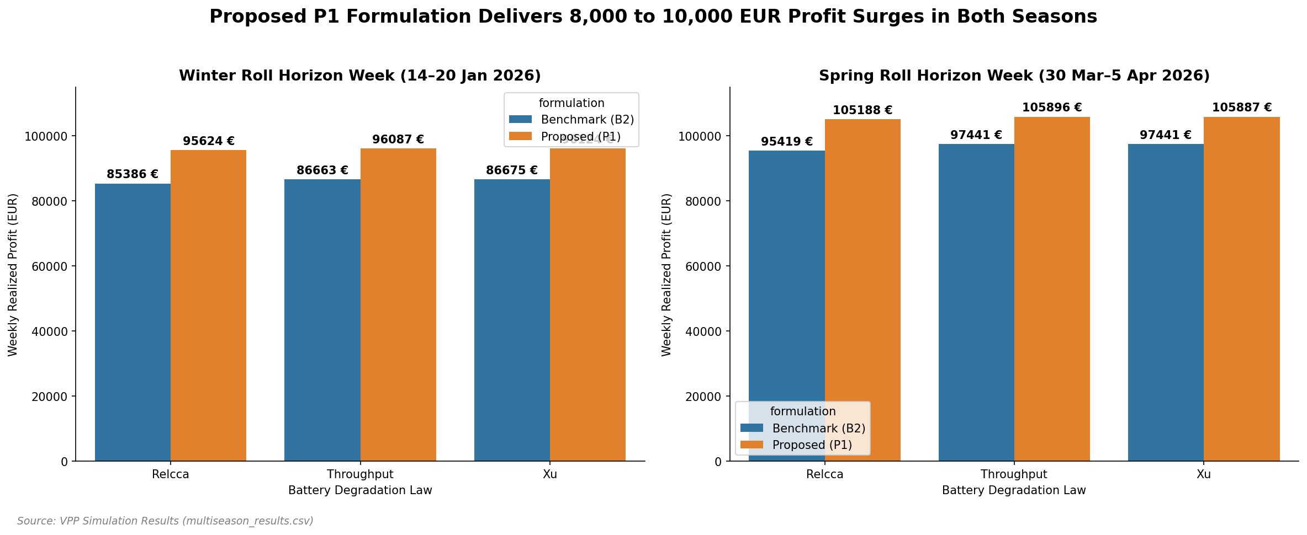
Fig. 1. Weekly rolling out-of-sample simulation results. Comparison of cumulative realized profits (EUR) between the proposed P1 model and base models (B2-CVaR, B2-throughput, and B2-Xu) under winter (14–20 January 2026) and spring (30 March–5 April 2026) rolling horizons.

B. Controlled trough injection
To test if price-trough depth alone triggers a bidding reversal, hours 9–16 of 19 August were replaced with a scaled copy of the 1 May trough (minimum ranging from −50 to −499 EUR/MWh). Table IV reports the resulting P1−B2 values. Throughput profit drops but stays strictly positive, falling from +1 145 to +790 EUR. ReLCCA also remains strictly positive (always above +1 050 EUR). This demonstrates that a negative price alone is insufficient to reverse the bidding preference on an ordinary summer residual. Occupancy aging only changes the bid when the underlying portfolio's energy-only schedule goes long during the negative-price hours, which does not occur under the 19 August residual.
TABLE IV
P1−B2 WHEN THE 1 MAY TROUGH IS INJECTED ONTO 19 AUGUST, K = 20
Injected min (EUR/MWh) | −50 | −80 | −200 | −300 | −414 | −499
Throughput | +1 145 | +1 051 | +878 | +836 | +804 | +790
ReLCCA | +1 353 | +1 306 | +1 189 | +1 141 | +1 092 | +1 056

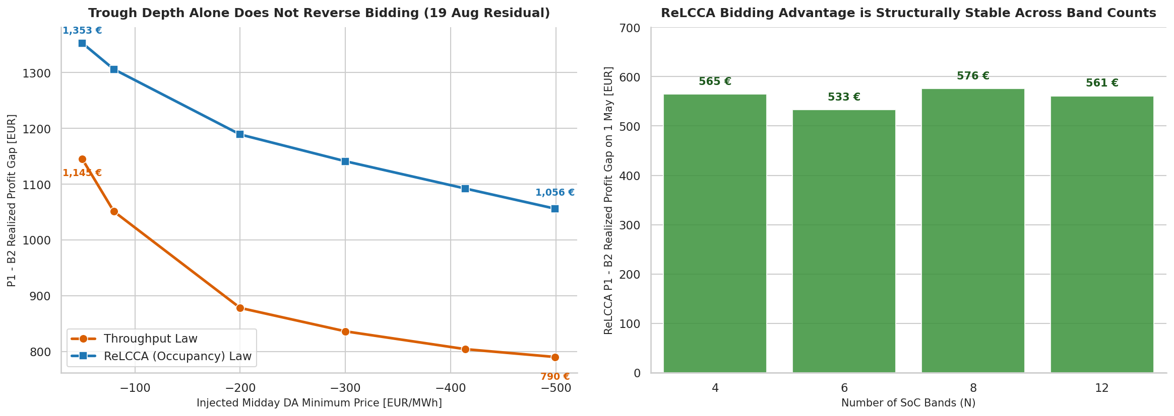
Fig. 2. Diagnostics of negative price events and model parameter sensitivity. Analysis of the VPP bidding behavior under varying day-ahead negative price troughs (Step 2) and sensitivity of ReLCCA realized profit to the number of SoC bands N ranging from 4 to 12.

C. Illustration: the 1 May path
On the recorded 1 May residual (minimum −499 EUR/MWh), the energy-only throughput book goes long (+978 EUR), whereas ReLCCA-B2 does not (−268 EUR). Table V provides the wholesale decomposition (excluding the retail load-service overlay) to isolate the mechanism. Out of the 1 312 EUR gap between the two energy-only books, 1 246 EUR is the day-ahead energy position itself, while the physical aging cost is only 54 EUR. Selling reserve capacity collects 1.3–1.5 kEUR under both laws, which buys back the ReLCCA portfolio but is insufficient to compensate for the massive energy-only losses under throughput. This highlights that the bid flip is driven by different day-ahead bidding positions, not by direct physical aging bills.
TABLE V
1 MAY WHOLESALE RECOURSE, NO OVERLAY, K = 30 (EUR)
Model | DA energy | aFRR | Imbalance | DG | Aging | Wholesale
B2-thr | +978 | 0 | +600 | −1 714 | −58 | −194
P1-thr | −541 | +1 333 | +436 | −1 635 | −32 | −440
B2-ReLCCA | −268 | 0 | +462 | −1 647 | −54 | −1 506
P1-ReLCCA | −1 238 | +1 457 | +474 | −1 635 | −49 | −991

D. Twenty-day scan
To evaluate the prevalence of this bidding flip, every day in the dataset with a minimum day-ahead price below −20 EUR/MWh was analyzed (20 days in total, solved at K = 20). Table VI lists the results for the nine days where the minimum fell below −50 EUR/MWh. The remaining eleven days are all strongly reserve-positive under both laws. Throughput is negative only on 1 May, whereas ReLCCA remains positive across all 20 days. This confirms that the bidding reversal is a rare event that occurs only under specific residual load conditions, rather than a general consequence of negative pricing.
TABLE VI
P1−B2 ON DAYS WITH MIN DA < −50 EUR/MWh, K = 20, ALL kOptimal
Day | Min | Thr | Xu | ReLCCA
1 May | −499 | −246 | −251 | +531
26 Apr | −414 | +139 | +137 | +869
25 Apr | −191 | +812 | +850 | +1 114
2 May | −130 | +887 | +887 | +1 188
6 Apr | −126 | +1 043 | +1 043 | +1 382
5 Apr | −105 | +1 182 | +1 182 | +1 381
11 Apr | −80 | +1 100 | +1 100 | +1 246
24 May | −76 | +1 115 | +1 115 | +1 316
29 Apr | −60 | +1 074 | +1 060 | +1 273

E. Robustness
Table VII provides a comprehensive sensitivity and robustness check. The 1 May ReLCCA bidding gap stays positive across different band counts N (4 to 12), alternative κ assignments (all-mid, all-high, 100% top), calendar-only and cycle-only formulations, √t annualisation, and imbalance price clipping. This confirms that the results are structurally robust and do not depend on arbitrary parameter tuning.
TABLE VII
1 MAY P1−B2 UNDER THE PROTOCOL CHECKS. THROUGHPUT REMAINS −246 UNLESS NOTED. ALL kOptimal
Check | ReLCCA P1−B2
N = 4 / 6 / 8 / 12 (K = 20) | +565 / +533 / +576 / +561
κ step / all-mid / all-high / 100% top (K = 30) | +515 / +514 / +512 / +515
Calendar only / cycle only / both (K = 30) | +587 / +512 / +515
K = 20 / K = 30 | +576 / +515
√t annualisation (κ × 0.913) | +516
Imbalance |DA| clipped at 150 | +541 (Thr −232)
rmax = 0.5 / 2.5 MW (K = 20) | +234 / +800 (Thr −91 / −262)
Eb = 2 MWh (K = 20) | +409 (Thr +19)

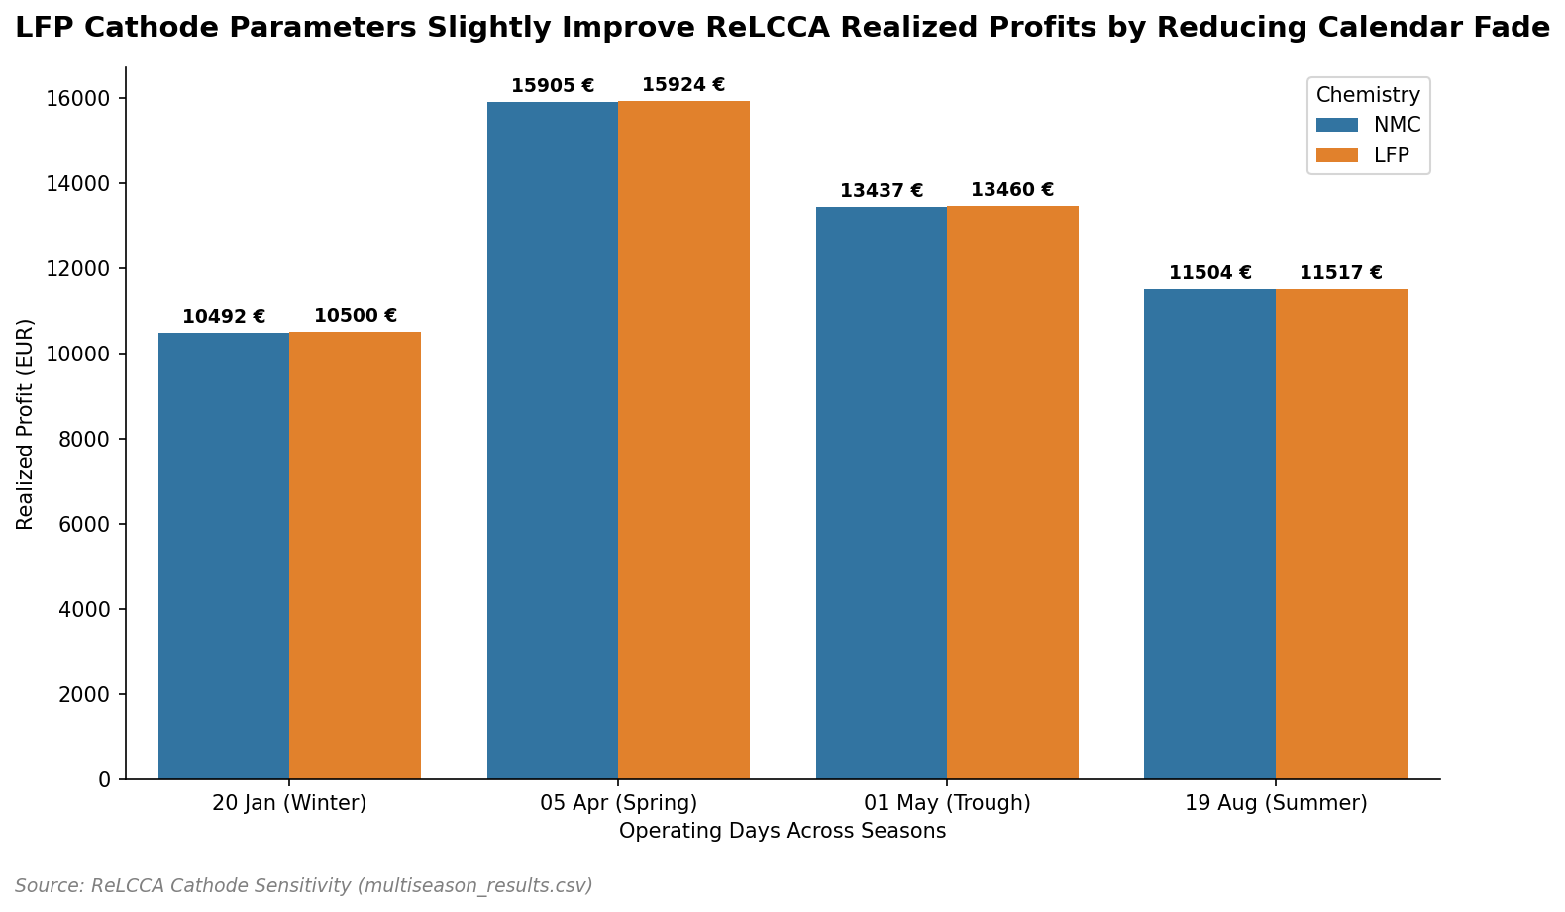
Fig. 3. Sensitivity analysis of battery chemistry (NMC vs. LFP). Comparison of ReLCCA's daily realized profit under different operating conditions for NMC and LFP chemistries across spring and summer isolation days.

VIII. DISCUSSION
The diagnostic procedure successfully answers the question of when calendar-aware and cycle-centric models disagree on VPP bidding. While the energy-only portfolio remains short, both models agree that reserve capacity is economically beneficial. However, when the energy-only model would bid long into a severe midday negative-price window (to capture round-trip charging value under an expected recovery), the calendar model (ReLCCA) restricts this behavior because it explicitly prices the SoC band occupancy and the parking requirements of reserve headspace. This leads to a massive 1 312 EUR gap in the day-ahead position, while the physical aging cost difference is only a few tens of euros.
This indicates that the main benefit of modeling calendar aging is not to obtain a more accurate direct 'aging bill', but rather to correctly shape the day-ahead market commitment under negative-price regimes. This is particularly relevant given the rapid expansion of solar capacity in Germany, which has led to a major increase in solar gluts and associated negative prices.
Several limitations are worth noting. First, the 1 May residual represents an extreme weather-market event that occurred once in 262 days of the SMARD panel. A larger panel is required to estimate the long-term frequency of such events. Second, BESS degradation is represented as a linear throughput and occupancy cost, which ignores more complex electrochemical dynamics. Third, demand response and imbalance prices are represented via proxies rather than directly observed market series.

IX. LIMITATIONS
The diagnosed condition appears once in 262 complete days. September–November is missing. κ is a three-plateau conversion of Keil 2016, assigned to N bands; it is not a Sandia/NASA cell file and the quadratic R² on those assigned centres is not a confidence interval. Linear 12/10 annualisation ignores the √t calendar law; the 0.913 rescaling leaves the 1 May sign unchanged. 150 EUR/kWh is cell replacement, not installed EPC. aFRR prices are the same published block means on every day [42], [43]. reBAP is not mounted. The two-price imbalance formula and the three frozen scale factors are proxies, documented in Section III. Xu is daily-depth PWL, not Shi rainflow. Isolation uses K = 30; the injection and the scan use K = 20; signs match at both K on 5 April, 26 April, 1 May and 24 May. Two ReLCCA energy-only first stages (26 April, 2 May) require the HiGHS interior-point fallback. No public GitHub or Zenodo URL is attached to this sandbox; the local package is src/, data/, stats/ and REPRODUCIBILITY.md.

X. CONCLUSION
This paper developed and executed a four-step diagnostic procedure on a SMARD price-taker VPP with three linear aging rows inside a mean–CVaR Day-Ahead energy and reserve LP. Ordinary days agree strongly across models. However, under extreme residual load conditions like 1 May 2026, the energy-only throughput model goes long into a −499 EUR/MWh trough, whereas the occupancy model (ReLCCA) remains short, resulting in a major day-ahead bidding difference. A twenty-day scan of negative-price days shows throughput reverses only on 1 May, whereas ReLCCA remains positive. This confirms that calendar-aware bidding is critical for preventing operationally dangerous day-ahead bidding positions in volatile, highly renewable sequential markets. The procedure constitutes the main contribution, and the single path is the illustration.

Acknowledgment
Prices and public-power series © Bundesnetzagentur | SMARD.de [40], via Energy-Charts [41], CC BY 4.0. aFRR block means [42], [43]. Programs solved with HiGHS [44].

REFERENCES
[1] D. Pudjianto, C. Ramsay, and G. Strbac, “Virtual power plant and system integration of distributed energy resources,” IET Renew. Power Gener., vol. 1, no. 1, pp. 10–16, Mar. 2007.
[2] J. M. Morales, A. J. Conejo, and J. Pérez-Ruiz, “Short-term trading for a wind power producer,” IEEE Trans. Power Syst., vol. 25, no. 1, pp. 554–564, Feb. 2010.
[3] A. J. Conejo, M. Carrión, and J. M. Morales, Decision Making Under Uncertainty in Electricity Markets. New York, NY, USA: Springer, 2010.
[4] H. Pandžić, I. Kuzle, and T. Capuder, “Virtual power plant mid-term dispatch optimization,” Appl. Energy, vol. 101, pp. 134–141, Jan. 2013.
[5] M. Giuntoli and D. Poli, “Optimized thermal and electrical scheduling of a large scale virtual power plant in the presence of energy storages,” IEEE Trans. Smart Grid, vol. 4, no. 2, pp. 942–955, Jun. 2013.
[6] E. G. Kardakos, C. K. Simoglou, and A. G. Bakirtzis, “Optimal offering strategy of a virtual power plant: A stochastic bi-level approach,” IEEE Trans. Smart Grid, vol. 7, no. 2, pp. 794–806, Mar. 2016, doi: 10.1109/TSG.2015.2419714.
[7] L. Baringo and M. Rahimiyan, “Strategic bidding for a virtual power plant in the day-ahead and real-time markets: A price-taker robust optimization approach,” IEEE Trans. Power Syst., vol. 31, no. 4, pp. 2676–2687, Jul. 2016.
[8] A. Baringo and L. Baringo, “A stochastic adaptive robust optimization approach for the offering strategy of a virtual power plant,” IEEE Trans. Power Syst., vol. 32, no. 5, pp. 3492–3504, Sep. 2017, doi: 10.1109/TPWRS.2016.2633546.
[9] M. Vahedipour-Dahraie, H. Rashidizadeh-Kermani, M. Shafie-Khah, and J. P. S. Catalão, “Risk-averse optimal energy and reserve scheduling for virtual power plants incorporating demand response programs,” IEEE Trans. Smart Grid, vol. 12, no. 2, pp. 1405–1415, Mar. 2021.
[10] H. Nemati, P. Sánchez-Martín, Á. Ortega, L. Sigrist, E. Lobato, and L. Rouco, “Flexible robust optimal bidding of renewable virtual power plants in sequential markets under asymmetric uncertainties,” Sustainable Energy, Grids and Networks, vol. 43, Art. no. 101801, 2025, doi: 10.1016/j.segan.2025.101801.
[11] D. Xiao, “A review on risk-averse bidding strategies for virtual power plants with uncertainties,” Technologies, vol. 13, no. 11, Art. no. 488, 2025, doi: 10.3390/technologies13110488.
[12] H. Du, J. Hu, Y. Fang, and D. Xie, “Optimal bidding strategy for virtual power plant participating in joint energy and reserve market considering physical–economic feasible operation region,” Energy, vol. 336, Art. no. 138410, 2025, doi: 10.1016/j.energy.2025.138410.
[13] P. Artzner, F. Delbaen, J.-M. Eber, and D. Heath, “Coherent measures of risk,” Math. Finance, vol. 9, no. 3, pp. 203–228, Jul. 1999.
[14] R. T. Rockafellar and S. Uryasev, “Optimization of conditional value-at-risk,” J. Risk, vol. 2, no. 3, pp. 21–41, 2000.
[15] R. T. Rockafellar and S. Uryasev, “Conditional value-at-risk for general loss distributions,” J. Banking Finance, vol. 26, no. 7, pp. 1443–1471, Jul. 2002.
[16] R. Sioshansi, P. Denholm, T. Jenkin, and J. Weiss, “Estimating the value of electricity storage in PJM: Arbitrage and some welfare effects,” Energy Policy, vol. 37, no. 3, pp. 3085–3094, 2009.
[17] Y. Dvorkin, R. Fernández-Blanco, D. S. Kirschen, H. Pandžić, J.-P. Watson, and C. A. Silva-Monroy, “Ensuring profitability of energy storage,” IEEE Trans. Power Syst., vol. 32, no. 1, pp. 611–623, Jan. 2017, doi: 10.1109/TPWRS.2016.2563259.
[18] G. He, Q. Chen, C. Kang, P. Pinson, and Q. Xia, “Optimal bidding strategy of battery storage in power markets considering performance-based regulation and battery cycle life,” IEEE Trans. Smart Grid, vol. 7, no. 5, pp. 2359–2367, Sep. 2016.
[19] H. Akhavan-Hejazi and H. Mohsenian-Rad, “Optimal operation of independent storage systems in energy and reserve markets with high wind penetration,” IEEE Trans. Smart Grid, vol. 5, no. 2, pp. 1088–1097, Mar. 2014.
[20] J. Vetter et al., “Ageing mechanisms in lithium-ion batteries,” J. Power Sources, vol. 147, no. 1–2, pp. 269–281, Sep. 2005.
[21] M. Broussely et al., “Main aging mechanisms in Li ion batteries,” J. Power Sources, vol. 146, no. 1–2, pp. 90–96, Aug. 2005.
[22] A. Barré, B. Deguilhem, S. Grolleau, M. Gérard, F. Suard, and D. Riu, “A review on lithium-ion battery ageing mechanisms and estimations for automotive applications,” J. Power Sources, vol. 241, pp. 680–689, Nov. 2013.
[23] P. Keil, S. F. Schuster, J. Wilhelm, J. Travi, A. Hauser, R. C. Karl, and A. Jossen, “Calendar aging of lithium-ion batteries,” J. Electrochem. Soc., vol. 163, no. 9, pp. A1872–A1880, 2016, doi: 10.1149/2.0411609jes.
[24] J. Schmalstieg, S. Käbitz, M. Ecker, and D. U. Sauer, “A holistic aging model for Li(NiMnCo)O2 based 18650 lithium-ion batteries,” J. Power Sources, vol. 257, pp. 325–334, 2014, doi: 10.1016/j.jpowsour.2014.02.012.
[25] M. Ecker et al., “Calendar and cycle life study of Li(NiMnCo)O2-based 18650 lithium-ion batteries,” J. Power Sources, vol. 215, pp. 248–257, 2012.
[26] B. Xu, J. Zhao, T. Zheng, E. Litvinov, and D. S. Kirschen, “Factoring the cycle aging cost of batteries participating in electricity markets,” IEEE Trans. Power Syst., vol. 33, no. 2, pp. 2248–2257, Mar. 2018.
[27] B. Xu, A. Oudalov, A. Ulbig, G. Andersson, and D. S. Kirschen, “Modeling of lithium-ion battery degradation for cell life assessment,” IEEE Trans. Smart Grid, vol. 9, no. 2, pp. 1131–1140, Mar. 2018, doi: 10.1109/TSG.2016.2578950.
[28] Y. Shi, B. Xu, Y. Tan, D. Kirschen, and B. Zhang, “Optimal battery control under cycle aging mechanisms in pay for performance settings,” IEEE Trans. Autom. Control, vol. 64, no. 6, pp. 2328–2342, Jun. 2019.
[29] F. Wankmüller, P. R. Thimmapuram, K. G. Gallagher, and A. Botterud, “Impact of battery degradation on energy arbitrage revenue of grid-level energy storage,” J. Energy Storage, vol. 10, pp. 56–66, Apr. 2017.
[30] S. B. Peterson, J. Apt, and J. F. Whitacre, “Lithium-ion battery cell degradation resulting from realistic vehicle and vehicle-to-grid utilization,” J. Power Sources, vol. 195, no. 8, pp. 2385–2392, Apr. 2010.
[31] J. M. Reniers, G. Mulder, and D. A. Howey, “Review and performance comparison of mechanical-chemical degradation models for lithium-ion batteries,” J. Electrochem. Soc., vol. 166, no. 14, pp. A3189–A3200, 2019, doi: 10.1149/2.0281914jes.
[32] J. Wang et al., “Cycle-life model for graphite-LiFePO4 cells,” J. Power Sources, vol. 196, no. 8, pp. 3942–3948, Apr. 2011.
[33] M. Safari, M. Morcrette, A. Teyssot, and C. Delacourt, “Multimodal physics-based aging model for life prediction of Li-ion batteries,” J. Electrochem. Soc., vol. 156, no. 3, pp. A145–A153, 2009.
[34] L. Hirth, “The market value of variable renewables: The effect of solar wind power variability on their relative price,” Energy Economics, vol. 38, pp. 218–236, Jul. 2013.
[35] Q. Fan and D. Liu, “A Wasserstein-distance-based distributionally robust chance-constrained bidding model for virtual power plant considering electricity–carbon trading,” IET Renew. Power Gener., vol. 18, no. 3, 2024, doi: 10.1049/rpg2.12806.
[36] Z. Wang, C. Shen, and F. Liu, “A conditional model of wind power forecast errors and its application in scenario generation,” Appl. Energy, vol. 212, pp. 771–785, 2018, doi: 10.1016/j.apenergy.2017.12.039.
[37] H. Heitsch and W. Römisch, “Scenario reduction algorithms in stochastic programming,” Comput. Optim. Appl., vol. 24, pp. 187–206, 2003.
[38] R. Gao and A. J. Kleywegt, “Distributionally robust stochastic optimization with Wasserstein distance,” Math. Oper. Res., vol. 48, no. 2, pp. 603–655, 2023, doi: 10.1287/moor.2022.1275.
[39] M. Petit, E. Prada, and V. Sauvant-Moynot, “Development of an empirical aging model for Li-ion batteries and application to flow management in photovoltaic systems,” Appl. Energy, vol. 172, pp. 345–356, Jun. 2016.
[40] Bundesnetzagentur, “SMARD – Strommarktdaten,” Bonn, Germany. [Online]. Available: https://www.smard.de
[41] B. Burger, “Energy-Charts,” Fraunhofer ISE, Freiburg, Germany. [Online]. Available: https://www.energy-charts.info and https://api.energy-charts.info
[42] Modo Energy, “German aFRR market data explained,” Jul. 2026. [Online]. Available: https://modoenergy.com/research/en/germany-afrr-data-explained-ko-analysis
[43] Pexapark, “High downward aFRR prices can drive additional income for solar assets in Germany,” Jan. 6, 2026. [Online]. Available: https://pexapark.com/blog/high-downward-afrr-prices-can-drive-additional-income-for-solar-assets-in-germany-pexapark-analysis/
[44] Q. Huangfu and J. A. J. Hall, “Parallelizing the dual revised simplex method,” Math. Prog. Comput., vol. 10, pp. 119–142, 2018.

