Evaluating Reinforcement Learning for Dynamic Difficulty Adjustment
in a Godot-Based Game Using Simulated Player Behaviours

Amir Mashhadi
23012712

1. Introduction

1.1 Background
Dynamic Difficulty Adjustment (DDA) addresses a persistent game-design problem: a single fixed challenge level rarely suits every player. A setting that is appropriate for a skilled player may be inaccessible to a beginner, while a setting designed for a beginner may become unchallenging as the player improves. DDA therefore changes gameplay parameters during play in response to player performance or behaviour, with the aim of keeping challenge at an appropriate level (Castro Lopes and Lopes, 2022; Mortazavi et al., 2024).
Traditional approaches usually rely on manually authored thresholds or fixed difficulty selections such as easy, normal and hard. These approaches are understandable and easy to control, but they cannot fully respond to changes that occur during play. Reinforcement learning (RL) offers a different formulation because the difficulty controller can observe a gameplay state, choose an adjustment, receive reward feedback and learn a policy over repeated interactions. This makes DDA a sequential decision-making problem rather than a one-off difficulty selection.
This framing is central to the methodological anchor used in this dissertation. Climent et al. (2024) present a framework for designing RL agents specifically for DDA in single-player action games. Their framework explicitly defines states, actions and rewards, with states combining player and agent performance, actions increasing or decreasing game difficulty, and rewards reflecting gameplay outcomes such as round duration and winning/losing behaviour. The present project follows that structure, but adapts it to a Godot-based 2D survival prototype and uses PPO rather than the 2Q-table approach used by Climent et al. (2024).

1.2 Problem Definition
Although RL-based DDA is promising, practical evidence remains fragmented across different engines, genres and evaluation methods. Much of the wider RL game-engine literature focuses on Unity or custom simulation environments, while Godot-specific work is smaller in scale. Ranaweera and Mahmoud (2024), for example, demonstrate that Python-based deep RL can communicate with a Godot environment, while Beeching et al. (2021) provide the Godot RL Agents framework used to connect Godot simulations to standard Python RL libraries.
The problem investigated here is therefore whether an RL-based DDA controller can maintain balanced gameplay in a real-time Godot environment when it is evaluated using controlled simulated player behaviours. No human participants are used. Consequently, the project does not claim to measure subjective constructs such as enjoyment, frustration, immersion, fairness perception or psychological flow. Instead, balance is operationalised using measurable gameplay outcomes including failure rate, survival time, health remaining, hits taken, difficulty level, difficulty-change frequency and time spent within a predefined target balance range.

1.3 Real-World Impact
Adaptive difficulty has practical value in entertainment games, serious games, training systems and other interactive environments in which users differ in ability and improve at different rates. However, adaptive systems can also create instability or perceived unfairness if they respond too aggressively or opaquely. For this reason, the technical behaviour of a DDA controller should be measured rather than assumed to be beneficial.
The use of simulated profiles makes repeated controlled evaluation possible without collecting personal or physiological data. It also enables explicit testing of several behaviour patterns: beginner, intermediate, skilled, inconsistent and improving. This supports a technical form of robustness testing, although it cannot replace later validation with human participants.

1.4 Aim and Objectives
The aim of this project is to evaluate whether reinforcement learning can be used to maintain balanced gameplay in a Godot-based game through dynamic difficulty adjustment using simulated player behaviours.
- Design and implement a small Godot-based game environment with an interpretable 0-10 difficulty scale.
- Create simulated player profiles representing beginner, intermediate, skilled, inconsistent and improving behaviour patterns.
- Implement and compare static difficulty, rule-based DDA and RL-based DDA under the same game environment and profile conditions.
- Formulate the RL controller in terms of state, action, transition and reward design, following the methodological direction of Climent et al. (2024).
- Evaluate the systems using objective gameplay metrics including failure rate, survival time, health, hits, target-range occupancy and difficulty behaviour.
- Identify practical challenges in deploying an RL-based DDA controller through Godot, including reward shaping and inference-mode behaviour.

1.5 Report Structure
Section 2 reviews relevant work on DDA, player modelling, reinforcement learning, simulation-based evaluation and Godot deployment. Section 3 describes the combined methodology and implementation, with Climent et al. (2024) used as the methodological anchor. Section 4 presents the final static, rule-based and RL results, followed by RL policy diagnostics and hypothesis evaluation. Section 5 concludes the study and discusses limitations and future work.

2. Literature Review

2.1 Dynamic Difficulty Adjustment
DDA research is motivated by the mismatch between fixed game difficulty and heterogeneous player ability. Rule-based systems remain common because they are interpretable and controllable, but they depend on assumptions about which performance indicators should trigger which adjustments. Systematic reviews therefore describe a broad progression from fixed and heuristic balancing toward player modelling and learning-based approaches (Mortazavi et al., 2024; Souza et al., 2025).
A central evaluation difficulty is that 'successful' DDA can mean different things. Human studies may evaluate enjoyment, perceived challenge or frustration, while automated studies often use completion, score, survival or win/loss outcomes. The present work adopts the latter technical perspective because no human participants are used.

2.2 Rule-Based, Performance-Based and Affective DDA
Rule-based DDA modifies difficulty when manually selected thresholds are crossed. Examples include reducing attack rate after repeated damage or increasing enemy challenge after sustained strong performance. Such systems are useful baselines because their behaviour can be explained directly, but this same transparency also reveals their limitation: the developer must anticipate the relevant conditions in advance.
Performance-based DDA extends this idea by using variables such as score, survival, deaths and accuracy. Affective systems attempt to estimate emotional state from physiological or behavioural signals, but this introduces sensor noise, additional implementation complexity and privacy considerations. Fisher and Kulshreshth (2024) emphasise that different DDA techniques can produce different objective and subjective effects, which supports evaluating multiple metrics rather than treating any single outcome as definitive.

2.3 Machine Learning and Player Modelling
Machine-learning approaches attempt to infer player skill or behaviour from gameplay data. Romero-Mendez et al. (2023), for example, use skill classification to inform adaptive difficulty, while Pfau et al. (2020) examine deeper player-behaviour models. These approaches can capture patterns that simple thresholds miss, but classification can still oversimplify a player who changes during a session. The inconsistent and improving profiles in the present study were included specifically to challenge this assumption of a fixed player category.

2.4 Reinforcement Learning for DDA
Reinforcement learning is well suited to DDA because the controller repeatedly observes performance and changes the environment over time. Oliveira and Chaimowicz (2023) investigate RL directly for DDA, while Rahimi et al. (2023) demonstrate continuous RL-based difficulty adaptation using player score and game difficulty as part of the state-action formulation. These studies reinforce the importance of state representation and reward design.
Climent et al. (2024) provide the anchor framework for this dissertation. Their paper defines DDA-specific states, actions and rewards and demonstrates the framework in a single-player action game. Importantly, their objective is not simply to train an agent that wins; the RL agent is used to regulate difficulty. Their states combine player and agent performance, their actions alter game difficulty, and their rewards are designed around round duration and winning/losing outcomes. Their proposed 2Q-table system targets an approximately balanced win/loss ratio while extending round duration.
The present project adopts these methodological ideas rather than reproducing the exact algorithm. PPO is used instead of Q-tables, the player is simulated rather than exclusively human-controlled, and health-based target occupancy is used as a primary operational balance measure. The anchor paper therefore acts as a design framework and comparison point rather than a template that is copied unchanged.

2.5 Simulation-Based Evaluation and Godot Deployment
Automated playtesting and simulation-driven balancing allow researchers to run many repeatable episodes without requiring a large participant sample. Rupp et al. (2024) use simulation-driven RL for level balancing, while Jeon et al. (2024) demonstrate automated balancing for boss-raid content. These methods support controlled experimentation, but the simulated agents remain abstractions of human play.
For deployment, Beeching et al. (2021) provide Godot RL Agents, which connects Godot environments to external Python RL tooling. Ranaweera and Mahmoud (2024) similarly demonstrate a Python framework communicating with Godot for deep reinforcement learning. These studies support the feasibility of using Godot as the environment while retaining Python-based learning infrastructure.

2.6 Research Gaps
Five gaps motivate the present design. First, RL-based DDA is often studied without a direct, controlled comparison against both static and rule-based baselines. Second, human studies can be difficult to reproduce and may be infeasible within a dissertation timeframe, creating a need for careful simulation-based alternatives. Third, DDA studies use inconsistent definitions of success, making multi-metric evaluation important. Fourth, Godot-specific RL deployment remains less established than Unity-based workflows. Fifth, any adaptive controller should be evaluated across different behaviour patterns rather than optimised only for one player type.
The anchor paper partially addresses several of these issues by evaluating both computer-driven and human players and by explicitly linking states, actions and rewards to DDA objectives (Climent et al., 2024). The present project narrows the scope to controlled simulated-player evaluation while extending the comparison to three difficulty systems inside a Godot implementation.

2.7 Research Questions
Primary Research Question: To what extent can a reinforcement-learning-based dynamic difficulty adjustment system maintain balanced gameplay in a Godot-based game when evaluated using simulated player behaviours?
- RQ1. How does RL-based DDA compare with static and rule-based difficulty systems using objective gameplay metrics such as survival time, failure rate and performance stability?
- RQ2. Which gameplay variables are suitable as state inputs and reward signals for an RL-based DDA system in a Godot environment?
- RQ3. How effectively can simulated player profiles represent beginner, intermediate, skilled, inconsistent and improving gameplay patterns for controlled evaluation?
- RQ4. What practical challenges arise when integrating and deploying reinforcement learning with a Godot-based game environment?

2.8 Research Hypotheses
H1: An RL-based DDA system will maintain simulated player performance closer to a target balanced gameplay range than static difficulty and rule-based DDA systems.
H2: An RL-based DDA system will adapt more effectively across different simulated player profiles than static difficulty and rule-based DDA systems.

3. Methodology and Implementation

3.1 Methodological Anchor Paper
Climent et al. (2024) were used as the methodological anchor because their framework is explicitly designed for RL-driven DDA in single-player action games. The paper structures the problem around states, actions and rewards, with difficulty regulation as the RL objective. The authors also evaluate their design with computer-driven and human players, providing a useful precedent for automated evaluation followed by player-facing validation.
This dissertation follows the same high-level sequence: define measurable player/game state, define a compact difficulty action space, design reward feedback around balanced outcomes, train through repeated interaction, and then compare the learned controller with non-learning baselines. The implementation differs in algorithm, engine and evaluation population. PPO is used instead of a 2Q-table system; Godot is used as the environment; and the final experimental evaluation is conducted with scripted player profiles rather than human participants.

3.2 Reinforcement-Learning Problem Formulation

3.2.1 State Space
The final observation contained six normalised variables: current health percentage, recent health trend, hits taken since the previous action, current difficulty level, survival progress through the 60-second episode, and cooldown progress until another normal difficulty change was permitted. This choice follows the anchor paper's principle that DDA state should represent both player performance and the current controller/game condition (Climent et al., 2024).
The state was intentionally objective. No emotional or affective variables were included because the experiment used simulated players. Health, recent damage and survival therefore acted as measurable indicators of whether challenge was becoming excessive or insufficient.

3.2.2 Action Space
The PPO controller used a discrete three-action space: decrease difficulty, maintain difficulty, or increase difficulty. Climent et al. (2024) similarly frame DDA actions as changes that increase or decrease challenge. The present implementation includes 'maintain' explicitly because stability is also a valid DDA decision when the current state is already acceptable.
The agent did not directly control projectile speed, damage, fire interval and spread as separate actions. Instead, it changed one interpretable difficulty level from 0 to 10, and the DifficultyManager mapped that level to the underlying enemy parameters. This kept the action space compact and made the RL controller directly comparable with the rule-based controller.

3.2.3 Transition Dynamics
Godot generated the transition dynamics. After an action, the simulation continued: the turret fired, projectiles moved, the scripted player detected threats and dodged, collisions changed health, and survival time advanced. The next state therefore emerged from the same game logic used in every experimental condition rather than from a manually defined transition table.
Stochasticity was introduced through projectile interaction and profile behaviour. The inconsistent profile also randomised its behaviour parameters between runs, while the improving profile progressively changed from beginner-like to skilled values.

3.2.4 Reward Function
Reward design followed the same central principle as the anchor paper: the agent should be rewarded for achieving the DDA objective rather than simply maximising game difficulty or defeating the player (Climent et al., 2024). The final reward therefore centred on the simulated player's health relative to a target value, with additional penalties for death and recent hits and smaller shaping terms that encouraged corrective difficulty changes when the player was clearly under-challenged or struggling.
The final controller used a target health percentage of 60%, with a broad tolerance around that value. A death penalty of 10 was used after development testing showed that a smaller terminal penalty could be outweighed by accumulated step rewards. The controller also reduced the reward for unnecessary reversals and allowed an emergency reaction when health was falling sharply or several hits were received in quick succession. Reward tuning was treated as an implementation variable rather than evidence that RL was inherently superior; Zheng (2024) similarly identifies reward design as a central challenge in RL-based DDA.
The reward did not directly force an increase or decrease action. The policy retained access to all three actions, while reward shaping expressed the project's operational definition of a desirable gameplay state. This distinction was important for keeping the RL condition different from the manually triggered rule-based baseline.

3.3 Godot Game Environment
The experiment used a small 2D top-down survival prototype in Godot. A simulated player moved within an arena while a turret fired projectiles. Each episode lasted up to 60 seconds and ended early if the player died. Separate scripts handled the player, turret, projectiles, difficulty mapping and experiment management. This modular structure allowed the same environment to be reused for static, rule-based and RL-based conditions.
Godot RL Agents provided the connection between the Godot controller node and Python, while Stable-Baselines3 provided PPO training. This follows the general engine-to-Python separation demonstrated by Beeching et al. (2021) and is consistent with the broader feasibility of Godot/Python deep-RL integration shown by Ranaweera and Mahmoud (2024).

3.4 Difficulty Scale and Calibration
Difficulty was represented on a 0-10 scale. Level 0 was the easiest setting, level 5 was the calibrated medium baseline, and level 10 was the hardest. Increasing difficulty raised projectile speed and damage, shortened the turret's fire interval and narrowed shot spread. Decreasing difficulty produced the opposite changes.
Early calibration showed that the original level-5 mapping was too punishing for the intermediate profile. The enemy mapping was therefore recalibrated rather than repeatedly changing the intermediate profile. This preserved the interpretation of the profile as the central simulated-skill reference while allowing level 5 to function as a meaningful static baseline.

3.5 Simulated Player Profiles
Five profiles were evaluated. The beginner profile moved more slowly, reacted later, dodged less reliably and made more mistakes. The intermediate profile represented the calibrated central behaviour. The skilled profile moved faster, reacted quickly and dodged more reliably. The inconsistent profile randomised behaviour values between runs. The improving profile gradually interpolated from beginner-like values toward skilled values across the 30-run evaluation.
These profiles are controlled abstractions rather than claims about real player psychology. Their purpose is to expose the difficulty systems to repeatable differences in simulated performance. This complements the computer-driven evaluation precedent in Climent et al. (2024), while also making the lack of human-experience measurement explicit.

3.6 Profile Settings
Profile | Speed | Reaction | Dodge chance | Mistake chance | Detection radius | Dodge duration | Description
Beginner | 130 | 0.70 | 0.28 | 0.45 | 120 | 0.55 | Slow; frequent mistakes
Intermediate | 170 | 0.30 | 0.65 | 0.15 | 220 | 0.85 | Calibrated baseline
Skilled | 195 | 0.20 | 0.85 | 0.06 | 260 | 0.95 | Fast; reliable dodging
Inconsistent | Randomised | Randomised | Randomised | Randomised | Randomised | Randomised | Varies between runs
Improving | 130→195 | 0.70→0.20 | 0.28→0.85 | 0.45→0.06 | 120→260 | 0.55→0.95 | Improves across runs

3.7 Difficulty Systems

3.7.1 Static Difficulty
The static condition remained at difficulty level 5 for the entire episode. It provided the non-adaptive baseline and established how each profile behaved when exposed to identical challenge.

3.7.2 Rule-Based DDA
The rule-based controller checked player condition at fixed intervals and changed difficulty using manually defined thresholds. Low health or repeated hits caused difficulty to decrease, while sustained high health with few hits allowed difficulty to increase. This created a transparent adaptive baseline against which the learned controller could be judged.

3.7.3 RL-Based DDA
The RL controller used PPO to select decrease, maintain or increase actions from the six-variable observation. During training, the player profile was randomised across beginner, intermediate, skilled and inconsistent behaviour, while the improving profile was reserved for evaluation because its behaviour depends on progression across ordered runs. Initial training difficulty was also randomised within a moderate range so that the policy did not learn only from one fixed starting state.
All final profile comparisons used stochastic PPO action sampling. Deterministic inference was also tested as a deployment diagnostic, but it collapsed to a fixed maintain policy and therefore did not perform meaningful DDA. Reporting this behaviour is important because Climent et al. (2024) emphasise practical design challenges in RL-DDA systems; in the present PPO implementation, inference mode became one such deployment challenge.

3.8 Experimental Procedure
Each of the three systems was evaluated for 30 episodes on each of the five profiles. This produced 150 evaluation episodes per system and 450 episodes in the final three-system comparison. Every evaluation episode started at difficulty 5. Static difficulty remained there, while the two adaptive systems were allowed to change difficulty during play.
The same 60-second cap, environment, player logic and difficulty mapping were used across conditions. The experiment manager logged death status, survival time, score, health remaining, hits taken, initial/final/average/minimum/maximum difficulty, number of difficulty changes and, where available, time spent within the target balance range.
For the RL condition, final profile evaluation used stochastic policy sampling because this mode reproduced the reactive behaviour observed during PPO training. Deterministic evaluation was retained as a diagnostic condition, not included as the primary RL comparator.

3.9 Evaluation Metrics and Analysis
The principal outcomes were death rate, average survival time, average difficulty, difficulty-change frequency and target-range occupancy. Health remaining and hits taken were retained as supporting metrics. Static target-range occupancy was unavailable because this metric was added after the earliest static baseline collection; consequently, target-range comparisons are limited to rule-based and RL-based DDA.
Time in the target range is the most direct logged measure of the project's operational definition of balance. Failure rate is interpreted alongside it rather than as a stand-alone objective: a controller that always lowers difficulty could reduce deaths while producing insufficient challenge. A supplementary 'distance from 50% failure' analysis was also used because the anchor framework of Climent et al. (2024) explicitly treats an approximately balanced win/loss ratio as one desirable DDA outcome. In this dissertation, however, 50% failure is used only as a secondary reference and not as the sole definition of balance.
The Jupyter analysis used profile-level summaries, bar charts, line charts and distribution plots. Rolling averages were used for the improving profile to reveal trends across noisy individual episodes. RL diagnostics separately compared training and stochastic evaluation reactivity, deterministic and stochastic inference, and the association between difficulty-change frequency and failure rate.

3.10 Implementing the Hypotheses
H1 was assessed using the combined outcome measures, with particular emphasis on target-range occupancy for the adaptive controllers and on failure/survival patterns across all three systems. H2 was assessed from cross-profile performance, difficulty-change behaviour and the improving/inconsistent profiles. A hypothesis was treated as supported only where the evidence was consistent across relevant metrics; a higher change count alone was not treated as proof of better adaptation.

4. Results and Evaluation
The final comparison contains 30 runs for every profile under static, rule-based and RL-based difficulty. The RL results in this section use stochastic PPO inference. Deterministic PPO is reported separately as a deployment diagnostic because it produced no difficulty changes and therefore did not represent dynamic adjustment.

4.1 Final Three-System Outcomes
Profile | Static death % | Rule death % | RL death % | Static survival (s) | Rule survival (s) | RL survival (s)
Beginner | 73.33 | 70.00 | 50.00 | 49.45 | 46.68 | 46.80
Intermediate | 36.67 | 36.67 | 13.33 | 56.26 | 56.27 | 57.36
Skilled | 16.67 | 46.67 | 26.67 | 59.06 | 55.41 | 52.55
Inconsistent | 43.33 | 23.33 | 43.33 | 56.20 | 58.44 | 48.95
Improving | 56.67 | 46.67 | 23.33 | 52.22 | 54.82 | 57.10
Table 1. Final death-rate and average-survival comparison across the three difficulty systems.
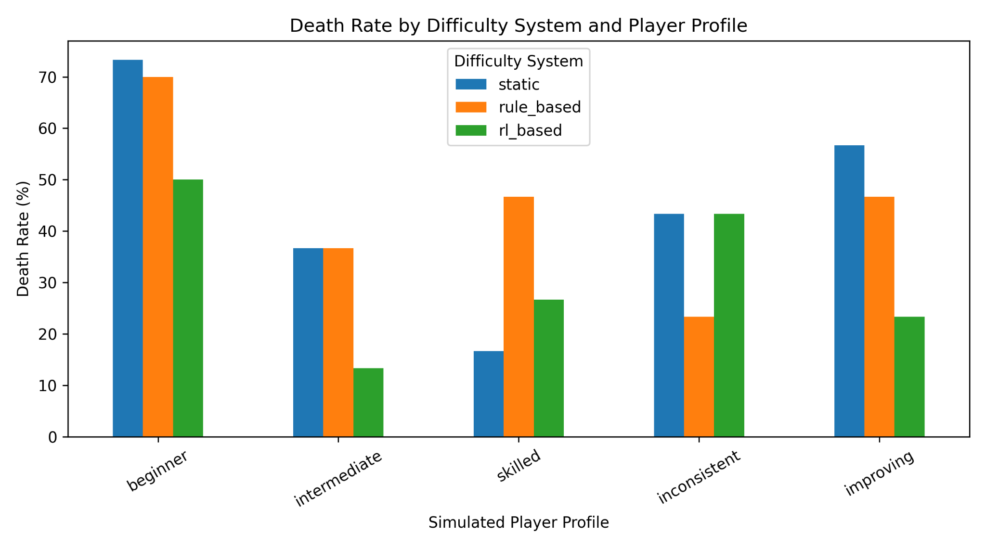
Figure 1. Death rate by difficulty system and simulated player profile.
The death-rate results show a mixed but substantial effect for RL. The RL controller reduced beginner failure from 73.33% under static difficulty and 70.00% under rule-based DDA to 50.00%. For the intermediate profile, RL produced 13.33% deaths compared with 36.67% under both baselines. The improving profile also fell to 23.33%, compared with 56.67% static and 46.67% rule-based.
The result was not uniformly favourable. The skilled profile had a lower death rate under static difficulty (16.67%) than under RL (26.67%), while the inconsistent profile performed best under the rule-based controller (23.33%) and reached 43.33% under RL. These results immediately show why DDA effectiveness cannot be judged from one profile alone.
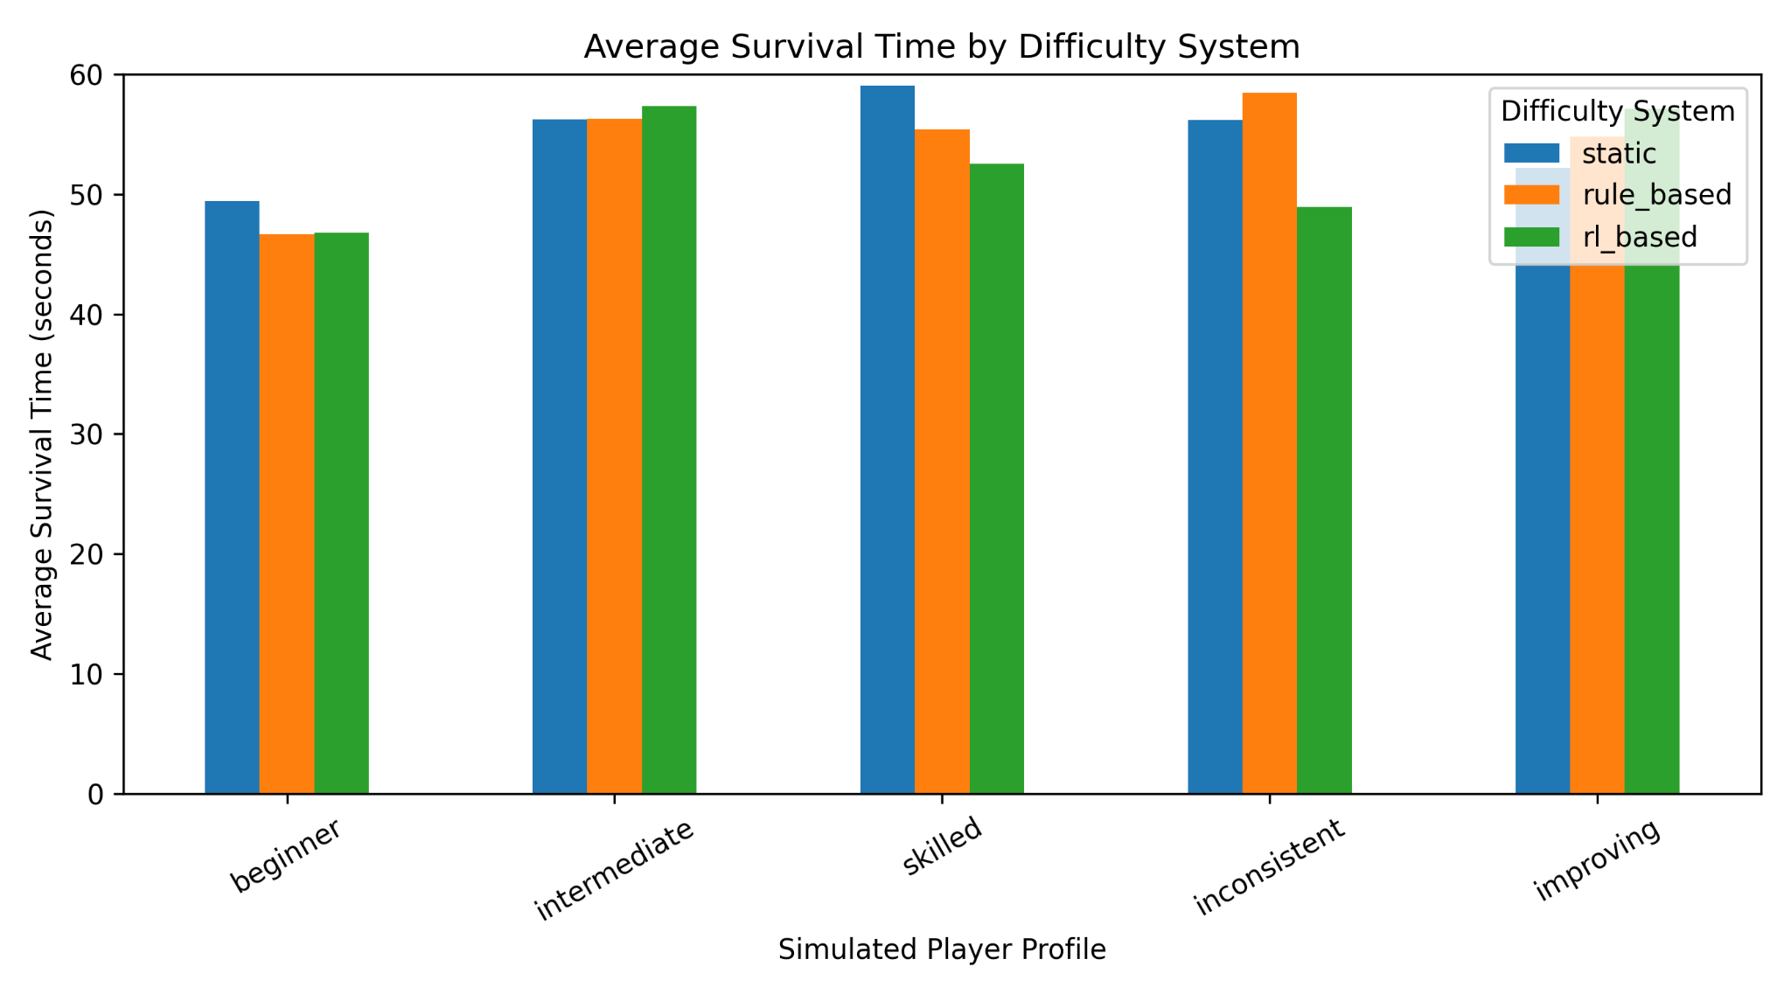
Figure 2. Average survival time by difficulty system and simulated player profile.
Average survival broadly reflects the death-rate pattern. RL produced 57.36 seconds for the intermediate profile and 57.10 seconds for the improving profile, while beginner survival remained lower at 46.80 seconds. Skilled and inconsistent RL survival averaged 52.55 and 48.95 seconds respectively. Because successful runs are capped at 60 seconds, survival time is interpreted as supporting evidence rather than as an unbounded performance measure.

4.2 Target Balance Range
Profile | Rule target % | RL target % | Rule avg diff | RL avg diff | RL changes
Beginner | 47.32 | 49.86 | 4.31 | 3.55 | 12.17
Intermediate | 48.78 | 48.31 | 4.93 | 3.52 | 13.30
Skilled | 46.96 | 39.89 | 5.19 | 4.01 | 12.20
Inconsistent | 50.06 | 49.52 | 4.72 | 4.10 | 12.50
Improving | 46.40 | 55.42 | 4.52 | 3.57 | 13.93
Table 2. Adaptive-system target-range and difficulty behaviour.
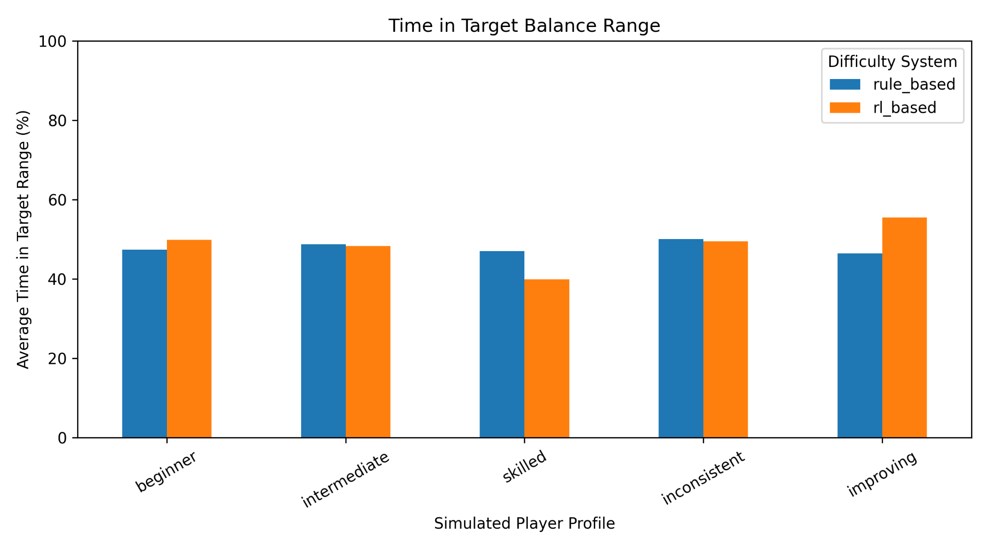
Figure 3. Mean time spent within the target balance range for rule-based and RL-based DDA.
Mean target-range occupancy was similar overall between the two adaptive systems but varied by profile. RL improved the beginner result from 47.32% to 49.86% and the improving profile from 46.40% to 55.42%. Intermediate and inconsistent performance were effectively similar: 48.31% versus 48.78% for intermediate and 49.52% versus 50.06% for inconsistent. The skilled profile was the clearest weakness, with RL reaching 39.89% compared with 46.96% for rule-based DDA.
Across the five profiles, mean target-range occupancy was 48.60% for RL and 47.90% for rule-based DDA. The difference is small, and the profile-level variation prevents a claim that RL consistently dominates the rule-based controller.
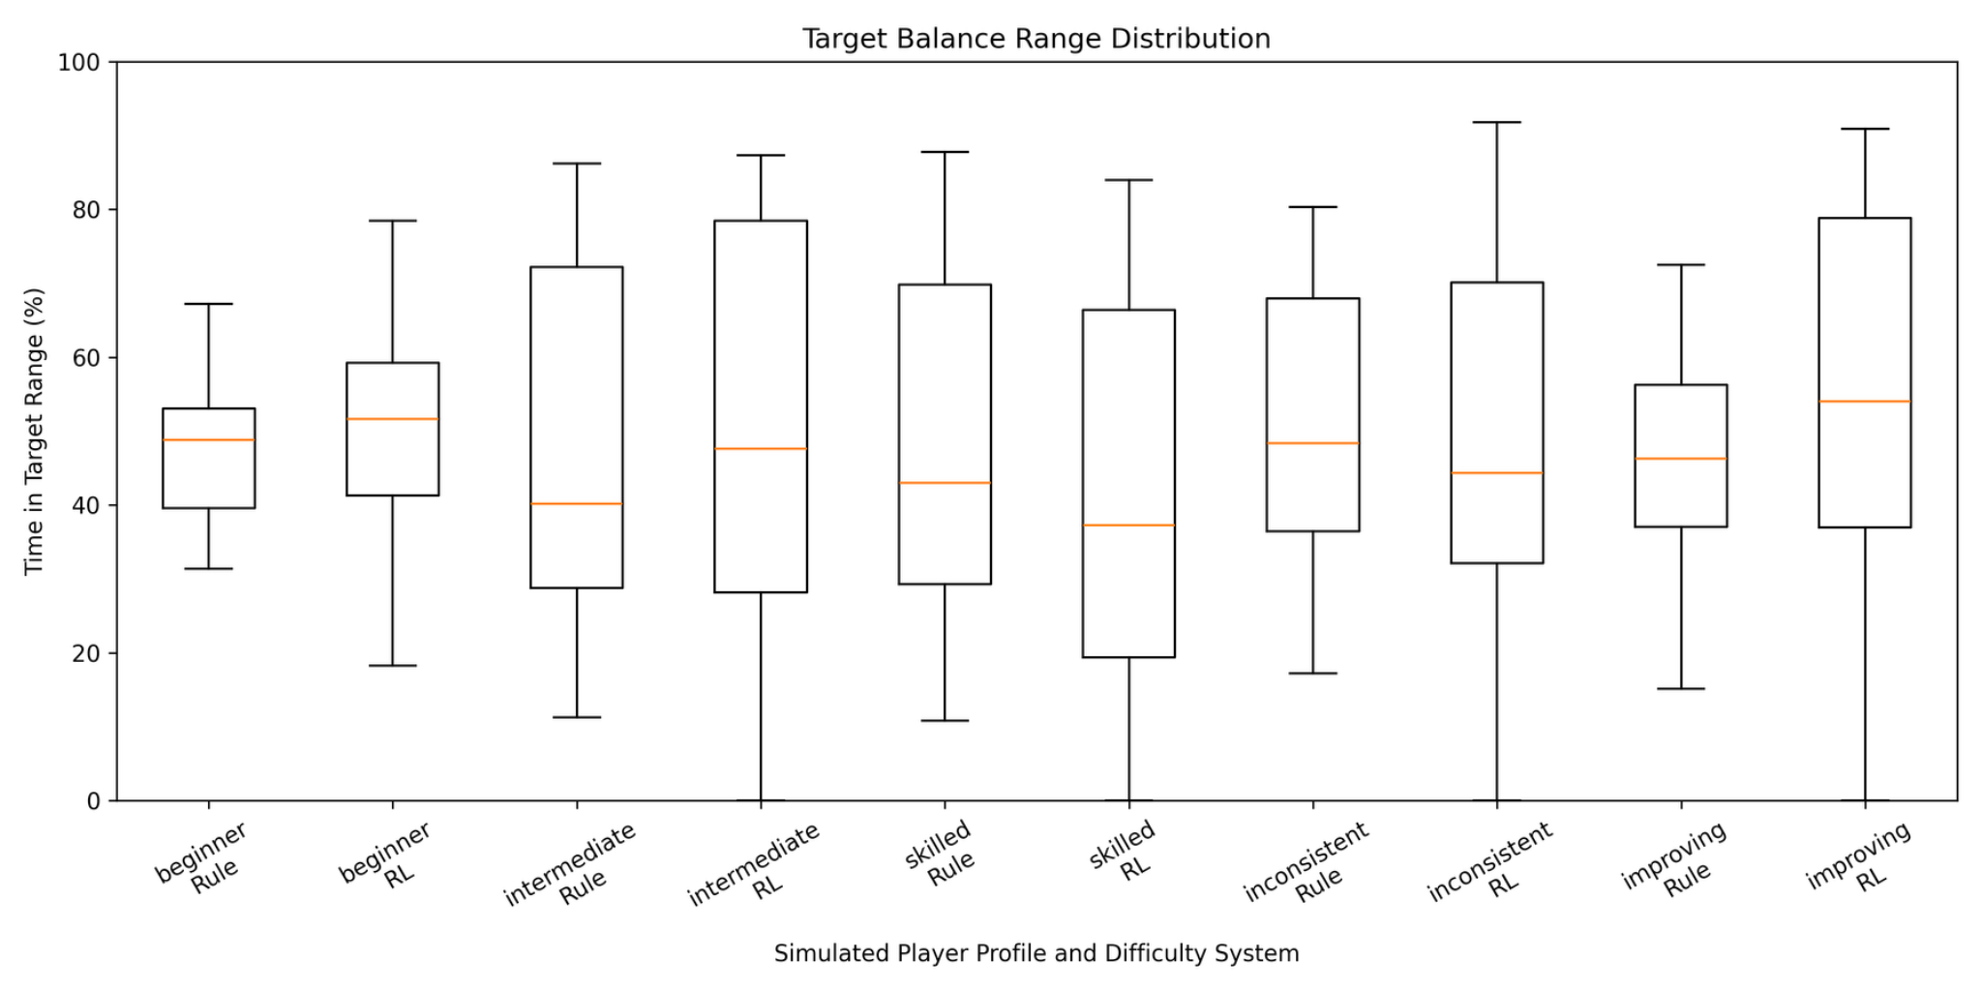
Figure 4. Distribution of target-range occupancy for rule-based and RL-based DDA.
The distribution plot adds an important qualification to the mean values. RL often shows a wider range of episode outcomes, particularly for intermediate, inconsistent and improving profiles. This indicates that the stochastic PPO policy is adaptive but less consistent than the threshold-based controller. The result is therefore compatible with the literature's warning that learning-based DDA introduces additional stability and reward-design challenges (Zheng, 2024).

4.3 Difficulty Level and Adaptation Behaviour
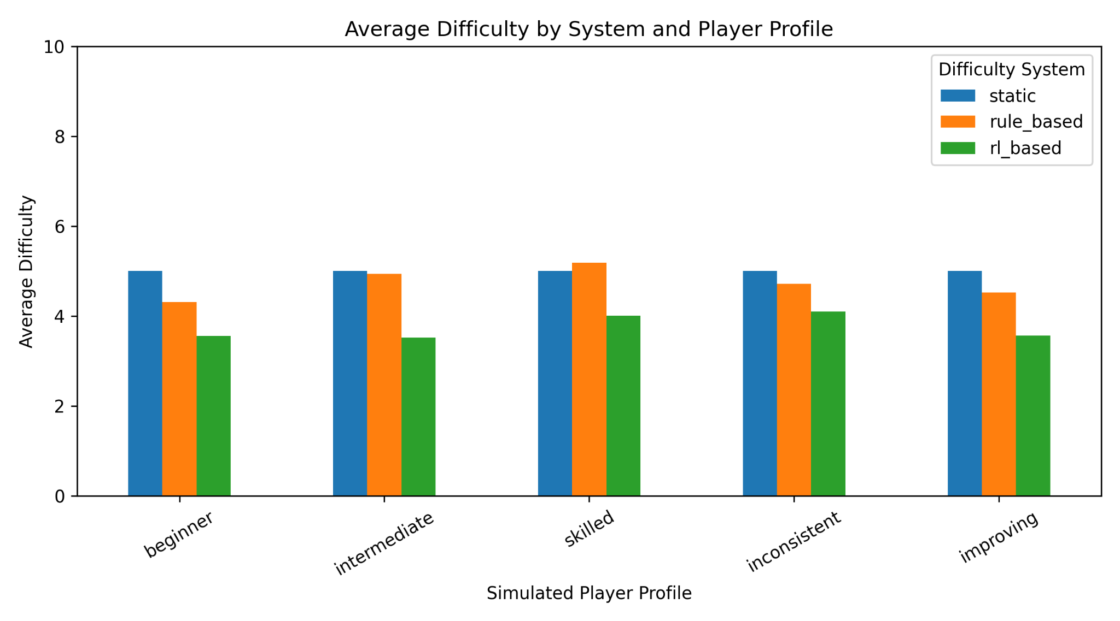
Figure 5. Average difficulty by system and simulated player profile.
The RL policy operated at a lower average difficulty than the static and rule-based systems across every profile. Episode-average difficulty ranged from 3.52 for intermediate to 4.10 for inconsistent. This lower mean does not imply that the policy simply selected one easy fixed setting, because its within-episode range and change frequency show substantial movement across the scale.
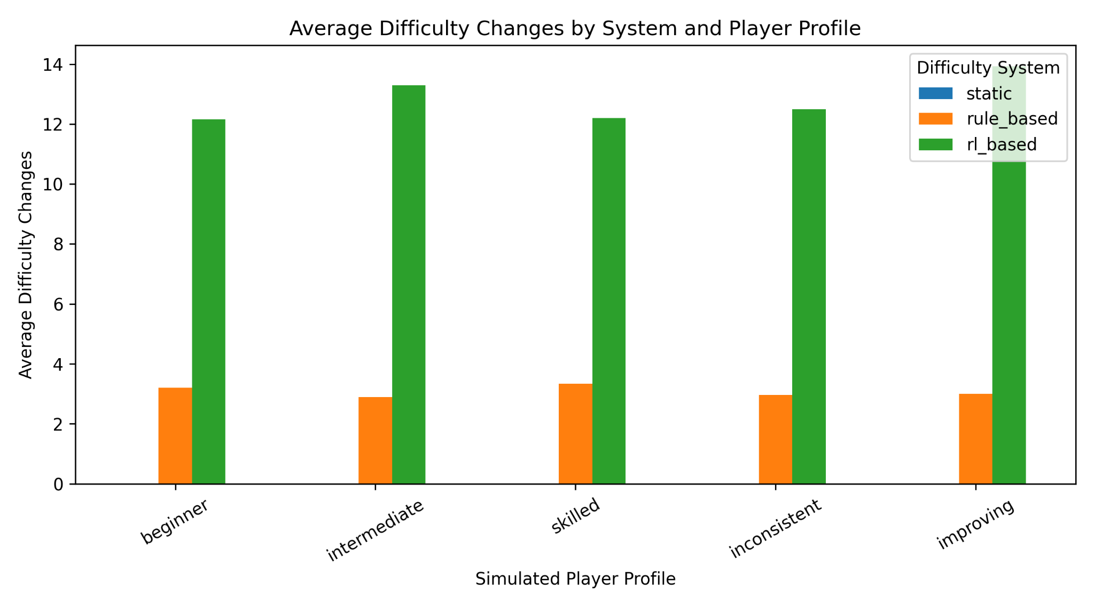
Figure 6. Average number of difficulty changes by system and simulated player profile.
Rule-based DDA changed difficulty approximately three times per episode, whereas RL changed difficulty between 12.17 and 13.93 times on average depending on the profile. Static difficulty produced zero changes by design. The RL policy was therefore much more reactive, but reactivity alone is not treated as a quality measure; it must be considered alongside target occupancy and failure.
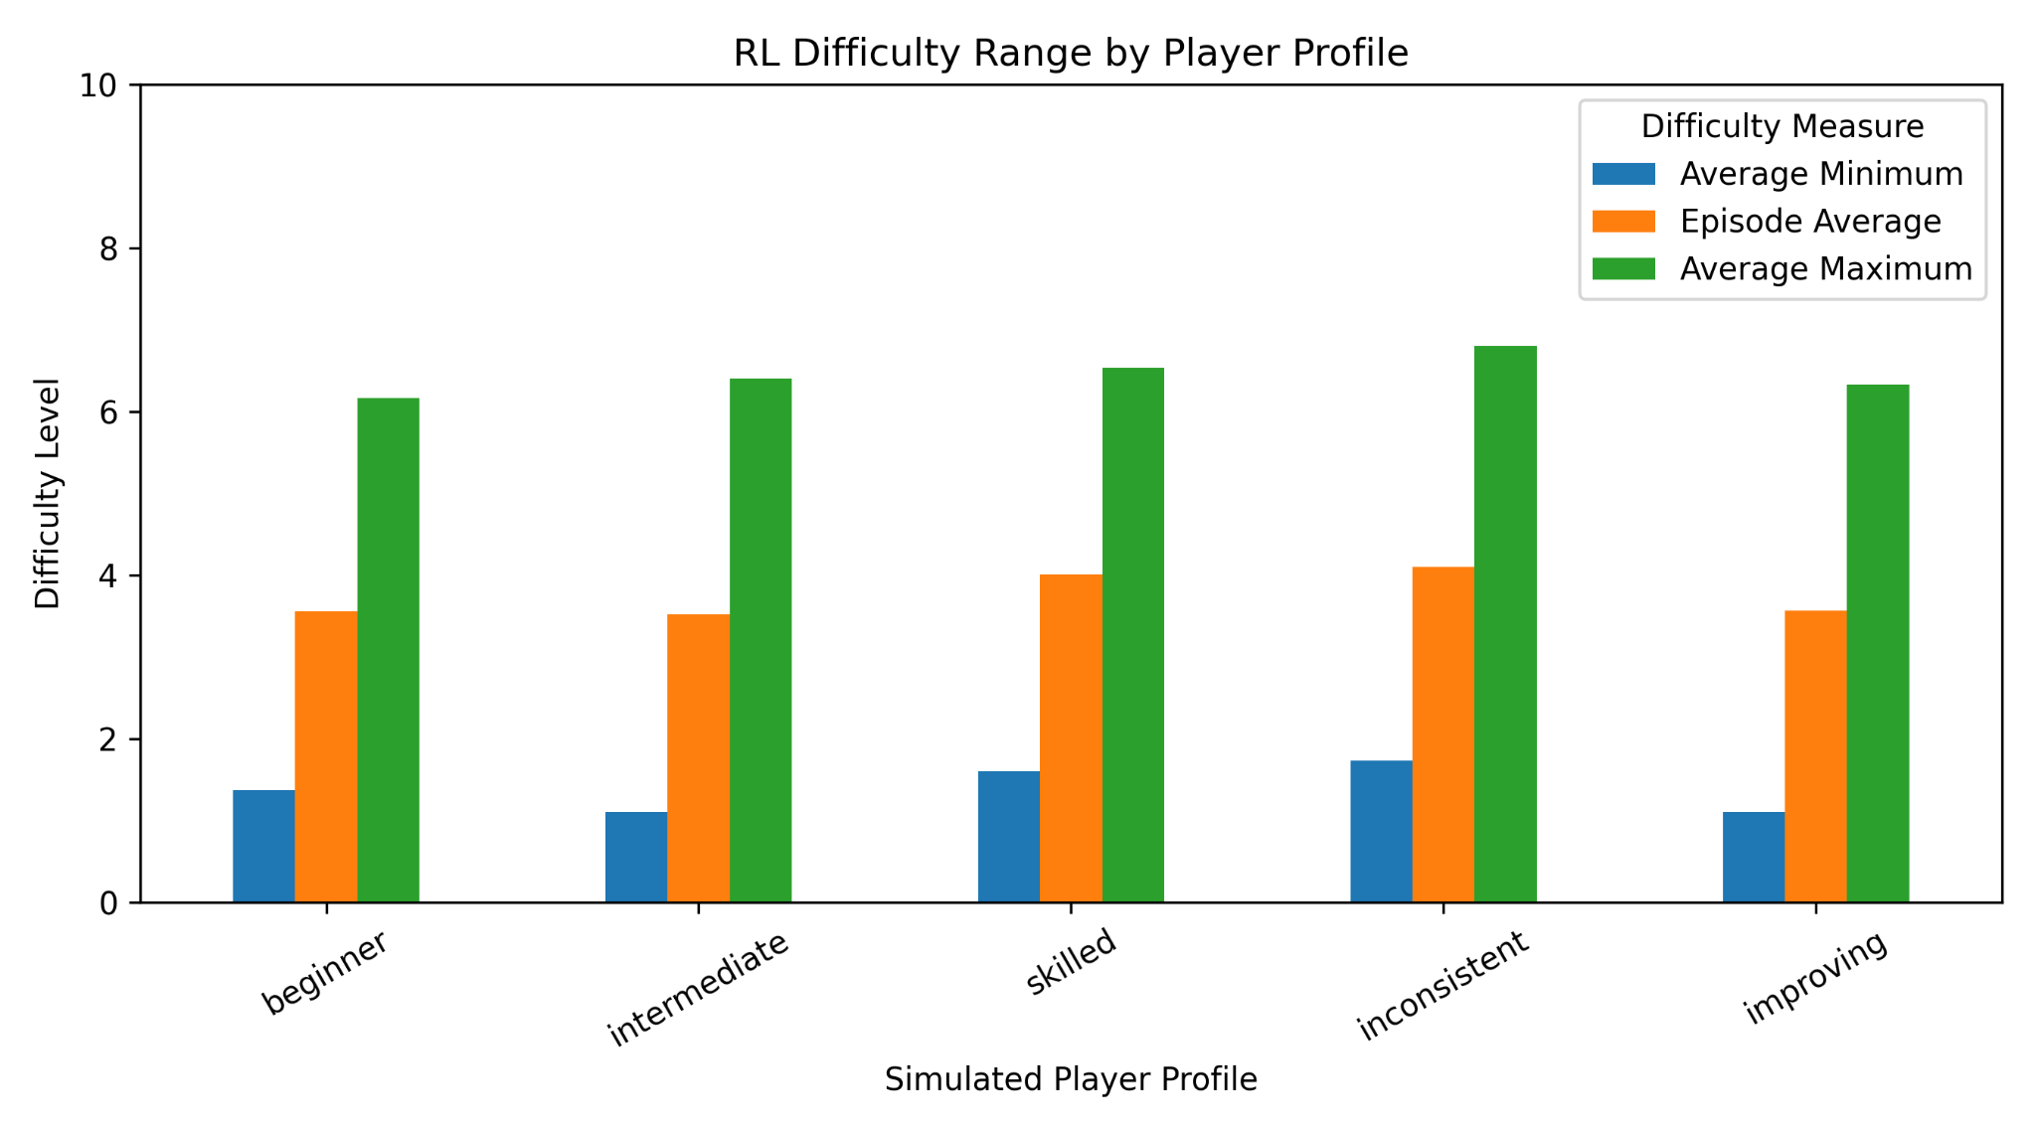
Figure 7. Mean minimum, episode-average and mean maximum difficulty reached by the RL controller.
The range analysis confirms that RL did not behave like a static difficulty around level 3-4. Mean minimum difficulty was approximately 1.1-1.7 across profiles, while mean maximum difficulty was approximately 6.2-6.8. This demonstrates repeated movement through a substantial part of the 0-10 scale, consistent with the sequential-adjustment view of DDA used by Climent et al. (2024).

4.4 Improving Profile
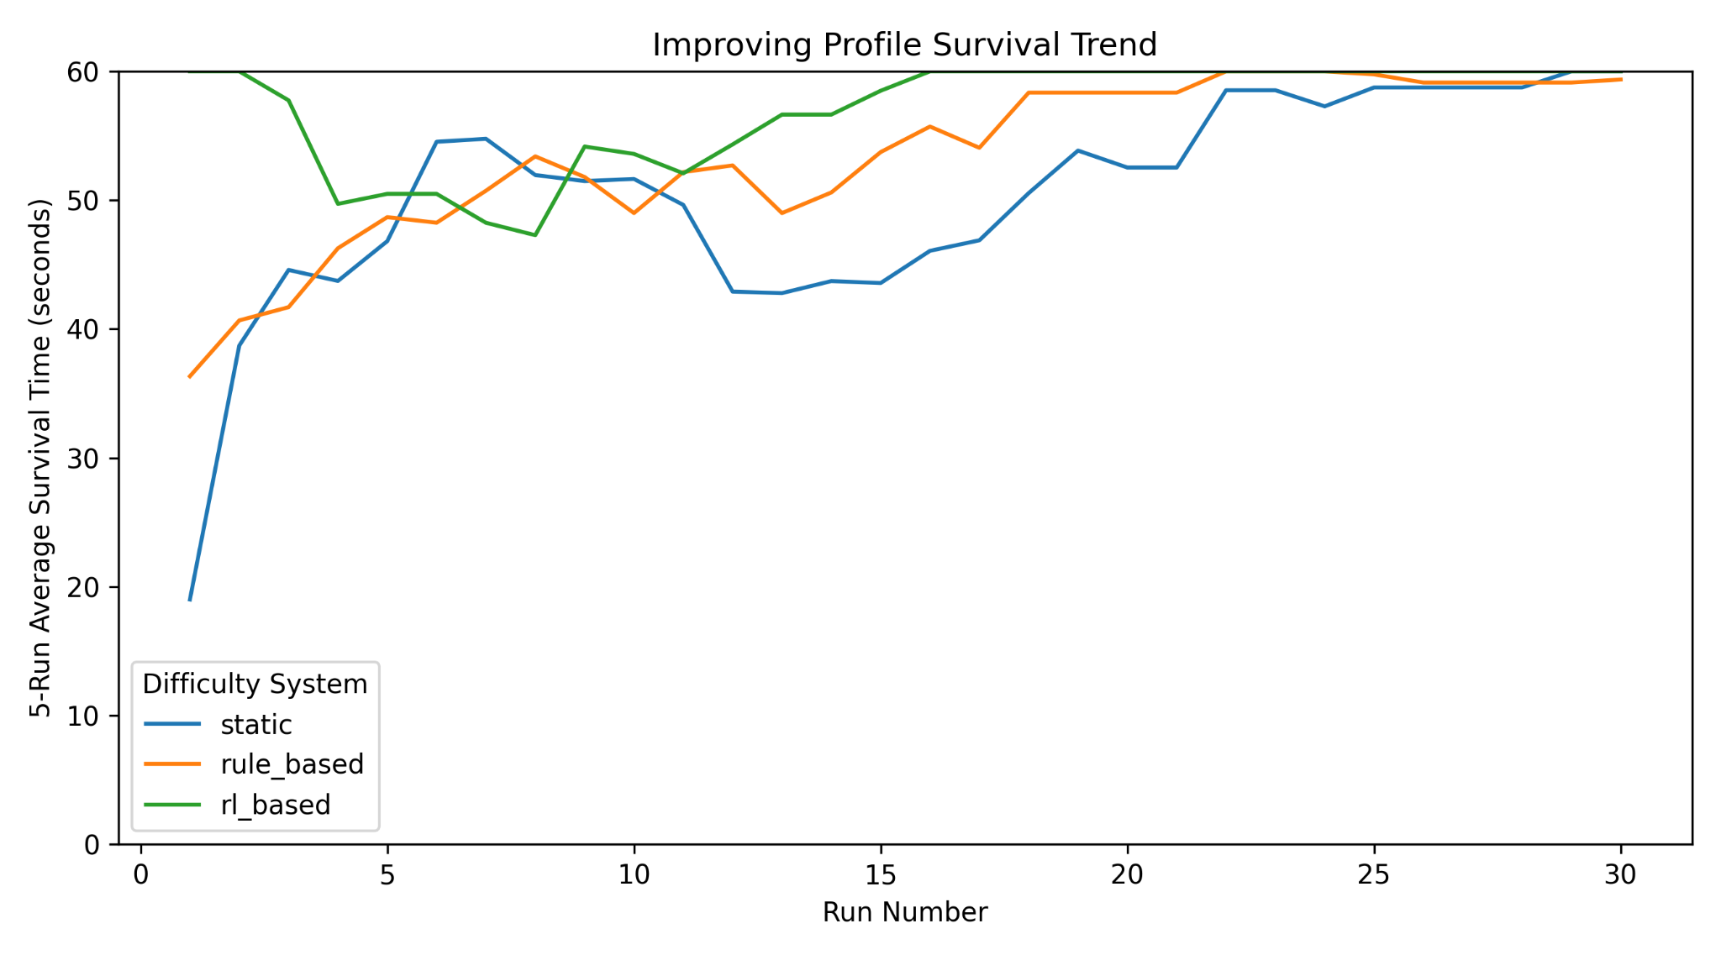
Figure 8. Five-run rolling survival trend for the improving simulated player profile.
The improving profile shows that all three systems approach long survival times as the underlying player behaviour becomes stronger. RL begins with relatively high survival, dips during the middle portion of the progression, and later returns to near-maximum survival. The response is therefore not monotonic and does not show a simple 'player improves, difficulty rises proportionally' pattern.
This is important for H2. RL clearly reacts throughout the sequence, but the evidence does not show that its adaptation tracks improvement more cleanly than the rule-based system. The improving profile instead illustrates both the flexibility and variability of stochastic policy control.
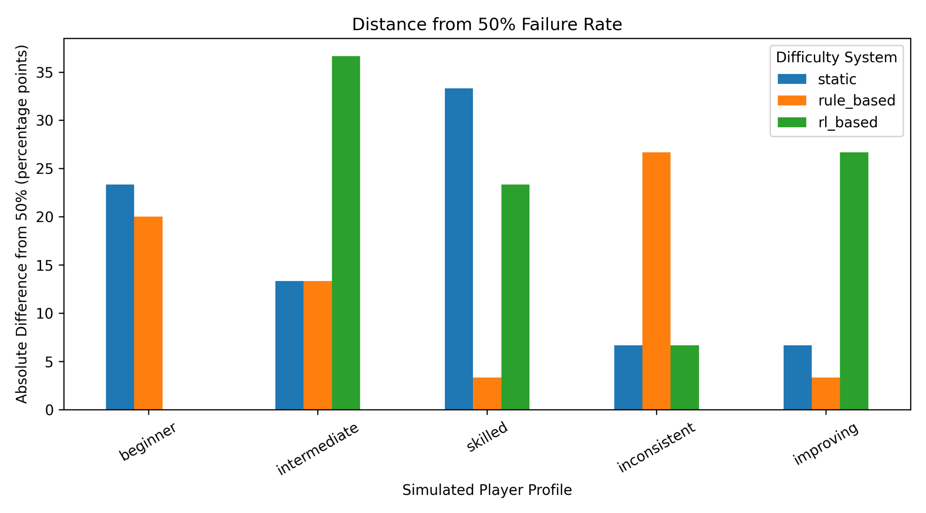
Figure 9. Absolute distance from a 50% failure-rate reference.
Climent et al. (2024) use an approximately balanced win/loss ratio as one outcome for DDA, so a 50% failure reference was included as a supplementary comparison. The present systems do not show one universal winner. RL is exactly at 50% for the beginner profile and relatively close for inconsistent, but it is much further from 50% for intermediate and improving. Rule-based DDA is closest for skilled and improving. This reinforces the decision not to equate 'lower death rate' with 'better balance' automatically.

4.5 RL Policy Diagnostics
The final PPO model also produced a practical deployment finding that was not visible from the static and rule-based comparisons. During training, PPO learns a stochastic action distribution. When the same model was evaluated greedily, the most probable action could dominate repeatedly, causing policy collapse.
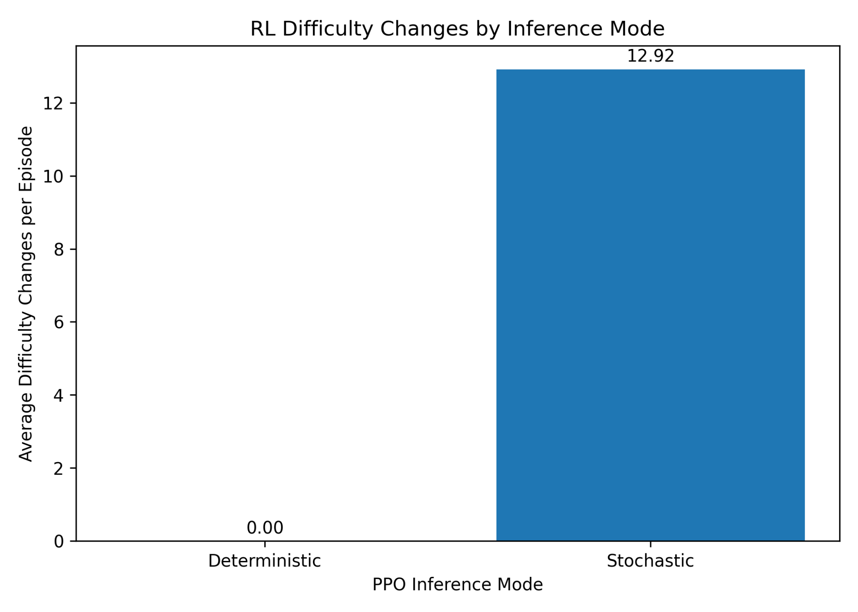
Figure 10. Average RL difficulty changes under deterministic and stochastic PPO inference.
Deterministic evaluation produced 0.00 difficulty changes per episode in the final diagnostic, whereas stochastic evaluation produced 12.92. The deterministic policy therefore remained at the starting difficulty of 5 and was not performing DDA. Stochastic inference was retained for the final experimental comparison because it preserved the sequential adjustment behaviour the PPO policy exhibited during training.
This distinction is methodologically relevant. Climent et al. (2024) emphasise that RL-DDA design must connect learned decisions to actual difficulty regulation. A policy that produces acceptable survival while never changing difficulty would fail that functional criterion even if its headline death rate looked favourable.
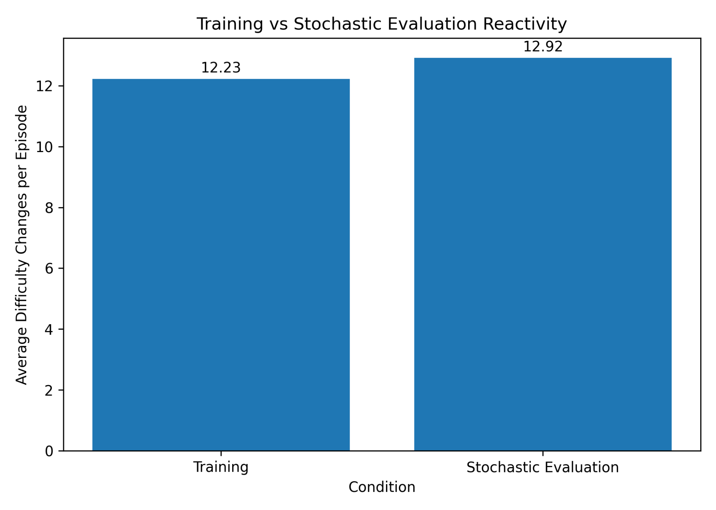
Figure 11. Difficulty-change frequency during PPO training and stochastic evaluation.
Training and stochastic evaluation were closely aligned in reactivity: 12.23 changes per episode during training and 12.92 during stochastic evaluation. Average difficulty was also similar, at 3.45 in training and 3.79 in the diagnostic stochastic evaluation. This reduces concern that the deployed stochastic policy is behaving as an unrelated random controller; it samples from the learned PPO action distribution and reproduces the broad difficulty behaviour observed during training.
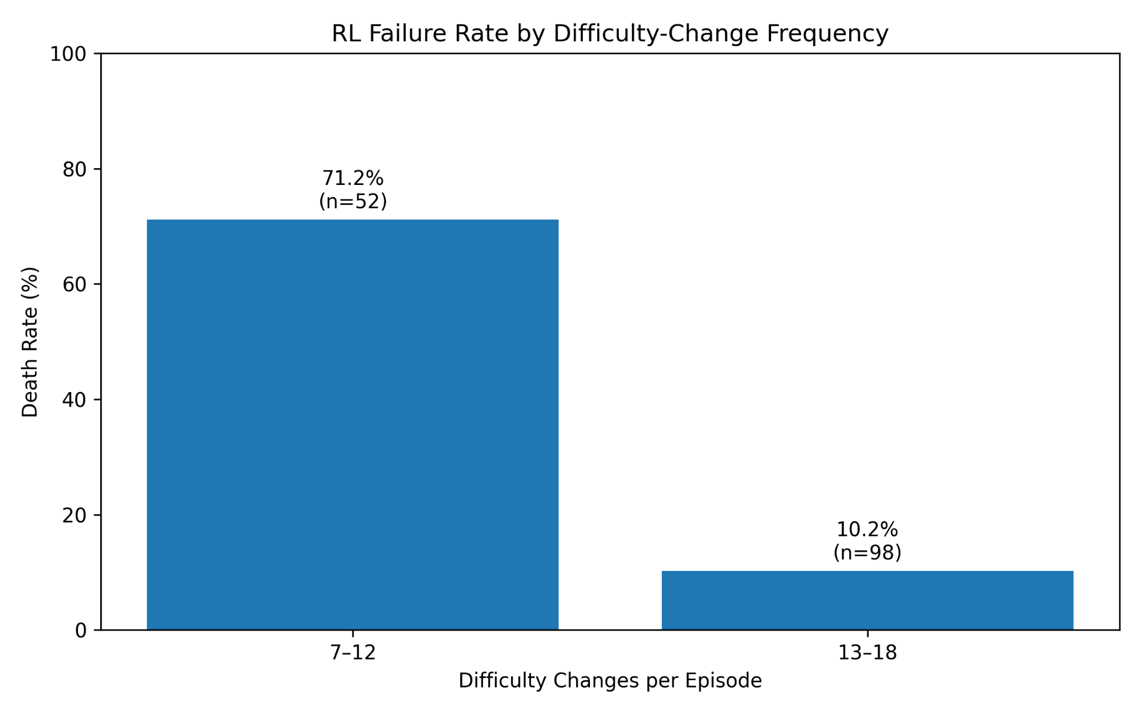
Figure 12. RL failure rate by difficulty-change frequency in the final evaluation episodes.
The final RL runs show a strong association between controller reactivity and outcome. Episodes with 7-12 difficulty changes had a 71.2% failure rate (n=52), whereas episodes with 13-18 changes had a 10.2% failure rate (n=98). This does not establish that additional changes directly cause survival, because difficult episodes may also terminate before the controller has time to make more adjustments. Nevertheless, it shows that the low-reactivity pattern is associated with poor outcomes and helps explain why deterministic collapse was unsuitable for final evaluation.

4.6 Hypothesis Evaluation

4.6.1 H1: Maintaining the Target Balanced Range
H1 is partially supported. RL produced the lowest overall mean death rate across profiles (31.33%, compared with 45.33% static and 44.67% rule-based) and substantially improved beginner, intermediate and improving failure outcomes. It also produced slightly higher mean target-range occupancy than rule-based DDA when averaged across the five profiles (48.60% versus 47.90%).
However, the advantage was not consistent. Rule-based DDA performed better for the inconsistent profile, static difficulty produced the lowest skilled failure rate, and RL had the lowest target-range occupancy for the skilled profile. The target-range distribution also showed greater variability for several RL conditions. H1 is therefore supported as evidence of useful RL balancing behaviour, but not as evidence that RL is consistently superior to both baselines.

4.6.2 H2: Adapting Across Player Profiles
H2 is also partially supported. RL was clearly adaptive in a behavioural sense: it changed difficulty roughly four times as often as the rule-based system and traversed a broad difficulty range for every profile. Its death-rate variation across profiles was also smaller than that of the static baseline, indicating that outcomes were less dominated by a single fixed challenge level.
At the same time, 'more changes' did not always translate into better profile-specific balance. The inconsistent profile remained a weakness and the skilled profile spent less time in the target range under RL than under the rule-based controller. The improving profile showed active adjustment but no simple monotonic tracking of skill progression. H2 is therefore only partially supported: PPO demonstrated flexible cross-profile adaptation, but the adaptation was not consistently more effective than rule-based DDA on every measure.

4.7 Discussion in Relation to the Anchor Paper
The results support the central methodological claim taken from Climent et al. (2024): DDA can be framed as an RL problem in which states represent gameplay performance, actions alter difficulty and rewards encode desirable challenge outcomes. The present PPO controller successfully learned an actively changing difficulty policy rather than merely controlling the player or optimising an enemy for victory.
The comparison also exposes an important difference. Climent et al. (2024) report a 2Q-table design that approximately balances winning and losing while extending rounds. The present PPO policy did not converge to a uniform 50% failure outcome across all simulated profiles. Instead, it produced a lower overall failure rate, highly reactive difficulty control and profile-dependent target-range performance. This suggests that the exact operational definition of 'balanced' and the reward/inference design remain decisive even when the high-level RL-DDA formulation is shared.
The inference-mode finding extends the practical deployment discussion. Stochastic PPO sampling retained adaptive behaviour, while greedy selection collapsed to a fixed action pattern. This is not a failure of the DDA framing itself, but it is a concrete example of the implementation challenges highlighted by Climent et al. (2024) and by broader RL-DDA reviews such as Zheng (2024): the learned policy, reward design and deployment rule must all be considered together.

5. Conclusion and Future Work

5.1 Conclusion
This dissertation evaluated reinforcement-learning-based DDA in a Godot 2D survival prototype using controlled simulated player behaviours. The final experiment compared static difficulty, manually designed rule-based DDA and PPO-based DDA across five profiles and 450 evaluation episodes.
The RL controller demonstrated genuine dynamic behaviour under stochastic inference. It changed difficulty frequently, explored a broad range of the 0-10 scale and reduced overall death rate relative to both baselines. It produced particularly strong failure-rate results for the beginner, intermediate and improving profiles. However, it was not consistently superior: rule-based DDA performed better for inconsistent behaviour, static difficulty remained easier for the skilled profile, and target-range occupancy showed only a small overall advantage for RL with greater variability.
The study therefore does not support a simple conclusion that reinforcement learning is always better than rule-based DDA. Instead, it shows that PPO can provide flexible adaptive control in Godot, but that reward formulation, inference mode and profile-specific behaviour strongly affect the outcome. This conclusion is consistent with the anchor framework of Climent et al. (2024), which treats RL-DDA design as the coordinated definition of states, actions and rewards rather than as an algorithm choice alone.

5.2 Limitations
The most important limitation is the absence of human participants. Simulated profiles make controlled repeated experiments possible, but they cannot measure subjective enjoyment, frustration, fairness, boredom or flow. Results should therefore be interpreted as technical gameplay-balance evidence rather than a direct claim about player experience.
The profiles are also simplified scripted models. Although inconsistent and improving variants increase behavioural diversity, they do not reproduce strategic learning, fatigue, risk preference or the unpredictability of real players.
The game environment is intentionally small. A single turret and projectile-dodging task produce a controlled DDA problem, but larger games may contain multiple difficulty dimensions, objectives and player strategies.
The target-range metric was not logged during the earliest static baseline runs, preventing a complete three-system comparison on that measure. In addition, stochastic PPO inference was required to preserve adaptive behaviour. This is a practical limitation because repeated sampling introduces policy variability, while deterministic deployment collapsed to non-adaptive behaviour.
Finally, the strong association between higher difficulty-change frequency and lower failure should not be interpreted causally. Episodes that end early naturally provide fewer opportunities for adjustment, so future work should analyse reactivity using time-normalised change rates and longer controlled sequences.

5.3 Future Work
Future work should first validate the system with human participants. This would allow objective metrics such as target-range occupancy and failure rate to be compared with perceived challenge, enjoyment and fairness.
The RL action space could be expanded from a single difficulty level to separate control over projectile speed, fire interval, damage and spread. This would move closer to a multidimensional DDA problem, although it would also increase the action space and training burden highlighted by Climent et al. (2024).
A continuous-action policy could also be investigated, alongside entropy scheduling or alternative policy architectures, to test whether deterministic deployment can retain meaningful adaptation. The current stochastic/deterministic contrast suggests that inference design is an important research question in its own right.
More sophisticated simulated players could incorporate explicit learning, strategic changes, fatigue or risk-taking. The same methodology could then be applied to other genres or compared directly with Unity-based RL workflows to determine how much of the observed behaviour is specific to the Godot implementation.

References
Beeching, E., Debangoye, J., Simonin, O. and Wolf, C. (2021) Godot Reinforcement Learning Agents. arXiv [preprint]. Available from: https://arxiv.org/abs/2112.03636 [Accessed 1 September 2026].
Castro Lopes, J. and Lopes, R.P. (2022) A review of dynamic difficulty adjustment methods for serious games. In: Pereira, A.I., Košir, A., Fernandes, F.P., Pacheco, M.F., Teixeira, J.P. and Lopes, R.P., eds. Optimization, Learning Algorithms and Applications: Second International Conference, OL2A 2022, Proceedings. Cham: Springer, pp. 144-159. doi:10.1007/978-3-031-23236-7_11.
Climent, L., Longhi, A., Arbelaez, A. and Mancini, M. (2024) A framework for designing reinforcement learning agents with dynamic difficulty adjustment in single-player action video games. Entertainment Computing [online]. 50: 100686. doi:10.1016/j.entcom.2024.100686. [Accessed 1 September 2026].
Fisher, N. and Kulshreshth, A.K. (2024) Exploring dynamic difficulty adjustment methods for video games. Virtual Worlds [online]. 3 (2), pp. 230-255. doi:10.3390/virtualworlds3020012. [Accessed 1 September 2026].
Jeon, H.-C., Baek, I.-C., Bae, C.-M., Park, T., You, W., Ha, T., Jung, H., Noh, J., Oh, S. and Kim, K.-J. (2024) RaidEnv: Exploring new challenges in automated content balancing for boss raid games. IEEE Transactions on Games [online]. 16 (3), pp. 645-658. doi:10.1109/TG.2023.3335399. [Accessed 1 September 2026].
Mortazavi, F., Moradi, H. and Vahabie, A.-H. (2024) Dynamic difficulty adjustment approaches in video games: a systematic literature review. Multimedia Tools and Applications [online]. 83 (35), pp. 83227-83274. doi:10.1007/s11042-024-18768-x. [Accessed 1 September 2026].
Oliveira, T.N. de and Chaimowicz, L. (2023) Investigating reinforcement learning for dynamic difficulty adjustment. In: Proceedings of the 22nd Brazilian Symposium on Games and Digital Entertainment. Association for Computing Machinery, pp. 66-75. doi:10.1145/3631085.3631229.
Pfau, J., Smeddinck, J.D. and Malaka, R. (2020) Enemy within: long-term motivation effects of deep player behavior models for dynamic difficulty adjustment. In: Proceedings of the 2020 CHI Conference on Human Factors in Computing Systems. Association for Computing Machinery, pp. 1-10. doi:10.1145/3313831.3376423.
Rahimi, M., Moradi, H., Vahabie, A.-H. and Kebriaei, H. (2023) Continuous reinforcement learning-based dynamic difficulty adjustment in a visual working memory game. arXiv [preprint]. Available from: https://arxiv.org/abs/2308.12726[Accessed 1 September 2026].
Ranaweera, M. and Mahmoud, Q.H. (2024) Deep reinforcement learning with Godot game engine. Electronics [online]. 13 (5): 985. doi:10.3390/electronics13050985. [Accessed 1 September 2026].
Romero-Mendez, E.A., Santana-Mancilla, P.C., Garcia-Ruiz, M., Montesinos-Lopez, O.A. and Anido-Rifon, L.E. (2023) The use of deep learning to improve player engagement in a video game through a dynamic difficulty adjustment based on skills classification. Applied Sciences [online]. 13 (14): 8249. doi:10.3390/app13148249. [Accessed 1 September 2026].
Rupp, F., Eberhardinger, M. and Eckert, K. (2024) Simulation-driven balancing of competitive game levels with reinforcement learning. IEEE Transactions on Games [online]. 16 (4), pp. 903-913. doi:10.1109/TG.2024.3399536. [Accessed 1 September 2026].
Souza, C.H.R., Nascimento, D.F., Berretta, L.O. and Carvalho, S.T. (2025) Solutions for dynamic difficulty adjustment in digital games: a systematic literature review. Entertainment Computing [online]. 55: 101041. doi:10.1016/j.entcom.2025.101041. [Accessed 1 September 2026].
Zheng, T. (2024) Dynamic difficulty adjustment using deep reinforcement learning: a review. Applied and Computational Engineering [online]. 71, pp. 157-162. doi:10.54254/2755-2721/71/20241633. [Accessed 1 September 2026].

