

Itec 224

Composition diagram

Created by:

Amirhossein rahnama

Shahriar minaee

Introduction

First of all that was too hard when we started but when we got a logic of it

Made it easier for us although we are beginner but we tried our best

The project was big there was a some part we could do but it wasn’t

Included .

We started with photo of the places we worked on and we tried to cover all

Partes secondly we moved to ERD which is means , entity relationship

diagram (ERD) shows the relationships of entity sets stored in a database. An

entity in this context is an object, a component of data. An entity set is a

collection of similar entities. These entities can have attributes that define its

properties. and we drew it by visio and then documentation of our ERD

which is we defiened every single part of our ERD in it and at the end we

moved to our composition diagramwhich is Used to visually describe the

problem domain in terms of types of objects (classes) related to each other in

different ways.

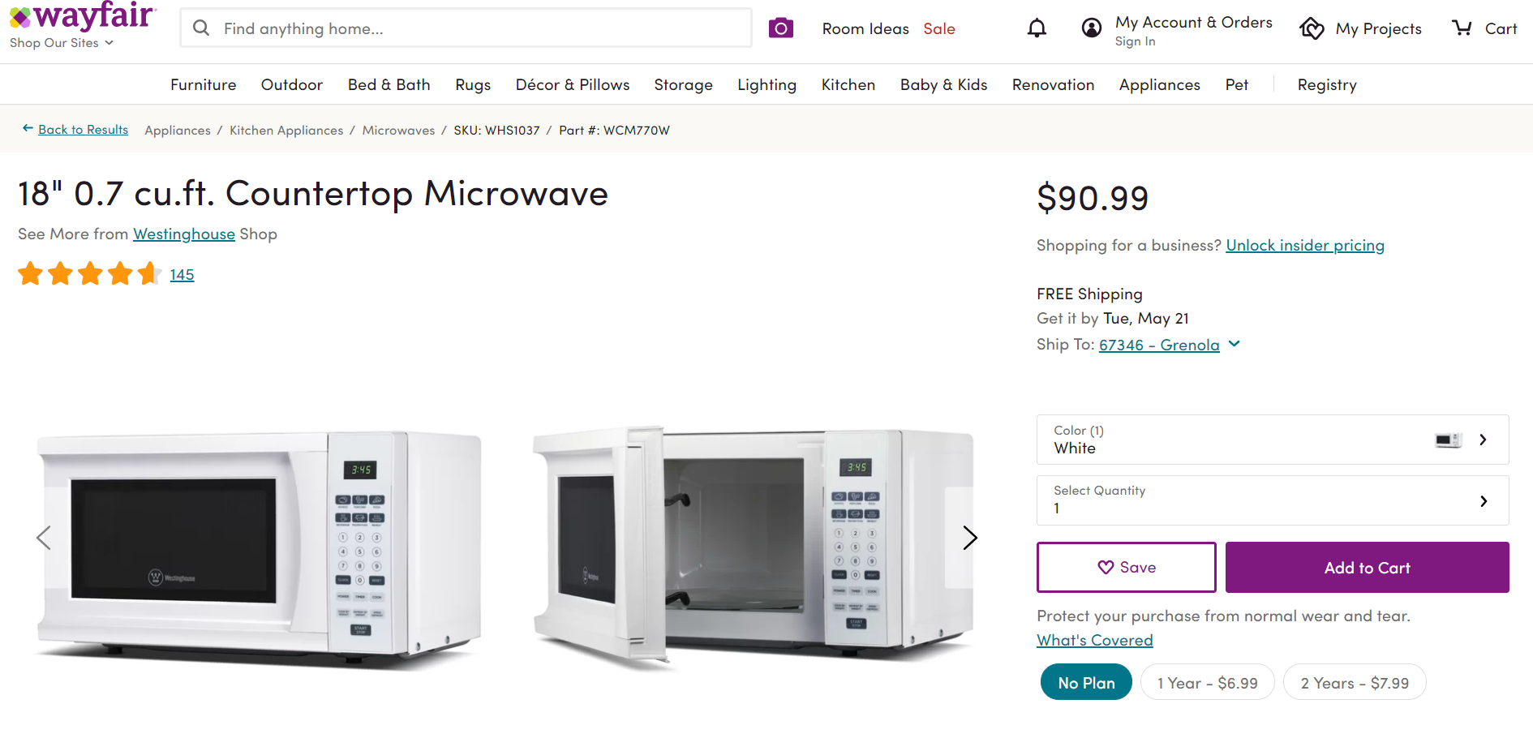

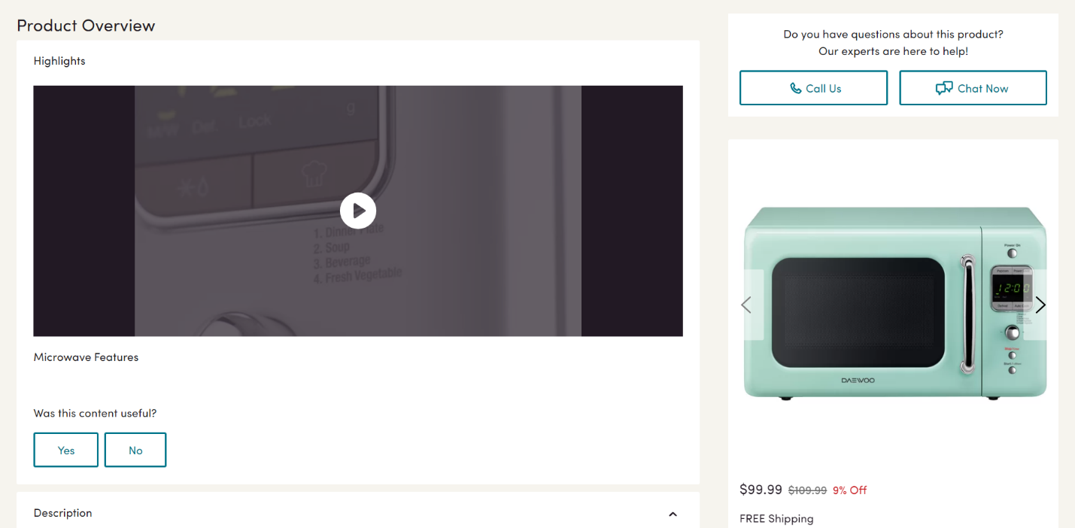

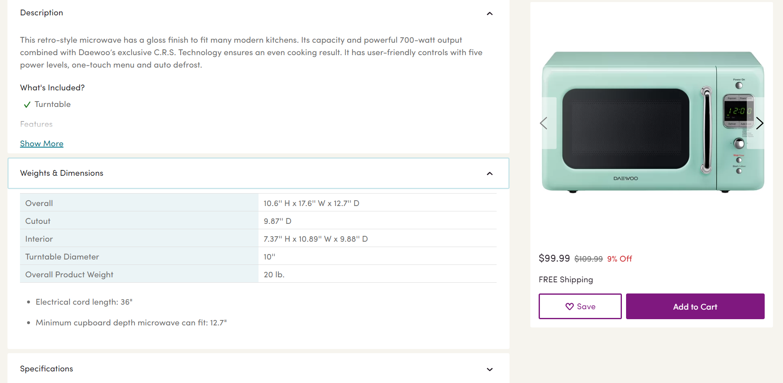

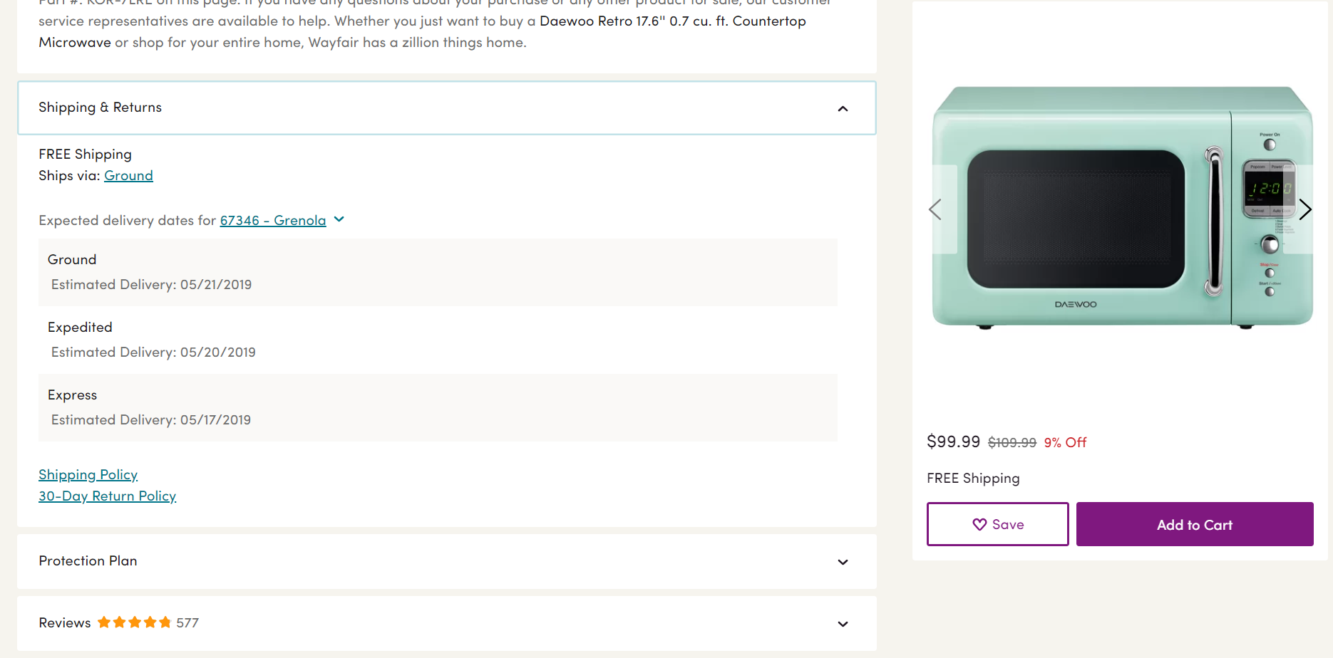

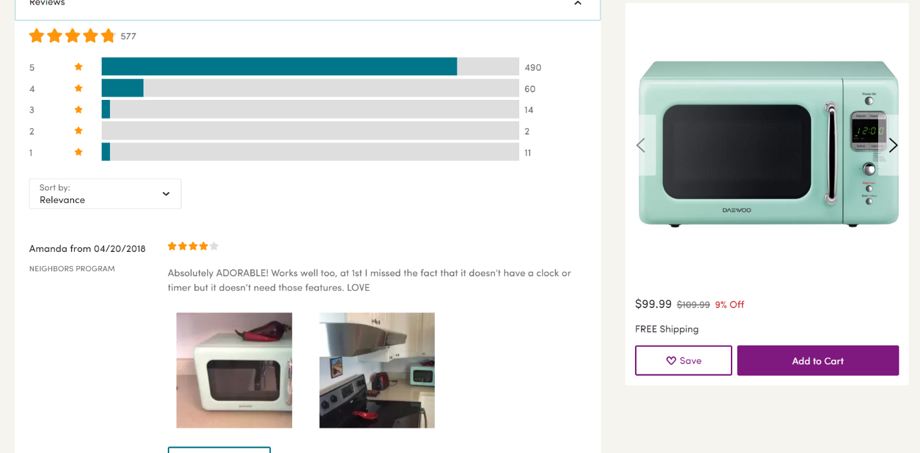

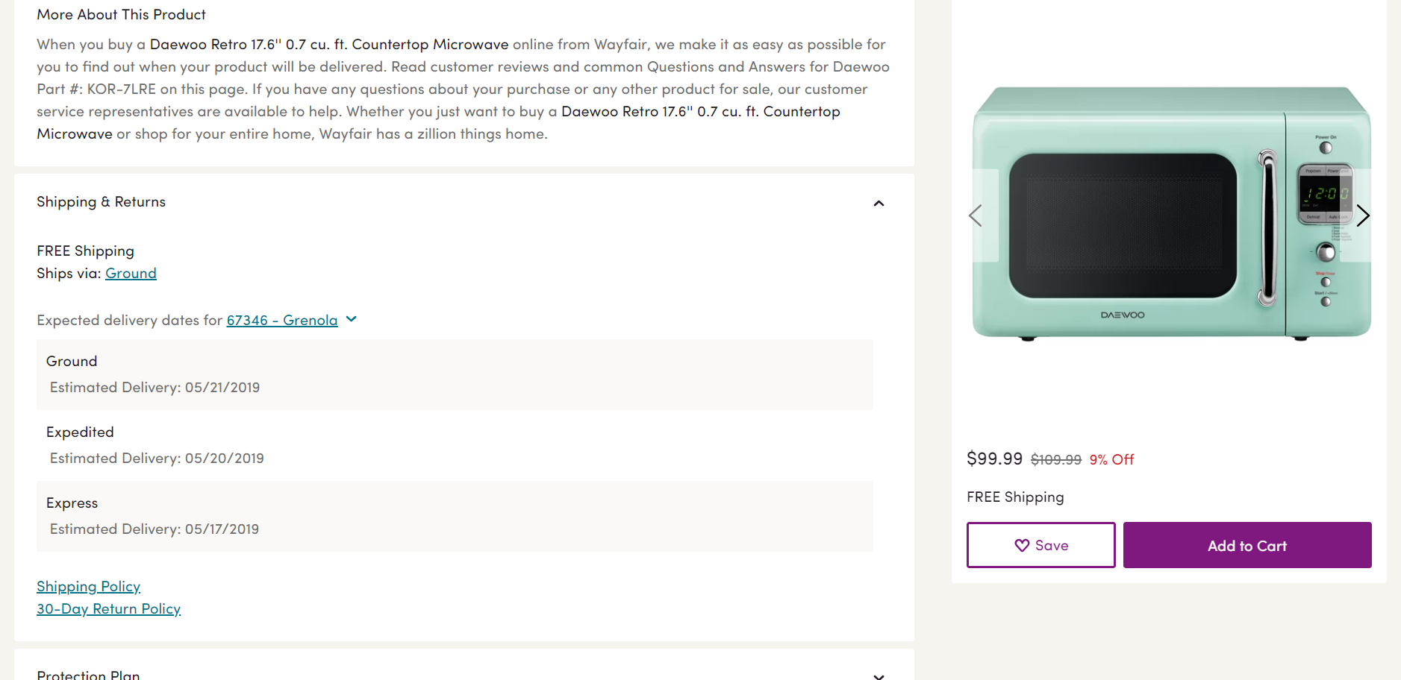

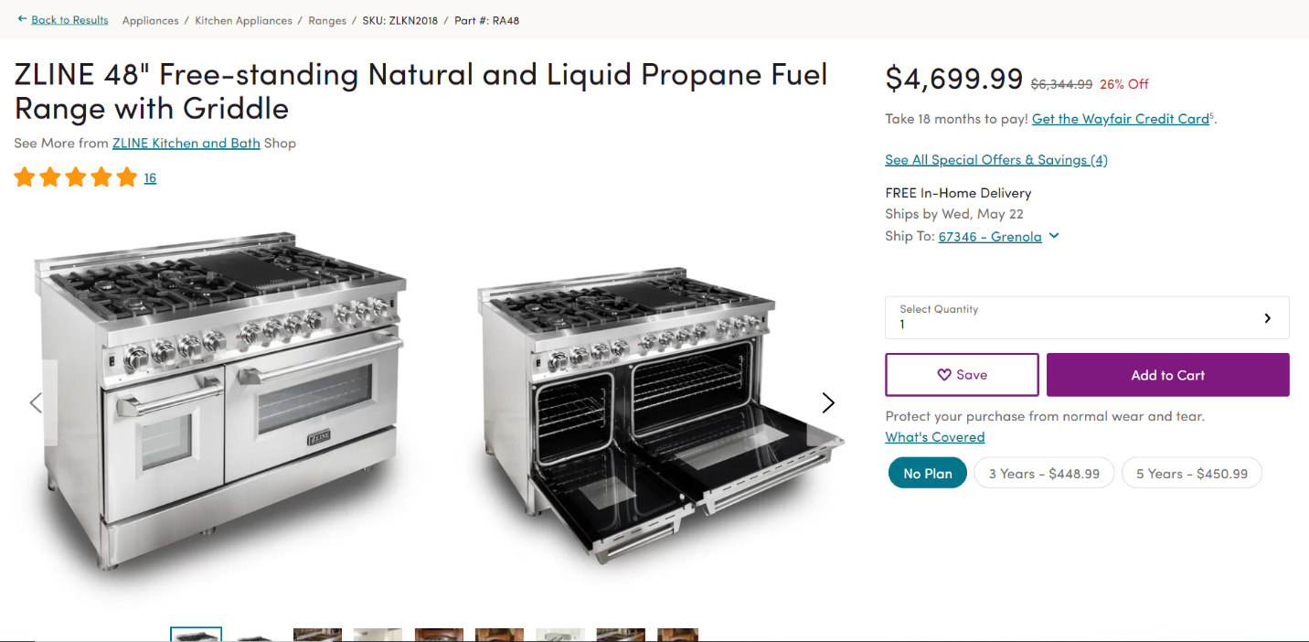

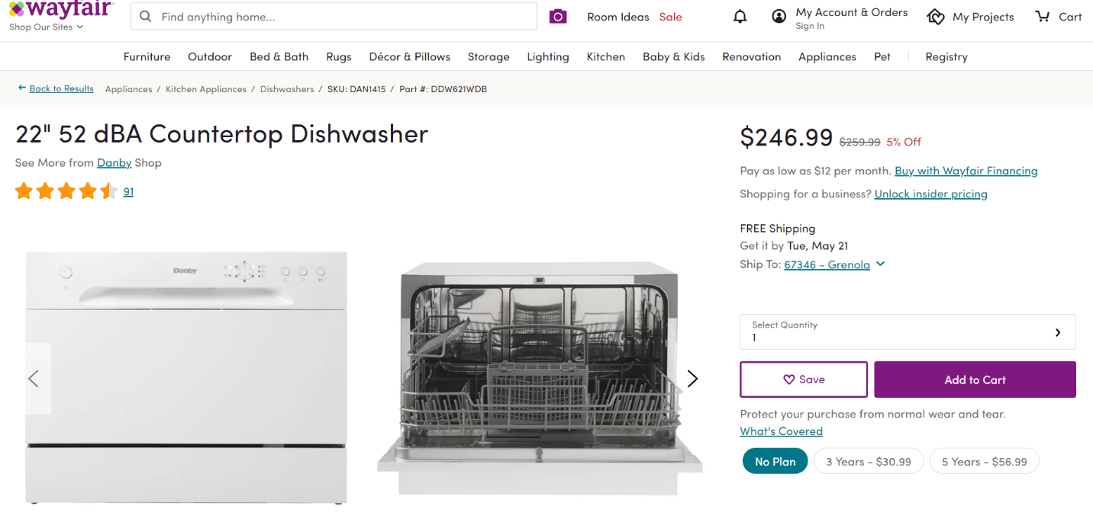

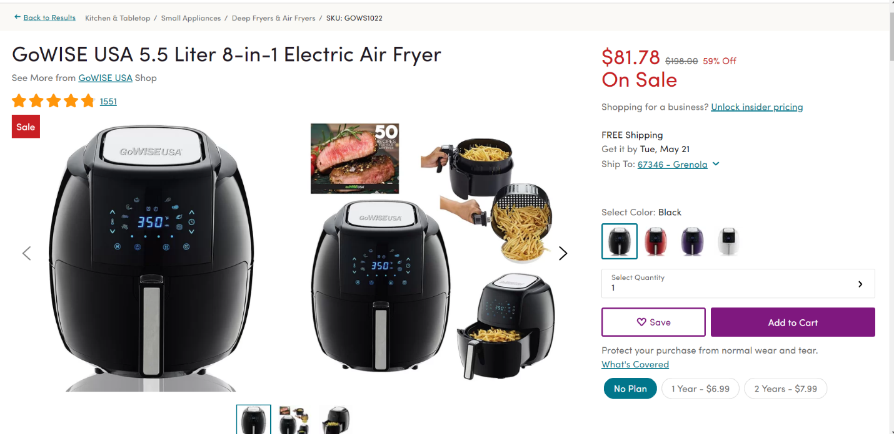

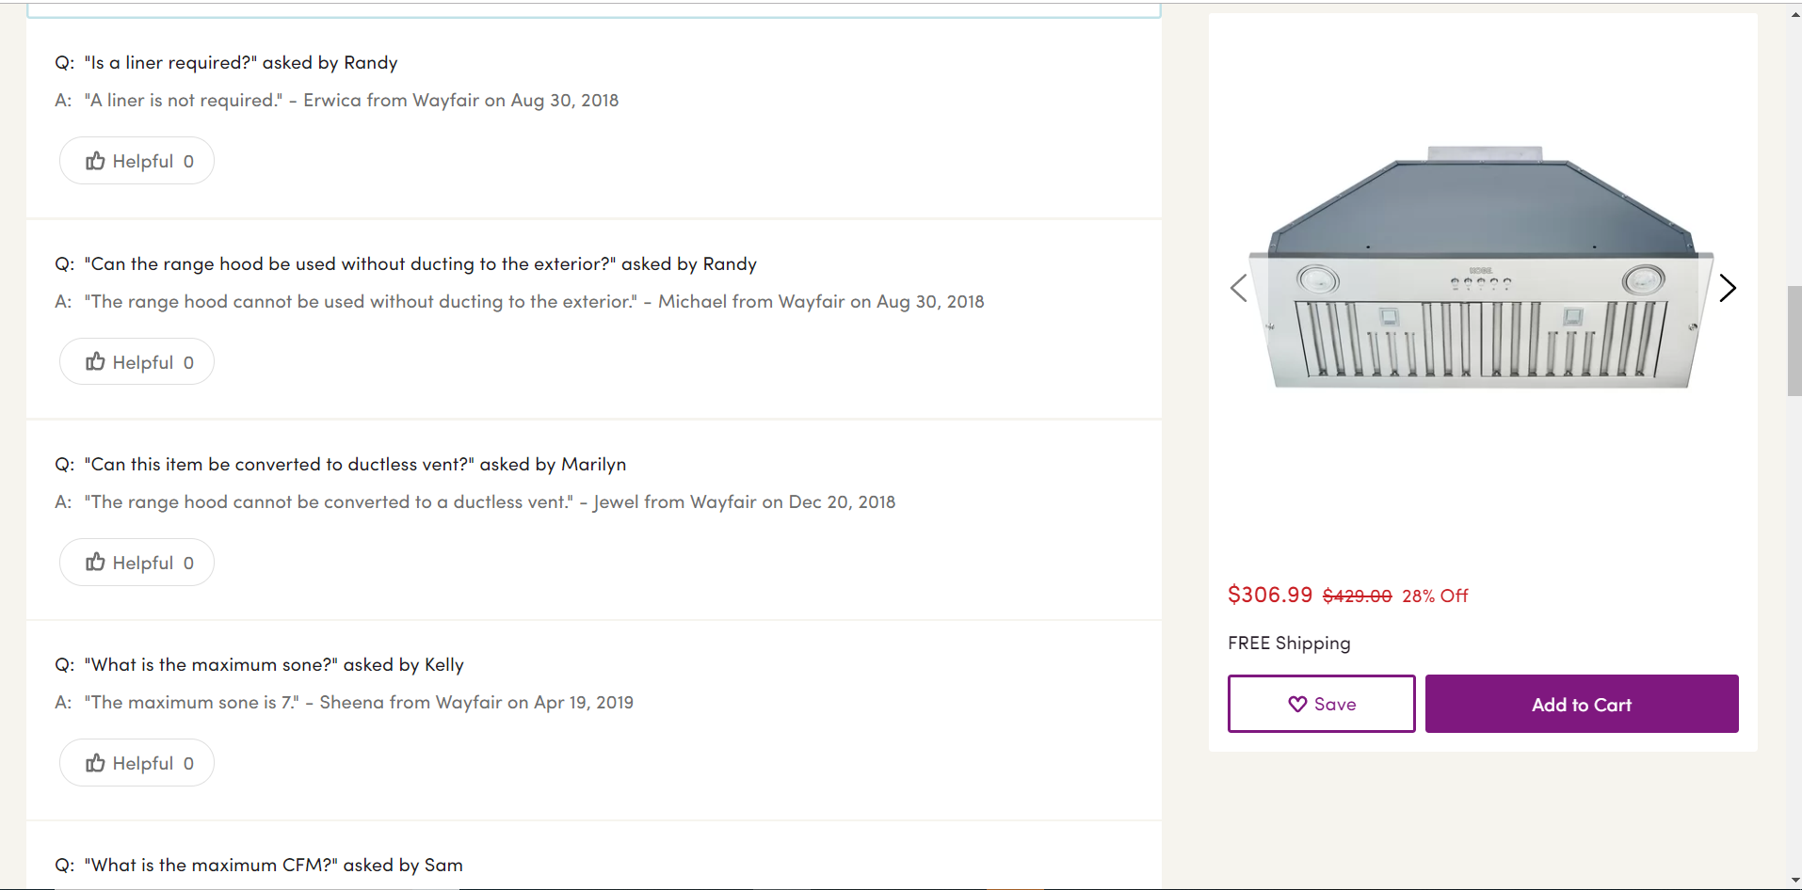



Price number :1

Duration date :1

Note string :1

Guaranteeno number :1 pk

Guarantee :1

specification :M

Power :1

Voltage :1

wattage

amperage

Unit string :1

Value number :1

Unit sting :1

Value number :1

Unit string :1

Value number :1

Unit string :1

Value number :1

Material string :M

Highlight :M

Product overview :1

Capacity :1

P iamge lob :1

P video lob :1

p caption string :1

Extra info string :1

Image lob :M

Electrical length number :1

Overall :1

Overall weight :1

Weight & dimension :M

Feature :1

User :1

Id number :1 pk

password number :1 uk

email string :1

dob date :1

first name string :1

first name string :1

question & answers :M

Review :M

:M

R id number :1 pk

Rate number check:1 (v1,v2,v3,v4,v5)

Time_date date :1

comment string :1

image lob :M

Feature name string :1

Feature id number :1 pk

Unit string :1

Value number :1

Unit string :1

Value number :1

Shiping price number :1

Shiping date date :1 zip code number :1

Shiping type string :1

Shiping id number :1 pk

Phone no number :1

Address :1

Country string :1

City string :1

Street string :1

Image LOB :M

Shiping policy string :1

Product_name string :1

Product_id Number :1 pk

Manufacture_details string :1

description string :1

Price number :1 calculated

quantity number :1

Color :M

Discount price number :1 calculated

Prod_detail string :1

Shop :1

Shiping :1

Color_id number :1 unique

Color_price number :1

Shop id number :1 pk

Shop name string :1

Price unit string :1

Price value number :1

Additional information:

* Price=(whole price-discount price)
* Shiping policy belong to product because different product has different shiping policy
* rate is check constraint
* Feature in composition diagram is the header of specification , weight and dimension , power entities
* And appliances is header of all

**Relationship Type Document:**

|  |  |  |  |
| --- | --- | --- | --- |
| **Relationship Type** | **Entity Type** | **Cardinality Ratio** | **Participation** |
| Goes to | Shipping | 1 | Mandatory |
| User | 1 | Mandatory |
| From | User | 1 | Mandatory |
| Question & answers | M | Optional |
| to | User | 1 | Mandatory |
| review | M | Mandatory |
| belong | User | 1 | Mandatory |
| product | 1 | Mandatory |
| Belong to | Product | M | Mandatory |
| Shop | 1 | Mandatory |
| Belong to | Product | 1 | Mandatory |
| guarantee | 1 | Optional |
| Has | Product | 1 | Mandatory |
| Feature | M | Mandatory |
| include | Feature | 1 | Mandatory |
| power | M | Optional |
| Lead to | Specification | M | Optional |
| Feature | 1 | Mandatory |
| has | Feature | 1 | Mandatory |
| Weight & dimension | M | Optional |

|  |  |  |
| --- | --- | --- |
| **Entity Type Document** | | |
| Entity name | Description | Occurrences |
| Shipping | It can be transferred to many users | The way product can be transferred |
| Product | Each product belongs to one user | Product can be of one category |
| Review | A comment to evaluate the product/each product has only one review | A user can write many reviews but a review can be written by many users |
| User | Member in the website that buys product can ask many questions, order many products. | User in the website |
| Question & answers | Each user can ask many questions | Make evaluation, give possibility to the user to make comment |
| Weight and dimension | Each product has specific one weight and Hight | Product physical analysis |
| Specification | Each product has one specification | All necessary product information |
| Feature | One product can have many features | the characteristics of each product |
| shop | one shop can sell many products | The place products come from |
| guarantee | One product has one guarantee | The advantage thing in order to support the product |
| power | One electrical device has one specific engine power. | The power of product engines/ The information of electrical wattage, voltage, amperage |

|  |  |  |  |  |  |  |
| --- | --- | --- | --- | --- | --- | --- |
| *Entity Relationship Type* | | *Attribute* | *Description* | *constraint* | *Data type and length* | *Null* |
| **Shipping** | | Phone no | User phone number |  | Number(15) | no |
| Shipping id | Shipping id | pk | VarChar(6) | no |
| country | Country name |  | Char(25) | yes |
| street | Street name |  | Char(25) | yes |
| city | City name |  | Char(25) | yes |
| Zip code | City code |  | VarChar(16) | no |
| Shipping Type | The way of shipping |  | Char(25) | No |
| **product** | | Value | Name of product |  | Char(10) | no |
| unit | Number of unit |  | VarChar(6) | no |
| description | Product information |  | Char(30) | No |
| Shipping policy | Way of shipping |  | Char(10) | no |
| Color id | Color code |  | VarChar(6) | yes |
| Color price | Price depend on color |  | Char(10) | yes |
| image | Product picture |  | Char(10) | yes |
| quantity | Number of product |  | VarChar(6) | yes |
| Product id | Product code | PK | VarChar(6) | yes |
| **Reviw** | | image | Review image |  | Varchar2(5) |  |
| comment | Reviw comment |  | Char(10) |  |
| Date& type | Review date |  | date | Yes |
| rate | Rate grade |  | check | Yes |
| rid | Review id | PK | Varchar(5) | no |
| **User** | | Last name | User last name |  | Char(10) |  |
| First name | User first name |  | Char(10) |  |
| id | User id | pk | Char(10) |  |
| dob | User dob |  | date |  |
| email | User email |  | Char(10) |  |
| password | User password |  | Varchar(5) |  |
| *Entity Relationship Type* | *Attribute* | *Description* | *constraint* | *Data type and length* | *Null* |  |
| **Question & answers** | question | Ask question |  | Char(10) | no |  |
| answer | Answer question |  | Char(10) | no |  |
| A date | Date of question |  | date | no |  |
| User name | Who asks question |  | Char(10) | no |  |
| **Weight &dimension** | Electrical engine | Engine name | pk | Char(10) | no |  |
| unit | Number of Overall weight unit |  | VarChar(6) | no |  |
| value | number of overall value |  | Char(10) | no |  |
| Unit | Number of Overall unit |  | VarChar(6) | no |  |
| value | Number of Overall value |  | Char(10) | no |  |
|  |  |  |  |  |  |
| Entity Relationship Type | Attribute | Description | constraint | Data type and length | Null |
| **Specification** | cunit | Capacity unit |  | Varchar(10) | No |
| cvalue | Capacity value |  | Char(10) | No |
| Extra info | Highlight overview |  | Char(10) | Yes |
| image | Highlight image |  | image | No |
| material |  |  | Char(10) | No |
|  | P caption | Product caption |  | Char(10) | Yes |
|  | P image | Product image |  | image | No |
|  | P video | Product video |  | video | Yes |
|  | **power** | Voltage unit |  | Varchar(10) | yes |
|  |  |  |  |  |  |
| *Entity Relationship Type* | *Attribute* | *Description* | *constraint* | *Data type and length* | *Null* |
| **power** | V unit | Voltage unit |  |  | no |
| V value | Voltage value |  |  | no |
| W value | Wattage value |  |  | No |
| W unit | Wattage unit |  |  | no |
| unit | amPerage unit |  |  | no |
| value | amPerage value |  |  | no |
| **feature** | Feature id | Feature identity id | pk | Varchar(9 | no |
| Feature name | Name of feature |  | Char(15) | no |
| **shop** | Shop name | Name of store |  | Char(15) | No |
| Shop id | Store identity number | pk | Varchar(9 | no |
| **quarantee** | Note | Guarantee information |  | Char(15) | no |
| Duration | Period of Guarantee |  | time | no |
| Price | Guarantee expense |  | Varchar(9 | No |
| guarantee no | guarantee identity number | pk | Varchar(9 | no |
|  |  |  |  |  |  |
|  |  |  |  |  |  |
|  |  |  |  |  |  |
|  |  |  |  |  |  |
|  |  |  |  |  |  |
|  |  |  |  |  |  |
|  |  |  |  |  |  |
|  |  |  |  |  |  |
|  |  |  |  |  |  |
|  |  |  |  |  |  |
|  |  |  |  |  |  |

*Conclusion*

**Where did you discuss the problems you have faced?**

Since me and my partner faced any problem, we tried our best to google and do research via educational videos and if we still dealt with the problems, we did our best to visit the instructor to sort out the problem.

**How you overcome the difficulties?**

To put it nutshell, review the points that we learnt in the class and expand it via searching in internet besides guideline of the other groups came too much in handy.

**How you would complete the project if you had more time**?

we preferred to put more time to make sure about the orders we did in diagram and with better possibility we could focus more properly on how follow the rules in doing this project deeper but to cut the long story short we are happy with this and the thing with it is that we put our all knowledge we got from this course in to practice.