Instruction Manual

**Carbon Nanotube Mesh Monte Carlo Simulator**

Version: 1.00

Alexander Gabourie

Amirhossein Davoody

Prof. Irena Knezevic



Contents

Introduction 2

References 3

# Introduction

The National Academy of Engineering, concerned about the increasing energy demands as well as the environmental cost of meeting them, has determined that development of an economic solar panel is a grand engineering challenge of the 21st century. To address the challenge, much effort has been placed towards finding a suitable light-absorbing material. In recent years, carbon nanotubes (CNTs) have become a material candidate due to more effective separation techniques.[1] Researchers now have the ability to separate optically absorptive, semiconducting nanotubes from others. With a wide range of possible band gaps due to different nanotube chiralities, CNTs can be used to create widely tunable photovoltaic cells. The optical versatility, ultrafast exciton and charge transport, and chemical stability of CNTs has been the impetus of much recent research.[2]

While research on bilayer donor/acceptor heterojunction photovoltaics has shown that exciton dissociation at the semiconducting CNT (s-CNT) and C60 junction [fig. 1] is very efficient, the diffusion of the exciton to the junction has been determined to be a bottleneck in increasing the overall process efficiency.[2] Amirhossein Davoody, a member of Professor Knezevic’s research group at the the University of Wisconsin-Madison, has undertaken a project to develop the theory of exciton diffusion in CNTs and use his theoretical framework to computationally simulate exciton dynamics in a CNT mesh. Before development of the CNT Mesh Generator began, he had already found success calculating exciton transfer rates between CNTs with arbitrary chirality, angle, and separation.

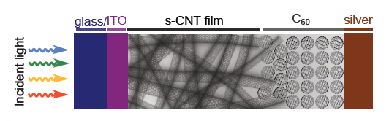

**Fig. 1** Structure of a CNT-based bilayer donor/acceptor heterojunction photovoltaic device.[2]

The purpose of this project is to bridge the two research fronts: Carbon nanotube mesh generator, and exciton transition rates. The CNT mesh acts as the media for a Monte Carlo simulation and the exciton transition rates act as the mechanisms for exciton movement in the simulation. The amalgmation of the two projects will allow a better comparison between older exciton diffusion techniques and Amirhossein’s updated technique. Additionally, since the Monte Carlo simulation will be run on a randomly distributed carbon nanotube network, which better imitates real carbon nanotube meshes, it will allow the connection between the theoretical findings in a more direct and meaningful way to experiment. This software is the tool to accomplish these tasks.

The manual provides the information necessary to understand how to use the software and how the software works. This software is dependent on results from both the Carbon Nanotube Mesh Generator program and the exciton transition rate tables. The proceedings operate under the assumption that the external information is available and in the correct location. Discussion of the external information will be provided when deemed necessary by the author.

# Usage

## Installing

The current set-up for the software does not have a website for automatic updates. However,it does have a Dropbox link to the most recent deployed version of the software. The link is:

<https://www.dropbox.com/sh/900pnvuqqiqds5y/AADmWEKqXcbm_PWAYmuEv6RMa?dl=0>

After clicking on the link you will come to a screen that looks like the image below. Click on the “Download” button and select “Download as .zip.”

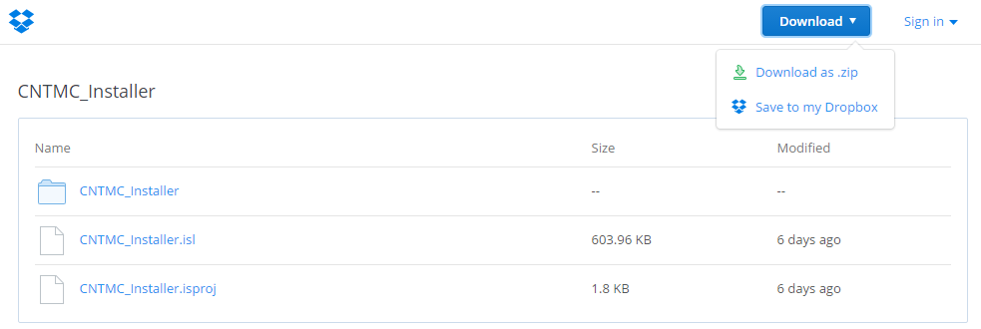

This will download all the necessary program files. Extract the .zip to a directory of your choosing and open that directory. From that directory navigate to the following path:

*.\express\singleimage\diskimages\disk1*

At this location, a setup executable will be located as seen in the picture below.

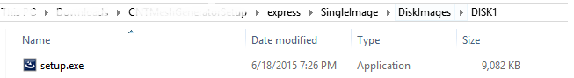

Click on “setup.exe” and follow the on screen instructions to install. The installer may ask to download and install some Microsoft redistributables. Please install them as they are necessary components to the software.

# References

[1] M. S. Arnold, J. L. Blackburn, J. J. Crochet, S. K. Doorn, J. G. Duque, A. Mohite, and H. Telg,

“Recent developments in the photophysics of single-walled carbon nanotubes for their use as active and passive material elements in thin film photovoltaics.,” *Phys. Chem. Chem. Phys.*, vol. 15, no. 36, pp. 14896–918, 2013.

[2] A. Davoody and I. Knezevic, “Theoretical study of exciton dynamics in carbon nanotube

composites,” Poster presented at ICPS, Zurich, Switzerland, 2013 .