JNetX Proprietary Information
Disclosure:
This document is not intended for any form of external distribution and is for jNetX internal and proprietary use only.
Trademarks:
The Trademarks mentioned in this document are the property of their respective owners/licensee.
Configuration Management Elements
Document Authors:
Written by: Sergey Klimenko
Modified by: AK,GLP
Classification: Internal use
Document Owner: Sergey Klimenko
Document History:
Rel.Ver | Change Description | Issue Date | Validity Date | Author
v0.0 | Document started | 05/19/09 |  | Sergey Klimenko

Tools: OpenOffice 3
Visual Paradigm for UML 3.4
Electronic Location:

- Contents
Introduction 3

Introduction

Purpose
The purpose of this document is to describe the architecture of the WiseMathes and provide a rationale for all the architectural decision made.

Document Organization
This Architecture is described using concurrent views, where View is intended to be an abstraction of a System with respect to different criteria. Each abstraction boils away details about the software structures that are independent of the concern reflected by the abstraction. This means that each view addresses a specific set of concerns of interest to different stakeholders in the system.
This document is organized according to this approach.
Chapter 1 - Introduction
TBD: write organization here

Definitions, Abbreviations and Conventions
For the purposes of this document, the following definitions apply:

Overview

Project Overview
TBD

Project Organization
WiseMatches project is separated into some modules united into three groups: kernel, server and webapp as shown in following image:
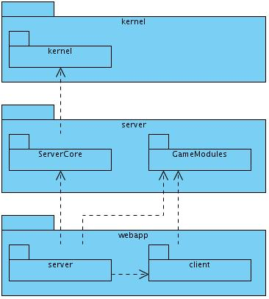
Kernel group contains only one module with the same name. This module contains base interfaces for all project. Now it contains only Player interface and all related things (PlayerProfile, PlayerNotification and so on).
Server group is a game server implementation and contains two modules:
- ServerCore contains implementation and base interfaces for games. This is server core which can have a lot of client access points. Now only one like point is implemented – WebApplication.
- GameModules contains implementation of concrete games. Now this module contains implementation of Scrabble game.
Webapp group is implementation of Web application and contains following modules:
- server – Web application server which export set of RPC servelts for access from remote Web clients.
- client – GWT implementation of application client. This module is compiled into JavaScript and HTML code by GWT and also used in server module as set of serializeable classed and interfaces.

Project Entities
There are set of main project entities which is connected each other to process client calls. Each of entity has a postfix name according to it type and function in system. Following figure describes these entities:
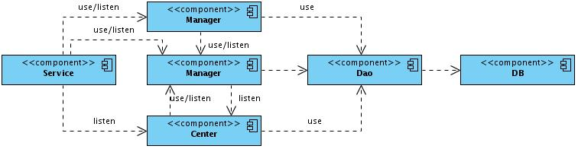
- Service – is a client access point. Now all services implemented in WebApp/server module and is a RemoteServiceServlet or just Servlet. Service interacts with system using Managers.
- Manager – is a common unit of system. Manager interacts with database and can implements some logic for data processing. Manager can interact with other managers to implement some functionality or with Dao to access a DB.
- Center – is kind of manager but does not have methods for data manipulation. It just implements some logic for data processing. Usually it's thread based or event based component which wake up by timer to do some logic or by receiving event from managers. Center can fire events to package-accessed managers. It means that other components can't listen center events and all events methods should be declared as package or protected visibility.
- Dao – is access point to database. Each Dao manages one or many DB entities. Dao does not have any data manipulation logic and does not fire any events.
- DB – database table.
NOTE: The main difference between Manager and Center that center does not have methods for data manipulation.
There are a lot of other entities which transmitted between these components, stored into database and so one. These entities is out of scope of this document and can be sound in source code and JavaDocs.

Abstract Design

Components and dependencies

Server components
This section describes base managers and DAOs and dependencies between them.

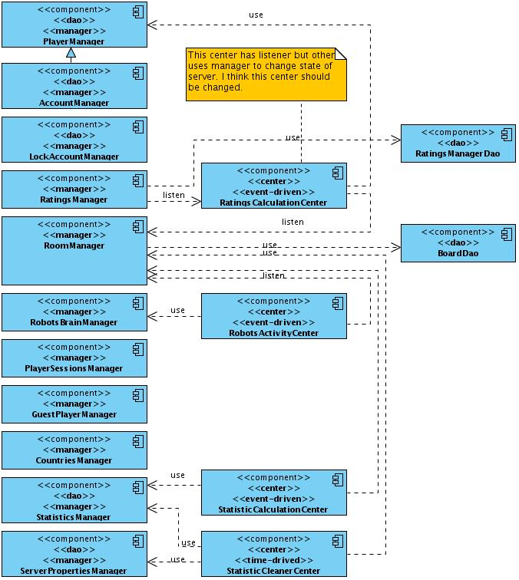
Web Application components
WebApplication additional declares set of it owns components which shown in following figure:

Detailed Design

Transaction Model
The Application has mixed declarative and programming transaction models. All components expect Centers are using declarative transactions which are managed by services (client requests).
The Centers is kind of client because started by timer or events so its should start new transaction when its work with managers. It's possible when center use a declarative transaction if it's methods declared as protected.
The following transaction model is used in application:
- DAO objects declared with PROPAGATION_SUPPORTS. If transaction exist the Dao should use it. In other case it can work without transaction. This schema is used because each method of Dao perform simple work (like get or insert operation for simple object).
Dao should not rollbacks transaction if any exception is happened.
- Managers declared with PROPAGATION_MANDATORY transaction. Each call of manager's method should be done in transaction. This schema is used because manager is middle ware of server and should be managed outside.
Manager should not rollbacks transaction if any exception is happened.
- Services declared with PROPAGATION_REQUIRED transaction. When client call a service the service should begin and finish transaction.
Service commits or rollbacks transaction if exception happened.
- Centers declared with PROPAGATION_REQUIRES_NEW transaction. When center receive external event (or wake up by timer) when new transaction should be started. This schema is used because center is kind of client which uses manager to do some work and this work usually should be done in separate transaction.
Center commits or rollbacks transaction if exception happened.

