# Abstract

* dynamic trading and allocation mechanism
* dynamic algorithm have superior performance in comparison to the repeated use of a static algorithm.
* learn optimal patient-donor weights
* improves egalitarian fairness by 10%
* increasing the number of transplants by 6%
* decreasing waiting times by 24%.
* most critical factor is not the judicious assignment of positive weights (rewards) to patient-donor pairs but assignment of a negative weight (penalty) to the small number of non-directed donors in the kidney exchange program

# Introduction

* Incompatible patient-donor pairs and non-directed anonymous donors, henceforth called nodes
* Weighting (point) scheme to select compatible kidney exchanges between the donors and patients
* finding is that a judicious choice of weights to improve performance

## Background and Related Literature

* KEP can be modelled by a directed graph (kidney exchange graph)
* incompatible patient-donor pairs, denoted (pi, di), and non-directed anonymous donors (NDADs) denoted (∅, dj)
* arc in the graph indicates that a transplant is feasible

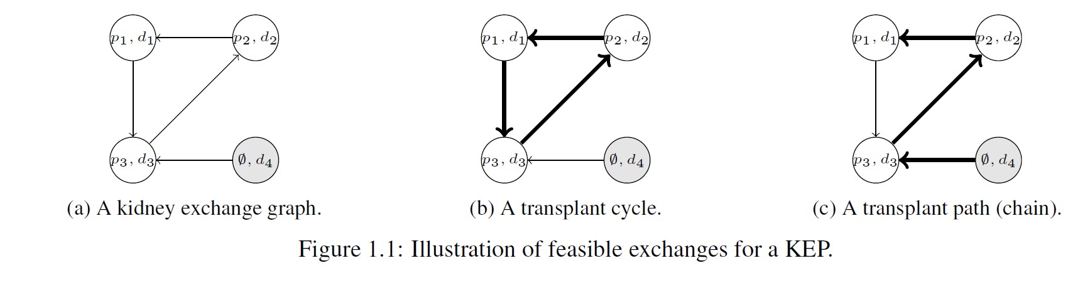

* directed cycle or a directed simple path
* A valid directed cycle consists only of patient-donor pairs
* d4 is unused in cycle and d1 is unused in path
* maximize the number of transplants???
  1. multi-criteria decision problem: medical practitioners, waiting times, quality of potential transplants, etc.
  2. myopic algorithm is implicitly unfair: prioritize patients who are easy-to-match
  3. KEPs are repeated, dynamic mechanisms: to optimize an objective in the short-term may not optimize the objective over the long-term ( maximizing the number of transplants in each round may not maximize the number of transplants over many years)
* Group fairness????

# The Graphical Kidney Exchange Model

## Transplant Selection

* Node weights or arc ??? how does it work?

# Fairness in Kidney Exchanges

## Measures of Fairness

* Parameters of fairness measure ($u, ρ$)???
* Different fairness measures(