Hw 1

Aviv and Amir

GrabCut

Results for basic configuration ( 4/5 components, gamma = 19, lamda = 45):

|  |  |  |  |  |
| --- | --- | --- | --- | --- |
| Image name | Accuracy | Jaccard | Time to converge | # of components |
| Banana1 | 0.67 | 0.44 | 3.06 | 4 |
| Banana2 | 0.97 | 0.907 | 2.6 | 4 |
| Book | 0.938 | 0.912 | 2.9 | 4 |
| Bush | 0.92 | 0.58 | 1.8 | 4 |
| Cross | 0.77 | 0.52 | 3.04 | 5 |
| Flower | 0.986 | 0.928 | 3.06 | 5 |
| fullmoon | 0.99 | 0.875 | 0.5 | 5 |
| Grave | 0.976 | 0.831 | 1.4 | 5 |
| Llama | 0.988 | 0.9366 | 1.7 | 4 |
| Memorial | 0.98 | 0.9 | 2.1 | 5 |
| Sheep | 0.99 | 0.92 | 1 | 5 |
| Stone2 | 0.996 | 0.984 | 1.5 | 5 |
| teddy | 0.983 | 0.929 | 0.7 | 5 |

As we can see, the images that were the most difficult to process were Banana1, Cross and Bush.Banana1 has a lot of similarity between the banana and the background, which might cause the algorithm to have trouble separating the rest of the background.Cross image has a lot of similarity between the base of the cross and the background. Also, its post is thin, so it vanishes after one or two iterations because of the gamma and lambda values (which should be lower in this case and ensure the convergence is slower).Bush image is doing well overall, but the trunk is too thin, so again, after a few iterations, we only have the bush itself without the flowerpot.

|  |  |  |
| --- | --- | --- |
| Image | Mask | GT Mask |
| Banana1 |  |  |
| Banana2 |  |  |
| Book |  |  |
| Bush |  |  |
| Cross |  |  |
| Flower |  |  |
| Fullmoon |  |  |
| Grave |  |  |
| Llama |  |  |
| Memorial |  |  |
| Sheep |  |  |
| Stone2 |  |  |
| Teddy |  |  |

I’ll examine Book and Sheep images more closely.

The Book gives some of the best results with certain settings and enhances the current accuracy.

The Sheep is hard to process in our project because of its shape, colors, and thin legs.

Book with 3 components. Accuracy : 0.978 and Jaccard: 0.931.

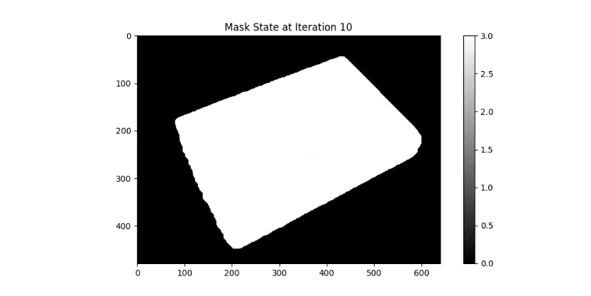

Book with 2 components and gamma = 25. Accuracy : 0.972 and Jaccard: 0.931.

Running time : 1.8 minutes (instead of 2.9 minutes)

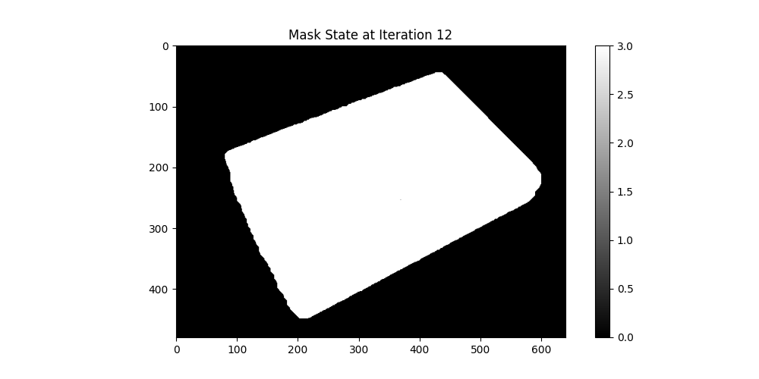

Book with 2 components and gamma = 5. Accuracy : 0.972 and Jaccard: 0.929.

Running time : 1.7 minutes (instead of 2.9 minutes)

