**HW3**

**Amir Livne 201301405**

**Carmel Rabinovitz 302958145**

# BFGS

The implementation of our BFGS algorithm is attached at “BFGS.py”.

Following is a log scale graph of the convergence of Rosenbruk function, as achieved by the above algorithm:

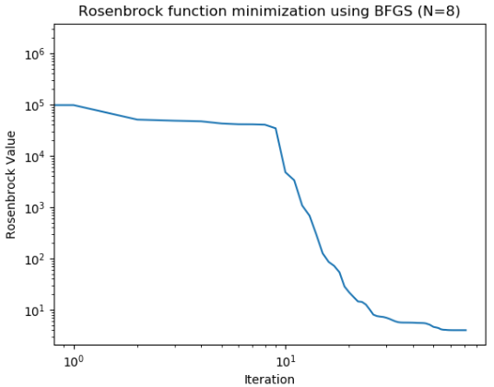

As seen, the BFGS algorithm found the correct minimum value (~0), in the point (1,1,…,1), as expected.

# DNN

### Task 3

The analytical expression for the gradient of the error function:

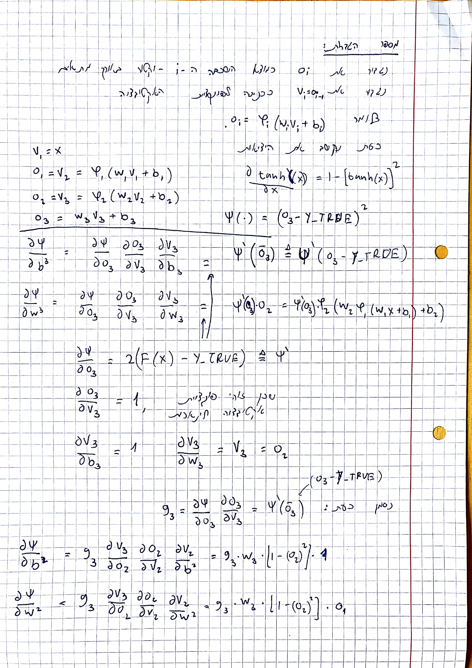

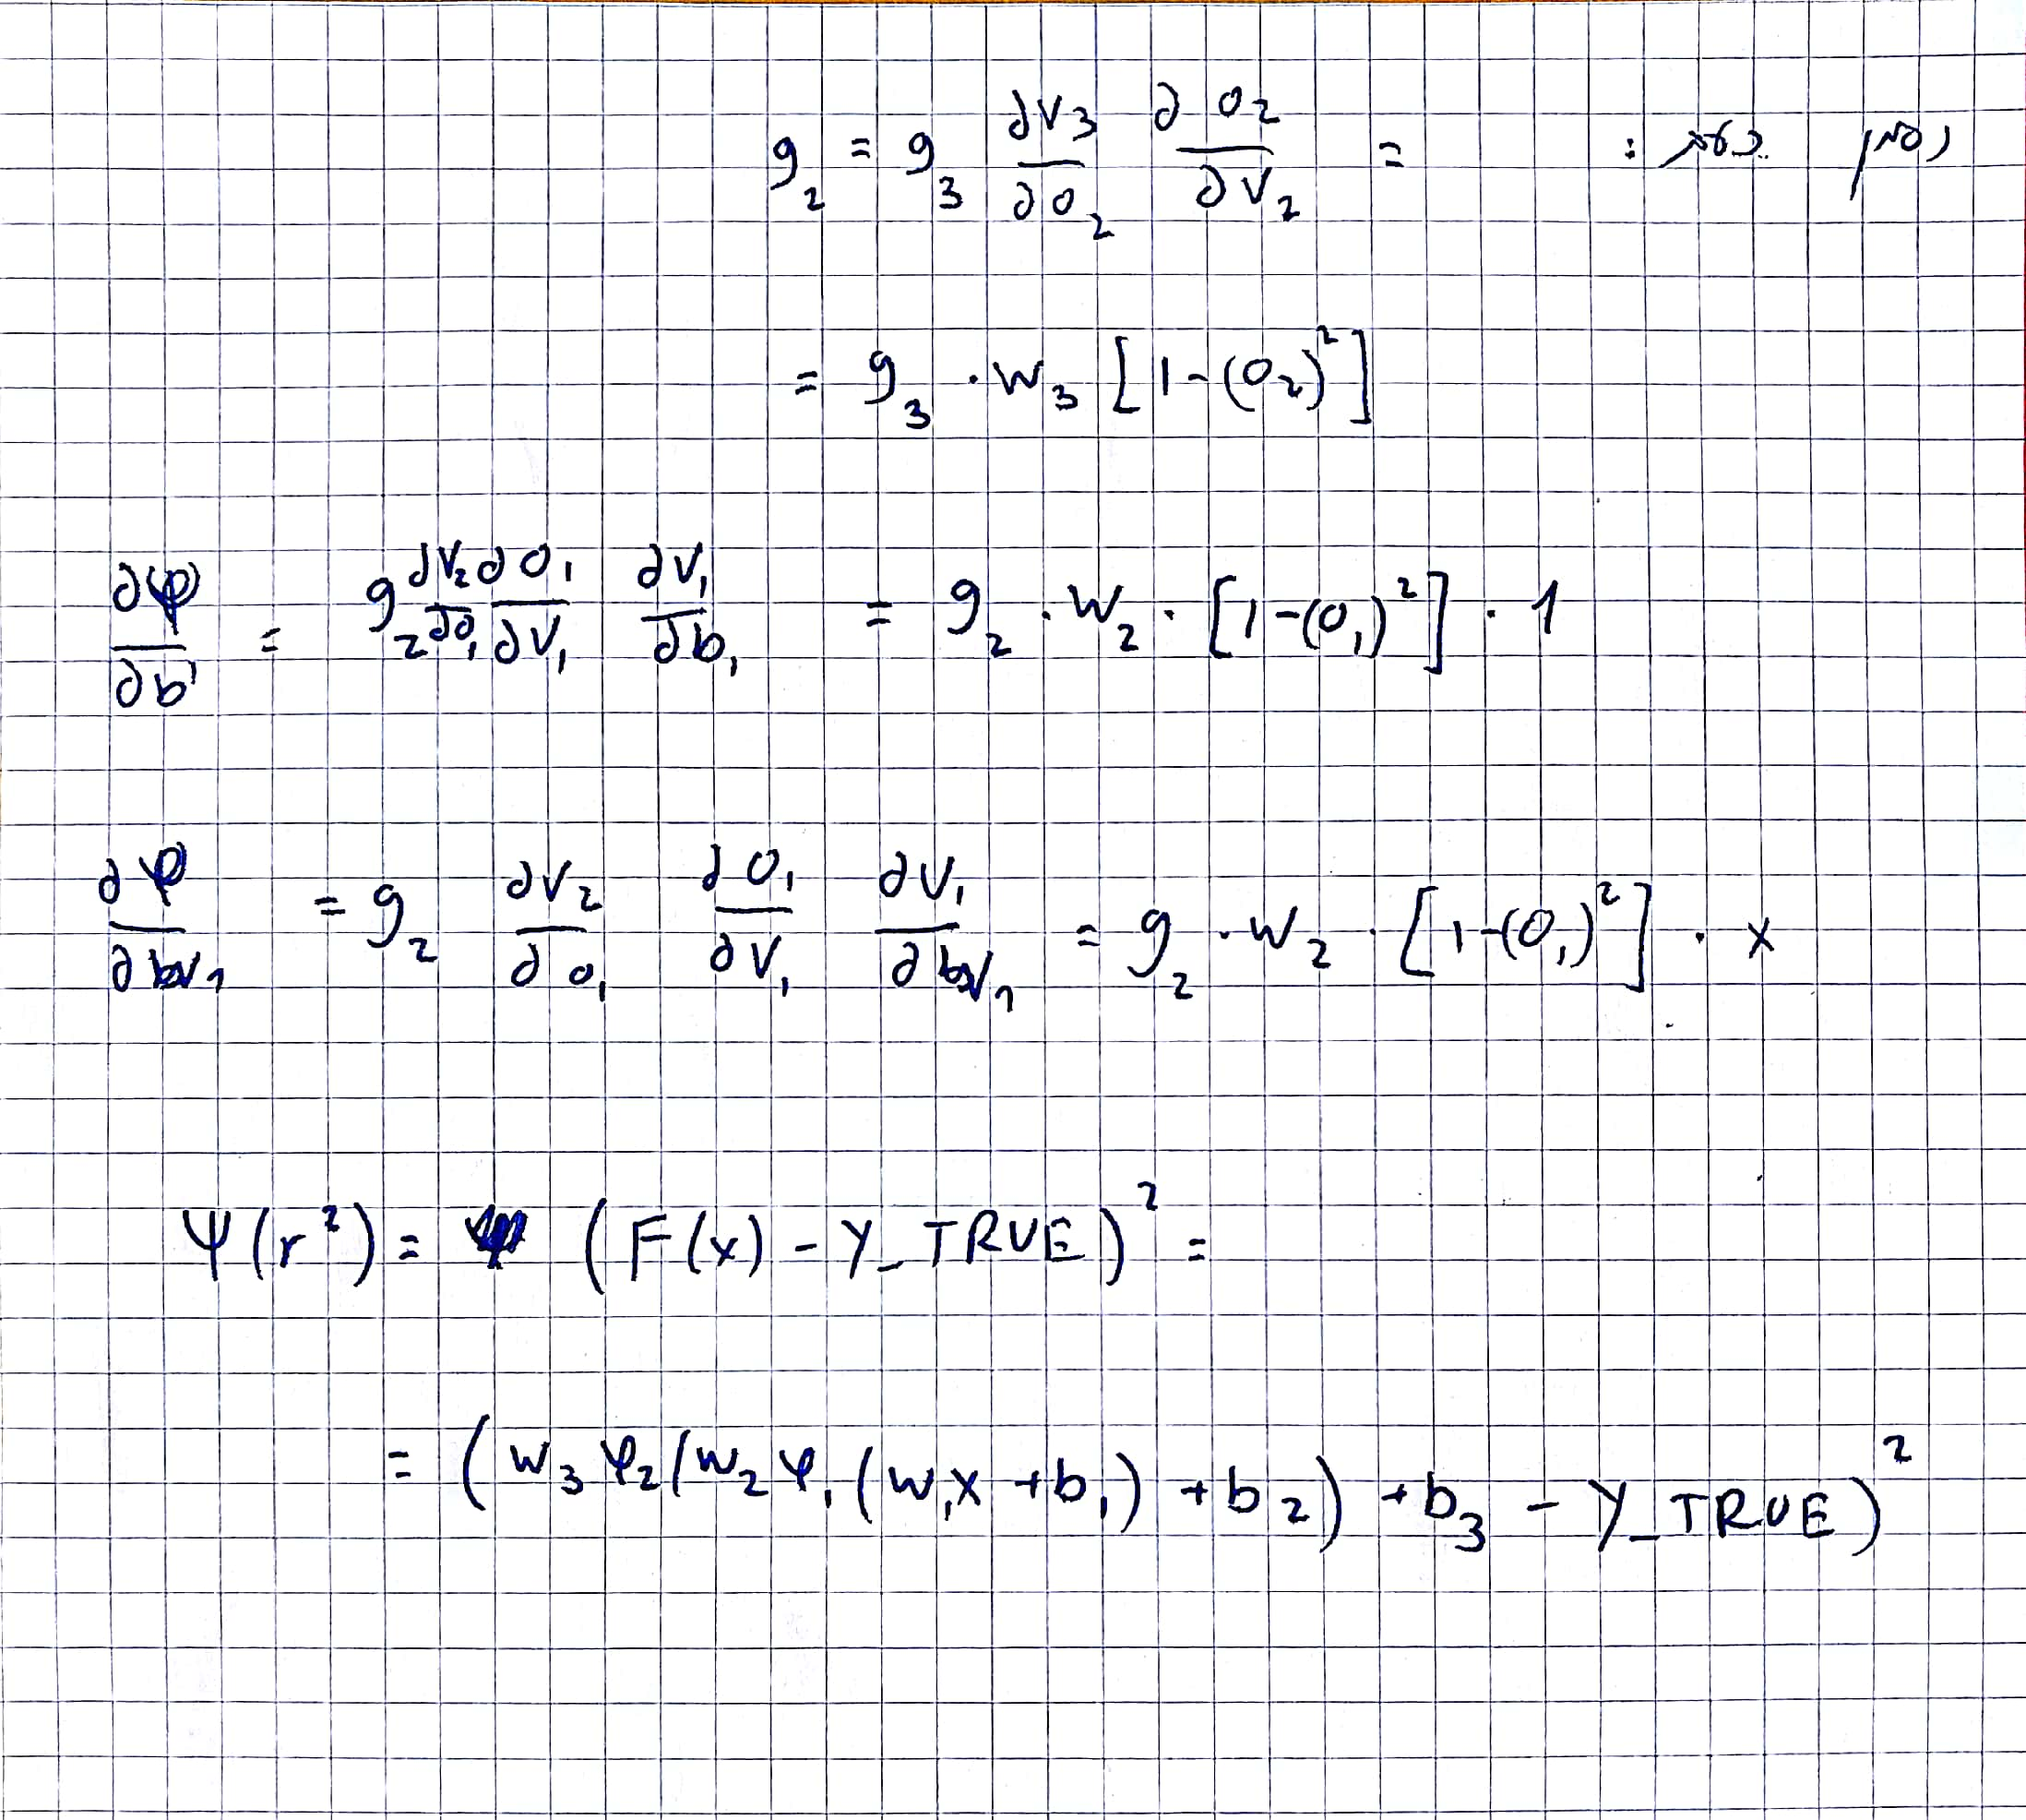

To test the gradients we used numerically approximation with this data:

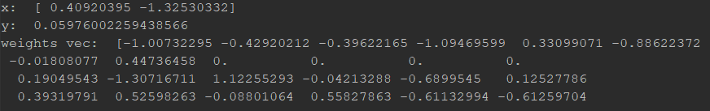

And the diff between analytical gradients an approx. are:

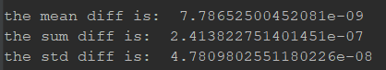

Code attached

### Task 4

1. The function graph:

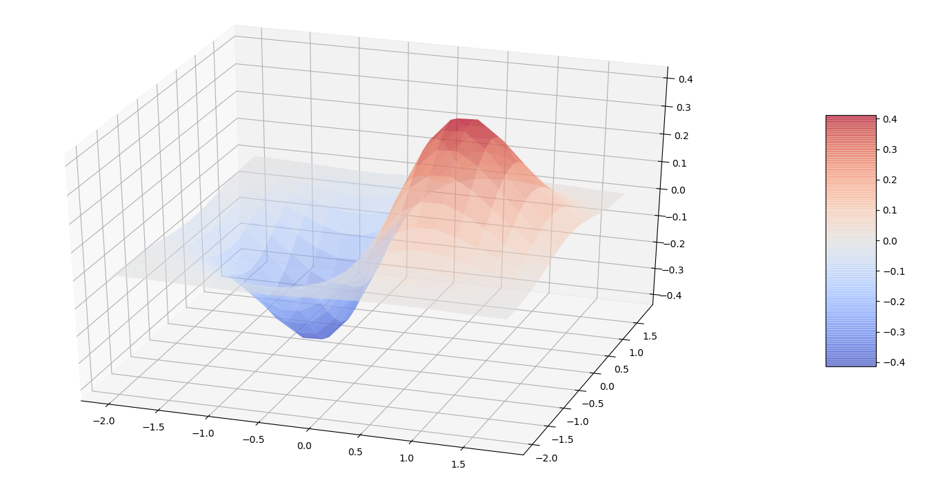

1. The value of the error function in each iteration

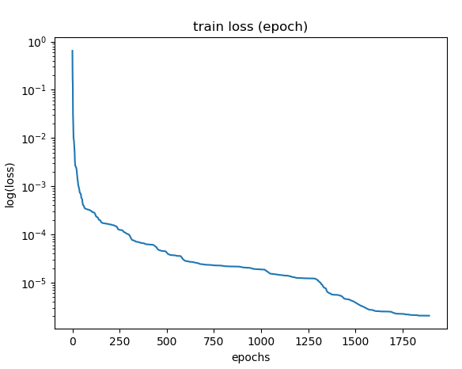

1. Reconstructed 200 points on the function graph from test set

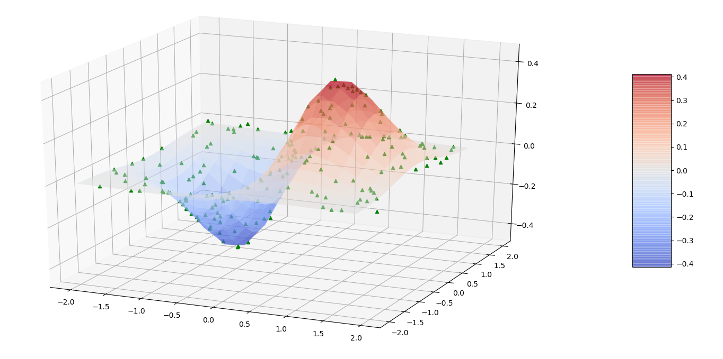

As we can see we get very good results, typically each point from the test set is about e-5 close to the true value.

In the training set we converge after about 400 – 200 epochs and get a loss values of about e-6 – e-5.

For the graph above we got to loss of 2.382729163844694e-06

All the code is attached.