THE E.M.E.R.G.E+ FRAMEWORK
A Theoretical Model for Meaning Emergence Through Dual Entropy Dynamics

Article Type: Research Article (Theoretical + Simulations)
Amir Lotfifar
Independent Researcher, Cognitive Psychology
Email: amir.lotfifar1994@gmail.com
Date: 16 February 2026 (v1)
Table of Contents
Abstract 4
1. INTRODUCTION 5
1.1 The Entropy Paradox in Consciousness Research 5
1.2 Why Existing Theories Cannot Resolve the Paradox 6
1.3 Toward a Dual-Process Resolution 7
1.4 Transparency Statement 8
1.5 Structure 8
2. THEORETICAL FOUNDATIONS 9
2.1 Free-Energy Minimization as Entropy Reduction 9
2.2 Entropy Elevation as Reorganization Catalyst 9
2.3 Cultural Modulation of Emotional Experience 10
2.4 Synthesis: Dual Processes, Distinct Trajectories 10
3. MATHEMATICAL FRAMEWORK 11
3.1 State Variables and Operationalization 11
3.2 Process 1: Routine Meaning Dynamics 12
3.3 Process 2: Transformative Meaning Dynamics 13
3.4 Boundary Conditions 13
4. COMPUTATIONAL DEMONSTRATIONS 13
4.1 Implementation 14
4.2 Demonstration 1: Routine Meaning Emergence 14
4.3 Demonstration 2: Transformative Trajectory 17
4.4 Demonstration 3: Cultural Modulation 20
4.5 Parameter Sensitivity 20
4.6 Simulation Summary 21
5. TESTABLE PREDICTIONS AND VALIDATION 21
5.1 Falsifiable Predictions 21
5.2 Validation Strategy 22
5.3 Potential Validation Datasets 23
6. DISCUSSION 23
6.1 Theoretical Contributions 23
6.2 Clinical Implications 24
6.3 Cross-Cultural Mental Health 24
6.4 Limitations 25
6.5 Alternative Interpretations 25
6.6 Future Theoretical Extensions 26
6.7 Relationship to Other Computational Frameworks 26
6.8 Practical Implementation Considerations 26
7. CONCLUSION 27
7.1 Summary of Framework 27
7.2 Key Contributions 28
7.3 Current Status and Next Steps 28
7.4 Significance and Impact 28
Acknowledgments 29
Author Contributions 29
Competing Interests 29
Data Availability 30
Funding 30
References 30

Abstract

A longstanding tension in consciousness research is that serotonergic psychedelics reliably occasion experiences rated as highly meaningful, while concurrently increasing indices of neural signal diversity (often colloquially described as “neural entropy”). Meanwhile, active inference and the free-energy principle describe adaptive perception and action as processes that reduce uncertainty (via minimization of variational free energy). We propose the E.M.E.R.G.E+ framework to reconcile the apparent paradox by distinguishing two qualitatively different processes of meaning emergence: (1) Routine meaning, arising through gradual entropy reduction during everyday coherent functioning, and (2) Transformative meaning, arising through a biphasic trajectory—transient entropy elevation followed by deep entropy reduction—during critical transitions (e.g., psychedelic states, profound therapy, existential crises). We formalize these dynamics through coupled differential equations and provide computational simulations demonstrating distinct temporal signatures across seconds (routine) and hours (transformative) scales.

In routine contexts, emotional entropy decreases through nonlinear regulation, awareness feedback, memory integration, and cultural modulation, producing monotonic meaning increases. In transformative contexts, psychedelic-like perturbation profiles increase entropy during onset/peak, relaxing rigid priors and enabling novelty, followed by accelerated attractor dynamics that reorganize experience into a lower-entropy post-session equilibrium. This provides a mechanistic resolution of the entropy paradox: both processes ultimately minimize entropy and increase coherence, but transformation requires a temporary “entropy detour” through instability.

The framework generates falsifiable predictions for psychedelic sessions: neural signal diversity (e.g., Lempel–Ziv complexity or related entropy/complexity measures) should show a peak-related increase followed by a post-peak decrease that can undershoot baseline in a subset of individuals; and the magnitude of the post-peak decrease should correlate with retrospective ratings of personal meaning (e.g., MEQ30). We outline validation protocols using open datasets and specify operationalizations for future empirical work.

Keywords: meaning, entropy, psychedelics, active inference, theoretical framework, consciousness, emotion regulation

1. INTRODUCTION

1.1 The Entropy Paradox in Consciousness Research
Neuroimaging and M/EEG work has repeatedly shown that psychedelics can increase neural signal diversity/complexity (often described as increased “brain entropy”), alongside profound alterations in phenomenology. For example, psilocybin MEG studies report broadband cortical desynchronization and altered network dynamics, and signal diversity measures such as Lempel–Ziv complexity increase under psychedelic compounds in M/EEG recordings (Muthukumaraswamy et al., 2013; Schartner et al., 2017).

These findings motivated the Entropic Brain perspective, which frames psychedelic states as relatively higher-entropy modes of brain dynamics compared to ordinary waking cognition (Carhart-Harris, 2018; Carhart-Harris et al., 2014).

Terminology note: In this manuscript, “entropy” is used as shorthand for operational indices of neural signal diversity/complexity (e.g., Lempel–Ziv complexity, spectral entropy, sample/multiscale entropy), rather than thermodynamic entropy.

Participants' subjective reports revealed profound experiences of meaning, unity, and existential insight. This finding catalyzed the Entropic Brain Hypothesis: consciousness exists on a spectrum from low-entropy (rigid, habitual) to high-entropy (flexible, chaotic) states, with psychedelics pushing the brain toward the latter (Carhart-Harris, 2018).

Yet this framework stands in apparent contradiction with Karl Friston's Free-Energy Principle (FEP). Active inference posits that biological systems minimize variational free energy—a quantity that bounds surprise and entropy (Friston, 2010). The free-energy principle implies that adaptive systems minimize the entropy of posterior beliefs to maintain coherent internal models. In experiential terms, meaning should arise from reducing uncertainty and entropy, not increasing it.

This is the Entropy Paradox: Two well-supported theories make opposing claims. Carhart-Harris's data show entropy increase during meaningful experiences. Friston's framework predicts entropy minimization for adaptive functioning. How can both be correct?

Why This Matters:
• Psychedelic-assisted therapy shows promise for depression and PTSD (Carhart-Harris et al., 2016), yet mechanisms remain unclear
• Mindfulness meditation reduces neural entropy (increased alpha synchronization; Travis & Shear, 2010) yet also increases meaning (Hölzel et al., 2011)
• Anxiety disorders involve elevated uncertainty (Hirsh et al., 2012) yet entropy reduction alone doesn't always restore meaning (Pizzagalli, 2014)
• Understanding when and why entropy dynamics relate to meaning could inform more effective interventions.

1.2 Why Existing Theories Cannot Resolve the Paradox
1. Active Inference (Friston, 2010; Seth & Friston, 2016)
Active inference elegantly explains everyday perception through free-energy minimization. The brain maintains low prediction error by updating beliefs or acting on the world. This framework models routine meaning-making: familiar experiences feel meaningful because they fit coherent internal models with low surprise.

However, standard active inference struggles with psychedelic phenomenology. If brains minimize entropy, why would psilocybin—which increases entropy (Carhart-Harris et al., 2014)—reliably produce experiences described as "among the most meaningful of my life" (Griffiths et al., 2006)? Active inference approaches have sometimes treated entropy elevation as pathological, characteristic of psychotic states (Adams et al., 2013), not therapeutic transformation.

2. The REBUS Model (Carhart-Harris & Friston, 2019)
The "Relaxed Beliefs Under pSychedelics" (REBUS) model attempted reconciliation: psychedelics reduce the precision of high-level priors, increasing representational entropy to enable cognitive flexibility. This explains acute effects but leaves open core questions:
• Why does transient chaos feel meaningful? High entropy should feel confusing, not profound.
• What happens after the session? Clinical benefits persist months later (Carhart-Harris et al., 2016). If entropy decreases, when and how?
REBUS implies entropy increase enables meaning but does not specify whether meaning emerges during high-entropy states or after subsequent reorganization.

3. Constructed Emotion Theory (Barrett, 2017)
Barrett's framework explains how brains construct emotional experiences via predictive interoception, with cultural learning shaping emotion categories. While this accounts for affective diversity, it does not directly specify:
• How emotional construction relates to entropy trajectories,
• Why some emotional states feel meaningful and others feel empty,
• How psychedelic states map onto constructed emotion dynamics.

1.3 Toward a Dual-Process Resolution
We propose that the paradox dissolves when meaning emergence is treated as a dual-process phenomenon with distinct temporal signatures and (seemingly) opposite entropy dynamics:

Routine Meaning:
• Emerges through gradual entropy reduction
• Operates during everyday functioning
• Requires coherent emotional–cognitive integration
• Modulated by cultural norms
• Closely aligned with active inference and free-energy minimization

Transformative Meaning:
• Emerges through temporary entropy elevation followed by deep reduction
• Operates during critical transitions (e.g., major life events, intense therapy, psychedelic sessions)
• Requires dismantling rigid structures before building new coherence
• Less culturally dependent during the acute phase
• Conceptually aligned with entropic brain / REBUS perspectives

Key Insight: Both processes can end in lower entropy and higher coherence, but transformation requires a detour through instability—analogous to annealing, where temporary heating enables reorganization into stronger structures upon cooling.

1.4 Scope and Contributions
This theoretical paper provides:
- A mathematical formalization of dual-process dynamics using phenomenological differential equations motivated by free-energy minimization.
- Computational demonstrations illustrating distinct temporal signatures (routine: seconds; transformative: hours), using hypothetical parameters.
- Falsifiable predictions and a validation roadmap for future empirical testing.
- Proposed operationalizations for key constructs and candidate measurements.
What this paper does not provide:
- Any new empirical dataset or human-participant results (n = 0).
- Parameter estimates derived from empirical model fitting; all simulation parameters are illustrative.
- Evidence-based clinical recommendations or treatment protocols; clinical implications are discussed conditionally.
- A comprehensive theory of consciousness; the scope is limited to meaning-related dynamics and their hypothesized entropy trajectories.
Acknowledged limitations:
All mathematical formulations are phenomenological and are not derived from first principles via variational calculus. Simulation results demonstrate internal consistency of the equations rather than empirical validity. The framework addresses the dynamics of meaning emergence rather than the content of meaning.

1.4 Transparency Statement
This manuscript was developed with assistance from large language model (LLM) tools—Claude (Anthropic) and ChatGPT (OpenAI)—for language editing (grammar, clarity), formatting, and consistency checking during revision. All theoretical concepts, framework design, predictions, and scientific arguments represent the author’s original intellectual contribution. The author reviewed and validated all edits, remains fully responsible for the content, and manually verified all citations and factual claims. Simulations were independently coded.
Current status: Theoretical framework with computational simulations; no empirical human-participant data were collected (n = 0). Validation requires future studies as detailed in Section 5.

1.5 Structure
Section 2 presents theoretical synthesis of active inference, constructed emotion, and psychedelic neuroscience.
Section 3 provides mathematical formulations with explicit variable definitions.
Section 4 demonstrates computational simulations illustrating both processes.
Section 5 specifies testable predictions and validation strategies.
Section 6 discusses implications, limitations, and future directions.

2. THEORETICAL FOUNDATIONS

2.1 Free-Energy Minimization as Entropy Reduction
Friston's Free-Energy Principle (FEP) proposes that living systems minimize variational free energy—a quantity bounding surprise (Friston, 2010). Free energy decomposes as:
F = Complexity − Accuracy
where complexity reflects the entropy/complexity of beliefs and accuracy reflects predictive fit to sensory data. Minimizing F implies reducing belief entropy while maintaining accurate predictions. In experiential terms, coherent, low-uncertainty beliefs that accurately predict the world constitute the foundation for meaning in routine contexts.

Application to Routine Meaning:
Everyday experiences feel meaningful when sensory inputs match predictions (low surprise), beliefs are coherent (low entropy), and actions effectively reduce prediction errors.

Challenge for Psychedelics:
Under psilocybin, prediction errors can spike (Carhart-Harris et al., 2014) and signal diversity measures can increase (Schartner et al., 2017). By a simplified interpretation of the free-energy principle, this should feel meaningless or distressing. Yet many participants report profound meaning (Griffiths et al., 2006). Standard active inference does not fully explain transformative meaning.

2.2 Entropy Elevation as Reorganization Catalyst
Carhart-Harris (2018) proposed consciousness exists on an entropy spectrum. Psychedelics can increase entropy, enabling:
• Breakdown of entrenched patterns
• Access to novel associations
• Cognitive flexibility
• Emotional breakthroughs

The REBUS model (Carhart-Harris & Friston, 2019) reconciles this with predictive coding: psychedelics reduce precision of high-level priors, allowing bottom-up signals to propagate, increasing representational entropy.

Key Evidence:
• Psilocybin increases Lempel–Ziv complexity (Schartner et al., 2017)
• Increases functional connectivity entropy (Tagliazucchi et al., 2016)
• Correlates with ego dissolution (Carhart-Harris et al., 2014)

Challenge for Everyday Meaning:
If high entropy directly produces meaning, why do anxiety disorders (chronically high uncertainty; Hirsh et al., 2012) often involve meaninglessness? Why can meditation reduce entropy (Travis & Shear, 2010) yet increase meaning (Hölzel et al., 2011)?

2.3 Cultural Modulation of Emotional Experience
Barrett (2017) argues emotions are brain-constructed predictions based on interoceptive inputs and cultural concepts. Cultural learning shapes emotion granularity and emotion regulation norms. Cross-cultural work suggests expressive cultures more strongly encourage emotional display, whereas restrained cultures value control (Matsumoto et al., 2008). Such norms may modulate how quickly individuals reduce emotional uncertainty after disruptions, affecting meaning-making dynamics.

Challenge:
Constructed emotion explains cultural variation qualitatively, but it does not directly specify quantitative entropy trajectories or computationally explicit predictions about meaning emergence.

2.4 Synthesis: Dual Processes, Distinct Trajectories
We synthesize these frameworks by proposing:

Routine Meaning:
• Process: FEP-style entropy minimization
• Trajectory: gradual, monotonic decrease
• Timescale: seconds to minutes (micro-dynamics)
• Mechanism: emotional–cognitive synergy reduces uncertainties
• Cultural role: norms modulate reduction speed
• Phenomenology: comfort, coherence (“things make sense”)

Transformative Meaning:
• Process: REBUS-like elevation, then deep reduction
• Trajectory: spike → collapse (potentially below baseline)
• Timescale: hours to days (macro-dynamics)
• Mechanism: dismantle rigid priors → reconstruct at lower entropy
• Cultural role: minimal during peak, relevant in integration
• Phenomenology: awe, dissolution, rebirth (“everything connects”)

Critical Distinction:
Routine meaning is a direct path to low entropy (tidying). Transformative meaning is an indirect path (destabilize → rebuild).

3. MATHEMATICAL FRAMEWORK

3.1 State Variables and Operationalization
We operationalize key constructs as measurable state variables for future empirical testing:

Variable | Symbol | Definition | Measurement (Proposed)
Emotional Entropy | H_e | uncertainty/dispersion in affective predictions (phenomenological construct) | (i) neural signal diversity/complexity indices from EEG/MEG (e.g., Lempel–Ziv complexity; spectral entropy; multiscale/sample entropy) computed over pre-registered bands/regions; plus (ii) self-report of affective uncertainty/instability; optionally (iii) autonomic indices (e.g., HRV) as convergent measures.
Cognitive Entropy | H_c | uncertainty in beliefs | RT variance, confidence calibration
Routine Meaning | M_r | everyday coherence | MLQ presence (Steger et al., 2006)
Transformative Meaning | M_t | depth of insight | MEQ30 (Barrett et al., 2015)
Emotional Energy | E | arousal/valence intensity | SAM scale (Bradley & Lang, 1994)
Cognitive Structure | C | strength of priors | confidence ratings
Cultural Factor | Ψ | emotion regulation norms | DRAI (Matsumoto et al., 2008)

Critical Note: H_e and H_c are expressed in arbitrary units requiring within-study standardization. They represent operational indices derived from continuous signals, not thermodynamic entropy. In the provided demonstrations, H_e and H_c are effectively centered/standardized proxies; therefore, negative values are expected and do not imply “negative entropy” in a thermodynamic sense.

3.2 Process 1: Routine Meaning Dynamics

3.2.1 Emotional Entropy Evolution
We propose emotional entropy evolves according to:
dH_e/dt = −α_E · tanh(E − E_opt) − β_E · Φ(t−τ_Φ) − χ_E · Θ(t−τ_Θ) + ν_E(t)

3.2.2 Cognitive Entropy Evolution
dH_c/dt = −α_C · C(t) − β_C · Φ(t−τ_Φ) − χ_C · Θ(t−τ_Θ) + ν_C(t)

3.2.3 Routine Meaning Emergence
We define a bounded latent meaning signal:
M_r,raw(t) = tanh[ξ · E(t) · C(t) − λ_e · H_e(t) − λ_c · H_c(t) + δ_Ψ · Ψ(t)].

For interpretability in the simulations (and to match the exported plots/tables), we report a rescaled quantity on [0, 1]:
M_r(t) = (M_r,raw(t) + 1) / 2.

In empirical applications, routine meaning is operationalized by validated instruments (e.g., MLQ presence) and is not assumed to follow a tanh-bounded transformation.
In the simulations, entropy proxies entering the meaning equations are baseline-centered (z-scored) to represent relative uncertainty; therefore, negative values indicate below-baseline dispersion rather than negative thermodynamic entropy.

3.3 Process 2: Transformative Meaning Dynamics

3.3.1 Phase 1: Entropy Elevation
dH_e/dt = +γ · D(t) − α_E · tanh(E − E_opt) + ν_E(t)

3.3.2 Phase 2: Deep Reorganization
dH_e/dt = −α_E · tanh(E − E_opt) − β_transform · [H_e(t) − H_e*] + ν_E(t)

3.3.3 Transformative Meaning Emergence
Transformative meaning is modeled as an accumulated (integrated) quantity:
M_t(t) = ∫_0^t f(ΔH_e(s), E(s), insight(s)) ds

3.4 Boundary Conditions
Condition | Routine Process | Transformative Process
Perturbation | ΔH_e < 0.3 | ΔH_e > 0.5
Timescale | seconds–minutes | hours–days
Arousal range | E ∈ [0.2, 0.7] | E can exceed 0.8
Voluntary control | high | low (surrender)
Cultural dependence | high (Ψ matters) | lower during peak (greater during integration)

4. COMPUTATIONAL DEMONSTRATIONS
Disclaimer. All results in this section are mathematical demonstrations based on hypothetical parameters and stylized inputs. They are not empirical measurements from human participants. The demonstrations are intended to illustrate qualitative model behavior and internal consistency; empirical validation remains future work.

4.1 Implementation
Software: Python (NumPy, pandas, matplotlib). Method: forward Euler integration. Routine step: dt = 0.01 s.
Unit note: Routine dynamics are simulated in seconds, whereas transformative dynamics are simulated in hours; accordingly, rate parameters in the transformative demonstration (e.g., β_transform) are interpreted in h⁻¹ units within that simulation.
Simulation-output alignment (exported values; not empirical data): seed=2025. Routine demonstration (10 s): H_e 0.000 → -0.714, M_r 0.210 → 0.922. Transformative demonstration (0–8 h): H_e peaks at 0.895 (2 h) and falls to -0.455 by 8 h (below baseline), with normalized cumulative M_t reaching 1.000.
Transformative step: dt = 0.01 h (≈ 36 s). Duration: 8 h. Random seed: 2025. All figures and numerical values in Section 4 are taken from the provided CSV exports and images; no new simulation was performed for this revision.

4.2 Demonstration 1: Routine Meaning Emergence
Scenario: Mildly challenging task with moderate engagement. Export sources: H_e and M_r are taken from table_demo1_routine_timepoints.csv; H_c values at the same timestamps are sampled from routine_timeseries_full.csv (seed=2025; dt=0.01 s).
Time (s) | H_e (arb.u.) | H_c (arb.u.) | M_r (0-1)
0.000 | 0.000 | 0.000 | 0.210
2.000 | -0.153 | -0.457 | 0.365
5.000 | -0.416 | -1.183 | 0.657
10.000 | -0.714 | -2.410 | 0.922
Interpretation (simulation-defined): H_e decreases over time while M_r increases. In this export, M_r rises from 0.210 at baseline to 0.922 at 10 s, concurrent with H_e decreasing from 0.000 to -0.714.
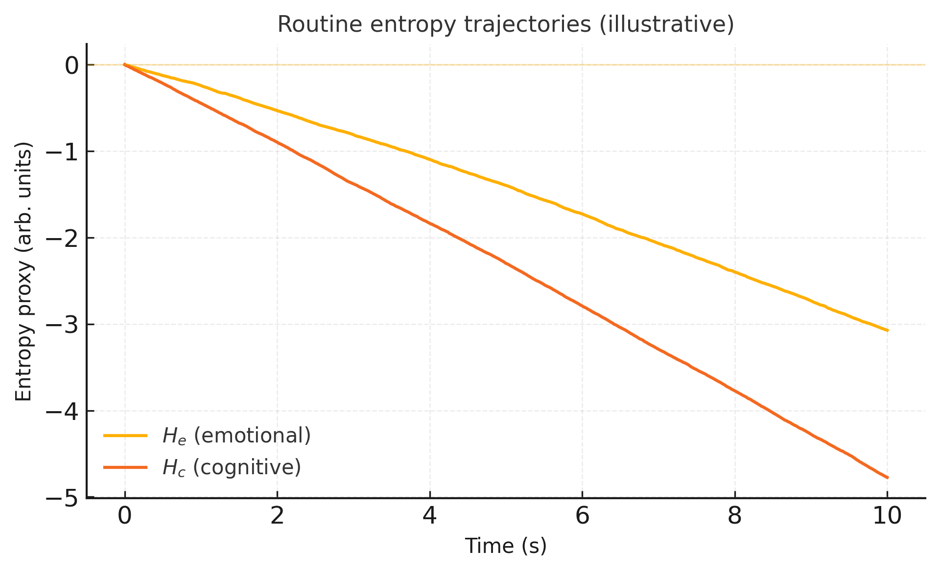
Figure 1. Routine entropy trajectories (routine_entropy.png). Simulated emotional entropy proxy H_e and cognitive entropy proxy H_c over a 10-s routine scenario under the routine-process equations. Trajectories are generated using hypothetical parameters and stylized inputs, and are intended solely to illustrate qualitative model behavior. This figure presents a mathematical demonstration and does not reflect empirical measurements from human participants.
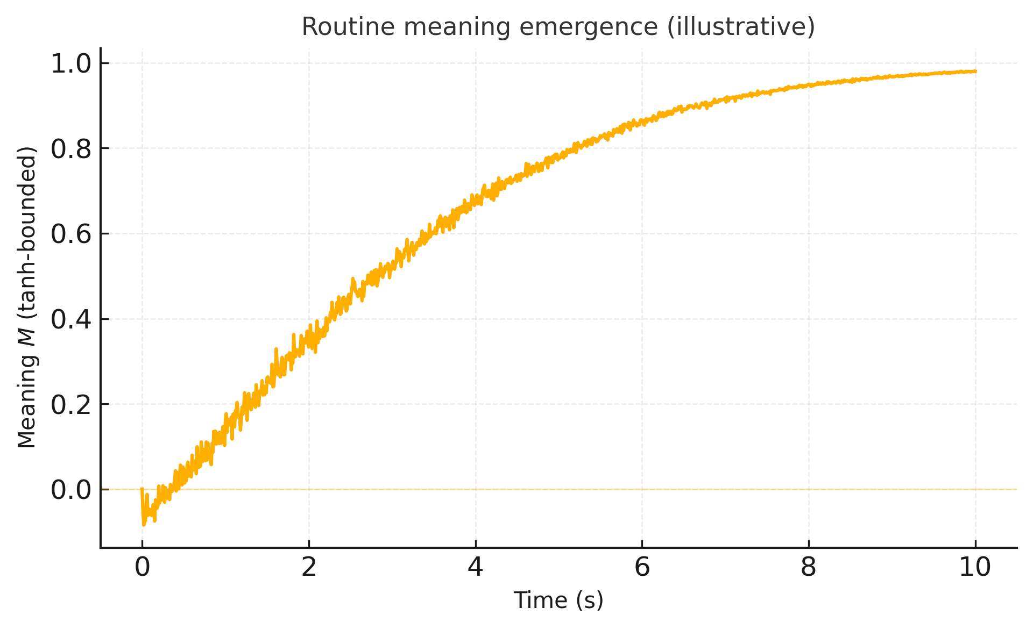
Figure 2. Routine meaning emergence (routine_meaning.png). Simulated meaning signal M_r over 10 s in the routine-process demonstration. Entropy terms entering the meaning equation are standardized relative to an early baseline window; the tanh-bounded output is mapped to [0, 1] for interpretability. Outputs reflect a mathematical demonstration with hypothetical parameters rather than empirical data.
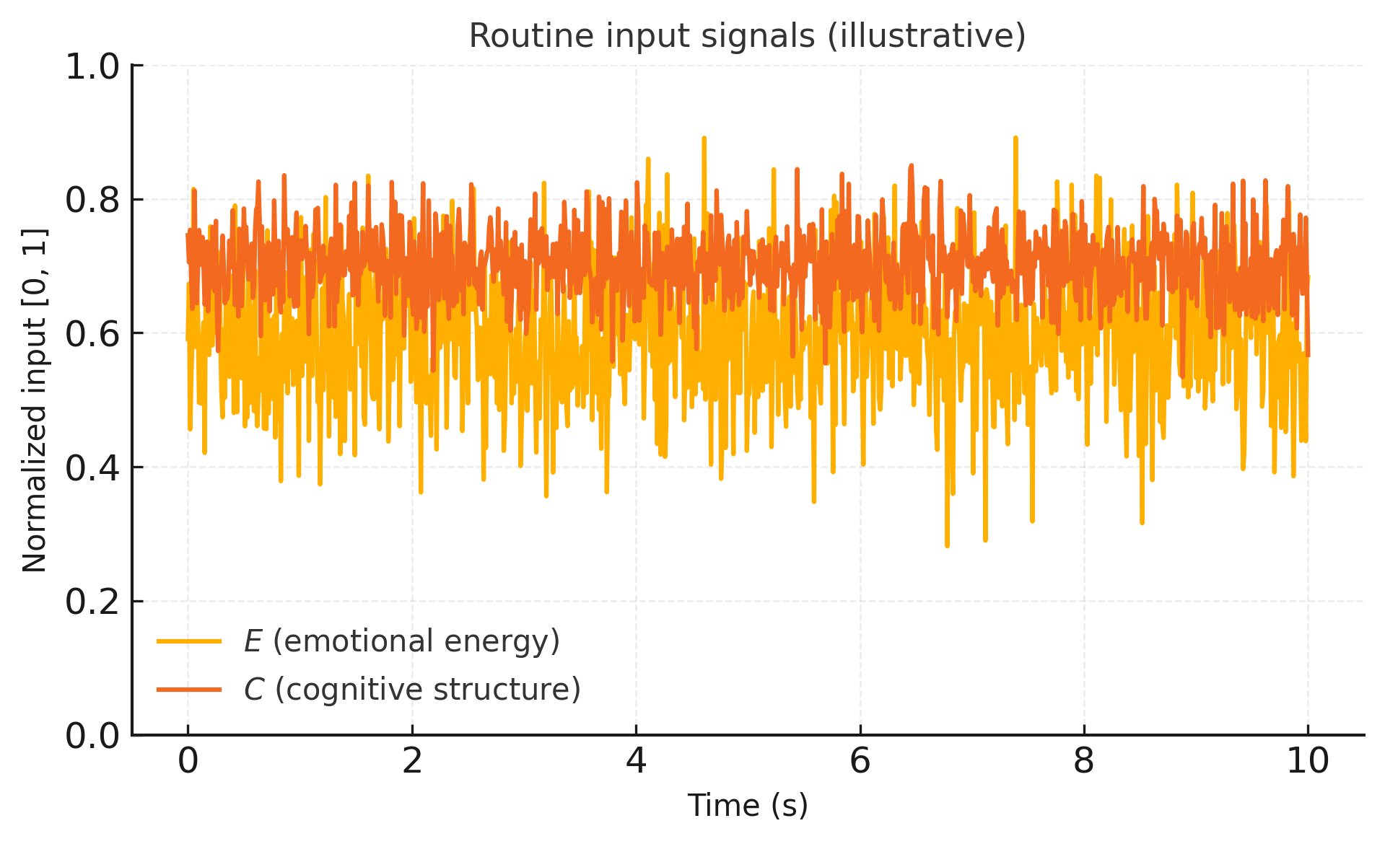
Figure 3. Routine input signals (routine_inputs.png). Stylized input trajectories for emotional energy E and cognitive structure C used to drive the routine-process simulation. Inputs are normalized to [0, 1] and include stochastic variation for illustration; they are not derived from physiological or behavioral recordings.
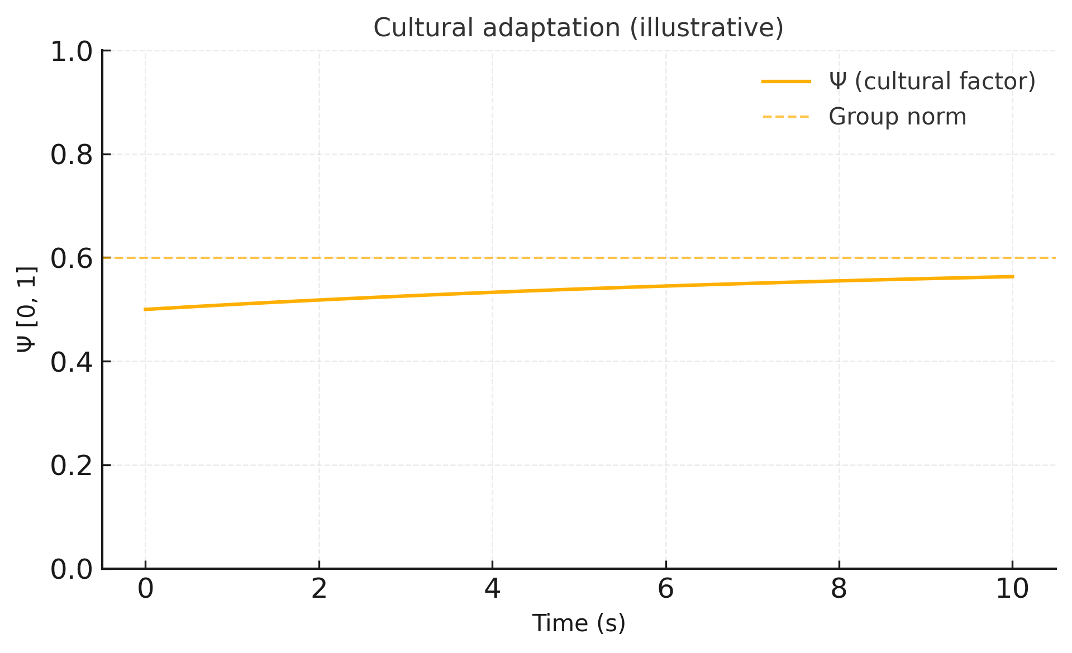
Figure 4. Cultural adaptation in routine dynamics (routine_culture.png). Simulated cultural factor Ψ adapting toward a fixed group norm S_group during the routine-process demonstration. This panel illustrates a simplified first-order cultural adaptation mechanism; parameter values and trajectories are hypothetical and not empirically estimated.

4.3 Demonstration 2: Transformative Trajectory
Scenario: Simulated 8-hour transformative episode. Simulated time-point values (exported):
Time (h) | H_e (arb.u.) | M_t (cumulative; normalized)
0.000 | 0.000 | 0.001
1.000 | 0.175 | 0.105
2.000 | 0.895 | 0.166
3.000 | 0.199 | 0.228
4.000 | -0.162 | 0.340
5.000 | -0.331 | 0.487
6.000 | -0.403 | 0.651
8.000 | -0.455 | 1.000
Interpretation (simulation-defined): H_e increases from 0.000 to a peak of 0.895 at 2 h (Phase 1), then decreases and reaches −0.455 at 8 h (Phase 2), below baseline. In the exported demonstration, the perturbation profile D(t) reaches D_max = 1.20 at t = 2 h (Figure 5). Parameters used (from the code defaults): γ=0.80, β_transform=0.60, H_e*=-0.50. The present manuscript reports the exported trajectories and their summaries rather than re-running simulations.

Note: The cumulative M_t is normalized in the exported output; its non-zero initial value (0.001 at t=0) reflects numerical initialization/normalization rather than a theoretical claim that meaning is non-zero at baseline.

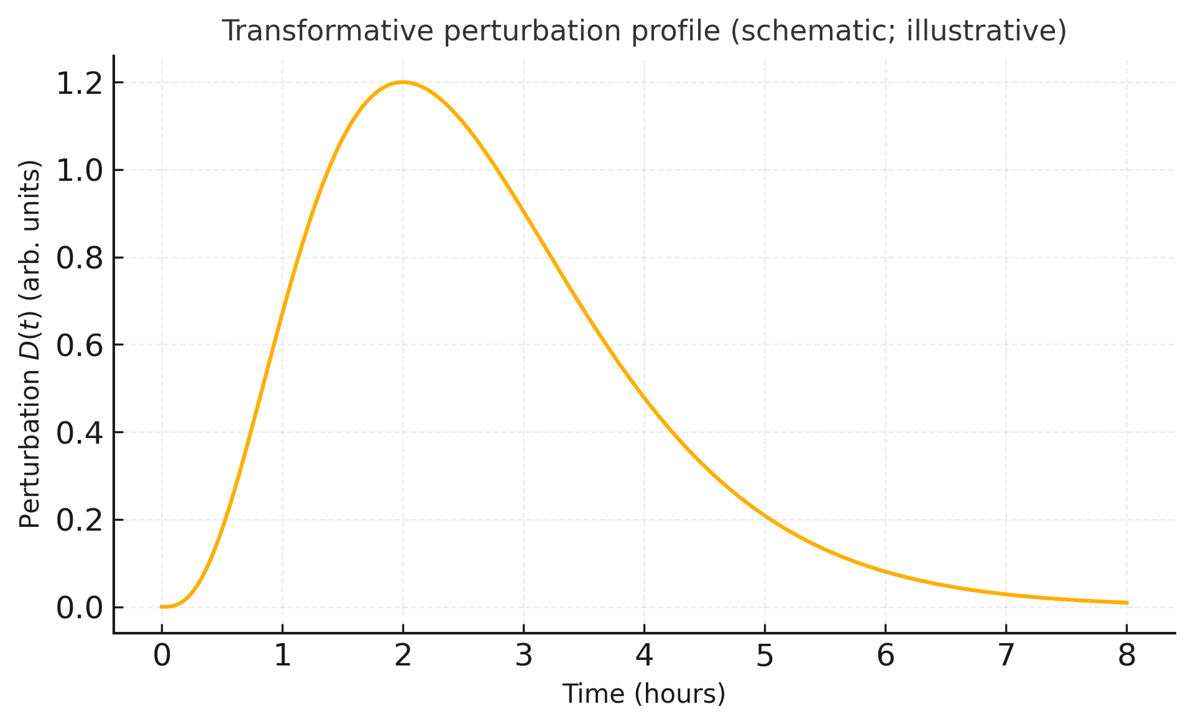
Figure 5. Transformative perturbation profile (transformative_drug_profile.png). Stylized perturbation curve D(t) (gamma-shaped; “psilocybin-like” schematic) used to generate the transformative biphasic demonstration. The profile is a computational convenience rather than a validated pharmacokinetic model. In the exported demonstration, D(t) reaches its maximum (1.20) at t = 2 h and decays toward ~0 by 8 h.
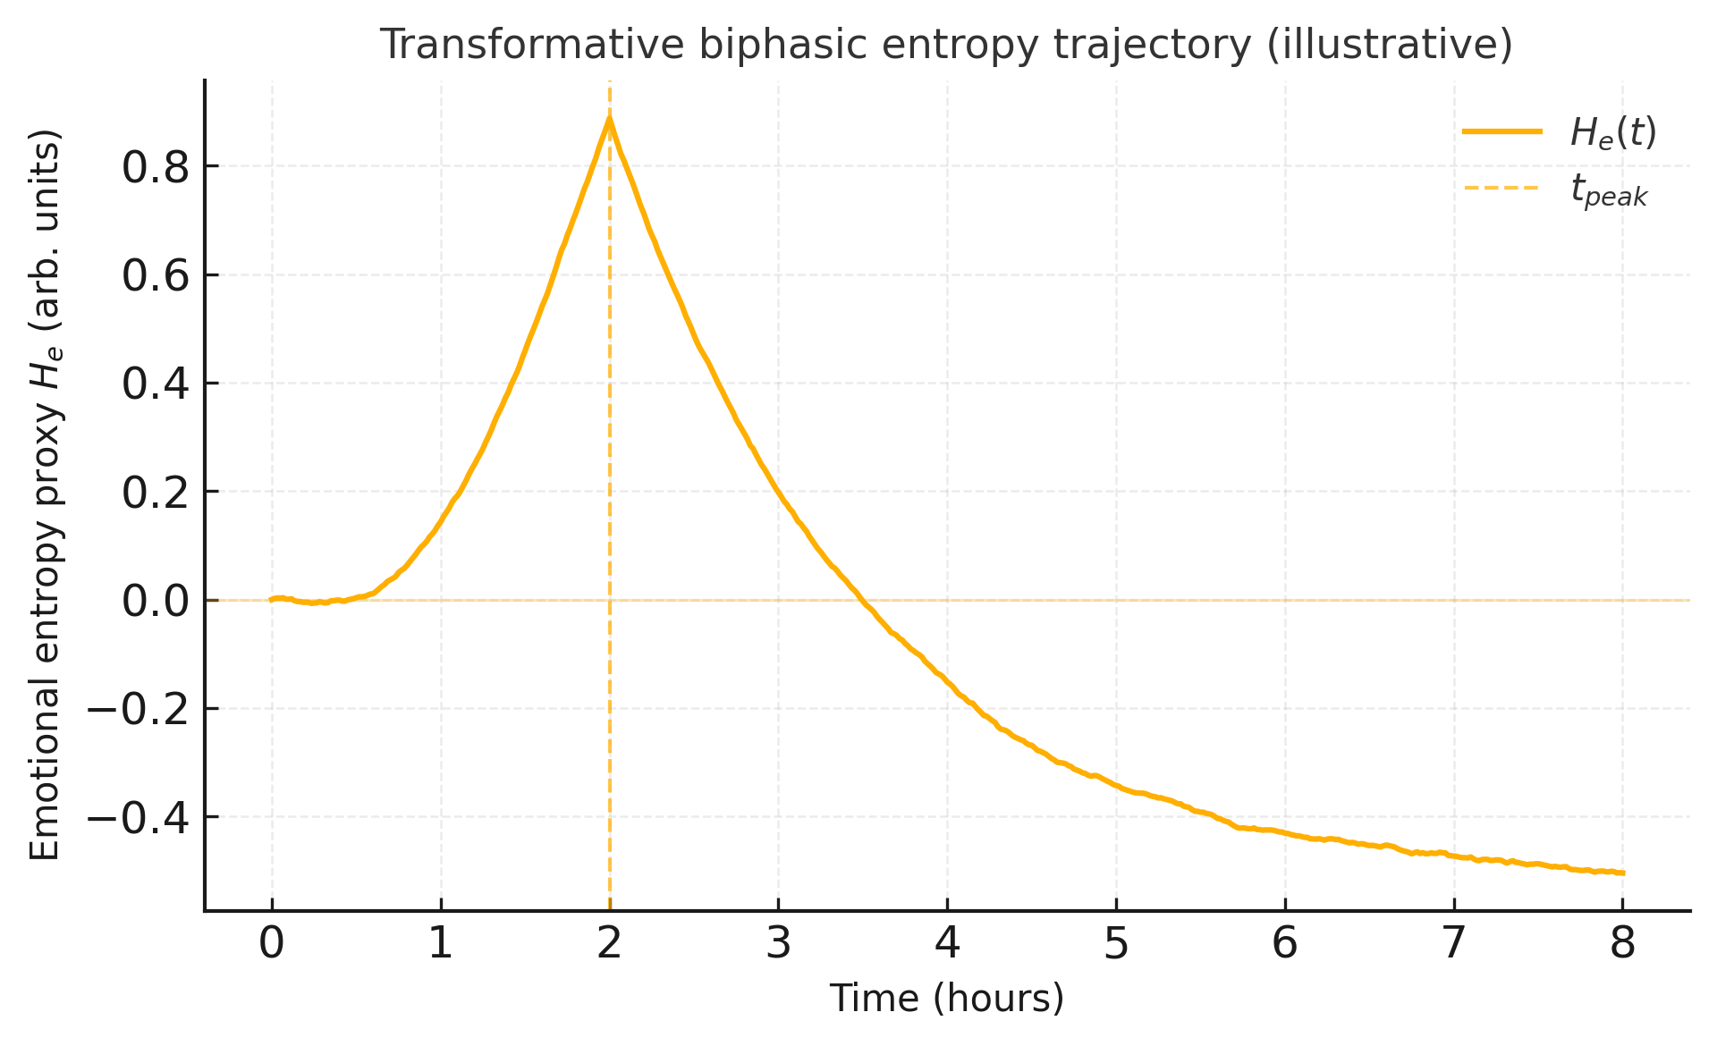
Figure 6. Transformative biphasic entropy trajectory (transformative_entropy.png). Simulated emotional entropy proxy H_e(t) across an 8-hour transformative trajectory exhibiting biphasic dynamics: an elevation phase during onset/peak followed by a post-peak collapse toward a lower setpoint. The dashed line marks the observed peak time (t_peak = 2 h) in the exported demonstration.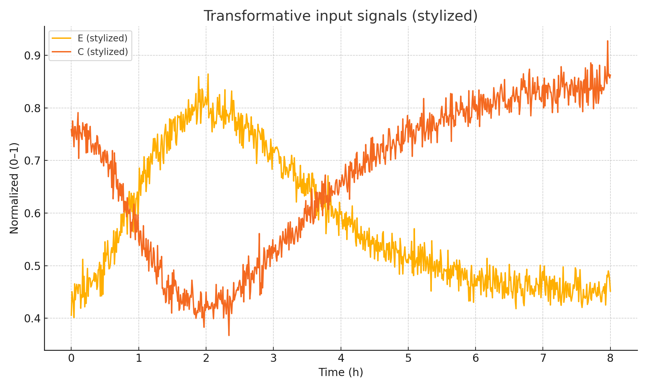
Figure 7. Transformative input signals (transformative_inputs.png). Stylized input trajectories for emotional energy E and cognitive structure C used in the transformative demonstration. Inputs are schematic and normalized, included for interpretive transparency rather than empirical realism.
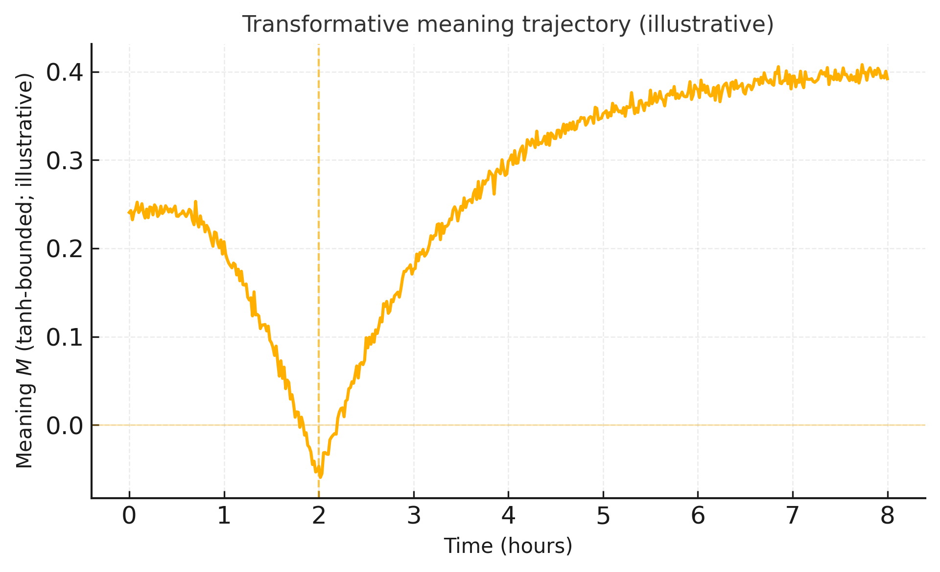
Figure 8. Transformative meaning trajectory (transformative_meaning.png). Simulated meaning signal M_t(t) during the transformative demonstration, shown as a cumulative (time-integrated) quantity computed from the instantaneous simulation-defined meaning signal. This trace is intended to show how meaning could covary with biphasic entropy dynamics; it is not a quantitative model of MEQ30 scores or long-term therapeutic outcomes.

4.4 Demonstration 3: Cultural Modulation
Comparison: Simulated “restrained” vs “expressive” cultural settings. Simulated results (exported):
Culture | Ψ (initial) | S_group | Ψ (final) | H_e final (arb.u.) | M_r final (0–1) | Time to M>0.35 (s)
Restrained | 0.320 | 0.320 | 0.320 | -0.726 | 0.911 | 1.990
Expressive | 0.680 | 0.680 | 0.680 | -0.708 | 0.921 | 1.600

4.5 Parameter Sensitivity
Varying α_E (emotional regulation capacity). Simulated results (exported):
α_E (arb.u./s) | time_to_M_gt_0p40_s | M_r_final | H_e_final
0.200 | 2.470 | 0.904 | -0.515
0.400 | 2.280 | 0.922 | -0.714
0.600 | 2.230 | 0.937 | -0.912

4.6 Simulation Summary
The demonstrations indicate that:
- The equations generate qualitatively plausible trajectories under the selected parameter regimes.
- The system converges to stable regimes in the routine condition.
- A biphasic pattern emerges when a transient perturbation term is introduced.
- Cultural modulation and parameter sensitivity behave as expected within a stylized demonstration.
The demonstrations do not establish that:
- The parameter values are empirically accurate.
- Human participants follow these trajectories.
- The proposed predictions will be confirmed.
- The model has external validity without empirical testing.
Accordingly, the critical next step is empirical evaluation with preregistered measurements, reliability assessment of entropy proxies, and parameter estimation using real participant data.

5. TESTABLE PREDICTIONS AND VALIDATION

5.1 Falsifiable Predictions
Prediction 1: Routine Entropy–Meaning Correlation
Hypothesis: In routine contexts, H_e negatively correlates with self-reported meaning.
Test: r(H_e, MLQ_presence) < −0.3, p < 0.05
Falsification: If |r| < 0.2 or positive, core assumption is undermined.
Sample: n=50 (power=0.80 for r=0.4, α=0.05; G*Power calculation)

Prediction 2: Biphasic Psychedelic Trajectory (primary test)
Hypothesis: During psilocybin sessions:
• Phase 1 (0–3 h): H_e increases
• Phase 2 (4–8 h): H_e decreases, potentially undershooting baseline in a subset of individuals
Test: Within-subject comparison, H_e(8 h) < H_e(0 h)
Falsification: If H_e(8 h) ≥ H_e(0 h) in >80% of participants, the below-baseline claim is unsupported.
Sample: n=20 (pilot; within-subjects d=0.6 detectable at power=0.80)

Prediction 3: Cultural Moderation
Hypothesis: Ψ moderates the H_e → meaning relationship.
Model: MLQ = β0 + β1·H_e + β2·Ψ + β3·(H_e×Ψ) + ε
Expected: β3 > +0.10, p < 0.05
Falsification: If β3 ≈ 0, cultural modulation is unsupported.
Sample: n=100 (50 per culture)

5.2 Validation Strategy
Phase 1: Measurement validation (6 months, n=20)
• Test–retest reliability of H_e (ICC > 0.70 target)
• Convergent validity: r(H_e, anxiety) > 0.3
• Decision: ICC < 0.50 → revise measures

Phase 2: Cross-cultural test (12 months, n=100)
• Two cultural contexts (high vs low Ψ distributions)
• Test Predictions 1 and 3
• Decision: β3 ≈ 0 → drop cultural claim

Phase 3: Prospective validation (24 months, n=200)
• Longitudinal design, full model fitting
• Out-of-sample prediction (R² > 0.25 target)
• Decision: R² < 0.10 → reject framework

5.3 Potential Validation Datasets
Existing open-access datasets could enable preliminary testing:
LEMON Database (Babayan et al., 2019):
• N=227, resting EEG + life satisfaction measures
• Publicly available at: http://fcon_1000.projects.nitrc.org/indi/retro/MPI_LEMON.html
• Could test entropy–wellbeing correlation (Prediction 1 proxy)
• Limitation: no MLQ specifically; life satisfaction is related but distinct

Note: These are proposed validation routes; analyses have not been conducted in this manuscript.

6. DISCUSSION

6.1 Theoretical Contributions
This framework proposes a mechanistic resolution of the entropy paradox by distinguishing routine from transformative dynamics:

Why both traditions can be correct:
• Friston: routine functioning requires entropy minimization.
• Carhart-Harris: transformation can involve transient entropy elevation.
Resolution: different processes, different trajectories, with convergence toward coherence.

Novel predictions emphasized here:
• A post-peak “below-baseline” reduction in entropy indices in some individuals.
• A functional emphasis on the post-peak (integration) window rather than peak alone.
• Quantified (though simplified) cultural modulation via Ψ.

6.2 Clinical Implications
Anxiety treatment personalization:
• Increase α_E: HRV biofeedback for low regulatory capacity
• Increase Ψ: group support interventions for social isolation
• Reduce σ: pharmacotherapy for high neural noise
Testable prediction: pathway-matching yields better outcomes than standard CBT (predicted d ≈ 0.5)

Specific intervention: HRV biofeedback
• Protocol: 8 weeks, 2× weekly, resonance-frequency breathing
• Expected mechanism: strengthens parasympathetic control → faster entropy reduction
• Predicted outcome: 15–20% reduction in STAI scores (Goessl et al., 2017)
• Empirical test: pre–post STAI, with fitted α_E as mediator

Psychedelic therapy optimization:
Current clinical focus often emphasizes the “mystical peak experience” (Griffiths et al., 2011). E.M.E.R.G.E+ suggests refinement:
• Peak (Phase 1) enables transformation, but Phase 2 consolidation may determine outcome.
• Extend post-session monitoring to 8–12 h to capture Phase 2 signatures.
• Emphasize integration supports (guided reflection, journaling) during the descent window.
• Pre-screen regulatory capacity (baseline HRV) as a candidate marker of Phase 2 dynamics.

6.3 Cross-Cultural Mental Health
Problem: Western psychological interventions show reduced efficacy in some non-Western contexts (Kirmayer et al., 2013).

E.M.E.R.G.E+ interpretation:
Interventions may implicitly assume moderate-to-high Ψ (encouraging emotional disclosure). In low-Ψ contexts, this mismatch can reduce efficacy.

Example application (hypothesis): Anxiety treatment in Japan
• Standard CBT: emotional expression encouraged → Ψ mismatch → moderate efficacy
• Culturally adapted CBT: mindfulness and internal emotion cultivation → better Ψ alignment → improved efficacy
Testable: RCT comparing standard vs adapted CBT; Ψ (DRAI scores) moderates response.

6.4 Limitations
Theoretical limitations:
• Phenomenological equations: inspired by FEP but not derived from variational calculus.
• Linear approximations: real neural dynamics are highly nonlinear.
• Cultural over-simplification: Ψ collapses complex norms into one dimension.
• Meaning as unitary: real meaning is multi-dimensional (coherence, purpose, significance).

Empirical limitations:
• No data (n=0). Simulations are demonstrations only.
• Parameter count can enable overfitting; cross-validated tests are required.
• Measurement challenges: reliability of EEG-derived entropy indices varies across pipelines.

Scope limitations:
The framework addresses meaning dynamics, not consciousness as a whole, not all altered states, and not meaning content.

6.5 Alternative Interpretations
Alternative 1: Reverse causality
Low meaning could increase entropy rather than vice versa. The model can accommodate bidirectionality; longitudinal designs are needed.

Alternative 2: Third variable (e.g., prefrontal function)
dlPFC might drive both entropy reduction and meaning; this is compatible if dlPFC implements α_E/α_C-like processes.

Alternative 3: Illusory meaning (apophenia)
High entropy may yield false pattern detection. E.M.E.R.G.E+ distinguishes Phase 1 (risk of apophenia) from Phase 2 consolidation. Test: beneficial sessions show deeper Phase 2 descent than harmful sessions.

6.6 Future Theoretical Extensions
Possible extensions include:
1) Oscillatory dynamics (circadian/ultradian modulation of H_e)
2) Social network effects (Ψ as network property rather than individual scalar)
3) Developmental trajectories (age-dependent α_E, Θ parameters)
4) Formal derivation from free energy (future work to connect phenomenology to principled inference)

6.7 Relationship to Other Computational Frameworks
Comparison with IIT:
IIT quantifies consciousness as integrated information (Φ). E.M.E.R.G.E+ focuses on meaning dynamics rather than the substrate of consciousness.

Comparison with GWT:
GWT emphasizes global broadcasting. E.M.E.R.G.E+ can be interpreted as specifying why low-entropy, high-coherence representations dominate broadcasted content.

6.8 Practical Implementation Considerations
Real-time entropy measurement:
Entropy computation is often offline; clinical use may require near-real-time pipelines.

Individual parameter estimation:
Fitting many parameters per person suggests hierarchical Bayesian estimation (e.g., Stan/PyMC), balancing stability and identifiability.

Cultural measurement:
DRAI is long; a brief version (e.g., 10 items) could enable practical use, but requires psychometric validation.
6.9 Ethical Considerations
Because psychedelic compounds can carry psychological and medical risks, the present framework should not be interpreted as endorsing unsupervised or recreational use. The predictions are intended for controlled research or therapeutic contexts that include preparation, monitoring, and integration support. A suitable statement for submissions is:
“These predictions apply to controlled therapeutic or research contexts and should not be interpreted as endorsement of recreational psychedelic use. Psychedelic substances carry risks including psychological distress and adverse reactions, and should only be used under appropriate medical supervision in jurisdictions where legal.”
Quantifying the cultural factor Ψ also carries interpretive risks. In this framework, Ψ represents an individual’s internalization of emotion-regulation norms as measured by validated instruments; it should not be inferred from nationality, ethnicity, or geography. Within-culture variance may equal or exceed between-culture variance, and interpretations should remain probabilistic rather than deterministic. Any clinical translation should be considered conditional on empirical validation and subject to appropriate oversight and approvals.

7. CONCLUSION

7.1 Summary of Framework
The E.M.E.R.G.E+ dual-process framework proposes that meaning emerges through two distinct entropy dynamics:
Routine Meaning:
• Gradual entropy minimization via emotional–cognitive synergy
• Modulated by cultural norms (Ψ)
• Monotonic trajectory toward coherence

Transformative Meaning:
• Biphasic trajectory: temporary elevation → deep reduction (sometimes below baseline)
• Enabled by perturbations that relax rigid priors
• Reorganization into a more coherent configuration

Core innovation: both processes can end in lower entropy and higher coherence, but via different temporal dynamics.

7.2 Key Contributions
• Mechanistic resolution of the entropy paradox via dual-process dynamics
• Explicit falsifiable predictions (including a below-baseline post-peak signature)
• Computational demonstrations of internal consistency
• Quantified (toy) cultural modulation via Ψ
• Practical implications for intervention timing and personalization (pending validation)

7.3 Current Status and Next Steps
The present work introduces a mathematically specified theoretical framework for meaning emergence, alongside computational demonstrations intended to establish internal consistency and generate falsifiable predictions. No empirical human-participant data were collected for this manuscript (n = 0), and all parameter values used in simulations are hypothetical.
The next steps are: (i) empirical operationalization and reliability assessment of the proposed entropy proxies and meaning measures, (ii) parameter estimation and model fitting using real participant data (preferably with preregistered analyses), (iii) replication across independent samples and datasets, and (iv) evaluation of any clinical implications only after core predictions are supported.

7.4 Significance and Impact
If validated, E.M.E.R.G.E+ could provide:
• A mechanistic foundation for computational meaning research
• Tools for computational psychiatry and intervention personalization
• Templates for cultural neuroscience modeling
• A framework for affective AI systems that explicitly represent uncertainty/meaning dynamics
7.5 Commitment to Open Science
We commit to transparency about limitations and to publishing results regardless of outcome—confirmatory, null, or contradictory—because negative results are informative for cumulative science (Ioannidis, 2005). Reproducibility will be supported through open code, archived simulation outputs, and clearly pre-registered empirical tests of the framework’s falsifiable predictions.
7.6 Invitation to the Scientific Community
We welcome theoretical critiques, empirical replications (confirmatory or disconfirmatory), methodological refinements, and cross-cultural collaborations to evaluate the framework’s claims. Scientific progress requires constructive skepticism and explicit falsification criteria (Popper, 1959). If E.M.E.R.G.E+ motivates careful empirical testing—even if ultimately refuted—it will have served a meaningful role in clarifying how meaning relates to uncertainty dynamics.
7.7 Final Reflection
E.M.E.R.G.E+ is ambitious and incomplete. It proposes a mechanistic story about the dynamics of meaning emergence rather than the content of meaning or a comprehensive theory of consciousness. As Box (1976) noted, “All models are wrong, but some are useful.” The present model should be judged by whether its predictions survive empirical scrutiny and whether it improves the precision of research questions about meaning and entropy dynamics.

Acknowledgments
AI/LLM disclosure: Large language model tools were used for limited language editing and formatting assistance. The author reviewed all outputs and takes full responsibility for the content, citations, and interpretations.
The author thanks the scientific community for open-access datasets, transparent methodological reporting, and constructive peer review culture that make frameworks like this possible. Special acknowledgment to developers of open-source scientific software that enable reproducible computational research.

Author Contributions
A.L. conceived the framework, conducted literature review, developed mathematical formulations, implemented simulations, and wrote the manuscript.

Competing Interests
The author declares no competing financial interests or personal relationships that could influence this work.

Data Availability
No empirical data were collected for this theoretical paper. Simulation code and outputs are included with this manuscript package. Future empirical studies will share data via Open Science Framework following IRB approval and participant consent. A versioned project archive (manuscript, dashboard, code, and CSV exports) is maintained in the public repositories: https://github.com/amirlotfifar1994-dot/Emerge and https://github.com/amirlotfifar1994-dot/cv (dashboard page: https://amirlotfifar1994-dot.github.io/cv/emerge/index.html).

Funding
This theoretical work was conducted independently without institutional or external funding. Future empirical validation studies will require grant support; funding sources will be disclosed in subsequent publications.

References

Adams, R. A., Stephan, K. E., Brown, H. R., Frith, C. D., & Friston, K. J. (2013). The computational anatomy of psychosis. Frontiers in Psychiatry, 4, 47. https://doi.org/10.3389/fpsyt.2013.00047
Albantakis, L., et al. (2023). Integrated information theory (IIT) 4.0: Formulating the properties of phenomenal existence from first principles. PLOS Computational
Biology, 19(10), e1011465. https://doi.org/10.1371/journal.pcbi.1011465
Baars, B. J. (1988). A cognitive theory of consciousness. Cambridge University Press.
Babayan, A., et al. (2019). A mind-brain-body dataset of MRI, EEG, cognition, emotion, and peripheral physiology in young and old adults. Scientific Data, 6, 180308. https://doi.org/10.1038/sdata.2018.308
Barrett, F. S., Johnson, M. W., & Griffiths, R. R. (2015). Validation of the revised Mystical Experience Questionnaire in experimental sessions with psilocybin. Journal of Psychopharmacology, 29(11), 1182–1190. https://doi.org/10.1177/0269881115609019
Barrett, L. F. (2017). The theory of constructed emotion: An active inference account of interoception and categorization. Social Cognitive and Affective Neuroscience, 12(1), 1–23. https://doi.org/10.1093/scan/nsw154
Barrett, L. F., Gross, J., Christensen, T. C., & Benvenuto, M. (2001). Knowing what you're feeling and knowing what to do about it: Mapping the relation between emotion differentiation and emotion regulation. Cognition & Emotion, 15(6), 713–724. https://doi.org/10.1080/02699930143000239
Box, G. E. P. (1976). Science and statistics. Journal of the American Statistical
Association, 71(356), 791–799. https://doi.org/10.1080/01621459.1976.10480949
Bradley, M. M., & Lang, P. J. (1994). Measuring emotion: The Self-Assessment Manikin and the semantic differential. Journal of Behavior Therapy and Experimental
Psychiatry, 25(1), 49–59. https://doi.org/10.1016/0005-7916(94)90063-9
Berman, M. G., Peltier, S., Nee, D. E., Kross, E., Deldin, P. J., & Jonides, J. (2011).
Depression, rumination and the default network. Social Cognitive and Affective Neuroscience, 6(5), 548–555. https://doi.org/10.1093/scan/nsq080
Carhart-Harris, R. L. (2018). The entropic brain - revisited. Neuropharmacology, 142, 167–178. https://doi.org/10.1016/j.neuropharm.2018.03.010
Carhart-Harris, R. L., & Friston, K. J. (2019). REBUS and the anarchic brain: Toward a unified model of the brain action of psychedelics. Pharmacological Reviews, 71(3), 316–344. https://doi.org/10.1124/pr.118.017160
Carhart-Harris, R. L., Leech, R., Hellyer, P. J., Shanahan, M., Feilding, A.,
Tagliazucchi, E., Chialvo, D. R., & Nutt, D. (2014). The entropic brain: A theory of conscious states informed by neuroimaging research with psychedelic drugs. Frontiers in Human Neuroscience, 8, 20. https://doi.org/10.3389/fnhum.2014.00020
Carhart-Harris, R. L., et al. (2016). Psilocybin with psychological support for treatment-resistant depression: An open-label feasibility study. Lancet Psychiatry, 3(7), 619–627. https://doi.org/10.1016/S2215-0366(16)30065-7
Carpenter, B., et al. (2017). Stan: A probabilistic programming language. Journal of Statistical Software, 76(1), 1–32. https://doi.org/10.18637/jss.v076.i01
Csikszentmihalyi, M. (1990). Flow: The psychology of optimal experience. Harper & Row.
Disner, S. G., Beevers, C. G., Haigh, E. A., & Beck, A. T. (2011). Neural mechanisms of the cognitive model of depression. Nature Reviews Neuroscience, 12(8), 467–477. https://doi.org/10.1038/nrn3027
Friston, K. (2010). The free-energy principle: A unified brain theory? Nature Reviews
Neuroscience, 11(2), 127–138. https://doi.org/10.1038/nrn2787
Goessl, V. C., Curtiss, J. E., & Hofmann, S. G. (2017). The effect of heart rate variability biofeedback training on stress and anxiety: A meta-analysis. Psychological Medicine, 47(15), 2578–2586. https://doi.org/10.1017/S0033291717001003
Griffiths, R. R., Richards, W. A., Johnson, M. W., McCann, U. D., & Jesse, R. (2008). Mystical-type experiences occasioned by psilocybin mediate the attribution of personal meaning and spiritual significance 14 months later. Journal of
Psychopharmacology, 22(6), 621–632. https://doi.org/10.1177/0269881108094300
Griffiths, R. R., Richards, W. A., McCann, U., & Jesse, R. (2006). Psilocybin can occasion mystical-type experiences having substantial and sustained personal meaning and spiritual significance. Psychopharmacology, 187(3), 268–283. https://doi.org/10.1007/s00213-006-0457-5
Griffiths, R. R., et al. (2011). Psilocybin occasioned mystical-type experiences: Immediate and persisting dose-related effects. Psychopharmacology, 218(4), 649–665. https://doi.org/10.1007/s00213-011-2358-5
Gross, J. J. (2015). Emotion regulation: Current status and future prospects. Psychological Inquiry, 26(1), 1–26. https://doi.org/10.1080/1047840X.2014.940781
Hartogsohn, I. (2017). Constructing drug effects: A history of set and setting. Drug
Science, Policy and Law, 3, 2050324516683325. https://doi.org/10.1177/2050324516683325
Heine, S. J., Proulx, T., & Vohs, K. D. (2006). The meaning maintenance model: On the coherence of social motivations. Personality and Social Psychology Review, 10(2), 88–110. https://doi.org/10.1207/s15327957pspr1002_1
Heintzelman, S. J., & King, L. A. (2014). Life is pretty meaningful. American
Psychologist, 69(6), 561–574. https://doi.org/10.1037/a0035049
Hirsh, J. B., Mar, R. A., & Peterson, J. B. (2012). Psychological entropy: A framework for understanding uncertainty-related anxiety. Psychological Review, 119(2), 304–320. https://doi.org/10.1037/a0026767
Hölzel, B. K., Lazar, S. W., Gard, T., Schuman-Olivier, Z., Vago, D. R., & Ott, U. (2011). How does mindfulness meditation work? Proposing mechanisms of action from a conceptual and neural perspective. Perspectives on Psychological Science, 6(6), 537–559. https://doi.org/10.1177/1745691611419671
Ioannidis, J. P. A. (2005). Why most published research findings are false. PLOS
Medicine, 2(8), e124. https://doi.org/10.1371/journal.pmed.0020124
Jacobson, N. S., Martell, C. R., & Dimidjian, S. (2001). Behavioral activation treatment for depression: Returning to contextual roots. Clinical Psychology: Science and Practice, 8(3), 255–270. https://doi.org/10.1093/clipsy.8.3.255
Johnson, M. W., Richards, W. A., & Griffiths, R. R. (2008). Human hallucinogen research: Guidelines for safety. Journal of Psychopharmacology, 22(6), 603–620. https://doi.org/10.1177/0269881108093587
Kirmayer, L. J., Guzder, J., & Rousseau, C. (Eds.). (2013). Cultural consultation: Encountering the other in mental health care. Springer. https://doi.org/10.1007/978-1-4614-7615-3
Laborde, S., Mosley, E., & Thayer, J. F. (2017). Heart rate variability and cardiac vagal tone in psychophysiological research. Frontiers in
Psychology, 8, 213. https://doi.org/10.3389/fpsyg.2017.00213
Martela, F., & Steger, M. F. (2016). The three meanings of meaning in life: Distinguishing coherence, purpose, and significance. The Journal of Positive Psychology, 11(5), 531–545. https://doi.org/10.1080/17439760.2015.1137623
Matsumoto, D., Yoo, S. H., Fontaine, J., et al. (2008). Mapping expressive differences around the world: The relationship between emotional display rules and individualism versus collectivism. Journal of Cross-Cultural Psychology, 39(1), 55–74. https://doi.org/10.1177/0022022107311854
Miller, E. K., & Cohen, J. D. (2001). An integrative theory of prefrontal cortex function. Annual Review of Neuroscience, 24, 167–202. https://doi.org/10.1146/annurev.neuro.24.1.167
Moran, R. J., Campo, P., Symmonds, M., Stephan, K. E., Dolan, R. J., & Friston, K. J. (2013). Free energy, precision and learning: The role of cholinergic neuromodulation. Journal of Neuroscience, 33(19), 8227–8236. https://doi.org/10.1523/JNEUROSCI.4255-12.2013
Nakamura, J., & Csikszentmihalyi, M. (2002). The concept of flow. In C. R. Snyder & S. J. Lopez (Eds.), Handbook of positive psychology (pp. 89–105). Oxford University Press.
Panksepp, J. (1998). Affective neuroscience: The foundations of human and animal emotions. Oxford University Press.
Pizzagalli, D. A. (2014). Depression, stress, and anhedonia: Toward a synthesis and integrated model. Annual Review of Clinical Psychology, 10, 393–423. https://doi.org/10.1146/annurev-clinpsy-050212-185606
Popper, K. (1959). The logic of scientific discovery. Hutchinson.
Schartner, M. M., et al. (2017). Increased spontaneous MEG signal diversity for psychoactive doses of ketamine, LSD and psilocybin. Scientific Reports, 7, 46421. https://doi.org/10.1038/srep46421
Seth, A. K., & Friston, K. J. (2016). Active interoceptive inference and the emotional brain. Philosophical Transactions of the Royal Society B, 371(1708), 20160007. https://doi.org/10.1098/rstb.2016.0007
Sporns, O. (2010). Networks of the brain. MIT Press. https://doi.org/10.7551/mitpress/8476.001.0001
Steger, M. F., Frazier, P., Oishi, S., & Kaler, M. (2006). The Meaning in Life Questionnaire: Assessing the presence of and search for meaning in life. Journal of Counseling Psychology, 53(1), 80–93. https://doi.org/10.1037/0022-0167.53.1.80
Tagliazucchi, E., et al. (2016). Increased global functional connectivity correlates with LSD-induced ego dissolution. Current Biology, 26(8), 1043–1050. https://doi.org/10.1016/j.cub.2016.02.010
Tononi, G. (2008). Consciousness as integrated information: A provisional manifesto. The Biological Bulletin, 215(3), 216–242. https://doi.org/10.2307/25470707
Travis, F., & Shear, J. (2010). Focused attention, open monitoring and automatic self-transcending: Categories to organize meditations from Vedic, Buddhist and Chinese traditions. Consciousness and Cognition, 19(4), 1110–1118. https://doi.org/10.1016/j.concog.2010.01.007
Wang, T., Huang, X., Xiao, Z., Cai, W., & Tang, Y. (2024). EEG emotion recognition based on differential entropy feature matrix through 2D-CNN-LSTM network. EURASIP Journal on Advances in Signal Processing, 2024(1), 49. https://doi.org/10.1186/s13634-024-01146-y
Yerkes, R. M., & Dodson, J. D. (1908). The relation of strength of stimulus to rapidity of habit-formation. Journal of Comparative Neurology and Psychology, 18(5), 459–482. https://doi.org/10.1002/cne.920180503
Muthukumaraswamy, S. D., Carhart-Harris, R. L., Moran, R. J., Brookes, M. J., Williams, T. M., Errtizoe, D., Sessa, B., Papadopoulos, A., Bolstridge, M., Singh, K. D., Feilding, A., Friston, K. J., & Nutt, D. J. (2013). Broadband cortical desynchronization underlies the human psychedelic state. Journal of Neuroscience, 33(38), 15171–15183. https://doi.org/10.1523/JNEUROSCI.2063-13.2013

