Billing Alarm -> you go and let the cloudwatch to get billing logs , it creates metrics
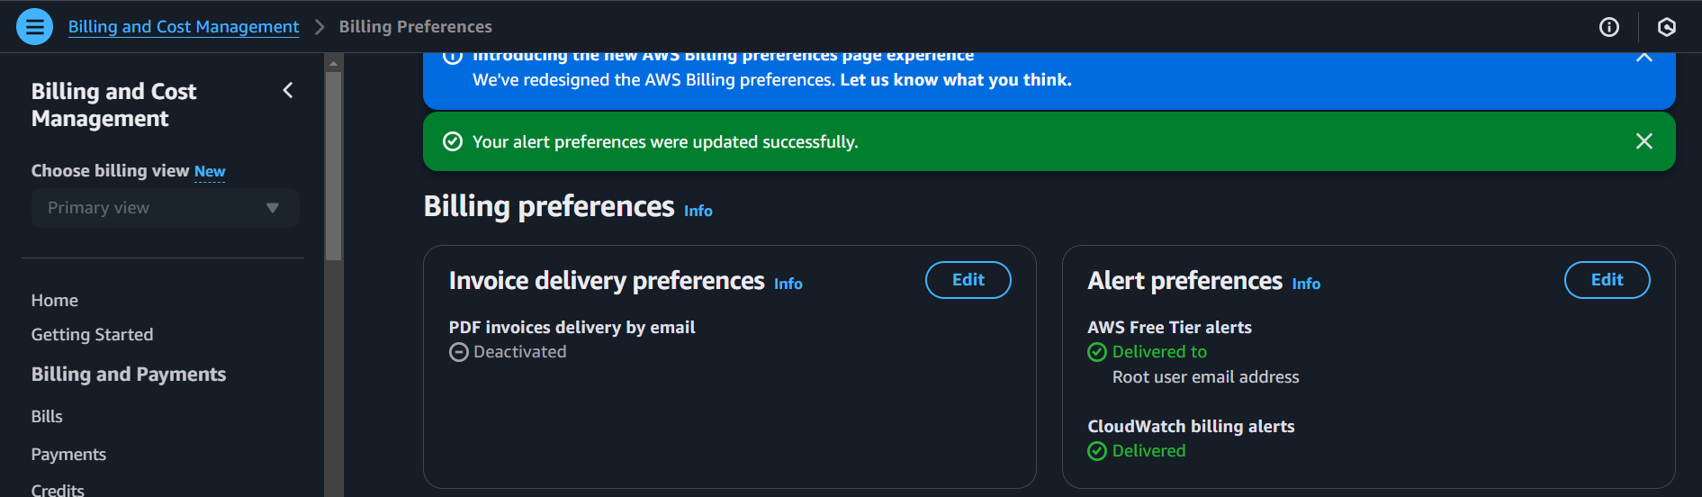

Create a Billing alarm condition if the billing < or > or <= or >= ……….
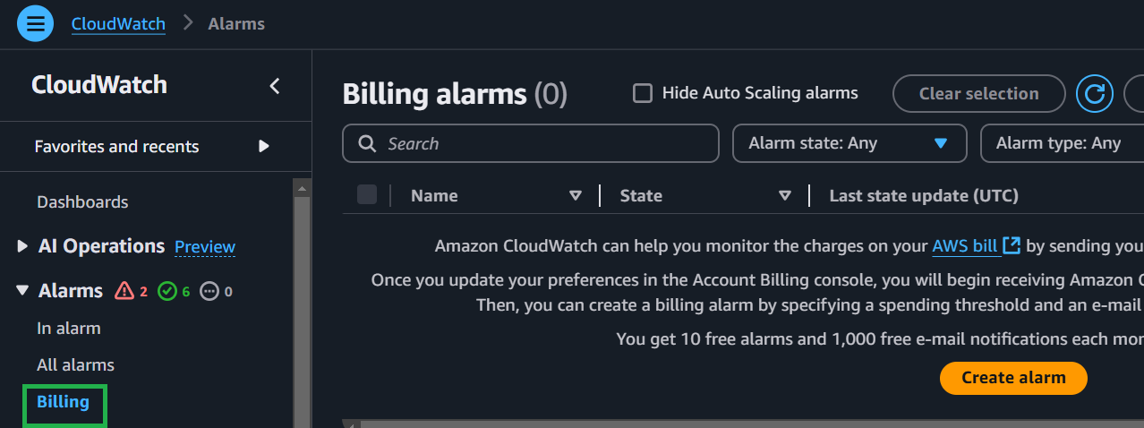

The second solution -> use the Budget
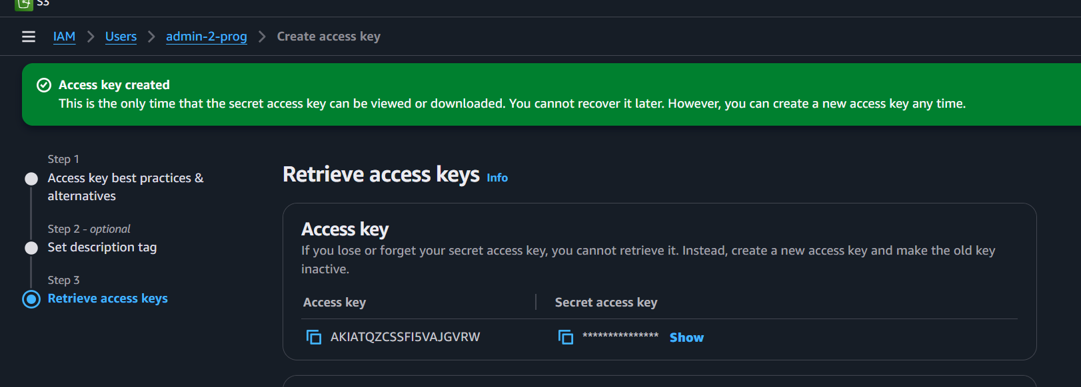

List all users and groups

Create a new user dev-user and attach to developers group
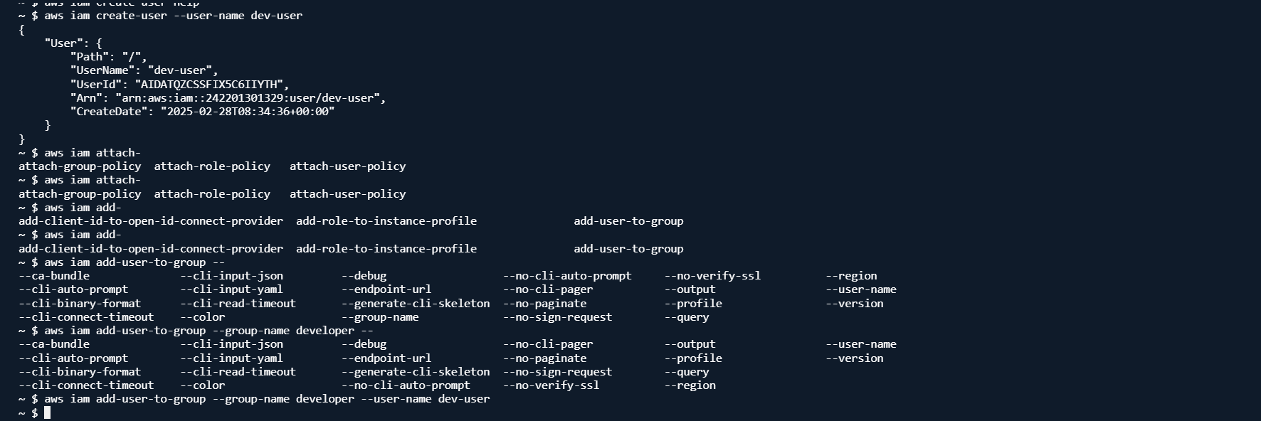

Dev-user can access EC2 but not S3
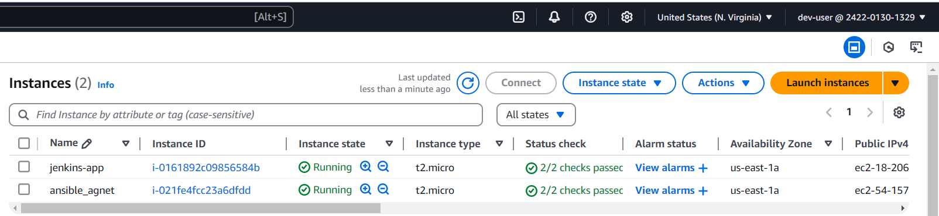

Dev-user can’t access EC2 but not S3

