Create VPC , (private , public) route tables , ( private , public ) subnets , Internet and NAT gateways
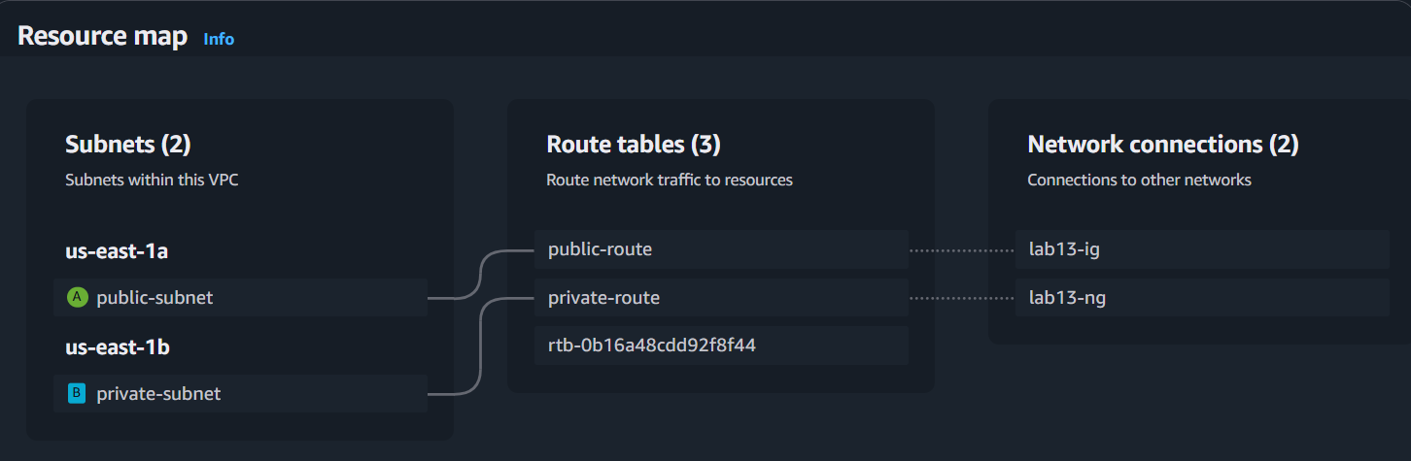

Create two security groups
- ONLY_SSH -> enable ssh from all source IPs
- ONLY_SSH_FROM_BASTION -> enable ssh from only ONLY_SSH security group

Create two instances (bastion instance , private instance)
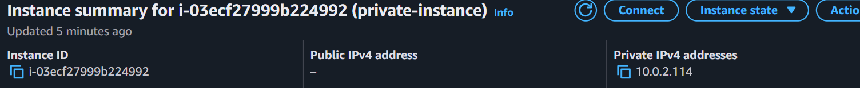
SSH from the bastion to the private instance
