Create VPC with two public subnets
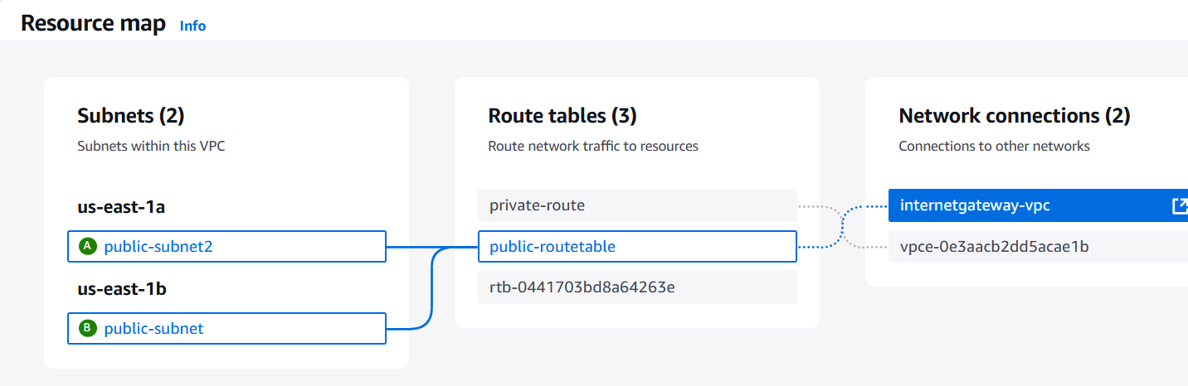

Create two instances In the two different subnets

Load balancer
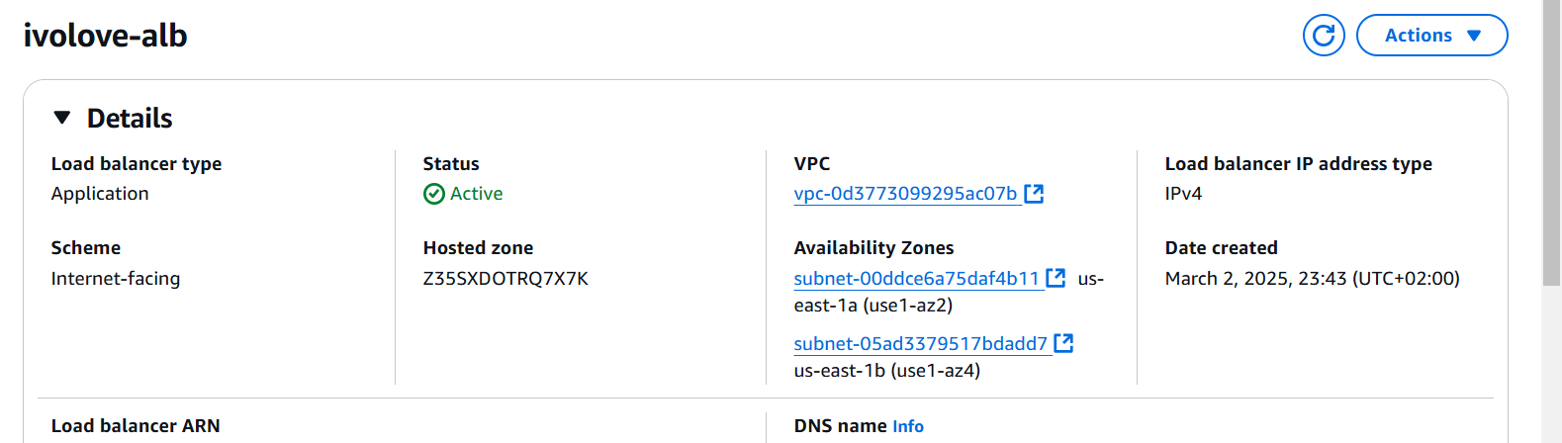

The listener that attached to the load balancer
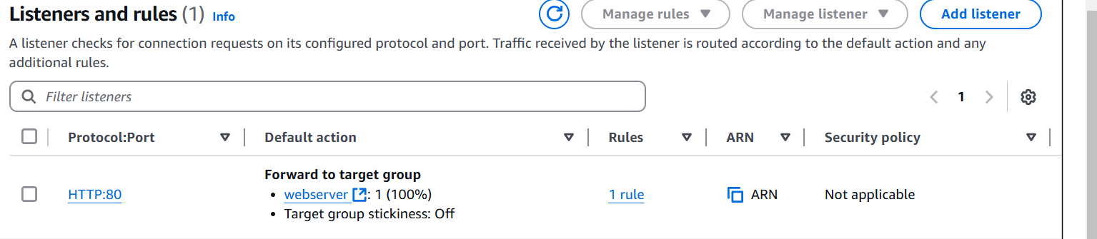

The user data of nginx instance
#!/bin/bash
sudo dnf update -y && dnf install nginx -y
sudo systemctl start nginx
sudo systemctl enable nginx
echo "Hello nginx" | sudo tee /usr/share/nginx/html/index.html
sudo systemctl restart nginx

The user data of httpd instance
#!/bin/bash
sudo dnf update -y && dnf install httpd -y
sudo systemctl start httpd
sudo systemctl enable httpd
echo "Hello httpd " | sudo tee /var/www/html/index.html
sudo systemctl restart nginx

Insert the two instances in the target group
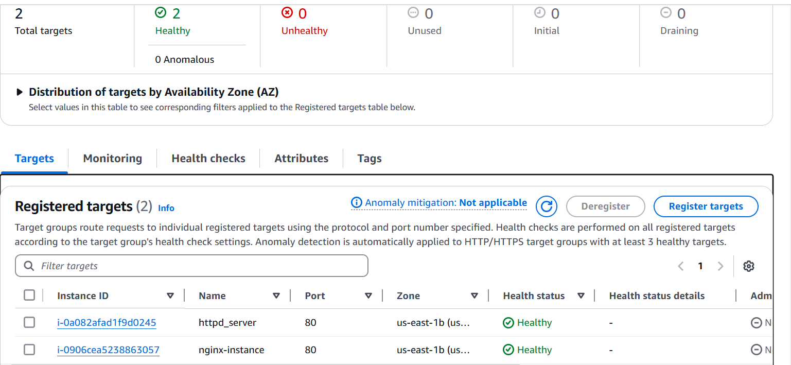

Try the DNS of ALB


