Now we noticed:
That the resources directory must be out of the src directory (beside it). loosly coupled.

The package of each java file
package org.user;
It’s the hierarchical directories from the src directory to the directory holding the java file.

In each of the modules
Java folder -> make the directory as a src directory
resources -> make the directory as a src directory
Pom.xml -> make as a maven project.s
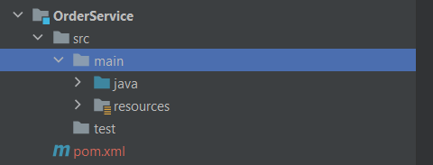

Note:

Create a procedure
DELIMITER $$
CREATE DEFINER=`root`@`localhost` PROCEDURE food_db.`checkStockAndQuantity`(
IN nameItem VARCHAR(50),
IN quantity INT,
OUT result INT
)
BEGIN
DECLARE item_var VARCHAR(50);
DECLARE count_var INT;
---------------------
END$$
DELIMITER ;

Always debug , امشي خطوة بخطوة سطر ب سطر و اعرف بيعطل فين و ليه

We used a Shared Module to use some Classes in global manner for all services that depend on this Shared Module.
<dependency>
<groupId>org.eureka</groupId>
<artifactId>Shared-Modules</artifactId>
<version>0.0.1-SNAPSHOT</version>
</dependency>

