Amir Mamdouh Helmy Shaker
Fawry Assessment
Task 2

Your internal web dashboard (hosted on internal.example.com) is suddenly unreachable from multiple systems. The service seems up, but users get “host not found” errors. You suspect a DNS or network misconfiguration. Your task is to troubleshoot, verify, and restore connectivity to the internal service.

1. Verify DNS Resolution:

in /etc/resolv.conf, All DNS servers that host check for DNS resolution.
It contains Local DNS servers like 192.168.1.1 and Global DNS Servers like 8.8.8.8


in /etc/resolv.conf

we can ping on the service two times:
→ by IP address
→ by domain

if IP address ping succeed but domain is not then this is a DNS resolution problem
If IP address ping was failed then this is the server problem itself.

2. Diagnose Service Reachability:

3. Trace the Issue – List All Possible Causes

* DNS Problem or Reachability

→ if pinging on server using IP address but domain is not, then the problem must be in the local DNS server , we need to make sure that it’s working.

* Service Problem
- The web service is not running or listening on a wrong port.
- The web server is down or misconfigured.
- The firewall is blocking the service port.

4. Propose and Apply Fixes

* Solve DNS Problem or Reachability

IN DNS SERVER ITSELF in this case I can’t write commands because I don’t have a local DNS server
- We need to make sure that the local DNS server is working well.
→ SSH on the DNS server and check the DNS service , configurations and opened ports.

- We need to check DNS server IP address and check if it’s reachable.

- We need to check that DNS service contains the right records like (internal.example.com – Internal_IP_address) → DNS records themselves exist

IF WE CHECKED ALL OF THAT , SO DNS SERVER ITSELF HAS NO PROBLEMS.

IN Other SERVERS
- We need to check if these servers are connecting to DNS server correctly → using nmcli
if servers are attached to a wrong DNS IP address → insert the correct DNS IP address in the connection
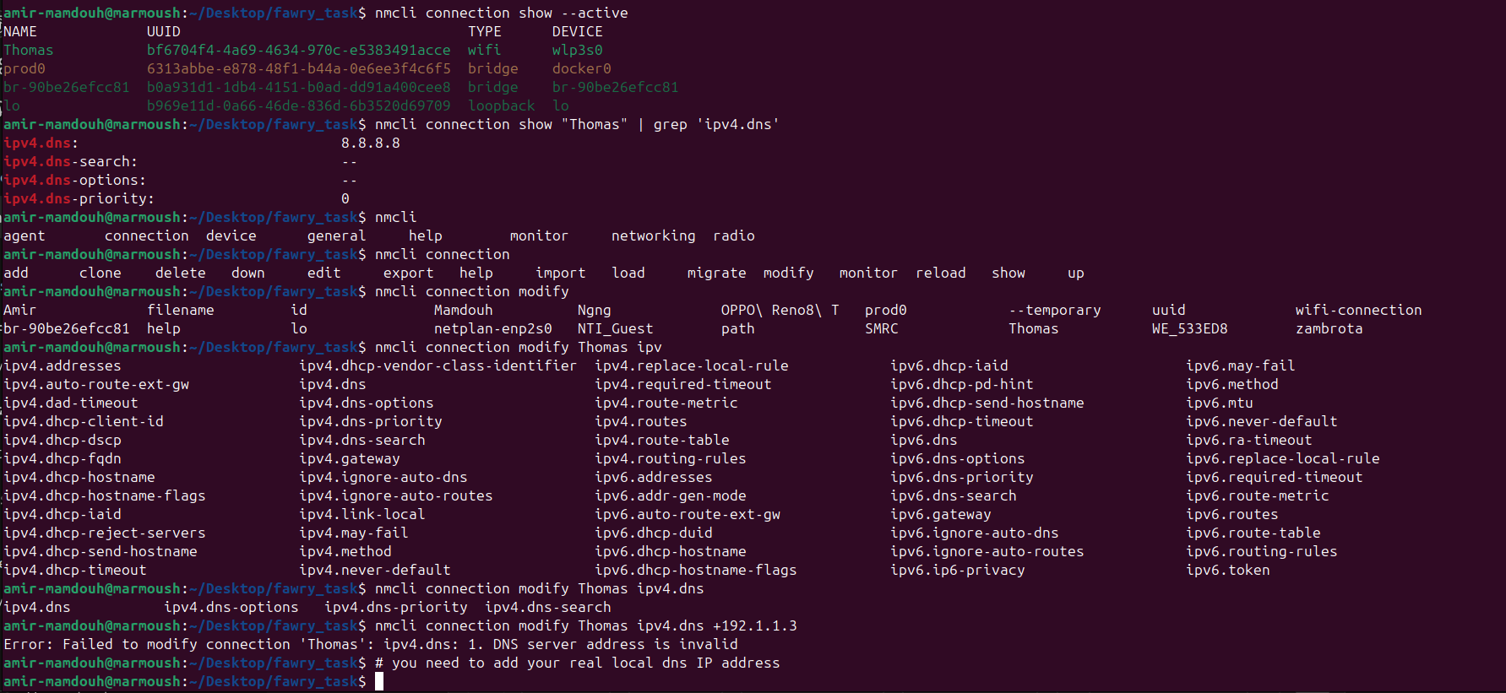
IF WE CHECKED ALL OF THAT , SO CONNECTION BETWEEN LOCAL SERVERS AND DNS SERVER HAS NO PROBLEM.
* Check and Solve Service Problem

check if the service is up and running
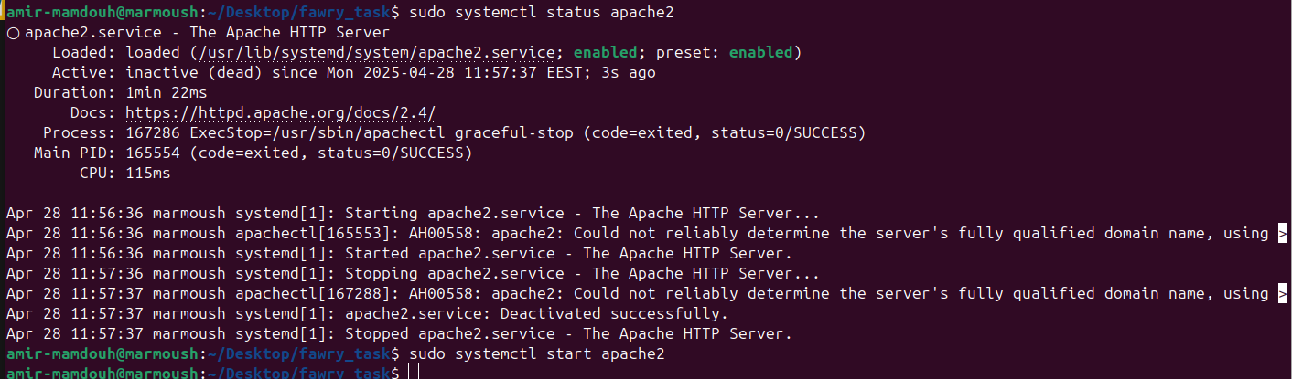

check if the service is listening on the port → from apache2 configurations
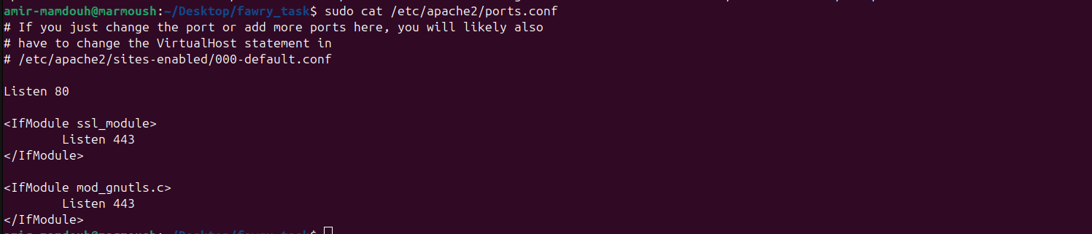
check if our server is listening on port 80
check if firewall is blocking this service

run the service port

ALL PROBLEMS MUST BE SOLVED.

BONUS
- Add the domain inside /etc/hosts for test
change the listening port to 100 and try


- persist DNS server settings using nmcli.



