Name: Amir Mamdouh
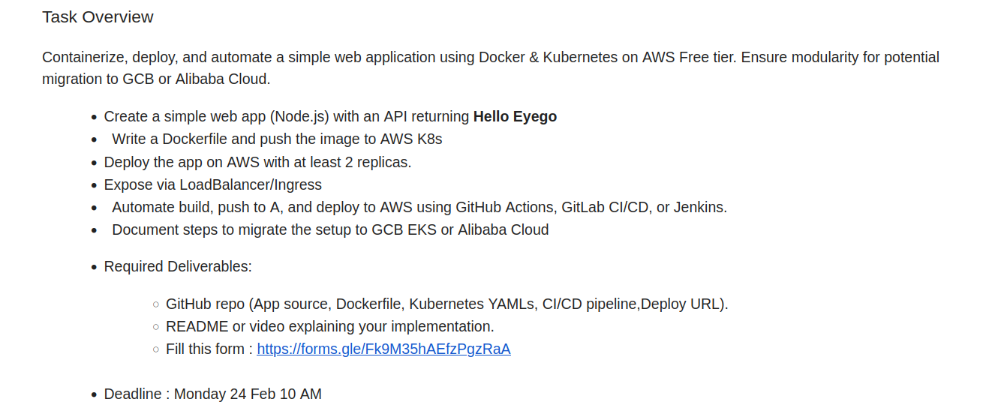
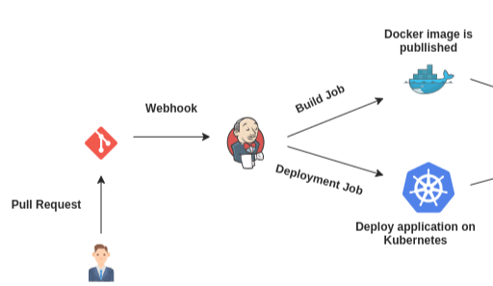

- Create a simple web app (Node.js) with an API returning Hello Eyego
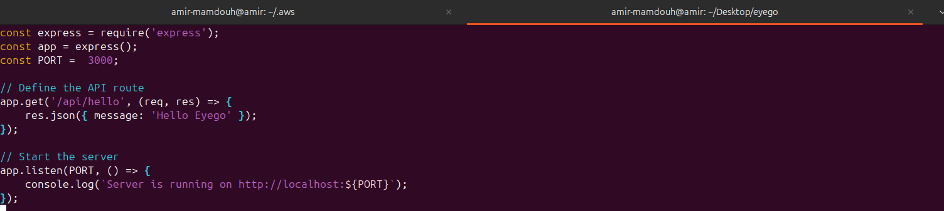
- Write a Dockerfile and push the image to AWS K8s
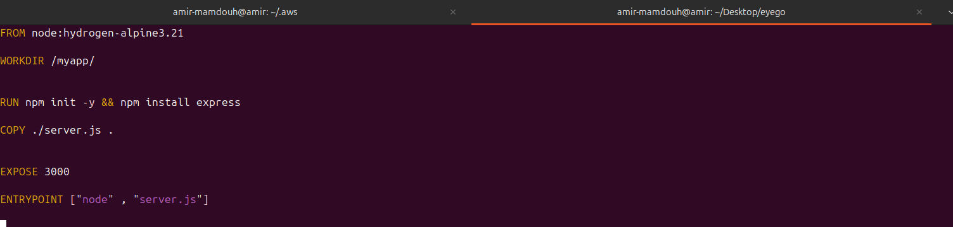
to Push the image to the AWS ECR,First we need to do the following:
1- Create a repository in AWS ECR.

2- give the EC2 instance the permissions to do different actions on ECR repo like pushing the images and so on by attaching a role to the EC2 instance.
NOTE: at this point we could create an access key for our IAM user and put the credentials inside the EC2 instance using 'aws config' command.

3- let EC2 instance login to the Repository. Using 'docker login <options>'
4- push the image to the ECR

DEMOS:
Create ECR
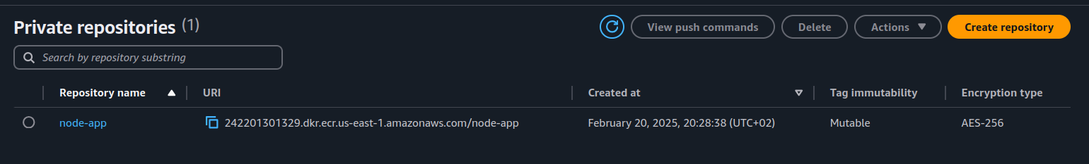
Create a role with permissions to be attached to EC2 instance to access the ECR repo.
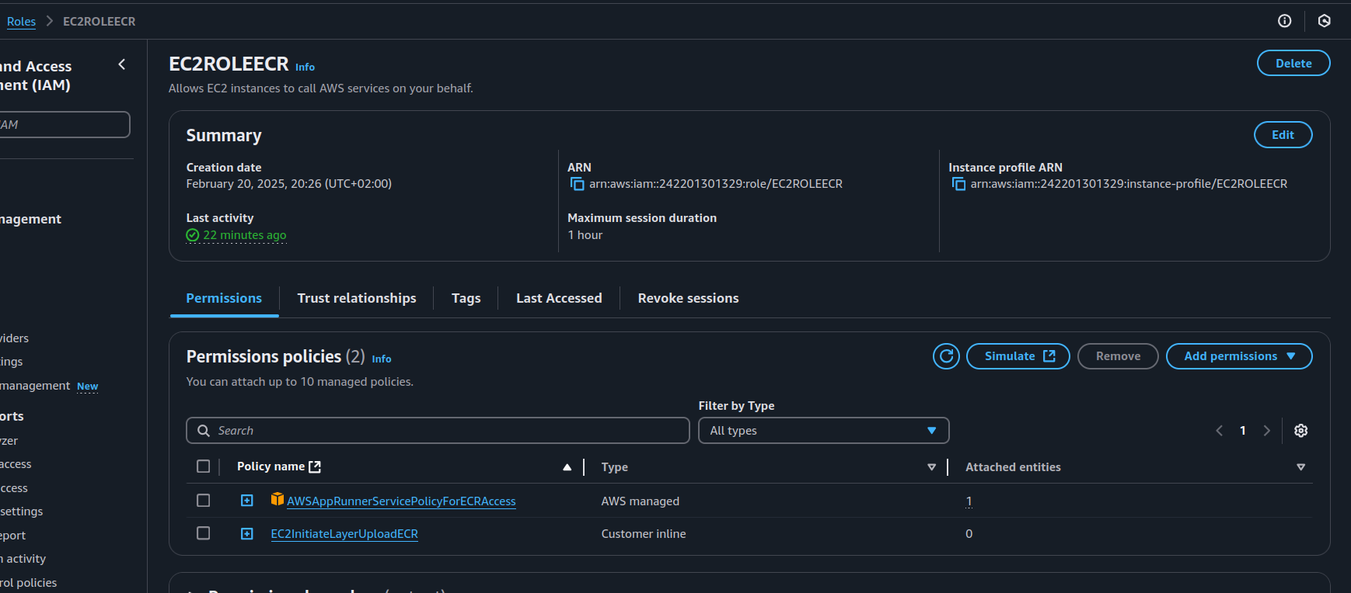
Notice:
That I used one AWS managed Policy and another one I’ve created for Pulling Image from the ECR to EC2 instance.

- build , login and Push it to ECR
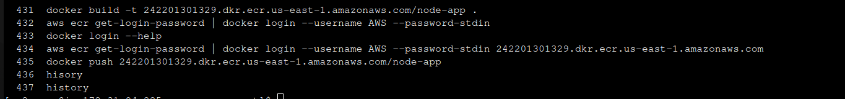

Deploy the app on AWS with at least 2 replicas.
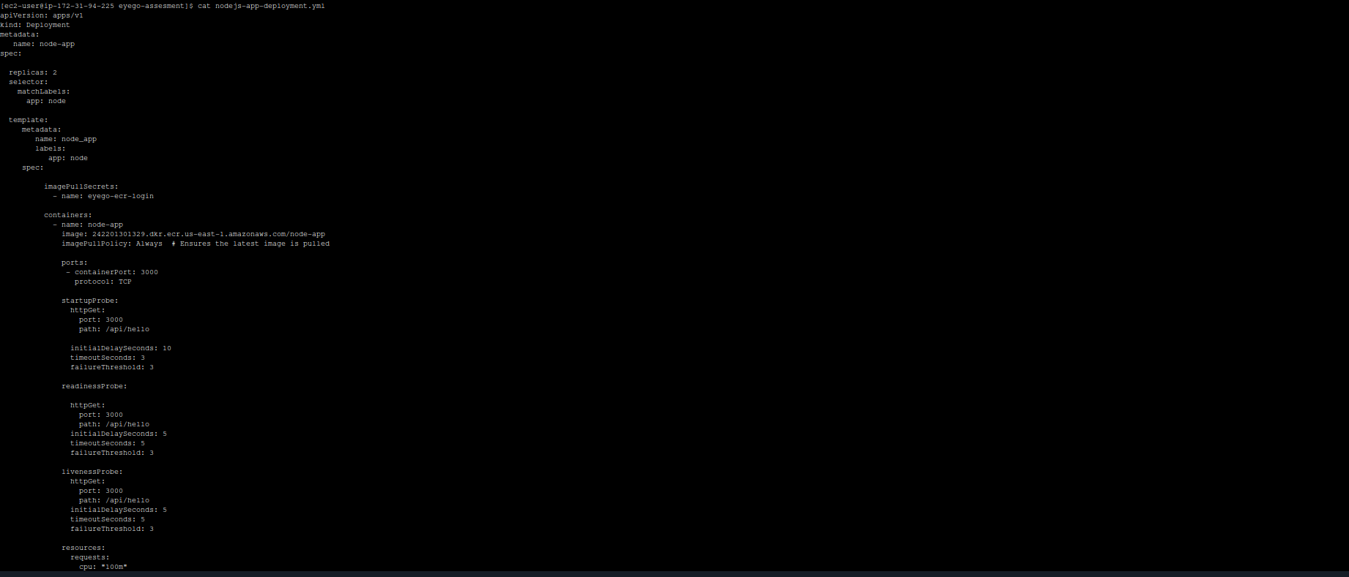
Zoom in:
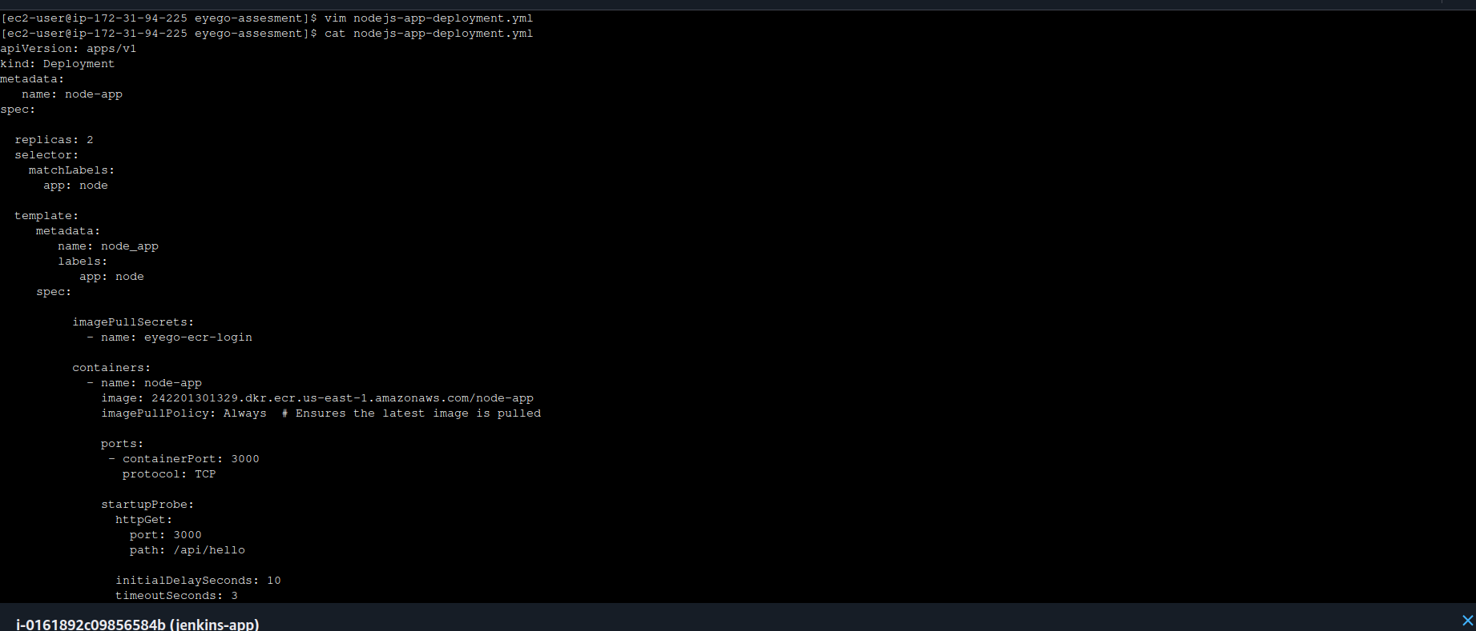
run the deployment:
Expose via LoadBalancer/Ingress
NOTE:
I’m using a local kubernetes cluster on an EC2 instance on AWS so It will not create a physical loadbalancer
because EKS is not included in the Free tier.
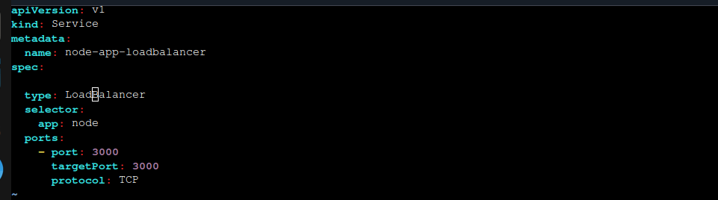

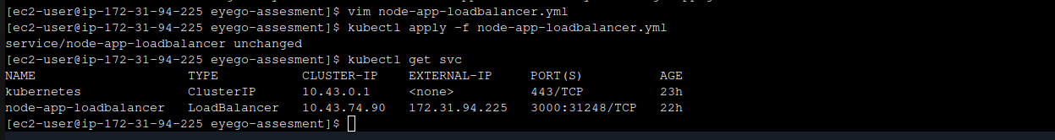
Automate build, push to A, and deploy to AWS using GitHub Actions, GitLab CI/CD, or Jenkins.

First:
I’ve installed jenkins on the EC2 instance.
it’s necessary to make the jenkins instance public with a public key. (to be reachable by the Github Webhook later)

jenkins user must have permissions to access docker and ~/.kube/config, so:
- I put the jenkins user inside the docker group → usermod -aG docker jenkins
- I’ve created a home directory to jenkins and added a specific ~/.kube/config file inside /home/jenkins.
- export KUBECONFIG=~/.kube/config

Second:
we need to create a webhook In our github repo to automate the jenkins pipeline with each commit on the repo.
We need to do the following:
1- Create access key inside the jenkins
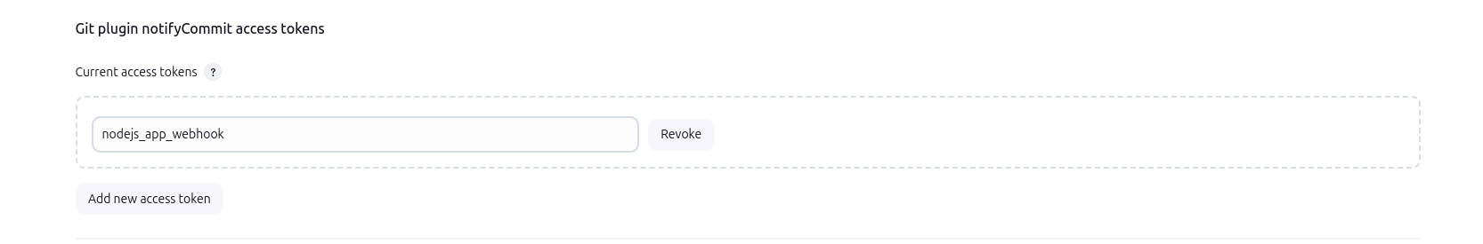

2- create the webhook in the github repository
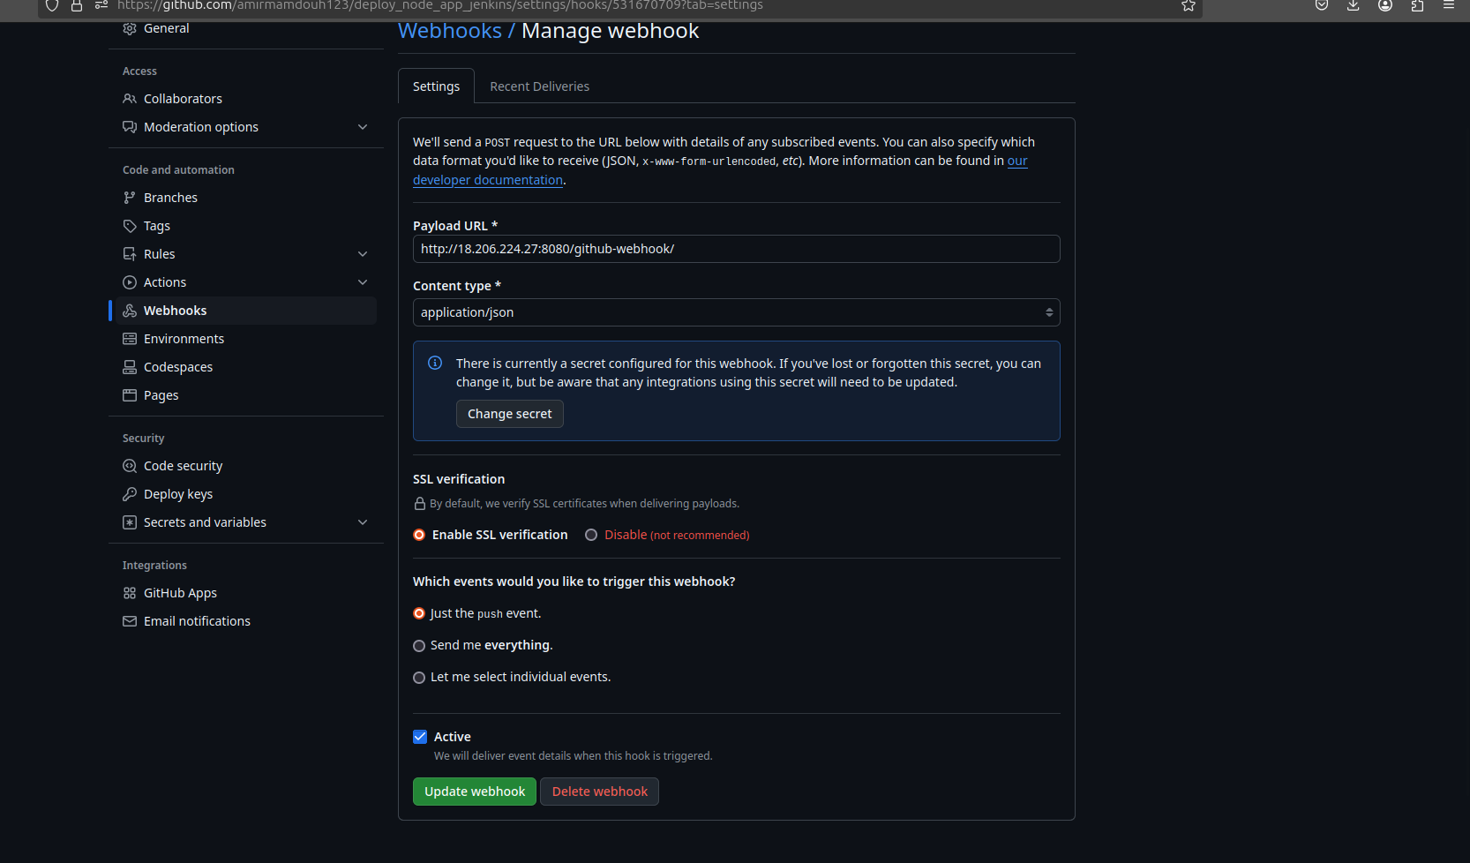
Enable the Trigger Webhook
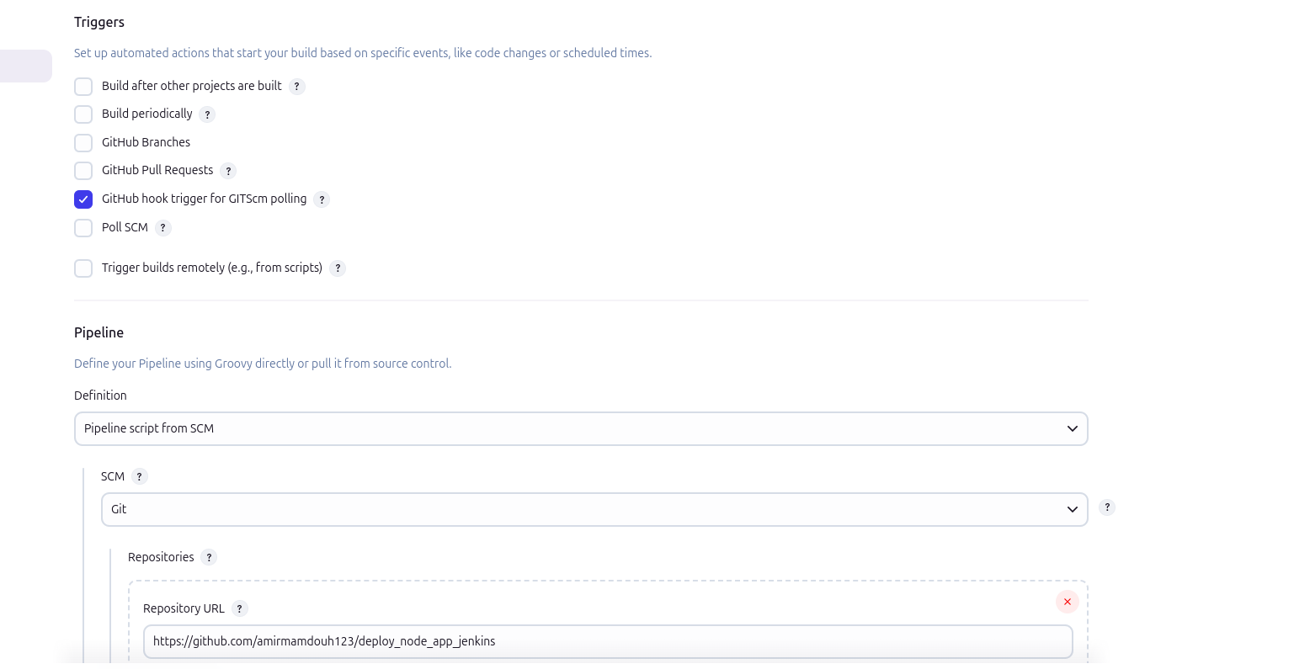
Right now If there’s any new commits in the github repo
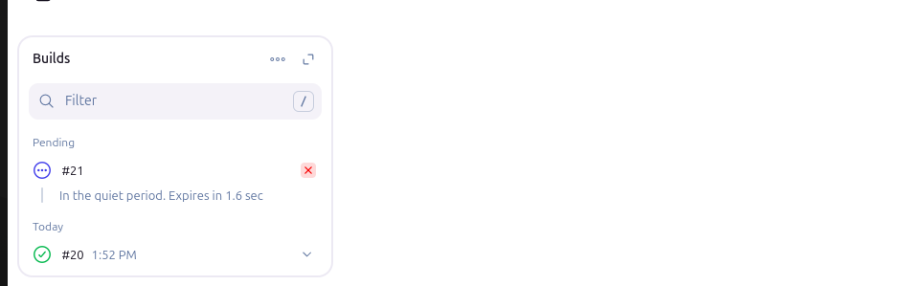

all Permissions that EC2 instance needed to treat and pull images from ECR
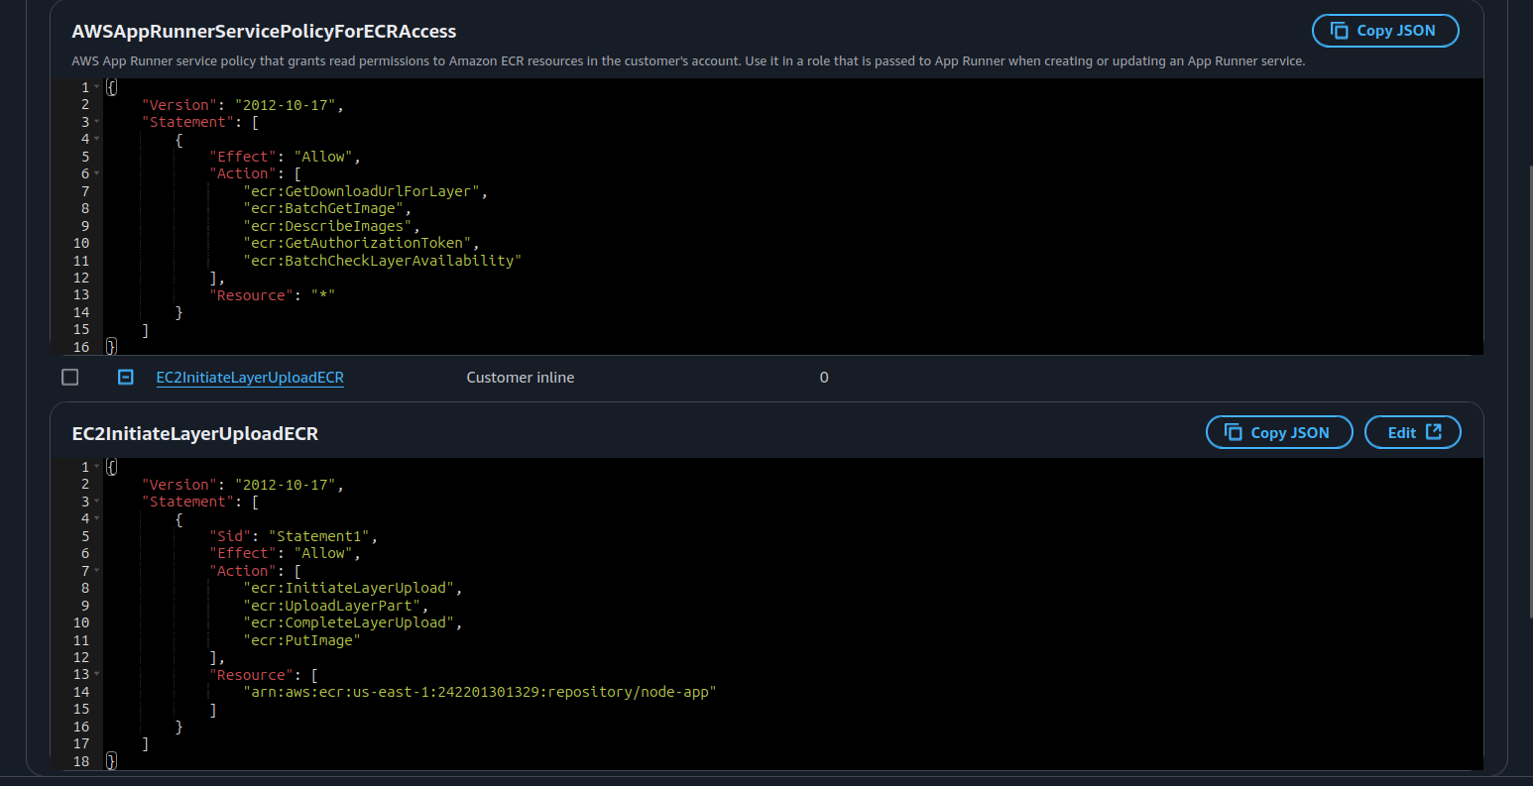
to create an accessible , I tried to create a NodePort service to access the application using the public ip of the Jenkins EC2 instance
and finally:
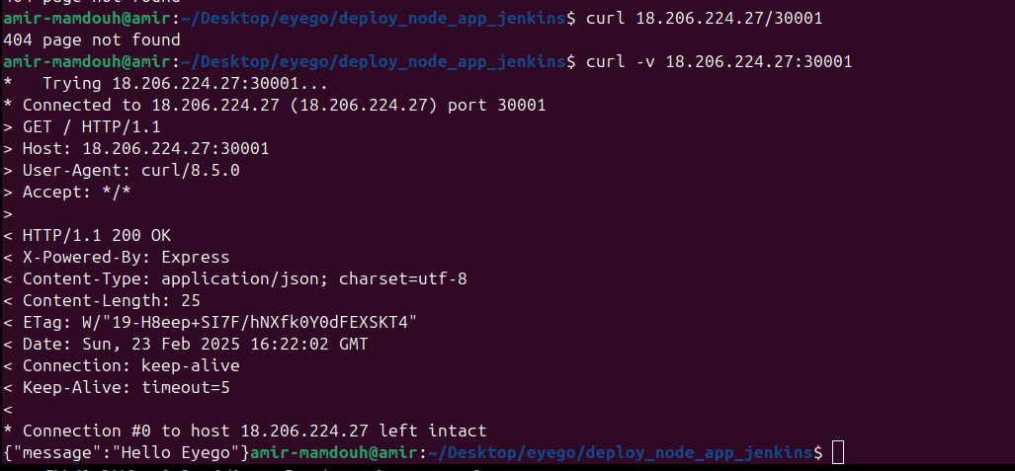
If you Tried to run it on the Browser: 404 page not fount
If you tried to run it in the curl command so the payload of the response → you get it. "Hello Eyego"

Document steps to migrate the setup to GCB EKS or Alibaba Cloud
AWS and other cloud providers like GCP has the same concepts and also similar services.

If I want to do the same project with GCP:
I will give you all changes between both of them:

1- Change EC2 instance to ECE (Google Compute Engine)
2- Elastic Container Registry (ECR) changed to Google Container Registry (GCR)
3- IAM Roles in AWS is the same of IAM Service Accounts & Permissions
4- AWS Load balancer is the same of GCP Load Balancer

I can create another Jenkins ECE on the Google cloud and give it the permissions to access the GCR and attach it will a webhook to run its pipeline then build and push the application image on GCR.
- then deploy the pods on the Google Kubernetes Engine (GKE) or - k3s as a free tier -

command to run the Hello Eyego API → curl -v 18.206.224.27:30001

Thank you :)

