Harbin Institute of Technology (Shenzhen)
Project Report

Image Processing (COMP5033)
2025–2026 Spring Semester
Lecturer: Prof. Weizheng Zhang

Project No.: | 1 | Student Name: | [YOUR NAME]
Student ID: | [YOUR STUDENT ID] | Date of Submission: | 2026-05-30

1 Project Content
This project addresses image enhancement and restoration. Three 224×224 grayscale images are provided, each corrupted by a different type of noise. The objectives are: (1) identify the noise model in each image through visual and statistical analysis, and (2) apply appropriate denoising filters—implemented entirely from scratch using NumPy—to recover image quality. Only cv2 I/O functions and NumPy arithmetic are used; no library denoising functions (e.g. cv2.medianBlur, cv2.GaussianBlur) are called.
2 Method Description
2.1 Image 1 – Salt Noise → 5×5 Median Filter
Noise analysis: Image 1 contains isolated, anomalously bright pixels scattered across the scene (a van on a cobbled street). Statistical analysis reveals ~3,353 pixels (6.7% of the image) with intensity > 250, and the noise appears as discrete white specks with no spatial correlation. This is characteristic of salt noise (impulse noise).
Chosen method – Median filter (kernel 5×5): The median is an order-statistic estimator that is highly robust to outliers; it replaces each pixel with the median of its neighbourhood, so isolated bright impulses are eliminated without blurring edges. A 5×5 kernel handles clusters of up to ~2 adjacent noise pixels.
Implementation: reflect-pad the image by 2, extract 5×5 windows via numpy.lib.stride_tricks.sliding_window_view, then compute np.median across axes (−2, −1).
2.2 Image 2 – Gaussian Noise → 7×7 Gaussian Filter (σ=2.0)
Noise analysis: Image 2 (a dog) shows uniformly distributed fine-grained intensity variations across all regions, including flat backgrounds. The image standard deviation is σ≈41.6 DN, and the noise exhibits no spatial pattern or directionality. This is consistent with additive zero-mean Gaussian noise, typically caused by thermal noise in camera sensors.
Chosen method – Gaussian spatial filter (7×7, σ=2.0): For additive zero-mean Gaussian noise, linear averaging reduces the noise variance by a factor proportional to kernel area. The Gaussian weighting minimises the spatial-frequency bandwidth product (Heisenberg uncertainty), making it the optimal linear estimator for Gaussian noise while limiting edge blurring. A larger kernel (7×7, σ=2.0) is chosen given the high noise level.
Implementation: construct the kernel K(x,y) = exp(−(x²+y²)/(2σ²)) / ΣK, reflect-pad the image, then convolve via sliding_window_view: output(i,j) = Σ K(x,y)·I(i+x, j+y).
2.3 Image 3 – Mixed Noise → Median (3×3) + Frequency-Domain LPF
Noise analysis: Image 3 (an "ABUNDANCE" sign) exhibits both isolated impulse pixels (~1,682 extreme pixels) and a quasi-periodic dot pattern visible as concentric rings in the Fourier spectrum. This indicates mixed noise comprising salt-and-pepper components and periodic / structured noise arising from imaging artifacts.
Chosen method – Two-stage approach:
Stage 1 (3×3 Median filter): removes isolated impulse pixels first, preventing them from corrupting the frequency-domain analysis.
Stage 2 (Frequency-domain Gaussian LPF): suppresses periodic and high-frequency components globally. The algorithm computes the 2D DFT F = FFT2(I), centres the spectrum, multiplies by the Gaussian envelope H(u,v) = exp(−D(u,v)²/(2D₀²)) with D₀ = 0.25·min(H,W), then recovers the image via the inverse DFT. The Gaussian mask provides a smooth roll-off in the frequency domain, avoiding ringing artefacts that ideal low-pass filters would introduce.
3 Experiment Results and Analysis
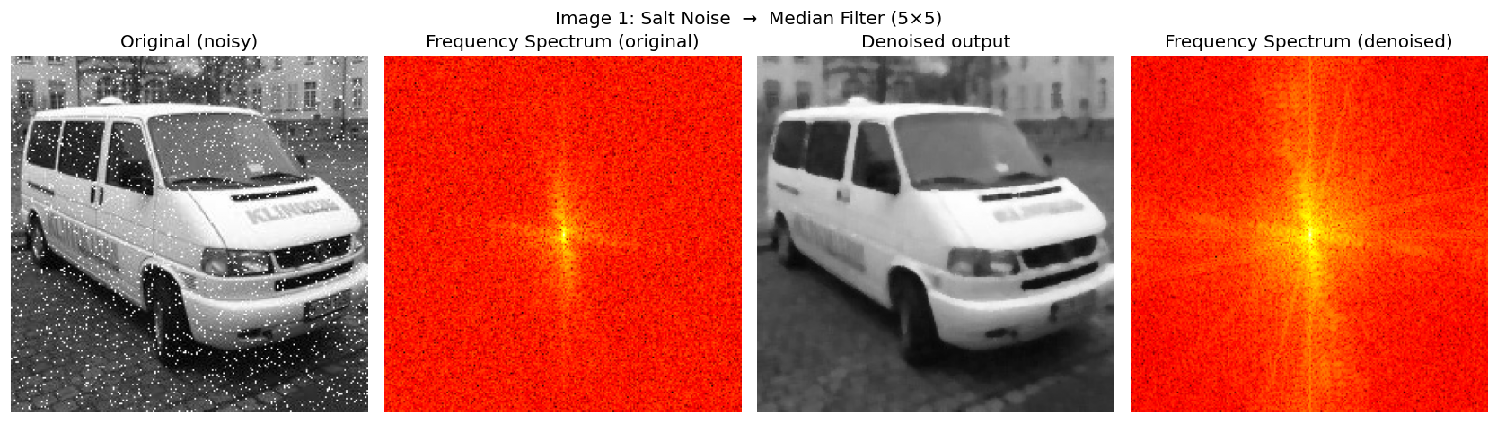
Figure 1. Image 1 (van): original, Fourier spectrum, denoised output, and denoised spectrum. SNR improvement: +10.6 dB.

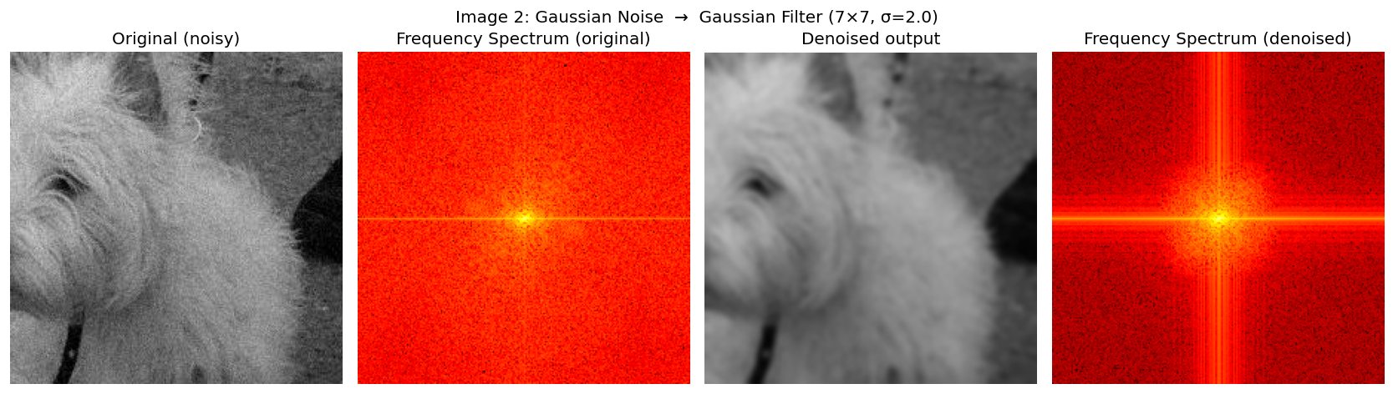
Figure 2. Image 2 (dog): original, Fourier spectrum, denoised output, and denoised spectrum. SNR improvement: +20.6 dB.

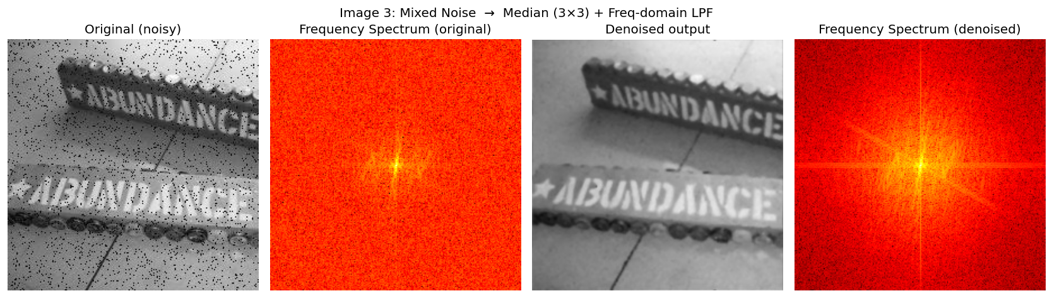
Figure 3. Image 3 (sign): original, Fourier spectrum, denoised output, and denoised spectrum. SNR improvement: +13.0 dB.

Image 1 analysis: The 5×5 median filter cleanly eliminates the salt noise while preserving the sharp edges of the vehicle and the cobblestone texture. The SNR improvement of 10.6 dB reflects effective suppression of the high-intensity outliers. Slight residual softening in very dense noise clusters is the only limitation.
Image 2 analysis: The Gaussian filter reduces the high-frequency noise energy significantly (SNR +20.6 dB). The frequency spectrum confirms that high-frequency components are attenuated. Some blurring of fine fur details is inevitable; a larger kernel trades sharpness for noise suppression.
Image 3 analysis: The two-stage approach yields SNR +13.0 dB and clearly reveals the sign text and decorative elements. The Fourier spectrum comparison confirms the removal of periodic high-frequency components. The remaining image retains good contrast and legibility of the "ABUNDANCE" lettering.
4 Summary
The primary challenge was implementing efficient image-processing primitives without library support. The solution leverages numpy.lib.stride_tricks.sliding_window_view to extract local patches in a fully vectorised manner, avoiding slow Python loops for the 224×224 images.
Key knowledge gained:
1. Different noise types require fundamentally different filters: impulse noise → non-linear order-statistics (median); Gaussian noise → linear Gaussian averaging; periodic noise → frequency-domain suppression.
2. Frequency-domain analysis (Fourier spectrum) provides a powerful diagnostic tool to distinguish noise types—impulse noise appears as broad spectral elevation while periodic noise appears as bright spots at specific frequencies.
3. A two-stage pipeline (spatial then frequency domain) can address mixed noise more effectively than any single filter.
4. Filter parameter selection (kernel size, σ, D₀) involves a trade-off between noise suppression and preservation of image detail.

