Harbin Institute of Technology (Shenzhen)
Project Report

Image Processing (COMP5033)
2025–2026 Spring Semester
Teacher: Prof. Weizheng Zhang

Project No.: | 2 | Student Name: | [YOUR NAME]
Student ID: | [YOUR STUDENT ID] | Date of Submission: | 2026-05-30

1 Project Content
This project implements a morphological algorithm to detect the boundary of all objects in a binary image. The input is Figure_P2.jpg (1024×1024 grayscale), a yin-yang design with two interlocking cat silhouettes and a gray background. The processing pipeline is: (1) convert the grayscale image to binary using Otsu's automatic thresholding, then (2) extract object boundaries via morphological erosion. All key processing steps are implemented using only NumPy; cv2 is used solely for image I/O.
2 Method Description
2.1 Binarization – Otsu's Method
Otsu's method (1979) automatically selects the threshold T* that maximises the inter-class variance between the two resulting pixel classes (foreground and background):
σ²_B(t) = w₀(t) · w₁(t) · [μ₀(t) − μ₁(t)]²
where w₀, w₁ are the class probabilities and μ₀, μ₁ are the class mean intensities at threshold t. The optimal threshold is T* = argmax_t σ²_B(t).
Implementation:
1. Compute the 256-bin intensity histogram.
2. Scan t from 0 to 255, maintaining running sums of w₀ and cumulative mean.
3. Compute σ²_B(t) at each t and track the maximum.
For Figure_P2.jpg the algorithm returns T* = 107. Pixels with intensity > 107 are set to 1 (foreground: white cat + bright areas), while pixels ≤ 107 are set to 0 (background: black cat + gray border). This produces a clean binary image with 60.9% foreground pixels.
2.2 Morphological Boundary Extraction
The inner boundary of a binary set A with structuring element B is defined as:
β(A) = A − (A ⊖ B)
where ⊖ denotes morphological erosion. Erosion shrinks every foreground region by removing pixels that are on or near the boundary; subtracting the eroded image from the original leaves exactly the 1-pixel-wide boundary layer.
Erosion implementation (3×3 square structuring element):
1. Zero-pad the binary image by 1 pixel on each side.
2. Extract 3×3 sliding windows via numpy.lib.stride_tricks.sliding_window_view (output shape: H×W×3×3).
3. A pixel is set to 1 iff ALL 9 pixels in its 3×3 neighbourhood are 1 (np.all over the last two axes).
To capture boundaries of BOTH the white (bright) regions and the black (dark) regions:
• boundary_fg = binary − erosion(binary) [boundary of white cat]
• boundary_bg = (1−binary) − erosion(1−binary) [boundary of dark cat]
• Final boundary = clip(boundary_fg + boundary_bg, 0, 1)
3 Experiment Results and Analysis
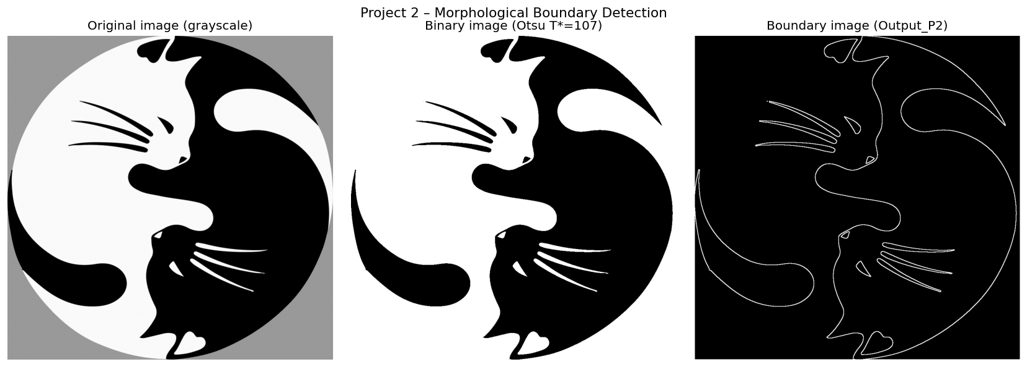
Figure 1. Left: original grayscale image. Centre: binary image after Otsu thresholding (T*=107). Right: boundary image (Output_P2.jpg).

Binarization (centre panel): Otsu's threshold T*=107 correctly separates the white cat body and the fine detail regions from the dark cat body and the gray background. The thin whisker lines and facial features are well preserved in the binary image.
Boundary detection (right panel): The morphological boundary image contains 27,460 white pixels (2.62% of the image). The output shows a continuous, 1-pixel-wide boundary that accurately traces: the outer circular perimeter, the S-shaped dividing curve between the two cats, the silhouettes of both cat heads, the whiskers and ear details, the tails, and paw features. The result is visually clean with no spurious edges in the interior regions.
Algorithm strengths and limitations: The 3×3 square structuring element produces sharp, single-pixel boundaries and is computationally efficient (vectorised with numpy). A limitation is that very thin structures such as the fine whisker lines (width < 3 px) may appear slightly fragmented after erosion; a cross-shaped or smaller structuring element could preserve these better.
4 Summary
The main difficulty in this project was correctly binarizing a multi-tone image (gray background + white + black) before applying the morphological operation. Otsu's method elegantly solved this by analytically finding the optimal threshold without manual tuning.
Key knowledge gained:
1. Otsu's thresholding is a powerful unsupervised binarization technique whose inter-class variance formulation can be computed in a single O(L) sweep over the histogram (L = number of intensity levels).
2. Morphological erosion combined with simple set subtraction provides a precise, 1-pixel-wide boundary without complex edge operators or gradient thresholding.
3. Detecting boundaries for both bright and dark regions (by processing both the binary image and its complement) captures all object edges in a single unified boundary map.
4. The choice of structuring element (size and shape) directly controls the thickness of the boundary and sensitivity to thin structures.

