

Prepared by:
Eng.Amir Mohamed

ALU SystemVerilog Verification Project

Table of Contents
1. Introduction 5
2. Design Specification 6
2.1 Logic References 8
2.2 TEST CASES 8
3. Design Implementation Overview 9
3.1 Design Requirement 9
3.2 Dut Code 10
4. Verification Enviroment Architecture 13
4.1 testbench architecture / Block diagram 13
4.2 flow of Testbench 13
4.3 Verification Plan 14
4.3.1 Interface 18
4.3.2 Interface Code 18
4.4 Transaction Class 23
4.4.1 Transaction Class Code 23
4.5 Generator Class 25
4.5.1 Generator Class Code 25
4.6 Driver Class 28
4.6.1 Driver Class Code 28
4.7 Monitor Class 31
4.7.1 Monitor Class Code 31
4.8 Scoreboard Class 33
4.8.1 Scoreboard Class Code 33
4.9 Environment Class 36
4.9.1 Environment Class Code 36
4.10 ALU Package 38
4.11 Top Module 39
4.11.1 Top Module Code 39
5. Coverage Results and Analysis 41
5.1 Coverage Results 41
5.2 Assertion Coverage Analysis 42
5.3 Code Coverage Analysis 43
5.4 Coverage Gap and Bug Analysis 44
5.4.1 Line Coverage Gap 44
5.4.2 Branch Coverage Gap 44
5.4.3 Condition Coverage Gap 45
5.4.3 Bug Analysis Summary 46
6. Simulation Result 47
7.Conclusion 49

List of Figures

Figure 1: ALU BLOCK 6
Figure 2: Total Coverage summary 41
Figure 3: Transactions 46
Figure 4:simulation results 47
Figure 5: simulation results 47
Figure 6: simulation results 48
Figure 7: simulation results 48

1. Introduction
In this project, a SystemVerilog OOP-based verification environment is used to functionally verify a signed 5-bit Arithmetic Logic Unit (ALU). Verifying that the ALU generates the right output for every valid operation mode specified in the design specification is the primary goal of the project.
The ALU generates a signed 6-bit output C and allows arithmetic and logical operations utilizing two signed 5-bit operands, A and B. The control signals ALU_en, a_en, b_en, a_op, and b_op determine the chosen operation.
SystemVerilog classes, interface, assertions, functional coverage, directed tests, constrained-random tests, monitor, and scoreboard were used to create the verification environment. The scoreboard contrasts the expected output produced by a golden reference model with the actual DUT output.

2. Design Specification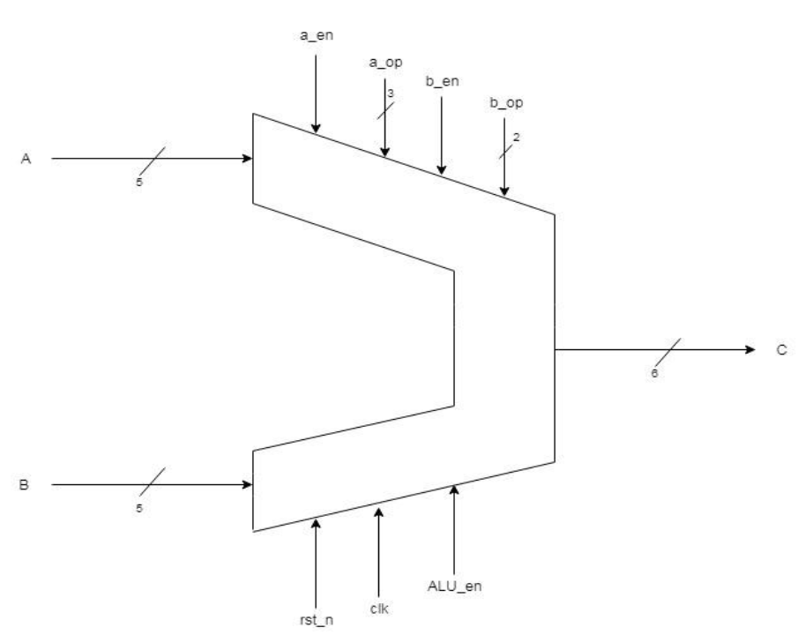
Figure 1: ALU BLOCK
This Section Discusses the different inputs and outputs of the ALU block (Figure 1) with a brief description of each. The following table will contain the overall system I/O:
Signal Name | Type | Width (Bits) | Description
A | Input | 5 | Signed 5 bits input data
B | Input | 5 | Signed 5 bits input data
a_en | Input | 1 | Enable signal for a_op operations
a_op | Input | 3 | 3 bits defining a set of operations to be performed
b_en | Input | 1 | Enable signal for b_op operations
b_op | Input | 2 | 2 bits defining a set of operations to be performed
rst_n | Input | 1 | Asynchronous Active Low reset signal
clk | Input | 1 | System input Clock Signal
Alu_en | Input | 1 | The overall system Enable signal
C | Output | 6 | Signed 6 bits output data

- Rst_n: a reset signal that clears any pending errors or events and brings a system to normal condition or an initial state.
- ALU_en: Enable signal to the system.
- A_en: When this enable signal is active high, only the set of a_op (Spec #7) operations are performed.
- B_en: when this enable signal is active high, only a set of b_op (Spec #8) operations are performed.
- Input A: This is a 5 bits signed input bus to the ALU ranging from (-15 to +15) on which operations will be performed.
- Input B: This is a 5 bits signed input the ALU ranging from (-15 to +15) on which operations will be performed.
- Output C: This is a 6 bits signed Output bus to the ALU ranging from (-31 to + 31) which contains the results of ALU operations.
- a_op: it is 3 unsigned bus representing an encoding for a set of operations. Each value refers to a specific function for the ALU to perform. The Following table (Table 2) illustrates these functions with a brief description of each, putting into consideration the following 2 constraints:
- These functions are performed if and only if the a_en is active-high and b_en is active low.
- The values with a “Null” operation refer to an illegal input for the system.
Sub_Spec | A-op | C(Function) | Description
8.a | 0 | A + B | The Summation of the inputs
8.b | 1 | A - B | Subtracting Input B from A
8.c | 2 | A “XOR” B | Bitwise “XOR” logic operation
8.d | 3 | A & B | Bitwise “AND” logic operation
8.e | 4 | A & B | Bitwise “AND” logic operation
8.f | 5 | A || B | Bitwise “OR” logic operation
 | 6 | A “XNOR” B | Bitwise “XNOR” logic operation
 | 7 | Null | The System is not permitted to take this value

9. b_op (SET 1): It is 3-bit unsigned bus representing an encoding for a set of operations. Each value refers to a specific function for the ALU to perform. There are 2 different sets of these operations depending on the enable signals (a_en & b_en). The following table (Table 3) illustrates the first set of functions with a brief description of each, putting into consideration the following 2 constraints:
- These functions are performed if and only if the b_en is active-high and a_en is active low.
- The values with a “Null” operation refer to an illegal input for the system.
Sub_Specs | B_op (set 1) | C (Function) | Description
9.a | 0 | A “AND” B | The summation compliment of the inputs
9.b | 1 | A + B | The summation of the inputs
9.c | 2 | A + B | The summation of the inputs
 | 3 | Null | The system is not permitted to take this value

10. b_op (SET 2): These are the second set of b_operations. The following table (Table 3) illustrates these functions with a brief description of each, putting into consideration the following 2 constraints:
- These functions are performed if and only if both the b_en and a_en are active high.
Sub_Specs | b_op (Set 2) | C (Function) | Description
10.a | 0 | A “XOR” B | Bitwise “XOR” logic operation
10.b | 1 | A “XNOR” B
10.c | 2 | A - 1
10.d | 3 | B + 2

2.1 Logic References
As observed in section 2, various operations are based on standard logic gates such as XOR, XNOR, etc… The logical truth table of these gates are stated in table 5, as a reference during the output evaluation stage.
INPUTS |  | GATES
A(1bit) | B(1bit) | AND | NAND | OR | XOR | XNOR
0 | 0 | 0 | 1 | 0 | 0 | 1
0 | 1 | 0 | 1 | 1 | 1 | 0
1 | 0 | 0 | 1 | 1 | 1 | 0
1 | 1 | 1 | 0 | 1 | 0 | 1

2.2 TEST CASES
In this section we are going to handle the functional verification using selected test cases to ensure that the system is functioning as per required in all cases within the specified specs extracted in the section above. In each test case the following aspects are considered:
- Derivation of Inputs to create the needed environment for testing.
- Monitoring the output as a result of the tested environment.
- Checking the output is as expected.

3. Design Implementation Overview

3.1 Design Requirement

SPEC ID | SPEC Description
ALU_01 | clk: System clock used to register the ALU output C on the positive edge.
ALU_02 | rst_n: Asynchronous active-low reset. When rst_n = 0, output C must be cleared to zero.
ALU_03 | A and B: Signed 5-bit input operands used for arithmetic and logical ALU operations.
ALU_04 | C: Signed 6-bit registered output used to store the ALU operation result.
ALU_05 | ALU_en: Overall ALU enable. When ALU_en = 0, the expected output C is zero.
ALU_06 | a_en: Enable signal for a_op operation set. a_op operations are selected when a_en = 1 and b_en = 0.
ALU_07 | a_op: 3-bit opcode for A-operation set. Legal values in A-only mode are 0 to 6; value 7 is illegal/null.
ALU_08 | When a_en = 1 and b_en = 0, a_op = 0 shall perform A + B.
ALU_09 | When a_en = 1 and b_en = 0, a_op = 1 shall perform A - B.
ALU_10 | When a_en = 1 and b_en = 0, a_op = 2 shall perform A XOR B.
ALU_11 | When a_en = 1 and b_en = 0, a_op = 3 shall perform A AND B.
ALU_12 | When a_en = 1 and b_en = 0, a_op = 4 shall perform A AND B.
ALU_13 | When a_en = 1 and b_en = 0, a_op = 5 shall perform A OR B.
ALU_14 | When a_en = 1 and b_en = 0, a_op = 6 shall perform A XNOR B.
ALU_15 | b_en: Enable signal for b_op operation sets. b_op set 1 is selected when a_en = 0 and b_en = 1.
ALU_16 | b_op: 2-bit opcode. In B-only mode, legal values are 0 to 2; value 3 is illegal/null.
ALU_17 | When a_en = 0 and b_en = 1, b_op = 0 shall perform NAND operation ~(A & B).
ALU_18 | When a_en = 0 and b_en = 1, b_op = 1 shall perform A + B.
ALU_19 | When a_en = 0 and b_en = 1, b_op = 2 shall perform A + B.
ALU_20 | When a_en = 1 and b_en = 1, b_op set 2 shall be selected and all b_op values 0 to 3 are legal.
ALU_21 | When a_en = 1 and b_en = 1, b_op = 0 shall perform A XOR B.
ALU_22 | When a_en = 1 and b_en = 1, b_op = 1 shall perform A XNOR B.
ALU_23 | When a_en = 1 and b_en = 1, b_op = 2 shall perform A - 1.
ALU_24 | When a_en = 1 and b_en = 1, b_op = 3 shall perform B + 2.
ALU_25 | When a_en = 0 and b_en = 0, no operation is selected and output C shall be zero.
ALU_26 | Logical operation results shall be sign-extended from 5 bits to the 6-bit signed output C.
ALU_27 | The ALU shall be verified using directed tests to cover all legal operation bins and boundary operand values.
ALU_28 | The ALU shall be verified using constrained-random tests to improve stimulus diversity.
ALU_29 | Assertions shall check reset behavior, ALU disabled behavior, illegal opcode prevention, and output range.
ALU_30 | Functional coverage shall cover reset, ALU enable, enable mode combinations, opcode bins, and A/B boundary value bins.

3.2 Dut Code
//firstly, time_unit = 1ns, time_precision = 1ps
`timescale 1ns/1ps

module alu (
//5-bits signed input A,B [-16 to +15]
input logic signed [4:0] A,
input logic signed [4:0] B,
//Enable signals for a_op operations
input logic a_en,
//3 bits defining a set of operations to be performed
input logic [2:0] a_op,
//Enable signals for a_op operations
input logic b_en,
//2 bits defining a set of operations to be performed
input logic [1:0] b_op,
//Asynchronous Active Low reset signal ( reset=0 -> reset active, reset=1 -> normal operation )
input logic rst_n,
//System input Clock Signal
input logic clk,
//The overall system Enable signal
input logic ALU_en,
//6-bits Signed output data [15+15=30, -16+ (-16)=-32]
output logic signed [5:0] C
);

/*automatic function for extension 5-bit to 6-bits
it takes 5-bits and retured signed 6-bits
We need this function because operations like
in_a ^ in_b,in_a & in_b,in_a | in_b ===> their output is 5bits
while the C output is signed 6-bits
so we need signed extension
*/
function automatic logic signed [5:0] ext5(input logic [4:0] value);
//concatenations takes signed bit [4] and put it firstly
//if value is +ve like value=5'b00101 (+5)
//value[4]=0, {value[4],value} = 6'b000101

//if value is -ve like value=5'b11100 (-4)
//value[4]=1, {value[4],value}=6'b111100

ext5 = $signed({value[4], value});
endfunction

//automatic function for calculation the result

function automatic logic signed [5:0] calc_result(
//inputs of the functions
input logic signed [4:0] in_a,
input logic signed [4:0] in_b,
input logic in_a_en,
input logic [2:0] in_a_op,
input logic in_b_en,
input logic [1:0] in_b_op,
input logic in_alu_en
);

//if ALU_en=0 then output=0
if (!in_alu_en) begin
calc_result = '0; //all bits are filled with zero
end
//Case1
//if (a_en=1, b_en=0)
//in this case we use a_op
else if (in_a_en && !in_b_en) begin
case (in_a_op)
3'd0: calc_result = in_a + in_b;
3'd1: calc_result = in_a - in_b;
3'd2: calc_result = ext5(in_a ^ in_b);//XOR
3'd3: calc_result = ext5(in_a & in_b);//AND
3'd4: calc_result = ext5(in_a & in_b);//AND
3'd5: calc_result = ext5(in_a | in_b); //OR
3'd6: calc_result = ext5(~(in_a ^ in_b)); //XNOR
default: calc_result = '0; //Null,illegal (a_op)
endcase
end

//Case2
//if (a_en=0, b_en=1)
//in this case we use b_op set 1
else if (!in_a_en && in_b_en) begin
case (in_b_op)
2'd0: calc_result = ext5(~(in_a & in_b)); //Compilent of the input which is AND
2'd1: calc_result = in_a + in_b;//addition
2'd2: calc_result = in_a + in_b;//addition
default: calc_result = '0;
endcase
end
//Case3
//if (a_en=1, b_en=1)
//in this case we use b_op set 2
else if (in_a_en && in_b_en) begin
case (in_b_op)
2'd0: calc_result = ext5(in_a ^ in_b);//XOR
2'd1: calc_result = ext5(~(in_a ^ in_b));//XNOR
2'd2: calc_result = in_a - 6'sd1;//A-(signed decimal 1)
2'd3: calc_result = in_b + 6'sd2;//B+2
endcase
end
//Case4
//if (a_en=0, b_en=0)
//expected output is 0
else begin
calc_result = '0;
end
endfunction

//Sequential Block
always_ff @(posedge clk or negedge rst_n) begin
//Active-Low
if (!rst_n) begin
C <= '0;
end
else begin
C <= calc_result(A, B, a_en, a_op, b_en, b_op, ALU_en);
end
end

endmodule

4. Verification Enviroment Architecture

4.1 testbench architecture / Block diagram
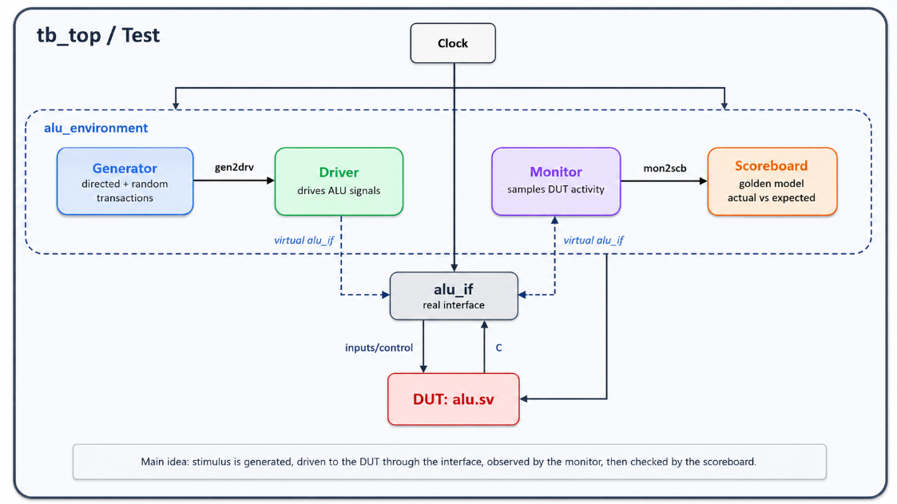

4.2 flow of Testbench
The verification environment is based on a SystemVerilog OOP structure. It contains a transaction class, generator, driver, monitor, scoreboard, environment, interface, and top module.
The main verification flow is:
Generator → Driver → Interface → DUT → Monitor → Scoreboard
- The generator makes ALU transactions.
- These transactions are sent to the driver through a mailbox.
- The driver converts each transaction into signal-level activity and drives the ALU interface.
- The DUT receives the input signals through the interface and produces the output C.
- The monitor observes the interface signals after the DUT output is updated, it captures the applied inputs, control signals, and actual output, then sends the observed transaction to the scoreboard.
- The scoreboard calculates the expected output using a golden reference model and compares it with the actual DUT output.

4.3 Verification Plan
The verification plan was formed to make sure that all ALU requirements are checked using appropriate verification methods. The plan includes directed testing, constrained-random testing, assertions, functional coverage, and scoreboard checking.
Throughout this verification plan includes both legal operation modes and important boundary cases. Illegal opcode values are not generated as normal legal stimulus because they are classified as invalid operation cases.
SPEC ID | SPEC Description | Requirment (chk/cov/test) | component | Comment | status
ALU_01 | clk: System clock used to register the ALU output C on the positive edge. | Test / Check | tb_top, alu_if, alu_driver, alu_monitor | Clock generated in tb_top. Driver drives on negedge, DUT updates on posedge, monitor samples after posedge. | Done
ALU_02 | rst_n: Asynchronous active-low reset. When rst_n = 0, output C must be cleared to zero. | Check / Assertion / Coverage | alu_driver, alu_if, alu | Driver applies reset before tests. reset_p assertion checks C == 0 during reset. cp_rst_n covers asserted/released. | Done
ALU_03 | A and B: Signed 5-bit input operands used for arithmetic and logical ALU operations. | Test / Coverage | alu_transaction, alu_generator, alu_if | Constrained-random stimulus covers signed operand range; directed tests include boundary values such as -16, 0, and 15. | Done
ALU_04 | C: Signed 6-bit registered output used to store the ALU operation result. | Check / Assertion | alu, alu_monitor, alu_scoreboard, alu_if | Monitor captures actual C. Scoreboard compares actual against golden model. range_p assertion checks signed 6-bit output range. | Done
ALU_05 | ALU_en: Overall ALU enable. When ALU_en = 0, expected output C is zero. | Check / Coverage / Test | alu_transaction, alu_generator, alu_scoreboard, alu_if | Directed and random tests include ALU_en = 0. alu_disable_p assertion and scoreboard golden model check C = 0. | Done
ALU_06 | a_en: Enable signal for a_op operation set. a_op operations selected when a_en = 1 and b_en = 0. | Test / Coverage | alu_generator, alu_if | Enable-mode coverpoint cp_enable_mode covers a_only, b_only, both, and none modes. | Done
ALU_07 | a_op: 3-bit opcode. Legal values in A-only mode are 0 to 6; value 7 is illegal/null. | Assertion / Coverage / Test | alu_transaction, alu_if, alu_generator | Constraint prevents illegal a_op = 7 in A-only mode. illegal_aop_p assertion checks that illegal opcode is not applied. | Done
ALU_08 | A-only mode a_op = 0 performs A + B. | Check / Coverage / Directed Test | alu_generator, alu_scoreboard, alu | Directed test covers a_op 0. Golden model checks A+B result. | Done
ALU_09 | A-only mode a_op = 1 performs A - B. | Check / Coverage / Directed Test | alu_generator, alu_scoreboard, alu | Directed test covers a_op 1. Golden model checks A-B result. | Done
ALU_10 | A-only mode a_op = 2 performs A XOR B. | Check / Coverage / Directed Test | alu_generator, alu_scoreboard, alu | Directed test covers XOR. Scoreboard sign-extends logical result to 6-bit signed. | Done
ALU_11 | A-only mode a_op = 3 performs A AND B. | Check / Coverage / Directed Test | alu_generator, alu_scoreboard, alu | Directed test covers AND operation. | Done
ALU_12 | A-only mode a_op = 4 performs A AND B. | Check / Coverage / Directed Test | alu_generator, alu_scoreboard, alu | Directed test covers duplicate AND operation as specified. | Done
ALU_13 | A-only mode a_op = 5 performs A OR B. | Check / Coverage / Directed Test | alu_generator, alu_scoreboard, alu | Directed test covers OR operation. | Done
ALU_14 | A-only mode a_op = 6 performs A XNOR B. | Check / Coverage / Directed Test | alu_generator, alu_scoreboard, alu | Directed test covers XNOR using ~(A ^ B). | Done
ALU_15 | b_en selects b_op operation set. B-only mode is selected when a_en = 0 and b_en = 1. | Test / Coverage | alu_generator, alu_if | cp_enable_mode covers B-only mode. Directed tests include b_op set 1. | Done
ALU_16 | In B-only mode, legal b_op values are 0 to 2; value 3 is illegal/null. | Assertion / Coverage / Test | alu_transaction, alu_if, alu_generator | Constraint prevents b_op = 3 in B-only mode. illegal_bop_p assertion checks illegal opcode prevention. | Done
ALU_17 | B-only mode b_op = 0 performs NAND ~(A & B). | Check / Coverage / Directed Test | alu_generator, alu_scoreboard, alu | Directed test covers b_op 0 set 1. Golden model checks NAND operation. | Done
ALU_18 | B-only mode b_op = 1 performs A + B. | Check / Coverage / Directed Test | alu_generator, alu_scoreboard, alu | Directed test covers b_op 1 set 1. Golden model checks A+B result. | Done
ALU_19 | B-only mode b_op = 2 performs A + B. | Check / Coverage / Directed Test | alu_generator, alu_scoreboard, alu | Directed test covers b_op 2 set 1. Golden model checks A+B result. | Done
ALU_20 | Both-enable mode is selected when a_en = 1 and b_en = 1; all b_op values 0 to 3 are legal. | Test / Coverage | alu_generator, alu_if | cp_b_op_both covers all b_op values in both-enable mode. | Done
ALU_21 | Both-enable mode b_op = 0 performs A XOR B. | Check / Coverage / Directed Test | alu_generator, alu_scoreboard, alu | Directed test covers both-mode b_op 0. Golden model checks XOR. | Done
ALU_22 | Both-enable mode b_op = 1 performs A XNOR B. | Check / Coverage / Directed Test | alu_generator, alu_scoreboard, alu | Directed test covers both-mode b_op 1. Golden model checks XNOR. | Done
ALU_23 | Both-enable mode b_op = 2 performs A - 1. | Check / Coverage / Directed Test | alu_generator, alu_scoreboard, alu | Directed test covers both-mode b_op 2. Golden model checks A-1. | Done
ALU_24 | Both-enable mode b_op = 3 performs B + 2. | Check / Coverage / Directed Test | alu_generator, alu_scoreboard, alu | Directed test covers both-mode b_op 3. Golden model checks B+2. | Done
ALU_25 | When a_en = 0 and b_en = 0, no operation is selected and output C shall be zero. | Check / Coverage / Directed Test | alu_generator, alu_scoreboard, alu_if | Directed no-operation test included. cp_enable_mode covers none mode. | Done
ALU_26 | Logical operation results are sign-extended from 5 bits to 6-bit signed output. | Check | alu, alu_scoreboard | ext5 function used in DUT and golden model for logical operations. Scoreboard compares against sign-extended expected output. | Done
ALU_27 | Directed tests shall cover all legal operation bins and boundary operand values. | Test / Coverage | alu_generator, alu_if | Directed tests cover all legal opcode bins and boundary operands. Covergroup report shows all bins covered. | Done
ALU_28 | Constrained-random tests shall improve stimulus diversity. | Test | alu_transaction, alu_generator | Generator sends 100 constrained-random transactions after directed tests. Legal opcode constraints are applied. | Done
ALU_29 | Assertions shall check reset behavior, disabled ALU behavior, illegal opcode prevention, and output range. | Assertion | alu_if | Assertions reset_p, alu_disable_p, illegal_aop_p, illegal_bop_p, and range_p all passed with 100% assertion coverage. | Done
ALU_30 | Functional coverage shall cover reset, ALU enable, enable modes, opcode bins, and A/B boundary values. | Coverage | alu_if | Covergroup alu_functional_cg reached 100% with all 32 bins covered. | Done
ALU_31 | Scoreboard shall compare DUT output with reference golden model. | Check | alu_monitor, alu_scoreboard | Monitor sends observed transaction to scoreboard. Scoreboard reported PASS = 118 and FAIL = 0. | Done
ALU_32 | Coverage closure shall explain remaining code coverage gaps. | Coverage / Report | coverage_report, Synopsys URG report | Remaining uncovered line/branch/condition items are illegal/default or failure-handling paths; justify or exclude during coverage closure. | Done

4.3.1 Interface
The interface carries all ALU signals, including inputs, output, clock, and reset. It is used to connect the DUT with the verification components. The interface also contains assertions and functional coverage.

4.3.2 Interface Code
`timescale 1ns/1ps

interface alu_if(input logic clk);

//signals
logic signed [4:0] A;
logic signed [4:0] B;
logic a_en;
logic [2:0] a_op;
logic b_en;
logic [1:0] b_op;
logic rst_n;
logic ALU_en;
logic signed [5:0] C;

//dut modport

modport dut (
input A,
input B,
input a_en,
input a_op,
input b_en,
input b_op,
input rst_n,
input clk,
input ALU_en,
output C
);

//==============================Assertions==============================

property reset_p;
@(posedge clk)
//if reset(Asynchronous) is active then C must equal to zero @(+vedge)
(!rst_n) |-> (C == '0); //using overlapped implication (happens at same time)
endproperty

assert property (reset_p)
else $error("ASSERT FAIL: Reset active but C != 0");

//property for ALU disable
property alu_disable_p;
@(posedge clk)
//if reset is active, stop checking this property
disable iff (!rst_n)
//non-overlapped implication
(!ALU_en) |=> (C == '0); //if ALU_en=0, next cycle C=0
endproperty

assert property (alu_disable_p)
else $error("ASSERT FAIL: ALU_en is low but C did not become 0");

//illegal property for a_op
property illegal_aop_p;
@(posedge clk)
disable iff (!rst_n)
//if ALU_en is 1 (enabled) and mode is a only then a_op can't be 7
//because specs says that a_op = 7 is Null/illegal in a_op mode
(ALU_en && a_en && !b_en) |-> (a_op != 3'd7);
endproperty

assert property (illegal_aop_p)
else $error("ASSERT FAIL: Illegal a_op = 7 detected in A-only mode");

//illegal property for b_op
property illegal_bop_p;
@(posedge clk)
disable iff (!rst_n)
//if ALU_en is 1 (enabled) and mode is b only then b_op can't be 3
//because specs says that b_op = 3 is Null/illegal in b_op set 1 mode
(ALU_en && !a_en && b_en) |-> (b_op != 2'd3);
endproperty

assert property (illegal_bop_p)
else $error("ASSERT FAIL: Illegal b_op = 3 detected in B-only mode");

//Output Range Property
property range_p;
@(posedge clk)
disable iff (!rst_n)
//output should be between -32 to +31 (signed 6-bits)
(C inside {[-32:31]});
endproperty
//since this is signed 6-bits output
//normally the output is between the specified range
//this is calll sanity check more than functionality check
assert property (range_p)
else $error("ASSERT FAIL: Output out of signed 6-bit range");

//==============================Functional Coverage==============================
//functional coverage, to ask whether the tests has covered the specified cases or not
//@each clock cycle, see the signals and decide that the bins is covered or not
covergroup alu_functional_cg @(posedge clk);

option.per_instance = 1; //calculate coverage for each instance from covergroup
//in our project we have one instance ( alu_cg )

//coverpoint on reset
cp_rst_n: coverpoint rst_n {
bins asserted = {0}; //rst_n = 0 -> reset asserted
bins released = {1}; //rst_n = 1 -> reset released
}

//coverpoint on ALU_en
//do not take sample unless reset is not active
cp_ALU_en: coverpoint ALU_en iff (rst_n) {
bins disabled = {0}; //ALU_en = 0 -> disabled
bins enabled = {1}; //ALU_en = 1 -> enabled
}

//coverpoint on enable modes
//concatenation between {a_en, b_en}
cp_enable_mode: coverpoint {a_en, b_en} iff (rst_n && ALU_en) {
bins none = {2'b00};//a_en = 0, b_en = 0 -> 2'b00 (none)
bins a_only = {2'b10};//a_en = 1, b_en = 0 -> 2'b00 (use a_op table)
bins b_only = {2'b01};//a_en = 0, b_en = 1 -> 2'b00 (use b_op set1 table)
bins both = {2'b11};//a_en = 1, b_en = 1 -> 2'b00 (use b_op set2 table)
}

//coverpoint on a_op
//sample a_op only when -> rst_n=1, ALU_en=1, a_en=1, b_en=0
cp_a_op_a_only: coverpoint a_op iff (rst_n && ALU_en && a_en && !b_en) {
bins op0 = {3'd0};
bins op1 = {3'd1};
bins op2 = {3'd2};
bins op3 = {3'd3};
bins op4 = {3'd4};
bins op5 = {3'd5};
bins op6 = {3'd6};
illegal_bins illegal_op7 = {3'd7};//illegal bin
}

//coverpoint on b_op
//sample a_op only when -> rst_n=1, ALU_en=1, a_en=0, b_en=1
cp_b_op_b_only: coverpoint b_op iff (rst_n && ALU_en && !a_en && b_en) {
bins op0 = {2'd0};
bins op1 = {2'd1};
bins op2 = {2'd2};
illegal_bins illegal_op3 = {2'd3};//illegal bin
}

//coverpoint on b_op in both modes when (a_en=1, b_en=1)
cp_b_op_both: coverpoint b_op iff (rst_n && ALU_en && a_en && b_en) {
bins op0 = {2'd0};
bins op1 = {2'd1};
bins op2 = {2'd2};
bins op3 = {2'd3};
}

//coverpoint for A if reset is released and ALU enabled
cp_A_values: coverpoint A iff (rst_n && ALU_en) {
bins min = {-16}; //cover least
bins zero = {0}; //cover zero
bins max = {15}; //cover max positive
bins negative = {[-15:-1]}; //cover negative value
bins positive = {[1:14]}; //cover positive value
}

//coverpoint for B if reset is released and ALU enabled
cp_B_values: coverpoint B iff (rst_n && ALU_en) {
bins min = {-16};
bins zero = {0};
bins max = {15};
bins negative = {[-15:-1]};
bins positive = {[1:14]};
}

endgroup

//make instance from covergroup called alu_cg
alu_functional_cg alu_cg = new();

endinterface

4.4 Transaction Class
The transaction class represents one ALU test item. It contains the randomized operands, control signals, actual output, and expected output. The transaction is used to transfer data between the generator, driver, monitor, and scoreboard.

4.4.1 Transaction Class Code
class alu_transaction;
//transaction is the data transfered between blocks
//rand variable to use randomization
rand logic signed [4:0] A;
rand logic signed [4:0] B;

rand logic ALU_en;
rand logic a_en;
rand logic [2:0] a_op;
rand logic b_en;
rand logic [1:0] b_op;

//store actual output from DUT
//monitor will fill it as (tr.actual = vif.C)
logic signed [5:0] actual;
//Store expected from specs from Scoreboard Calculation
//tr.expected = golden_model (tr);
logic signed [5:0] expected;
//then make comparison between actual and expected

//constraint for inputs A and B ranges
constraint input_range_c {
A inside {[-16:15]};
B inside {[-16:15]};
}

//constraint on ALU_en
constraint enable_c {
ALU_en dist {1 := 9, 0 := 1}; //distribution
//ALU_en =1 weight 9, 90% enabled
//ALU_en =0 weight 1, 10% disabled
}

//constraint for prevernting illegal opcodes in random tests
constraint legal_opcode_c {

if (ALU_en && a_en && !b_en)
//if ALU enabled and a_en=1 and b_en=0 (A-only mode)
a_op inside {[3'd0:3'd6]}; //a_op inside from 0 to 6 and prevent 7

if (ALU_en && !a_en && b_en)
//if ALU enabled and a_en=0 and b_en=1 (B-only mode)
b_op inside {[2'd0:2'd2]}; //a_op inside from 0 to 2 and prevent 3

}

//Constructor new
function new();

A = 0;
B = 0;
ALU_en = 0;
a_en = 0;
a_op = 0;
b_en = 0;
b_op = 0;
actual = 0;
expected = 0;

endfunction

//function to return string
//we will use it for debugging and display
function string to_string();

return $sformatf("A=%0d B=%0d ALU_en=%0b a_en=%0b a_op=%0d b_en=%0b b_op=%0d expected=%0d actual=%0d",
A, B, ALU_en, a_en, a_op, b_en, b_op, expected, actual);

endfunction

endclass

4.5 Generator Class
The generator makes both directed and constrained-random transactions. Directed tests are used to make sure that all significant operation modes and boundary values are tested. Random tests are used to increase verification confidence by testing different input combinations.

4.5.1 Generator Class Code
class alu_generator;
// we will create ALU transaction
// Send them to the driver

//mailbox generator to driver
//generator will put inside the transaction
//& the driver will take the transaction from this mailbox
mailbox #(alu_transaction) gen2drv;

int random_count;// integer to calculate the nu,ber of random trans.

//constructor new (called whenever we make object from generator)
function new(mailbox #(alu_transaction) gen2drv, int random_count = 100);
//constructor take 2 i/p which are mailbox gen2dr and random_count
this.gen2drv = gen2drv;
//store mailbox that comes from env inside generator
this.random_count = random_count;

endfunction

//task for specific test cases manually
task send_directed(
logic signed [4:0] A,
logic signed [4:0] B,
logic ALU_en,
logic a_en,
logic [2:0] a_op,
logic b_en,
logic [1:0] b_op
);

alu_transaction tr; // handle tr

tr = new(); // transaction object

//put argument A in field A inside transaction
tr.A = A;
//same as previous one
tr.B = B;
tr.ALU_en = ALU_en;
tr.a_en = a_en;
tr.a_op = a_op;
tr.b_en = b_en;
tr.b_op = b_op;

//put this transaction into gen2drv mailbox
gen2drv.put(tr);
//after this the driver will take this transaction (gen2drv.get(tr))
//take same transaction and start to drive signals
endtask

//when enviroment makes gen.run() then generator starts
//run will make 2 things, 1.send directed test, 2.send random test
task run();

alu_transaction tr;//transaction handle will use it in random_tests

// A enable only
//ALU_en=1, a_en=1, b_en=0
send_directed(5'sd7, 5'sd3, 1'b1, 1'b1, 3'd0, 1'b0, 2'd0);
send_directed(5'sd7, 5'sd3, 1'b1, 1'b1, 3'd1, 1'b0, 2'd0);
send_directed(5'sd10, 5'sd5, 1'b1, 1'b1, 3'd2, 1'b0, 2'd0);
send_directed(-5'sd4, 5'sd6, 1'b1, 1'b1, 3'd3, 1'b0, 2'd0);
send_directed(-5'sd4, 5'sd6, 1'b1, 1'b1, 3'd4, 1'b0, 2'd0);
send_directed(5'sd8, 5'sd2, 1'b1, 1'b1, 3'd5, 1'b0, 2'd0);
send_directed(5'sd8, 5'sd2, 1'b1, 1'b1, 3'd6, 1'b0, 2'd0);

// signed boundaries
send_directed(5'sb10000, 5'sd0, 1'b1, 1'b1, 3'd0, 1'b0, 2'd0);//-16+0=-16 expected
send_directed(5'sd0, 5'sb10000, 1'b1, 1'b1, 3'd0, 1'b0, 2'd0);

// B enable only
//ALU_en=1, a_en=0, b_en=1
send_directed(5'sd7, 5'sd3, 1'b1, 1'b0, 3'd0, 1'b1, 2'd0);
send_directed(5'sd7, 5'sd3, 1'b1, 1'b0, 3'd0, 1'b1, 2'd1);
send_directed(-5'sd5, 5'sd4, 1'b1, 1'b0, 3'd0, 1'b1, 2'd2);

// both enables
//ALU_en=1, a_en=1, b_en=1
send_directed(5'sd10, 5'sd5, 1'b1, 1'b1, 3'd0, 1'b1, 2'd0);
send_directed(5'sd10, 5'sd5, 1'b1, 1'b1, 3'd0, 1'b1, 2'd1);
send_directed(-5'sd8, 5'sd0, 1'b1, 1'b1, 3'd0, 1'b1, 2'd2);
send_directed(5'sd0, -5'sd3, 1'b1, 1'b1, 3'd0, 1'b1, 2'd3);

// disabled and no operation
//ALU disabled
send_directed(5'sd7, 5'sd3, 1'b0, 1'b1, 3'd0, 1'b0, 2'd0);
// No operation is selected
send_directed(5'sd7, 5'sd3, 1'b1, 1'b0, 3'd0, 1'b0, 2'd0);

//Random testing
repeat (random_count) begin

tr = new(); //new transaction

//randomization for field of rand in alu_transactions but with respect to constraints
if (!tr.randomize()) begin
$fatal(1, "Randomization failed"); //if randomization failed simulation stops
//$fatal is stronger than error means simulation has a big problem so stop it
end
// if randomization successed then send this transaction to driver
gen2drv.put(tr);

end
endtask
endclass

4.6 Driver Class
The driver accepts transactions from the generator through the gen2drv mailbox. It drives the transaction fields to the interface signals at the proper simulation time.

4.6.1 Driver Class Code
class alu_driver;
//takes transactions from generator and drive transactions values to the interface

//real interface on alu_if and it is made in tb_top (alu_if alu_vif(clk));

//virtual interface as driver class is not module and thus we can't instantiate from interface
virtual alu_if vif; //vif inside driver points to alu_vif which is inside top
//and from this we can write vif.A <= tr.A;

//mailbox between generator to driver
mailbox #(alu_transaction) gen2drv;
//generator makes gen2drv.put(tr); while driver makes gen2drv.get(tr);

//constructor is called when env makes -> drv=new(vif, ge2drv);
//gives driver 2 things 1.virtual interface handle, mailbox connected with generator
function new(virtual alu_if vif, mailbox #(alu_transaction) gen2drv);
//this.sth means argument inside the constructor
this.vif = vif; //store virtual interface which comes from env inside driver
this.gen2drv = gen2drv;

endfunction

//task for making reset for DUT from the beggining of the simulation
//driver is resposible for it bec driver is responsible for driving signals to DUT

task reset();

vif.A <= '0;
vif.B <= '0;
vif.a_en <= 1'b0;
vif.a_op <= '0;
vif.b_en <= 1'b0;
vif.b_op <= '0;
vif.ALU_en <= 1'b0;

vif.rst_n <= 1'b1; //initially inactive

@(posedge vif.clk); //wait till one rising edge of clock

vif.rst_n <= 1'b0; //reset active means design C<=0
repeat (3) @(posedge vif.clk); //make reset active for 3 cycles
// not specifed no. as 3, but to make sure that design is in reset mode and assertions and coverage see reset asserted

vif.rst_n <= 1'b1;// then release reset

@(posedge vif.clk);//wait one clock cylce after releasing reset
//bec to give the design opportunity to be stable before driving transactions

endtask

task run(int count); //task run of driver, takes input count
//count is the number of transactions that driver receives
/*in enviroment
test_count= directed_count + random_count;
and then drv.run (test_count);
driver will know what he will receive exactly */

alu_transaction tr; //transaction handle

repeat (count) begin

gen2drv.get(tr); //receive transactions from generator
//this means, take transactions from gen2drv mailbox and put it in tr

//we will use negative edge because DUT reads and output happens @posedge

/*this means:
1.driver drives at negedge
2.DUT samples/calculates @posedge
3.monitor samples after posedge
*/
@(negedge vif.clk);
//put the value of tr on real signal that is inside interface
vif.A <= tr.A;
vif.B <= tr.B;
vif.ALU_en <= tr.ALU_en;
vif.a_en <= tr.a_en;
vif.a_op <= tr.a_op;
vif.b_en <= tr.b_en;
vif.b_op <= tr.b_op;
end
endtask
endclass

4.7 Monitor Class
The monitor samples the interface signals after the DUT output is updated. It makes an observed transaction containing the applied inputs and actual output, then sends it to the scoreboard by the mon2scb mailbox.

4.7.1 Monitor Class Code
class alu_monitor;
/*monitor do the following
1.Read DUT/Inteface signals
2.Store them in transaction
3.Send transaction to scoreboard
*/
virtual alu_if vif; //handle for real interface
//monitor has a reference to the real alu_if instance created in tb_top

mailbox #(alu_transaction) mon2scb; //monitor to scoreboard mailbox
//monitor put inside observed transactions

//constructor new
//called from enviroment when it makes mon=new(vif,mon2scb);
//it takes 2 values 1.virtual interface handle, 2.mailbox connected to scoreboard
function new(virtual alu_if vif, mailbox #(alu_transaction) mon2scb);

this.vif = vif; //store virtual interface inside monitor (so monitor can read signals using vif.A,..etc)
this.mon2scb = mon2scb;//store mailbox inside monitor so monitor can send trans. to scoreboard

endfunction

task run(int count); //takes parameter count, no.of transactions that monitor will observe

alu_transaction tr; //transaction variables
//new transaction based on readings from interface

repeat (count) begin

//wait on +ve edge because the design output happens at posedge clk
//normally, we will monitor @posedge to see new output
@(posedge vif.clk);
#1ps;//delay after positive edge to avoid race condition
//at same positive edge DUT updates C output using non-blocking assignment
//so if monitor read the C at same clock, may read the old value
//so we will wait for 1 picosecond after clock edge and then read

tr = new(); //new object of alu_transaction
//read the signal from interface and put it inside the transaction
tr.A = vif.A;
tr.B = vif.B;
tr.ALU_en = vif.ALU_en;
tr.a_en = vif.a_en;
tr.a_op = vif.a_op;
tr.b_en = vif.b_en;
tr.b_op = vif.b_op;

// read output from DUT and store it inside actual
//actual = real value output from DUT
//scoreboard compares actual vs expected
tr.actual = vif.C;

//send the transactions to scoreboard
mon2scb.put(tr);

end
endtask
endclass

4.8 Scoreboard Class
The scoreboard is in charge for checking the exactness of the DUT. It holds a golden model that calculates the expected ALU result according to the requirement. The scoreboard compares the expected result with the actual DUT output and reports PASS or FAIL for each transaction.

4.8.1 Scoreboard Class Code
class alu_scoreboard;

/*it does the following
1.Calculate expected output
2.Compare expected with actual DUT output
3.Print Pass or Fail*/

mailbox #(alu_transaction) mon2scb; //mailbox from monitor to scoreboard

int pass_count; //count passed transactions
int fail_count; //count failed transactions

//constructor new
// when enviroment call scoreboard, scb=new(mon2scb);
//means that scoreboard will take mailbox that received from monitor
function new(mailbox #(alu_transaction) mon2scb);

this.mon2scb = mon2scb;//store mailbox inside scoreboard
pass_count = 0;
fail_count = 0;

endfunction

//function extension 5-bits to 6-bits signed value
function automatic logic signed [5:0] ext5(input logic [4:0] value);

ext5 = $signed({value[4], value});

endfunction

//function golden_model
//calculate output C as expected from specs
//takes transactions tr
//can see tr.A,tr.B,...till tr.b_op
function automatic logic signed [5:0] golden_model(alu_transaction tr);

if (!tr.ALU_en) begin
//if ALU_en = 0 then expected output = 0
golden_model = '0;

end
else begin

case ({tr.a_en, tr.b_en}) //Concatenation

2'b10: begin
case (tr.a_op)
3'd0: golden_model = tr.A + tr.B;
3'd1: golden_model = tr.A - tr.B;
3'd2: golden_model = ext5(tr.A ^ tr.B);
3'd3: golden_model = ext5(tr.A & tr.B);
3'd4: golden_model = ext5(tr.A & tr.B);
3'd5: golden_model = ext5(tr.A | tr.B);
3'd6: golden_model = ext5(~(tr.A ^ tr.B));
default: golden_model = '0;
endcase
end

2'b01: begin
case (tr.b_op)
2'd0: golden_model = ext5(~(tr.A & tr.B));
2'd1: golden_model = tr.A + tr.B;
2'd2: golden_model = tr.A + tr.B;
default: golden_model = '0;
endcase
end

2'b11: begin
case (tr.b_op)
2'd0: golden_model = ext5(tr.A ^ tr.B);
2'd1: golden_model = ext5(~(tr.A ^ tr.B));
2'd2: golden_model = tr.A - 6'sd1;
2'd3: golden_model = tr.B + 6'sd2;
default: golden_model = '0;
endcase
end
//default enable mode if a_en=0, b_en=0 -> No operations selected
//Mo operations selected
default: begin
golden_model = '0;
end

endcase

end

endfunction

task run(int count);
//takes count, means no.of transactions from scoreboard is same test cases generator send and monitor observed

alu_transaction tr; //transaction variable

repeat (count) begin

mon2scb.get(tr); //get observed transaction from monitor

tr.expected = golden_model(tr); //calculate expected output
// so here takes same transcation input/control signals
// & send it to the golden_model

if (tr.actual === tr.expected) //comparison between expected and actual
begin
pass_count++;
$display("[SCB] PASS : %s", tr.to_string());
end
else begin
fail_count++;
$display("[SCB] FAIL : %s", tr.to_string());
end
end
//after finishing call function report to print summary of results
report();
endtask
function void report();
$display("=======================================");
$display("ALU SCOREBOARD REPORT");
$display("PASS : %0d", pass_count);
$display("FAIL : %0d", fail_count);
$display("TOTAL : %0d", pass_count + fail_count);
$display("=======================================");
endfunction
endclass

4.9 Environment Class
The Environment builds, connects, and runs all verification components. It creates the generator, driver, monitor, and scoreboard, connects them using mailboxes, applies reset, and runs the test.

4.9.1 Environment Class Code
class alu_environment;
/*enviroment do these things:
1.Build components
2.connect components
3.Run components
*/

//so it created generator, driver, monitor and scoreboard and connect them by mailboxes and vif
//then run them all with each other

virtual alu_if vif; //handle for real interface
//it need to handle reference to send it to driver and monitor
//so it receive interface from tb_top and then gives it to the components that need it

mailbox #(alu_transaction) gen2drv; //mailbox between generator to driver
mailbox #(alu_transaction) mon2scb; //mailbox between monitor to scoreboard

//component handles
alu_generator gen;
alu_driver drv;
alu_monitor mon;
alu_scoreboard scb;

//counters
int random_count; //generator will make 100 random tests
int directed_count; //generator will ake 18 directed tests
int test_count; //total = random + directed

//constructor
//almost called from tb_top as env=new(alu_vif,100);

function new(virtual alu_if vif, int random_count = 100);

this.vif = vif; //store interface hand inside env
this.random_count = random_count; //store random tests inside env

directed_count = 18; //same as send_directed() in generator
test_count = random_count + directed_count;

gen2drv = new(); //mailbox object
mon2scb = new(); //mailbox object

gen = new(gen2drv, random_count);
drv = new(vif, gen2drv);
mon = new(vif, mon2scb);
scb = new(mon2scb);
endfunction
task run();
//firstly, call reset task of driver
//bec before start test, DUT must be in a known state
drv.reset();
fork
gen.run();
drv.run(test_count);
mon.run(test_count);
scb.run(test_count);
join
//after finished all components
//env take a look on no.of failures in scoreboard
if (scb.fail_count != 0) begin
$fatal(1, "ALU test failed, fail_count = %0d", scb.fail_count);
end
endtask
endclass

4.10 ALU Package
`timescale 1ns/1ps

//Package for all classes
package alu_pkg;
`include "alu_transaction.sv"
`include "alu_generator.sv"
`include "alu_driver.sv"
`include "alu_monitor.sv"
`include "alu_scoreboard.sv"
`include "alu_environment.sv"
endpackage

4.11 Top Module
The top module instantiates the DUT, interface, clock generator, and verification environment. It starts the simulation by creating the environment object and calling the environment run task.

4.11.1 Top Module Code
`timescale 1ns/1ps

module tb_top;

/*combine 3 main things
1.Clock
2.Interface
3.DUT + Enviroment
*/
import alu_pkg::*;
logic clk;
alu_if alu_vif(clk); //interface instance alu_vif and send clock to it
alu_environment env; //enviroment handle
//DUT instantiation
alu dut (
.A (alu_vif.A), //port A in Dut is connect to Signal A inside interface
.B (alu_vif.B),
.a_en (alu_vif.a_en),
.a_op (alu_vif.a_op),
.b_en (alu_vif.b_en),
.b_op (alu_vif.b_op),
.rst_n (alu_vif.rst_n),
.clk (alu_vif.clk),
.ALU_en (alu_vif.ALU_en),
.C (alu_vif.C)
);
//clock generator
initial begin

clk = 1'b0;
forever #5 clk = ~clk;

end
initial begin

env = new(alu_vif, 100); //create object from alu_enviroment
//send 2 things 1.alu.vif which real interface instance
//this instance goes to env and env send it to driver and monitor as virtual interface
//2.random counts =100
$display("=======================================");
$display("Starting ALU test");
$display("=======================================");
env.run();//start real test
/*inside enviroment
1.drv.reset()
2.for generator,driver,monitor,scoreboard
3.wait until all finish
4.check fail_count*/
$display("=======================================");
$display("ALU test completed");
$display("=======================================");
$finish;
end
endmodule

5. Coverage Results and Analysis
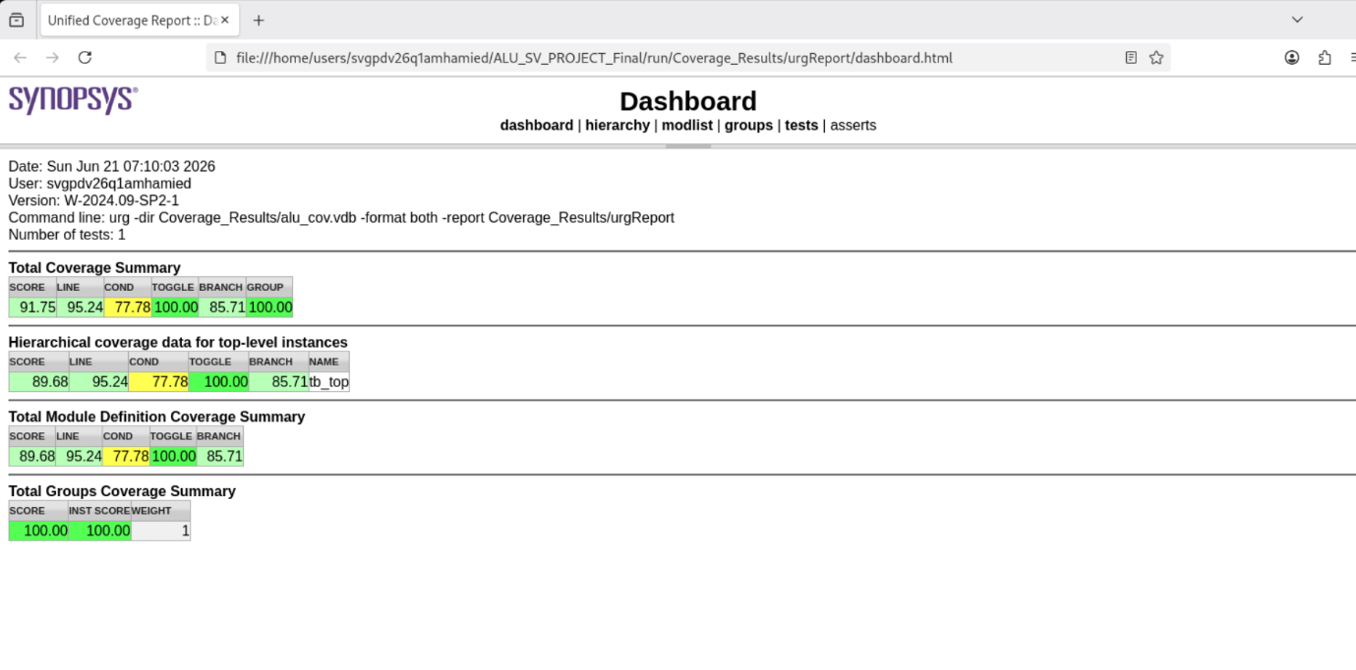
Figure 2: Total Coverage summary

5.1 Coverage Results
Coverage collection was made to evaluate how totally the ALU design and the verification environment were exercised through simulation. The coverage analysis contains functional coverage, assertion coverage, and code coverage. The main goal of this section is to show whether the verification plan was achieved and to clarify any lasting coverage gaps.
The simulation was done using two kinds of tests: directed tests and constrained-random tests. Directed tests made sure that all the important Arithmetic Logic Unit operation modes and boundary cases were checked. Constrained-random tests were used to make sure that lots of things were tried out. This means trying inputs and control combinations for the Arithmetic Logic Unit as this helps to increase confidence, in the simulation.
1. Functional Coverage Analysis
Functional coverage was applied using a covergroup inside the ALU interface. The aim of the functional coverage model is to check whether the significant scenarios from the verification plan were exercised during simulation.
The covergroup included the following overpoints:
Coverpoint | Purpose
cp_rst_n | Covers reset asserted and reset released states
cp_ALU_en | Covers ALU enabled and disabled states
cp_enable_mode | Covers all enable combinations: no-operation, A-only, B-only, and both-enabled modes
cp_a_op_a_only | Covers all legal a_op values in A-only mode
cp_b_op_b_only | Covers all legal b_op values in B-only mode
cp_b_op_both | Covers all b_op values in both-enabled mode
cp_A_values | Covers important values of operand A: minimum, zero, maximum, negative, and positive
cp_B_values | Covers important values of operand B: minimum, zero, maximum, negative, and positive
The functional coverage reached 100%. This means that all planned functional coverage bins were hit successfully. Thus, the verification environment successfully covered all required functional scenarios defined in the verification plan.
The illegal opcode bins, such as a_op = 7 in A-only mode and b_op = 3 in B-only mode, were not hit. This is predictable because these values are classified as illegal cases and are intentionally disallowed during legal constrained-random testing.

5.2 Assertion Coverage Analysis
Assertions were added inside the ALU interface to check important design rules during simulation. These assertions confirm reset behavior, ALU disable behavior, illegal opcode prevention, and output range correctness.
The following assertions were used:
Assertion | Purpose | Result
reset_p | Checks that output C is zero when reset is active | Passed
alu_disable_p | Checks that output C becomes zero when ALU_en is low | Passed
illegal_aop_p | Checks that a_op = 7 is not used in A-only mode | Passed
illegal_bop_p | Checks that b_op = 3 is not used in B-only mode | Passed
range_p | Checks that output C remains within the signed 6-bit range | Passed

Assertion coverage reached 100%, and no assertion failures were reported. This confirms that the major protocol and control rules were respected during simulation.

5.3 Code Coverage Analysis
Code coverage was collected using Synopsys VCS and URG. The coverage report showed the following results:
Coverage Metric | Result
Total Coverage Score | 91.75%
Line Coverage | 95.24%
Condition Coverage | 77.78%
Toggle Coverage | 100.00%
Branch Coverage | 85.71%
Group Coverage | 100.00%
Toggle coverage reached 100%, which means that all monitored design signals toggled between 0 and 1 during simulation. Group coverage also reached 100%, which confirms that the functional coverage model was fully covered.
Line coverage reached 95.24%, which is a strong result. The uncovered lines mainly correspond to default branches for illegal opcode values or failure-handling code inside the testbench.
Branch coverage reached around 85%. The uncovered branches are mainly related to default cases and error/failure paths that are not expected to occur during legal testing.
Condition coverage reached 77.78%. This is lower than the other metrics mainly because some conditions are part of priority if-else logic. In such logic, some combinations become structurally unreachable because earlier conditions already capture those cases.

5.4 Coverage Gap and Bug Analysis
This section explains the uncovered coverage items and whether they represent real design bugs.

5.4.1 Line Coverage Gap
The line coverage did not reach 100% because some lines were not executed during simulation. The main uncovered lines are related to default branches inside the DUT operation selection logic.
Examples of such cases include:
- Default branch for a_op in A-only mode.
- Default branch for b_op in B-only mode.
These branches correspond to illegal operation values such as:
- a_op = 7 in A-only mode
- b_op = 3 in B-only mode

These values are illegal according to the verification plan and are intentionally not generated during legal testing. Thus, the missed line coverage does not indicate a design bug.
Some uncovered lines also exist in the testbench package. These lines are related to failure-handling paths, such as:
- randomization failure handling
- scoreboard mismatch handling
- fatal error handling when fail_count is not zero
Since the simulation completed successfully and all transactions passed, these failure-handling lines were not expected to execute.

5.4.2 Branch Coverage Gap
The branch coverage did not reach 100% because some branches represent illegal or default cases. These branches are intentionally avoided by the constrained-random stimulus.
For example, the legal stimulus prevents invalid opcode combinations such as:
- A-only mode with a_op = 7
- B-only mode with b_op = 3
The verification environment treats these cases as illegal. The assertions also check that these illegal cases do not occur during normal operation.
Therefore, hitting these branches would require generating illegal stimulus. This is not part of the normal legal verification test and may cause assertion failures. For this reason, the uncovered branches are not considered functional bugs.

5.4.3 Condition Coverage Gap
Condition coverage is lower than the other metrics because some conditions are part of priority if-else logic.
For example, the DUT checks the enable modes using conditions similar to:
if (!in_alu_en)
else if (in_a_en && !in_b_en)
else if (!in_a_en && in_b_en)
else if (in_a_en && in_b_en)
else
In this code, once a condition is true, the following conditions are not evaluated for that same transaction. Therefore, some combinations may not be counted as covered by the condition coverage tool, even though the corresponding functional scenario was already tested in another branch.
This means the condition coverage gap is mainly caused by the structure of the priority logic, not by a missing functional scenario.
Some condition coverage gaps also come from testbench failure conditions, such as:
- if (tr.actual === tr.expected)
The false branch of this condition was not hit because all DUT outputs matched the expected outputs. This is a good result, not a bug.
Similarly:
- if (scb.fail_count != 0)
The true branch was not hit because the scoreboard reported zero failures.

5.4.3 Bug Analysis Summary
No functional bugs were detected during simulation.
The scoreboard reported:
PASS : 118
FAIL : 0
TOTAL : 118
This means that all generated transactions produced the expected DUT output according to the golden reference model.
The remaining uncovered coverage items are classified as justified coverage gaps, not functional bugs.
Coverage Gap | Reason | Bug
Default a_op branch | Represents illegal a_op = 7 in A-only mode | No
Default b_op branch | Represents illegal b_op = 3 in B-only mode | No
Scoreboard failure branch | Not reached because all comparisons passed | No
Environment fatal branch | Not reached because fail_count = 0 | No
Randomization failure branch | Not reached because randomization succeeded | No
Some condition combinations | Structurally unreachable due to priority if-else logic | No
Thus, the uncovered coverage items are not considered design bugs. They are either illegal/default cases, structurally inaccessible conditions, or failure-handling paths that should not be executed in a successful legal simulation.
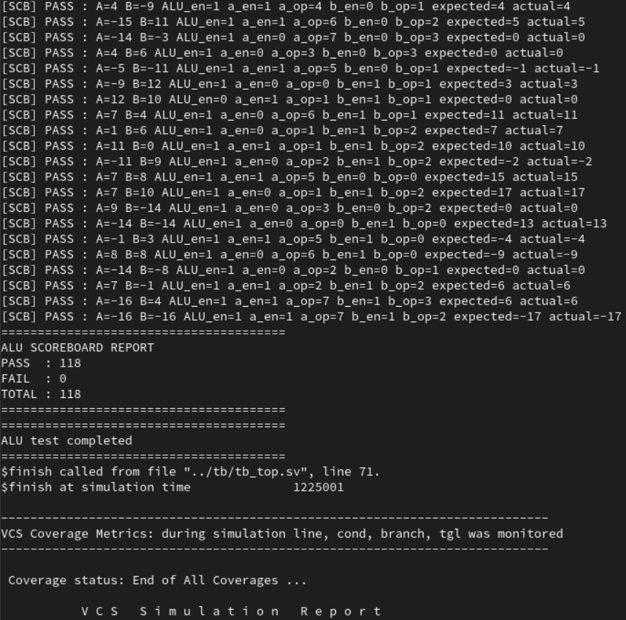
Figure 3: Transactions

6. Simulation Result
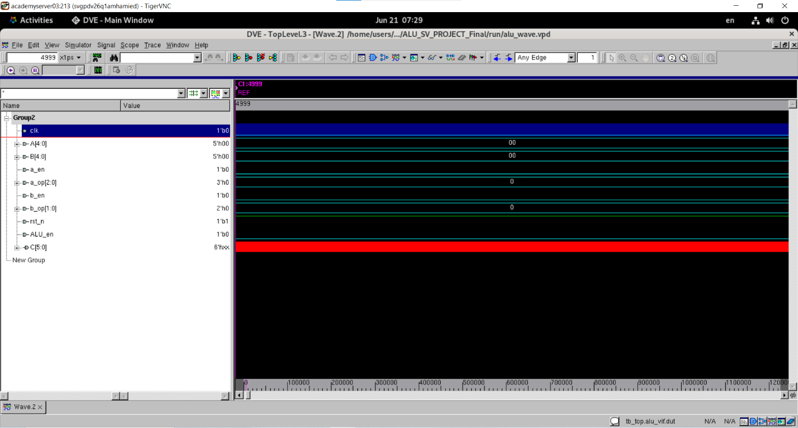
Figure 4:simulation results

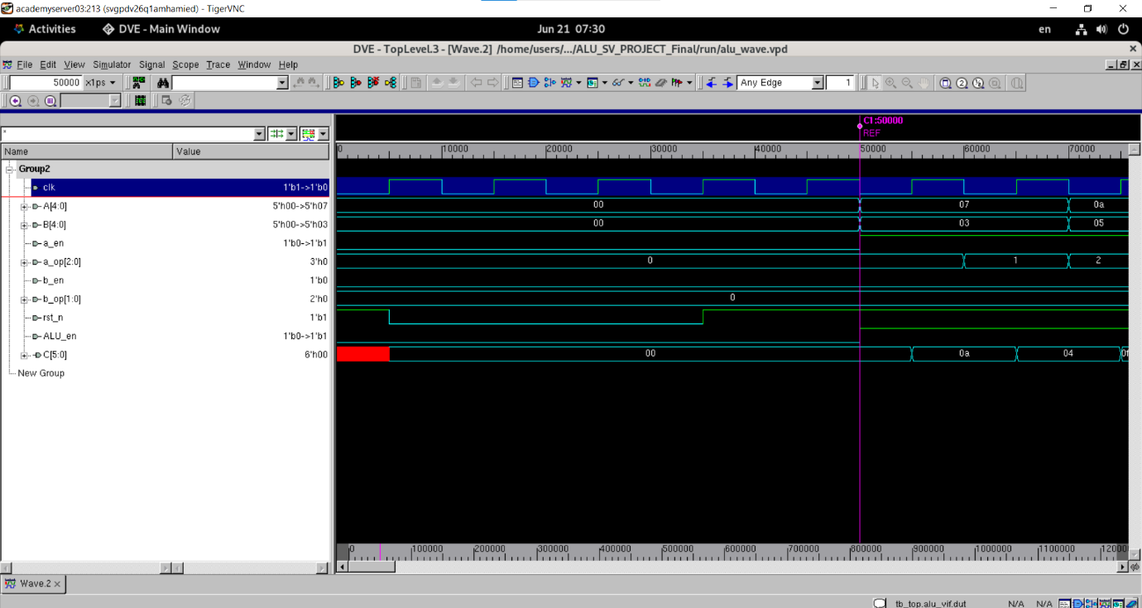
Figure 5: simulation results
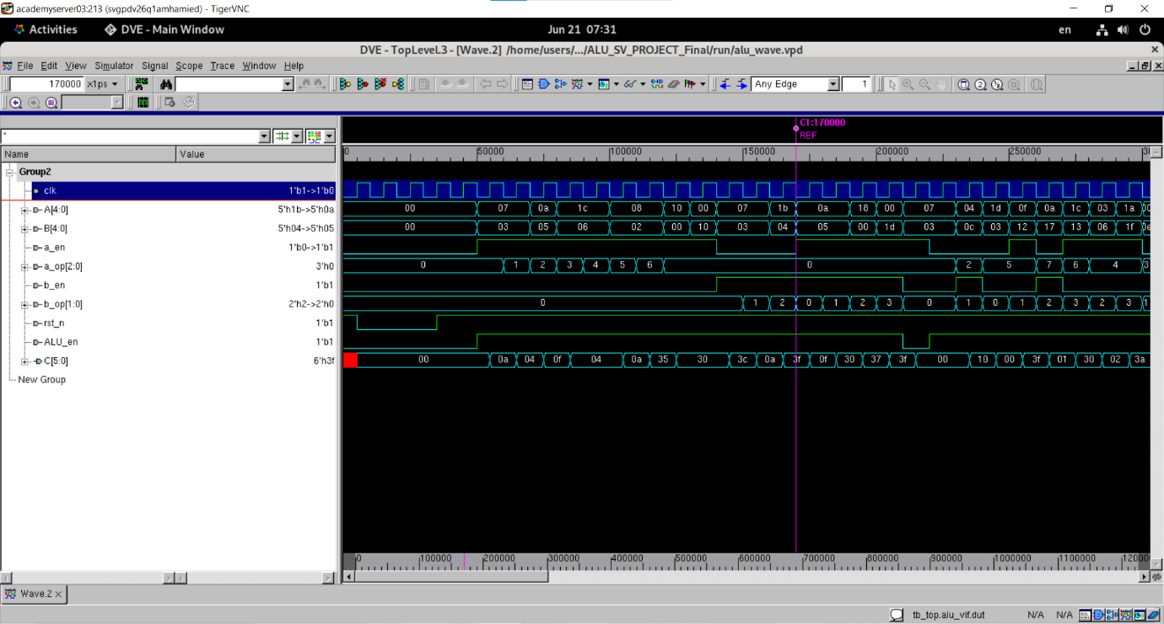
Figure 6: simulation results

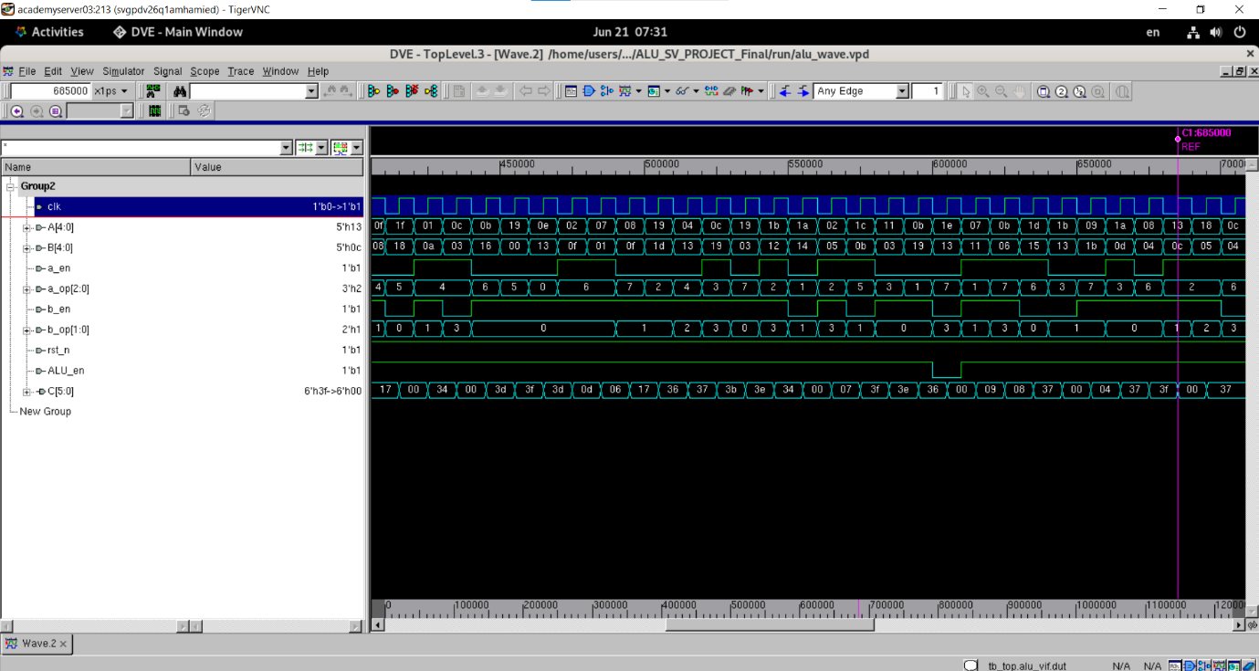
Figure 7: simulation results

7.Conclusion
A SystemVerilog OOP-based verification environment was used to successfully validate the ALU design. A generator, driver, monitor, scoreboard, interface, assertions, and functional coverage were all part of the environment.
Constrained-random tests were employed to boost verification confidence, while directed tests ensured coverage of all authorized operation modes and significant boundary values. The scoreboard revealed 118 successful transactions with no failures when comparing the DUT output to a golden reference model.
Both assertion coverage and functional coverage attained 100%. In several measurements, code coverage fell short of 100%; the remaining gaps were associated with failure-handling paths, structurally unreachable scenarios, and illegal/default cases. These holes are not regarded as functional defects.
The ALU is deemed functionally sound based on the simulation results, scoreboard checking, assertions, and functional coverage.

