



COE 371L

Computer Networks I

Fall 2019

Lab #2

Section #2

Title: Network Device Configuration

Name: Amir Mohideen, Zayed Mohamed

ID : 74559, 75771

Lab - Exploring Router Physical Characteristics

1. Topology

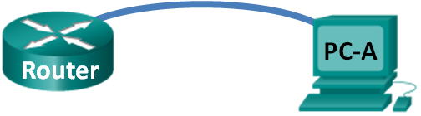

1. Objectives

Part 1: Examine Router External Characteristics

Part 2: Examine Router Internal Characteristics Using Show Commands

1. Background / Scenario

In this lab, you will examine the outside of the router to become familiar with its characteristics and components, such as its power switch, management ports, LAN and WAN interfaces, indicator lights, network expansion slots, memory expansion slots, and USB ports.

You will also identify the internal components and characteristics of the IOS by consoling into the router and issuing various commands, such as **show version** and **show interfaces**, from the CLI.

**Note**: The routers used with CCNA hands-on labs are Cisco 1941 Integrated Services Routers (ISRs) with Cisco IOS Release 15.2(4)M3 (universalk9 image). Other routers and Cisco IOS versions can be used. Depending on the model and Cisco IOS version, the commands available and output produced might vary from what is shown in the labs.

**Note**: Make sure that the routers have been erased and have no startup configurations. If you are unsure, contact your instructor.

1. Required Resources

* 1 Router (Cisco 1941 with Cisco IOS Release 15.2(4)M3 universal image or comparable)
* 1 PC (Windows 7 or 8 with terminal emulation program, such as Tera Term)
* Console cables to configure the Cisco IOS devices via the console ports

1. Examine Router External Characteristics

Use the images below, as well as your own direct inspection of the backplane of a Cisco router, to answer the following questions. Feel free to draw arrows and circle the areas of the image that correctly identify the parts.

**Note**: The router depicted in the images below is a Cisco 1941 router, which may be different from the make and model of the routers in your particular academy. You can find device information and specifications for the Cisco 1941 series routers at the Cisco.com website. Additional information, including answers to many of the questions below can be found here:

<http://www.cisco.com/en/US/prod/collateral/routers/ps10538/data_sheet_c78_556319.html>

* 1. Identify the various parts of a Cisco router.

The image shown in this step is of the backplane of a Cisco 1941 ISR. Use it to answer the questions in this step. In addition, if you are examining a different model router, a space has been provided here for you to draw the backplane and identify components and interfaces as specified in the questions that follow.

Module slots

Power Switch

Management Ports

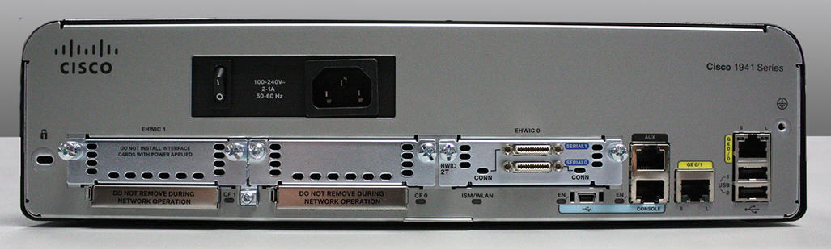

Flash storage

WAN ports

LAN ports

USB

Ports

Mini USB

* + 1. **[Report]** Circle and label the router’s power switch. Is the power switch on your router in the same area as the router depicted in the image?

Yes, it is.

* + 1. **[Report]** Circle and label the management ports. What are the built-in management ports? Are the management ports the same on your router? If not, how are they different?

Auxiliary port and console. Yes, they are same on my router.

* + 1. **[Report]** Circle and label the router’s LAN interfaces. How many LAN interfaces does the router in the image have and what is the interface technology type? Are the LAN interfaces the same on your router? If not, how are they different?

2 Gbps ports and Yes

* + 1. **[Report]** Circle and label the router’s WAN interfaces. How many WAN interfaces does the router in the image have and what is the interface technology type? Are the WAN interfaces the same on your router? If not, how are they different?

2 WAN interfaces

* + 1. **[Report]** The Cisco 1941 ISR is a modular platform and comes with module expansion slots for varied network connectivity requirements. Circle and label the module slots. How many module slots are there? How many are used? What type of module expansion slots are they? Are the module slots the same on your router? If not, how are they different?

There are two slots present even though only one is being used. These are used for interface cards. The module slots are the same.

* + 1. **[Report]** The Cisco 1941 router comes with CompactFlash memory slots for high speed storage. Circle and label the CompactFlash memory slots. How many memory slots are there? How many are used? How much memory can they hold? Are the memory slots the same on your router? If not, how are they different?

2 memory slots present. The memory slots are the same.

* + 1. **[Report]** The Cisco 1941 router comes with USB 2.0 ports. The built-in USB ports support eToken devices and USB flash memory. The USB eToken device feature provides device authentication and secure configuration of Cisco routers. The USB flash feature provides optional secondary storage capability and an additional boot device. Circle and label the USB ports. How many USB ports are there? Are there USB ports on your router?

2 ports located and they are the same on my router.

* + 1. **[Report]** The Cisco 1941 router also comes with a mini-B USB console port. Circle and label the mini-B USB console port.

In the diagram

* 1. Examine the router activity and status lights.

The following images highlight the activity and status lights of the front panel and backplane of a powered up and connected Cisco 1941 ISR.

**Note**: Some of the indicator lights are obscured from view in the image of the backplane of the Cisco 1941 router below.

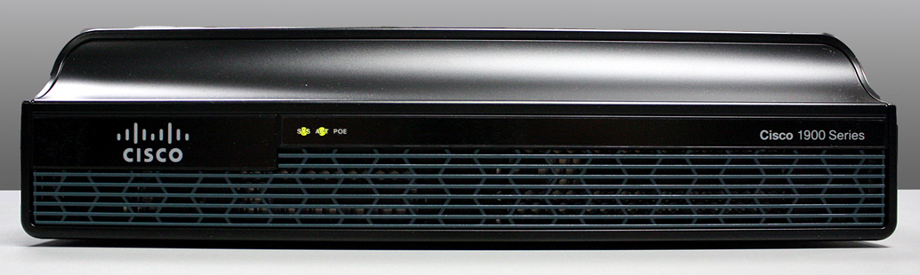

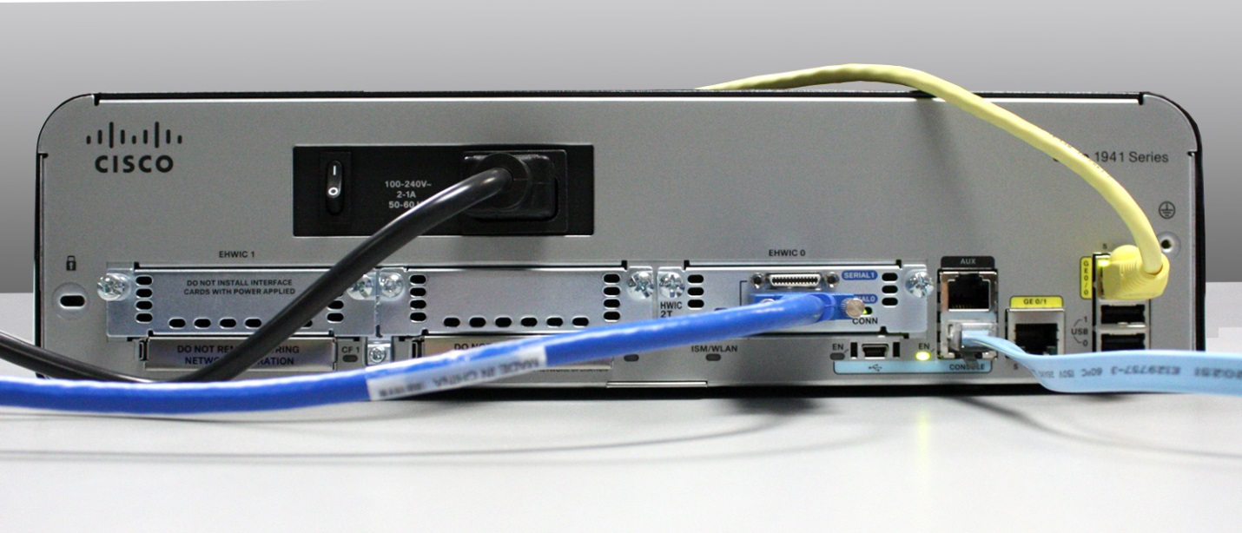

* + 1. **[Report]** In the top image above, examine the indicator lights on the front panel of the router? The lights are labeled SYS, ACT, and POE. What do the labels refer to? What do the lights in the image indicate about the status of the router? These labels would be readable if they were not lit.

SYS is for system status, ACT is for network activity and POE is for power over Ethernet. From the picture, the system is on, there is network activity and the Power over Ethernet is off.

* + 1. **[Report]** In the backplane image above, examine the indicator lights on the router. There are three visible activity lights, one for each of the connected interfaces and management ports. Examine the interface lights on your router. How are the lights labeled, and what is their meaning?

The lights on the image show that the serial and gigabit Ethernet is switched on and the management port is active. Gigabit has two lights; S for sending and L for link. The Console port and mini USB console have the EN label for enabled and the Conn light is for the serial interface.

* + 1. **[Report]** Aside from the management ports and network interfaces, what other indicator lights are on the backplane of the router and what might their purpose be?

There are Cf0 and Cf1 lights that are for the compact flash memory slots and ISM/WLAN light which indicates if there is interface module or a network card installed.

1. Examine Router Internal Characteristics Using Show Commands
   1. Establish a console connection to the router and use the show version command.
      1. Using Tera Term, console into the router and enter privileged EXEC mode using the **enable** command:

Router> **enable**

Router#

* + 1. Display information about the router by using the **show version** command. Use the Spacebar on the keyboard to page through the output.

Router# **show version**

Cisco IOS Software, C1900 Software (C1900-UNIVERSALK9-M), Version 15.2(4)M3, RELEASE SOFTWARE (fc1)

Technical Support: http://www.cisco.com/techsupport

Copyright (c) 1986-2011 by Cisco Systems, Inc.

Compiled Thu 26-Jul-12 19:34 by prod_rel_team

ROM: System Bootstrap, Version 15.0(1r)M15, RELEASE SOFTWARE (fc1)

Router uptime is 1 day, 14 hours, 46 minutes

System returned to ROM by power-on

System restarted at 07:26:55 UTC Mon Dec 3 2012

System image file is "flash0:c1900-universalk9-mz.SPA.152-4.M3.bin"

Last reload type: Normal Reload

Last reload reason: power-on

<output omitted>

If you require further assistance please contact us by sending email to

export@cisco.com.

Cisco CISCO1941/K9 (revision 1.0) with 487424K/36864K bytes of memory.

Processor board ID FGL16082318

2 Gigabit Ethernet interfaces

2 Serial(sync/async) interfaces

1 terminal line

1 Virtual Private Network (VPN) Module

DRAM configuration is 64 bits wide with parity disabled.

255K bytes of non-volatile configuration memory.

250880K bytes of ATA System CompactFlash 0 (Read/Write)

<output omitted>

Technology Package License Information for Module:'c1900'

-----------------------------------------------------------------

Technology Technology-package Technology-package

Current Type Next reboot

------------------------------------------------------------------

ipbase ipbasek9 Permanent ipbasek9

security securityk9 Permanent securityk9

data None None None

Configuration register is 0x2102

* + 1. Based on the output of the **show version** command, answer the following questions about the router. If you are examining a different model router, include the information about it here.
       1. **[Report]** What is the version of the Cisco IOS and what is the system image filename?

IOS v.15.2(3)M3, C1900-universalk9-mz.SPA.152-4.M3.bin

* + - 1. **[Report]** What is the Bootstrap program version in ROM BIOS?

version 15.0(1r)M15

* + - 1. **[Report]** How long has the router been running without a restart (also known as its uptime)?

1 day, 14 hours, 46 minutes

* + - 1. **[Report]** How much dynamic random-access memory (DRAM) memory does the router have?

512MB

* + - 1. **[Report]** What is the router’s processor board ID number?

FGL16082318

* + - 1. **[Report]** What network interfaces does the router have?

2 Gigabit interfaces and 2 serial interfaces

* + - 1. **[Report]** How much CompactFlash memory for IOS storage is there?

250880K of CompactFlash memory

* + - 1. **[Report]** How much nonvolatile random-access memory (NVRAM) memory for configuration file storage is there?

255K of NVRAM

* + - 1. **[Report]** What is the setting of the configuration register?

0x2102

* 1. Use the show interface command to examine the network interfaces.
     1. Use the **show interface gigabitEthernet 0/0** command to see the status of the Gigabit Ethernet 0/0 interface.

**Note**: After typing part of the command, for example, **show interface g**, you can use the **Tab** key on your keyboard to complete the gigabitEthernet command parameter.

Router# **show interface gigabitEthernet 0/0**

GigabitEthernet0/0 is administratively down, line protocol is down

Hardware is CN Gigabit Ethernet, address is 442b.031a.b9a0 (bia 442b.031a.b9a0)

MTU 1500 bytes, BW 100000 Kbit/sec, DLY 100 usec,

reliability 255/255, txload 1/255, rxload 1/255

Encapsulation ARPA, loopback not set

Keepalive set (10 sec)

Full Duplex, 100Mbps, media type is RJ45

output flow-control is unsupported, input flow-control is unsupported

ARP type: ARPA, ARP Timeout 04:00:00

Last input never, output never, output hang never

Last clearing of "show interface" counters never

Input queue: 0/75/0/0 (size/max/drops/flushes); Total output drops: 0

Queueing strategy: fifo

Output queue: 0/40 (size/max)

5 minute input rate 0 bits/sec, 0 packets/sec

5 minute output rate 0 bits/sec, 0 packets/sec

3 packets input, 276 bytes, 0 no buffer

Received 0 broadcasts (0 IP multicasts)

0 runts, 0 giants, 0 throttles

0 input errors, 0 CRC, 0 frame, 0 overrun, 0 ignored

0 watchdog, 0 multicast, 0 pause input

0 packets output, 0 bytes, 0 underruns

0 output errors, 0 collisions, 0 interface resets

0 unknown protocol drops

0 babbles, 0 late collision, 0 deferred

0 lost carrier, 0 no carrier, 0 pause output

0 output buffer failures, 0 output buffers swapped out

* + 1. Given the output of the **show interface gigabitEthernet 0/0** command depicted above, or using the output from your router, answer the following questions:

**[Report]** What is the hardware type and MAC address of the Gigabit Ethernet interface?

-Hardware type is CN Gigabit Ethernet and MAC address is 442b.031a.b9a

**[Report]** What is the interface media type? Is the interface up or down?

-Interface media type is rj45; interface is down

* + 1. Use the **show interfaces serial 0/0/0** command to view the status of the Serial 0/0/0 interface.

Router# **show interface serial 0/0/0**

Serial0/0/0 is administratively down, line protocol is down

Hardware is WIC MBRD Serial

MTU 1500 bytes, BW 1544 Kbit/sec, DLY 20000 usec,

reliability 255/255, txload 1/255, rxload 1/255

Encapsulation HDLC, loopback not set

Keepalive set (10 sec)

Last input 07:41:21, output never, output hang never

Last clearing of "show interface" counters never

Input queue: 0/75/0/0 (size/max/drops/flushes); Total output drops: 0

Queueing strategy: fifo

Output queue: 0/40 (size/max)

5 minute input rate 0 bits/sec, 0 packets/sec

5 minute output rate 0 bits/sec, 0 packets/sec

1 packets input, 24 bytes, 0 no buffer

Received 1 broadcasts (0 IP multicasts)

0 runts, 0 giants, 0 throttles

0 input errors, 0 CRC, 0 frame, 0 overrun, 0 ignored, 0 abort

0 packets output, 0 bytes, 0 underruns

0 output errors, 0 collisions, 2 interface resets

0 unknown protocol drops

0 output buffer failures, 0 output buffers swapped out

1 carrier transitions

DCD=down DSR=down DTR=down RTS=down CTS=down

* + 1. Given the output command depicted above, answer the following questions:

**[Report]** What is the frame encapsulation type?

HDLC

**[Report]** What is the hardware type? Is the interface up or down?

WIC MBRD serial; interface is down

1. Reflection
   1. **[Report]** Why might you need to use an EHWIC expansion slot?

-The router doesn’t come with a WAN interface technology. Therefore, we might need to use EHWIC expansion slot if a WAN connection through ISP is required.

* 1. **[Report]** Why might you need to upgrade the Flash memory?

In order to store an additional IOS image file or a large IOS image file, we might need to upgrade.

* 1. **[Report]** What is the purpose of the mini-USB port?

To give the user the ability to console into the router when a COM serial port is unavailable on the user’s computer.

* 1. **[Report]** What is the purpose of the ISM/WLAN indicator light on the backplane of the router? What does it refer to?

The purpose is to indicate that the router can support an Internal Services Module that can boost the abilities of the router to perform actions like intrusion prevention scanning. It can also be equipped with a WLAN card for supporting wireless local area networks.