1-dars: Static Routing
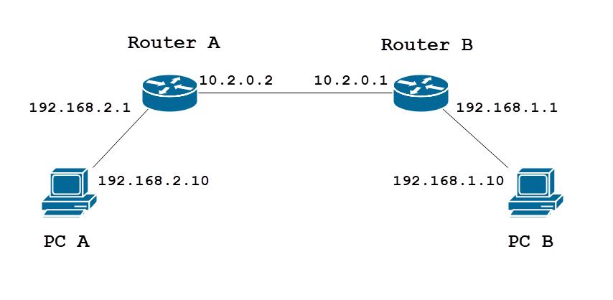
cisco.com
Avval qisqacha tushuncha:
- Static Route — administrator routerga qaysi tarmoqqa qaysi yo‘l orqali borishni qo‘lda ko‘rsatadi.
- Default Route — routerda aniqroq yo‘l topilmasa, trafikni belgilangan keyingi routerga yuboradi.
- Floating Static Route — asosiy yo‘l ishlamay qolsa, zaxira yo‘l sifatida ishlatiladi.
Bularni uchta alohida nazariy dars qilib cho‘zmaymiz. Bitta kichik laboratoriyada bosqichma-bosqich o‘rganamiz.
Birinchi ishimiz
Yangi, alohida Packet Tracer fayli ochamiz. Oldingi enterprise loyihamizni o‘zgartirmaymiz.
Laboratoriya topologiyasi
PC1
192.168.1.10/24
R1
192.168.1.1
R2
192.168.12.2
R1 va R2 orasidagi aloqa: 192.168.12.0/30. R2 ortida ikkinchi LAN tarmog‘i bo‘ladi.
Hozir faqat birinchi qadam: Packet Tracer’da yangi fayl ochib, ikkita router va ikkita switch hamda ikkita PC joylashtir. Qurilmalarni PC1 → SW1 → R1 → R2 → SW2 → PC2 tartibida ulang.

1-qadam: Qurilmalarni ulash va IP manzillarni rejalashtirish
Avval topologiyamizni aniq belgilaymiz. Hozircha faqat IP manzillarni sozlaymiz, routing buyruqlariga keyin o‘tamiz.
Bizning topologiyamiz
PC1 ── SW1 ── R1 ═════ R2 ── SW2 ── PC2
Quyidagi IP manzillar rejasidan foydalanamiz:
Qurilma | Interfeys | IP manzil | Subnet mask
PC1 | FastEthernet0 | 192.168.1.10 | 255.255.255.0
R1 | LAN interfeysi | 192.168.1.1 | 255.255.255.0
R1 | R2 tomonga | 192.168.12.1 | 255.255.255.252
R2 | R1 tomonga | 192.168.12.2 | 255.255.255.252
R2 | LAN interfeysi | 192.168.2.1 | 255.255.255.0
PC2 | FastEthernet0 | 192.168.2.10 | 255.255.255.0
PC’larning Default Gateway manzillari:
- PC1: 192.168.1.1
- PC2: 192.168.2.1
Nima uchun routerlar orasida /30 ishlatyapmiz?
192.168.12.0/30 tarmog‘ida jami 4 ta IP manzil mavjud:
- 192.168.12.0 — Network address
- 192.168.12.1 — R1 uchun
- 192.168.12.2 — R2 uchun
- 192.168.12.3 — Broadcast address
Routerlar orasidagi nuqtadan nuqtaga ulanish uchun ikkita foydalaniladigan IP manzil yetarli.
2-qadam: R1 routerini sozlash
Avval R1 qurilmasini ochib, CLI bo‘limiga kiring.
Quyidagi buyruqlarni kiriting:
enable
configure terminal
interface gigabitEthernet0/0
ip address 192.168.1.1 255.255.255.0
no shutdown
exit
interface gigabitEthernet0/1
ip address 192.168.12.1 255.255.255.252
no shutdown
end
Buyruqlar nima qiladi?
- interface gigabitEthernet0/0 — PC1 joylashgan LAN tomonidagi interfeysni sozlaydi.
- ip address 192.168.1.1 255.255.255.0 — R1 ning LAN manzilini belgilaydi.
- interface gigabitEthernet0/1 — R2 tomonidagi interfeysni sozlaydi.
- ip address 192.168.12.1 255.255.255.252 — routerlar orasidagi ulanish manzilini belgilaydi.
- no shutdown — interfeysni yoqadi.
Muhim: Agar sening routeringda GigabitEthernet0/0 va GigabitEthernet0/1 portlari bo‘lmasa, boshqa interfeys nomlarini taxmin qilib ishlatma. Avval menga port nomlarini yubor.
Tekshirish
Buyruqlar tugagach, R1 da quyidagini bajar:
show ip interface brief

3-qadam: R2 routerini sozlash
Packet Tracer’da R2 → CLI oynasini oching va quyidagi buyruqlarni kiriting:
enable
configure terminal
interface gigabitEthernet0/0
ip address 192.168.12.2 255.255.255.252
no shutdown
exit
interface gigabitEthernet0/1
ip address 192.168.2.1 255.255.255.0
no shutdown
end
Nima uchun bu manzillarni berdik?
- G0/0 — 192.168.12.2/30: R1 bilan aloqa qilish uchun.
- G0/1 — 192.168.2.1/24: PC2 joylashgan LAN uchun.
Eslab qol: R1 va R2 orasidagi tarmoq 192.168.12.0/30. R1 manzili .1, R2 manzili .2.
Tekshirish
R2 da quyidagi buyruqni bajar:
show ip interface brief

Router#show ip interface brief Interface IP-Address OK? Method Status Protocol GigabitEthernet0/0 192.168.12.1 YES manual up up GigabitEthernet0/1 192.168.2.1 YES manual up up Vlan1 unassigned YES unset administratively down down
Yaxshi, interfeyslar up/up, lekin bitta muhim nomuvofiqlik bor: sen yuborgan natijada R2 ning GigabitEthernet0/0 manzili 192.168.12.1 bo‘lib turibdi. Bu esa R1 ga berilgan manzil edi.
Bizning rejamiz bo‘yicha:
- R1 G0/1: 192.168.12.1/30
- R2 G0/0: 192.168.12.2/30
Agar ikkala routerda ham .1 bo‘lsa, IP manzil to‘qnashuvi yuz beradi. Buni hozir tuzatamiz.
4-qadam: R2 IP manzilini to‘g‘rilash
R2 routerida quyidagilarni kiriting:
enable
configure terminal
interface gigabitEthernet0/0
ip address 192.168.12.2 255.255.255.252
end
Keyin tekshiring:
show ip interface brief

