Howard University
College of Engineering and Architecture
Department of Electrical Engineering & Computer Science

Large Scale Programming
Fall 2024

Midterm Exam – Part I
October 17, 2024

Part I: 50 pts. (essay questions)

Instructions:
- Submit completed exam to your github repository under package org.howard.edu.lsp.midterm

Verify that the commit(s) completed successfully

- OPEN BOOK, OPEN NOTES. THERE IS NO COLLABORATION ON THIS EXAM
- Site any and ALL references for anything obtained off the internet.

Question 1. (10 pts.)

You are reviewing the following class in a Fitness Tracking System. The class is intended to manage various aspects of a user’s fitness activities.

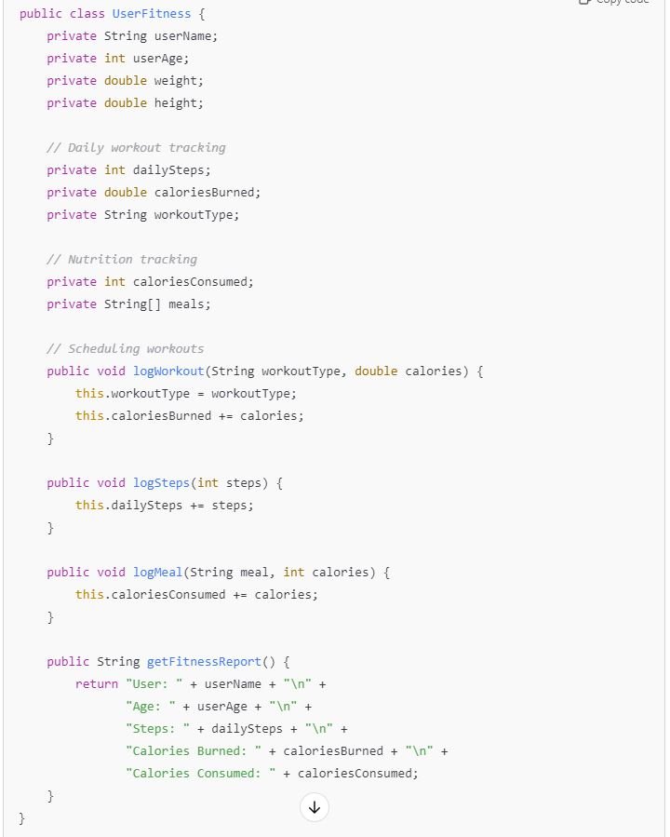

Tasks:
- Analyze the UserFitness class. Explain why this class has low cohesion. (5 pts.)

The UserFitness class has multiple different responsibilities all under the same class. It holds the information to track and identify who the user is, a daily workout routine, and a nutrition tracker. There are too many responsibilities with differing objectives under one singular class proving its low cohesion.

- Describe, in general, how you would split the UserFitness class into more cohesive classes. Your answer should not be a complete design. (5 pts.)

Split the UserFutness class into classes with more objective goals.
- UserInfo class to manage the user information
- DailyWorkout class to track the workouts and workout type
- DietTracker class to handle the nutrition part of the UserFitness class

Question 2. (5 pts.)
Given the following, answer the below questions.

A university manages its students using a program that has a class Student with subclasses FirstYear, SecondYear, and ThirdYear for year-specific state and behaviors. The program has a List that contains all Students.

Should Student be a class, an abstract class or an interface? Explain your answer

- At the end of each year, the third-year students graduate and must be removed. This is done by passing the list to the following method:

void removeThirdYears(List<Students> students) {
for (Student student : students) {
try {
ThirdYear = (ThirdYear) student;
students.remove(thirdyear);
}
}
}

Student should be an abstract class. Since “student” is more of a vague concept, a framework, there are many properties that can be shared. However, each student could vary between first, second, or third year. Therefore, the implantation could be different for each student, although they can share common functions and “Student” should be an abstract class

Why is the above method flawed? Hint: Another Arthur Riel heuristic (5 pts.)

The removeThirdYear method uses Student as an object for ThirdYear, and should’ve rather used a Student subclass objects. Violating Riel’s heuristic of “classes should avoid behaviors that are better handled by a different class”.

Question 3. (5 pts.)
Given the following, answer the below questions.

public class BankAccount {
public String accountHolderName;
public String accountNumber;
public double balance;
public double interestRate;

public BankAccount(
String accountHolderName,
String accountNumber,
double initialDeposit,
double interestRate) {
this.accountHolderName = accountHolderName;
this.accountNumber = accountNumber;
this.balance = initialDeposit;
this.interestRate = interestRate;
}

// Exposed implementation for adding interest
public void addInterest() {
double interest = balance * (interestRate / 100);
balance += interest;
}

// Exposed implementation for deposits
public void deposit(double amount) {
balance += amount;
}

// Exposed implementation for withdrawals
public void withdraw(double amount) {
balance -= amount;
}
}

- Is BankAccount well-encapsulated? Why or why not? If so, describe what changes you would make to the class. Otherwise, state nothing. (5 pts.)

BankACcount is not well-encapsulated. There are no private fields for things like accNumber and balance which should be private violating the definition of encapsulation. Encapsulation implies that internal objects are hidden from outside interference to maintain control which is proven to be wrong with the lack of private methods and fields. The changes I’d make is the first four fields should be private, and having public getter and setter methods for account balance and account name.

Question 4. (10 pts.)
Given the following, answer the below questions.

Given:
A car manufacturer uses Java software to track current vehicles being built. The UML diagram below shows an excerpt of the current software structure. You should assume the presence of other appropriate fields and methods

Car
getTrimLevel()
Engine
accelerate()
getFuelLevel()
Base
Sports
Luxury
Electric
Petrol

Each car can be built to one of three trim levels: Base, Luxury or Sport. They can also be configured with an electric or petrol engine. At various points in the manufacturing process the customer can choose to change the trim level.

Task:
- Explain in detail why the current structure does not support this. (5 pts.)

Because the inheritance is static, it does not allow for induvial change for trim levels. A car cant go from Base to Sports without a new instance of Car.

- Describe how to refactor the structure to allow trim-level change for a car to dynamically change. Hint: How would you modify Car to use composition to solve the problem? (5 pts.)

Create a TrimLevel class holding “Base, Sports, Luxury” and implement TrimLevel as a field rather than an inheritance so the TrimLevels can change without a new instance of Car.

Question 5. (5 pts.)
Suppose you are about to code a particular class and find that you have written another class with nearly the functionality that you now are developing. This means that the two classes in large parts contain the same code, but in smaller parts have different code. Explain in detail why this may be a problem and how to solve it. Give your answer in terms of Arthur Riel’s design heuristics.

This problem describes the heuristic of “minimizing duplicate code for high cohesion”. Because there are a lot of duplicate codes, identify the common functionality of both codes and using inheritance, the class can share functionality and reduce the amount of copied code.

Question 6. (5 pts.)
Suppose we need to store instances of the classes Car and BankAccount in a database. To obtain low coupling it may seem as if the functionality to save an instance should be in precisely those classes, since they have the information that shall be saved. Why is it unwise to place the database calls there?

It is unsafe to be placed inside the classes as it violates the heuristic of “class should have a single responsibility principle”. It might affect how each class runs depending on the database functionalities.

Question 7. (5 pts.)
Given a set of requirements, what conditions must be met to make it appropriate to create a new class hierarchy using inheritance? Neither superclass nor subclass exist before, the question is about designing a new class hierarchy.

Shared behaviors, what could be inherited from different classes, “Is-A” relationship to avoid redundancy.

Question 8. (2.5 pts.)
Describe the difference between inheritance and composition why would you choose one over the other.

Inheritance is where a subclass inherits attributes and behaviors from a parent class allowing for a top-down relationship. Better to use inhertance when the behavoirs are less dynamic but more shared attributes.
Composition is where one class contains an instance of another class. Composition is better for a more dynamic behavior.

Question 9. (2.5 pts.)
Explain the meaning of cohesion and describe whether low or high cohesion is better.
Cohesion is how closely related are the attributes and behavior of a class. High Cohesion is better as it is more understandable and maintainable.

