Assumptions
- You don’t have another program using port 80

Install and Run
- Install VWB to C:\Program Files\Vidiom Systems\VISION Workbench
- Make sure that C:\Program Files\Vidiom Systems\VISION Workbench\env\hostapp.properties has write permission
- Unzip Fitnesse_020108.zip to c:\fitnesse
- Unzip Patch.zip to c:\fitnesse and agree to overwrite existing files
- Create c:\temp folder
- cd c:\fitnesse\testtool\fitnesse
- execute run.bat
- Use browser to browse to -> http://localhost/

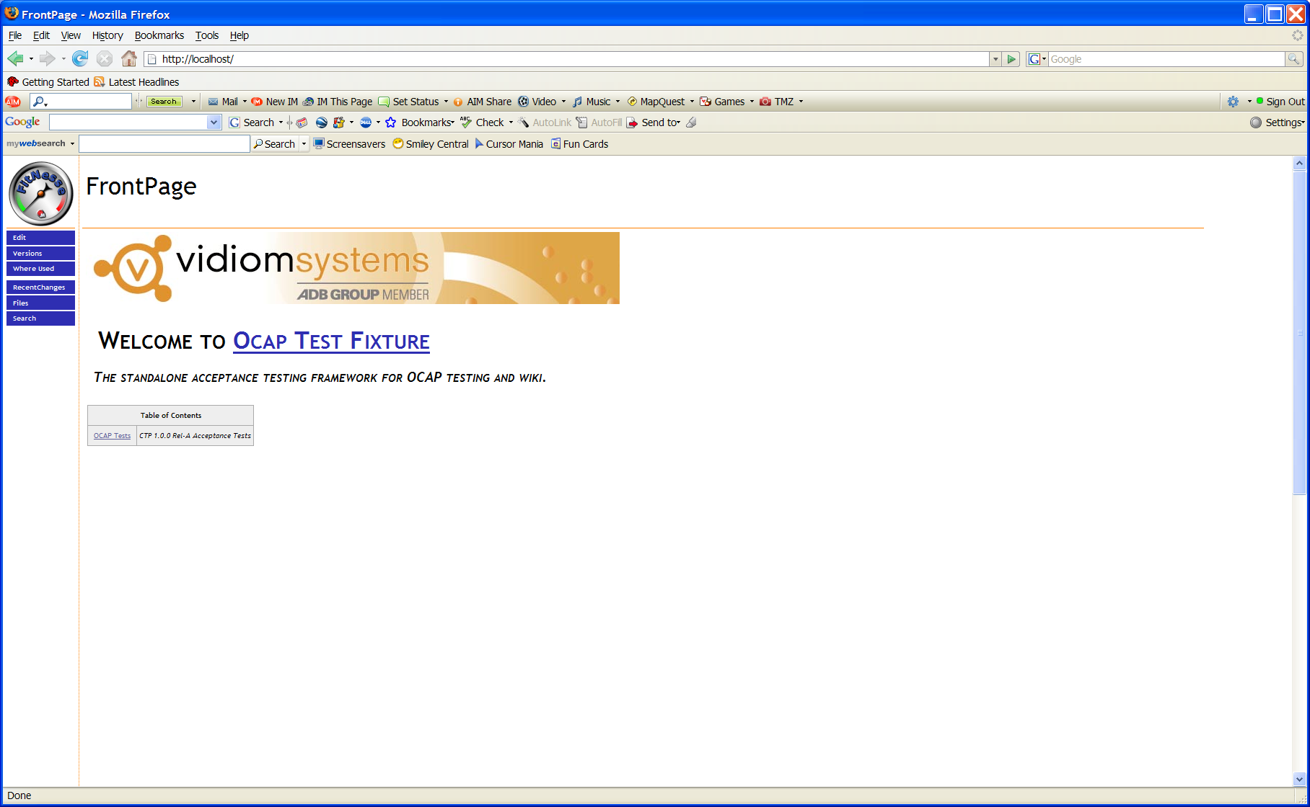

- Follow the test links to find a test to run starting with OCAP Tests link.
- Select “Suite” to run a suite of tests.
- Select “Test” to run a single test.
- Detailed results can be viewed in Fitnesse or a summary in c:\temp

