OpenCable™
Reference Implementation – Java Virtual Machine Porting Guide
Notice
This document is an effort for the benefit of the OpenCable Team. Neither CableLabs, nor any other entity participating in the creation of this document, is responsible for any liability of any nature whatsoever resulting from or arising out of use or reliance upon this document by any party. This document is furnished on an AS-IS basis and neither CableLabs, nor other participating entity, provides any representation or warranty, express or implied, regarding its accuracy, completeness, or fitness for a particular purpose.
© Copyright 2009 Cable Television Laboratories, Inc.
All rights reserved.
Version History

Version Number | Date | Contributor | Description
V1.0 | 12/27/09 | Greg Rutz | First Draft
V1.1 | 1/5/10 | Greg Rutz | Added sections for file type modifications
V1.2 | 4/23/10 | Greg Rutz | Added new FontFactorPeer information
V1.3 | 1/17/11 | Greg Rutz | Updates for new AWT EventQueue mechanism
V1.4 | 1/24/11 | Greg Rutz | Add AWT diagrams and implementation choices
V1.5 | 9/22/11 | Greg Rutz | Removed AWT EventQueue section

Contents
1 Overview 1
2 DIREcTORIES & Build System 1
3 NATIVE JVM Porting 2
3.1 VM / Stack Integration 2
3.2 mpelib_init 2
4 tru2way JVM functionality 3
4.1 File I/O 3
4.1.1 Filesystem Types 3
4.1.1.1 Object Carousel 3
4.1.1.2 HTTP 3
4.1.1.3 Zip/Jar 3
4.1.1.4 Authenticated Filesystems 4
4.1.2 JVM Modifications 4
4.1.2.1 java.io.FileSystem 4
4.1.2.2 File I/O 4
4.1.2.3 Pluggable Filesystem 5
4.1.2.4 File Type Discovery 5
4.1.2.5 MIME Type Table 5
4.2 Focus Management 5
4.2.1 KeyboardFocusManager 6
4.2.2 java.awt.Component 6
4.3 Application Context 6
4.4 J2ME IXCRegistry 7
4.5 Resource Reclamation 7
4.6 AWT Implementation 7
4.6.1 org.dvb.ui.FontFactory Support 10
4.7 Custom AWT Implementation 10
4.7.1 KeyEvent Dispatch 11
4.8 DVB Character Set 11

Overview
The tru2way Reference Implementation (RI) is based on the Java2 Micro Edition (J2ME) technology from Sun Microsystems. More specifically, its foundation is Java Specification Request (JSR) 217 – Personal Basis Profile 1.1. This specification references the following Java API set specifications:
- Connected Device Configuration (CDC) 1.1.2 – http://jcp.org/en/jsr/summary?id=218
- Foundation Profile 1.1.2 – http://jcp.org/en/jsr/summary?id=219
- Personal Basis Profile 1.1.2 – http://jcp.org/en/jsr/summary?id=217
This VM specification roughly (but not entirely) represents the API set present in the Java2 Standard Edition (J2SE) 1.4.
Unfortunately, you can not just drop any compliant J2ME virtual machine into the RI and expect to satisfy the requirements of the tru2way specification. tru2way imposes some very non-standard requirements for the JVM on which it executes. For example, even though the RI itself runs within the VM, each application launched by the RI must see itself as running in its own VM with access to set of Java system properties that are specific to that application. Most commercial JVM porting layers will not provide developers with all the tools they need to implement tru2way requirements. Modifications to source code outside the porting area will almost certainly be necessary.
To facilitate the JVM porting process, the RI provides a set of classes and interfaces that will help to minimize and simplify the required set of changes. This document is intended to help the developer understand the tru2way-specific VM requirements and the tools provided by the RI to help integrate these changes into the VM of your choice.
The RI currently uses the open source phoneME Advanced JVM from Sun (https://phoneme.dev.java.net/). Several examples presented throughout this document are references to the modifications we have made to this particular JVM.

DIREcTORIES & Build System
It is possible to have multiple VMs integrated into the RI source tree at one time (although each RI build target may reference only a single VM). All VMs and VM code live under the $OCAPROOT/jvm directory. Each VM and all associated source, build, and data files should be placed in its own subdirectory under this location.
The RI build system relies mostly on Apache Ant and GNU Make for performing build-related tasks. To begin integrating your VM into the RI build system, you must create an Ant build file somewhere under your VM subdirectory that controls all of the VM-specific build tasks. This build file must contain at least the following build targets:
- build – performs a build of the VM and copies any modified build products to their target-specific installation location
- clean – removes all intermediate build products produced by the VM build
- purge – removes all installed build products from their target-specific installation location
To allow the RI build system to kick off your VM build, you must create/modify $OCAPROOT/target/$OCAPTC/buildrules.properties. This is the Ant properties file that defines all target-specific build properties. There are only 2 options which must be specified:
- build.jvm.BUILDFILE – this path identifies the location and name of the VM-specific Ant build file described above. The path should be relative to $OCAPROOT. For example, jvm/phoneME/build.xml. This is the build file that the main build system will delegate to performing VM build operations
- build.jvm.exclude – This boolean variable indicates whether or not the build of the JVM is enabled by default. Once the VM is in place and operating correctly, it may not require much modification. You may choose to exclude the JVM from standard builds use pre-built binaries to decrease total build times for the RI stack.
Feel free to add any other properties to this file to help configure your VM build and/or install VM binaries and products that are appropriate for the build target.

NATIVE JVM Porting
Most portable VMs are distributed with porting APIs that the developer must implement to the underlying native operating system for the target device. It is possible to carry out this work completely independent of the tru2way stack porting effort, but you would be essentially doubling the porting effort. The RI team recommends that you instead port your JVM to the stack’s MPE APIs. This will allow you to do a single port of the stack to each target device and operating system and get the associated JVM port mostly for free.

VM / Stack Integration
To instruct the RI stack how to load your VM at runtime, you must modify the main stack configuration file for your desired target -- $OCAPROOT/bin/$OCAPTC/env/mpeenv.ini. Modify these two parameters to suit your VM:
- VMDLLPATH – Set this to the location and name of the main shared library for your VM. Your VM library should contain the standard exported JNI_CreateJavaVM() function that the RI will call to instantiate the VM.
- VMOPT.x – Here, you can specify one or more arguments that the stack will pass to the JNI_CreateJavaVM() function.

Below is an example set of mpeenv.ini entries for configuring the JVM.

# VM arguments
VMOPT.0=-Djava.class.path=/syscwd/sys/ocap-classes.jar;/syscwd/sys/ocap-rez.jar;/syscwd/sys/support.jar;/
syscwd/qa/ocap-test.jar;/syscwd/qa/support-test.jar;/syscwd;/syscwd/usr;/syscwd/apps/eas
VMOPT.1=-Djava.library.path=../bin
VMOPT.2=-Djava.home=cvm
VMOPT.3=-Xlinenum
VMOPT.4=-Xmx64m

# VM Library location
VMDLLPATH=cvm/bin/libcvm.so

mpelib_init
The MPE APIs (the RI stack porting APIs) are nothing more than tables (arrays) of function pointers. At runtime, the RI sets all of these function pointers from the MPE/MPEOS function implementations created by the developer while porting the stack to the target platform. When you compile an independent library (like a VM native library) against the MPE API header files, you are referencing a table of function pointers that must be populated at runtime if any of your calls are to succeed. If you wish to call MPE APIs from your VMs native source library, you must allow the RI stack to “inject” its true function pointer tables into your library when it is loaded.
To facilitate this process, the RI provides a very simple, but essential C source file that must be compiled in with your VM source. The file is $OCAPROOT/mpe/test/mpelib_init.c. When the RI loads your VM shared library (or any library), it looks for the function defined in this C module. If the function exists, it calls the function to inject the actual MPE global function table definition into the shared library’s own local variable reference.

tru2way JVM functionality
As described previously, there are several functional areas where tru2way specifies non-standard JVM behaviors. Therefore, a VM must be modified to accommodate these requirements. The areas are:
- File I/O
- Focus Management
- Application Context (app-specific properties)
- J2ME Inter-Xlet Communication (IXC) Registry support
- Resource Reclamation
- Abstract Window Toolkit (AWT)
- DVB Character Set
The sections in this chapter will describe the JVM modifications required for each of these functional areas and the source libraries provided by the RI that will facilitate integration with the stack.

File I/O
In Java, file input/output operations are handled by classes in the java.io package. A standard JVM implementation only supports a single filesystem – usually the native filesystem of the platform on which the VM is deployed. On Windows systems for example, the java.io classes would give you access to file data in the underlying FAT32 or NTFS filesystem. On Linux, you would be able to access the files in your ext3 or ext4 filesystem. tru2way, however, requires that the stack and its applications be able to access several different types of non-standard filesystems via the java.io library. The need for these new filesystems arises from the multitude of ways in which files can be delivered to a tru2way device and also in the types of pre-processing that must take place before access to file data is allowed. Let’s go over some of these filesystem types in more detail.

Filesystem Types

Object Carousel
Object carousels are data carried in the private section area of an MPEG transport stream that can describe a filesystem structure and all its associated file byte data. This data is streamed continuously to the target device and then repeated (thus, the term “carousel”). This sort of filesystem introduces some unique challenges for file data access. First of all, access to the file is not performed by simply reading from the disk. The implementation must set section filters to parse the object carousel data format and retrieve the file data. Secondly, at the time a java.io file access is made for a file on the object carousel, the data for that file may not yet be available in the MPEG transport stream. Therefore, file access must often times be performed asynchronously so that we do not block threads unnecessarily while waiting for the file to be broadcast again.

HTTP
Often times, tru2way applications are delivered to the stack via HTTP protocol. The act of performing a file “read” operation actually generates an HTTP request to retrieve the file data. Then, that data (or a subset of it) would be returned to the caller.

Zip/Jar
Instead of all files existing in a large filesystem, tru2way applications can also be packaged in a single zip or jar file. This archive file could have been delivered to the device via object carousel or HTTP. As you can see, sometimes these filesystem types can become nested within each other and the stack must provide seamless access to these files via the java.io package.

Authenticated Filesystems
Most tru2way applications are digitally signed to ensure the integrity of all encompassed data. The digital signing process is described in detail by the tru2way specification. Before access to signed files is allowed, they must be authenticated by the implementation according to a specified process. Additionally, once a file is authenticated, it may be added to a file cache so that authentication is not repeated on subsequent access attempts.

JVM Modifications
The JVM modifications required in the area of file I/O are the most pervasive and complex of any that we will discuss in this document. All of the RI source libraries for file I/O that must be included in your JVM build are located in $OCAPROOT/jvm/ocap_vmlib/io. The underlying goal of these modifications is to replace the current Java filesystem with a “pluggable” filesystem implementation. The JVM can use the RI helper classes to select a proper filesystem based on the file path and it will forward all filesystem-related operations to classes that can handle the working details of each filesystem type.

java.io.FileSystem
For all non-I/O filesystem operations, VMs provide an abstract class that developers must extend and implement to provide basic file operations and semantics. This class is called java.io.FileSystem and the RI provides a complete implementation of this class that supports the full needs of the stack and all of its filesystems. The implementation class is located in $OCAPROOT/jvm/ocap_vmlib/io/java/io/MPEFileSystem.java. Ensure that your VM build system includes this file and that your VM selects this filesystem type as its choice.

File I/O
The most fundamental change to your standard JVM classes to support file I/O will be to java.io.FileDescriptor. We actually recommend that you completely replace your current version with the one provided in $OCAPROOT/jvm/ocap_vmlib/io/java/io/FileDescriptor.java. This new FileDescriptor class implementation is fully compliant with the JSR 217 specification. However, it also contains many new package-private constructors and methods that the fundamental java.io classes will need to use in order to work with our new pluggable filesystem implementation.
Next, we must ensure that all file input/output is redirected to use FileDescriptor and our new package private constructors and methods. There are three Java objects that perform all file I/O operations – java.io.FileInputStream, java.io.FileOutputStream, java.io.RandomAccessFile. It is required that you modify each of these classes to:
- Instantiate a FileDescriptor instance during object construction using one of the new package-private FileDescriptor constructors.
- Modify the I/O methods of these classes to ONLY use the package-private I/O methods in FileDescriptor to handle all file input/output operations. Do not allow any of these functions to call existing native methods.
You can see examples of how we modified the java.io classes of the open source phoneME VM in:
- $OCAPROOT/jvm/phoneME/mpe_jvm/src/mpe/foundation/classes/java/io/RandomAccessFile.java
- $OCAPROOT/jvm/phoneME/mpe_jvm/src/mpe/classes/java/io/FileInputStream.java
- $OCAPROOT/jvm/phoneME/mpe_jvm/src/mpe/classes/java/io/FileOutputStream.java

These modifications force all file I/O operations to be routed through the RI’s pluggable filesystem implementation. The RI will handle all the rest of the dirty details for you!

Pluggable Filesystem
The rest of the pluggable filesystem is implemented by the remaining classes in $OCAPROOT/jvm/ocap_vmlib/io. Ensure that all classes in the org.cablelabs.impl.io package along with their associated JNI implementations (in $OCAPROOT/jvm/ocap_vmlib/io/native) are copied to your VM-specific build directories and incorporated into the VM build. The MPEFileSystem and FileDescriptor classes described above rely on this library of classes for proper compilation and function.

File Type Discovery
The MHP specification (MHP1.0.3 11.3.1.6) requires the VM to take additional steps to determine the type of a particular file as returned by java.net.URL.getContentType(). The steps are:
- For Object Carousel files, use the content type descriptor in the OC
- Use the filename extension and the MIME type table for the VM to determine the file type
- Open the file and look at its contents to try to determine the type
The mechanism by which file types are determined in a VM can sometimes be very specific, so this document simply provides a code fragment that you must insert into the proper location for your VM:
import org.cablelabs.impl.io.FileSys;
import org.cablelabs.impl.io.FileSysManager;
import org.cablelabs.impl.io.FileIntrospector;

……
// First check OCAP filesystem for contentType
FileSys fs = FileSysManager.getFileSys(filename);
contentType = fs.contentType(filename);

// Next, use JVM file name map just like traditional operation
if (contentType == null)
{
// Insert the original MIME table lookup code from your
// VM implementation here
}

// Finally, try to look into the file contents to determine the type
if (contentType == null)
{
try
{
contentType =
(new FileIntrospector(new FileInputStream(filename))).getContentType();
}
catch (FileNotFoundException e) { }
}
……
In the phoneME VM, the required modification is made to sun.net.www.protocol.file.FileURLConnection.java, you can find our implementation in $OCAPROOT/jvm/phoneME/mpe_jvm/src/mpe/foundation/classes.

MIME Type Table
OCAP contains a very specific list of supported content formats (MHP1.0.3 Section 7.6, OCAP1.1.1 Section 9.2.1.4). Therefore, any VM integrated with the stack must deploy the MIME type properties table in $OCAPROOT/jvm/ocap_vmlib/io/content-types.properties.

Focus Management
In a standard J2ME VM, when a Component requests the input focus it is almost always immediately granted. Then, the AWT system simply handles all aspects of updating the visual state of other Components and Frames affected by focus transition. In tru2way however, all focus requests must first be OK’d by the Monitor Application. The MonApp has the ability to deny any focus requests based on network operator policy.

KeyboardFocusManager
The Java AWT class, KeyboardFocusManager, is primarily responsible for managing focus requests across all AWT Components. The RI provides its own implementation of KeyboardFocusManager along with a few other helper classes to ensure that all focus requests are passed through the stack. Ensure that all Java source contained under $OCAPROOT/jvm/ocap_vmlib/focus are included in your VM build. KeyboardFocusManager is a singleton object, so the only thing we have left to do is to modify the singleton accessor method in java.awt.KeyboardFocusManager to return the RI version instead. Here is an example of our modification for phoneME:
public static KeyboardFocusManager getCurrentKeyboardFocusManager()
{
org.cablelabs.impl.awt.KeyboardFocusManager kfm =
org.cablelabs.impl.awt.KeyboardFocusManagerFactory.getKFM();
if (kfm != null)
{
KeyboardFocusManager awtKFM = kfm.getAWTKeyboardFocusManager();
if (awtKFM == null)
{
// Create a new KFM implementation based on the OCAP KFM
// produced by the factory
awtKFM = new OcapKeyboardFocusManager(kfm);

// Assign our KFM impl object back to the factory object so
// that we don’t create another new AWT KFM next time
kfm.setAWTKeyboardFocusManager(awtKFM);
}
return awtKFM;
}

// No OCAP, so do it the original way
return getCurrentKeyboardFocusManager(AppContext.getAppContext());
}
OcapKeyboardFocusManager is a subclass of java.awt.KeyboardFocusManager that overrides a few methods to call into a class provided by the stack (org.cablelabs.impl.awt.KeyboardFocusManager). Most importantly, the OcapKeyboardFocusManager provides a requestFocus() method through which all focus requests must pass.

java.awt.Component
The final VM modification required to complete the stack focus integration is to modify java.awt.Component to pass focus requests to the OcapKeyboardFocusManager. The developer should cast the return value of java.awt.KeyboardFocusManager.getCurrentKeyboardFocusManager() to OcapKeyboardFocusManager and then call requestFocus(). You can see our phoneME example in $OCAPROOT/jvm/phoneME/mpe_jvm/src/mpe/awt/classes/java/awt/Component.java.

Application Context
In the RI, the tru2way stack itself and all applications run in a single VM instance. However, the tru2way specification dictates some requirements that make each application appear to run in its own unique VM instance. These requirements are actually quite simple at this time. They simply indicate a few Java system properties that must return application-specific values.
In order to allow the stack to register a handler that will provide app-specific operations, the VM must include an implementation of org.cablelabs.impl.appctx.AppContextManager. An example implementation is provided in $OCAPROOT/ocap_vmlib/appctx and may suffice for some VMs. However, the developer may choose to implement some custom code in the ‘register’ method to integrate this functionality into their VM. A VM must use the registered AppContextHandler for all app-specific operations – which, as mentioned before, is limited at this time to retrieval of Java system properties only. Here is the current interface for AppContextHandler:
/**
* Represents a handler for app-specific requests. The stack will register
* a handler with the <code>AppContextManager</code> sometime during startup.
*
* @author Greg Rutz
*/
public interface AppContextHandler
{
/**
* Returns the app-specific value for the given system property. At this time,
* the app-specific properties are:
* <p>
* <ul>
* <li>user.dir
* <li>ocap.j.location
* <li>java.io.tmpdir
* </ul>
*
* @param name the property name
* @return the app-specific property value, if defined. Returns null otherwise
*/
public String getProperty(String name);
}

J2ME IXCRegistry
With the release of the OCAP1.0.1 specification, the JVM requirement was modified from Personal Profile (JSR 216) to Personal Basis Profile (JSR 217). This upgrade introduced many new public Java APIs to the tru2way specification. One of these new classes was javax.microedition.xlet.ixc.IxcRegistry. Unfortunately, tru2way already inherited an IxcRegistry class from its MHP foundation (org.dvb.io.ixc.IxcRegistry). Aside from being located in different Java packages, these two classes have slightly different semantics in how IXC objects are named. Therefore, the specification was updated to indicate that applications could seamlessly use either registry. The specification also indicates how tru2way implementations should handle the semantic differences between the two IXC registry object naming schemes. Additionally, the tru2way specification dictates some very specific security constraints regarding which applications can access particular IXC objects.
As you can probably guess, the default J2ME IxcRegistry implementation would not be compliant with the tru2way specification. The solution to this problem is to modify your existing IxcRegistry.getRegistry() singleton access method to attempt to return a registry instance provided by the RI. The RI provides a single class that must be added to your VM build -- $OCAPROOT/jvm/ocap_vmlib/ixc/org/cablelabs/impl/manager/ixc/IxcRegistryFactory.java. In your IxcRegistry.getRegistry() method, call IxcRegistryFactory.getRegistry() and return its value instead.
You can see the example phoneME modification that supports this functionality in $OCAPROOT/jvm/phoneME/mpe_jvm/src/mpe/basis/classes/javax/microedition/xlet/ixc/IxcRegistry.java.

Resource Reclamation
NOT YET IMPLEMENTED IN THE RI

AWT Implementation
Most standard VMs provide a well known mechanism for supplying your own AWT implementation. The typical procedure is to extend java.awt.Toolkit and several other AWT classes. Implementations are free to write a complete AWT Toolkit implementation ported directly to the native platform graphics system as in Figure 1.
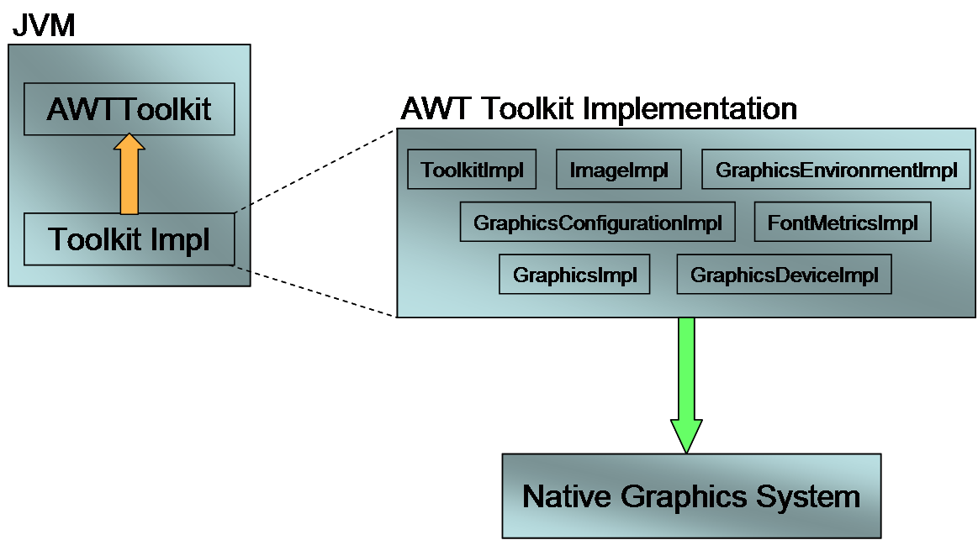

Figure 1
The RI comes complete with its own AWT implementation. Simply include all of the files under $OCAPROOT/jvm/ocap_vmlib/awt (all Java and native sources) in your VM build. Then, ensure that your VM is configured to use java.awt.MPEToolkit as its AWT implementation.
The MPE AWT implementation relies on the MPE porting layer to handle drawing of all graphical primitives as well as retrieval of the native graphics framebuffer. The RI provides a default port of the MPEOS graphics APIs (mpeos_gfx) to the DirectFB open source graphics library for all 2D graphics primitive rendering and software compositing as shown in Figure 2.
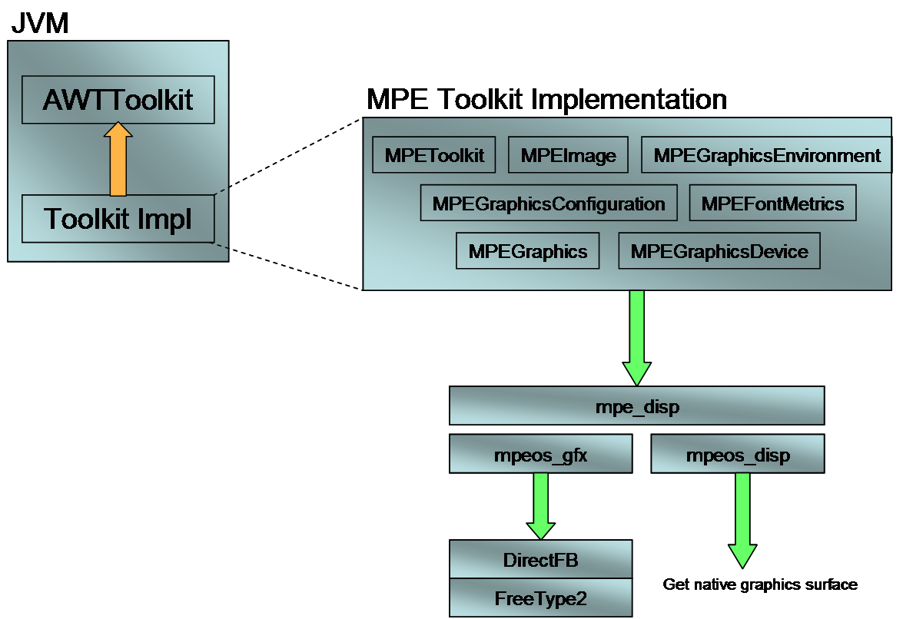

Figure 2
Alternatively, you may provide your own implementation of the MPEOS graphics APIs to use a custom 2D rendering library for 2D graphics and fonts as shown in Figure 3.
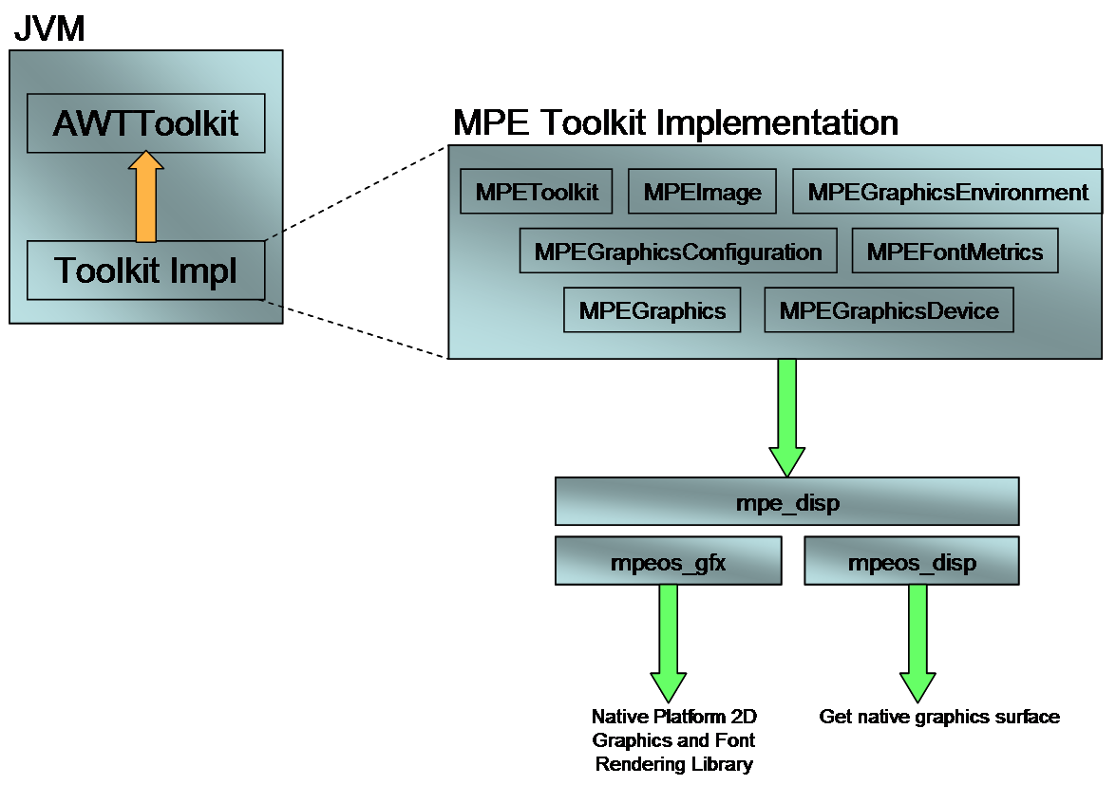

Figure 3

org.dvb.ui.FontFactory Support
OCAP provides applications the ability to load fonts at runtime. Normally, font management is handled by the VM’s AWT implementation. For ports that wish to use an AWT implementation other than the one provide by the RI (java.awt.MPEToolkit), you must provide your own implementation of org.cablelabs.impl.dvb.ui.FontFactoryPeer.
If you choose to use your own AWT implementation, you must still include the following files in your VM build (located in $OCAPROOT/jvm/ocap_vmlib/awt):
- org.cablelabs.impl.dvb.ui.FontFactoryPeer
- org.cablelabs.impl.dvb.ui.FontFactoryPeerFactory
Somewhere during your AWT initialization (in your Toolkit contstructor, for instance) you must call FontFactorPeerFactory.setFontFactoryPeer(String className). This establishes the class name that the factory will use to instantiate your AWT-specific FontFactoryPeer implementation any time the stack requests it.

Custom AWT Implementation
You are free to implement your own AWT Toolkit which directly references your native hardware graphics platform. However, you must take care to make the modifications described in the following sections. Please see the RI MPEToolkit and phoneME JVM implementations for examples of these modifications.

KeyEvent Dispatch
The RI stack is responsible for managing focus transitions between various OCAP application windows (HScenes). Therefore, all java.awt.KeyEvents must be routed through the stack for dispatch. Your AWT Toolkit implementation should implement the org.cablelabs.impl.awt.EventDispatchable interface. This interface allows the stack to register itself with the Toolkit as an event dispatcher. The Toolkit implementation must send all KeyEvents delivered by the native platform to the EventDispatcher.dispatch(AWTEvent e) method.

DVB Character Set
The MHP specification indicates that an additional character set should be supported by compliant VMs. This character set is called DVBMarkupUTF8, and is the same as for the standard UTF8 character set except for the markup sequences designating bold text and colored text. When adding this new character set to a VM you must include two classes that allow the VM to convert characters from this set to and from byte. For the DVBMarkupUTF8 character set, the markup characters, as well as the color values for the case of the color markup, need to be passed through the conversion to/from Java characters such that the most significant byte of the Java character is zero and the least significant byte is the value of the markup character. See sec 11.2.11 of the DVB specification for more details.
Some VMs are very particular about which Java package they will search for character conversion routines. Some investigation will be required to determine which package works best with your VM.

