I. How to set-up a Cygwin-based environment for compiling VLC (online installation) 2
II. How to set-up a Cygwin-based environment for compiling VLC (offline installation) 20
III. How to set-up Cygwin’s ddd (graphical interface for gdb debugger) 26

- How to set-up a Cygwin-based environment for compiling VLC (online installation)
- Go to http://www.cygwin.com:
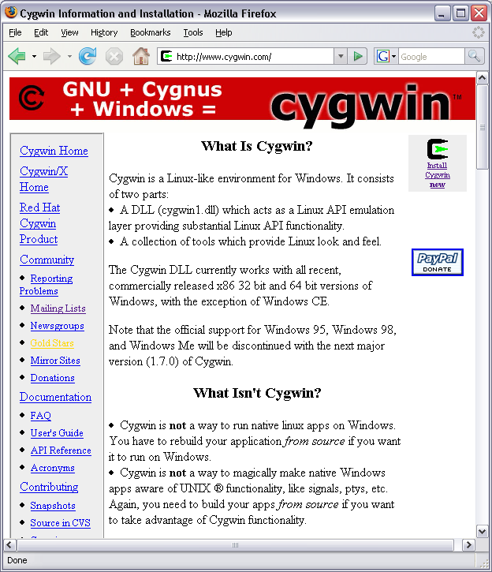

- Scroll down to the Installation section:
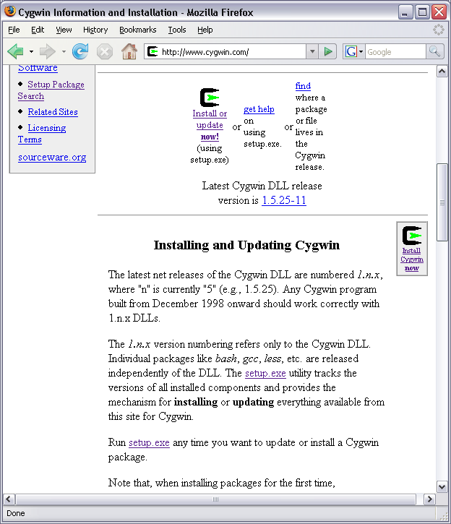
- Click on the “Install or update now!” link and download setup.exe file.
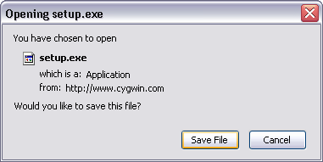
- Go to the directory where setup.exe was downloaded and launch it. Click “Next”.
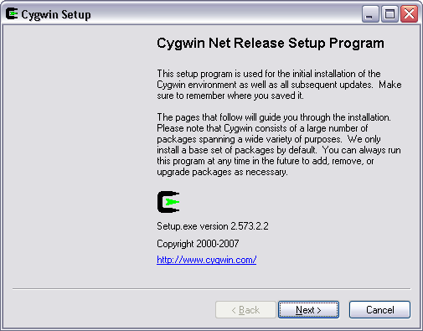
- Select “Install from Internet” and click “Next”.
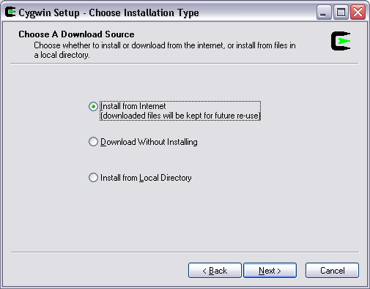
- Select your installation options and click “Next”.
Note: it is recommended to use default installation settings.
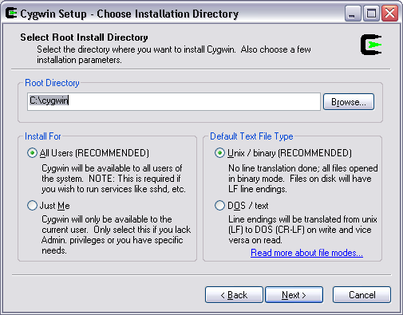
- Tell cygwin where you want your packages to be stored and click “Next”.
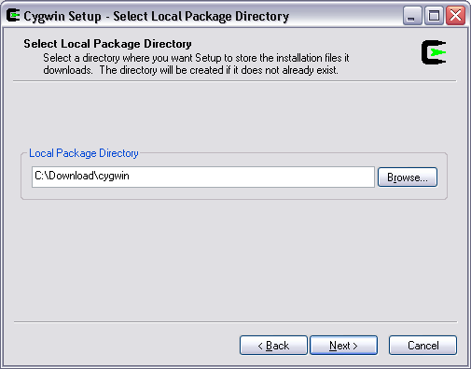
- Select “Direct Connection” and click “Next”.
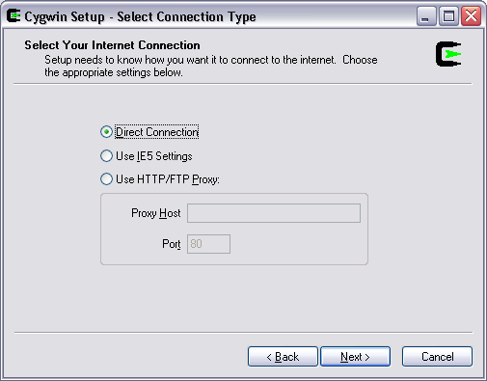
- Choose the download site(s) and click “Next”.
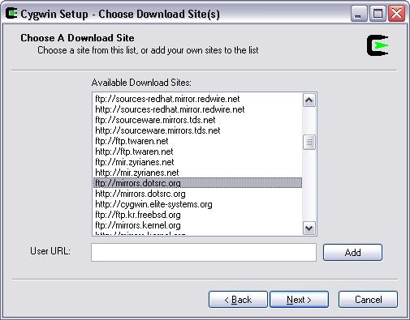
- Expand the “Archive” section and select the following packages:
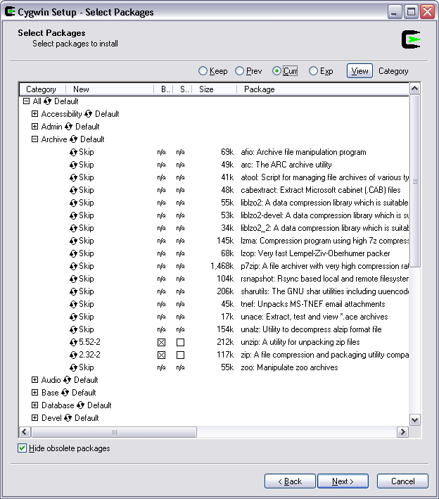
- Expand the “Base” section and make sure that every package is selected.
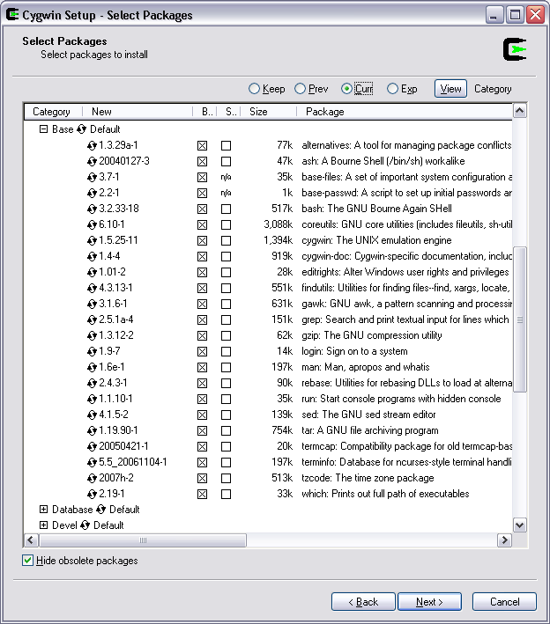
- Expand the “Devel” section and select the following packages:
Note: other packages will become automatically selected as the dependencies are automatically resolved and satisfied by the installation program.

  - automake1.10, binutils
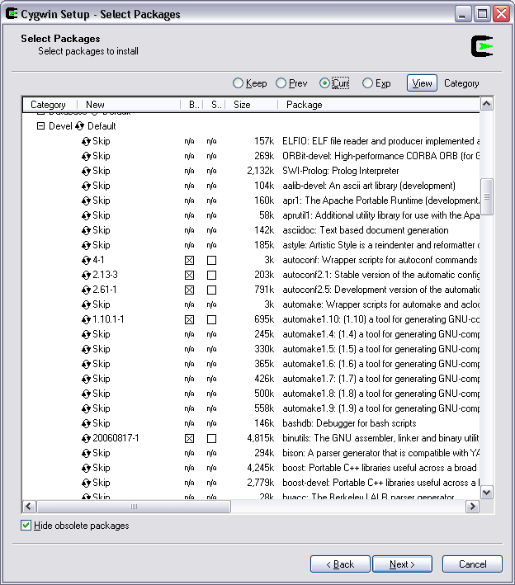
  - cvs, ddd, gcc-core, gcc-g++
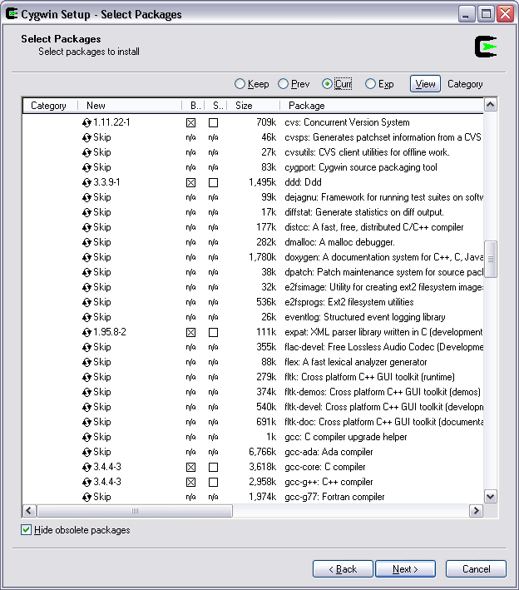
  - gcc-mingw, gcc-mingw-core, gcc-mingw-g++, gdb (ver. 20041228-3), gettext, gettext-devel
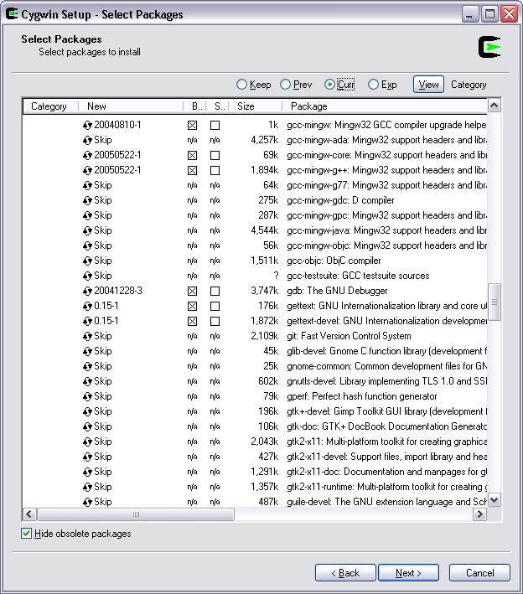
  - libtool1.5, make, mingw-runtime, nasm, patchutils
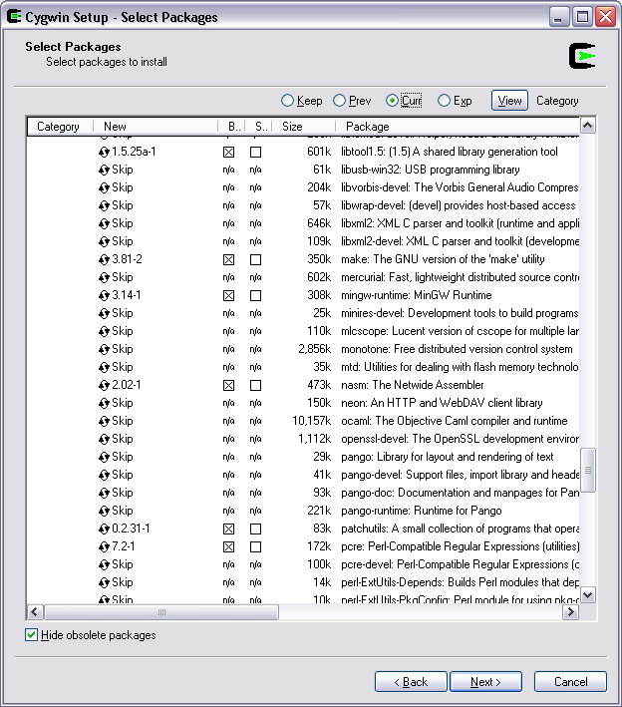
  - pkgconfig, subversion
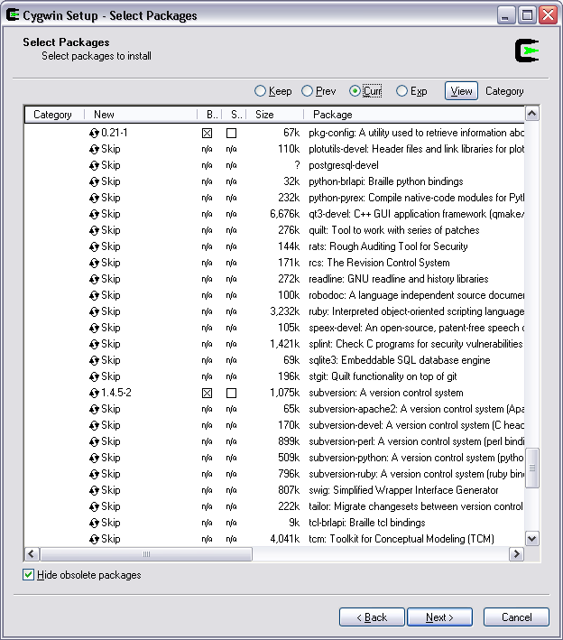
- Expand the “Lib” section and select the following packages:
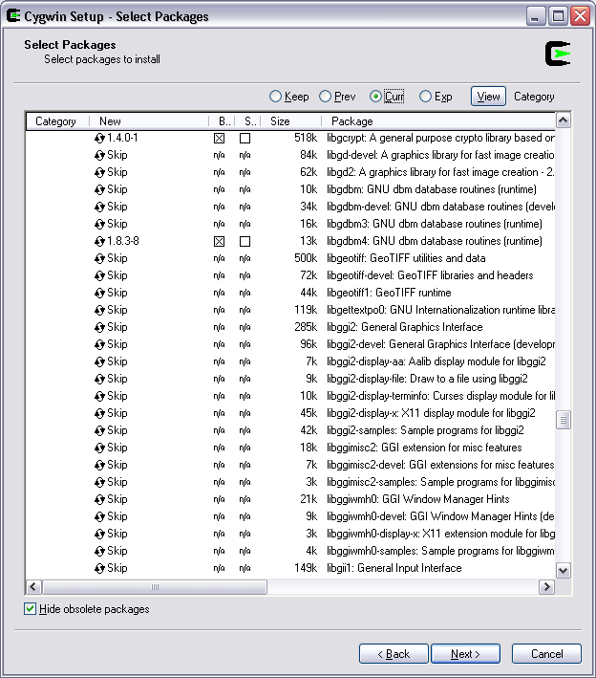
- Expand the “Web” section, select the following packages and click “Next”.
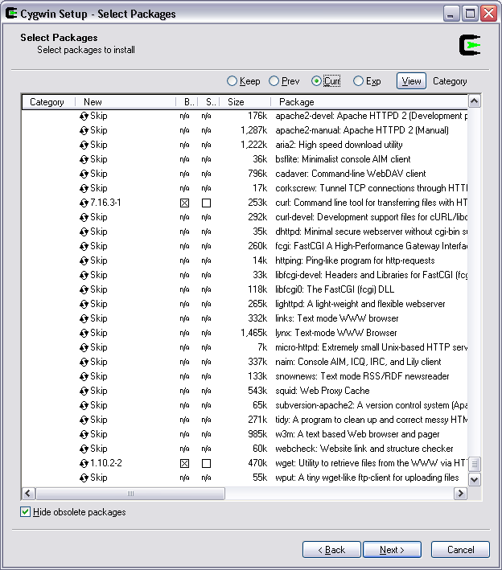
- After the installation is finished, select your post-installation preferences and click “Finish”.
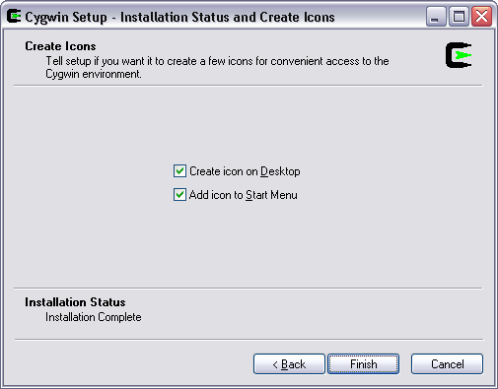
- How to set-up a Cygwin-based environment for compiling VLC (offline installation)
  - Unpack \\srvfile\public\OpenCable-Private\RefImpl\Install\cygwin.zip into a temporary location.
  - Go to the unpacked cygwin directory and launch setup.exe. Click “Next”.
  - Select “Install from Local Directory” and click “Next”.
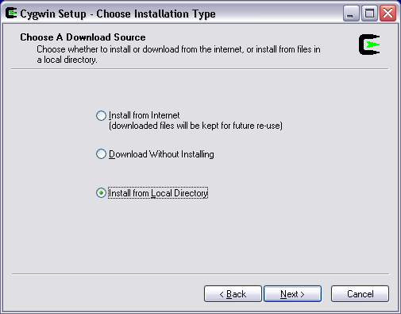
  - Select your installation options and click “Next”.
Note: it is recommended to use default installation settings.
  - Tell cygwin where the unpacked packages are located and click “Next”.
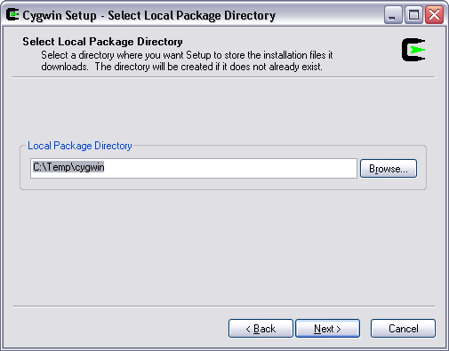
  - Select all packages to install by clicking on “Default” in the “All” category. Click “Next”.
Note: the zip file already contains only the required packages so there is no need to manually
specify which packages need to be installed.
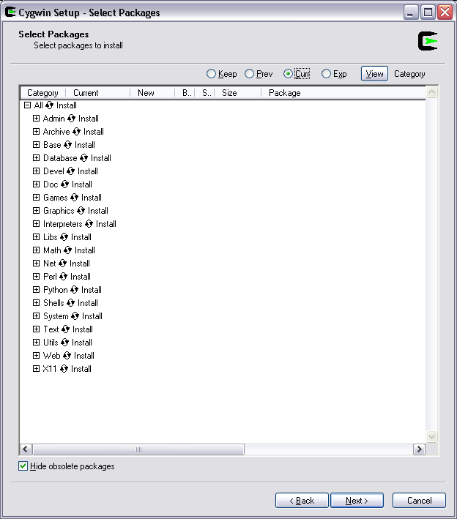
  - After the installation is finished, select your post-installation preferences and click “Finish”.
- How to set-up Cygwin’s ddd (graphical interface for gdb debugger)
  - First step.

