Video Screen Presentation Overview

This section provides an overview of what is involved in presenting a video frame to an output device. Figure 1 - Video Display Overview provides a simple illustration of the problem which is incoming video frames must be scaled and positioned in a window on the output device/monitor.

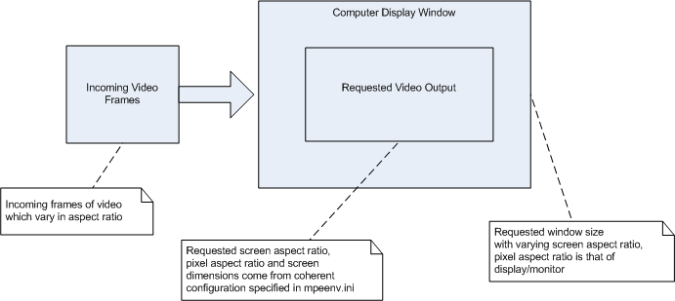

Figure 1 - Video Display Overview

Definition of Terms

Screen Dimensions –

Screen dimensions are the width and height of a screen in pixels. Examples are 640 x 480 pixels for window dimensions.

Screen Aspect Ratio (SAR) -

The screen aspect ratio is the screen width divided by its height. Typically SARs are 4:3 or 16:9.

Pixel Aspect Ratio (PAR) -

Pixels in the graphics world are square. A 100 pixel vertical line is the same length as a 100 pixel horizontal line on a graphics monitor.
Some pixels in the standard-def video world (specifically, the digital electrical signals universally used in studios for 480i and 576i production, as defined by the infamous ITU-R BT.601-4 or "Rec. 601") are non-square. A 100 pixel vertical line may be longer or shorter than a 100 pixel horizontal line on a video monitor, depending on the video system.
Pixels in the HD (e.g. 1080i and 720p) video world are, fortunately, square.
The term which describes this squareness or non-squareness is pixel aspect ratio, expressed as a fraction of horizontal (x) pixel size divided by vertical (y) pixel size. The pixel aspect ratio for square pixels is 1/1.
Video Aspect Ratio Width & Height Factor –
Scaling of video can be accomplished using a single multiplier or “factor” for both the width and the height which is referred to as the Video Aspect Ratio Width or Height Factor. The derivation of this factor is described in Section ?.

Formulas

The basic formula used in relation to scaling video is as follows:

PARx SARx Pixelw
------- = ------- * ---------
PARy SARy Pixelh

OR

SARx PARx Pixelw
------- = ------- * ---------
SARy PARy Pixelh

Calculations

Scaling of the video can be accomplished via a single multiplying factor for the height and the width referred to as the “Video Aspect Ratio Height or Width Factor”. This factor is determined as follows:

Window Pixelw
VARFw = -----------------------------
Incoming Video Pixelw

Window Pixelh
VARFh = -----------------------------
Incoming Video Pixelh

If the Video SAR is to be maintained or a different video output SAR is requested, additional adjustments to the factor are made.

First Adjustment

The first adjustment is to adjust the window height used in the factor calculation so it imposes the desired video output SAR if window SAR is not equal to video output SAR as follows:

Window Pixelw Window PARx Video Output Pixelw Video PARx
---------------------------------- * ------------------- = -------------------------- * ---------------
Adjusted Window Pixelh Window PARy Video Output Pixelh Video PARy

Window Pixelw Window PARx Video SARx
---------------------------------- * ------------------- = ---------------
Adjusted Window Pixelh Window PARy Video SARy

Adjusted Window Pixelh * Window PARy * Video SARx =
Window Pixelw * Window PARx * Video SARy

Window Pixelw * Window PARx * Video SARy
Adjusted Window Pixelh = ---------------------------------------------------------------
Window PARy * Video SARx

The Video Aspect Ratio Height Factor is calculated using this adjusted window height.

Second Adjustment

The next adjustment is to determine which factor, height or width, to use since the aspect of the incoming video must be maintain so the factor should be the same for both the width and the height. Use the smaller of the two factors. If the height factor is larger, set the height factor to the width factor. If the width factor is larger, set the width factor to the height factor.

Third Adjustment

The next adjustment is for the desired video output pixel aspect ratio. The Output Video PAR is multiplied by either the height or the width factor to ensure the desired pixel aspect ratio is achieved. The factor which was the larger of the two is multiplied by Output Video PAR.

The Video Aspect Ratio Height & Width Factors are now ready to be used with the OpenGL calls to render the video frames to the screen.

OpenGL Positioning and Scaling

The video frame is centered in the window by adjusting the starting X and Y coordinates by calculating the size difference of the window and the scaled video and dividing in half.

The OpenGL will perform any additional scaling as required (e.g. if the video is to be displayed in quarter screen, etc.)

Step by Step Example

Example Configuration:

Incoming video frames are 320 x 240, SAR 4:3 with PAR 1/1
Window size is 800 x 700 with PAR 1/1.
Desired Video Output is 1920x1080, SAR 16:9 and PAR 1/1.

Step 1 – Determine if Window SAR is equal to Output Video SAR

Window PARx Window Pixelw 1 800
WindowSAR = ------------------ * -------------------- = -- * ---- = 1.14~
Window PARy Window Pixelh 1 700

NOT equal to Video Output SAR of 16:9 which is 1.7~, adjust window height used in calculations:

Window Pixelw * Window PARx * Video SARy
Adjusted Window Pixelh = ---------------------------------------------------------------
Window PARy * Video SARx

800 * 1 * 9
Adjusted Window Pixelh = -------------- = 450
1 * 16

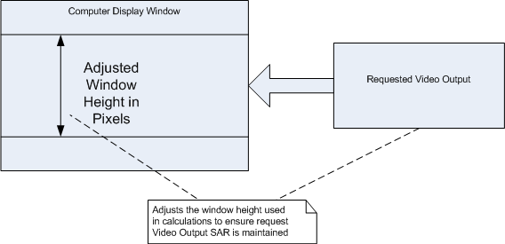

Step 2 – Calculate Video Aspect Ratio Factor

Window Pixelw 800
VARFw = ----------------------------- = ---- = 2.5
Incoming Video Pixelw 320

Adjusted Window Pixelh 450
VARFh = ------------------------------- = ----- = 1.875
Incoming Video Pixelh 240

Step 3 – Chose the smaller factor to use for both

VARFw = 1.875
VARFh = 1.875

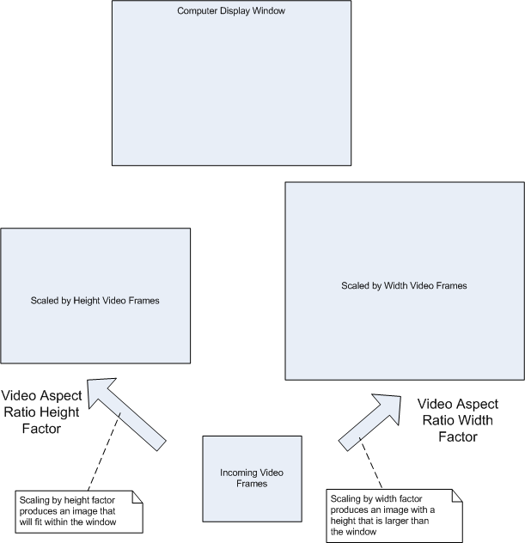

Step 4 – Adjust for the desired Video Output PAR

Video Output PARx 1
VARFw = VARFw * ------------------------ = 1.875 * --- = 1.875
Video Output PARy 1

??? How could this be illustrated???

Step 5 – Use the factors to scale the incoming video frames to output device

Output Image Pixelw = Incoming Video Pixelw * VARFw = 320 * 1.875 = 600
Output Image Pixelh = Incoming Video Pixelh * VARFh = 240 * 1.875 = 450

