OpenCable™
Content Database Design
Draft
Notice
This document is an effort for the benefit of the OpenCable Team. Neither CableLabs, nor any other entity participating in the creation of this document, is responsible for any liability of any nature whatsoever resulting from or arising out of use or reliance upon this document by any party. This document is furnished on an AS-IS basis and neither CableLabs, nor other participating entity, provides any representation or warranty, express or implied, regarding its accuracy, completeness, or fitness for a particular purpose. Distribution of this document is restricted to internal CableLabs personnel.
© Copyright 2008 Cable Television Laboratories, Inc.
All rights reserved.
Version History

Version Number | Date | Contributor | Description
V 0.5 | 12/24/2008 | Michael A. Jastad | Initial draft

Table of Contents
1 Introduction 1
2 Functional Description 1
2.1 Base Node 1
2.2 Container Nodes 1
2.3 Item Nodes 1
3 High Level Description 2
3.1.1 Assumptions 2
3.1.2 Design Goals 2
3.1.3 Component Interaction Diagram 3
3.1.4 Non Functional Requirements 8
3.1.5 Design Rationale 8
3.1.6 Components Affected 9
4 Functional Components 10
4.1 Class: Content Database 10
4.1.1 Description and rationale 10
4.1.2 Component Use Cases and Interaction Diagrams 11
4.1.3 Interfaces 12
4.2 Component Node Tree 13
4.2.1 Description and Rationale 13
4.2.2 Component Use Cases and Interaction Diagrams 14
4.2.3 Interfaces 14
4.3 Logging 16
5 Build/Packaging 17
6 Unit Test cases 17
7 Annex A 18
8 Annex B - Glossary 19

Figures

Tables
Table 1 - Document Text Conventions Error! Bookmark not defined.

Introduction

The Content Database manages a Digital Media Repository that can be shared by multiple OCAP services and managers. The Database provides an API on the front-end, used by various OCAP Services and Managers for accessing and navigating a tree/graph structure comprised of Nodes on the back-end. Each node contains metadata about the Containers or the published digital media content (i.e. pictures, audio, and video).

Functional Description

The Content Database structure is composed of various nodes organized and structured to represent a hierarchy such as a file system, or directory structure. Associations between nodes represent the ordered hierarchy structure, while properties within the given structures define the metadata describing the physical or logical entity, such as a directory, file or recording.

Each node managed by the Content Database share a base node as a common hierarchy building block which contains basic properties and structure needed by the Content Database to navigate the node hierarchy. Additional nodes are created by extending the base node having more specific properties unique to the semantics and role of node. There are two distinct node types within the Content Database Hierarchy; 1.) Container Nodes, and 2.) Items Nodes.

Base Node
The base node contains the basic structure and properties required by the Content Database to programmatically navigate the structure, and locate or assemble data about the hierarchy or content.

Container Nodes
Container Nodes extend the base nodes to represent directories or folders containing other containers or Items. For OCAP HN Ext, Container Nodes can then be extended as Directories or as Scheduled Recordings. The data associated with each of the node types is unique to the semantics of the node.

The Content Database always maintains a Root Container, or Root Node. The Root Node is the starting point for traversing the content hierarchy.

Item Nodes
Item Nodes also extend the base node. The item node contains metadata about the published content representing a file. Item nodes contain information specific to files such as filename, filesize, filetype (mime type), and may sometimes contain extended node information such as Author, creation date, etc… Items nodes can be extended as FileItemNodes, and RecordingItemNodes. FileItemNodes represent ordinary files such as text, MP3, JPEG, PSG, etc.., while RecordingItemNodes represent individual scheduled recordings.

High Level Description

The following is a high level illustration of the Content Database API, business logic, and Node hierarchy. The red solid lines represent extensions, and the blue dashed lines represent possible associations between container nodes and item nodes.
Directory

Scheduled
Recording

File
Item

Recording
Item

Content Database
CD-API
Item
Node
Node
Container
Node
Format
GIF
Format
MPEG2
Format
MPEG1
Format
JPEG
Format
MP3
Format
AC3
Format
PNG
Format

Each Node contains a list with references to its parent node, and child nodes. It’s the policy of the Content Database that INDEX-0 of the reference list is reserved for Parent references, while INDEXES 1 through N-1, contain references to its Children (see section 3.1.3 for more details). Indexed references map 1:1 with the Node ID.

Assumptions

The assumption was made that having a single data repository shared by common UPnP Services would be more effective and efficient than having each service maintain and manage their own database, requiring services to periodically synchronize the individual data stores.

Design Goals

The Goals of the Content Database design is to provide a single data repository shared by multiple OCAP Services, and Managers. The repository requires an ordered hierarchy, with the ability to persist, and retrieve published digital media metadata.

Component Interaction Diagram

Server Side
The following is a component interaction diagram of the Server Side framework and the Content Directory Service.

DATA/CONTROL FLOW
Server Side

HTTP Request
HTTPResponse
Eventing
OCAP HN Ext Impl

U
P
n
P

IServerFacade
IMedia
Server
CDS
SRS

Content
Database

Server-Side components are designed to provide UPnP Device and Service support for OCAP HN. The
following table outlines the Server-Side components, their context (lifecycle), and a description of their
role within the Server-Side framework.

Server Side Framework
Component | Context | Description
UPnP | Library | A 3rd party UPnP compliant java library providing UPnP Discovery, Description, Control, and Eventing.
IServerFacade | API/Façade | An implementation of the Façade Design Pattern used to provide loose coupling of OCAP HN implementation and the UPnP SW stack. The Server Façade provides HTTP Server function.
IMediaServer | Static | Acts as a UPnP Media Server device. Provides announce, description, and Service control. Advertises IP, Port, and protocol (HTTP). Listens for http requests, and facilitates http responses.
ContentDirectoryService | Static | Provides UPnP Content Directory service support. The CDS registers itself with the IMediaServer
ScheduleRecording | Static | Provides UPnP AV Scheduled Recording service support. The SRS registers with IMediaServer
Content Database | Static | A Database managing published content, providing r/w function of digital media content.

Content Database

The Content Database is partitioned into two major components; 1.) Frontend – provides APIs for manipulating and accessing digital media content, 2.) Backend – manages the data store, and the relationships between Nodes. Other sub components/agents include an Event Manager for managing notifications to registered observers, Node Factory for creating various nodes that represent the content, and a Search Engine that references the various mapping tables, navigates the data store, and generates a result.

Node Factory
Search
Engine
Map Table
Manager
Event
Manager
Content Database - API

The Content Database supports the following intrinsic API functions:

Function | Arguments | Returns | Description
getRoot() | N/A | Node | A Node Object representing the Data Store’s Root. This is often the starting point for most Search requests.
Search() | Int: containerNodeID  Bool: Deep | DataSet | A result set containing data from the search criteria.
addContainer() | Int: parentContainerID  Int: containerType  String[]: CSV | Bool
addItem() | Int: parentContainerID  Int: itemType  String[]: CSV | Bool
addReference() | Int: srcContainerID  Int: trgContainerID | Bool
Delete() | Int: srcNodeID | Bool | Removes a node from the DataStore
DeleteReference() | Int: srcContainerID  Int: trgContainerID | Bool
Modify() | Int: nodeID  String[]: CSV | Bool
RegisterListener() | Listener: listener | Notify
getInstance() | N/A | ContentDatabase
Destroy() |  | Bool
ClearAll() | N/A | Bool
Backup() | N/A | Bool | Keeps an N-1 image of the Content Database and associated reference tables.

Content Database – API Concurrency

The API synchronizes all write/create/add requests to the API, while read, search, and browse requests operate concurrently.
Write #1
Write #2
Read
SRS
OCAP HN

Node Factory
Search
Engine
Map Table
Manager
Event
Manager
CD

API
CDS
Blocked until write #1 completes

Content Database – Node Creation

When Nodes are created and added to the persistent data store the Content Database uses a global ID counter that behaves monotonically. The value of the counter is assigned to a new node upon creation. The counter is then incremented for the next new node to be created and added the Data Store.

ID=4
ID=3
ID=2
ID=1
ID=0
Node 0
Node 1
Node 2
Node 3
Node 4
ID=4
. . .
ID=3
. . .
ID=2
. . .
ID=0
. . .
ID=1
. . .
.

Content Database – Node Mappings using a list of references

As Nodes are created they are added to the Node Data Store List. Each Node contains a Node Reference List to reference relationships with other nodes. Index “0” of each Node Reference List, points to its parent, while index “1” through index “N”, represent child references. References are indexes to the Node Data Store . Null or terminations are represented using the ground symbol. The first node, Node ID=0, is terminated at index-0. This indicates the Root Node, as it has no parent relationship. The illustration above shows parent relationships represented as blue dashed lines, and child relationships represented with red dashed lines. This implementation limits Nodes to having a single parent.

Content Database – Node Mapping using a Table of references

Data Stores with Nodes requiring multiple parent and children references can use a Node Mapping Table to map references between nodes.
Node List

ID=4
ID=3
ID=2
ID=1
ID=0
Node 0
Node 1
Node 2
Node 3
Node 4
 | 0 | 1 | 2 | 3 | 4
0 |  | C | C
1 | P
2 | P |  |  | C | C
3 |  |  | P
4  Node Reference Table |  |  | P

Nodes will be created by the Content Database as defined above, but instead of creating lists of references embedded in each node, the Nodes will be added to a Node List. The Node ID and list index will have a 1:1 mapping. A Node mapping table will be used by the Content Database to map the relationships between nodes. The outer row and column represent the Nodes and are indexed by their ID. The table cells under each column, and corresponding row marked with “C”, indicates that intersects between nodes is a child relationship. The table cells marked with “P”, indicates that intersects between nodes is a Parent relationship. The mapping table should be symmetrical, mapping the corresponding relationships in each direction. The reference mapping table will be more efficient in both O(t), and O(m), as content boundaries exceed 1k Nodes.

Content Database – Data Store Updates and Events

CD

API
SRS
register
notify
CDS
register
notify
OCAP HN
register
notify

Event
Manager
modify

Map
Table
Manager

The Content Database provides event registration for consumer notifications when the backend data store is modified. Notifications are broadcasted to all registered observers, signaling them that a data element has been added, modified, or deleted. The notification will provide the element ID, and the type of update:

- New – implies that a new Node has been added to the backend data store
- Deleted – implies that an existing Node has been removed from the backend data store.
- Modified – implies that an existing Node has been updated. This may be a new reference, or property.

Content Database – Data Store File Formats

Media Type | OCAP | DLNA Profile ID
Images | JPEG, PNG, GIF | JPEG_SM max resolution 640 x 480,  JPEG_MED,  JPEG_LRG,  JPEG_TN,  JPEG_SM_ICO,  JPEG_LRG_ICO,  PNG_TN,  PNG_SM_ICO,  PNG_LRG_ICO,  PNG_LRG
Video | MPEG-2 TS according to [SCTE 43] | MPEG1,  MPEG_PS_NTSC ( MPEG-2 PS),  MPEG_PS_NTSC_XAC3,  MPEG_TS_SD_NA_ISO,  MPEG_TS_SD_NA_XAC3_ISO,  MPEG_TS_HD_NA_ISO,  MPEG_TS _SD_NA_T,  MPEG_TS _HD_NA_T,  MPEG_TS_HD_NA_XAC3_ISO,  AVC_TS_MP_SD_MPEG1_L3_ISO,  AVC_TS_MP_SD_AAC_MULT5_ISO,  AVC_TS_MP_SD_AC3_ISO,  AVC_TS_MP_HD_MPEG1_L3_ISO,  AVC_TS_MP_HD_AAC_MULT5_ISO,  AVC_TS_MP_HD_AC3_ISO
Monomedia Audio | MPEG-1 layer 1, 2 & 3; Dolby AC-3 | LPCM
Broadcast Streaming  Audio | Dolby AC-3 | LPCM  AC3,  MP3,  MP3X,  AAC_ADTS,  AAC_ADTS_320,  AAC_ISO,  AAC_ISO_320,  AAC_LTP_ISO,  AAC_LTP_MULT5_ISO,  AAC_LTP_MULT7_ISO,  AAC_MULT5_ADTS,  AAC_MULT5_ISO

The Table above identifies the supported formats for each content item. All Content Items stored in the Content Database will be assigned a Content Format. Format objects provide specific implementation for managing the MIME type of the assigned content item, reading header information, and determining the file extensions.

Content Database – Data Store File Format Table API

Class | Function | Arguments | Returns | Description
Format  (base class) | getMimeType | NA | String | Returns the MIME Type of the Content Item
Format  (base class) | getMediaClass | NA | String | Returns the Media class defines by DLNA and the OCAP HN specification
Format  (base class) | getTitle | NA | String | Returns the Title of the content item. This is not the same as the file name.
Format  (base class) | getAuthor | NA | String | Returns the originator’s name of the content item.
ImageFormat | getImageAttributes | NA | AttributeList | Returns a list of attributes pertaining to the image. These will image height, width, and resolution.
JPEGFormat |  |  |  | Extends ImageFormat
GIFFormat |  |  |  | Extends ImageFormat
PNGFormat |  |  |  | Extends ImageFormat
MP3Format
MPEGFormat

Non Functional Requirements

There are no Non Functional requirements at this time.

Design Rationale

The design rationale is that the Content Database provide adequate translation between UPnP Content Directory and Scheduled Recording Action requests, and the backend data Structures. The content contained within the backend structures must also conform to the data expected or required by the UPnP services. Since the Content Database is a service providing access to data on behalf of multiple consumers, the database must synchronize access and provide content change notification to registered consumers.

Components Affected

The Content Database API allows OCAP HN Ext Services and other OCAP Managers to store, update, or retrieve persisted data managed by the Content Database. The OCAP HN Ext components are as follows:

Component | Integration Point | Description
Content Directory | CD-API
Scheduled Recording | CD-API
ContentNetServerModule | CD-API/CDS
ContentContainer | CD-API/CDS
ContentItem | CD-API/CDS
RecordingNetModule

Functional Components

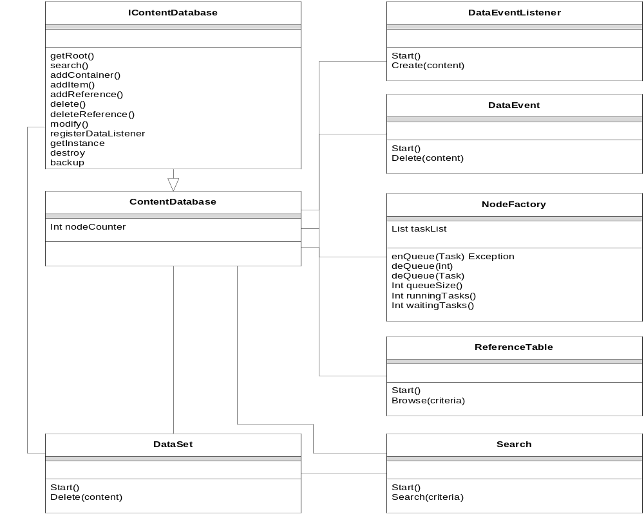

Class: Content Database
The Content Database is a singleton class that encapsulates function providing API’s, allowing consumers to register for content change events, retrieve content, and create, add, or delete content.

Description and rationale

Since the database is a shared resource, API’s are synchronized, serializing all requests for reading and writing content. This implies that multiple consumers making multiple requests will be blocked by the runtime until the current method on the runtime stack has exited and released its resources.

Component Use Cases and Interaction Diagrams

Event Registration
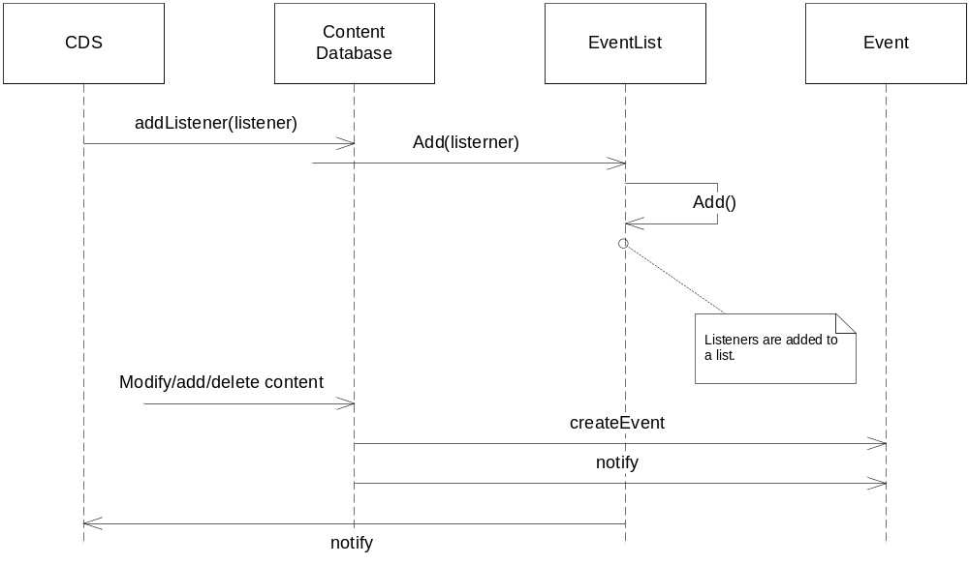

Browse Content:

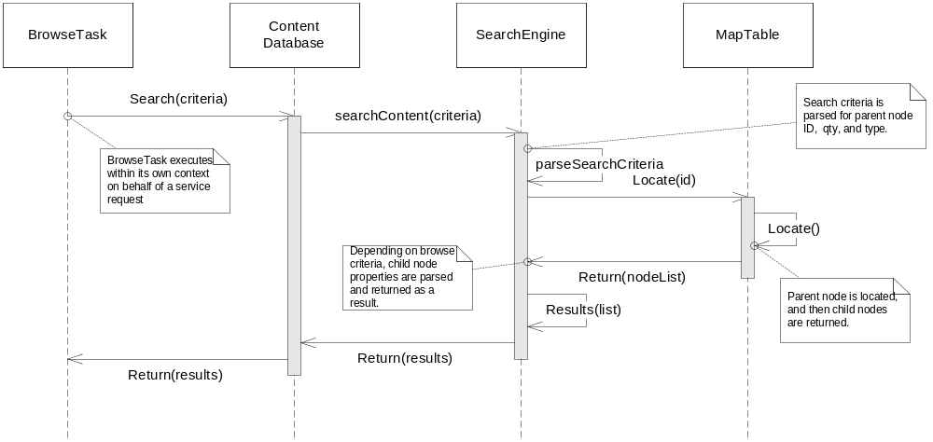

Create Content:

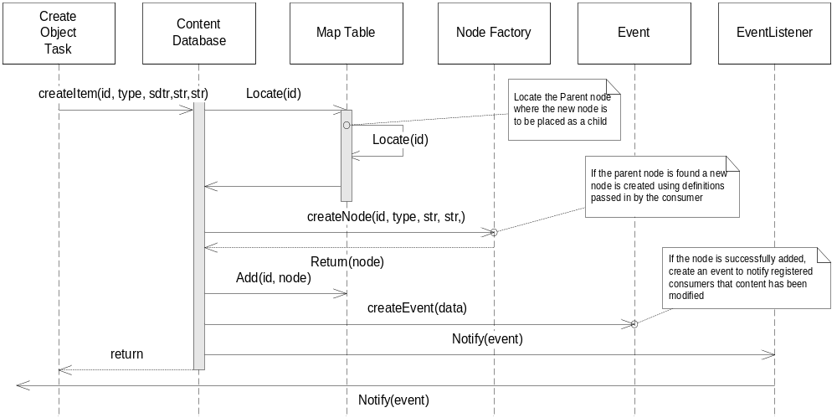

Interfaces

Class: NodeFactory
Element | Name | Arguments | Semantics/Description
Properties | Int NodeCount |  | Global counter that increments by 1 each time a new node is created.
Interfaces | createNode(type

Component Node Tree

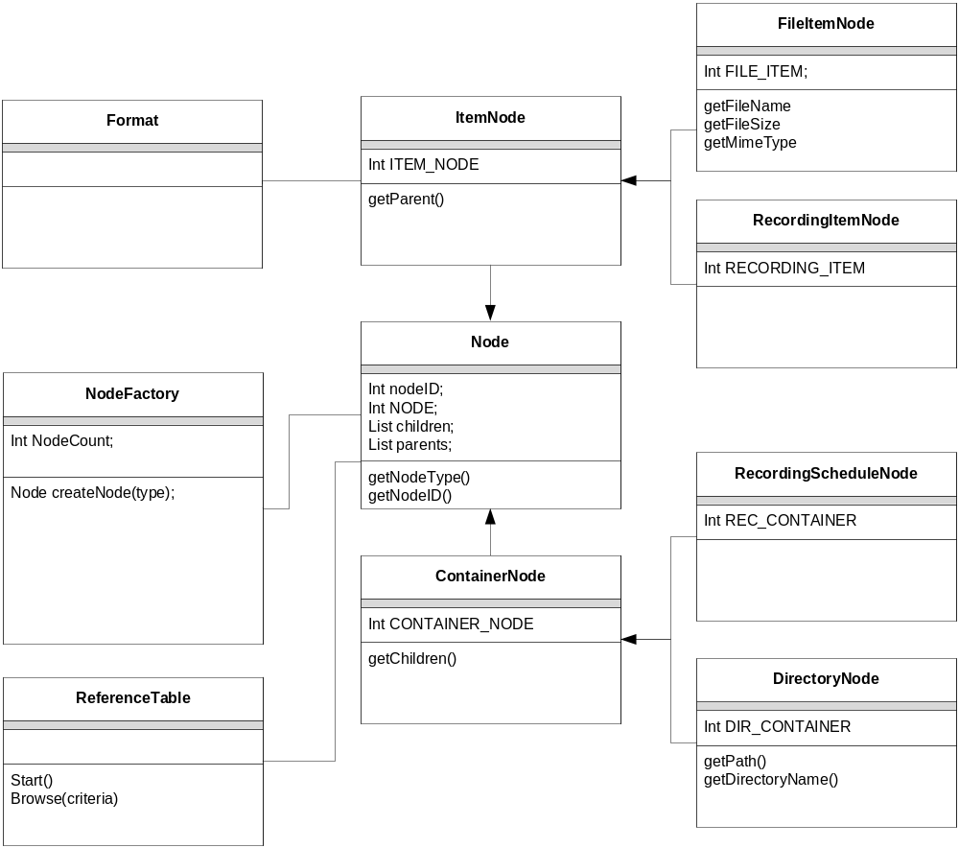

Description and Rationale

The container node tree is designed to programmatically represent a CDS hierarchy which includes a root node representing top of tree, followed by parent and child nodes. Parent nodes will always be organized into Container Nodes (Directories), while Children nodes can be organized as container nodes (directories), or Item nodes (files).

Parent/Child relationships are established using references. The base node contains a parent list that keeps references to parent nodes, while the Container Node implements an additional Child list that maintains references to its children.

Component Use Cases and Interaction Diagrams

Use cases centered around the Node Tree and Relation Reference Tables, and comprised of traversing the Node Tree are as follows:

Locate Parent Nodes given a Node ID.

Locate Children Nodes given a Parent Node ID.

Inserting a Node given a Parent Node ID.

Deleting a Node given a Parent Node ID.

Interfaces

Class: NodeFactory
Element | Name | Arguments | Semantics/Description
Properties | Int NodeCount |  | Global counter that increments by 1 each time a new node is created.
Interfaces | createRootNode
Interfaces | createContainer | Int parentId  Int nodeType  String nodeName | Creates a Container node either as a  Directory or a RecordingSchedule
Interfaces | createItem | Int parentId  Int nodeType  String nodeName | Creates an Item node either as a file or a recording.

Class: Node (base class)
Element | Name | Arguments | Semantics/Description
Properties | Int NodeID |  | Property identifies the Node ID
Properties | List Children |  | A list containing references to Children
Properties | List Parents |  | A list containing references to Parents
Properties | Int NODE_TYPE |  | The NODE TYPE 0x00;
Interfaces | getNodeType() | NA | Returns the node type:  ROOT 0x00;  DIRECTORY 0x01  RECORDINGSCHEDULE 0x02  FILEITEM 0x03  RECORDINGITEM 0x04
Interfaces | getNodeID | NA | Returns the Node ID

Class: FileItem
Element | Name | Arguments | Semantics/Description
Properties | String FileName |  | The name of the file this item node  represents
Properties | String MIMEType |  | The type of file (see supported types)
Properties | Int FileSize |  | The size of the file in bytes
Properties | Int NODE_TYPE |  | The NODE TYPE 0x00;
Interfaces | getFileName | NA | Returns the file name represented by this Item.
Interfaces | getFileSize | NA | Returns the file size
Interfaces | getMIMEType |  | Returns the MIMEType of this file.

Class: Directory (Container)
Element | Name | Arguments | Semantics/Description
Properties | String dirName |  | The name of the directory this container Node represents.
Interfaces | getDirectoryName | NA | Returns the file name represented by this Item.

Class: Format
Element | Name | Arguments | Semantics/Description
Properties | String dirName |  | The name of the directory this container Node represents.
Interfaces | getMimeType | NA | Returns the file name represented by this Item (see supported types):  video/mpeg…  image/jpeg…  audio/mp3…
Interfaces | getMediaClass | NA | Returns the Media Class:  Object.item.imageItem.photo  Object.item.audioItem.audio  Object.item.videoItem.movie
Interfaces | getTitle | NA | Returns the native title (original name)
Interfaces | getAuthor | NA | Returns the Author of the file (if exists)

Logging

Message Tag ID | Definition

Build/Packaging

Unit Test cases

Test Case | Description

Annex A

7.1 Exceptions

Exceptions | Exception Description

7.2 Algorithms

Annex B - Glossary

Term | Definition

