OpenCable™
Content Directory Service
REv 1.1
Notice
This document is an effort for the benefit of the OpenCable Team. Neither CableLabs, nor any other entity participating in the creation of this document, is responsible for any liability of any nature whatsoever resulting from or arising out of use or reliance upon this document by any party. This document is furnished on an AS-IS basis and neither CableLabs, nor other participating entity, provides any representation or warranty, express or implied, regarding its accuracy, completeness, or fitness for a particular purpose. Distribution of this document is restricted to internal CableLabs personnel.
© Copyright 2008 Cable Television Laboratories, Inc.
All rights reserved.
Version History

Version Number | Date | Contributor | Description
V1.0 | 12/1/2008 | M. Jastad | Initial release
V1.1 | 12/11/2008 | M. Jastad | Review Updates: section 1.0, 2.0, and 3.0

Table of Contents
1 Introduction 1
2 Functional Description 2
2.1 Hierarchy 2
2.2 Action 3
3 High Level Description 4
3.1.1 Assumptions 4
3.1.2 Design Goals 4
3.1.3 Component Interaction Diagram 5
Server Side 5
Client Side 6
Content Directory Service(CDS) Class Diagram 7
The CDS is a static class that registers for HTTP request Events with the IMediaServer. The Media Server listens for HTTP requests, and dispatches the request as a RequestEvent notification. Registered services (i.e. CDS), examine the Event Request type to determine if it’s an event that they’re responsible for servicing. 7
3.1.4 Non Functional Requirements 8
3.1.5 Design Rationale 8
3.1.6 Components Affected 8
4 Functional Components 9
4.1 Class: Content Directory Service 9
4.1.1 Description and rationale 9
4.1.2 Component Use Cases and Interaction Diagrams 10
4.1.3 Class Diagram 12
4.1.4 Interfaces 13
4.2 Component Task Handler 15
4.2.1 Description and Rationale 15
4.2.2 Component Use Cases and Interaction Diagrams 16
4.2.3 Class Diagram 18
4.2.4 Interfaces 19
4.3 Logging 21
5 Build/Packaging 22
6 Unit Test cases 22
7 Annex A 23
a) Component Client Façade Algorithms 23
8 Annex B - Glossary 24

Figures

Tables
Table 1 - Document Text Conventions Error! Bookmark not defined.

Introduction

Many devices within the home network contain various types of content that other devices would like to access (e.g. music, videos, still images, etc). As an example, a “Media Server” device might contain a significant portion of the homeowner’s audio, video, and still-image library. In order for the homeowner to enjoy this content, the homeowner must be able to browse the objects stored on the Media Server, select a specific one, and cause it to be “played” on an appropriate rendering device (e.g. an audio player for music objects, a TV for video content, an Electronic Picture Frame for still-images, etc).

For maximum convenience, it is highly desirable to allow the homeowner to initiate these operations from a variety of UI devices. In most cases, these UI devices will either be a UI built into the rendering device, or it will be a stand-alone UI device such as a wireless PDA or tablet. In any case, it is unlikely that the homeowner will interact directly with the device containing the content (i.e. the homeowner won’t have to walk over to the server device). In order to enable this capability, the service device needs to provide a uniform mechanism for UI devices to browse the content on the server and to obtain detailed information about individual content objects. This is the purpose of the Content Directory Service

The Content Directory Service additionally provides a lookup/storage service that allows clients (e.g. UI devices) to locate (and possibly store) individual objects (e.g. songs, movies, pictures, etc) that the (server) device is capable of providing. For example, this service can be used to enumerate a list of songs stored on an MP3 player, a list of still-images comprising various slide-shows, a list of movies stored in a DVD-Jukebox, a list of TV shows currently being broadcast (a.k.a an EPG), a list of songs stored in a CD-Jukebox, a list of programs stored on a PVR (Personal Video Recorder) device, etc. Nearly any type of content can be enumerated via this Content Directory service. For those devices that contain multiple types of content (e.g. MP3, MPEG2, JPEG, etc), a single instance of the Content Directory Service can be used to enumerate all objects, regardless of their type

Functional Description

Hierarchy
The Content Directory Service (CDS) provides lookup and publishing services of digital media that is stored on a local Host device. Lookup and publishing services supported by the CDS are commonly referred to as Actions, and are supported by UPnP state variables (see section 4.1.2).

Using actions in combination with state variables, the CDS exposes a class hierarchy which is used to type all objects that can be retrieved from it. Each class is named using Strings as tags, and each class definition includes a list of properties.

Container Hierarchy:
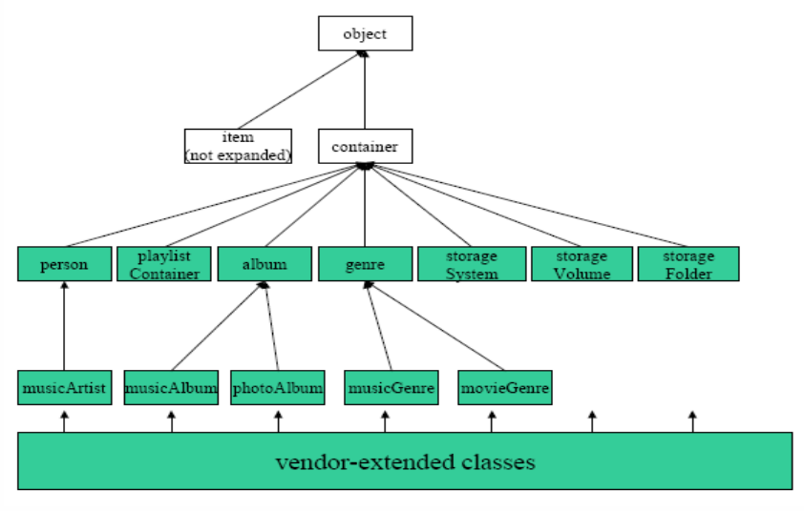

Item Hierarchy:

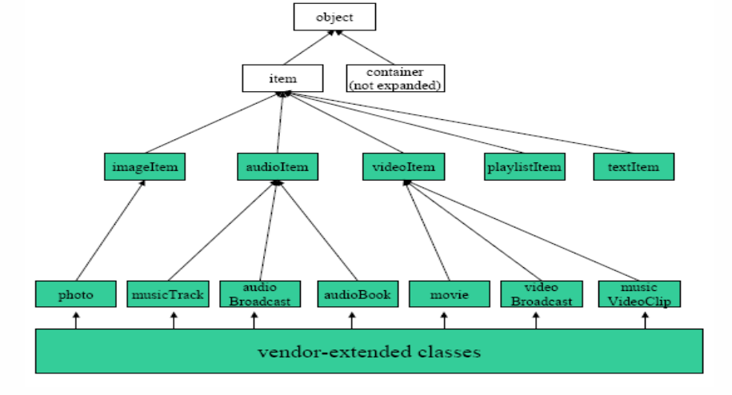

Action
Control points may invoke actions on a device’s services and receive results or errors back. The action, results and errors are encapsulated in SOAP, sent via HTTP requests, and received via HTTP responses.

Supported CDS actions are as follows:

Action | Description
Browse | This action allows the caller to incrementally browse the native hierarchy of the Content Directory objects exposed by the Content Directory Service, including information listing the classes of objects available in any particular object container.
Search | This action allows the caller to search the content directory for objects that match some search criteria. The search criteria are specified as a query string operating on properties with comparison and logical operators.
getSearchCapabilities | This action returns the searching capabilities that are supported by the device
getSortCapabilities | Returns the CSV list of meta-data tags that can be used in sortCriteria.
getSystemUpdateID | This action returns the current value of state variable SystemUpdateID. It can be used by clients that want to ‘poll’ for any changes in the Content Directory (as opposed to subscribing to events).
ExportResource | This action transfers a file from a local source resource, specified by SourceURI, to a remote destination resource, specified by DestinationURI. When the CDS identifies the source resource, the action will return a unique TransferID in the response and start the HTTP POST
Action | Description
*CreateObject | This action creates a new object in the container identified by ContainerID. The new object is created with the required id attribute set to "" and the required restricted attribute set to false. The actual value of the id attribute is supplied by the Content Directory Service.
*DestroyObject | This action destroys the specified object when permitted. If the object is a container, all of its child objects are also deleted, recursively. Each deleted object becomes invalid and all references to it are also deleted.
*UpdateObject | This action modifies, deletes or inserts object metadata. The object to be updated is specified by ObjectID.

*Indicates that Actions are performed locally for OCAP HN Ext for RI. This implies that the CDS will provide a set of Out-Of-Band (relative to UPnP/HTTP), API’s for publishing content. OCAP HN Ext for RI Clients publishing content will interact directly with the CDS.

High Level Description

Assumptions

The following technical assumptions were taken into account during the design of the Content Directory Service (CDS):

The CDS runtime will be Java 1.5 or greater, and may utilize explicit JDK 1.5 API’s, and reserved namespace symbols.

Content Directory Service design will be Content Directory:1, service template 1.01 compliant.

Content Directory Service design will be compatible with the UPnP Device Architecture, version 1.0.

Design Goals

The goal of the design is to implement and integrate the OCAP Home Networking APIs coupled with UPnP Devices and Services. The Content Directory Service will run as a standalone service on behalf of a device.

Design Goals are as follows:

Content Directory will run within its own static context listening for and responding to HTTP requests.
- The Service implementation should not be tightly coupled or integrated with any particular UPnP library or implementation.
- Content Directory Service errors should be recoverable and not affect the function or performance of existing OCAP services and processes running within the same JRE footprint.
- Consistently maintain a reflection of published digital media in meta-data.
- Content Directory Services will utilize existing Resource Management (i.e. threads, etc…), when creating new threads, or mutex.

Component Interaction Diagram

Server Side
The following is a component interaction diagram of the Server Side framework and the Content Directory Service.

DATA/CONTROL FLOW
Server Side

U
P
n
P

IServerFacade
IMedia
Server
CDS
SRS

Content
Database
HTTP Request
HTTPResponse
Eventing

Server-Side components are designed to provide UPnP Device and Service support for OCAP HN. The
following table outlines the Server-Side components, their context (lifecycle), and a description of their
role within the Server-Side framework.

Server Side Framework
Component | Context | Description
UPnP | Library | A 3rd party UPnP compliant java library providing UPnP Discovery, Description, Control, and Eventing.
IServerFacade | API/Façade | An implementation of the Façade Design Pattern used to provide loose coupling of OCAP HN implementation and the UPnP SW stack. The Server Façade provides HTTP Server function.
IMediaServer | Static | Acts as a UPnP Media Server device. Provides announce, description, and Service control. Advertises IP, Port, and protocol (HTTP). Listens for http requests, and facilitates http responses.
ContentDirectoryService | Static | Provides UPnP Content Directory service support. The CDS registers itself with the IMediaServer
ScheduleRecording | Static | Provides UPnP AV Scheduled Recording service support. The SRS registers with IMediaServer
Content Database | Static | A Database managing published content, providing r/w function of digital media content.

Client Side
The following is a component interaction diagram of the Client Side framework and the OCAP HN Implementation integration.

Client Side

IClientFacade

U
P
n
P
IDevice
IService
IAction
IArgument

OCAP HN Impl
O
C
A
P
A
P
I
A
P
P

DATA/CONTROL FLOW
Discovery
Description
Control
Eventing

Client-Side components are designed to provide UPnP Device and Service support for OCAP HN. The
following table outlines the Client-Side components, their context (lifecycle), and a description of their role
within the Client-Side framework.

Client Side Framework
Component | Context | Description
UPnP | Library | A 3rd party UPnP compliant java library providing UPnP Discovery, Description, Control, and Eventing.
IClientFacade | API/Façade | An implementation of the Façade Design Pattern used to provide loose coupling of OCAP HN implementation and the UPnP SW stack. The Client Façade provides UPnP Control Point support.
IDevice | API/Façade | Represents a discovered upnp device
IService | API/Façade | Represents a discovered upnp service for a given upnp device
IAction | API/Facade | Represents a control action supported by a upnp service

Content Directory Service(CDS) Class Diagram

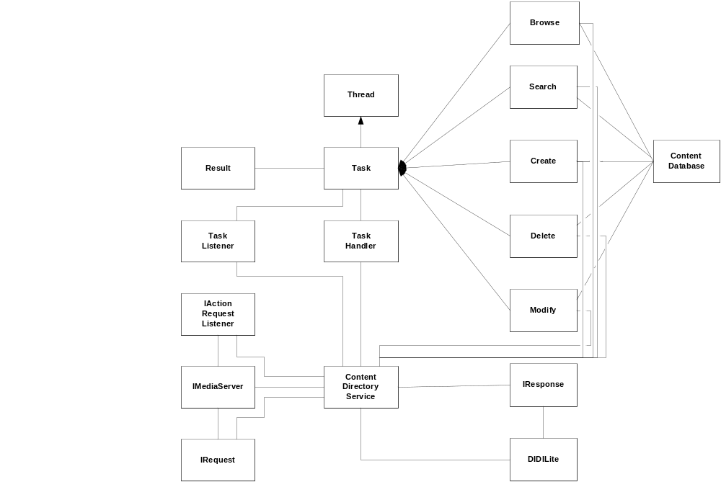

The CDS is a static class that registers for HTTP request Events with the IMediaServer. The Media Server listens for HTTP requests, and dispatches the request as a RequestEvent notification. Registered services (i.e. CDS), examine the Event Request type to determine if it’s an event that they’re responsible for servicing.

When a service determines that the Event request is to be performed by them , the service will extract and process the arguments from the IRequest, and conditionally branch to a request handler that is unique for servicing the request. In the case of the CDS these handlers would be Search, Browse, Update, Delete, and create handlers which directly interact with the Content Database.

Once a request handler, has completed, a result is generated in the form of an IResponse, and posted through the IServerFacade API. Content Directory Service responses are encapsulated in an Argument container, formatted in DIDILite, and then added to the Response object to be posted by the MediaServer.

In the case where a service receives multiple requests, they are queued and serviced once a worker thread is available. If the CDS encounters an overrun condition on the request queue, the CDS generates and returns a “busy” response.

Non Functional Requirements

Packaging of the Content Directory Service implementation modules will conform to the existing OCAP source tree, and naming conventions.

Design Rationale

The rationale or motivation of the design for the Content Directory Service was to establish a singleton instance representing Content Directory Service that can respond to client requests on the front-end facilitated by an HTTP Server, and manage a structured hierarchy representing published digital media content on the back end.

Components Affected

Most of the Content Directory Service components are extensions to pre-existing OCAP elements, so very little of the existing OCAP stack will require changes. Components directly affected by Content Directory Service design are as follows:

Component | Integration Point | Description
MPE | N/A | N/A
MPEOS | N/A | N/A
Recording Manager | Event/Listener Registration | Content Directory Service (CDS) will be required to registers for changes in the Recording Manager (RM) functions. As RM alters recording content, the CDS will be required to update its published content if applicable.
GStreamer | N/A | N/A
UPnP Façade | ServerFacade | Content Directory Service (CDS) will be required to register for HTTP Received Requests, and process the request if applicable.
ContentNetServerModule
ContentContainer
ContentItem

Functional Components
The following subsections define the design details for each of the Content Directory Service Class objects from the Class Diagram.

Class: Content Directory Service
The following is an illustration between the Content Directory Service (CDS), UPnP Façade, and the OCAP DVR Recording Manager elements.

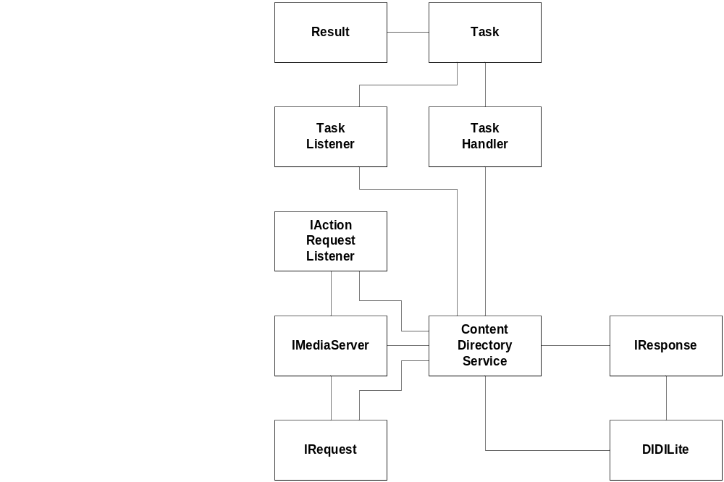

Description and rationale

The Content Directory Service (CDS), Class is a singleton instance that receives Action Request Events, invokes an Action Request Handler to service the event, and generates a response based on the results of the request. The Content Directory Service class also provides external API’s for non network (UPnP/HTTP), actions for publishing content to the CDS.

Component Use Cases and Interaction Diagrams

CDS Initialization & Registration Sequence:

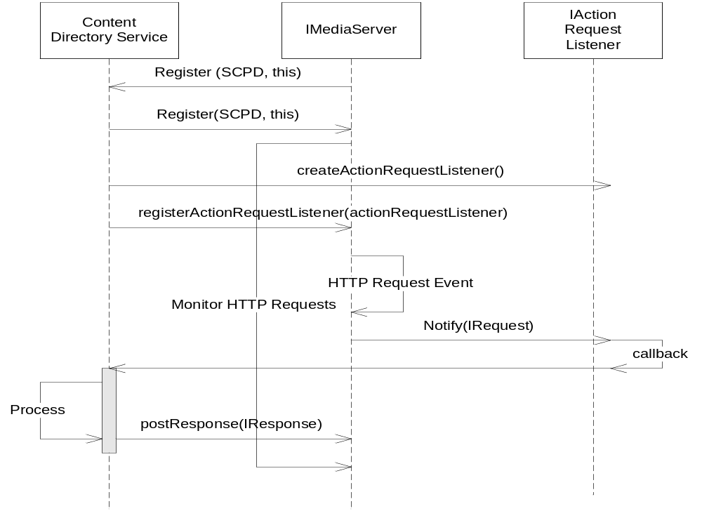

Initialization

Initialization starts with a Monitor Application initializing a local IMediaServer. The IMediaServer gets an instance of the Content Directory Service, and the Content Directory service registers its Service Capabilities Program Description (SCPD), data with the Server for description support. The SCPD provides specific information about the CDS regarding; capabilities, state variables, action/control support, service-type, service-template version, etc… .

After registration the Content Directory Service will then create an IActionRequestListener from the façade, implement the callback “notify”, and register the Listener with the IMediaServer. The listener will notify the Content Directory Service when an HTTP Request has been made and dispatched by the IMediaServer.

Basic Initialization and Task Generation Sequence:
The following sequence diagram illustrates the initialization of the Media Server and the flow of task execution during an HTTP Request event.

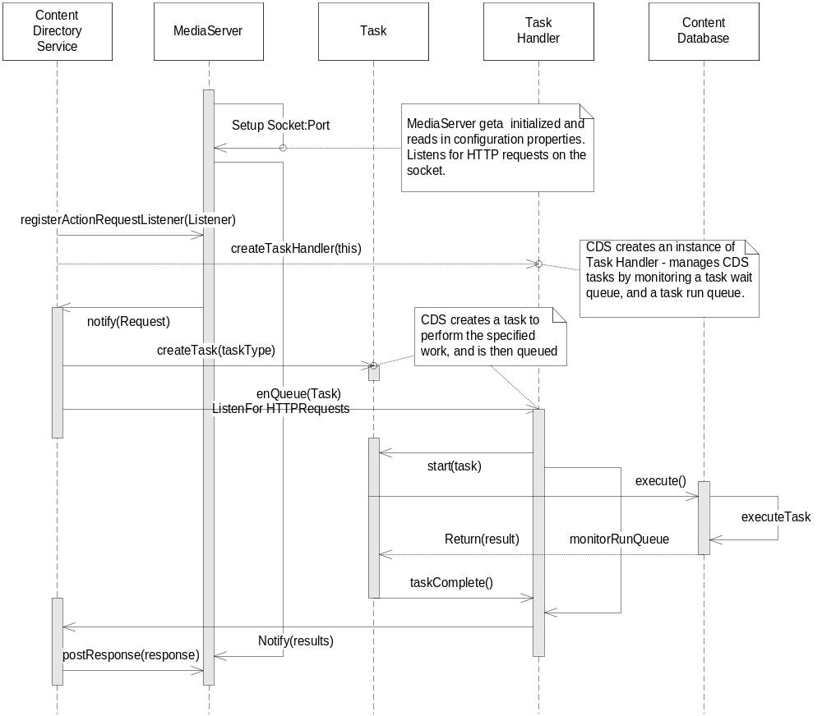

Initialization

Initialization starts with a Monitor Application initializing a local IMediaServer, and a Content Directory Service instance. The IMediaServer sets up an HTTP-Server using the platforms IP Address, and a configurable Port to listen for HTTP Requests. The Content Directory Service registers an IActionRequestListener with the IMediaServer, and then creates an instance of TaskHandler for servicing requests received by the IMediaServer

Request Notification

When the IMediaServer receives an HTTP-Request, it notifies all registered observers via the listener notification mechanism. The observer (i.e. CDS), interrogates the event for serviceability. If the observer determines the notification was intended for itself, the service will examine the request-type, create the appropriate Task to service the request, and then queue the task on the Task Handler. If the queue is full, the TaskHandler.enQueue(task) method will throw a QueueFullException. The CDS will generate a “BUSY” response and post it to the IMediaServer as a response to the requester.

Task Execution

The Task Handler schedule’s queued tasks to run as follows:

- Tasks are created and enQueued with a Listener. The listener is used by the task to notify the observer (creator of the task), that the action has completed.
- Task scheduling is performed in FIFO order.
- New Tasks added to the queue can be started if the number of Tasks on the queue in a state of “STATE_RUNNING”, is less than MAX_RUNNING_TASKS,
- When a Task is scheduled to run, the Task Handler will Timestamp the Task. A polling thread will examine the queue for Tasks in the running state and check their Timestamp, and compare it with the current time. If the delta exceeds the value TIME_TO_LIVE, the Task Handler will kill the Task, and schedule the next in order.

Results and Cleanup

Once the Task has completed, it resets the “STATUS_RUNNING”, to “STATUS_COMPLETED”, and notifies the registered observer. The notification includes an IResult object containing the results and state of the results. The Observer (i.e. CDS), will read the results, and result state, formulate an IResponse and format response arguments using the DIDILite formatter.

If the Task is pre-empted and terminated early due to the runtime exceeding TIME_TO_LIVE, the Task will notify the Observer, and return a result with a state of “ABEND”. The Observer (i.e. CDS), will generate a response with no data, and a state of “ABEND”.

In either case above, the Task Handler will remove the Task from the work-queue, and schedule the next task to run.

Class Diagram

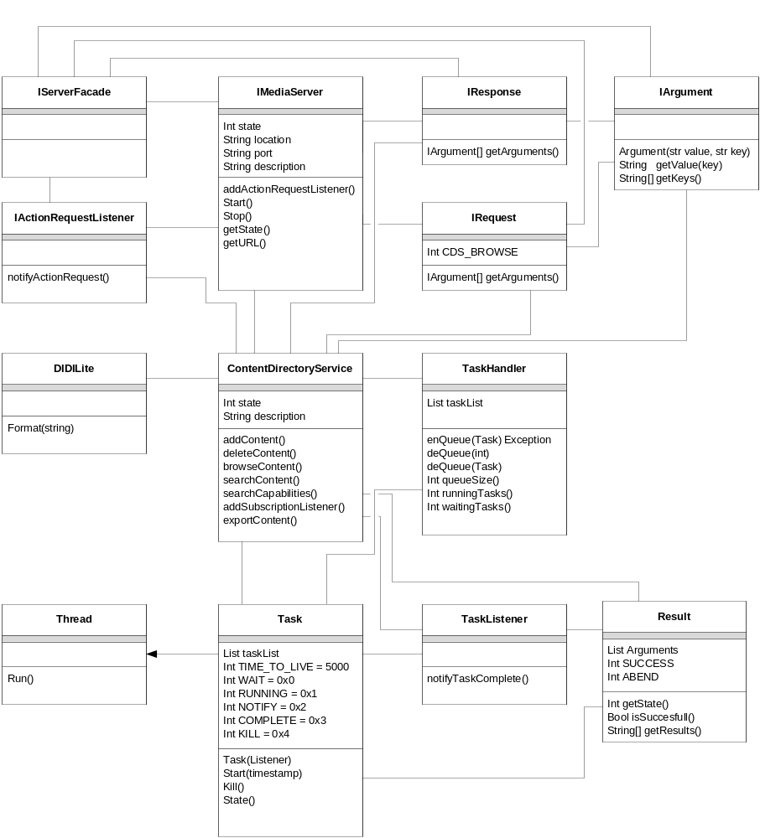

Interfaces

Interface: IMediaServer
Element | Name | Semantics/Description
Properties | Int state
Properties | String location
Properties | String port
Properties | String Description
Interfaces | Start | Starts the HTTP Server, announces “isAlive”, advertises device & service descriptions.
Interfaces | Stop | Shuts down the http server announces “byebye”.
Interfaces | getState | Determines if the device is running or stopped
Interfaces | getURL | Retrieves the universal locator of the device (ip:port)

Interface: IResponse
Element | Name | Semantics/Description
Properties | String ActionID | Identifies the Action request this response is mapped with.
Properties | Int CDS_BROWSE | Identifies a browse request
Properties | Int CDS_SEARCH | Identifies a search request
Properties | Int CDS_EXPORT | Identifies an export content request
Properties | Int CDS_SEARCHCAP | Identifies a search capabilities request
Properties | Int CDS_DELETE | Identifies a delete content request
Properties | Int CDS_CREATE | Identifies a create content request
Interfaces | IArgument[] getArguments | Returns an Array of arguments as a return value to a previous request.
Interfaces | Int getResponseType | Returns the type of request this response is mapped with.
Interfaces | String getActionID | Returns the Action identifier this response is mapped to.

Interface: IRequest
Element | Name | Semantics/Description
Properties | String ActionID | Identifies the Action request this request object is mapped with.
Properties | Int CDS_BROWSE | Identifies a browse request
Properties | Int CDS_SEARCH | Identifies a search request
Properties | Int CDS_EXPORT | Identifies an export content request
Properties | Int CDS_SEARCHCAP | Identifies a search capabilities request
Properties | Int CDS_DELETE | Identifies a delete content request
Properties | Int CDS_CREATE | Identifies a create content request
Interfaces | IArgument[] getArguments | Returns an Array of arguments as input values for a request.
Interfaces | Int getRequestType | Returns the type of request this request is mapped with.
Interfaces | String getActionID | Returns the Action identifier this request is mapped to.

Interface: IArgument
Element | Name | Semantics/Description
Properties | String key | Identifies the Action request this request object is mapped with.
Properties | String value | Identifies a browse request
Interfaces | String getKey | Returns the key for this argument
Interfaces | String getValue | Returns the value for this argument
Interfaces | Argument(key, value) | Constructor created with pass in the key, value  pairs.

Class: ContentDirectory
Element | Name | Semantics/Description
Properties | String SCPD | Provides description information about the service:  STATE VARIABLES  SUPPORTED ACTIONS  VERSION
Properties | Int state | Provides state information about the service.
Properties | String SERVICE_TYPE | A constant defining the service type:  urn:schemas-upnp-org:service:ContentDirectory:1
Interfaces | addContent | External API for publishing content – local only
Interfaces | deleteContent | External API for removing content from the Content  Database – local only
Interfaces | browseContent | External API for browsing content – local only
Interfaces | searchContent | External API for searching content – local only
Interfaces | searchCapabilities | External API for retrieving search capabilities – local only
Interfaces | Subscribe(listener) | External API for subscribing to service events. Events would be when new data is published or existing data has been modified. – local only
Interfaces | getInstance | Returns the singleton instance of the Content Directory Service.

Component Task Handler

The following is an illustration of the Task Handler, Tasks, and extended Task elements supporting the Content Directory Service.

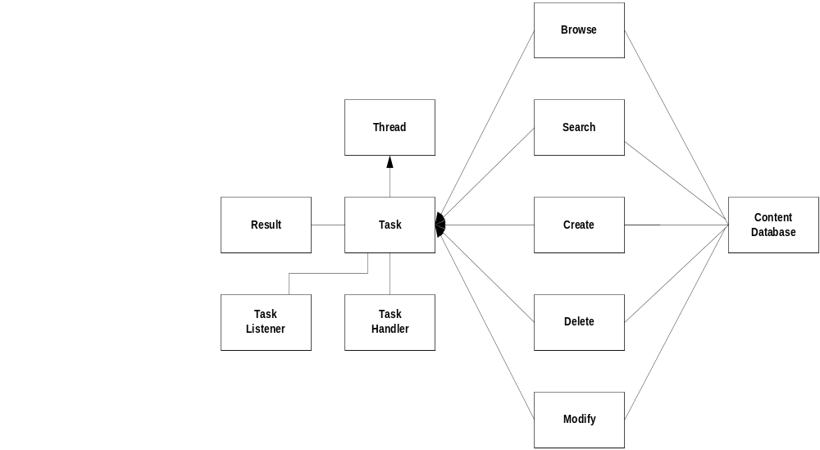

Description and Rationale

The Task Handler is a class created and managed by the Content Directory Service. The role of the Task Handler is to maintain a Task queue (work queue), and manage the lifecycle of scheduled tasks placed on the queue. The purpose of having a Task Handler is to allow the overall UPnP service framework to scale, and maintain concurrency.

The Task Handler is configurable through a properties file that allows a user to tune the number of Tasks that can be queued and running concurrently. The Handler is configured during initialization only, and doesn’t dynamically check for changes to properties during runtime.

The state of the Handler is not preserved across reboots. Tasks in the waiting, running or notify states will not be restored across reboots.

Component Use Cases and Interaction Diagrams

Basic Initialization and Task Handler Sequence:

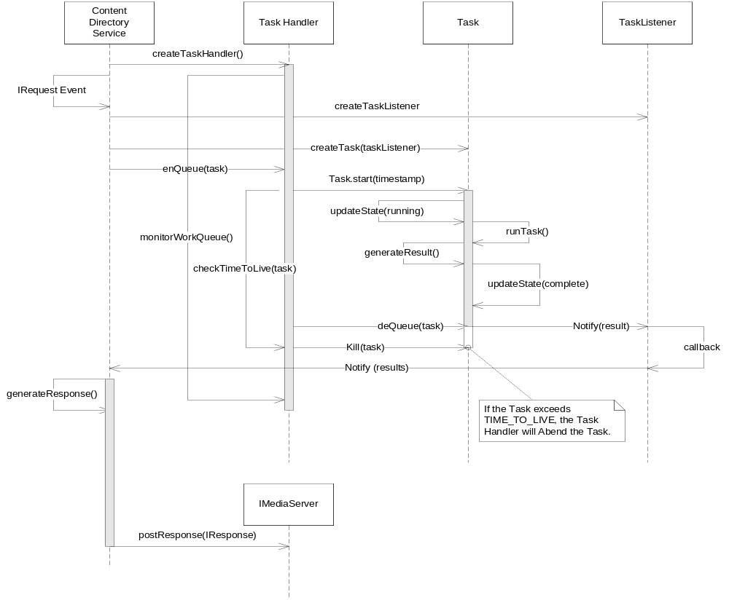

The Task Handler is created by the Content Directory Service. When an HTTP Request event is generated, the Content Directory service will parse the Arguments from the IRequest and create; 1.) A TaskListener, and 2.) An appropriate Task based on the action-type of the request, and then queue the Task. The Task Handler schedules the Task to run based on FIFO order. Once the Task has been started, the Task updates its status to Running, and performs the logic relative to the task. The Task Handler monitors all running Tasks, to verify that they have not exceeded TIME_TO_LIVE. If the Task has not completed within the TIME_TO_LIVE duration, the TaskHandler kills the Task. The Task sets the Result.State = Abend, and notifies the Content Directory Service. If the Task completes within the TIME_TO_LIVE duration, the Task sets the Result.State = Success, and adds the result data, and notifies the Content Directory Service.

Task State Diagram

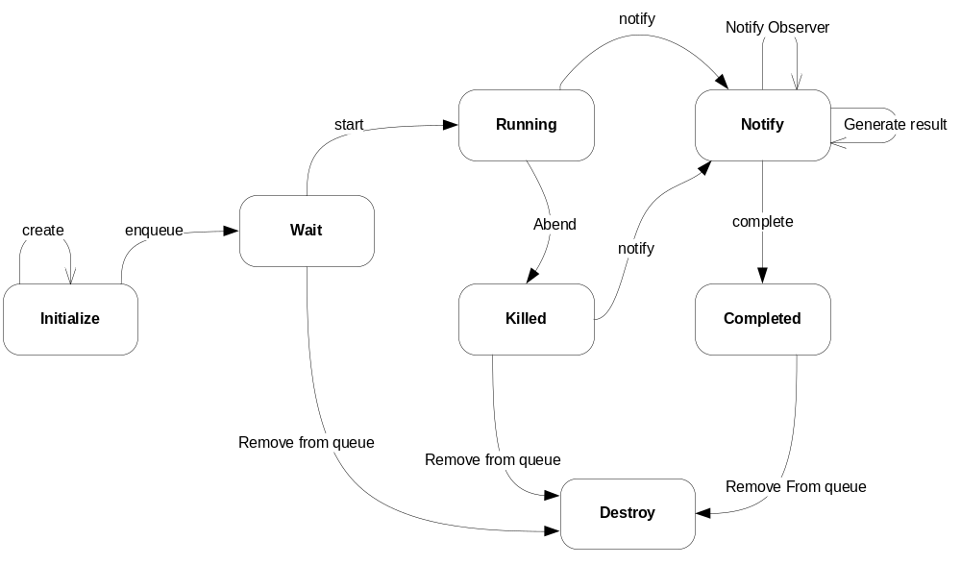

The State Diagram shows the various states that a Task will have in its lifecycle, and the transition from one State to another.

State Name | Description
Initialize | The task is created with a callback registered, and then queued for scheduling.
Wait | Indicates the Task is on the queue and is waiting to be scheduled
Running | Indicates the Task is running.
Killed | Indicates that the task has not completed within the TIME_TO_LIVE duration, and has been preempted by the Handler, in preparation to shutdown.
Notify | Task prepares a result, sets the result data, result state, and notifies the registered observer.
Completed | Indicates the Task has completed and is ready to be removed from the work queue by the Handler.
Destroy | Removed from the work queue with all references and handles released.

Class Diagram

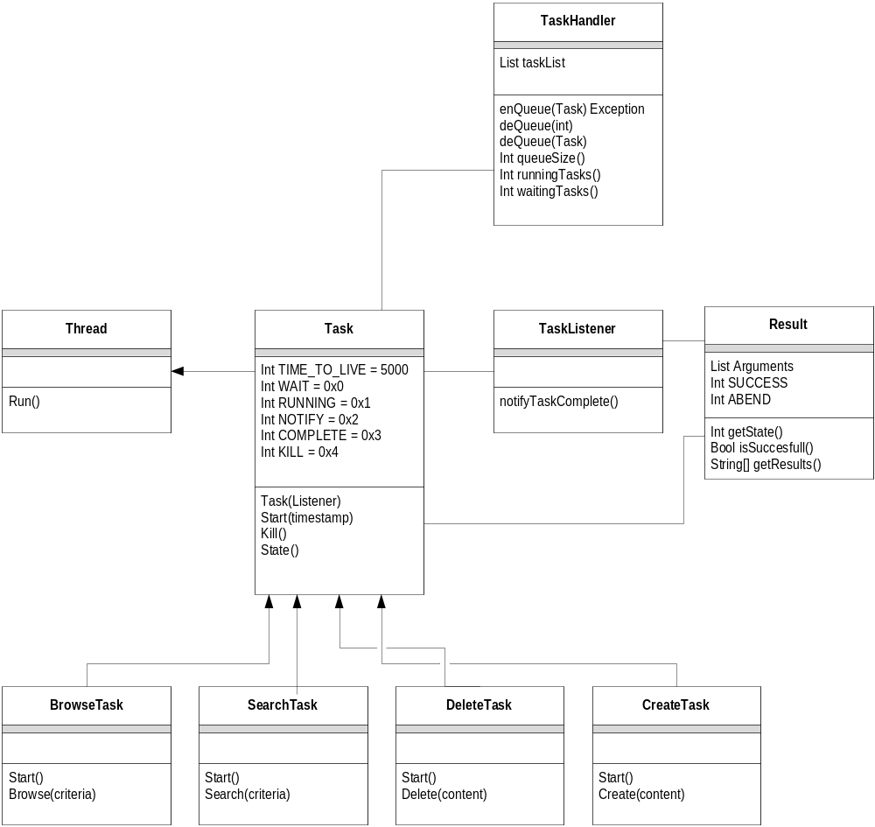

Interfaces

Class: TaskHandler
Element | Name | Semantics/Description
Properties | List workQueue | A queue used to manage Tasks.
Properties | Int MAX_QUEUE_SIZE | Determines the number of Tasks that can be placed onto the workQueue
Properties | Int MAX_TASK_RUN | Determines the number of Tasks that can be in a RUNNING_STATE.
Properties | Thread monitor | A timer thread that monitors the work queue, and performs the scheduling and lifecycle of tasks.
Interfaces | enQueue | Places Tasks onto the work queue
Interfaces | deQueue | Removes Tasks from the work queue
Interfaces | Int getWaitingTasks | Returns the number of tasks on the work queue that are in a WAITING_STATE
Interfaces | Int getRunningTasks | Returns the number of tasks on the work queue that are in a RUNNING_STATE
Interfaces | abort() | Kills all tasks, and cleans up.
Exceptions | QueueFullException | Signals the caller of enQueue(task), that the work queue is full or an OVERRUN has occurred. The task is not queued and will be scheduled.

Class: Task Super Class: Thread
Element | Name | Semantics/Description
Properties | Int TIME_TO_LIVE | Determines the lifecycle of a running task. The value is based on epoch time, and is compared with the TIMESTAMP passed in during start, and the current time
Properties | Int WAIT_STATE | Indicates the Task is waiting to be scheduled
Properties | Int RUNNING_STATE | Indicates the Task is running
Properties | Int NOTIFY_STATE | Indicates the Task is preparing a result, and notifying the registered listener that the task has completed.
Properties | Int COMPLETE_STATE | Indicates the Task has completed and is ready to be removed from the work queue
Properties | Int KILL_STATE | Indicates the Task has been killed, and is waiting to be cleaned up.
Interfaces | Task(listener) | Constructor that takes a listener during creation. The listener is used to notify the observer that the task has completed.
Interfaces | Start(timestamp) | Starts the Task. A timestamp value (epoch), is passed in to identify when the task has started.
Interfaces | Kill | Stops the thread, moves the task in to KILLED_STATE. Prepares for clean-up.
Interfaces | Int getState | Returns the current state of the Task.

Class: BrowseTask Super Class: Task
Element | Name | Semantics/Description
Properties
Interfaces | start() | Entry point of the thread to start work.
 | Browse(criteria) | Performs the browse function

Class: SearchTask Super Class: Task
Element | Name | Semantics/Description
Properties
Interfaces | start() | Entry point of the thread to start work
 | Search(criteria) | Performs the search function on the Content  Database

Class: SearchCapabilitiesTask Super Class: Task
Element | Name | Semantics/Description
Properties
Interfaces | start() | Entry point of the thread to start work
 | SearchCapabilities(criteria) | Performs the search capabilities function on the  Content Database.

Class: DeleteTask Super Class: Task
Element | Name | Semantics/Description
Properties
Interfaces | start() | Entry point of the thread to start work
 | delete(criteria) | Performs the delete function on the Content  Database

Class: CreateTask Super Class: Task
Element | Name | Semantics/Description
Properties
Interfaces | start() | Entry point of the thread to start work.
 | create(criteria) | Performs the create function on the Content  Database

Class: Result
Element | Name | Semantics/Description
Properties | Int STATE_SUCCESS | Identifies the state of the Result is successful
 | Int STATE_ABEND | Identifies the state of the Result failed or abnormally ended.
Interfaces | Int getState() | Returns the state of the result
 | String[] getResults | Returns the results

Logging
The OCAP HN Extension implementation and supporting code will use the existing “log4j”, framework. The following table defines the type of Log Message tags that will used.

Message Tag ID | Definition
ERROR | Indicates that the log entry is an error message and could represent a catastrophic condition within the runtime environment. May also be accompanied with a stack trace.
INFO | Indicates that the log entry is for information only
WARNING | Indicates that the log entry is a warning
EXCEPTION | Indicates that the log entry is from an Exception and may be accompanied with a stack trace.
TRACE | Indicates that the log entry is a trace message. These entries are configurable (on/off), and are primarily used for debug to improve serviceability.

Build/Packaging
The build and packaging of these components will be performed within the guidelines of the OCAP for RI build & package requirements.

Unit Test cases

Test Case | Description

Annex A

7.1 Exceptions

Exceptions | Exception Description
QueueFullException | Exception thrown when a work queue has detected an OVERRUN condition. This allows the caller to recover or retry later.
ServerBusyException | Exception is thrown by the Content Directory Service in the condition that it has detected a QueueFullException or OVERRUN condition has been detected.
UnavailableServerException | Thrown if the HTTPServer managed by the IMediaServer is not available.
UnauthorizedException | TBD.

7.2 Algorithms

Component Client Façade Algorithms

Function | ClientFacade API

- Component Server Façade Algorithms

Function | ServerFacade API

Annex B - Glossary

Term | Definition
OVERRUN | A term used to indicate that a ceiling has been met on a boundary condition.
OCAP | Open Cable Application Program
HN | Home Networking, implies Universal Plug and Play support for OCAP.
Facade | The façade pattern is a software engineering design pattern commonly used with object oriented programming. A façade is an object that provides a simplified interface to a larger body of code, such as a class library

Annex C – SCPD Data
"<?xml version=\"1.0\" encoding=\"utf-8\"?>\n" +
"<scpd xmlns=\"urn:schemas-upnp-org:service-1-0\">\n" +
" <specVersion>\n" +
" <major>1</major>\n" +
" <minor>0</minor>\n" +
" </specVersion>\n" +
" <actionList>\n" +
" <action>\n" +
" <name>ExportResource</name>\n" +
" <argumentList>\n" +
" <argument>\n" +
" <name>SourceURI</name>\n" +
" <direction>in</direction>\n" +
" <relatedStateVariable>A_ARG_TYPE_URI</relatedStateVariable>\n" +
" </argument>\n" +
" <argument>\n" +
" <name>DestinationURI</name>\n" +
" <direction>in</direction>\n" +
" <relatedStateVariable>A_ARG_TYPE_URI</relatedStateVariable>\n" +
" </argument>\n" +
" <argument>\n" +
" <name>TransferID</name>\n" +
" <direction>out</direction>\n" +
" <relatedStateVariable>A_ARG_TYPE_TransferID</relatedStateVariable>\n" +
" </argument>\n" +
" </argumentList>\n" +
" </action>\n" +
" <action>\n" +
" <name>StopTransferResource</name>\n" +
" <argumentList>\n" +
" <argument>\n" +
" <name>TransferID</name>\n" +
" <direction>in</direction>\n" +
" <relatedStateVariable>A_ARG_TYPE_TransferID</relatedStateVariable>\n" +
" </argument>\n" +
" </argumentList>\n" +
" </action>\n" +
" <action>\n" +
" <name>DestroyObject</name>\n" +
" <argumentList>\n" +
" <argument>\n" +
" <name>ObjectID</name>\n" +
" <direction>in</direction>\n" +
" <relatedStateVariable>A_ARG_TYPE_ObjectID</relatedStateVariable>\n" +
" </argument>\n" +
" </argumentList>\n" +
" </action>\n" +
" <action>\n" +
" <name>DeleteResource</name>\n" +
" <argumentList>\n" +
" <argument>\n" +
" <name>ResourceURI</name>\n" +
" <direction>in</direction>\n" +
" <relatedStateVariable>A_ARG_TYPE_URI</relatedStateVariable>\n" +
" </argument>\n" +
" </argumentList>\n" +
" </action>\n" +
" <action>\n" +
" <name>UpdateObject</name>\n" +
" <argumentList>\n" +
" <argument>\n" +
" <name>ObjectID</name>\n" +
" <direction>in</direction>\n" +
" <relatedStateVariable>A_ARG_TYPE_ObjectID</relatedStateVariable>\n" +
" </argument>\n" +
" <argument>\n" +
" <name>CurrentTagValue</name>\n" +
" <direction>in</direction>\n" +
" <relatedStateVariable>A_ARG_TYPE_TagValueList</relatedStateVariable>\n" +
" </argument>\n" +
" <argument>\n" +
" <name>NewTagValue</name>\n" +
" <direction>in</direction>\n" +
" <relatedStateVariable>A_ARG_TYPE_TagValueList</relatedStateVariable>\n" +
" </argument>\n" +
" </argumentList>\n" +
" </action>\n" +
" <action>\n" +
" <name>Browse</name>\n" +
" <argumentList>\n" +
" <argument>\n" +
" <name>ObjectID</name>\n" +
" <direction>in</direction>\n" +
" <relatedStateVariable>A_ARG_TYPE_ObjectID</relatedStateVariable>\n" +
" </argument>\n" +
" <argument>\n" +
" <name>BrowseFlag</name>\n" +
" <direction>in</direction>\n" +
" <relatedStateVariable>A_ARG_TYPE_BrowseFlag</relatedStateVariable>\n" +
" </argument>\n" +
" <argument>\n" +
" <name>Filter</name>\n" +
" <direction>in</direction>\n" +
" <relatedStateVariable>A_ARG_TYPE_Filter</relatedStateVariable>\n" +
" </argument>\n" +
" <argument>\n" +
" <name>StartingIndex</name>\n" +
" <direction>in</direction>\n" +
" <relatedStateVariable>A_ARG_TYPE_Index</relatedStateVariable>\n" +
" </argument>\n" +
" <argument>\n" +
" <name>RequestedCount</name>\n" +
" <direction>in</direction>\n" +
" <relatedStateVariable>A_ARG_TYPE_Count</relatedStateVariable>\n" +
" </argument>\n" +
" <argument>\n" +
" <name>SortCriteria</name>\n" +
" <direction>in</direction>\n" +
" <relatedStateVariable>A_ARG_TYPE_SortCriteria</relatedStateVariable>\n" +
" </argument>\n" +
" <argument>\n" +
" <name>Result</name>\n" +
" <direction>out</direction>\n" +
" <relatedStateVariable>A_ARG_TYPE_Result</relatedStateVariable>\n" +
" </argument>\n" +
" <argument>\n" +
" <name>NumberReturned</name>\n" +
" <direction>out</direction>\n" +
" <relatedStateVariable>A_ARG_TYPE_Count</relatedStateVariable>\n" +
" </argument>\n" +
" <argument>\n" +
" <name>TotalMatches</name>\n" +
" <direction>out</direction>\n" +
" <relatedStateVariable>A_ARG_TYPE_Count</relatedStateVariable>\n" +
" </argument>\n" +
" <argument>\n" +
" <name>UpdateID</name>\n" +
" <direction>out</direction>\n" +
" <relatedStateVariable>A_ARG_TYPE_UpdateID</relatedStateVariable>\n" +
" </argument>\n" +
" </argumentList>\n" +
" </action>\n" +
" <action>\n" +
" <name>GetTransferProgress</name>\n" +
" <argumentList>\n" +
" <argument>\n" +
" <name>TransferID</name>\n" +
" <direction>in</direction>\n" +
" <relatedStateVariable>A_ARG_TYPE_TransferID</relatedStateVariable>\n" +
" </argument>\n" +
" <argument>\n" +
" <name>TransferStatus</name>\n" +
" <direction>out</direction>\n" +
" <relatedStateVariable>A_ARG_TYPE_TransferStatus</relatedStateVariable>\n" +
" </argument>\n" +
" <argument>\n" +
" <name>TransferLength</name>\n" +
" <direction>out</direction>\n" +
" <relatedStateVariable>A_ARG_TYPE_TransferLength</relatedStateVariable>\n" +
" </argument>\n" +
" <argument>\n" +
" <name>TransferTotal</name>\n" +
" <direction>out</direction>\n" +
" <relatedStateVariable>A_ARG_TYPE_TransferTotal</relatedStateVariable>\n" +
" </argument>\n" +
" </argumentList>\n" +
" </action>\n" +
" <action>\n" +
" <name>GetSearchCapabilities</name>\n" +
" <argumentList>\n" +
" <argument>\n" +
" <name>SearchCaps</name>\n" +
" <direction>out</direction>\n" +
" <relatedStateVariable>SearchCapabilities</relatedStateVariable>\n" +
" </argument>\n" +
" </argumentList>\n" +
" </action>\n" +
" <action>\n" +
" <name>CreateObject</name>\n" +
" <argumentList>\n" +
" <argument>\n" +
" <name>ContainerID</name>\n" +
" <direction>in</direction>\n" +
" <relatedStateVariable>A_ARG_TYPE_ObjectID</relatedStateVariable>\n" +
" </argument>\n" +
" <argument>\n" +
" <name>Elements</name>\n" +
" <direction>in</direction>\n" +
" <relatedStateVariable>A_ARG_TYPE_Result</relatedStateVariable>\n" +
" </argument>\n" +
" <argument>\n" +
" <name>ObjectID</name>\n" +
" <direction>out</direction>\n" +
" <relatedStateVariable>A_ARG_TYPE_ObjectID</relatedStateVariable>\n" +
" </argument>\n" +
" <argument>\n" +
" <name>Result</name>\n" +
" <direction>out</direction>\n" +
" <relatedStateVariable>A_ARG_TYPE_Result</relatedStateVariable>\n" +
" </argument>\n" +
" </argumentList>\n" +
" </action>\n" +
" <action>\n" +
" <name>Search</name>\n" +
" <argumentList>\n" +
" <argument>\n" +
" <name>ContainerID</name>\n" +
" <direction>in</direction>\n" +
" <relatedStateVariable>A_ARG_TYPE_ObjectID</relatedStateVariable>\n" +
" </argument>\n" +
" <argument>\n" +
" <name>SearchCriteria</name>\n" +
" <direction>in</direction>\n" +
" <relatedStateVariable>A_ARG_TYPE_SearchCriteria</relatedStateVariable>\n" +
" </argument>\n" +
" <argument>\n" +
" <name>Filter</name>\n" +
" <direction>in</direction>\n" +
" <relatedStateVariable>A_ARG_TYPE_Filter</relatedStateVariable>\n" +
" </argument>\n" +
" <argument>\n" +
" <name>StartingIndex</name>\n" +
" <direction>in</direction>\n" +
" <relatedStateVariable>A_ARG_TYPE_Index</relatedStateVariable>\n" +
" </argument>\n" +
" <argument>\n" +
" <name>RequestedCount</name>\n" +
" <direction>in</direction>\n" +
" <relatedStateVariable>A_ARG_TYPE_Count</relatedStateVariable>\n" +
" </argument>\n" +
" <argument>\n" +
" <name>SortCriteria</name>\n" +
" <direction>in</direction>\n" +
" <relatedStateVariable>A_ARG_TYPE_SortCriteria</relatedStateVariable>\n" +
" </argument>\n" +
" <argument>\n" +
" <name>Result</name>\n" +
" <direction>out</direction>\n" +
" <relatedStateVariable>A_ARG_TYPE_Result</relatedStateVariable>\n" +
" </argument>\n" +
" <argument>\n" +
" <name>NumberReturned</name>\n" +
" <direction>out</direction>\n" +
" <relatedStateVariable>A_ARG_TYPE_Count</relatedStateVariable>\n" +
" </argument>\n" +
" <argument>\n" +
" <name>TotalMatches</name>\n" +
" <direction>out</direction>\n" +
" <relatedStateVariable>A_ARG_TYPE_Count</relatedStateVariable>\n" +
" </argument>\n" +
" <argument>\n" +
" <name>UpdateID</name>\n" +
" <direction>out</direction>\n" +
" <relatedStateVariable>A_ARG_TYPE_UpdateID</relatedStateVariable>\n" +
" </argument>\n" +
" </argumentList>\n" +
" </action>\n" +
" <action>\n" +
" <name>GetSortCapabilities</name>\n" +
" <argumentList>\n" +
" <argument>\n" +
" <name>SortCaps</name>\n" +
" <direction>out</direction>\n" +
" <relatedStateVariable>SortCapabilities</relatedStateVariable>\n" +
" </argument>\n" +
" </argumentList>\n" +
" </action>\n" +
" <action>\n" +
" <name>ImportResource</name>\n" +
" <argumentList>\n" +
" <argument>\n" +
" <name>SourceURI</name>\n" +
" <direction>in</direction>\n" +
" <relatedStateVariable>A_ARG_TYPE_URI</relatedStateVariable>\n" +
" </argument>\n" +
" <argument>\n" +
" <name>DestinationURI</name>\n" +
" <direction>in</direction>\n" +
" <relatedStateVariable>A_ARG_TYPE_URI</relatedStateVariable>\n" +
" </argument>\n" +
" <argument>\n" +
" <name>TransferID</name>\n" +
" <direction>out</direction>\n" +
" <relatedStateVariable>A_ARG_TYPE_TransferID</relatedStateVariable>\n" +
" </argument>\n" +
" </argumentList>\n" +
" </action>\n" +
" <action>\n" +
" <name>CreateReference</name>\n" +
" <argumentList>\n" +
" <argument>\n" +
" <name>ContainerID</name>\n" +
" <direction>in</direction>\n" +
" <relatedStateVariable>A_ARG_TYPE_ObjectID</relatedStateVariable>\n" +
" </argument>\n" +
" <argument>\n" +
" <name>ObjectID</name>\n" +
" <direction>in</direction>\n" +
" <relatedStateVariable>A_ARG_TYPE_ObjectID</relatedStateVariable>\n" +
" </argument>\n" +
" <argument>\n" +
" <name>NewID</name>\n" +
" <direction>out</direction>\n" +
" <relatedStateVariable>A_ARG_TYPE_ObjectID</relatedStateVariable>\n" +
" </argument>\n" +
" </argumentList>\n" +
" </action>\n" +
" <action>\n" +
" <name>GetSystemUpdateID</name>\n" +
" <argumentList>\n" +
" <argument>\n" +
" <name>Id</name>\n" +
" <direction>out</direction>\n" +
" <relatedStateVariable>SystemUpdateID</relatedStateVariable>\n" +
" </argument>\n" +
" </argumentList>\n" +
" </action>\n" +
" </actionList>\n" +
" <serviceStateTable>\n" +
" <stateVariable sendEvents=\"no\">\n" +
" <name>A_ARG_TYPE_SortCriteria</name>\n" +
" <dataType>string</dataType>\n" +
" </stateVariable>\n" +
" <stateVariable sendEvents=\"no\">\n" +
" <name>A_ARG_TYPE_TransferLength</name>\n" +
" <dataType>string</dataType>\n" +
" </stateVariable>\n" +
" <stateVariable sendEvents=\"yes\">\n" +
" <name>TransferIDs</name>\n" +
" <dataType>string</dataType>\n" +
" </stateVariable>\n" +
" <stateVariable sendEvents=\"no\">\n" +
" <name>A_ARG_TYPE_UpdateID</name>\n" +
" <dataType>ui4</dataType>\n" +
" </stateVariable>\n" +
" <stateVariable sendEvents=\"no\">\n" +
" <name>A_ARG_TYPE_SearchCriteria</name>\n" +
" <dataType>string</dataType>\n" +
" </stateVariable>\n" +
" <stateVariable sendEvents=\"no\">\n" +
" <name>A_ARG_TYPE_Filter</name>\n" +
" <dataType>string</dataType>\n" +
" </stateVariable>\n" +
" <stateVariable sendEvents=\"yes\">\n" +
" <name>ContainerUpdateIDs</name>\n" +
" <dataType>string</dataType>\n" +
" </stateVariable>\n" +
" <stateVariable sendEvents=\"no\">\n" +
" <name>A_ARG_TYPE_Result</name>\n" +
" <dataType>string</dataType>\n" +
" </stateVariable>\n" +
" <stateVariable sendEvents=\"no\">\n" +
" <name>A_ARG_TYPE_Index</name>\n" +
" <dataType>ui4</dataType>\n" +
" </stateVariable>\n" +
" <stateVariable sendEvents=\"no\">\n" +
" <name>A_ARG_TYPE_TransferID</name>\n" +
" <dataType>ui4</dataType>\n" +
" </stateVariable>\n" +
" <stateVariable sendEvents=\"no\">\n" +
" <name>A_ARG_TYPE_TagValueList</name>\n" +
" <dataType>string</dataType>\n" +
" </stateVariable>\n" +
" <stateVariable sendEvents=\"no\">\n" +
" <name>A_ARG_TYPE_URI</name>\n" +
" <dataType>uri</dataType>\n" +
" </stateVariable>\n" +
" <stateVariable sendEvents=\"no\">\n" +
" <name>A_ARG_TYPE_ObjectID</name>\n" +
" <dataType>string</dataType>\n" +
" </stateVariable>\n" +
" <stateVariable sendEvents=\"no\">\n" +
" <name>SortCapabilities</name>\n" +
" <dataType>string</dataType>\n" +
" </stateVariable>\n" +
" <stateVariable sendEvents=\"no\">\n" +
" <name>SearchCapabilities</name>\n" +
" <dataType>string</dataType>\n" +
" </stateVariable>\n" +
" <stateVariable sendEvents=\"no\">\n" +
" <name>A_ARG_TYPE_Count</name>\n" +
" <dataType>ui4</dataType>\n" +
" </stateVariable>\n" +
" <stateVariable sendEvents=\"no\">\n" +
" <name>A_ARG_TYPE_BrowseFlag</name>\n" +
" <dataType>string</dataType>\n" +
" <allowedValueList>\n" +
" <allowedValue>BrowseMetadata</allowedValue>\n" +
" <allowedValue>BrowseDirectChildren</allowedValue>\n" +
" </allowedValueList>\n" +
" </stateVariable>\n" +
" <stateVariable sendEvents=\"yes\">\n" +
" <name>SystemUpdateID</name>\n" +
" <dataType>ui4</dataType>\n" +
" </stateVariable>\n" +
" <stateVariable sendEvents=\"no\">\n" +
" <name>A_ARG_TYPE_TransferStatus</name>\n" +
" <dataType>string</dataType>\n" +
" <allowedValueList>\n" +
" <allowedValue>COMPLETED</allowedValue>\n" +
" <allowedValue>ERROR</allowedValue>\n" +
" <allowedValue>IN_PROGRESS</allowedValue>\n" +
" <allowedValue>STOPPED</allowedValue>\n" +
" </allowedValueList>\n" +
" </stateVariable>\n" +
" <stateVariable sendEvents=\"no\">\n" +
" <name>A_ARG_TYPE_TransferTotal</name>\n" +
" <dataType>string</dataType>\n" +
" </stateVariable>\n" +
" </serviceStateTable>\n" +
"</scpd>";

