OpenCable™
NetManager Discovery and Description
Work in Progress
Notice
This document is an effort for the benefit of the OpenCable Team. Neither CableLabs, nor any other entity participating in the creation of this document, is responsible for any liability of any nature whatsoever resulting from or arising out of use or reliance upon this document by any party. This document is furnished on an AS-IS basis and neither CableLabs, nor other participating entity, provides any representation or warranty, express or implied, regarding its accuracy, completeness, or fitness for a particular purpose. Distribution of this document is restricted to internal CableLabs personnel.
© Copyright 2008 Cable Television Laboratories, Inc.
All rights reserved.
Version History

Version Number | Date | Contributor | Description
V1.0 | 12/11/2008 | B. Foran | Initial release

Contents
1 Introduction 1
2 Functional Components 2
2.1.1 Sequence Diagrams 2
2.1.2 Class Diagrams 4
3 Device Description Template 5
Figures
Figure 1 - NetManager Device Discovery At System Power Up - Non-DVR Host 2
Figure 2 - NetManager Device Discovery At System Power Up - DVR Enabled Host 3
Figure 3 - NetManager Class Diagram 4

Introduction

The NetManager is the entry point for OCAP home networking. By interfacing between the UPnP stack and the OCAP stack, the NetManger provides a way to map UPnP objects to OCAP home networking objects. Rather than being tightly coupled to any one particular UPnP stack, the NetManager interfaces through a facade mechanism. This allows for the UPnP stack to change underneath the OCAP home networking without requiring the NetManager to be modified to accommodate this change.

After the host system powers up or reboots, the NetManager is initialized and begins running. Depending on the configuration for the host, the NetManager has several tasks that it must kickoff. At a minimum, the NetManager is responsible for gathering the list of devices and their services and capabilities on the UPnP network. If the particular host that the NetManager is running on also has a media server, media player, and media recorder, these services must be initialized and broadcast to the UPnP network as well before the device discovery process takes place.
Functional Components
The following subsection contains the Sequence Diagrams and Class Diagram for the NetManager.

Sequence Diagrams

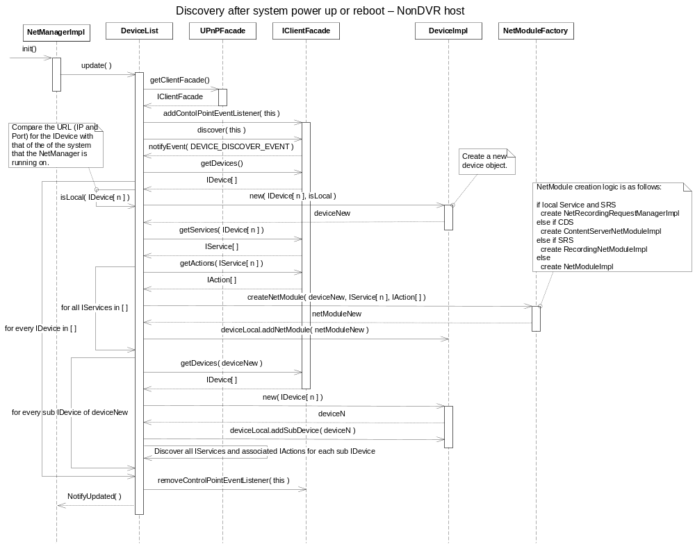

Figure 1 - NetManager Device Discovery At System Power Up - Non-DVR Host

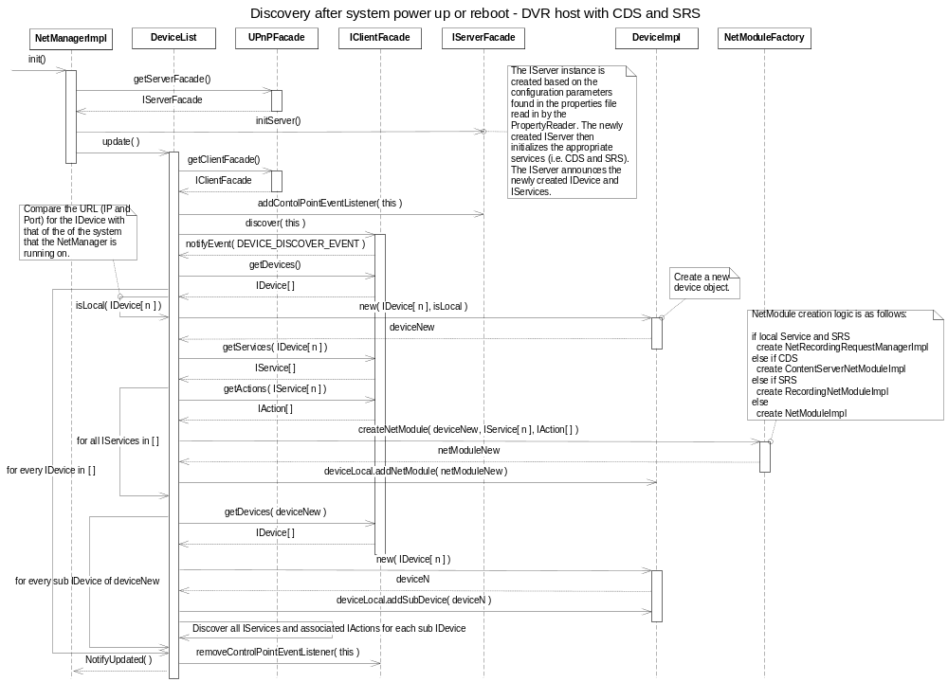

Figure 2 - NetManager Device Discovery At System Power Up - DVR Enabled Host

Class Diagrams
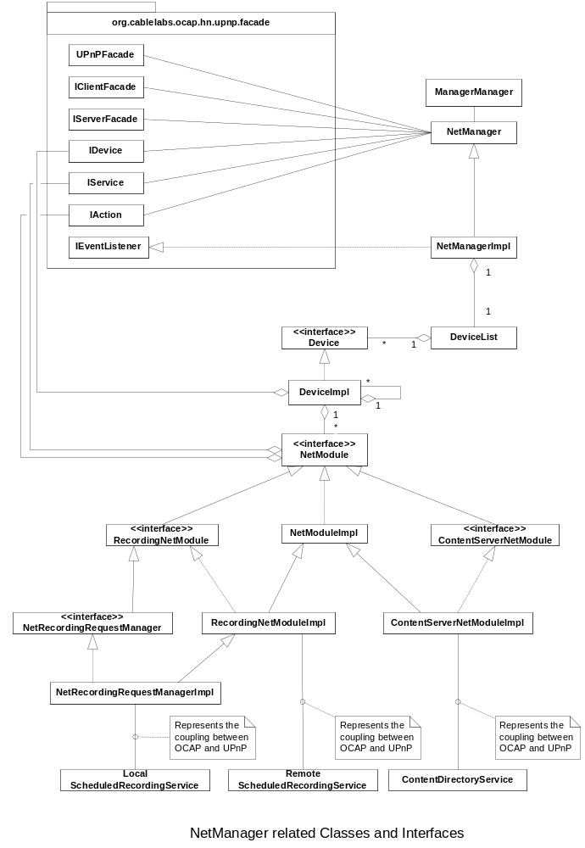

Figure 3 - NetManager Class Diagram

Device Description Template
The following is the template that each will be populated by each device and then sent to the interested party who queries the device for additional information.

<?xml version="1.0"?>
<root xmlns="urn:schemas-upnp-org:device-1-0">
<specVersion>
<major>1</major>
<minor>0</minor>
</specVersion>
<URLBase>base URL for all relative URLs</URLBase>
<device>
<deviceType>
urn:schemas-upnp-org:device:MediaServer:2
</deviceType>
<friendlyName>short user-friendly title</friendlyName>
<manufacturer>manufacturer name</manufacturer>
<manufacturerURL>URL to manufacturer site</manufacturerURL>
<modelDescription>long user-friendly title</modelDescription>
<modelName>model name</modelName>
<modelNumber>model number</modelNumber>
<modelURL>URL to model site</modelURL>
<serialNumber>manufacturer's serial number</serialNumber>
<UDN>uuid:UUID</UDN>
<UPC>Universal Product Code</UPC>
<iconList>
<icon>
<mimetype>image/format</mimetype>
<width>horizontal pixels</width>
<height>vertical pixels</height>
<depth>color depth</depth>
<url>URL to icon</url>
</icon>
<!-- XML to declare other icons, if any, go here -->
</iconList>
<serviceList>
<service>
<serviceType>
urn:schemas-upnp-org:service:ContentDirectory:2
</serviceType>
<serviceId>
urn:upnp-org:serviceId:ContentDirectory
</serviceId>
<SCPDURL>URL to service description</SCPDURL>
<controlURL>URL for control</controlURL>
<eventSubURL>URL for eventing</eventSubURL>
</service>
<service>
<serviceType>
urn:schemas-upnp-org:service:ScheduledRecording:1
</serviceType>
<serviceId>
urn:upnp-org:serviceId:ScheduledRecording
</serviceId>
<SCPDURL>URL to service description</SCPDURL>
<controlURL>URL for control</controlURL>
<eventSubURL>URL for eventing</eventSubURL>
</service>
<!-- Declarations for standard non-AV services defined by UPnP (if any) go here -->
<!-- Declarations for other services added by UPnP vendor (if any) go here -->
</serviceList>
<deviceList>
<!-- Description of embedded devices added by UPnP vendor (if any) go here -->
</deviceList>
<presentationURL>URL for presentation</presentationURL>
</device>
</root>

