OpenCable™
Home Networking Extension ScheduledRecording Service Design
Work in Progress
Notice
This document is an effort for the benefit of the OpenCable Team. Neither CableLabs, nor any other entity participating in the creation of this document, is responsible for any liability of any nature whatsoever resulting from or arising out of use or reliance upon this document by any party. This document is furnished on an AS-IS basis and neither CableLabs, nor other participating entity, provides any representation or warranty, express or implied, regarding its accuracy, completeness, or fitness for a particular purpose. Distribution of this document is restricted to internal CableLabs personnel.
© Copyright 2008 Cable Television Laboratories, Inc.
All rights reserved.

Version History
Date | Description | Author
12/31/08 | Initial Draft Version | Daniel Woodard
01/02/09 | Updates and corrections | Daniel Woodard
2/13/09 | Updates and corrections | Daniel Woodard
3/06/09 | Updates for iteration3 discovery | Daniel Woodard
3/27/09 | Updates for iteration 4 discovery | Daniel Woodard
4/17/00 | Updates for iteration 5 discovery | Daniel Woodard

Table Of Contents

Table Of Contents 3
1 Overview and Scope 5
2 References 5
3 Functional Overview 6
4 Design Areas 6
4.1 UPnP to OCAP mapping 6
4.2 RecordingRequest changes and dependencies 10
4.3 Lifetime of RecordSchedule and RecordTask 11
4.4 SRS State Variables 11
4.5 Eventing and Moderation 12
4.6 SRS Action processing 13
4.7 RecordTask and RecordSchedule states 14
4.8 HN-DVR Integration Design 14
4.9 Concurency 18
4.10 SRS Priority Model 18
4.11 Rating System 18
4.12 Conflict Detection and Resolution 18
4.13 Initialization 18
4.14 Power cycle 18
5 Implementation Structure and Interactions 19
5.1 Class Diagrams 19
5.2 Interactions 22
5.3 UPnP SRS Classes 27
6 Use Cases 28
6.1 SRS 28
6.2 UPnP Action Use Cases 28
6.3 CDS Use Cases 33
6.4 ContentContainer 34
6.5 NetRecordingEntry Use Cases 37
6.6 NetRecordingRequestManager Use Cases 38
6.7 OcapRecordingManager Use Cases 38
6.8 RecordingContentItem Use Cases 39
6.9 RecordingNetModule 39
6.10 NetActionRequest 40
7 Issues With OCAP HN API and Specifications 40
7.1 MetadataNode 40
7.2 MetadataIdentifiers 41
7.3 NetRecordingSpec 41
7.4 NetActionRequest 41
7.5 NetActionEvent 41
7.6 NetRecordingEntry 41
7.7 HNP 2.0 Annex C 42
7.8 ECO 1334-4 42

Table 1 OCAP types to UPnP types 6
Table 2 UPnP SRS Action Handling 7
Table 3 UPnP SRS Actions to NetRecordingRequestHandler Mapping 8
Table 4 OCAP HN API to UPnP SRS Action Mapping 9
Table 5 DVR Recording State to RecordTask State Mapping 10
Table 6 LastChange Eventing Elements 13
Table 7 RecordingContentItem/DVR Properties Mapping 18

Figure 1 HN/DVR Manager Properties 15
Figure 2 HN/DVR Integration 15
Figure 3 SRS Classes and associations 19
Figure 4 NetRecordingRequestManager Hierarchy 19
Figure 5 SRS-CDS associations 20
Figure 6 NetRecordingEntry Class Hierarchy 20
Figure 7 NetActionRequest Class Hierarchy 21
Figure 8 Local RecordingContentItemLocal 22
Figure 9 Initialization Sequence 23
Figure 10 CreateRecordSchedule Action Sequence 24
Figure 11 ContentContainer.addContentEntry( NetRecordingEntry ) Sequence 24
Figure 12 ContentContainer.addContentEntry( RecordingContentItem ) 25
Figure 13 State Update Sequence 25
Figure 14 RecordingNetModule.requestSchedule() Remote 26
Figure 15 RecordingNetModule.requestSchedule() Local 26
Figure 16 Homer's requestSchedule() data type round trip 27

Overview and Scope
This document describes the design to support the ScheduledRecording Service (SRS) class and associations on an OCAP Home Networking Host. Design description of the client requests and client responses through a control point to the SRS is not defined here. Client behavior may be described in order to add clarity to the SRS design however.

References
[OCAP HNP] OpenCable Home Networking Protocol 2.0, OC-SP-HNP2.0-I01-080418.pdf
[OCAP HNEXT] OC-SP-OCAP-HNEXT-I03-080418.pdf
[UPNP SRS] ScheduledRecording:1 Service Template Version 1.01 For UPnP Version 1.0
May 31, 2006.

The following is the complete list of Engineering Changes that apply to Home Networking. The Engineering Changes in red apply to SRS and SRS client behavior:

HNP2.0-O-08.1289-1 - Mandatory Media Format Profile Fix
HNP2.0-O-08.1298-2 - Application Metadata in RecordingContentItem
HNP2.0-O-08.1299-3 - HN Authorization API Mapping
HNP2.0-O-08.1300-1 - Maxbandwidth HTTP Header Requirements
HNP2.0-O-08.1301-2 - Port Number Re-use, refers to streaming media
HNP2.0-O-08.1307-1 - HN MSO Content Indicator property fix
HNP2.0-O-08.1314-5 - Revise informative appendix sequence diagrams and narrative
HNP2.0-O-08.1334-4 - Clarify processing of Schedule Recording
HNP2.0-O-08.1340-3 - Clarify SRS related methods in HNP2.0
HNP2.0-O-08.1341-1 - Remove ContentManagementNetModule interface from HNP2.0 and clarify support CDS actions
HNP2.0-O-08.1342-1 - Remove ContentDatabase class from HNP
HNP2.0-R-08.1343-1 - UPnP Object Clarification
HNP2.0-O-09.1369-1 - Set RecordingContentItem class to videoItem

OCAP-HNEXT-N-08.1253-1 - Home Networking Device InetAddress
OCAP-HNEXT-N-08.1261-2 - HN Overlapping Methods
OCAP-HNEXT-O-08.1280-1 - HN Security API
OCAP-HNEXT-O-08.1302-2 - HN Authorization API
OCAP-HNEXT-O-08.1306-4 - Miscellaneous HNEXT Phase II cleanup
OCAP-HNEXT-O-08.1333-2 - Clarify the behavior of the method of NetRecordingEntry
OCAP-HNEXT-O-08.1336-2 - Clarify the behavior of the method of ContentContainer
OCAP-HNEXT-O-08.1337-1 - Remove ContentManagementNetModule interface from OCAP HNExt
OCAP-HNEXT-O-08.1338-1 - Add and clarify the methods of RecordingContentItem
OCAP-HNEXT-O-08.1339-1 - Remove ContentDatabase class from HNEXT
OCAP-HNEXT-O-08.1344-1 - Clarify SRS related methods in OCAP HNExt
OCAP-HNEXT-O-08.1345-1 - Remove recording parameter from
RecordingContentItem.requestSetMediaTime()
OCAP-HNEXT-R-08.1357-2 – Home Networking Phase 2.0 API update
OCAP-HNEXT-O-09.1370-1 - Modify action state definitions of NetActionEvent

Functional Overview
The SRS is one of the services within a MediaServer on a DVR capable host. It enables recordings to be requested by another OCAP HN enabled host. It is likely that only OCAP HN enabled hosts will be able to schedule and playback DVR recordings. It is not clear how it could possibly work otherwise.
The SRS is primarily action based. It does maintain state between recording tasks and actual recordings and will generate change events based on state change.
An application with HomeNetPermission plays a central role in the recording creation, deletion, and stopping. It handles notifications from SRS actions, interacts with the OcapRecordingManager, and publishes recordings to the CDS. The SRS does not do those functions, it only enables that application to do them through notifications.
Since the HomeNetPermission application is central to a complete UPnP MediaServer with ScheduleRecord capability on an OCAP host, that application will have to be carefully designed. Wherever relevant, sequence diagrams showing the HomeNetPermission application’s involvement in SRS actions are shown so that it is clear to the application authors what is expected. There are some of these sequences shown in the [OCAP HNP] specification but they are inaccurate and should not be used.
If there is no HomeNetPermission application registered to handle SRS action requests, the SRS actions will fail and return error.

Design Areas

UPnP to OCAP mapping
This section describes the correlation between the UPnP and OCAP HN designs. The [OCAP HNP] specification is less than clear on this topic. This section attempts to remove any ambiguities in this regard.

Class and Interface Mapping
This section describes the correlation between OCAP defined classes and interfaces and UPnP components.
Table 1 OCAP types to UPnP types
OCAP | UPnP | Notes
org.ocap.hn.recording.NetRecordingEntry | RecordSchedule | These are closely tied to one another and could even be the same object instance.
org.ocap.hn. recording.RecordingContentItem | RecordTask | These are closely tied to one another and could even be the same object instance.
org.ocap.hn. recording.NetRecordingRequestManager | ScheduledRecording Service | Interface to a local instance of a SRS.
org.ocap.hn. recording.RecordingNetModule | ScheduledRecording Service | Interface to a remote instance of a SRS.
org.ocap.hn.recording.RecordingContentItem | A recording that has been published to a CDS | An instance of this will have an associated RecordTask.

An org.ocap.hn.RecordingContentItem instance also implements the org.ocap.dvr.OcapRecordingRequest interface.

SRS Actions
All required UPnP actions will be implemented. Most of the optional actions will not be implemented. See below for details.

Vendor Actions Defined
Recording X_PrioritizeRecordings Action defined in [OCAP HNP] Annex C.2. See below for description. This action is an OCAP HN vendor extension to the UPnP SRS defined Actions.

SRS Actions handled by SRS
All received SRS Actions are received and handled by the SRS. Some of them cause a notification to a registered HomeNetPermission application. All of the required SRS Actions are handled. Only the OCAP required SRS optional Actions are handled. All of the other optional Actions are not.
Table 2 UPnP SRS Action Handling
UPnP SRS Action | Causes notify to NetRecordingRequestHandler | UPnP  R/O¹ | OCAP  R/O
GetSortCapabilites() | no | R | R
GetPropertyList() | no | R | R
GetAllowedValues() | no | R | R
GetStateUpdateID() | no | R | R
BrowseRecordSchedules() | no | R | R
BrowseRecordTasks() | no | R | R
CreateRecordSchedule() | yes | R | R
DeleteRecordSchedule() | yes | R | R
GetRecordSchedule() | no | R | R
EnableRecordSchedule() | no | O² | O
DisableRecordSchedule() | yes | O² | R
DeleteRecordTask() | yes | O | R
GetRecordTask() | no | R | R
EnableRecordTask() | no | O³ | O
DisableRecordTask() | yes | O³ | R
ResetRecordTask() | no | O³ | O
GetRecordScheduleConflicts() | no | O⁴ | O
GetRecordTaskConflicts() | yes | O | R
X_PrioritizeRecordings() | yes | X | R

¹ R = REQUIRED, O = OPTIONAL, X = Vendor defined.
² CONDITIONALLY REQUIRED. if one of these is implemented, they both have to be. However, as you can see OCAP has no mapping for EnableRecordSchedule(). This action will be implemented but it will return failure.
³ CONDITIONALLY REQUIRED. If one of these is implemented, they all have to be. However, as you can see OCAP has no mapping for EnableRecordTask() and ResetRecordTask(). These actions will be implemented but they will return failure
⁴ CONDITIONALLY REQUIRED. Required if the SRS implementation allows for conflicting recordSchedule instances to be created. It is entirely possible for the SRS implementation to create conflicting recordSchedule instances to be created but as you can see, OCAP has no mapping for this action.

SRS Actions that cause notification to HomeNetPermission application
These UPnP SRS actions are handled by an instance of org.ocap.hn.recording.NetRecordingRequestHandler that is registered with org.ocap.hn.recording.NetRecordingRequestManager which is the interface to the local SRS instance.
Mapping of UPnP SRS Actions with NetRecordingRequestHandler notifications:
Table 3 UPnP SRS Actions to NetRecordingRequestHandler Mapping
UPnP SRS Action | NetRecordingRequestHandler  notify | Notes
CDS: DestroyObject() | notifyDelete( InetAddress, ContentEntry) | This is a CDS handled action but the notify is to a SRS registered handler.
DeleteRecordSchedule() or DeleteRecordTask() | notifyDeleteService( InetAddress,ContentEntry)
DisableRecordSchedule() or DisableRecordTask() | notifyDisable( InetAddress,ContentEntry)
X_PrioritizeRecordings() | notifyPriorititization( InetAddress,NetRecordingEntry[])
? | notifyPrioritization( InetAddress,ResourceUsage[]) | This call will never occur since there is no mapping.  Should this api use recordingContentItem[] instead of ResourceUsage[]?
CreateRecordSchedule() with non-empty id element. | notifyReschedule( InetAddress, ContentEntry, NetRecordingEntry )
CreateRecordSchedule() with non-empty id element. | notifySchedule( InetAddress, NetRecordingEntry )

Client side OCAP HN API to SRS Action mapping
Client API calls translate into SRS Actions. They are:
Table 4 OCAP HN API to UPnP SRS Action Mapping
HN API call | SRS Action | Notes
RecordingContentItem.requestConflictingRecordings() | GetRecordTaskConflicts()
RecordingContentItem.requestSetMediaTime() | CDS: UpdateObject() | This causes a CDS handled action.
RecordingNetModule.requestSchedule() | CreateRecordSchedule() with empty id element.
RecordingNetModule.requestReschedule() | CreateRecordSchedule() with non-empty id element.
RecordingNetModule.requestDisable() | DisableRecordSchedule() or DisableRecordTask()
RecordingNetModule.requestDeleteService() | CDS: DeleteResource | Check this This causes a CDS handled action.
RecordingNetModule.requestDelete() | CDS: DestroyObject | This causes a CDS handled action.
RecordingNetModule.requestPrioritize( RecordingContentItem[] | X_PrioritizeRecordings()
RecordingNetModule.requestPrioritize( NetRecordingEntry[] | X_PrioritizeRecordings()

Events
The only SRS event generated is for a LastChange state update. This event is generated whenever any recordSchedule or recordTask in the SRS changes. This event is moderated with max event interval of 0.2 seconds. See LastChange State Variable section below for more details.
This event maps to a control point notification to an org.ocap.hn.NetModuleEventListener instance that was registered with an org.ocap.hn.NetModule instance that represents a local or remote SRS.
The event to the NetModuleEventListener will be an org.ocap.hn.NetModuleEvent with type STATE_CHANGE with source of type RecordingNetModule. There does not appear to be any detail to indicate what caused the state change in the notification. See the SRS Client Design document for more details.

States
DVR Recording states affect RecordTask states.
Table 5 DVR Recording State to RecordTask State Mapping
OCAP DVR RECORDING STATE | UPNP SRS RECORDING TASK STATE
PENDING_NO_CONFLICT | IDLE.READY
PENDING_WITH_CONFLICT | IDLE.ATRISK
IN_PROGRESS | ACTIVE.TRANSITION.FROMSTART
IN_PROGRESS_INCOMPLETE | ACTIVE.TRANSITION.RESTART
IN_PROGRESS_WITH_ERROR | ACTIVE.NOTRECORDING
IN_PROGRESS | ACTIVE.RECORD.FROMSTART.OK
IN_PROGRESS_INSUFFICIENT_SPACE | ACTIVE.RECORDING.FROMSTART.ATRISK
IN_PROGRESS_INCOMPLETE | ACTIVE.RECORDING.RESTART.OK
<NO MAPPING> | ACTIVE.RECORDING.RESTART.ATRISK
COMPLETE | DONE.FULL
INCOMPLETE | DONE.PARTIAL
FAILED | DONE.EMPTY
CANCELLED | DONE.EMPTY
TEST | N/A
DELETED | DONE.EMPTY
PARENT RECORDING STATE | UPNP SRS RECORD SCHEDULE STATE
UNRESOLVED | OPERATIONAL
PARTIALLY_RESOLVED | OPERATIONAL
COMPLETELY_RESOLVED | COMPLETED
CANCELLED | <NO_MAPPING>
<NO_MAPPING> | ERROR

Data Structures
TODO: show client side data mappings to server side data. e.g. MetaDataNode, client api parms to srs action parms etc.

RecordingRequest changes and dependencies

State Change
Anything that causes a RecordingRequest state to change will notify RecordTask that a change has taken place. The RecordSchedule will be notified as well and looks for a parent RecordingRequest state change. If the RecordingTask state or the RecordingRequest state change, the SRS LastChange state changes and will generate an event.

Lifetime of RecordSchedule and RecordTask
When all of the recordTask for a recordSchedule have completed, the recordSchedule can be deleted along with all of its recordTasks. Or, they can be deleted after a reasonable amount of time. TODO: pick one. Must consider the lifetime of NetRecordingEntry and RecordingContentItem. Do instances of those require that the RecordSchedule and RecordTask be tied to those lifetimes?

SRS State Variables
The description of these variables is best described by [UPNP SRS] section 2.4 State Variables:
‘Like the ContentDirectory service, the ScheduledRecording service is primarily action-based. The service
state variables exist primarily to support argument passing within service actions. Information is not
exposed directly through explicit state variables. Instead, a client retrieves ScheduledRecording service
information via the return arguments of the actions defined below. The majority of state variables defined below exist simply to provide data type information for the arguments of the various actions of this service.’

StateUpdateID
Type ui4.
Is incremented by 1 whenever:
- recordSchedule or recordTask is created or deleted
- recordSchedule or recordTask is modified
- any other change to state of SRS that could be observed by a control point including vendor defined behavior.

LastChange
Type string.
This state variable will generate a UPnP Event when it changes. The LastChange state variable will change whenever a recordSchedule or recordTask in the SRS changes.
See SRS-EVENT-XSD for the schema for the StateEvent XML Document used in this state variable. See [UPNP SRS] section 2.4.5 for more information on content of the event xml.
The types of events that will generate a LastChange state change are:
- RecordScheduleCreated
- RecordScheduleModified
- RecordScheduleDeleted
- RecordTaskCreated
- RecordTaskModified
- RecordTaskDeleted
- Vendor-defined
Each of the event elements in the xml document must have an updateID attribute which is set to the value of the StateUpdateID state variable at the time of the update and one objectID attribute which is set to the value of the @id property of the updated recordSchedule or recordTask instance.

SortCapabilites
Type ui4.

SortLevelCapability
Type ui4.

A_ARG_TYPE_PropertyList

A_ARG_TYPE_DataTypeID

A_ARG_TYPE_ObjectID

A_ARG_TYPE_ObjectIDList
Only required when GetRecordScheduleConflicts() or GetRecordTaskConflicts() actions are implemented.

A_ARG_TYPE_PropertyInfo

A_ARG_TYPE_Index

A_ARG_TYPE_Count

A_ARG_TYPE_SortCriteria

A_ARG_TYPE_RecordSchedule
Provides type information for various action arguments that contain a list of zero or more recordSchedule objects. It must comply with the SRS schema. This XML needs to be escaped before embedding in a SOAP response message.

A_ARG_TYPE_RecordTask
Similar to above

A_ARG_TYPE_RecordScheduleParts
Similar to above

Eventing and Moderation
The only State Variable that is evented is LastChange. The eventing is also moderated. When LastChange state variable changes, an event is generated. Max event rate is 0.2 seconds where rate = event/(n secs).
The possible StateEvent Elements are
Table 6 LastChange Eventing Elements
Element Name | Description
RecordScheduleCreated | A new recordSchedule is created.
RecordScheduleModified | One or more properties of a recordSchedule are modified( added, deleted or values are changed ).
RecordScheduleDeleted | A recordSchedule is deleted.
RecordTaskCreated | A new recordTask is created.
RecordTaskModified | One or more properties of a recordTask are modified( added, deleted or values are changed).
RecordTaskDeleted | A recordTask is deleted.

SRS Action processing

GetSortCapabilities()
Outputs: SortCapabilities and SortLevelCapability

GetPropertyList()
TODO: see 2.9.2.2 Checking Supported Properties and their Allowed Values

GetAllowedValues()
TODO: see 2.9.2.2 Checking Supported Properties and their Allowed Values

GetStateUpdateID()

BrowseRecordSchedules()

BrowseRecordTasks()

CreateRecordSchedule Received by SRS

DeleteRecordSchedule()

GetRecordSchedule()

EnableRecordSchedule()
Required only if DisableRecordSchedule() is implemented.

DisableRecordSchedule()
Required only if EnableRecordSchedule() is implemented.

DeleteRecordTask()
Optional.

GetRecordTask()

EnableRecordTask()
Required only if DisableRecordTask() and ResetRecordTask() are implemented.

DisableRecordTask()
Required only if EnableRecordTask() and ResetRecordTask() are implemented.

ResetRecordTask()
Required only if DisableRecordTask() and EnableRecordTask() are implemented.

GetRecordScheduleConflicts()
TODO: see section 2.6.17 GetRecordScheduleConflicts() to determine when this action must be implemented.

GetRecordTaskConflicts()
TODO: see section 2.6.18 GetRecordTaskConflicts() to determine when this action must be implemented.
This action is generated when the client calls RecordingContentItem.requestConflictingRecording( NetActionHandler ).

Recording X_PrioritizeRecordings
This is an OCAP defined UPnP action. The SRS will receive this action after a remote client calls RecordingNetModule.requestPrioritize(). If the parameter to requestPrioritize() is a NetRecordingEntry[], the prioritization applies to a list of RecordSchedule IDs. If the parameter to requestPrioritize() is a RecordingContentItem[], the prioritization applies to a list of RecordTaskIDs.
TODO: define how it works exactly. See HNP 2.0 section C.2.1 .

RecordTask and RecordSchedule states
See above for table of state mappings.
Whenever the RecordingRequest(RecordingContentItem) state changes, the associated RecordTask instance will generate an event (LastChanged). If that state change causes a change to a CDS property in the OCAP namespace, the CDS will generate a changed event. See HNP2.0 annex C OCAP Name Space.
TODO: describe the design for how the states are updated and kept in sync. components involved, sequences etc.

HN-DVR Integration Design
This design allows a HN/DVR implementation to be built by utilizing the ManagerManager.getInstance( class ) mechanism to return HN or DVR specific managers and replacing direct instantiations of specific implementation classes with interfaces and factory methods that return HN/DVR or DVR implementations.
The method of specifying a DVR only or HN/DVR implementation is specified in mgrmgr.properties or mpeenv.ini.
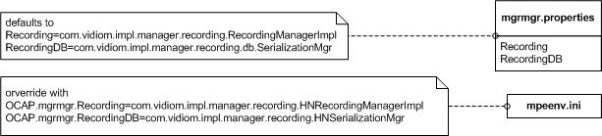
Figure 1 HN/DVR Manager Properties
This design has minimal impact on the current DVR implementation while allowing for a HN implementation to be transparently sub-classed onto it for the HN specific behavior.
Below is a diagram that shows the major integration points. The items in gray are new interfaces or classes that will be implemented. The diagram does not show all the affected classes in the current DVR implementation. These affected classes will be addressed in the dialog after the diagram.
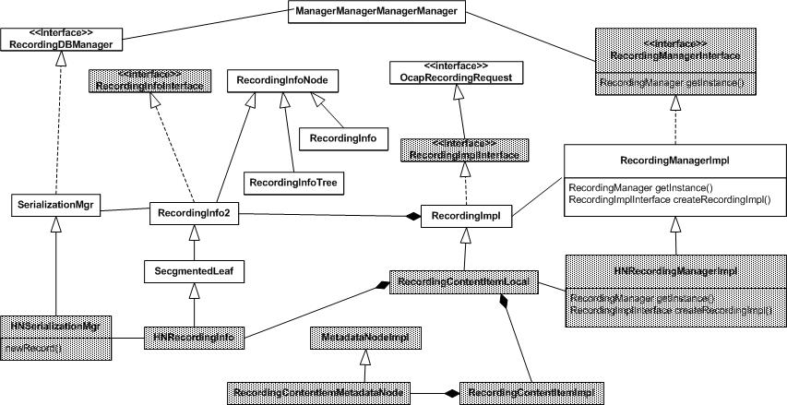
Figure 2 HN/DVR Integration
RecordingManagerInterface: This interface allows for multiple implementations to be returned from ManagerManager.getInstance( RecordingManager.class ). For the HN implementation, the implementation returned is HNRecordingManagerImpl. This class implements the factory methods to return a RecordingContentItemLocal instance, which implements RecordingImplInterface, that has the required HN behavior.
Anything that currently calls RecordingManagerImpl.getRecordingManagerInstance() will be changed to call (RecordingManagerInterface )ManagerManager.getInstance( RecordingManager.class ).
The mgrmgr.properties or mpeenv.ini will specify which RecordingManager implementation to return from ManagerManager.getInstance( RecordingManger.class ). Either RecordingManagerImpl or HNRecordingMangerImpl.
RecordingImplInterface: This interface allows for different DVR and HN/DVR implementations of that interface. For DVR only, the implementation will be RecordingImpl. For HN/DVR, the implementation will be RecordingContentItemLocal. The RecordingContentItemLocal class extends the RecordingImpl behavior and adds the HN behavior such that the RecordingImpl can be added to a UPnP ContentDIrectoryService so it can be browsed and played by a remote HN client.
RecordingInfoInterface: This interface is needed to allow for a RecordingInfo2/SegmentedLeaf sub-class named HNRecordingInfo to be used in a HN/DVR implementation. The HNRecordingInfo implementation forwards property changes to a RecordingContentItemLocal so it can update its metadata reliably when RecordingInfo2 properties change. This metadata needs to be captured such that interested remote UPnP clients can be notified and browse for that RecordingImpl’s metadata.
Since SerializationMgr has a factory method, newRecord(), that creates RecordingInfo2 instances, a RecordingInfo2 sub-class, HNSerializationMgr, needs to be created to override the newRecord() methods to return a HNRecordingInfo instance behind a RecordingInfoInterface instead of a SegmentedLeaf instance. HNSerializationMgr.newRecord() will return a HNRecordingInfo instance.
The ManagerManagerManagerManager.getInstance( RecordingDBManager.class) implementation will return a SerializationMgr implementation for DVR behavior and a HNSerializationMgr for HN/DVR behavior. These implementations will have factory methods to create either a RecordingInfo2, for DVR only, or a HNRecordingInfo, for HN/DVR that implement the RecordingInfoInterface.
Any code that uses a RecordingInfo2 directly will be changed to use a RecordingInfoInterface instance, obtained from RecordingDBManaer.newRecord(), instead.

Recording Serialization
Most of the existing serialization code for RecordingInfo2 is the same. Those instances are serialized to disk and reconstituted the same way as exists in code today. Since the HNRecordingInfo sub-class only adds extended behavior to RecordingInfo2 and not state, only the RecordingInfo2 needs to be serialized to disk.
There may be a problem with the serialization code that needs to be investigated. Since the RecordingInfo2.SegmentedLeaf is sub-classed by HNRecordingInfo, this may affect the serialization.
Loading from the disk is mostly the same as before. The restored instances of RecordingInfo2.SegmentedLeaf are wrapped with the sub-class HNRecordingInfo through a constructor that is created in the HNSerializationMgr.loadRecords() method.
Here is the pseudocode for restore recordings:
RecordingManagerImpl.restoreRecordings()
RecordingManagerImpl.loadPersistentRecordings(RecordingDBManager.loadRecords() )

HNSerializationMgr.loadRecords()
super.loadRecords()
for all elements in vector
create new HNRecordingInfo( element )
super( element.get_uniqueId, element )
add to new vector
return new vector

State Management
SRS registers as a RecordingManager listener and updates RecordTask and RecordSchedule states based on recording state from RecordingManager notification.

Metadata
RecordingContentItem property | MetadataNode return type | Maps to DVR Field
PROP_ACCESS_PERMISSIONS | ExtendedFileAccessPermissions | RecordingInfoNode.fap
PROP_APP_ID | org.dvb.application.AppID | RecordingInfoNode.appID
PROP_CONTENT_URI | String[] | N/A
PROP_DELETION_REASON | Integer | RecordingInfo2.deletionReason
PROP_DELETION_TIME | java.util.Date | RecordingInfo2.deletionTime
PROP_DESTINATION | ContentContainer | N/A
PROP_DURATION | Integer | RecordingInfo2.requestedDuration
PROP_EXPIRATION_PERIOD | Long | RecordingInfo2.expirationDate
PROP_FAILURE_REASON | Integer | RecordingInfo2.failedExceptionReason
PROP_MSO_CONTENT | Boolean | TBD
PROP_NET_RECORDING_ENTRY | String | N/A
PROP_ORGANIZATION | String | RecordingInfo2.organization
PROP_PRESENTATION_POINT | Long | TBD
PROP_PRIORITY_FLAG | Integer | RecordingInfo2.priority
PROP_RECORDING_STATE | Integer | Updated with notifications from RecordingManager to SRS.
PROP_RETENTION_PRIORITY | Integer | RecordingInfo2.retentionPriority
PROP_SOURCE_ID | Integer | TBD
PROP_SPACE_REQUIRED | Integer | TBD
PROP_START_TIME | java.util.Date | RecordingInfo2 RecordingStartTime

Table 7 RecordingContentItem/DVR Properties Mapping

Concurency
TBD
Must handle asynchronous calls from UPnP actions, application calls, notifications from RecordingRequest state change, CDS calls, …

SRS Priority Model
[UPNP SRS] section 2.8 ScheduledRecording Service Priority Model describes the priority model for prioritizing conflicting recordTask instances. How does this relate to the OCAP recording prioritization? I don’t think it does and can safely be ignored for now. The OCAP defined X_PrioritizeRecordings provides a mechanism for this already.

Rating System
This [UPNP SRS] defined feature is optional and will not be implemented.

Conflict Detection and Resolution
Conflicts between recordTask instances is handled through OCAP DVR mechanisms. The state of the recordingRequests map to recordTask states.

Initialization
todo: describe service advertisement sequence here and how NetManger will start the SRS.

Power cycle
There is no persistence of SRS state between power or reset cycles.

Implementation Structure and Interactions

Class Diagrams
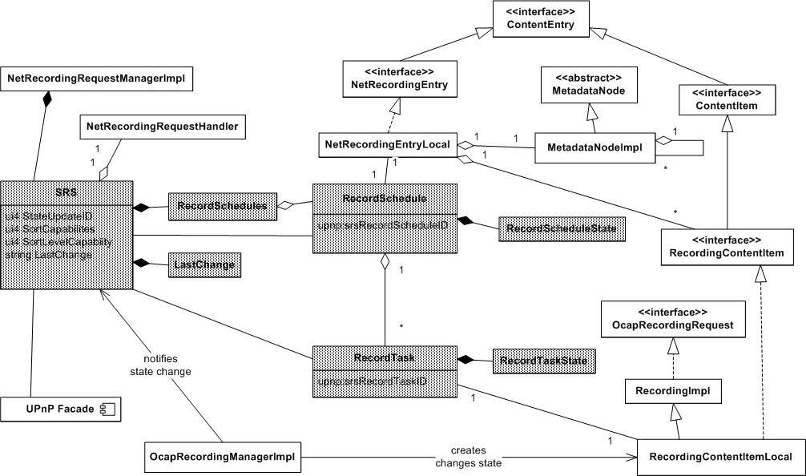
Figure 3 SRS Classes and associations

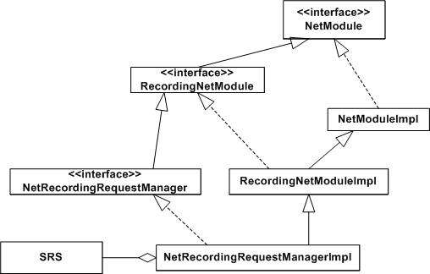
Figure 4 NetRecordingRequestManager Hierarchy
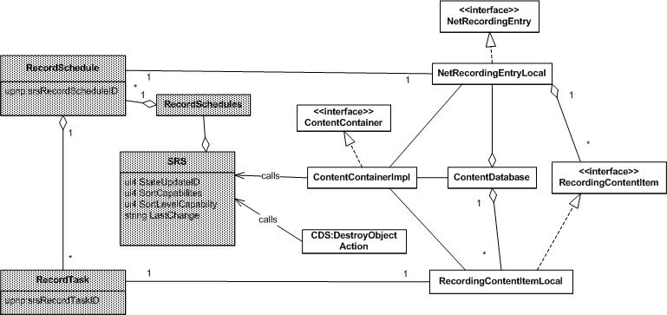
Figure 5 SRS-CDS associations

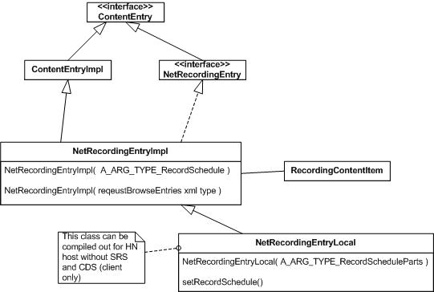
Figure 6 NetRecordingEntry Class Hierarchy

NetRecordingEntry
This represents a SRS RecordSchedule that contains zero or more RecordTask( RecordingContentItem).
There are two types of NetRecordingEntry implementations
- NetRecordingEntryImpl – base impl class and also represents the NetRecordingEntry from a remote SRS and CDS.
- NetRecordingEntryLocal – represents a NetRecordingEntry in a local SRS and CDS, extends NetRecordingEntryImpl with local behavior.
NetRecordingEntryLocal created by the SRS when a CreateRecordSchedule() action is received. This instance is ultimately added to CDS by ContentContainer.addContentEntry(NetRecordingEntry).
NetRecordingEntryImpl or NetRecordingEntryLocal can also be created by ContentServerNetModule.requestBrowseEntries() to represent NetRecordingEntry and contained RecordingContentItems on the remote or local CDS.
NetRecordingEntryImpl or NetRecordingEntryLocal can also be created by a client CreateRecordSchedule() action request from the return xml.
On hosts that have HN capability but not DVR, the NetRecordingEntryLocal can be excluded from the build since it is not needed.
For an example use of NetRecordingEntry example, see the sequence diagram for:
RecordingNetModule.requestSchedule( ) Local and Remote .

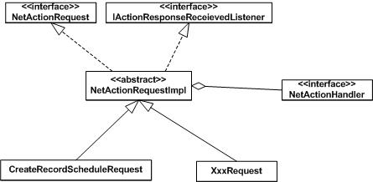
Figure 7 NetActionRequest Class Hierarchy

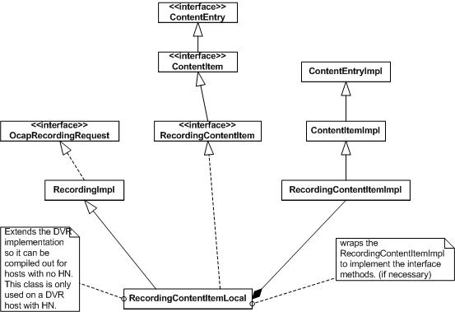
Figure 8 Local RecordingContentItemLocal

RecordingContentItemLocal
This class may need to be re-factored to derive from RecordingImpl and contain a RecordingContentItemImpl.java. If not, all the RecordingContentItem methods will have to be implemented instead of relying on the RecoridngContentItemImpl class to handle them. Also, since the RecordingContentItemImpl instance is contained and wrapped, those fields need to be populated with something somehow. This would have to be done by the DVR code since it is creating instances of these instead of OcapRecordingRequests. It might be easier to re-implement the RecordingContentItem interface.
For now, a temp implementation was created in org.cablelabs.impl.ocap.hn.recording.RecordingContentItemImpl.java to support this iteration.
RecordingContentItemLocal may have to be moved to com.vidiom.impl.manager.recording package because the RecordingImpl constructors are package private.
May need to re-factor and change the way the ocap name space properties are retrieved. For now each property is read as a String. There could be a get all method that returns an XML formatted String with all of the properties in it.

Interactions

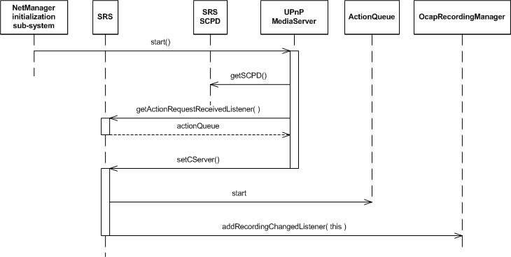
Figure 9 Initialization Sequence

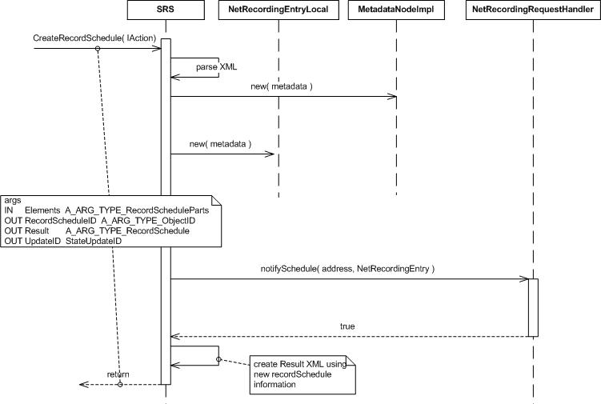
Figure 10 CreateRecordSchedule Action Sequence

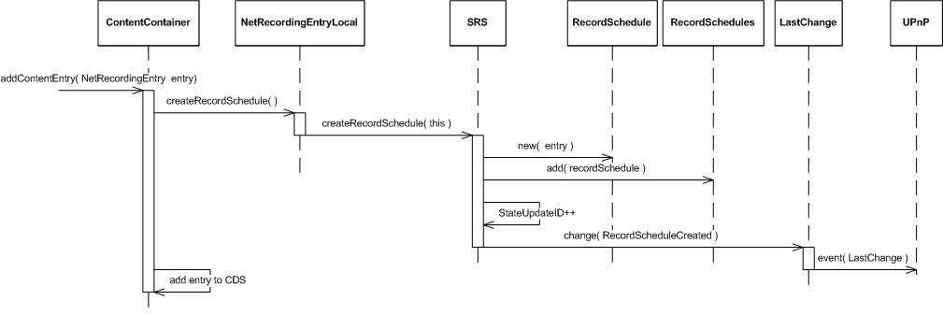
Figure 11 ContentContainer.addContentEntry( NetRecordingEntry ) Sequence
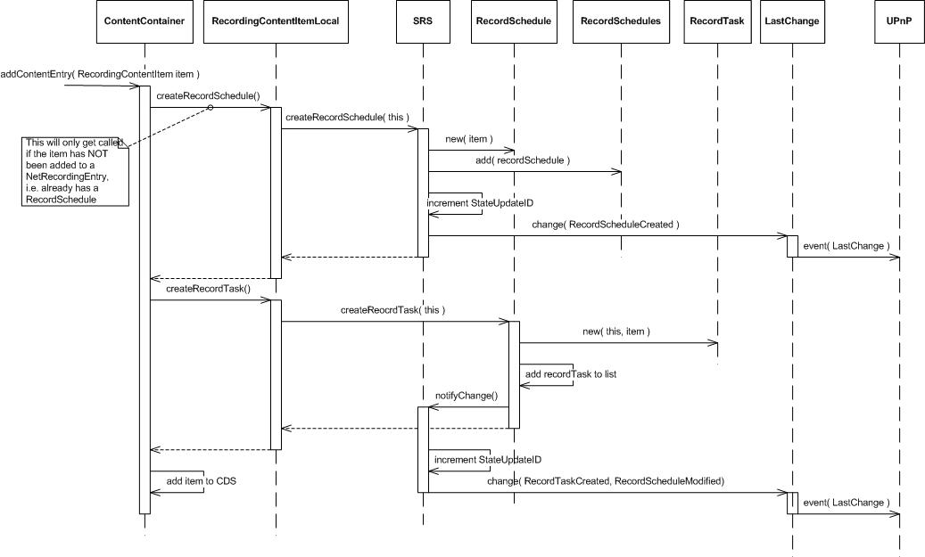
Figure 12 ContentContainer.addContentEntry( RecordingContentItem )
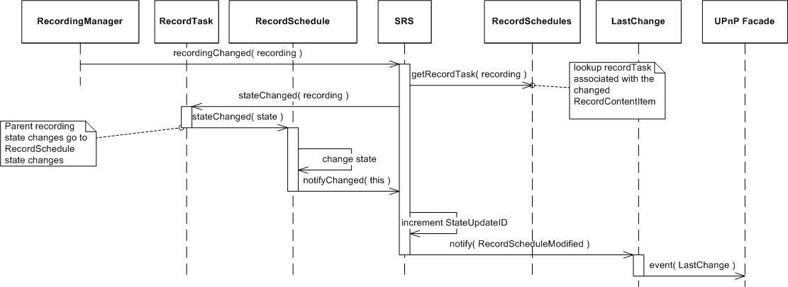
Figure 13 State Update Sequence
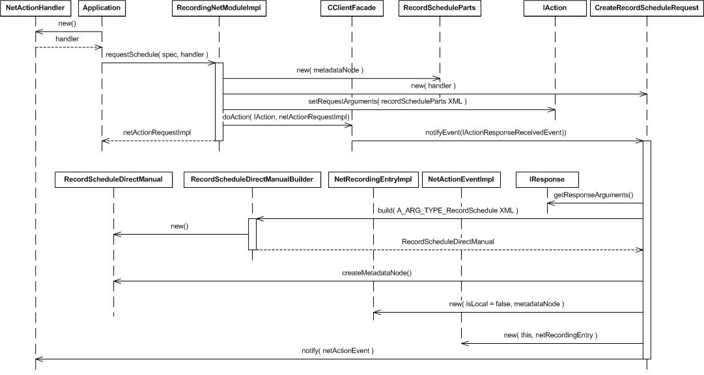
Figure 14 RecordingNetModule.requestSchedule() Remote

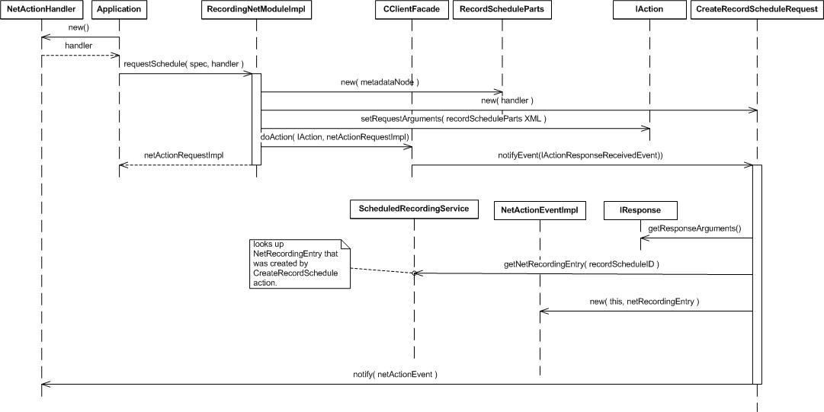
Figure 15 RecordingNetModule.requestSchedule() Local
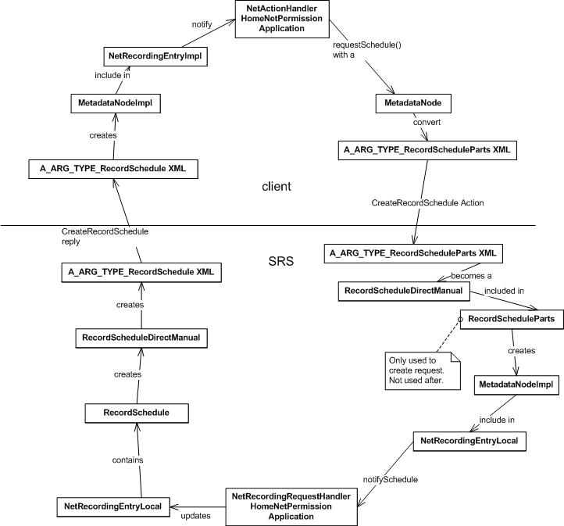
Figure 16 Homer's requestSchedule() data type round trip
Figure 15 shows most of the data types and conversions for a client requestSchedule() to server CreateRecordingRequest() action and back again. Plus, as a bonus feature, it kind of looks like a bust of Homer Simpson.

UPnP SRS Classes
object.recordSchedule.direct.manual

Use Cases

SRS

Initialization

Basic Course
Listen for recording changed events from OcapRecordingManager.
Advertise ScheduleRecording Service to UPnP network.
Wait for actions, application calls and recording changed events.

RecordTask completes recording

Basic Course
When all of the recordTask for a recordSchedule have completed, the recordSchedule can be deleted along with all of its recordTasks. Or, they can be deleted after a reasonable amount of time. TODO: pick one. Must consider the lifetime of NetRecordingEntry and RecordingContentItem. Do instances of those require that the RecordSchedule and RecordTask be tied to those lifetimes?

UPnP Action Use Cases

CreateRecordSchedule action received

Basic Course
Get action input parameters and parse.
Create InetAddress of requesting control point.
create MetadataNode from input parms
If the item id element is non-empty indicating that requestReschedule () was called by the client.
Look up recordSchedule or recordTask instance by id.
If id is a recordTask, find recordSchedule that contains the recordTask and recordingContentItem that is associated with the recordTask.
Find associated netRecordingEntry of recordSchedule.
Call NetRecordingRequestHandler.notifyReschedule( action sender InetAddress, contentEntry, netRecordingEntry2 ); TODO: there is a conflict between this api signature in javadoc and 1314
If notifyReschedule() returns true,
send action response with TBD parameters.
else send action response with UPnP error 720.
else the item id element is empty indicating that requestSchedule() was called by the client.
Create a netRecordingEntry instance.
The netRecordingEntry must have the properties defined in Table 6-2 of the HNP spec. See section 6.7.4.7 requestSchedule method for more details. Also, UPNP SRS table C-7. Also ECO 1298-2.
Call NetRecordingRequestHandler.notifySchedule( IPaddress, netRecordingEntry );
If notifySchedule() returns true
Verify the NetRecordingEntry parameter includes a parent container ID property to verify that the NetRecordingRequestHandler application added a CDS entry for the parameter.
Verify that the NetRecordingEntry has an associated RecordSchedule.
Verify that the associated RecordSchedule will has an ocap:cdsReference and ocap:scheduledCDSEntryID.
Send response to action with A_ARG_TYPE_ObjectID, A_ARG_TYPE_RecordSchedule, StateUpdateID.
else send action response with UPnP error 720.

Alternate Course
If the NetRecordingEntry was not added to CDS, the HNIMP SHALL fail the action with UPnP error 720, cannot process the request. (from HNP spec section 6.7.3.6) and ECO 1334-4.

Alternate Course
Action contains unsupported or unknown properties: ignore them.

Alternate Course
Action contains supported properties with unsupported values: return an error, don’t create recordSchedule.

Alternate Course
NetRecordingRequestHandler.notifySchedule() returns true without adding RecordingContentItem or adding NetRecordingEntry or a created RecordSchedule and RecordTask:

Alternate Course
Action handling is taking longer than 30seconds. What happens if NetRecordingRequestHandler is taking too long to process the action? There is no way to abort the action and tell the NetRecordingRequestHandler this has happened.

Alternate Course
There is no NetRecordingRequestHandler installed, error 720,

Alternate Course
Application execution thread context is not available

GetSortCapabilites() action received
TBD

GetPropertyList() action received
TBD

GetAllowedValues() action received
TBD

GetStateUpdateID() action received
TBD

BrowseRecordSchedules() action received
TBD

BrowseRecordTasks() action received
TBD

DeleteRecordSchedule() action received
This action is caused by the same client api that will cause a DeleteRecordTask(). Some of this behavior will be similar and the implementation for this action handler could possibly be reused. The client api is RecordingNetModule. requestDeleteService().
Lookup recordSchedule instance that corresponds to the action ObjectID.
Get netRecordingEntry that is associated with recordSchedule.
Call NetRecordingRequestHandler.notifyDeleteService( InetAddress, netRecordingEntry ).
If notifyDeleteService() returns true, return TBD.

Alternate Courses
If notifyDeleteService returns false, respond with error 720.
If no NetRecordingRequestHandler, respond with error 720.
If there is no ObjectID that corresponds to an existing RecordSchedule, TBD

GetRecordSchedule() action received
TBD

EnableRecordSchedule()
TBD
This is required to be handled by UPnP because DisableRecordSchedule() is implemented. However, OCAP has no defined behavior for this. This action will return TBD.

DisableRecordSchedule()

Basic Course
This action is caused by the same client api that will cause a DisableRecordTask(). Some of this behavior will be similar and the implementation for this action handler could possibly be reused. The client api is RecordingNetModule. requestDisable().
Lookup recordSchedule instance that corresponds to the action ObjectID.
check all recordTask in recordSchedule are in IDLS or DONE state, or no recordTask
Get netRecordingEntry that is associated with recordSchedule.
Call NetRecordingRequestHandler.notifyDisable( InetAddress, netRecordingEntry ).
If notifyDisable() returns true, TODO: just return response to action? Leave the recordTask and RecordSchedule alone? Change state of those?

Alternate Courses
If notifyDisable returns false, respond with error 720.
If no NetRecordingRequestHandler, respond with error 720.
If there is no ObjectID that corresponds to an existing RecordSchedule, 704
Any recordTask in recordSchedule is not IDLE or DONE, return 705

DeleteRecordTask() action received
This action is caused by the same client api that will cause a DeleteRecordSchedule(). Some of this behavior will be similar and the implementation for this action handler could possibly be reused. The client api is RecordingNetModule. requestDeleteService().
Lookup recordTask instance that corresponds to the action ObjectID.
Get recordingContentItem that is associated with recordSchedule.
Call NetRecordingRequestHandler.notifyDeleteService( InetAddress, recordingContentItem ).
If notifyDeleteService() returns true, return TBD.

Alternate Courses
If notifyDeleteService returns false, respond with error 720.
If no NetRecordingRequestHandler, respond with error 720.
If there is no ObjectID that corresponds to an existing RecordSchedule, TBD

GetRecordTask() action received
TBD

EnableRecordTask()
TBD
This is required to be handled by UPnP because DisableRecordTask() is implemented. However, OCAP has no defined behavior for this. This action will return TBD.

DisableRecordTask()

Basic Course
This action is caused by the same client api that will cause a DisableRecordSchedule(). Some of this behavior will be similar and the implementation for this action handler could possibly be reused. The client api is RecordingNetModule. requestDisable().
Lookup recordTask instance that corresponds to the action ObjectID.
Get recordingContentItem that is associated with recordTask.
Call NetRecordingRequestHandler.notifyDiable( InetAddress, recordingContentItem).
If notifyDisable() returns true, TODO: just return response to action? Leave the recordTask and RecordSchedule alone? Change state of those?

Alternate Courses
If notifyDisable returns false, respond with error 720.
If no NetRecordingRequestHandler, respond with error 720.
If there is no ObjectID that corresponds to an existing RecordTask, return TBD

ResetRecordTask()
TBD
This is required to be handled by UPnP because DisableRecordTask() is implemented. However, OCAP has no defined behavior for this. This action will return TBD.

GetRecordScheduleConflicts() action received
There is no hn client api to cause this action but it must be implemented according to upnp spec. TODO: what to return? No conflicts?

GetRecordTaskConflicts() action received
The HNScheduledRecordingService calls the OCAP DVR implementation OcapRecordingManger.getRecordingRequest() using the RecordingContentItem id passed in the UPnP ScheduledRecording Service Action metadata to acquire the org.ocap.dvr.OcapRecordingRequest object associated with the RecordingContentItem.
The HNScheduledRecordingService calls the OCAP DVR implementation org.ocap.dvr.OcapRecordingRequest.getOverlappingEntries() to get a RecordingList of overlapping or conflicting RecordingRequest objects.

X_PrioritizeRecordings() action received
This action is caused by a client calling RecordingNetModule.requestPrioritize(RecordingContentItem[] ) or RecordingNetModule.requestPrioritize( NetRecordingEntry[] ).
Look up action input to see if it is passing an array of recordSchedule or an array of recordTask.
If array of recordSchedule
build an array of netRecordingEntries associated with the recordSchedules
call NetRecordingRequestHandler.notifyPrioritization( InetAddress, netRecordingEntry[] )
else if array of recordTask
build an array of recordingContentItem associated with the recordTask
call NetRecordingRequestHandler.notifyPrioritization( InetAddress, recordingContentItem[] )
if notifyPrioritization() returns true, return TBD

CDS Use Cases

DeleteResource action
Caused by client call to RecordingNetModule.requestDeleteService() ???
check this out.

DestroyObject action
This action is caused by a client calling RecordingNetModule.requestDelete().
If the action ObjectID corresponds to a NetRecordingEntry or a RecordingContentItem, the CDS notifies the NetRecordingRequestManager with that contentEntry instance and inetAddress of the action caller. The SRS calls the registered NetRecordingRequestHandler.notifyDelete( InetAddress, contentEntry).
If notifyDelete() returns true, the CDS destroys the object.
else, the CDS returns error 720 to the action caller.
TODO: does the SRS remove the recordSchedule or recordTask?
TODO: there could be a way for the NetRecordingRequestManager to register the NetRecordingRequestHandler with the CDS. The CDS could call notifyDestroy() directly and then destroy the object.

ContentContainer

ContentContainer.addContentEntry( NetRecordingEntry )
see 1314, 1334

Basic Course
If either ContentContainer or NetRecordingEntry are not local, return false.
Create recordSchedule of type object.RecordSchedule.direct.manual with a unique upnp:srsRecordScheduleID.
Add the recordSchedule to the list of RecordSchedules
Associate recordSchedule with NetRecordingEntry
Create a CDS content item and add the unique upnp:srsRecordScheduleID to it.
Add the new CDS content item to this ContentContainer.
Add an ocap:scheduledCDSEntryID and an ocap:cdsReference to the RecordSchedule. The definitions of ocap:scheduleCDSEntryID and ocap:cdsReference are described in C.1.2. The ocap:scheduledCDSEntryID must contain the object ID of the CDS entry created for the NetRecordingEntry. The ocap:cdsReference must contain the properly escaped DIDL-Lite document of the CDS content item corresponding to the NetRecordingEntry.
Add the parentID property containing the ObjectID of this ContentContainer to the CDS entry.
Increment SRS StateUpdateID.
Generate LastChange event for the new RecordSchedule.

Alternate Course 1
If this is called multiple times with the same NetRecordingEntry instance: remove the entry from the other container and add to this one with this container’s parented property.

Alternate Course 2
If the NetRecordingEntry already has an associated RecordSchedule, don’t create a new one. Do everything else as if a new one was created.

ContentContainer.addContentEntry( RecordingContentItem )
see 1314, and 1334. This mainly describes SRS specific behavior. CDS behavior may not be completely described here.
In brief, if the RecordingContentItem has not been added to a NetRecordingEntry, create a RecordSchedule and RecordTask for this RecordContentItem. If the RecordingContentItem has been added to a NetRecordingEntry, create a RecordTask and add it to the RecordSchedule of the NetRecordingEntry. More detailed behavior as poorly defined in the specs follows:
If either ContentContainer or RecordingContentItem are not local, return false.
If the RecordingContentItem does not already contain a upnp:srsRecordScheduleID property, create an object.recordSchedule.direct.manual. Add the upnp:srsRecordScheduleID property containing the ID of the RecordSchedule to the new CDS content item created to represent this RecordingContentItem.
If the RecordingContentItem does contain a upnp:srsRecordTaskID property, create a SRS object.recordTask and add it to the RecordSchedule whose ID is indicated by the upnp:srsRecordScheduleID property of the RecordingContentItem. Add a upnp:srsRecordTaskID property containing the ID of the RecordTask to the CDS content item created to represent this RecordingContentItem. Add ocap:scheduledCDSEntryID defined in C.1.2 to the RecordTask.
If the RecordingContentItem is included in a NetRecordingEntry, add ocap:netRecordingEntry property to the CDS content item created to represent this RecordingContentItem. The ocap:netRecordingEntry must contain the ObjectID of the NetRecordingEntry. Add the Object ID of the RecordingContentItem to a list contained in the ocap:RCIList property of the CDS content item corresponding to the NetRecordingEntry. The definitions of ocap:netRecordingEntry property and ocap:RCIList property are described in C.1.3.
The ocap:RCIList property includes CSV list which represents the list of ObjectIDs of the RecordingContentItems added both to the NetRecordingEntry and to the CDS. When the OC-DMS responds to CDS:Browse or CDS:Search which retrieves the CDS content item corresponding to a NetRecordingEntry, the OC-DMS includes the ocap:RCIList property to the <item> block corresponding to the NetRecordingEntry by using ocap namespace<desc> block.
Create a CDS content item and add it to this ContentContainer. Add the properties defined in Annex C.1.1 to the new CDS content item. Use the values from the input RecordingContentItem and OcapRecordingRequest instance for the property values.
C.1.1 ocapRecordingItem: item CDS class property definitions
The following properties are mapped from the OCAP DVR RecordingRequest interface to a CDS ocapScheduledRecordingItem. When a RecordingRequest has been published to the network, these properties are mapped from the local RecordingRequest to the local CDS by the host implementation. Property values in the CDS are implicitly updated by the host as RecordingRequest parameters are updated, whether through normal DVR schedule operation or through manipulation by local OCAP applications. The properties listed in Table 6-2 are also used for requesting the scheduled recording.
Table C-1 ocapRecordingItem Mapped to CDS
Property Name | Name Space | Data Type | Multi-Valued | Reference
taskState | ocap | xsd:int | NO
scheduledStartDateTime | ocap | xsd:dateTime | NO
scheduledDuration | ocap | xsd:string | NO
scheduledChannelID | ocap | xsd:string | NO
destination | ocap | xsd:string | NO
priorityFlag | ocap | xsd:int | NO
retentionPriority | ocap | xsd:int | NO
eFAP | ocap | xsd:string | NO
organizationString | ocap | xsd:string | NO
AppID | ocap | xsd:string | NO
OrgID | ocap | xsd:string | NO
spaceRequired | ocap | xsd:long | NO
contentURI | ocap | xsd:string | YES
mediaPresentationPoint | ocap | xsd:long | NO
msoContentIndicator | ocap | xsd:long | NO
expirationPeriod | ocap | xsd:long | NO
mediaStorageVolume | ocap | xsd:boolean | NO

Add the parentID property containing the ObjectID of this ContentContainer to the CDS entry.
Increment SRS StateUpdateID.
If a new RecordTask was created, generate a LastChange event for the new RecordTask and RecordScheduleModified. If a new RecordSchedle was created, add a new RecordSchedule to the LastChange event also.

Alternate Course:
A RecordContentItem is added that already has a RecordTask: don’t create a new RecordTask, use the existing one.
From 1334: It is the responsibility of applications calling this method to determine whether addition of CDS item for this RecordingContentItem, that already contains a upnp:srsRecordTaskID property, is appropriate.

ContentContainer.removeContentEntry( RecordingContentItem )
see 1334
If the item contains a upnp:srsRecordTaskID property, remove the SRS object.recordTask indicated by the property. Remove the upnp:srsRecordTaskID property from the item.
if the item contains a upnp:srsRecordScheduleID property and is not added to any NetRecordEntry, remove the SRS object.recordSchedule.direct.manual indicated by the property. Remove the upnp:srsRecordSchedulID property from the item.
Increment SRS StateUpdateID.
Generate LastChange event.

ContentContainer.removeContentEntry( NetRecordingEntry )
see 1334
if the entry contains a upnp:srsRecordScheduleID property and contains one or more RecordingContentItems, throw an IllegalArgumentException.
if the entry contains a upnp:srsRecordScheduleID property and contains no RecordingContentItems, remove the SRS object.recordSchedule.direct.manual object indicated by the property. Remove the upnp:srsRecordScheduleID property from the entry.
Remove the ContentEntry parameter from the ContentContainer. The CDS entry corresponding to the ContentEntry parameter is also removed from the CDS. Remove the parented property from entry.
Increment SRS StateUpdateID.
Generate LastChange event.

ContentContainer.removeContentEntries()
see 1334
Call removeContentEntry() for each entry.

NetRecordingEntry Use Cases

application calls NetRecordingEntry.addRecordingContentItem( RecordingContentItem item )

Basic Course
From 1314: recordTask is created later, just associate the item with the entry at this point.
From 1334:
If the RecordingContentItem already contains a upnp:srsRecordScheduleID, throw an IllegalArgumentException.
If this NetRecordingEntry does not contain a upnp:srsRecordScheduleID, throw an IllegalStateException.
The upnp:srsRecordScheduleID indicates that the NetRecordingEntry has been added to the CDS via ContentContainer.addContentEntry( NetRecordingEntry) and that this NetRecordingEntry is associated with a RecordSchedule in the SRS.
Add a upnp:srsRecordScheduleID property and value to the RecordingContentItem and contain the RecordingContentItem within this NetRecordingEntry.

Alternate Course

Application calls getRecordingContentItemIDs()

Application calls getRecordingContentItems()
If not isLocal(), this call won’t return the correct values if this entry was retrieved as a notify from a CreateRecordSchedule() action. The Result return of that action does not have enough information to build these items to add to the entry. The CreateRecordSchedule return could do a browse srs tasks to get them and build them but am not sure this is the correct way to go yet.

Application calls removeRecordingContentItem()
Does this have any side affects on SRS or SDS entries? Or, does it just remove the reference to the item?

NetRecordingRequestManager Use Cases

Application calls NetRecordingRequestManager.createNetRecordingEntry()
Create empty MetadataNodeImpl.
Create new NetRecordingEntryImpl with empty metadataNoteImpl.
Return new netRecordingEntryImpl

Application calls setNetRecordingRequestHandler( handler )

Basic Course
Set the handler to the SRS so it can call the handler directly.

OcapRecordingManager Use Cases

All OcapRecordingManager methods that affect the RecordingRequest and RecordingContentItem instances..
Anytime a RecordingRequest(RecordingContentItem) instance changes, notify the associated RecordTask instance. TODO: are there other changes besides state change?
Increment StateUpdateID
Generate LastChange event.

Application calls OcapRecordingManager.record()

Basic Course:
An instance of RecordingContentItem is returned.

RecordingContentItem Use Cases

Properties change
TODO: If it is contained in a CDS, the CDS must be notified so it can generate a changed event to the upnp network.

Application calls getRecordingEntry()
Returns the NetRecordingEntry that contains this entry.

Application calls getRecordingEntryID()

Application calls requestConflictingRecordings()
This call generates a GetRecordTaskConflicts() action to the SRS.

Application calls requestSetMediaTime()
This call generates a UpdateObject() action to the CDS

RecordingNetModule

Application calls RecordingNetModule.requestSchedule( NetRecordingSpec, NetActionHandler)

Basic Course
Get the MetadataNode from the NetRecordingSpec. Convert MetadataNode into CreateScheduleRecording() Entries parameter. Register for action complete notify. Send action to remote SRS.
Create action parameter xml from the input MetadataNode with all of the required properties from the UPnP SRS table C.7 as well as the properties defined in HNP annex C.1.1 and Table 6-2.
Associate input NetActionHandler instance with the action request.
Create NetActionRequest instance and return to caller.
ECO 1298-2 adds to HNP 6.7.4.7: include all properties in the NetRecordingSpec including properties with the “ocapApp” namespace as defined in section 6.3.9.

Alternate Course

Action request completes and notifies

Basic Course
Find NetActionHandler instance associated with the action request.
If the action was a CreateRecordSchedule, create a NetRecordingEntry instance with a MetadataNode that contains all the returnl values from the action request.
Create a NetActionEvent instance such that getResponse() returns the NetRecordingEntry instance.
Call NetActionHandler.notify( NetActionEvent) with the newly created NetActionEvent instance.
ECR 1344: NetRecordingEntry is returned via NetActionEvent.getResponse()

Alternate Course
Is there a timeout event?

NetActionRequest

Application calls NetActionRequest.cancel()
Return false. Can’t cancel an action.

Application calls NetActionRequest.getActionStatus()

Application calls NetActionRequest.getError()

Application calls NetActionRequest.getProgress()
Return 1.0. Can’t determine progress.

Issues With OCAP HN API and Specifications

MetadataNode

public static MetadataNode createMetadataNode( String key )
The javadoc doesn’t talk about what to do with the key. It implies that the new node can be found with the key which means that the new node has to be added to some parent node. However, since this is a static method, the new node has no parent available to add to. Even if it did, the key parameter is not validated as in the addMetadata() call.
Why is a constructor defined for this abstract base class?
The ability to add a MetadataNode to a MetadataNode will set the parent of the added node to the add to node. If the added node was previously added to a different node, the parent and key information of the added node is no longer valid in the other tree. If a deep copy is made when adding all nodes, the references to the added node no longer matches the reference that is actually stored in the tree. This could lead to application confusion.
It is not clear how to implement namespace addition and checking in this class. The specifications and javadoc are extremely confusing what this means or how to implement it in regards to this class.

MetadataIdentifiers
The javadoc is nonsensical.
What is PROPRIETARY_DATA? The javadoc defines it as a string with specific data then talks about it as an array of bytes.
Why is there a constructor defined? It is an abstract class with static methods only.

NetRecordingSpec
Should NetRecordingSpec( MetadataNode node ) make a deep copy of the input node or just save a reference? The implications of just saving a reference is that the node can be changed outside of the NetRecordingSpec. The implications of making a copy is that the stored node reference is hidden from the application. The spec should be clear on this behavior.

NetActionRequest
getError() return values are not defined except for -1. NetActionEvent gives the error reason, why have another mechanism for getting the same value. This assumes that getError() would return NetActionEvent.ACTION_FAILED.
cancel() there is no easy way to implement this. Get rid of it.
getProgress() there is no easy or reliable way to implement this. Get rid of it.

NetActionEvent
getError() return values are not defined. If there are no standard return values, an application cannot be written to run on multiple implementations that rely on specific values.
protected constructor takes an Object for the request parameter. The getActionRequest() method returns a NetActionRequest instance. If a non-NetActionRequest is passed in the request parameter, there is no recourse other than returning null for getActionRequest().
ACTION_STATUS_NOT_AVAIALABLE AND ACTION_IN_PROGRESS have the same value of ACTION_FAILED + 1.

NetRecordingEntry
Having the same interface for both server side and client side behavior is confusing. For example addRecordingContentItem() or removeRecordingContentItem() does not make sense for a client to call if isLocal() returns false.
addRecordingContentItem and removeRecordingContentItem are supposed to throw an IOException if isLocal() returns false. However, IOException is a checked exception and must be declared in the throws clause which it isn’t currently.
It would be better to define two interfaces, one for client representation of an entry and one for local access for SRS required behavior. Mixing the two notions makes for a messy and confusing implementation. Application use of this interface is confusing as well.
The CreateRecordSchedule action returns a Result that does not include enough information to build the RecordingContentItem instances contained in the NetRecordingEntry on the SRS. That is yet another reason to have different interfaces for client and server. That action could browse for the recordTasks after the action return to get them and build the recordingContentItems and add to the entry but am not sure this is the way to go yet. TODO: see 6.7.4.7 HNP2 for more details and rules, look at ecns.

HNP 2.0 Annex C
The HNP2.0 specification Annex C OCAP Name Space is a mess. The Data Types in Table C-1 don’t match the descriptions of each property.
RecordingContentItem defines property strings used to access the meta values in MetadataNode. These are supposed to map to the property names in the HNP Table C-1; they don’t.
- RecordingContentItem.PROP_ACCESS_PERMISSIONS = “ocap:accessPermissions”. Table C-1 defines that property name as “ocap:eFAP”.
- Several names map but have a mismatch of case e.g. appID vs. AppID
- The definitions of the values in Table C-1 don’t match the name, data type or multi-valued setting in several cases. Very confusing.

ECO 1334-4
ECO 1334 is really poorly worded and hard to figure out what the required behavior is or why.
ECO 1334 6.3.2.1 addContentEntry method, step 2. when the pareameter is a RecordingContentItem reads: ‘If the RecordingContentItem does not already contain…’ should read ‘If the RecordingContentItem does already contain … ‘.

Section 6.7.3.6 notifySchedule method
The change obliterates the requirement to return an cds reference to the created and stored recording entry. The original HNP 2.0 spec defined using cdsReference and cdsReference@link in the result. However, UPnP does not allow those as return properties for a object.recordSchedule.direct.manual class. This ECN tries to correct that by using ocap name space property of ocap:cdsReference associated with the created RecordSchedule. However, the new text removes the need to return the ocap:cdsReference in the reply to the CreateRecordSchedule action.

