Home Work Assignment 1

Alon Zeltser -

Nadav Amir - 308339860

**Question 1**

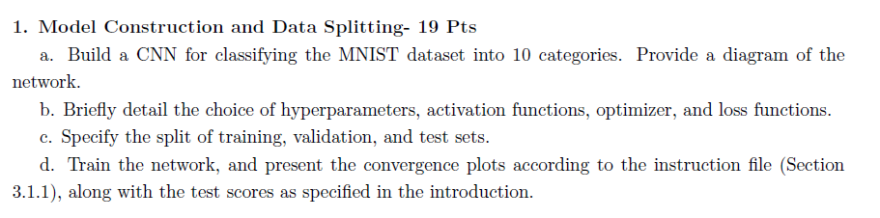

**Answer**

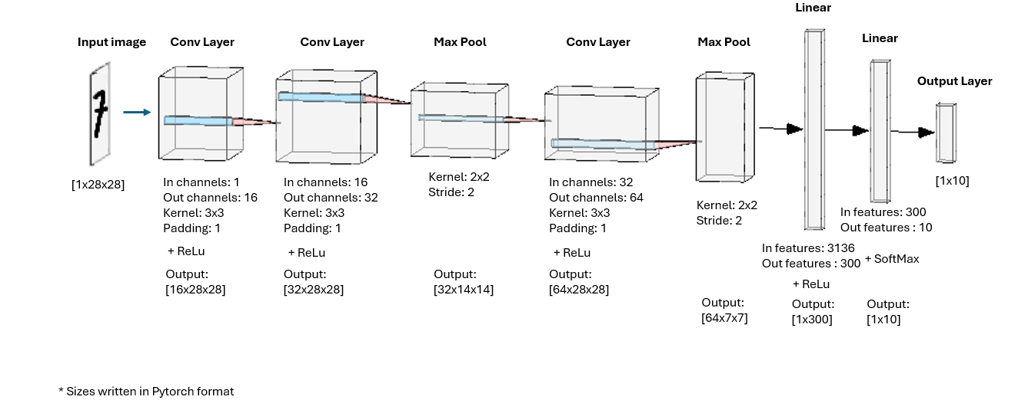

1. We followed a basic CNN structure. ReLU was used as the activation function to introduce non-linearity and minimize vanishing gradients phenomena, while SoftMax was applied at the output layer for probabilistic multi-class predictions[1]. A mini-batch size of 264 provided a balance between computational efficiency and convergence stability. We chose a learning rate of 0.001 for steady training and ran for 20 epochs to ensure sufficient learning without overfitting. Adam Optimizer was selected for its adaptive learning capability. Cross-entropy loss was used, as it is suitable for multi-class classification problems.
2. Train: 48,000 images (68.57%), Validation: 12,000 images (17.14%), Test: 10,000 images (14.28%)
3. See the next page:

|  |  |
| --- | --- |
| Figure 3 – Test Set F1 Score for each category + Macro (Average) Value | A graph showing a number of numbers  AI-generated content may be incorrect. Figure 2 – Test Set Confusion Matrix |
| A graph of a train  AI-generated content may be incorrect.  Figure 1 – Training vs. Validation Loss Progress Graph | |

**Question 2**

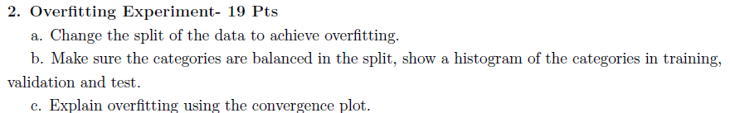

**Answer**

1. We changed the split to be - Train 120 images (0.17 %), Validation 59880 images (85.54%), Test 10,000 images (14.28%)
2. We used *StratifiedShuddleSplit* to make sure that the data is balanced:

|  |  |  |
| --- | --- | --- |
| Figure 4 – Train Set Class Distribution | A graph of a number of blue bars  AI-generated content may be incorrect.  Figure 5 – Validation Set Class Distribution | A bar graph with numbers and text  AI-generated content may be incorrect.  Figure 6 – Test Set Class Distribution |

1. According to Fig 7, around epoch 11 the validation loss stops decreasing and begins to rise slightly, while the training loss continues converging toward zero. This suggests the model is starting to "memorize" the training set rather than generalizing.

A graph of a train vs.

Figure 7 – Training vs. Validation Loss Progress Graph – Over Fitting Experiment

**Question 3**

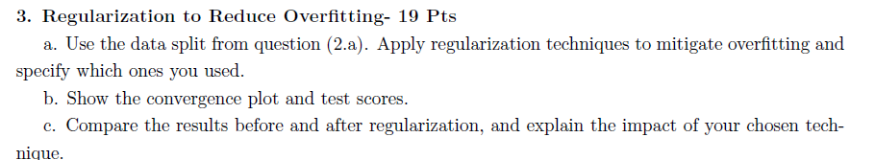

**Answer**

1. We Applied three regularization techniques separately:
   1. Early stopping with patience of 2 epochs
   2. Dropout – we applied dropout with probability 0.02 after each layer in the model (can see specification in the attached code)
   3. L2 regularization
2. Graphs are attached for each method:

**Early stopping with patience of 2 epochs**

|  |  |
| --- | --- |
| A graph of a number of classes  AI-generated content may be incorrect.  Figure 8 – Test Set F1 Score for each category + Macro (Average) Value – Over Fitting + Early Stopping | A graph with green squares  AI-generated content may be incorrect.  Figure 9 – Test Set Confusion Matrix – Over Fitting + Early Stopping |
| Figure 10 – Training vs. Validation Loss Progress Graph – OverFitting + Early Stopping | |

**Dropout**

|  |  |
| --- | --- |
|   Figure 11 – Test Set F1 Score for each category + Macro (Average) Value – Over Fitting + Dropout |   Figure 12 – Test Set Confusion Matrix – Over Fitting + Dropout |
| Figure 13 – Test Set F1 Score for each category + Macro (Average) Value – Over Fitting + Dropout  **L2 regularization** | |
| Figure 14 – Test Set F1 Score for each category + Macro (Average) Value – Over Fitting + l2 regularization | Figure 15 – Test Set Confusion Matrix – Over Fitting + l2 regularization |
| Figure 16 – Test Set F1 Score for each category + Macro (Average) Value – Over Fitting + l2 regularization | |

1. Comparison. Attached is a table with macro f1 score for each regularization scenarios and for the non-regularized one.

|  |  |  |  |  |
| --- | --- | --- | --- | --- |
| **Method** | **Without regularization** | **Early stooping** | **Dropout** | **L2** |
| **Macro F1** | 0.747 | 0.765 | 0.777 | 0.764 |

Overall, all regularization techniques provided only a slight improvement over the non-regularized model. Early Stopping: This method stops training when the validation performance stops improving. Although it increased the Macro F1 score from 0.747 to 0.765, the loss graphs indicate that it did not significantly reduce the validation loss. Dropout: Randomly deactivating a small subset of neurons during training forces the network to learn more robust features. We examined several dropout configurations, and the chosen configuration (Small dropout after each layer) was able to increase the macro F1 score from 0.747 to 0.777. L2 Regularization: Adding a penalty for large weights to the loss function, L2 regularization encourages simpler models that generalize better, resulting in a Macro F1 score of 0.764.

1. Although softmax is implied for multi-class classification, we did not apply it explicitly, as PyTorch’s CrossEntropyLoss includes it internally.