|  |  |  |  |  |  |
| --- | --- | --- | --- | --- | --- |
| 275-362 | Prediction  κ=0.529 | | | | |
| Actual |  | <90 | >90 | Total |
| <90 | 50 | 4 | 54 |
| >90 | 7 | 9 | 16 |
| Total | 57 | 13 | 70 |

|  |  |  |  |  |  |
| --- | --- | --- | --- | --- | --- |
| Full EEM | Prediction  κ=0.590 | | | | |
| Actual |  | <90 | >90 | Total |
| <90 | 52 | 2 | 54 |
| >90 | 7 | 9 | 16 |
| Total | 59 | 11 | 70 |

|  |  |  |  |  |  |
| --- | --- | --- | --- | --- | --- |
| 280 nm Excitation | Prediction  κ=0.213 | | | | |
| Actual |  | <90 | >90 | Total |
| <90 | 50 | 4 | 54 |
| >90 | 12 | 4 | 16 |
| Total | 62 | 8 | 70 |

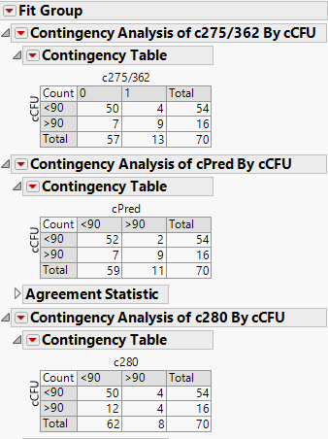

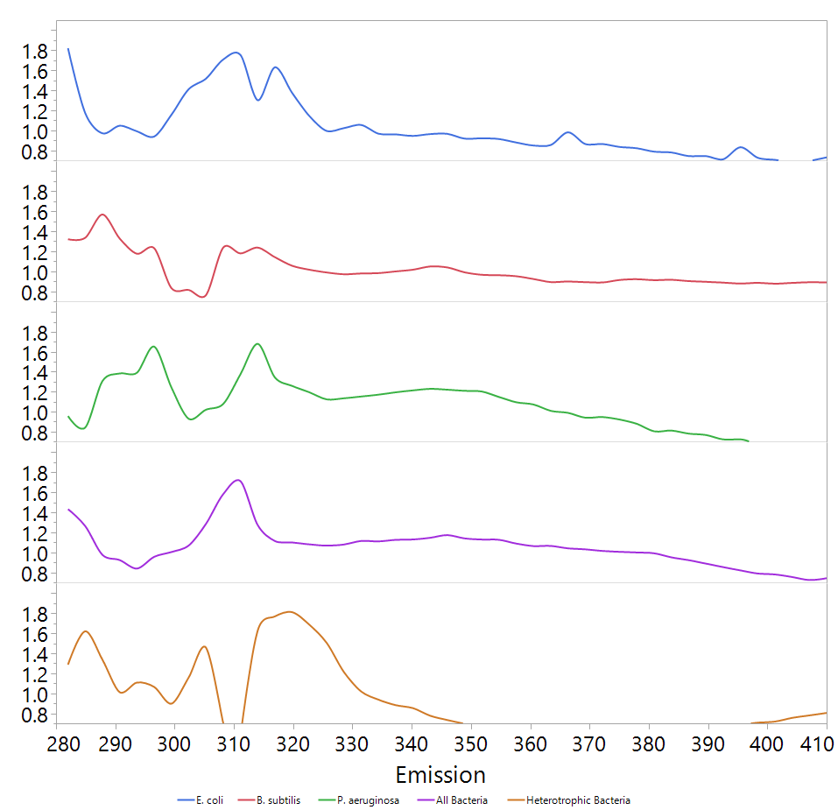

C

D

A

B

Figure 7. Variable importance (VI) plots of PLS models made from 280 nm excitation spectra. The plots show only values >0.8, as these are the important ones (JMP manual). Shades a,b,c and d indicate areas of peaks which may be indicative bacterial concentration.

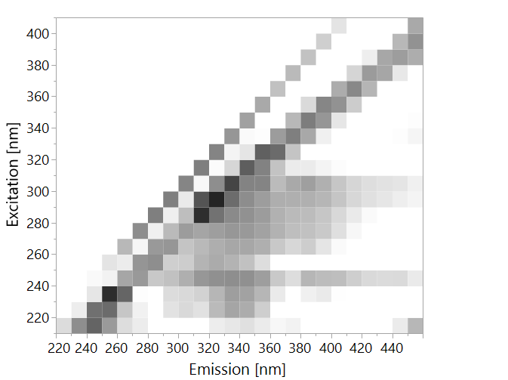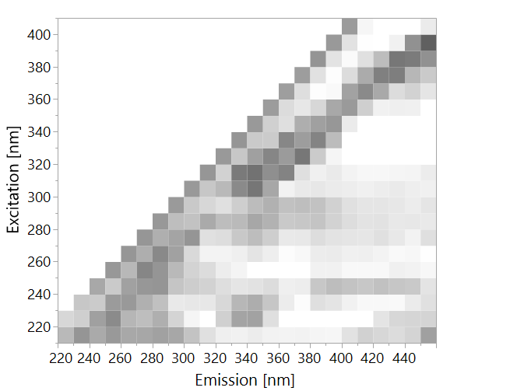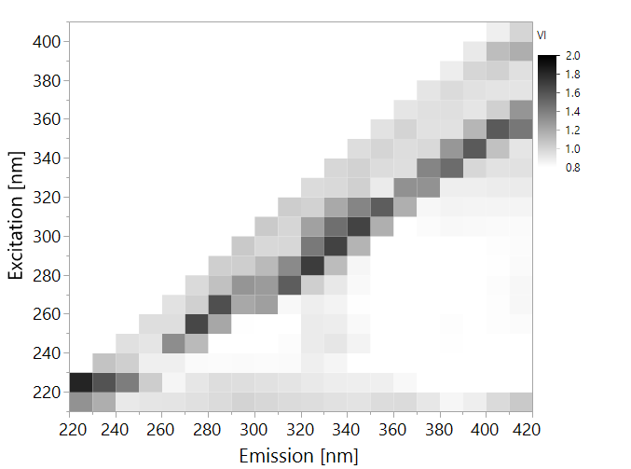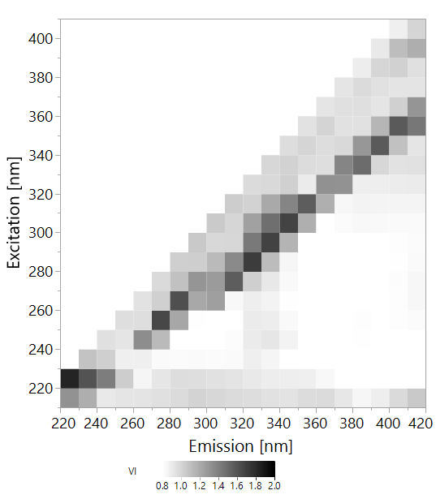

*E. coli*

Figure 7. Variable importance (VI) plots of PLS models made from entire EEMs. The plots show only values >0.8.

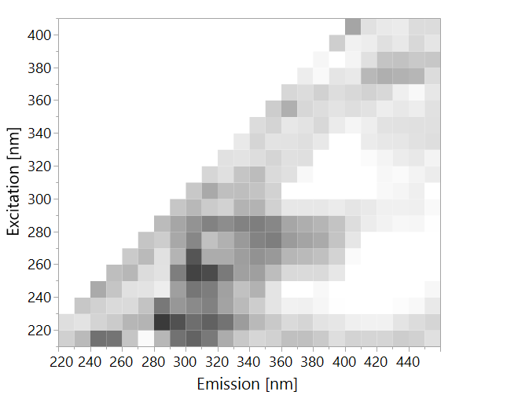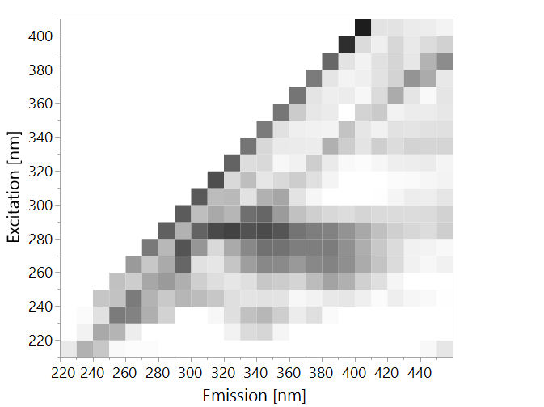

*B. subtilis*

All Bacteria

*P. aeruginosa*

Heterotrophic Bacteria

Next please:

|  |  |  |  |  |  |  |  |
| --- | --- | --- | --- | --- | --- | --- | --- |
|  | **Prediction** | | | | | | |
| **Actual** |  | ***B. subtilis*** | ***E. coli*** | ***P. aeruginosa*** | **Water** | **Total** |
| ***B. subtilis*** | 8 | 0 | 0 | 0 | 8 |
| ***E. coli*** | 0 | 8 | 0 | 1 | 9 |
| ***P. aeruginosa*** | 0 | 0 | 5 | 7 | 12 |
| **Water** | 0 | 0 | 1 | 50 | 51 |
| **Total** | 8 | 8 | 6 | 58 | 80 |