Supplementary

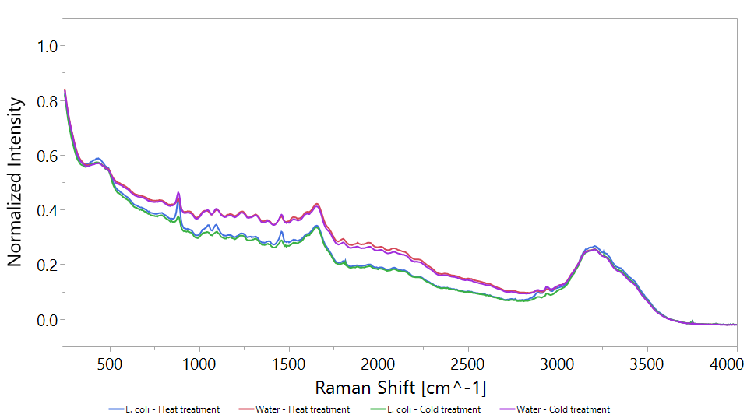

Supplementary Figure 1S. Effect of heat and cold treatments on water E. coli Raman spectrum. Exposure time was 60 seconds.