Gait Analysis Methods
  - DICE split-belt treadmill, military load carriage — how every metric is calculated, why each step is needed, and what a healthy value looks like
Version 1 — September 2026 — companion to gait_analysis.py and detect_gait_events.py
Table of Contents
How to read this document 5
Two things to keep in mind when you compare with the healthy ranges 5
Notation 6
1. Overview 7
1.1 What the analysis does 7
1.2 Why two scripts 7
1.3 The three frames of reference 8
1.4 Steady walking 8
2. Equipment and data 9
2.1 Motion capture: Theia3D, exported from Visual3D 9
2.2 The split-belt instrumented treadmill 9
2.3 The boots: MOVE4D scans 9
2.4 The participants file 9
2.5 The trials 9
3. The boots on Theia’s feet 11
3.1 Binding the scanned boots to Theia’s feet 11
3.2 The sole 11
3.3 The toe hinge 12
3.4 The belt surface 13
3.5 Is the boot touching the belt? 14
4. Gait events (detect_gait_events.py) 15
4.0 The two clocks 15
4.1 Belt contacts from the vertical force 15
4.2 The plates in Theia’s frame 16
4.3 Which force events to trust 17
4.4 Zeni events for the rest 18
4.5 The full sequence, and what is written 19
5. Preparing a trial 21
5.1 Events → steps 21
5.2 The belt’s speed and direction of travel 22
5.3 The boots over the belt 23
5.4 Forces into the motion-capture frame 23
5.5 Quiet standing: weighing body + load 24
5.6 The system (body + load) centre of mass 26
5.7 CoM velocity: markers and force plates together 27
6. Spatiotemporal metrics 30
6.1 Timing 30
6.2 Distances 30
6.3 Where the events came from 31
7. Posture and joint motion 33
8. Kinetics 35
8.1 Which stances 35
8.2 Vertical force landmarks 35
8.3 Impulses along the belt 35
8.4 CoP excursion and free moment 35
8.5 Normalisation: per body weight and per total weight 35
9. Centre-of-mass work: the individual limbs method 38
10. Margin of stability 40
11. Foot clearance and trip risk 43
11.1 Minimum foot clearance (MFC) 43
11.2 Margin of instability and the trip-risk integral 43
12. Confidence intervals 46
12.1 Why every value needs one 46
12.2 The circular block bootstrap 46
12.3 The block length 47
12.4 The same number of strides for every trial 47
12.5 DFA α: a parametric bootstrap 48
12.6 Lyapunov exponents: a stride bootstrap 48
13. Summary statistics, symmetry and walk ratio 49
13.1 Mean, SD and CV of every per-step metric 49
13.2 Symmetry angle 49
13.3 Walk ratio 49
13.4 Data-quality descriptors 50
14. Long-range correlations: detrended fluctuation analysis 51
15. Entropy 54
15.1 Sample entropy of the stride series 54
15.2 Refined composite multiscale entropy of the trunk 54
16. Trunk dynamics: harmonic ratio and regularity 56
16.1 The trunk signal 56
16.2 Harmonic ratio 56
16.3 Step and stride regularity 56
17. Control of stepping 59
17.1 The goal-equivalent manifold (GEM) 59
17.2 Foot placement control 59
18. Local dynamic stability 62
19. Results tables and figures 64
19.1 What is written 64
19.2 The healthy reference ranges 65
19.3 The per-trial figures 69
20. Validation 70
20.1 The synthetic trial 70
20.2 Event detection (test_detect_gait_events.py) 70
20.3 The whole analysis (test_gait_analysis.py) 70
20.4 The metric methods (gait_metrics_validation.py, lds_validation.py) 71
20.5 What the synthetic data cannot check 72
Appendix A. Every setting 73
A.1 detect_gait_events.py (CONFIG) 73
A.2 gait_analysis.py (§0 SETTINGS) 75
Appendix B. What a load is expected to do 78
Appendix C. Where each section is in the code 79
Appendix D. References 81

How to read this document
This document and the script gait_analysis.py are meant to be read side by side. Every section here has the same number as the section of the code that implements it. A section header in the code looks like this:
# %% ==========================================================================
# §10 MARGIN OF STABILITY (Word document §10, Fig. 17)
# =============================================================================
In Spyder, each # %% line starts a cell, so the outline pane lists the sections in the same order as this document. Sections 2–4 (equipment, boot meshes, gait events) are carried out by build_foot_binding.py and detect_gait_events.py, and every section from 5 onwards by gait_analysis.py.
Each metric section has the same parts, in the same order:
- What it measures, in words.
- The equations.
- The exact steps the code takes, numbered.
- Why: the reason each step is needed and the reason for each choice. Where another method exists, this explains why it was not used.
- A figure drawn by the real code on a synthetic trial whose true answers are known (Section 20).
- The healthy range: the values healthy, unloaded adults show in the literature, so you can see where your participants fall.
Three coloured boxes appear throughout:
In the code — the function in gait_analysis.py (or detect_gait_events.py) that carries out the step, and the settings from §0 that control it.
Why — the reason for a step or a choice.
Healthy range — what to expect, with the source. The same ranges colour every trial in the “Healthy ranges” sheet of the results workbook (Section 19).
Caution — something that changes how a number should be read (for example, the metronome in these trials).

Two things to keep in mind when you compare with the healthy ranges
The ranges are for healthy adults without a load, mostly walking overground at 1.2–1.4 m/s. Your participants walk on a treadmill at 1.3 m/s, to a 108 beats/min metronome, carrying a military load. Values outside a range are therefore expected for some metrics, and are often the finding: for example, the first force peak per body weight rises with load. Appendix B lists the direction in which load is expected to move each metric. Divide by total weight (the _tw columns) to see whether the pattern changed beyond simply carrying more.
Each range is marked “yes” (checked) or “verify”. “Yes” means the range was checked against the source’s abstract or a review. “Verify” means it comes from the gait literature at large and should be checked against the full paper before it is quoted in a publication. (The publishers’ websites could not be reached when this document was prepared, so the full texts could not be opened.) All ranges live in one place in the code, REFERENCE_RANGES in §19, so correcting one there corrects the workbook, and rebuilding this document corrects its tables.

Notation
Symbol | Meaning | Unit
$t_{HS},t_{TO}$ | time of a heel strike, of a toe-off | s
$L$, $R$ | left, right foot; “the other foot” is written $o$ | –
$\hat{f}$, $\hat{ℓ}$ | unit vectors along the belt’s direction of travel (forward), and across it (to the left) | –
$v_{b}$ | belt speed | m/s
$F$ | ground reaction force on the walker | N
$m_{b}$, $m_{ℓ}$, $m$ | body mass (from participants.csv), load mass, system mass $m=m_{b}+m_{ℓ}$ | kg
$x_{CoM}$, $v_{CoM}$ | system centre of mass (body + load), and its velocity | m, m/s
$g$ | 9.81 m/s² | m/s²
BW, TW | body weight $m_{b}g$; total weight $mg$ | N
ML, AP, VT | medio-lateral (across the belt), antero-posterior (along it), vertical | –
$N$ | number of strides in a series | –
$sd$, CV | standard deviation; coefficient of variation = 100 × sd / |mean| | –, %
Units are metres, seconds, newtons, kilograms and degrees unless a column name says otherwise: _mm, _pct (%), _bw (per body weight), _tw (per total weight), _j_kg (joules per kg of system mass).

1. Overview

1.1 What the analysis does
Participants walk on an instrumented split-belt treadmill while a markerless system (Theia3D) films them. The belt carries them at a fixed speed and a metronome sets their step rate. Each trial starts with a few seconds of standing still. The analysis turns three raw data streams into one row of results per trial:
- the Theia3D skeleton (100 Hz), exported from Visual3D;
- the two force plates under the belts (1000 Hz);
- a MOVE4D 3-D scan of the participant’s boots.
The row has about 370 columns, grouped in families: spatiotemporal, posture, kinetics, centre-of-mass work, stability, foot clearance, variability, entropy, trunk dynamics, control of stepping and local dynamic stability. Wherever it can be computed, each value comes with a 95% confidence interval.
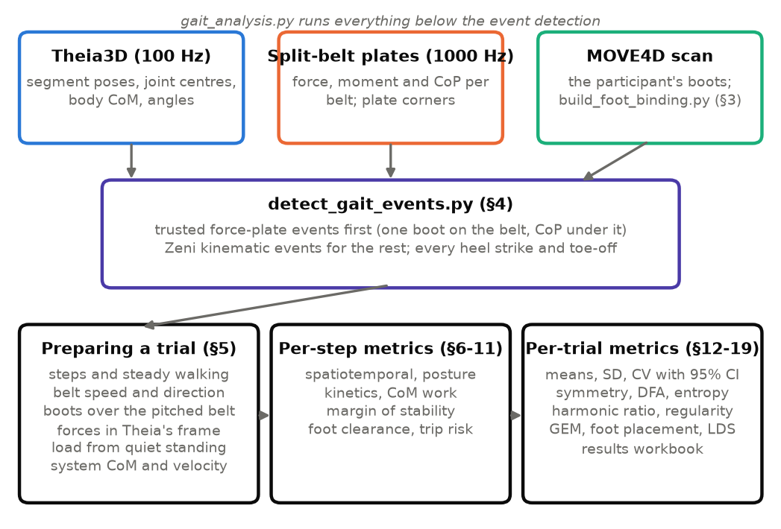
Figure 1. The pipeline. Step 1 (detect_gait_events.py) finds every heel strike and toe-off, trusting the force plates only where the boot meshes show that the event belongs to one foot on one belt. Step 2 (gait_analysis.py) prepares the trial (§5), computes the per-step metrics (§6–11) and then the per-trial metrics with their confidence intervals (§12–19).

1.2 Why two scripts
Event detection is the foundation: nearly every metric is a time or a position read at a heel strike or a toe-off. It is therefore done once, carefully, and saved ({trial}_event_qa.csv), so it can be checked before any metric is computed. gait_analysis.py then reads those events and never re-detects them. Both scripts use the same boot geometry: gait_analysis.py imports it from detect_gait_events.py. That way the step that decides which force-plate events to trust and the step that measures foot clearance agree on where the boot is.
In the code — detect_gait_events.py (step 1), then gait_analysis.py (step 2). In gait_analysis.py, analyse_trial() (end of the file, section RUN) carries out §5 → §19 for one trial, in the order of this document. main() repeats it for every trial and rebuilds the results workbook.

1.3 The three frames of reference
Theia’s lab frame. Every position is in Theia’s global frame: X and Y horizontal, Z vertical, in metres.
The belt frame. On a treadmill the walker hardly moves in the lab; the belt moves under them. A metric about forward motion, such as the extrapolated centre of mass (§10) or centre-of-mass work (§9), must be computed as if the walker were moving over still ground. To do that, the belt’s velocity ($v_{b}\hat{f}$, §5.2) is added to every velocity. This is the belt frame.
The walker’s axes. AP and ML are along and across the belt’s direction of travel, measured from the feet (§5.2), and not along Theia’s X and Y. The two need not line up. Even a 1–2° misalignment moves part of the step length (≈ 0.75 m) into the step width (≈ 0.1 m): 1.3° is 17 mm, which is the size of the effects of interest.
Why the direction of travel comes from the feet and not from the boots’ long axes — people toe out, and a boot’s long axis points a few degrees away from the direction the foot moves. A foot standing on the belt moves exactly with the belt, so its velocity gives the true direction of travel.

1.4 Steady walking
Each trial starts with a quiet standing, the belt ramps up, and the walker settles into the rhythm. Every per-trial number is computed only from the steps after a 60 s warm-up from the first event (WARMUP_S, §5.1). All steps are kept in {trial}_steps.csv, with a steady flag, so the warm-up can be inspected.

2. Equipment and data

2.1 Motion capture: Theia3D, exported from Visual3D
Theia3D estimates a skeleton from synchronised video without markers. Visual3D then exports, per frame at 100 Hz ({trial}_metrics.csv):
- each segment’s 4 × 4 pose (*_Global_4x4), including the feet and toes;
- joint centres and landmarks (Left_Heel_Position, Right_Toes_Position, Pelvis_Position, Low_Back_Position, Neck_Position, Trunk_Position, …);
- the whole-body centre of mass (Whole_body_COG);
- joint and segment angles (*_Joint_Angle, Thorax_Seg_Angle, Pelvis_Seg_Angle);
- the trunk’s linear velocity (Trunk_Linear_Velocity).
Markerless joint-angle estimates agree with marker-based ones to within a few degrees in the sagittal plane for healthy gait (Kanko et al. 2021). The body centre of mass comes from Theia’s segment model, which does not include the carried load. §5.6 adds the load.
In the code — read_export() reads the file (5 header rows, then one row per frame) into a dictionary of (frames × components) arrays. foot_pose() rebuilds each 4 × 4 pose and makes its rotation exactly orthonormal, because the export rounds it. The Trial class holds everything about one trial: kin() returns a signal in Theia’s frame, and kin_walker() returns it in the walker’s ML/AP/VT axes.

2.2 The split-belt instrumented treadmill
Each belt sits on its own force plate, sampled at 1000 Hz, which gives force (X, Y, Z), moment (X, Y, Z) and centre of pressure (CoP) per belt. The four measured corners of each plate come from the C3D force-plate parameters (force_plates_DICE_treadmill.txt). The handrails carry their own force channels. The DICE plates are pitched by about 0.8° (≈ 13 mm of height change over one stance). This is small, but it matters for foot clearance, which is measured in millimetres, so §3.4 fits the belt surface.

2.3 The boots: MOVE4D scans
Joint centres sit centimetres inside the real edge of a boot, and the underside of a boot is not the “toe” landmark. Two metrics are about the real boot: the base of support (§10) and foot clearance (§11). So each participant’s boots are scanned with MOVE4D and fixed to Theia’s feet (§3).

2.4 The participants file
participants.csv holds one row per participant: participant, body_mass_kg (without the load), leg_length_m, height_m, foot_length_m. Body mass is needed to know the load (§5.5). Without it, the load is unknown and the centre of mass is the body’s alone; the script says so in its output.

2.5 The trials
Trial names carry the condition, for example D05_C1_Treadmill_1.3mpers 108bpm: participant D05, condition C1, belt at 1.3 m/s, metronome at 108 beats (steps) per minute. The metronome fixes the step time at 60/108 = 0.556 s and the stride time at 1.111 s.
Caution: the metronome. With a fixed belt speed and a fixed step rate, the step length is also nearly fixed on average. The metronome also changes the variability structure of the timing series. Healthy adults walking freely show persistent long-range correlations in stride time (DFA α ≈ 0.75–0.9). When they follow a metronome, α falls below 0.5, because each step is corrected towards the beat (Hausdorff et al. 1996; Terrier et al. 2005). The code flags every timing series as “metronome-paced” (§14), and its α must not be compared with the uncued healthy range.

3. The boots on Theia’s feet

3.1 Binding the scanned boots to Theia’s feet
What. Each boot mesh is attached rigidly to Theia’s foot segment, so it can be posed on the foot in every frame of every trial.
Steps (build_foot_binding.py, run once per participant):
- MOVE4D → Theia transform. The participant stands in an A-pose that both systems record. The rigid transform $T_{M→T}$ between the two lab frames is solved from matching landmarks, with the rotation about the vertical only, because both systems take their vertical from gravity. The solve checks for mirroring, units and consistency between body segments, and estimates how uncertain the heading is.
- The boot meshes in Theia’s frame. The segmented .obj boot meshes are moved into Theia coordinates. The script checks that the soles land on Theia’s floor.
- Binding. With Theia’s foot pose $T_{foot}(t_{0})$ in the same static pose, every vertex is expressed in the foot’s own frame:
$$v^{foot}=T_{foot}(t_{0})^{−1} T_{M→T} v^{M4D}$$
In any later frame $t$, the boot is then posed by
$$v(t)=T_{foot}(t) v^{foot}.$$
Why a scan and not the joint centres — the ankle joint centre sits about 3–5 cm inside the lateral edge of a boot, and the “toe” landmark is not the lowest point of the toe cap. The margin of stability measured to the ankle understates the base of support by that much (§10). Foot clearance measured at a landmark is not the clearance of the sole (§11). The scan gives the boot’s real edge and its real underside.

3.2 The sole
What. The small set of vertices that can touch the ground.
Steps (dge.boot_sole()):
- Take “up” as the world vertical seen from the foot (the median over the trial), and the boot’s long axis as the first principal direction of the mesh in the horizontal plane.
- Divide the footprint into 10 mm × 10 mm cells (SOLE_CELL_MM) and keep the lowest vertex in each cell.
- Keep only cells whose lowest vertex is within 35 mm of the lowest point of the boot (SOLE_MAX_RISE_MM). This keeps the curved toe cap and heel, and drops the boot’s sides.
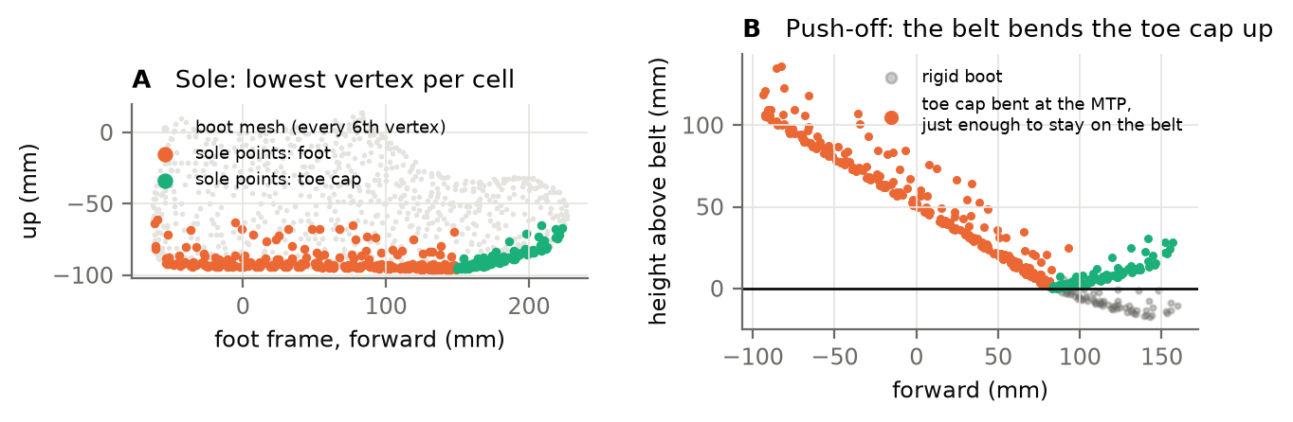
Figure 2. A: the scanned boot (grey), its sole points under the foot (orange) and under the toe cap (green). B: at push-off the heel is raised 30°. If the boot were rigid, the toe cap would pass 17 mm through the belt (grey points). Bending the toe cap about the MTP, just as far as the belt requires, keeps it on the belt (orange and green).
Why only the sole — a boot mesh has tens of thousands of vertices. Only the underside can touch the belt, and clearance is the height of the lowest point of that underside. Keeping one vertex per 10 mm cell leaves a few hundred points: enough to resolve the sole’s shape, few enough to pose them in every frame of a 7-minute trial.

3.3 The toe hinge
What. The toe cap bends about the metatarsophalangeal (MTP) joint. A boot’s toe cap is stiff: it bends when the belt pushes it up at push-off, and springs back once it is off the belt.
With $m$ the MTP in the foot frame (from <Side>_Toes_Position), $θ(t)$ the bend, and $R_{x}$ a rotation about the foot’s medio-lateral axis, each sole point in front of the MTP is posed by
$$v(t)=T_{foot}(t) \left[m+R_{x}\left(θ(t)\right) (v^{foot}−m)\right].$$
The analysis (gait_analysis.py §5.3) takes $θ(t)$ as the larger of two angles: Theia’s toe extension, $max(θ_{toe}−θ_{scan},0)$ (TOE_USE_THEIA_EXTENSION), and the smallest bend, from 0 to 60° in 0.5° steps (TOE_MAX_BEND_DEG, TOE_BEND_STEP_DEG), that keeps every point of the toe cap on or above the belt (§3.4). Lifting the toe cap further only raises it, so the result is never below the belt. The event detection (detect_gait_events.py) bends the toe cap by Theia’s toe angle $θ_{toe}$, extension only: $θ(t)=max\left(θ_{toe}(t)−θ_{scan}, 0\right)$, with $θ_{scan}$ the toe angle during the scan (TOE_REFERENCE_DEG, TOE_EXTENSION_ONLY).
Why — a rigid boot pitched heel-up at push-off drives its toe cap 30–40 mm through the belt (Fig. 2B). That would wreck the contact test in §4.3 (the boot would look as if it touched the wrong belt). It would also wreck the clearance just after toe-off, because the lowest point would be below the belt. Why not follow Theia’s toe angle both ways — Theia’s toe segment is fitted to a foot inside a stiff boot. In swing it can report toe flexion, and a hinge that follows it turns the toe cap down through the belt. On a synthetic trial, 25° of false flexion moved the mid-swing clearance from about 19 mm to about 5 mm, with some swings below the belt (test_gait_analysis_all_metrics.py). Extension is kept because Theia’s toe segment is fitted to the image of the boot’s toe. A bend driven by contact cannot put the boot through the belt. Any part of the boot still below the belt is then a pose error of the foot itself, and it is reported (mfc_below_belt_pct). What D05 showed — on the first real trial, Theia’s toe angle in swing was mostly extension (−1.5 to +11°), and the rigid boot already reached the belt in mid-swing. There the low clearance comes from Theia’s foot pose in swing, which no toe model can correct (§11).

3.4 The belt surface
What. The belt’s height under any point, as a plane pitched along the direction of travel:
$$z_{belt,b}(s)=z_{0,b}+k s, s=p⋅\hat{f},$$
with one slope $k$ shared by both belts and one offset $z_{0,b}$ per boot. The height of any sole point above the belt is then
$$h=z−z_{0,b}−k s.$$
Steps (dge.fit_belt_surface()):
- In every frame, find each boot’s lowest sole point. Keep its height and its position $s$ along the direction of travel.
- Start from $z_{0,b}$ = the 25th percentile of those heights and $k=0$.
- Fit $z_{0,L}$, $z_{0,R}$ and $k$ by least squares, using only frames whose lowest point is within 20 mm of the current surface. These are the frames with the boot on the belt; frames in swing are excluded.
- Refit three more times with a 8 mm band.
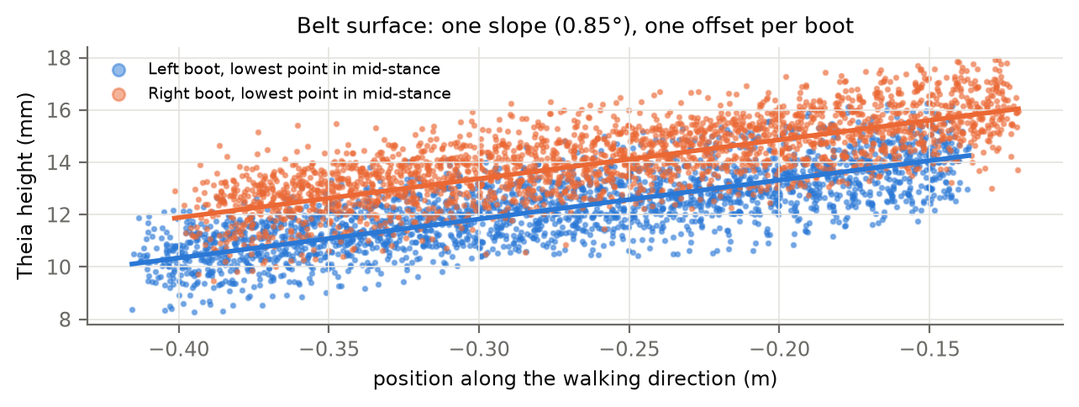
Figure 3. The belt surface. Each dot is the lowest sole point of a boot in mid-stance (every third stance shown). The lines are the fitted surface: one slope (0.88° here), one offset per boot. The 1–2 mm offset between the two boots absorbs a small bias in either foot’s pose.
Why one slope and two offsets — the belts are one rigid, slightly pitched structure, so they share a slope. Each foot’s pose can carry its own small vertical bias, which the separate offsets absorb. Otherwise that bias would show up as a clearance difference between the feet. Why the iteration — the lowest point of a swinging foot is not on the belt. The narrowing band removes those frames without having to know the gait events first.

3.5 Is the boot touching the belt?
A sole vertex touches the belt when $h<15$ mm (CONTACT_HEIGHT_MM). The boot is down when at least 3 vertices touch (MIN_CONTACT_VERTICES). A tolerance of 15 mm covers the sole’s own compression and the pose error, and three vertices cannot be produced by a single noisy point.
In the code — Boots (gait_analysis.py §5.3) poses the soles in every frame and keeps, per frame, the lowest sole point’s height and index and the boot’s extent along and across the belt. Boots.height() gives the height above the belt, and Boots.world() rebuilds all sole points for the frames a swing or a figure needs. The geometry itself comes from detect_gait_events.py (boot_sole, toe_hinge, fit_belt_surface, above_belt), so both steps use the same boot.

4. Gait events (detect_gait_events.py)
Every heel strike (HS) and toe-off (TO) is needed, for both feet, through the whole trial. Force plates time these events to the millisecond, but only when one foot is on one belt. On a split-belt treadmill a foot sometimes lands across the gap or on the other belt, and then a plate carries two feet, or part of one. The strategy is therefore:
- Force first. Find every belt contact from the force. Keep each of its two events only if the boots show that it belongs to one foot, alone on that belt (§4.1–4.3).
- Kinematics for the rest. Take every other event from the Zeni method, calibrated against the trusted force events of the same trial (§4.4).
- Last resort. Where Zeni finds nothing (a tracking dropout), use a clean-looking contact that the mesh could not check, then interpolation (§4.5).

4.0 The two clocks
What. The force file and the Theia export are recorded by different systems and are taken to start together. Before anything else, the offset between them is measured. The plates give the system CoM’s vertical acceleration as the summed vertical force, up to a scale. Theia gives it as the second derivative of Whole_body_COG (Savitzky–Golay, 11 frames, cubic). Both are band-passed to 0.5–8 Hz without phase shift. The lag $τ$ that maximises their correlation, within ±150 ms and refined by a parabola through the peak, is the offset. If $|τ|≥3$ ms (CLOCK_MIN_SHIFT_MS), the force data are moved by $τ$ (FORCE_SHIFT_MS = "auto"), and the shift is saved in the event summary. Both analysis scripts apply the same shift when they read the forces, then re-measure what is left.
Why — on D05, Theia’s CoM acceleration lined up with the plates’ 14 ms earlier (r = 0.98). At 1.32 m/s, 14 ms is 18 mm of belt travel. Every force-plate event was therefore read at the wrong kinematic instant, and the CoP appeared 18 mm ahead of the boot. Newton makes the check exact: it is the same acceleration, seen twice. On a synthetic trial whose force file was shifted by 30 ms, the offset was measured as 31 ms and removed, leaving 1 ms.

4.1 Belt contacts from the vertical force
Steps (dge.belt_baseline(), dge.find_contacts(), dge.raw_edge()):
- Baseline. An unloaded plate does not read zero, and the reading drifts. Every 10 s (BASELINE_WINDOW_S), the baseline is the median of that window’s lowest 20% of samples. A window whose level is more than 20 N from the median of all windows is one where the belt was never unloaded (standing before the belt starts). It borrows its neighbours’ baseline. The baseline is interpolated between windows.
- Filter. Apply a 4th-order Butterworth low-pass at 50 Hz, run forwards and backwards so there is no time lag (FORCE_FILTER_HZ).
- Threshold. The belt is loaded where the filtered force above baseline exceeds 20 N (FORCE_THRESHOLD_N).
- Merge and drop. Dips shorter than 30 ms do not split a contact (MERGE_GAP_S). Contacts shorter than 80 ms are dropped (MIN_CONTACT_S).
- Refine each edge on the raw force. Within ±15 ms of the filtered crossing (EDGE_SEARCH_S), the landing is the first sample from which the raw force stays above 20 N for 5 samples (EDGE_HOLD). The lift-off is the first sample from which it stays at or below 20 N for 5 samples.
- Shape. A real landing rises from 20 N to 200 N within 60 ms (MAX_LOADING_S). A real lift-off falls from 200 N within 80 ms (MAX_UNLOADING_S). Slower edges usually mean a foot sliding on or off the belt, or a second foot, and those events are not trusted.
$$\text{contact}=\left\{t:F_{z}^{filt}(t)−b(t)>20 \text{N}\right\}$$
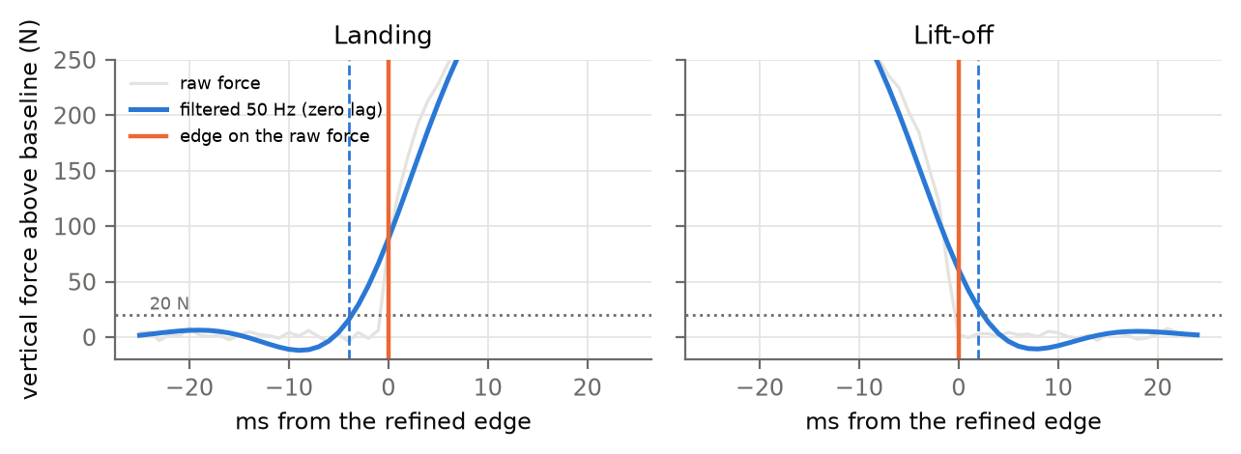
Figure 4. Why each edge is placed on the raw force. The zero-lag filter spreads a steep landing over a few milliseconds, so the filtered force (blue) crosses 20 N a few milliseconds before the raw force does (dashed blue line), and crosses it after the foot has left. The edge is placed where the raw force crosses and stays crossed (orange line).
Why filter, then refine — the raw force is noisy enough to cross 20 N on noise alone, so the filtered force decides whether the belt is loaded. But a zero-lag filter spreads a steep edge symmetrically, so the filtered crossing is early at a landing and late at a lift-off. That makes every stance a few milliseconds too long (up to about 1% of a stance). Searching the raw force near the filtered crossing gives the timing back. The 5-sample hold stops a single noise spike from triggering the edge. Why 20 N — well above the plate noise (a few N), and well below any real loading (hundreds of N within 20 ms).

4.2 The plates in Theia’s frame
The plates’ corners are in the motion-capture lab frame, which is not Theia’s. To check which boot stands on which belt, the plate outlines and the CoP must be in Theia’s frame.
Steps (dge.fit_plate(), dge.register_lab_to_theia()):
- Plate outlines. The nominal plate rectangle (length × width) is fitted rigidly onto the four measured corners (Kabsch algorithm), giving the plate’s rotation $R_{p}$ and position $t_{p}$. How far the measured corners miss the fitted ones (8 mm at most on DICE) is how uncertain the outline is.
- The rotation, lab → Theia. This is the angle between the belts’ direction of travel as seen by the plates (the plates’ long axis, pointed the way the CoP moves) and as seen by Theia (the stance boot’s velocity). Only single-support frames are used, with one boot down, the other boot well clear and the other belt unloaded.
- The translation. In those frames, the CoP must lie under the touching part of the boot. The translation is the median offset between the rotated CoP and the centre of the touching patch, computed per boot and averaged over the two boots, so a medial/lateral bias that mirrors between the feet cancels.
- Check. If the across-belt CoP runs against the across-belt boot position, the frames are mirrored, and the script stops rather than guess.
$$p_{Theia}=R(φ) p_{lab}+t$$

4.3 Which force events to trust
Contact labels. Around each belt contact, the posed boots show which boot is on that belt, and whether it is alone:
Label | Meaning | Trusted?
clean | one boot on its own belt | yes, if the event checks pass
crossover | one boot, alone, on the other foot’s belt | yes; the limb comes from the mesh, not from the belt’s name
straddle | the boot also stands on the other belt | no: the force is split
shared | the other boot also stands on this belt | no: two feet’s force
Per-event checks. Each event is judged on its own, over ±50 ms around it (TRUST_WINDOW_S). It is trusted only if all of these pass, and the first one that fails is written as the reason in {trial}_grf_contacts.csv:
- the contact is complete (it does not run off the start or end of the recording);
- the edge has the shape of a real landing or lift-off (§4.1 step 6);
- both boots are tracked (the mesh can be posed);
- the other boot is not on this belt;
- this boot is down near the event;
- this boot is not also on the other belt;
- while this foot alone loads the belt, the CoP lies within 30 mm of the boot’s touching patch at least 90% of the time (COP_TOLERANCE_MM, COP_MIN_INSIDE).
A boot is “on” a belt when at least 3 of its touching sole vertices lie inside the plate outline, grown by the outline’s own uncertainty. Hanging over the gap or the outer edge is fine: it moves no force anywhere.
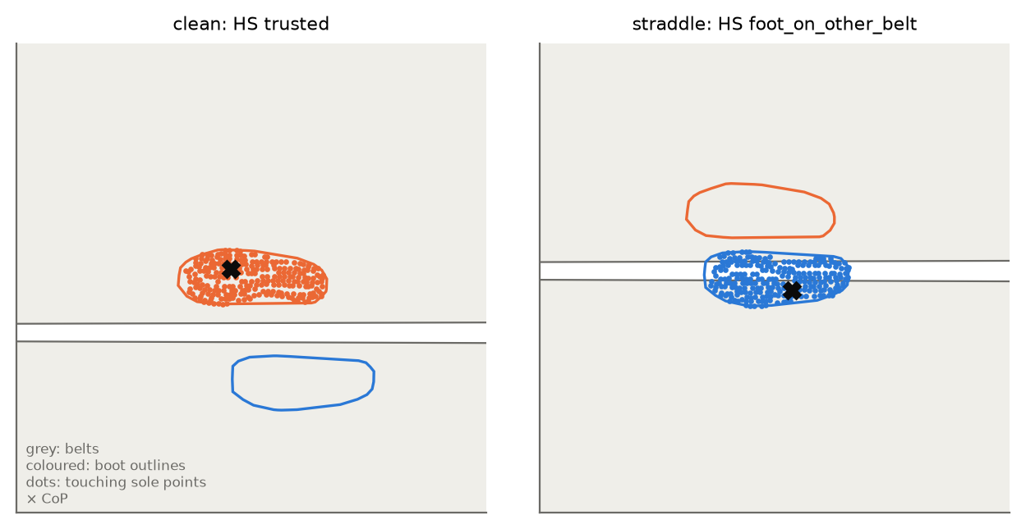
Figure 5. Two contacts seen from above, half-way through stance. Grey: the belts. Coloured outlines: the boots; dots: sole points touching the belt; ×: the CoP. Left, a clean contact: the right boot alone on its belt, the CoP under it; both events are trusted. Right, a straddle: the left boot stands across the gap, so each plate carries part of its force and the heel strike is not trusted (reason “foot_on_other_belt”). A crossover, where one boot lands wholly on the other belt, is trusted with the right limb.
Why check each event separately — a foot can land cleanly and then drift onto the gap before toe-off, or the reverse. Checking only the whole contact would throw away a good heel strike because of a bad toe-off, or keep a bad one. Why the CoP test — it catches what the geometry cannot: a trailing toe still loading this plate, or a hand on the rail.

4.4 Zeni events for the rest
What. Zeni et al. (2008): in walking, the heel strike is where the heel is furthest in front of the pelvis, and the toe-off is where the toe is furthest behind it. Heel strike is therefore a maximum of $x_{HS}$, and toe-off a maximum of $x_{TO}$:
$$x_{HS}(t)=(p_{heel}−p_{pelvis})⋅\hat{f}, x_{TO}(t)=−(p_{toe}−p_{pelvis})⋅\hat{f}.$$
Steps (dge.zeni_signals(), dge.peaks_between(), dge.zeni_offsets(), dge.build_sequence()):
- Bridge tracking gaps of up to 10 frames. Low-pass the heel, toe and pelvis at 10 Hz (KINEMATIC_FILTER_HZ).
- Find the maxima to a fraction of a frame by fitting a parabola through the peak sample $i$ and its neighbours:
$$δ=1/2 \frac{x_{i−1}−x_{i+1}}{x_{i−1}−2x_{i}+x_{i+1}}, t_{peak}=i+δ.$$
- Keep a maximum only if it stands at least 50 mm above the lowest point within ±0.6 s on each side (ZENI_MIN_PROMINENCE_M, ZENI_WINDOW_S). In walking a real swing gives about 0.3 m; a foot standing still during the opening quiet standing gives a few millimetres of tracking noise.
- Calibrate on this trial. Zeni’s events sit a consistent few milliseconds from the true ones, and the offset differs per person and per event. For every trusted force event, Zeni’s event is looked for exactly as a missing one would be, and the median difference is that limb’s and that event’s offset. If one limb has fewer than 10 such pairs, the two limbs are pooled. The spread of the differences is reported (in {trial}_event_summary.json) as the likely error of a Zeni event.
- Search only where the gait sequence leaves room. The events must come in the order L HS → R TO → R HS → L TO. Between two trusted events, the sequence says which events are missing and, from this trial’s median intervals, roughly when. Each missing event is searched for only in its own gap.
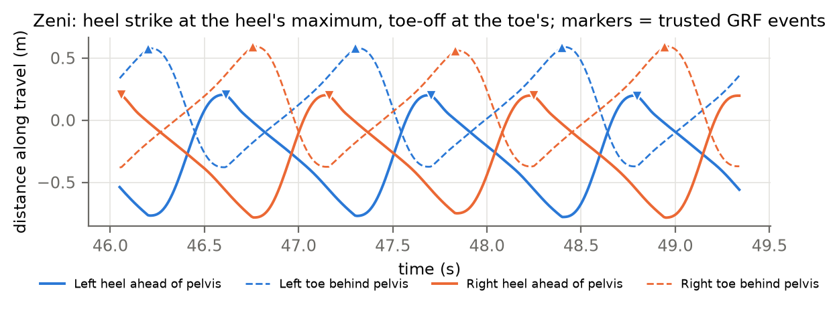
Figure 6. The Zeni signals over three strides: heel ahead of the pelvis (solid) and toe behind it (dashed), left (blue) and right (orange). Downward triangles are trusted force-plate heel strikes and upward triangles trusted toe-offs; each falls at the corresponding maximum.
Why Zeni rather than a velocity or height threshold — it needs no threshold that would depend on the participant, the footwear or the load. It works at any belt speed, and it is among the most accurate kinematic methods for treadmill walking. Why calibrate it — the median offset from the same trial’s force events removes Zeni’s systematic error. What remains is its random error, which the event summary reports.

4.5 The full sequence, and what is written
Where Zeni finds nothing in a gap, the gap is filled by a clean-looking force event that fell in a tracking dropout (source GRF_unverified). Only if there is none, and only between two trusted events, is the event interpolated at the time the sequence predicts (source interpolated). Each limb’s list is trimmed to start on a heel strike and end on a toe-off. Every stance and stride more than 25% away from the median is flagged (FLAG_RATIO).
Outputs per trial: {trial}_merged_events.csv (event, limb, frame, source), {trial}_event_qa.csv (the same events to a fraction of a frame, with the belt, the contact label and how each was found), {trial}_grf_contacts.csv (every contact and why each event was or was not trusted), and {trial}_event_summary.json (plate fit, registration, belt surface, Zeni offsets and errors).
The results workbook reports the share of events from each source: events_trusted_grf_pct, events_zeni_pct and events_interpolated_pct. A trial with many Zeni or interpolated events has less precise timing, and fewer stances can be used for kinetics (§8).

5. Preparing a trial
Before any metric is computed, load_trial() assembles everything one trial needs, in this order: the steps (§5.1), the belt’s speed and direction (§5.2), the boots (§5.3), the forces (§5.4), the weight of body + load (§5.5), the system centre of mass (§5.6) and its velocity (§5.7). Each step prints a line, so a problem shows up where it starts.

5.1 Events → steps
What. One row per heel strike, holding every event that step needs.
For a heel strike of foot $b$ at $t_{HS}$, with $o$ the other foot, the row holds (as fractional frames, 0 = first frame):
Column | Event | Used for
hs | this heel strike | start of stance and stride
to | this foot’s next toe-off | end of stance
next_hs | this foot’s next heel strike | end of the stride
contra_to | the other foot’s first toe-off after hs | end of initial double support
contra_hs | the other foot’s first heel strike after hs | start of terminal double support
prev_contra_hs | the other foot’s last heel strike before hs | start of the step that ends at hs
Each row also records where each event came from (force plate, Zeni or interpolated) and, for force events, which belt carried it. A toe-off that comes after the next heel strike means a missed event, and it is set to missing rather than used.
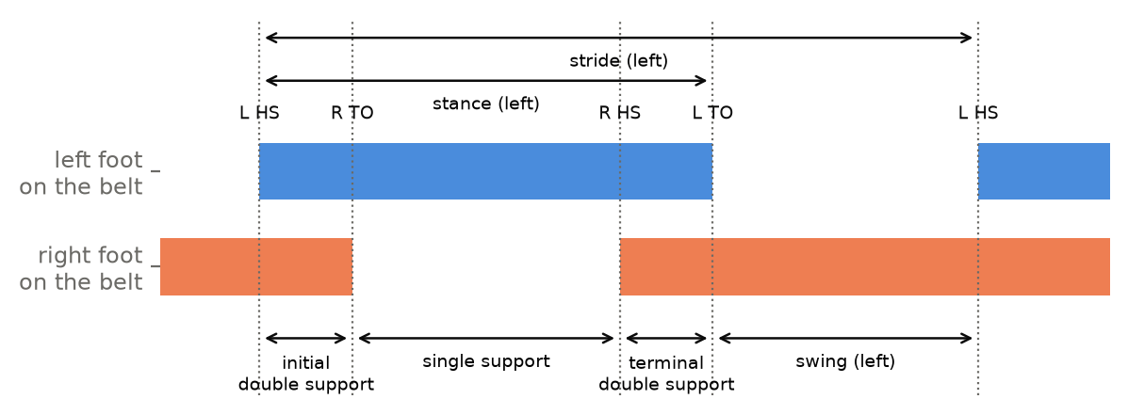
Figure 7. The timing of one stride of the left foot. A stride runs from one left heel strike to the next. Stance (left foot down) splits into initial double support (both feet down, until the right toe-off), single support (the right foot swinging), and terminal double support (from the right heel strike to the left toe-off). Swing follows.
Steps (read_events(), build_steps()):
- Read {trial}_event_qa.csv. Its frame_float column gives each event to a fraction of a frame. If only merged_events.csv exists, whole frames are used, the kinetics cannot know which belt carried a step, and the script warns about both.
- For each foot, look up each of the five other events with a sorted search: the first event of the right kind after (or before) this heel strike.
- Mark as steady every step whose heel strike is at least 60 s after the first event (WARMUP_S).
Why fractional frames — at 100 Hz a frame is 10 ms, which is 1.5% of a stance. Rounding each event to the nearest frame adds up to ±5 ms to each, which is larger than many effects of load. Force events are known to 1 ms and Zeni events to a fraction of a frame, and positions are read at those exact times by linear interpolation (at()). Why build the row once — every per-step metric is a difference between these events. Building and checking the row once means every metric uses the same, validated set of events. Why 60 s of warm-up — the belt ramps up, and people take tens of seconds to settle into a steady treadmill gait, especially with a metronome and a load.
In the code — §5.1: read_events(), build_steps(). The warm-up is applied in load_trial(). Settings: WARMUP_S.

5.2 The belt’s speed and direction of travel
What. The velocity of the belt, from the feet standing on it.
Equations. For each stance, take the frames from 25% to 55% of stance, $t∈[t_{HS}+0.25 T_{st}, t_{HS}+0.55 T_{st}]$, and fit a straight line to the heel’s horizontal position against time. Its slope is the heel’s velocity $u_{i}$. Then
$$\hat{f}=−\frac{{median}_{i}\left(u_{i}/\left\|u_{i}\right\|\right)}{∥{median}_{i}\left(u_{i}/\left\|u_{i}\right\|\right)∥}, v_{b}={median}_{i}\left(−u_{i}⋅\hat{f}\right), \hat{ℓ}=(−f_{y}, f_{x}).$$
The minus sign is there because a foot on the belt moves backwards. $\hat{ℓ}$ points to the walker’s left.
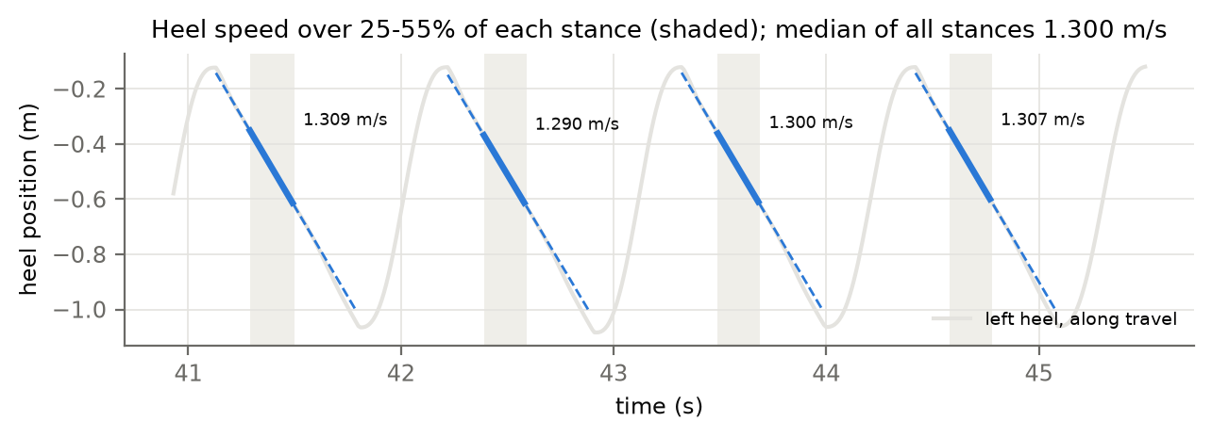
Figure 8. The belt speed from the heel. Grey: the left heel’s position along the direction of travel. In each stance, a straight line is fitted over 25–55% of stance (shaded; thick blue). There the heel is flat on the belt and moves with it, and the dashed line extends the fit over the whole stance. The belt speed is the median slope over every stance of the trial.
Why measure the belt at all — the nominal speed is a setting on the treadmill’s controller; the belt’s real speed under load can differ from it. Three things need the real speed: the belt frame (§1.3), the stride length over the belt (§6), and the GEM goal line (§17). Why 25–55% of stance — before 25% the heel is still rolling onto the belt, and after 55% it starts to lift. In between, the heel is fixed on the belt and moves exactly with it. Why the median — a few stances are disturbed (a stumble, a tracking error). The median ignores them; a mean would not. Why the direction from the feet — see §1.3.
In the code — §5.2: belt_motion(). Settings: BELT_FLAT = (0.25, 0.55). The result is belt_speed_ms in the results.

5.3 The boots over the belt
The boots of §3 are posed on Theia’s feet in every frame. For every frame and boot, Boots keeps the height and index of the lowest sole point, and how far the boot reaches forward, backward, left and right along the walker’s axes. The margin of stability (§10) uses those extents, and foot clearance (§11) uses the heights. Each sole is first levelled (level_sole()). In foot-flat (BELT_FLAT of each steady stance) a boot’s heel and forefoot are both on the belt, so the posed sole must lie flat. The sole is turned about the ankle by the angle that brings the heel’s lowest point level with the forefoot’s (toe cap excluded: it curls up), up to 6° (SOLE_FLAT_IN_STANCE, SOLE_FLAT_MAX_DEG). A tilt there means the boot sits tilted on Theia’s foot. The cause is the binding, or Theia’s foot angle in walking against the static pose the binding was built from. On D05 the boot touched the belt about 60 ms after the force-plate heel strike, with its heel 8 mm up at that instant, which is what a ~2° toe-down tilt does. The synthetic trial, built from the same mesh, gives 0.0–0.7°. The belt surface is refitted here (foot_flat_surface()) to the rigid boots’ lowest point in foot-flat only (BELT_FLAT of each steady stance), with the same form as §3.4. The event detection fits every frame’s lowest point, including push-off and landing. On D05 that gave 2.3° against the plates’ 0.8°, which over the ~0.35 m a foot travels to mid-swing changes the clearance by ~8 mm.
In the code — §5.3: class Boots (height(), world()), level_sole(), foot_flat_surface() and contact_toe_pose() (the toe cap, §3.3), which use dge.boot_sole(), dge.toe_hinge() (for the MTP), dge.fit_belt_surface() and dge.above_belt(). Settings: TOE_MAX_BEND_DEG = 60, TOE_BEND_STEP_DEG = 0.5.

5.4 Forces into the motion-capture frame
What. Each belt’s force, CoP and free moment, with the unloaded baseline removed and expressed in Theia’s frame. The forces are combined with Theia’s CoM (§5.7, §9) and with the boots (§8), so they must be in the same frame and point the same way.
Steps (read_forces()):
- Clock. The force data are moved by the offset the event detection measured and saved (force_shift_ms, §4.0), so the force samples agree with the events and with Theia.
- Baseline. Vertical: the drift-tracking baseline of §4.1. Horizontal: the median over the unloaded samples.
- Plate → lab → Theia. Rotate by the plate’s fitted rotation $R_{p}$ (§4.2), then rotate the horizontal part of $R_{p}F$ by the lab → Theia rotation $R(φ)$ (§4.2). The vertical part is unchanged, because both frames share the vertical.
- Sign. The export does not document whether it gives the force on the plate or on the body. The sign is chosen so that the vertical force holds the walker up (positive when loaded). §5.7 then checks the horizontal axes against the markers.
- Two copies. One is low-passed at 50 Hz (FORCE_FILTER_HZ), for peaks (§8). The other is kept raw, for integration (§5.7, §9), where filtering is unnecessary and would only blur the timing.
- CoP into Theia. The DICE export gives the CoP in each plate’s own frame. It is moved into the lab with $p=R_{p} ({\text{CoP}}_{x}, {\text{CoP}}_{y}, 0)+t_{p}$, then into Theia. It is kept only where the belt carries more than 150 N, because at low force the CoP is mostly noise.
- Free moment. This is the vertical torque between the foot and the belt that is not explained by the horizontal forces acting at the CoP:
$$T_{z}=M_{z}−\left(r_{x}F_{y}−r_{y}F_{x}\right), r=\text{CoP}−o,$$
- where $o$ is the plate’s moment origin. Because the export does not give $o$, it is recovered from the data: $o_{x}=median({\text{CoP}}_{x}+M_{y}/F_{z})$ and $o_{y}=median({\text{CoP}}_{y}−M_{x}/F_{z})$.
- Handrails. Any handrail force more than 15 N from its median counts as a hand on the rail (HANDRAIL_N). The GRF then misses an external force. Steps with handrail contact are flagged, and their share is reported (handrail_steps_pct).
- Levelling (align_gravity()). Over minutes of steady walking the body does not accelerate, so the mean total GRF is the weight and points straight up, whatever the treadmill’s incline. If the mean leans, the plates’ axes are tilted against Theia’s (corner survey, registration, or an export that was already levelled). The tilt is then undone as a rotation (FORCE_ALIGN_GRAVITY), up to 3° (FORCE_MAX_TILT_DEG). A larger lean is reported, not corrected. On D05 the lean was about 1°. That leaks sin 1° of the vertical force into AP and gives a net braking impulse of about 0.01 BW·s per stance, a quarter of the propulsive impulse.
Why recover the moment origin — the free moment is small (a few N·m) compared with the moments of the vertical force about the plate centre (hundreds of N·m). An origin that is wrong by 1 cm gives an error comparable to the free moment itself. The origin is exactly the point about which $\text{CoP}=(−M_{y}/F_{z},M_{x}/F_{z})$ holds, so it can be read back from the exported CoP and moments.
In the code — §5.4: read_forces(), align_gravity(). Settings: FORCE_FILTER_HZ, HANDRAIL_N, FORCE_ALIGN_GRAVITY, FORCE_MAX_TILT_DEG. The plate geometry and registration come from detect_gait_events.py (fit_plate, the saved lab_to_theia).

5.5 Quiet standing: weighing body + load
What. The weight of everything the walker carries, measured by the force plates while the walker stands still at the start of the trial.
Equations. Standing still, nothing accelerates, so the plates carry exactly the weight of body + load (Newton’s second law with $a=0$):
$$W=\overline{F_{z,L}+F_{z,R}}, m=\frac{W}{g}, m_{ℓ}=m−m_{b}.$$
Steps (quiet_standing()):
- Search from the start of the recording to the first gait event (at most the first 30 s, QS_SEARCH_S).
- Slide a 2 s window (QS_WINDOW_S) in steps of 0.1 s. A window qualifies only if:
  - the total vertical force is steady: $sd/\text{mean}<2\%$ (QS_MAX_CV);
  - both feet are loaded: each belt carries 15–85% of the total (QS_MIN_SHARE);
  - both heels are still: each moved less than 20 mm between the medians of the first and last 0.2 s of the window (QS_MAX_FOOT_TRAVEL).
- Keep the qualifying window with the smallest CV. $W$ is its mean total vertical force.
- Check: over the steady walk the body does not accelerate on average, so the mean vertical GRF while walking must also equal $W$. More than 2% apart means the plates drifted or the standing was not still, and the script warns.
- $m_{ℓ}=m−m_{b}$, with $m_{b}$ from participants.csv. A load below −1 kg means the entered body mass or the plate zero is wrong, and the script warns.
- Keep the force-weighted CoP of both belts during the window, for §5.6.
If no window qualifies, the system mass falls back to the mean vertical GRF while walking divided by $g$. The load then cannot be placed (§5.6), and the note in the results says so.
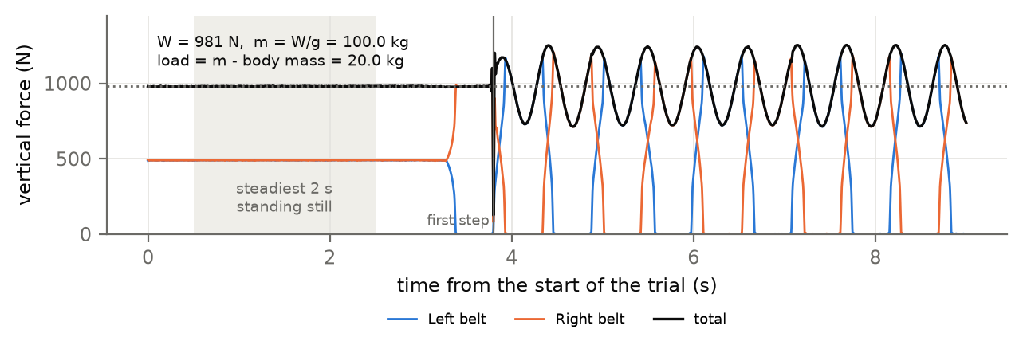
Figure 10. Weighing in the quiet standing. Blue and orange: the vertical force on each belt; black: their sum. The shaded 2 s is the steadiest window with both feet loaded and the heels still; its mean is the weight of body + load. In this synthetic trial, 981 N gives 100.0 kg, and with an 80 kg body mass the load is 20.0 kg.
Why weigh at all — the load differs between trials and conditions, and Theia cannot see it: its centre of mass is the body’s alone. Mass, total weight and the load’s position all enter the kinetics, the CoM and the margin of stability. Why standing — only when nothing accelerates does the force equal the weight exactly. While walking, the vertical force swings between about 0.7 and 1.3 body weights within each step. Why the three conditions — a window with one foot lifting, a shuffle or a lean would weigh correctly but place the load wrongly (§5.6). Asking for both feet down, still heels and a steady force picks true quiet standing.
In the code — §5.5: quiet_standing(). Settings: QS_SEARCH_S, QS_WINDOW_S, QS_MAX_CV, QS_MIN_SHARE, QS_MAX_FOOT_TRAVEL. Results: system_mass_kg, load_kg, quiet_standing_cv.

5.6 The system (body + load) centre of mass
What. The centre of mass of everything the walker moves: body and load.
Equations. Standing still, the CoP lies vertically below the system centre of mass. Horizontally, therefore,
$$m x_{CoP}=m_{b} x_{b}+m_{ℓ} x_{ℓ} ⇒ x_{ℓ,xy}=\frac{m x_{CoP}−m_{b} x_{b,xy}}{m_{ℓ}},$$
with $x_{b}$ Theia’s body CoM averaged over the quiet standing. Standing still gives no information about the load’s height. It is placed at the height of Trunk_Position (plus LOAD_HEIGHT_M, 0 by default) and on the body’s mid-line left-right (LOAD_CENTRED).
The position is then stored in a trunk frame:
- $\hat{z}$ points from Low_Back_Position to Neck_Position;
- $\hat{x}$ points to the right, made perpendicular to $\hat{z}$;
- $\hat{y}=\hat{z}×\hat{x}$ points forward.
The stored offset is $d=R_{trunk}^{T}(x_{ℓ}−x_{trunk})$, taken as the median over the standing. It moves with the trunk through the whole trial:
$$x_{ℓ}(t)=x_{trunk}(t)+R_{trunk}(t) d, x_{CoM}(t)=\frac{m_{b} x_{b}(t)+m_{ℓ} x_{ℓ}(t)}{m}.$$
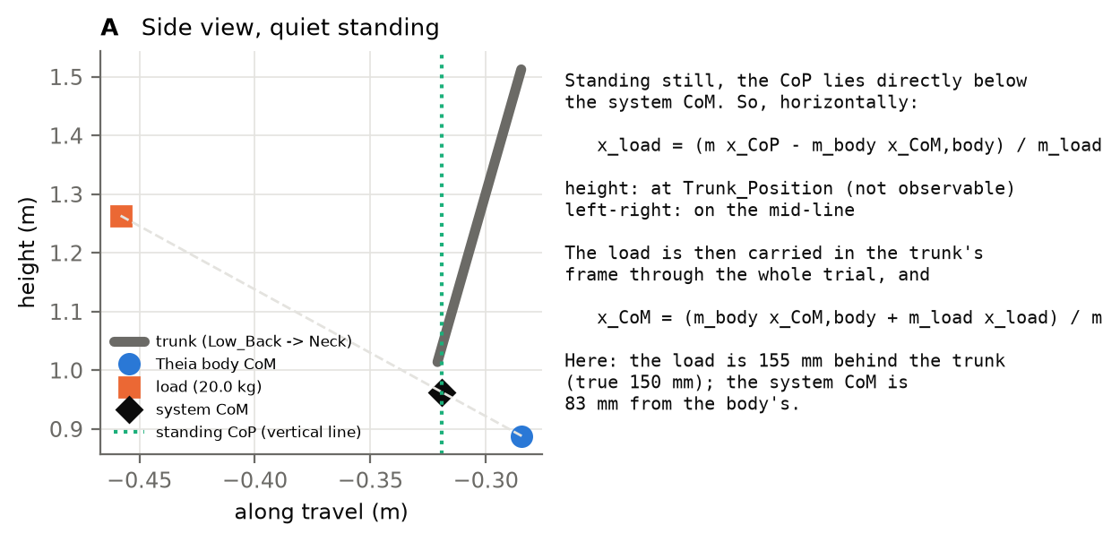
Figure 11. Placing the load (synthetic trial: 20 kg, 150 mm behind the trunk). A: side view in the quiet standing. The standing CoP (green dotted line) is below the system CoM (black diamond), which lies on the line between the body CoM (blue) and the load (orange). Knowing the two masses, the load is placed on that line. B: the equations. The load was recovered 155 mm behind the trunk, and the system CoM is 83 mm from the body’s.
Why the system CoM — a 20–40 kg pack moves the centre of mass by several centimetres, backwards and upwards. The margin of stability (§10) and CoM work (§9) concern the mass that has to be kept over the feet and moved: body and load. Why centre it left-right — the equation divides by $m_{ℓ}$, so any CoP error is multiplied by $m/m_{ℓ}$. That factor is about 5 for a 20 kg load on an 80 kg body, so a few millimetres of registration error would place the load centimetres to one side. Packs and vests are symmetric, so the mid-line is the better estimate. Why carry it with the trunk — a pack moves with the trunk, and the trunk leans and sways in every stride. Why the 0.40 m check — a load placed more than 40 cm from the trunk is physically implausible and means the standing or the body mass is wrong. It is then placed on the trunk instead, with a warning (LOAD_MAX_OFFSET_M). Why light loads are not placed — below 10 kg (LOAD_PLACE_MIN_KG) the factor $m/m_{ℓ}$ makes the answer noise: 18 for D05’s 4.7 kg of boots and clothing. Such a load is spread over the body anyway, so the CoM stays Theia’s. The mass is still the one weighed.
In the code — §5.6: trunk_frame(), system_com(). Settings: LOAD_MIN_KG, LOAD_PLACE_MIN_KG, LOAD_HEIGHT_M, LOAD_CENTRED, LOAD_MAX_OFFSET_M. Results: load_offset_x_m, load_offset_y_m, load_offset_z_m (trunk frame: x right, y forward, z up).

5.7 CoM velocity: markers and force plates together
What. The velocity of the system centre of mass, taken from the markers at low frequencies and from the integrated force at high frequencies.
Equations.
$$v_{mk}=\frac{d}{dt}x_{CoM}, a=\frac{F_{L}+F_{R}−\overline{F_{L}+F_{R}}}{m}, v_{F}(t)=\int_{0}^{t}{a} dτ$$
$$v=H_{LP}\{v_{mk}\}+\left(v_{F}−H_{LP}\{v_{F}\}\right)$$
The marker derivative $d/dt$ is a Savitzky–Golay filter (11 samples, cubic). $H_{LP}$ is a 2nd-order Butterworth low-pass at $f_{c}=0.5$ Hz, run forwards and backwards. Its gain is ${\left|H(f)\right|}^{2}$, so the force branch has gain $1−{\left|H(f)\right|}^{2}$, and the two gains add up to exactly 1 at every frequency (Fig. 12A). Nothing is counted twice and nothing is lost. In the belt frame,
$$v_{belt}=v+v_{b} \hat{f}.$$
Steps (complementary(), fuse_velocity()):
- Fill tracking gaps in the CoM by straight lines, only so the filters can run. The filled frames are set back to missing at the end, widened by the filter’s reach.
- Marker branch: one Savitzky–Golay step smooths the CoM and differentiates it.
- Force branch: add both belts’ raw GRF and subtract the mean over the trial. That removes gravity, because the mean vertical force over a steady walk is $mg$, and it removes the plates’ zero offsets. Divide by the system mass. Anti-alias at 40 Hz and take every 10th sample (1000 → 100 Hz). Integrate by the trapezoid rule and remove the mean.
- Axes check (Fig. 9). Band-pass (0.5–5 Hz) both the force-based acceleration and the markers’ second derivative, and correlate them per axis. If a horizontal axis correlates below −0.5, the force axis is reversed: it is flipped with a warning. If any axis falls below 0.7, the script warns that the axes or the mass are off.
- Combine the two branches with the complementary filter, and add the belt velocity.
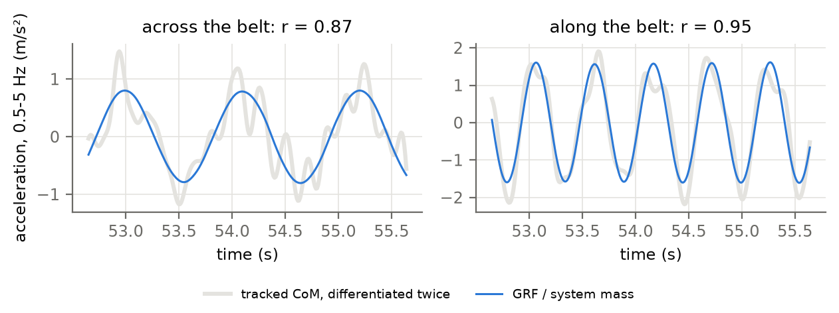
Figure 9. The axes check. Band-passed (0.5–5 Hz) acceleration of the tracked CoM (grey) against the GRF divided by the system mass (blue), across and along the belt. The two must agree: this tests the plate-to-Theia rotation, the sign of each horizontal axis and the mass. A reversed axis would give r ≈ −1. The correlations are reported per trial (grf_vs_marker_acc_r_X/Y/Z).
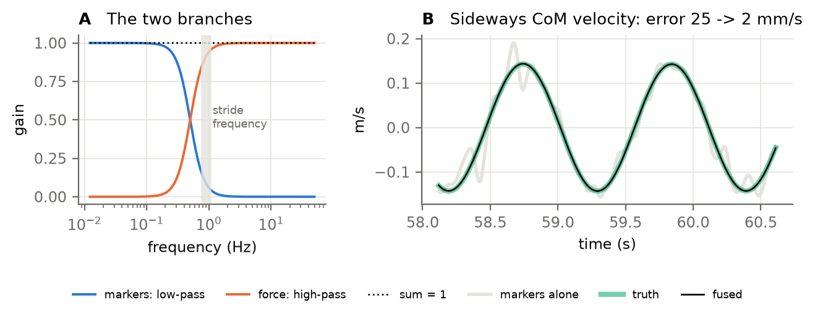
Figure 12. The complementary filter. A: the marker branch (blue) keeps frequencies below 0.5 Hz, and the force branch (orange) keeps those above; their gains add up to 1 (dotted). The stride frequency (grey band) lies well inside the force branch. B: the sideways CoM velocity in the synthetic trial: markers alone (grey), fused (black) and the truth (green). The RMS error falls from 25 to 2 mm/s.
Why fuse — the margin of stability (§10) divides the velocity by $ω_{0}≈3.3$ s⁻¹, so an error of 30 mm/s in velocity becomes 9 mm in the margin, against margins of a few centimetres. Differentiating a tracked position amplifies its noise exactly at the within-stride frequencies. Integrating the force is exact there (Newton’s law, sampled at 1000 Hz, no differentiation), but it drifts slowly with any error in the mass or the plate zero. Each source is used where it is good. Why 0.5 Hz — the stride frequency is about 0.9 Hz, so everything within a stride comes from the force, and the slow drift of the integral is replaced by the markers. Why the same filter on both branches — so the gains sum to exactly one and the fused signal has no gap or overlap in frequency. Validation (§20): with 1 mm of marker noise, the fused error is 0.5–3 mm/s against 25 mm/s for the markers alone, with no bias below 0.5 Hz.
In the code — §5.7: complementary(), fuse_velocity(). Settings: CROSSOVER_HZ = 0.5, MARKER_SAVGOL = (11, 3), ANTIALIAS_HZ = 40. The trial holds com_vel (lab frame), com_vel_belt (belt frame) and com_vel_markers (markers alone, for comparison).

6. Spatiotemporal metrics
What. The timing and the geometry of each step. One value is computed per heel strike; §13 turns them into trial means, SDs and CVs.

6.1 Timing
With the events of §5.1, all in seconds:
$$T_{stance}=t_{TO}−t_{HS}, T_{swing}=t_{HS}^{next}−t_{TO}, T_{stride}=t_{HS}^{next}−t_{HS}, T_{step}=t_{HS}−t_{HS,o}^{prev}$$
$$\text{cadence}=\frac{60}{T_{step}} \text{steps/min}$$
$$T_{DS}=(t_{TO,o}−t_{HS})+(t_{TO}−t_{HS,o}), T_{SS}=t_{HS,o}−t_{TO,o}$$
The first bracket of $T_{DS}$ is the initial double support, and the second the terminal double support.
Stance, swing, single and double support are also given as a percentage of the stride (_pct), which is the usual convention (the “gait cycle”).
Steps (spatiotemporal()):
- Compute each interval from the fractional event times. An interval is kept only if its end comes after its start.
- Compute double and single support only when the five events are in their natural order, $t_{HS}<t_{TO,o}<t_{HS,o}<t_{TO}<t_{HS}^{next}$. A missed or doubled event would otherwise give a negative or doubled time.
Why double support matters here — with a load, walkers spend longer with both feet down. That buys stability at the cost of speed, and it is one of the most consistent effects of load carriage (Appendix B). Why cadence from step time — cadence counts steps, and each step time is measured directly between consecutive heel strikes of opposite feet.

6.2 Distances
The two heels are read at the heel strike, at the exact fractional time, and projected on the walker’s axes (§5.2):
$$\text{step length}=(p_{heel,b}−p_{heel,o})⋅\hat{f}, \text{step width}=\left|(p_{heel,b}−p_{heel,o})⋅\hat{ℓ}\right|.$$
Stride length on a treadmill is how far the foot travelled over the belt from one landing to the next (Dingwell et al. 2010):
$$L_{stride}=v_{b} T_{stride}+\left(p_{heel,b}(t_{HS}^{next})−p_{heel,b}(t_{HS})\right)⋅\hat{f}, v_{stride}=\frac{L_{stride}}{T_{stride}}.$$
The second term is small. It is how much further forward (or back) in the lab the foot landed this time than last time.
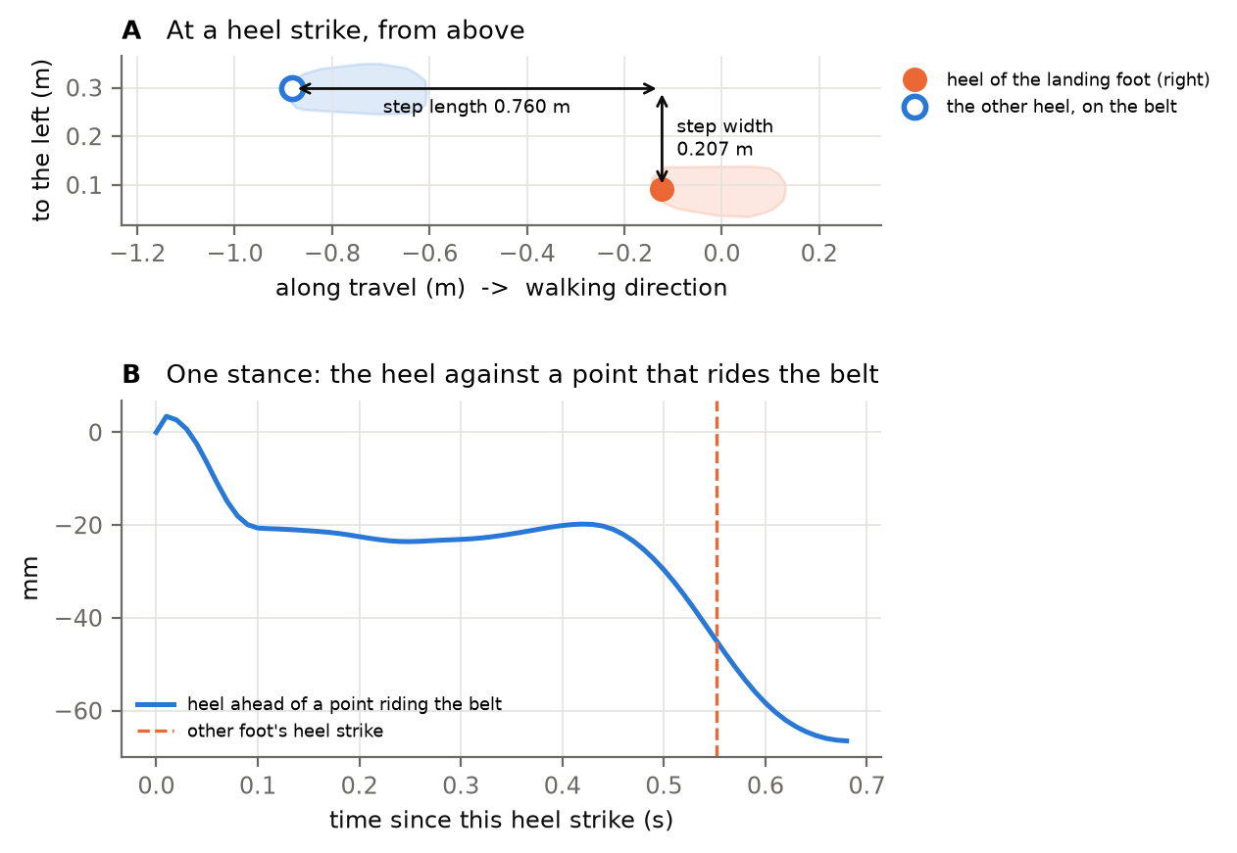
Figure 13. A: a heel strike seen from above, with travel to the right. The step length is the distance along the belt from the other heel (open circle) to the landing heel (filled circle); the step width is the distance across it. B: why two step lengths do not add up to a stride on a belt. During one stance the heel is compared with a point riding the belt. It stays with the belt through mid-stance (flat part), but by the other foot’s heel strike (dashed line) it has already started to lift, 30–50 mm ahead of where it landed.
Why heels — the heel is the point that lands, and it is tracked well at heel strike. Why along and across the belt — see §1.3: projecting on Theia’s X and Y would move part of the step length into the width. Why stride length is not two step lengths — overground, a stride is the sum of two steps. On a belt, the rear heel has already begun to lift, and has moved relative to the belt, by the time the other foot lands (Fig. 13B). Two heel-to-heel step lengths therefore fall 30–50 mm short of the stride each (D05: 96 mm per stride). Measuring the foot’s travel over the belt gives the true stride. It also makes stride speed ($L/T$) equal to the belt speed on average, which is the task goal used by the GEM (§17).

6.3 Where the events came from
Each step also records events_from_kinematics (either event came from Zeni or was interpolated) and events_interpolated. The per-step data can therefore be filtered to force-plate events only, to check that a result does not depend on the event source.
Gross event errors. A missed, doubled or misplaced event makes a step that cannot be gait: on D05, a step length of −0.38 m and a cadence of 144 steps/min at a 108-beat metronome. A steady step is taken out of steady walking for every metric if any of these is more than 5 robust SDs (1.4826 × MAD) from its foot’s median: stride, step, stance or swing time, step length or step width (OUTLIER_ROBUST_Z). A step length ≤ 0 is also taken out. The step keeps the flag gait_outlier. A robust 5 catches only what cannot be a real step, while Hausdorff-type screens remove everything beyond 3 SD of the mean. One bad event then cannot inflate a CV, a DFA α or a margin.
In the code — §6: spatiotemporal(). Per-step columns in {trial}_steps.csv: stance_s, swing_s, stride_s, step_s, cadence_spm, initial_ds_s, terminal_ds_s, double_support_s, single_support_s and their _pct, step_length_m, step_width_m, stride_length_m, stride_speed_ms, walk_ratio, gait_outlier. Setting: OUTLIER_ROBUST_Z = 5.
Healthy range — for healthy adults at about 1.3 m/s (Table 6.1). With the 108 steps/min metronome, cadence is set at 108 and the stride time at 1.11 s. Their variability is then partly the precision of beat-following.
Table 6.1. Healthy ranges for the spatiotemporal metrics (column names as in the results workbook).
Results column | What it is | Healthy range | Population | Source | Checked
stride_s | Stride time | 1 to 1.15 s | healthy adults ~1.3 m/s (fixed at 1.11 s by the 108-bpm metronome here) | Perry & Burnfield 2010; Oberg et al. 1993 | verify
cadence_spm | Cadence | 104 to 120 steps/min | healthy adults ~1.3 m/s | Oberg et al. 1993 | verify
stance_pct | Stance, % of stride | 58 to 62 % | healthy adults, % of gait cycle | Perry & Burnfield 2010 | verify
double_support_pct | Double support, % of stride | 18 to 24 % | healthy adults, both periods, % of gait cycle | Perry & Burnfield 2010 | verify
single_support_pct | Single support, % of stride | 38 to 42 % | healthy adults, % of gait cycle | Perry & Burnfield 2010 | verify
step_length_m | Step length (heel to heel, along the belt) | 0.65 to 0.8 m | healthy adults ~1.3 m/s (scales with stature) | Oberg et al. 1993 | verify
step_width_m | Step width (heel to heel, across the belt) | 0.08 to 0.15 m | healthy young adults, treadmill, heel to heel | Owings & Grabiner 2004 | verify
stride_s_cv | Stride time: CV over steps | 1 to 3 % | healthy young adults | Hausdorff 2005 | verify
stride_length_m_cv | Stride length over the belt: CV over steps | 1 to 3 % | healthy young adults | Hausdorff 2005 | verify
step_width_m_sd | Step width (heel to heel, across the belt): SD over steps | 0.01 to 0.03 m | healthy young adults, treadmill | Owings & Grabiner 2004 | verify

7. Posture and joint motion
What. How the trunk, pelvis and lower-limb joints move over each stride.
For each stride (this foot’s heel strike to its next), using the first (sagittal) component of Visual3D’s angles:
Results column | Signal | Statistic over the stride
trunk_lean_mean_deg, _rom_deg | Thorax_Seg_Angle X (thorax relative to the lab) | mean, range
pelvis_tilt_mean_deg | Pelvis_Seg_Angle X | mean
hip_rom_deg, knee_rom_deg, ankle_rom_deg | <Side>_Hip/Knee/Ankle_Joint_Angle X | range (max − min)
mean=1ni∈stride​θi, ROM=maxstrideθ−minstrideθ
Steps (posture()):
- For each stride with a valid next heel strike, take the frames from the heel strike to the next one.
- Skip the stride for that angle if any frame is missing, rather than filling it.
- Compute the mean and the range. Store the curve resampled to 101 points (0–100% of the stride) for the figures and the waveform file.
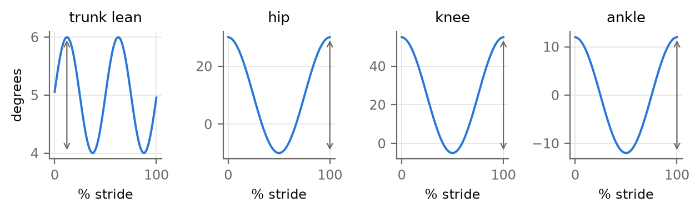
Figure 14. Mean ± SD angle curves over the stride (left foot, synthetic trial; the synthetic angles are simple sinusoids, not real joint curves). The arrows show the range of motion, the statistic reported for the joints; for the trunk the mean is also reported.
Why these variables — a load changes posture before it changes timing. The trunk leans forward to bring the system CoM back over the feet, and the knee flexes more during weight acceptance to absorb the extra load. Trunk lean and knee range of motion are therefore the most load-sensitive angles (Appendix B). Why the sagittal component only — it is the plane in which walking and load carriage act, and markerless sagittal angles agree best with marker-based ones (Kanko et al. 2021). Why ranges rather than peaks at events — a range does not depend on the exact event time, and it is robust to a constant offset in the angle definition. Signs are Visual3D’s. They are the same in every trial, so differences between conditions are valid whichever direction counts as positive.
In the code — §7: dictionary ANGLES (output name → Visual3D signal), function posture(). Setting: WAVE_POINTS = 101.
Table 7.1. Healthy sagittal ranges of motion over the stride. Trunk lean and pelvis tilt depend on each system’s reference posture, so no absolute range is given: compare them between conditions.
Results column | What it is | Healthy range | Population | Source | Checked
hip_rom_deg | Hip sagittal range of motion | 38 to 50 deg | healthy adults, sagittal | Winter 2009; Kadaba et al. 1990 | verify
knee_rom_deg | Knee sagittal range of motion | 55 to 68 deg | healthy adults, sagittal | Winter 2009; Kadaba et al. 1990 | verify
ankle_rom_deg | Ankle sagittal range of motion | 22 to 35 deg | healthy adults, sagittal | Winter 2009; Kadaba et al. 1990 | verify

8. Kinetics

8.1 Which stances
Kinetics are computed only for stances whose heel strike and toe-off were both trusted force events of the same belt contact (§4.3): one boot on that belt, the other boot off it, and the CoP under the boot. Any other stance may carry two feet’s force (a crossover onto a shared belt) or part of one foot’s (a straddle). Such stances are left missing, not estimated. Because the event record names the belt, a clean crossover step is read from the belt it actually landed on. The share of steady stances used is reported (stances_kinetics_pct).
Why so strict — a single stance mixing two feet’s force would add a peak of about 2 BW and bias the trial’s mean F1. Leaving it out loses one stance among hundreds.

8.2 Vertical force landmarks
For one trusted stance, with $F_{z}(t)$ the 50 Hz-filtered vertical force:
$$F_{1}=\max_{t<T/2}F_{z}, F_{2}=\max_{t≥T/2}F_{z}, \text{trough}=\min_{t_{F1}≤t≤t_{F2}}F_{z}$$
Loading rate is the least-squares slope of $F_{z}$ against time, between the moments it first reaches 20% and 80% of $F_{1}$ (LOADING_BAND):
$$\text{LR}=\frac{∑(t_{i}−\overset{‾}{t})(F_{i}−\overset{‾}{F})}{∑(t_{i}−\overset{‾}{t})^{2}}, t_{i}∈[t_{20\%}, t_{80\%}].$$

8.3 Impulses along the belt
With $F_{AP}=F⋅\hat{f}$ (positive = forward) at 1000 Hz, $Δt$ = 1 ms:
$$J_{brake}=∑min(F_{AP},0) Δt, J_{prop}=∑max(F_{AP},0) Δt, J_{vert}=∑F_{z} Δt.$$
Also reported: the peak braking and peak propulsive forces.

8.4 CoP excursion and free moment
The CoP is a point on the plate, and the boot on it rides the belt backwards about 0.9 m per stance. Its path over the belt is the plate CoP plus the belt’s travel since heel strike, $p_{CoP}(t)+v_{belt} (t−t_{HS}) \hat{f}$. That path runs along the foot, as it would over ground. Low-passed at 15 Hz (COP_FILTER_HZ), it gives the CoP’s range along and across the belt within the stance (cop_ap_range_mm, cop_ml_range_mm). The free moment (§5.4, 15 Hz) gives its largest absolute value (free_moment_peak_nm).

8.5 Normalisation: per body weight and per total weight
Every force and impulse is given twice: divided by body weight $m_{b}g$ (_bw), and by total weight $mg$ weighed in §5.5 (_tw).
Why both — per body weight is the convention, and it shows the load the body bears: with a load, $F_{1}$ in BW rises roughly in proportion to the added weight (Birrell et al. 2007). Per total weight asks whether the pattern changed beyond simply carrying more. If $F_{1}$/TW is unchanged, the walker is carrying the extra weight in the same way. Why a fitted slope for the loading rate — a two-point slope, or the peak of the derivative, is dominated by the heel-strike transient and by noise. A least-squares fit over 20–80% of F1 is the stable, conventional definition. Why the impulses — braking and propulsion must cancel over a stride at steady speed (a check). Propulsive impulse reflects push-off effort, which load increases.
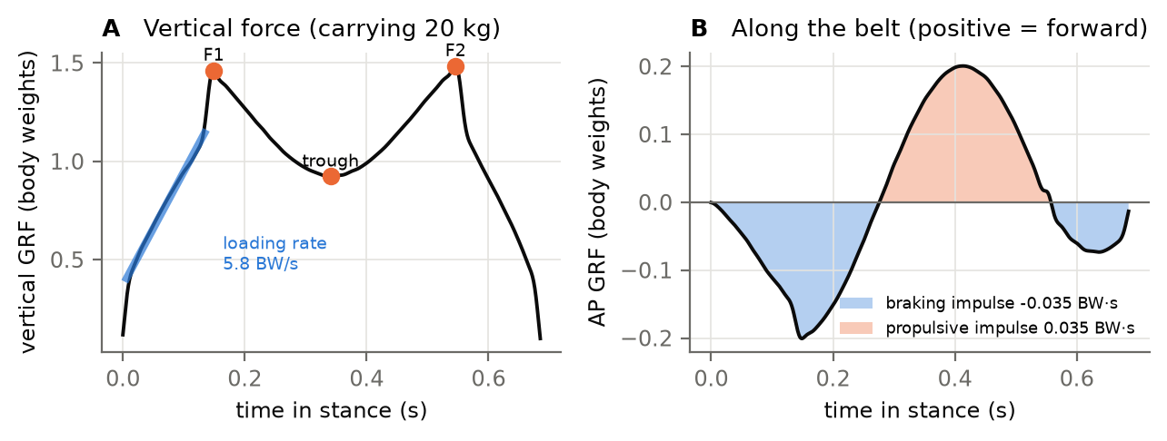
Figure 15. One trusted stance (synthetic trial, 20 kg load, per body weight). A: the vertical force with F1, the trough and F2; the blue line is the loading-rate fit (20–80% of F1). B: the force along the belt. Braking (blue area, negative) is followed by propulsion (orange area). At steady speed the two impulses cancel over the stride.
In the code — §8: trusted_stance(), kinetics(). Settings: LOADING_BAND = (0.20, 0.80), COP_FILTER_HZ = 15. The waveforms (vertical and AP force per total weight, 101 points) are saved in {trial}_waveforms.npz.
Healthy range — for healthy, unloaded adults per body weight (Table 8.1). With a load, the _bw values are expected to exceed these ranges roughly in proportion to $m/m_{b}$; the _tw values should stay close to the unloaded pattern.
Table 8.1. Healthy ranges for the kinetic metrics.
Results column | What it is | Healthy range | Population | Source | Checked
f1_bw | Vertical GRF first peak (weight acceptance) | 1.05 to 1.3 BW | healthy adults, treadmill (e.g. 1.19 BW) | Winter 2009; treadmill GRF studies | yes
trough_bw | Vertical GRF mid-stance trough | 0.6 to 0.85 BW | healthy adults ~1.3 m/s | Winter 2009 | verify
f2_bw | Vertical GRF second peak (push-off) | 1 to 1.25 BW | healthy adults, treadmill (e.g. 1.14 BW) | Winter 2009; treadmill GRF studies | yes
f1_tw | Vertical GRF first peak, per total weight | 1.05 to 1.3 TW | unloaded pattern (per total weight) | Birrell et al. 2007 | verify
f2_tw | Vertical GRF second peak, per total weight | 1 to 1.25 TW | unloaded pattern (per total weight) | Birrell et al. 2007 | verify
loading_rate_bw_per_s | Loading rate, 20-80% of F1 | 5 to 15 BW/s | shod walking, mean slope 20-80% of F1 | gait literature; method dependent | verify
peak_braking_bw | Peak braking force | 0.15 to 0.25 BW | healthy adults ~1.3 m/s | Winter 2009 | verify
peak_propulsive_bw | Peak propulsive force | 0.15 to 0.25 BW | healthy adults ~1.3 m/s | Winter 2009 | verify
braking_impulse_bw_s | Braking impulse (negative) | -0.04 to -0.02 BW s | healthy adults | Revi et al. 2020 | verify
propulsive_impulse_bw_s | Propulsive impulse | 0.02 to 0.04 BW s | healthy adults | Revi et al. 2020 | verify
vertical_impulse_bw_s | Vertical impulse | 0.5 to 0.6 BW s | physics: each limb carries ~half the weight over a stride of 1.0-1.2 s | Newton | yes
cop_ap_range_mm | CoP excursion along the belt | 150 to 220 mm | healthy adults (~60-75% of foot length) | gait literature | verify
cop_ml_range_mm | CoP excursion across the belt | 15 to 40 mm | healthy adults | gait literature | verify
free_moment_peak_nm | Peak |free moment| | 2 to 8 N m | healthy adults walking | Holden & Cavanagh 1991; Li et al. 2001 | verify

9. Centre-of-mass work: the individual limbs method
What. The mechanical work each leg does on the centre of mass, phase by phase through the stance (Donelan, Kram & Kuo 2002).
Equations. Each leg’s power into the system CoM is the dot product of that leg’s GRF with the CoM velocity in the belt frame (§5.7):
$$P_{leg}(t)=F_{leg}(t)⋅v_{belt}(t)$$
It is integrated over the phases of this foot’s stance (Fig. 7), counting positive and negative power separately:
Phase | From → to | Work
collision | heel strike → other toe-off (initial double support) | negative part
rebound | other toe-off → other heel strike (single support) | positive part
preload | other toe-off → other heel strike (single support) | negative part
push-off | other heel strike → toe-off (terminal double support) | positive part
$$W_{pos}=∑max(P,0) Δt, W_{neg}=∑min(P,0) Δt$$
Work is given in J and per kg of system mass (_j_kg), together with the positive and negative work over the whole stance.
Steps (kinetics(), phase_work()):
- Only trusted stances (§8.1), and only if the five events are in order.
- Read the fused belt-frame velocity at every 1000 Hz force sample, interpolating between the 100 Hz frames.
- Compute the power, and sum its positive and negative parts over each phase.
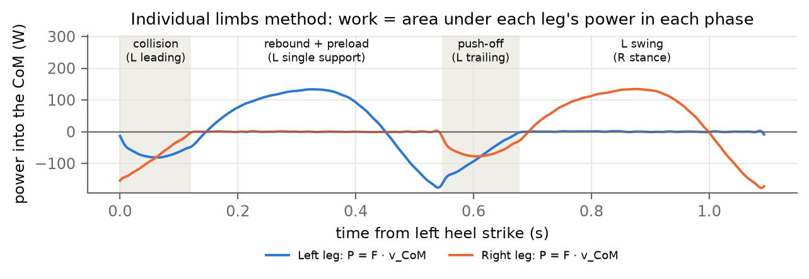
Figure 16. Each leg’s power into the CoM over one stride from the left heel strike, with the four phases of the left stance labelled (shading alternates by phase). The work in a phase is the area under the power curve, its positive and negative parts summed separately. The synthetic forces come from a simple model of the CoM’s motion, so these curve shapes are not those of real walking. In real walking the leading leg does negative work in the collision while the trailing leg does positive work at push-off (Donelan et al. 2002).
Why individual limbs — the older “combined limbs” method adds both legs’ forces before multiplying by the velocity. In double support the trailing leg pushes (positive) while the leading leg collides (negative), and their sum hides both. Separating the legs reveals the step-to-step transition, which is the main mechanical cost of walking and rises with load. Why the belt frame — on a treadmill the lab-frame CoM hardly moves forward. The work done on a mass moving at 1.3 m/s over still ground is recovered by adding the belt speed to the velocity. Why the system velocity and mass — the legs move the body and the load.
In the code — §9 is in the same loop as §8: kinetics() calls phase_work(). Results: collision_j_kg, rebound_j_kg, preload_j_kg, push_off_j_kg, com_work_pos_j_kg, com_work_neg_j_kg.
Table 9.1. Healthy ranges for CoM work per step (unloaded, about 1.25 m/s). Values per kg of system mass.
Results column | What it is | Healthy range | Population | Source | Checked
push_off_j_kg | Push-off: positive work, other heel strike to toe-off | 0.1 to 0.25 J/kg | healthy adults 1.25 m/s, per step | Donelan et al. 2002 | verify
collision_j_kg | Collision: negative work, heel strike to other toe-off | -0.25 to -0.08 J/kg | healthy adults 1.25 m/s, per step | Donelan et al. 2002 | verify

10. Margin of stability
What. How much base of support is left beyond the point to which the body’s momentum would carry the centre of mass (Hof, Gazendam & Sinke 2005).
Equations. Treat the body as an inverted pendulum of length $l$. If control stopped now, its dynamics would carry the CoM to the extrapolated centre of mass
$$x\text{CoM}=x_{CoM}+\frac{v_{belt}}{ω_{0}}, ω_{0}=\sqrt{\frac{g}{l}}, l=\left\|x_{CoM}−p_{ankle,stance}\right\|.$$
The margin is the distance from the xCoM to the edge of the base of support, positive when the xCoM is inside it:
$${\text{MoS}}_{ML}=e_{ML}−s (x\text{CoM}⋅\hat{ℓ}), {\text{MoS}}_{AP}=e_{AP}−x\text{CoM}⋅\hat{f}.$$
Here $e_{ML}$ is the stance boot’s outermost sole point across the belt, $e_{AP}$ is its most anterior sole point along the belt, and $s=±1$ says which way is “outward”: away from the other ankle at heel strike.
Steps (margin_of_stability()):
- For each stance (heel strike → toe-off), for every frame: compute $l$ and $ω_{0}$ frame by frame, and the xCoM from the system CoM (§5.6) and its fused belt-frame velocity (§5.7).
- Take the boundary from the stance boot’s extents (§5.3).
- Report the margins at heel strike (_contact), and their minima over single support (_min), from the other foot’s toe-off to its heel strike. Also report where in stance the ML minimum falls (mos_ml_min_at_pct).
- Also keep the ML margin to the ankle joint centre (mos_ml_contact_ankle), the boundary most studies use, for comparison with the literature.
- If the participant’s leg length is known, also give each margin divided by it (_per_leg), for comparisons between people.
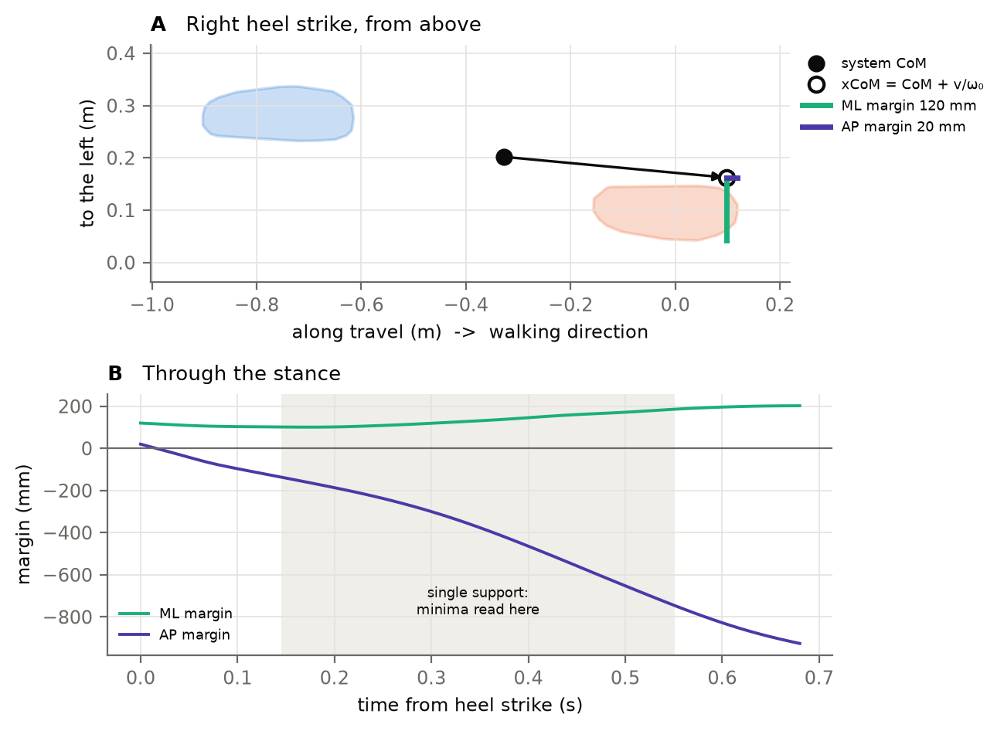
Figure 17. The margin of stability at a right heel strike, with travel to the right. A: from above. The system CoM (black) and its extrapolation along the belt-frame velocity (open circle, xCoM). The ML margin (green) runs from the xCoM to the outer edge of the right boot, and the AP margin (violet) to its front. B: both margins through the stance. The ML margin stays positive. The AP margin becomes strongly negative: the xCoM moves ahead of the stance foot, and walking “falls” onto the next step. The single-support minima (shaded) are the values reported.
Why the system CoM and the fused velocity — the load moves the CoM (§5.6). The velocity term is divided by $ω_{0}≈3.3$ s⁻¹, so velocity noise enters the margin directly, which is why §5.7 fuses the force plates in. Why the belt frame — in the lab the CoM hardly moves forward on a treadmill, so without the belt speed the AP margin would be meaningless. Why the boot edge — the ankle joint centre is 3–5 cm inside the boot’s real lateral edge. The boot is the physical base of support, and its edge also differs between footwear (boots vs shoes). The ankle-based value is kept only for comparison with the literature. Why single-support minima — only in single support is the stance boot alone the base of support; in double support the base spans both feet. Why “outward” from the ankles — it makes the sign independent of which way Theia’s axes point and of which foot is stepping.
In the code — §10: margin_of_stability(). Results: mos_ml_contact, mos_ml_min, mos_ap_contact, mos_ap_min, mos_ml_min_at_pct, mos_ml_contact_ankle, pendulum_m (m), and _per_leg versions. Steps with a hand on the rail are flagged (handrail).
Healthy range — most published values use the ankle or the lateral malleolus as the boundary, so the boot-edge margin (mos_ml_contact) is expected to be about 3–5 cm larger than the published range; compare mos_ml_contact_ankle with it directly. Treadmill margins are larger than overground ones. A negative AP margin in single support is normal.
Table 10.1. Healthy ranges for the ML margin of stability (published with an ankle or malleolus boundary).
Results column | What it is | Healthy range | Population | Source | Checked
mos_ml_contact | ML margin of stability at heel strike | 0.03 to 0.1 m | healthy adults, ankle/malleolus boundary (boot edge adds ~0.03-0.05 m); treadmill > overground | Hof et al. 2005; Rosenblum et al. 2021 | verify
mos_ml_min | ML margin of stability, single-support minimum | 0.02 to 0.08 m | healthy adults, ankle boundary | Hof et al. 2005 | verify

11. Foot clearance and trip risk

11.1 Minimum foot clearance (MFC)
What. How close the swinging boot comes to the belt in mid-swing, when a trip is most likely: the foot is low and moving fast.
Equations. In every frame of the swing,
$$c(t)=\min_{\text{sole points }j}h_{j}(t),$$
the height of the lowest sole point above the pitched belt (§3.4). The MFC is a local minimum of $c(t)$ in mid-swing that meets all three criteria of Schulz (2017):
- it is lower than the 2 frames on either side (MFC_LOCAL_WINDOW);
- the front of the boot is in the fastest 25% of its swing (MFC_SPEED_QUANTILE), with the speed measured over the belt, which rules out the dip just after toe-off;
- the rear half of the sole is not lower than it (the minimum is at the front of the boot).
If several minima qualify, the lowest one is taken. If none qualifies, the swing is a “non-MTC” cycle: its MFC is missing, and it is not replaced by the global minimum, which would be at toe-off or heel strike. The share of such swings is reported (swings_without_mfc_pct). The script also records whether the MFC point lies on the toe cap (mfc_on_toes) and the share of swings whose MFC is below the belt (mfc_below_belt_pct), which can only be a pose error.
Steps (swing_clearance(), foot_clearance()):
- Take the swing from toe-off to the next heel strike, trimming 2% at each end (SWING_TRIM), where the boot is still on the belt.
- Pose every sole point in every frame (§3), with the toe cap bent by Theia’s extension or as far as the belt requires, whichever is larger (§3.3), and compute each point’s height above the belt.
- Find the minima that meet (a)–(c), and keep the lowest.

11.2 Margin of instability and the trip-risk integral
What. If the foot caught on something now, how badly would the body be thrown forward, relative to how close the foot is to the ground (Schulz 2017)?
Equations. The margin of instability is how far the xCoM (along the belt, using the stance leg’s pendulum) is ahead of the front of either boot:
$$\text{MoI}(t)=max\left(x{\text{CoM}}_{AP}(t)−max(e_{AP,b}(t), e_{AP,o}(t)), 0\right) [\text{mm}]$$
The trip-risk integral adds up the ratio of MoI to clearance over the risky part of the swing:
$$\text{TRI}=\int_{t_{0}}^{t_{1}}{\frac{\text{MoI}(t)}{max\left(c(t), 1 \text{mm}\right)}} dt [\text{s}]$$
The point of MFC is the lowest sole point in each frame. Its speed over the belt peaks in mid-swing. Its resultant acceleration has two peaks: one as the foot is accelerated after lift-off, before the speed peak, and one as it is slowed before landing, after it. $t_{0}$ and $t_{1}$ are those two peaks (Schulz 2017, Fig. 2). Speed and acceleration are Savitzky–Golay derivatives (7 frames, order 3, TRI_DERIV_WINDOW) of each sole point’s path over the swing plus 3 frames either side. A one-sided difference at the swing’s first frame, where the boot is still on the belt, would otherwise produce a false peak that lets the lift-off spike into the integral. The 1 mm floor (MIN_CLEARANCE_MM) keeps the ratio finite. TRI is computed for every swing, including those without an MTC event, because it integrates the whole clearance trajectory.
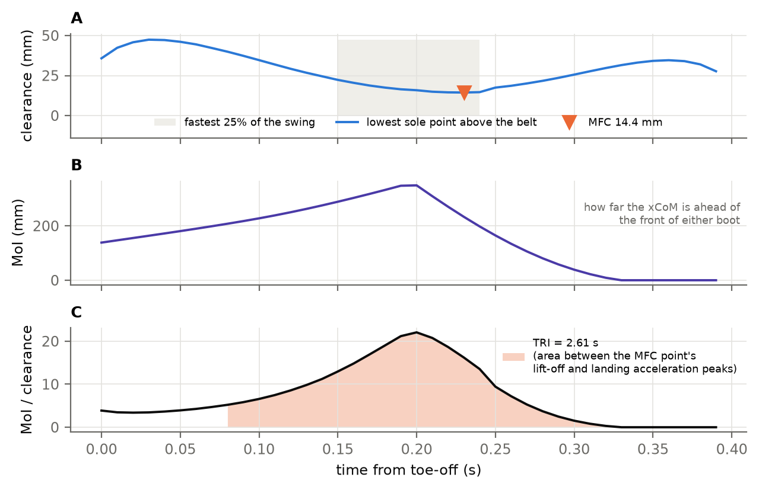
Figure 18. One swing. A: the clearance of the lowest sole point (blue). The MFC (orange triangle) is the local minimum inside the fastest 25% of the swing (shaded). B: the margin of instability, the distance by which the xCoM is ahead of the front of either boot. C: the ratio MoI/clearance. The trip-risk integral is the shaded area between the MFC point’s peak acceleration and peak deceleration.
Why the sole and not a toe marker — the lowest point of a boot moves around the sole during the swing. The “toe” landmark is neither the lowest point nor the front of the boot, so its height can be centimetres off the real clearance. Why the pitched belt — the 0.8° pitch changes the height by up to 13 mm over a stride, the same size as the MFC itself. Why Schulz’s criteria — the global minimum of a swing is at toe-off or heel strike, when the foot is meant to be on the ground. The criteria pick the mid-swing minimum that matters for tripping, and they say when a swing has none rather than inventing one. Why TRI — a low foot is only dangerous when a trip would destabilise the body. TRI weights clearance by the body’s forward momentum, and a load increases that momentum.
In the code — §11: swing_clearance(), foot_clearance(). Settings: MFC_LOCAL_WINDOW, MFC_SPEED_QUANTILE, SWING_TRIM, MIN_CLEARANCE_MM, TRI_DERIV_WINDOW. Results: mfc_m, moi_peak_mm, tri_s (plus mfc_on_toes, mfc_minima, moi_mean_mm, tri_window_s, tri_peak per step).
Table 11.1. Healthy ranges for minimum foot clearance. MoI and TRI are recent measures without established healthy ranges: compare them between conditions. Schulz’s (2017, Fig. 4) regressions on level floor give the order of magnitude to expect: MTC ≈ 3.15 v + 7.51 mm and TRI ≈ 3.18 v − 2.02 s, with v the speed in leg lengths per second. MoI grows with $v/ω_{0}$, so a fast walk (as in his Fig. 2) shows a larger MoI than 1.3 m/s.
Results column | What it is | Healthy range | Population | Source | Checked
mfc_m | Minimum foot clearance above the belt | 0.01 to 0.03 m | healthy young adults (1-2 cm overground; treadmill studies up to 3 cm) | Begg et al. 2007; Barrett et al. 2010 | yes
mfc_m_sd | Minimum foot clearance above the belt: SD over steps | 0.002 to 0.006 m | healthy young adults | Begg et al. 2007; Barrett et al. 2010 | verify

12. Confidence intervals

12.1 Why every value needs one
Each value comes from one walk of a few hundred strides. Walk again, and the value changes. A 95% confidence interval says by how much, so a difference between conditions can be judged against it. The metrics come in three kinds, and each kind needs its own method:
Kind | Examples | Method
a statistic of a series of strides | means, SDs, CVs, R² | circular block bootstrap (§12.2–12.3)
a long-range correlation | DFA α | parametric bootstrap (§12.5)
a divergence curve fitted over strides | Lyapunov exponents | stride bootstrap (§12.6)

12.2 The circular block bootstrap
What. Rebuild the stride series many times from runs of consecutive strides, recompute the statistic each time, and read the interval from the spread.
Steps (series_summary(), block_indices(), percentile_ci()):
- Take the series $x_{1},…,x_{N}$ (one value per steady step) and its block length $ℓ$ (§12.3).
- Draw $K=ceil(N/ℓ)$ random start points $s_{k}$ uniformly from $1..N$. Each block is $x_{s_{k}},x_{s_{k}+1},…,x_{s_{k}+ℓ−1}$, wrapping round the end of the series ($(s_{k}+j) mod N$). Glue the blocks together and cut to length $N$.
- Compute the statistic ${\hat{θ}}_{b}$ on the new series (resample $b$).
- Repeat $B=1000$ times (N_BOOT). The 95% interval runs from the 2.5th to the 97.5th percentile of the $B$ values ${\hat{θ}}_{b}$.
The random numbers come from a generator seeded by SEED and the series’ name (rng_for()), so the intervals are the same every time the script runs, and different series never share draws.
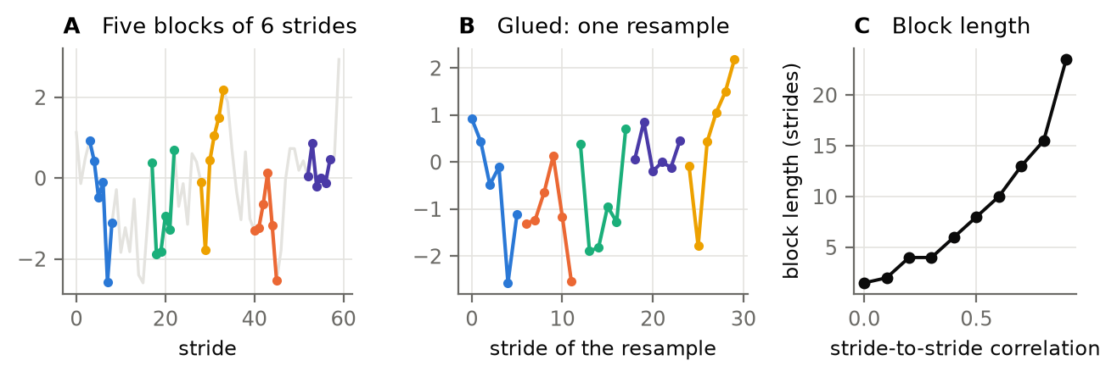
Figure 19. The circular block bootstrap. A: a series of strides and five blocks of 6 consecutive strides drawn at random start points. B: the blocks glued into one resampled series. The procedure is repeated 1000 times and the statistic recomputed on each. C: the block length chosen by the Politis–White rule grows with the stride-to-stride correlation: uncorrelated strides give 1 (the ordinary bootstrap), persistent series give longer blocks.
Why blocks — strides are not independent: a long stride tends to be followed by another long one. Resampling single strides destroys that correlation, and it underestimates the variance of the mean. Blocks of consecutive strides keep it. Validation (§20): on a persistent series (AR(1), $ϕ$ = 0.6, $N$ = 400), the 95% interval from blocks covered the true mean 93% of the time; resampling single strides covered it only 66% of the time. Why circular — wrapping round the end gives every stride the same chance of being drawn. Otherwise the first and last few strides would be under-represented. Why percentile intervals — they need no assumption about the shape of the sampling distribution, and SDs and CVs are skewed.

12.3 The block length
What. How many consecutive strides make one block. If blocks are too short, the correlation is lost; if too long, there are too few distinct blocks. The block length is chosen per series, from the series’ own autocorrelation, by the rule of Politis & White (2004), as corrected by Patton, Politis & White (2009).
Steps (optimal_block_length()):
- Compute the autocovariances $R(k)$ and autocorrelations $ρ(k)$ of the centred series up to lag $m_{max}=ceil(\sqrt{N})+K_{N}$, with $K_{N}=max(5,ceil(\sqrt{\log_{10}N}))$.
- Find $\hat{m}$, the first lag after which $K_{N}$ autocorrelations in a row are negligible: $\left|ρ(k)\right|<2\sqrt{\log_{10}N/N}$. Set $M=2\hat{m}$.
- Estimate the spectrum at zero and its “slope” with a flat-top lag window $λ(u)$: 1 up to $\left|u\right|=0.5$, falling linearly to 0 at $\left|u\right|=1$, and 0 beyond:
$$\hat{g}=\sum_{k=−M}^{M}{λ}\left(k/M\right)R(k), \hat{G}=\sum_{k=−M}^{M}{λ}\left(k/M\right)\left|k\right|R(k).$$
- The optimal block length for the circular block bootstrap is
$$ℓ={\left(\frac{2{\hat{G}}^{2}}{4/3{\hat{g}}^{2}}\right)}^{1/3}N^{1/3},$$
- rounded, and kept between 1 and $min(3\sqrt{N}, N/3)$.
Why chosen from the data — the correlation between strides differs between metrics (step width is more persistent than stance time) and between people. A fixed block length would be too short for some series and too long for others. The rule gives 1 for an uncorrelated series, so it reduces to the ordinary bootstrap when that is correct. The block length used is written next to every value in the long results table (block).

12.4 The same number of strides for every trial
DFA α, sample entropy and the Lyapunov exponents depend on how many strides the series has. Even an SD is slightly biased low in short series. Comparing conditions with different series lengths would mix the effect of the condition with the effect of $N$. With SERIES_LENGTH = "shortest" (the default), main() counts the steady strides per foot in every trial and cuts every trial’s series to the shortest one’s. The length used is written in the results (series_length). An integer fixes $N$ instead, and None uses every stride.
In the code — §12: rng_for(), optimal_block_length(), block_indices(), percentile_ci(), series_summary(), bootstrap_rows(). The series length is set in main() (RUN) through steady_strides(), and applied by series_for() (§17). Settings: N_BOOT = 1000, CI_LEVEL = 0.95, SEED = 0, SERIES_LENGTH = "shortest".

12.5 DFA α: a parametric bootstrap
Blocks would cut exactly the long-range correlation that α measures, so the block bootstrap cannot be used for DFA. Instead, $B=200$ series (N_BOOT_DFA) with the estimated $\hat{α}$ and the same length are simulated as exact fractional Gaussian noise (Davies & Harte 1987). For $\hat{α}≥1$ the simulated noise is summed. DFA is rerun on each simulated series. The basic bootstrap interval is
$$\left[ 2\hat{α}−q_{97.5}, 2\hat{α}−q_{2.5} \right],$$
where $q_{2.5}$ and $q_{97.5}$ are the percentiles of the α values of the simulated series.
It reflects the simulated spread around $\hat{α}$, which corrects for DFA’s small bias at this length. Validation (§20): at $N$ = 486 and α = 0.75, it covered the true α in 93% of trials, with a width of 0.33.
Caution — a 95% interval about 0.3 wide means that a difference in α between two conditions smaller than about 0.15 is within one trial’s uncertainty. DFA needs long series, and a few hundred strides is at the lower limit.

12.6 Lyapunov exponents: a stride bootstrap
The divergence curve of §18 is kept separately for each reference stride. Blocks of strides are resampled (block length from the per-stride short-term slopes, §12.3; 500 resamples, LDS_N_BOOT), and the exponents are refitted to each resampled mean curve. The interval shows how much λ depends on which strides happened to be walked. It does not include the method’s own bias, which is why λ is always compared between conditions with the same settings and the same $N$ (§18).
In the code — fractional_gaussian_noise(), simulate_alpha(), dfa_interval() (§12); the LDS interval is in window_lambda() (§18).

13. Summary statistics, symmetry and walk ratio

13.1 Mean, SD and CV of every per-step metric
For every per-step metric of §6–§11 (listed in STEP_METRICS), over the steady steps:
$$\overset{‾}{x}=\frac{1}{N}∑x_{i}, sd=\sqrt{\frac{1}{N−1}∑(x_{i}−\overset{‾}{x})^{2}}, \text{CV}=100 \frac{sd}{\left|\overset{‾}{x}\right|} \%.$$
Each is computed for both feet together, with its 95% block-bootstrap interval, and each foot’s mean separately. In the results workbook:
Column | Meaning
step_width_m | mean of all steady steps (both feet)
step_width_m_sd, step_width_m_cv | SD and CV over all steady steps
step_width_m_L, step_width_m_R | mean of the left foot’s and of the right foot’s steps
Why SD and CV — variability is the classic marker of gait control. Step width variability in particular separates groups that differ in lateral balance (Owings & Grabiner 2004). CV makes variability comparable between metrics with different means. It is not used for signed quantities near zero (such as the AP margin), where it is meaningless, and the SD is reported for those.

13.2 Symmetry angle
For the metrics in SYMMETRY_METRICS (stance and swing time, step length, MFC, ML margin, propulsive impulse, F1, TRI), from the left and right means (Zifchock et al. 2008):
$$\text{SA}=\frac{{45}^{∘}−arctan\left(X_{L}/X_{R}\right)}{{90}^{∘}}×100\%, \text{SA}←\text{SA}−200\% \text{if SA}>100\%.$$
0% is perfect symmetry, and a positive value means the right is larger.
Why the symmetry angle and not the symmetry index — the usual index $(X_{R}−X_{L})/1/2(X_{R}+X_{L})$ blows up when the mean of the two sides approaches zero (as it can for impulses or margins). It also needs one side to be chosen as the reference. The angle is bounded and needs no reference limb. An asymmetric load, or a limb that is favoured, would show up here.

13.3 Walk ratio
$$\text{walk ratio}=\frac{\text{step length}}{\text{cadence}} [\text{m}/(\text{steps/min})]$$
It is computed per step and averaged. Healthy adults keep it remarkably constant across walking speeds, at about 0.0063 m/(steps/min) (Sekiya & Nagasaki 1998). It shows how a walker achieves a speed: with longer steps or with faster ones. With the belt speed and the step rate both fixed, it mostly shows whether the participant follows the metronome.

13.4 Data-quality descriptors
Every trial row also says what the trial was and how trustworthy its data are. These columns are family “Trial” in the workbook:
- measured belt speed, system mass, load, and the CV of the quiet standing;
- the share of events from the force plates, from Zeni and from interpolation;
- the number of steady steps, and the share of stances trusted for kinetics;
- the share of swings without an MFC, and with an MFC below the belt;
- the share of steps with handrail contact;
- the GRF-vs-marker correlations (§5.7);
- the load offset in the trunk frame (§5.6).
Check these columns first. A trial with, say, 30% of its events interpolated or a GRF-vs-marker correlation below 0.7 needs a closer look before its metrics are used.
In the code — §13: STEP_METRICS, SYMMETRY_METRICS, row(), steady_steps(), trial_descriptors(), step_summaries(), symmetry_angle(), symmetry_rows(). The walk ratio is computed per step in spatiotemporal() (§6).
Table 13.1. Healthy ranges for the walk ratio and the symmetry angle.
Results column | What it is | Healthy range | Population | Source | Checked
walk_ratio | Walk ratio: step length / cadence | 0.0055 to 0.0072 m/(steps/min) | healthy adults, preferred speed (0.0063 +- 0.0007) | Sekiya & Nagasaki 1998 | yes
symmetry_angle_stance_s | Symmetry angle (0 = symmetric, + = right larger) of stance time | -3 to 3 % | healthy adults | Zifchock et al. 2008 | verify
symmetry_angle_step_length_m | Symmetry angle (0 = symmetric, + = right larger) of step length (heel to heel, along the belt) | -3 to 3 % | healthy adults | Zifchock et al. 2008 | verify
symmetry_angle_f1_bw | Symmetry angle (0 = symmetric, + = right larger) of vertical grf first peak (weight acceptance) | -3 to 3 % | healthy adults | Zifchock et al. 2008 | verify

14. Long-range correlations: detrended fluctuation analysis
What. Whether each stride “remembers” strides tens to hundreds of strides earlier. DFA (Peng et al. 1994) measures how the fluctuations of a series grow with the time scale over which they are observed. Its exponent α summarises that growth.
Equations and steps (dfa()), on one foot’s consecutive steady strides $x_{1}..x_{N}$:
- Integrate the centred series into its profile:
$$Y(k)=\sum_{i=1}^{k}{(}x_{i}−\overset{‾}{x}), k=1..N.$$
- Cut $Y$ into non-overlapping boxes of $n$ strides, counting both from the start and from the end, so no stride is left out. This gives $2floor(N/n)$ boxes.
- Detrend: in each box, fit a straight line ${\hat{Y}}_{box}(k)$ by least squares and keep the residual (DFA-1).
- Fluctuation at box size $n$: the RMS of all residuals,
F(n)=12floor(N/n) nboxes​k∈box​Y(k)−Ybox(k)2.
- Exponent: repeat for 20 box sizes, log-spaced from 16 to N/9 strides. α is the slope of $logF(n)$ against $logn$:
$$F(n)∝n^{α}.$$
α | Meaning
< 0.5 | anti-persistent: a long stride tends to be followed by a short one (actively corrected, e.g. by a metronome or a fixed belt speed)
≈ 0.5 | uncorrelated (white noise)
0.5–1 | persistent long-range correlations (healthy free-walking stride time: 0.75–0.9)
> 1 | non-stationary (drifting)
Checks reported with every α (in the note of the long table):
- Shuffle test: 20 random shuffles of the series must give α ≈ 0.5 (DFA_N_SURROGATE). Shuffling destroys any order, so a shuffled value far from 0.5 would mean a coding error or too short a series.
- A second estimator: the Geweke–Porter-Hudak periodogram slope. The log periodogram at the $\sqrt{N}$ lowest frequencies is regressed on $log\left(4\sin^{2}(ω/2)\right)$; the slope is $−d$, and $α_{GPH}=d+1/2$. It scatters about twice as much as DFA, so it is a ballpark check, not a replacement.
- the R² of the log–log fit and the box range used.
The 95% interval is the parametric bootstrap of §12.5. A series is analysed only if at least 95% of its strides are valid, with at least 50 strides. Gaps are not bridged, because a bridged series is not a series of consecutive strides. The box range 16 to $N/9$ needs at least one octave, so $N≥288$ strides.
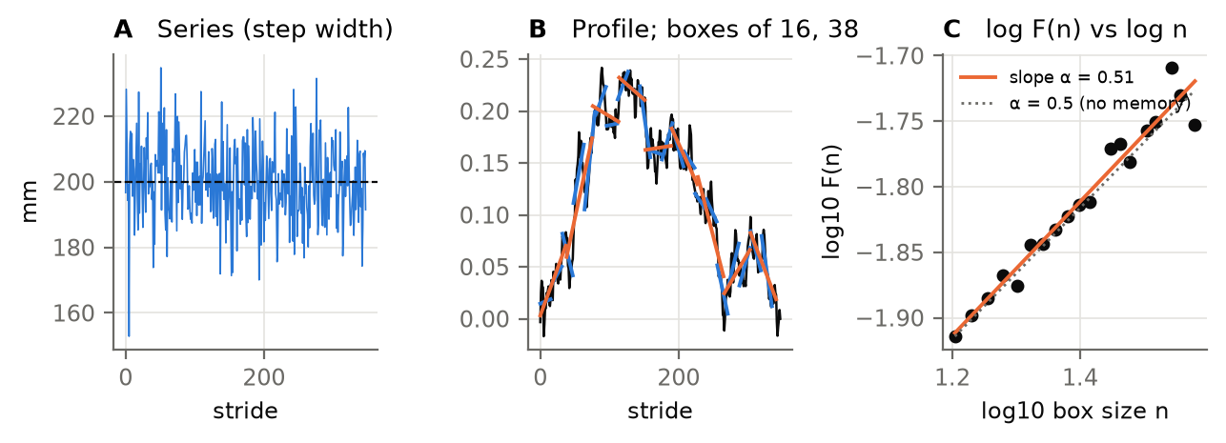
Figure 20. DFA step by step on the step-width series of the synthetic trial. A: the series. B: its integrated profile, with the straight lines fitted in the smallest (16-stride) and largest (N/9) boxes. C: log F(n) against log n; the slope is α (orange). The dotted line has the slope 0.5 of an uncorrelated series.
Series analysed (SERIES): stride, stance and swing time, double support %, step length and width, stride length and speed, MFC, the margins of stability, propulsive and braking impulses, F1 and trunk lean. DFA is computed for each foot separately (_L, _R).
Why DFA — the SD says how much strides vary; α says how they are organised in time. Persistent correlations in free walking are thought to reflect a healthy, flexible control; their loss is seen with ageing and disease (Hausdorff 2005). On a treadmill, the metrics the task constrains (stride speed, which must match the belt) are anti-persistent, and the unconstrained ones (stride length, step width) persistent. The pattern shows which variables the walker controls tightly (Dingwell et al. 2010). Why boxes 16 to N/9 — the widely used range of 4 to N/4 biases α upwards for gait-length series: small boxes are distorted by short-term correlations, and large boxes have too few boxes to average (Damouras et al. 2010). Why both ends — with $N$ not a multiple of $n$, counting from one end only would drop the last strides.
Caution: metronome-paced series. Stride, stance, swing and step time, cadence and the support percentages are paced by the 108 steps/min metronome (CUED). Their α measures how the walker follows the beat, typically < 0.5, and must not be compared with the uncued healthy range. The note of every such α says “metronome-paced”. The spatial series (lengths, width, clearance, margins) are not paced and are compared with the treadmill ranges.
In the code — §14: CUED, SERIES, dfa(), dfa_alpha(), gph_alpha(). The loop over series is stride_series_metrics() (§15), called per foot by variability_rows() (§17). Settings: DFA_MIN_BOX = 16, DFA_MAX_BOX_FRAC = 1/9, DFA_N_BOXES = 20, DFA_N_SURROGATE = 20, GPH_POWER = 0.5. Results: dfa_alpha_<series>_L/_R.
Table 14.1. Healthy ranges for DFA α. Stride time is uncued overground walking, and does not apply to metronome-paced trials; the other three are treadmill walking at a fixed speed.
Results column | What it is | Healthy range | Population | Source | Checked
dfa_alpha_stride_s | DFA alpha of stride time | 0.75 to 0.9 | healthy adults, uncued; METRONOME-PACED walking gives < 0.5 | Hausdorff et al. 1996; Terrier et al. 2005 | yes
dfa_alpha_stride_length_m | DFA alpha of stride length over the belt | 0.6 to 0.9 | healthy young adults, treadmill, UNCUED (a metronome paces it too: L = v T) | Dingwell et al. 2010 | yes
dfa_alpha_stride_speed_ms | DFA alpha of stride speed over the belt | 0.2 to 0.4 | healthy young adults, treadmill (anti-persistent) | Dingwell et al. 2010; Terrier 2012 | yes
dfa_alpha_step_width_m | DFA alpha of step width (heel to heel, across the belt) | 0.6 to 0.9 | healthy young adults, treadmill (persistent) | Dingwell & Cusumano 2015 | verify

15. Entropy

15.1 Sample entropy of the stride series
What. How predictable the series is: if two runs of $m$ strides are alike, how often are the next strides alike too (Richman & Moorman 2000)?
Equations. $z$-score the series (so the tolerance $r$ is in SD units). Take the templates $u_{m}(i)=(z_{i},…,z_{i+m−1})$ for $i=1..N−m$, using the same start points for length $m$ and length $m+1$. Two templates match when their Chebyshev (largest-component) distance is at most $r$. Then
$B$ is the number of pairs $i<j$ that match at length $m$, ${\left\|u_{m}(i)−u_{m}(j)\right\|}_{∞}≤r$. $A$ is the number of pairs that still match at length $m+1$, ${\left\|u_{m+1}(i)−u_{m+1}(j)\right\|}_{∞}≤r$.
$$\text{SampEn}(m,r)=−ln\frac{A}{B},$$
with $m=2$ and $r=0.2$ (ENT_M, ENT_R). Self-matches are excluded. If nothing matches at length $m+1$, SampEn is missing, not zero.
Steps (match_counts(), sample_entropy()): the pairs are counted with a KD-tree, which gives the same counts as the textbook double loop, much faster. Each series is also analysed with $r$ = 0.10, 0.15, 0.20, 0.25 and 0.30 (ENT_R_SWEEP). The sweep is written in the note, to show whether a conclusion depends on $r$ (Yentes & Raffalt 2021).

15.2 Refined composite multiscale entropy of the trunk
What. Entropy across time scales, from the continuous trunk acceleration (§16) at 100 Hz (Costa et al. 2002; refined composite version: Wu et al. 2014).
Equations and steps (rcmse()):
- $z$-score the steady trunk acceleration (up to 300 s, MSE_MAX_S).
- For each scale $τ=1..30$ (MSE_SCALES; 0.01–0.30 s), and each of the $τ$ starting phases $p$, coarse-grain by averaging non-overlapping runs of $τ$ samples:
$$y_{j}^{(τ,p)}=\frac{1}{τ}\sum_{i=0}^{τ−1}{z_{p+(j−1)τ+i}}.$$
- Count $A^{(τ,p)}$ and $B^{(τ,p)}$ on each coarse-grained series, with $r$ fixed at 0.2 SD of the original series. Sum over the phases before taking the logarithm:
RCMSE(τ)=−lnp​A(τ,p)p​B(τ,p).
- The area under the curve over scales 1–30 is the complexity index (mse_area_ML/AP/VT). White noise of the same length goes through the identical calculation as a reference.
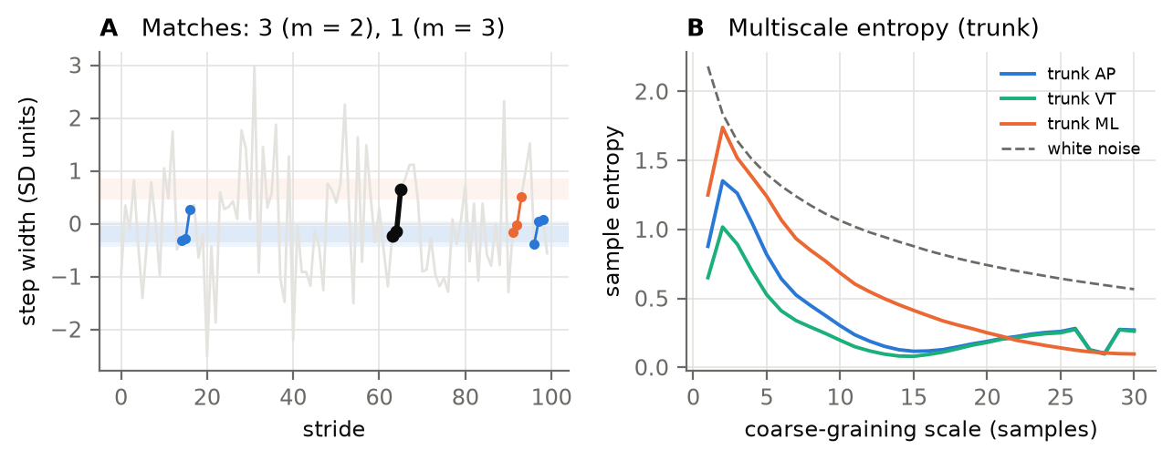
Figure 21. A: sample entropy, on part of the step-width series in SD units. The template (black) is two consecutive strides. Every other pair of strides within ±0.2 SD of it (shaded bands) is a match at m = 2 (blue); those whose third stride also matches are matches at m = 3 (orange). SampEn = −ln(A/B) over all templates. B: the multiscale entropy of the trunk acceleration. White noise (dashed) starts high and falls with scale; a structured signal keeps some of its entropy over scales.
Why both measures — sample entropy asks whether the step-to-step pattern is regular (low) or unpredictable (high). But white noise is the most unpredictable signal and also the least complex, so one value of SampEn cannot measure complexity. The multiscale curve separates the two: noise loses its entropy as it is averaged, while a signal with structure on many time scales keeps it (Costa et al. 2002). Why the refined composite version — plain coarse-graining shortens the series τ-fold, and at large scales too few templates match, which makes the estimate unstable or undefined. Pooling the counts over every starting phase before the logarithm fixes that (Wu et al. 2014). Why r fixed on the original series — re-scaling r at each scale would remove exactly the change in variance that the curve is meant to show.
In the code — §15: match_counts(), sample_entropy(), rcmse(), stride_series_metrics(). The trunk MSE is computed in trunk_rows() (§16). Settings: ENT_M = 2, ENT_R = 0.2, ENT_R_SWEEP, MSE_SCALES = 30, MSE_MAX_S = 300. Results: sample_entropy_<series>_L/_R, mse_area_ML/AP/VT. The curves are in {trial}_waveforms.npz.
Healthy range — none is given. Entropy values depend strongly on $N$, $m$, $r$, the sampling rate and the filtering, so values from other studies are not comparable (Yentes & Raffalt 2021). Compare conditions within this study, with the same settings and the same $N$ (§12.4).

16. Trunk dynamics: harmonic ratio and regularity

16.1 The trunk signal
The first linear trunk signal in the export is used, in the order of TRUNK_SOURCES: Trunk_Linear_Acceleration, Low_Back_Linear_Acceleration, Trunk_Linear_Velocity (the one on DICE), Low_Back_Linear_Velocity, then the positions. It is low-passed at 20 Hz, rotated into the walker’s ML/AP/VT axes (§5.2), and differentiated to an acceleration where needed. The derivative is a short Savitzky–Golay filter (5 samples, cubic), accurate up to about 18 Hz. Tracking gaps stay missing.
Caution — do not use *_Joint_Acc or Trunk_Joint_Acceleration: those are angular accelerations in deg/s². Also, the published ranges below were measured with accelerometers strapped to the lower back. Theia’s trunk signal comes from a model fitted to video, which is smoother, so compare conditions within the study first and the absolute ranges second.

16.2 Harmonic ratio
What. How symmetric the trunk’s motion is from one step to the next (Menz et al. 2003).
Equations. Take each stride of the right foot (heel strike to heel strike, LIMB_FOR_TRUNK), and compute the discrete Fourier transform of exactly one stride. Bin $k$ is then the $k$-th harmonic of the stride frequency, with amplitude $a_{k}$. AP and vertical accelerations repeat twice per stride (once per step), so their even harmonics are the intrinsic, symmetric part. ML repeats once, so its odd harmonics are intrinsic. Over $k=1..20$:
HRAP,VT=k even​akk odd​ak, HRML=k odd​akk even​ak
The improved harmonic ratio (Pasciuto et al. 2017) is the intrinsic share of the power:
iHR=100 intrinsic​ak2k=120ak2 %.
When the source is a velocity, the acceleration’s $k$-th harmonic is exactly $kω$ times the velocity’s. The amplitudes are therefore weighted by $k$ instead of differentiating numerically, which would attenuate the high harmonics. The factor $ω$ cancels in both ratios.
Steps (trunk_signal(), harmonics(), harmonic_ratio(), trunk_rows()): each stride must be complete, with at least 40 samples (HR_MIN_SAMPLES), so it can hold 20 harmonics. HR is unbounded, so the trial value is its median over strides. iHR is bounded 0–100%, so its mean is reported with a block-bootstrap interval.

16.3 Step and stride regularity
What. How alike consecutive steps and consecutive strides are (Moe-Nilssen & Helbostad 2004).
Equations. The unbiased autocorrelation of the trunk acceleration over the steady walk:
$$A(k)=\frac{\frac{1}{N−k}\sum_{i=1}^{N−k}{x_{i}} x_{i+k}}{\frac{1}{N}\sum_{i=1}^{N}{x_{i}^{2}}}.$$
The step regularity $d_{1}$ is the peak of $A$ within ±25% of half the median stride. The stride regularity $d_{2}$ is the peak within ±25% of one stride (REGULARITY_SEARCH). Their ratio $d_{1}/d_{2}$ is the step symmetry. The RMS of the trunk acceleration per axis is reported too.
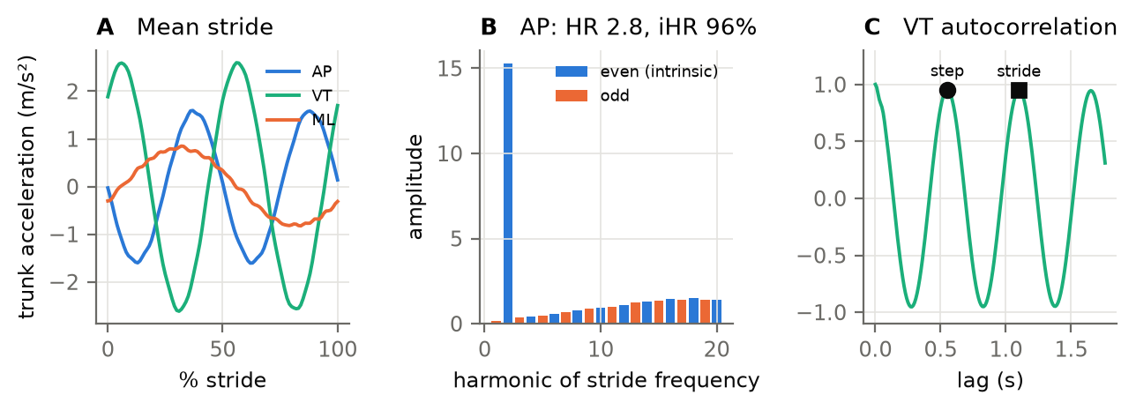
Figure 22. The trunk (synthetic trial). A: the mean trunk acceleration over the stride. AP and VT repeat twice per stride, and ML once. B: AP harmonic amplitudes; the even harmonics (blue) are intrinsic to a symmetric gait. C: the VT autocorrelation, with the step and stride regularity read at its peaks.
Why one stride per transform — then each bin is exactly a harmonic, with no leakage between them. Why iHR — HR is a ratio of sums, and it becomes very large when the odd harmonics happen to be small, so its mean is dominated by a few strides. iHR is bounded and can be averaged. Why peaks and not fixed lags — the stride time drifts a little through a trial. At a fixed lag, a 6% drift in stride time makes a perfectly regular signal read 0.94 (validated, §20). Why the unbiased autocorrelation — dividing by the overlap $N−k$ instead of $N$ stops a longer lag from being penalised just for being longer.
In the code — §16: trunk_signal(), harmonics(), harmonic_ratio(), unbiased_autocorr(), regularity(), trunk_rows(). Settings: TRUNK_SOURCES, TRUNK_LOWPASS_HZ = 20, TRUNK_DERIV_WINDOW = 5, HR_HARMONICS = 20, HR_MIN_SAMPLES = 40, REGULARITY_SEARCH = 0.25, LIMB_FOR_TRUNK = "R".
Table 16.1. Healthy ranges for the trunk measures (accelerometer on the lower back).
Results column | What it is | Healthy range | Population | Source | Checked
harmonic_ratio_hr_AP | Harmonic ratio AP (median over strides) | 3 to 4 | healthy young adults, trunk | Menz et al. 2003; Lowry et al. 2012 | yes
harmonic_ratio_hr_VT | Harmonic ratio vertical (median) | 3 to 4 | healthy young adults, trunk | Menz et al. 2003; Lowry et al. 2012 | yes
harmonic_ratio_hr_ML | Harmonic ratio ML (median) | 2 to 2.7 | healthy young adults, trunk | Menz et al. 2003; Lowry et al. 2012 | yes
harmonic_ratio_ihr_AP | Improved harmonic ratio AP (mean) | 85 to 97 % | healthy young adults, sacrum | Pasciuto et al. 2017 | verify
harmonic_ratio_ihr_VT | Improved harmonic ratio vertical (mean) | 85 to 97 % | healthy young adults, sacrum | Pasciuto et al. 2017 | verify
harmonic_ratio_ihr_ML | Improved harmonic ratio ML (mean) | 70 to 90 % | healthy young adults, sacrum | Pasciuto et al. 2017 | verify
step_regularity_VT | Step regularity vertical | 0.7 to 0.95 | healthy adults, trunk | Moe-Nilssen & Helbostad 2004; Kobsar et al. 2014 | verify
stride_regularity_VT | Stride regularity vertical | 0.75 to 0.95 | healthy adults, trunk | Moe-Nilssen & Helbostad 2004; Kobsar et al. 2014 | verify
step_regularity_AP | Step regularity AP | 0.6 to 0.9 | healthy adults, trunk | Moe-Nilssen & Helbostad 2004; Kobsar et al. 2014 | verify
stride_regularity_AP | Stride regularity AP | 0.65 to 0.9 | healthy adults, trunk | Moe-Nilssen & Helbostad 2004; Kobsar et al. 2014 | verify

17. Control of stepping

17.1 The goal-equivalent manifold (GEM)
What. Which stride-to-stride fluctuations the walker corrects, and which they leave alone (Dingwell, John & Cusumano 2010).
On a belt at a fixed speed, the task goal is to keep up with the belt: $L/T=v$. Many combinations of stride length $L$ and stride time $T$ achieve it; they lie on the line $L=vT$, the goal-equivalent manifold. After dividing each by its mean, the goal line becomes the diagonal, and each stride’s deviation splits into two parts:
$$\hat{T}=\frac{T}{\overset{‾}{T}}−1, \hat{L}=\frac{L}{\overset{‾}{L}}−1$$
$$δ_{∥}=\frac{\hat{T}+\hat{L}}{\sqrt{2}}, δ_{⟂}=\frac{\hat{L}−\hat{T}}{\sqrt{2}}.$$
$δ_{∥}$ is the deviation along the line: it is goal-equivalent and leaves the speed unchanged. $δ_{⟂}$ is the deviation across it: it is goal-relevant, a speed error.
For each component, per foot, the code reports:
- its SD in % of the mean stride (with a block-bootstrap interval);
- its lag-1 autocorrelation;
- its DFA α (with the parametric interval of §12.5).
These are computed only when there are at least 64 strides (4 × the smallest DFA box).
Steps (gem_decompose(), lag1(), variability_rows()): stride time from §6.1, stride length over the belt from §6.2, on the series cut to the common length (§12.4).
Why stride length over the belt — the goal is $L/T$ equal to the belt speed. That holds only for the distance travelled over the belt (§6.2), not for the sum of two heel-to-heel steps. Why normalise — time and length have different units. Dividing by their means makes both dimensionless, so “along” and “across” the goal line are well defined and the goal line is the diagonal. What to expect — healthy walkers correct speed errors quickly: $δ_{⟂}$ is small and anti-persistent (α < 0.5). They leave the goal-equivalent fluctuations alone: $δ_{∥}$ is larger and persistent (α ≈ 1). A load, or fatigue, could change that strategy. The metronome fixes $T$ on average, which constrains the walker further; the GEM shows how they trade $L$ against $T$ around that.

17.2 Foot placement control
What. How much of where the foot lands sideways is explained by the state of the centre of mass during the preceding stance (Wang & Srinivasan 2014).
Equations. At this foot’s mid-stance, $t_{mid}=t_{HS}+1/2(t_{TO}−t_{HS})$, relative to the stance ankle:
$$z=(x_{CoM}−p_{ankle})⋅\hat{ℓ}, v=v_{CoM}⋅\hat{ℓ}, y=\left(p_{heel,o}(t_{HS,o})−p_{ankle}\right)⋅\hat{ℓ}$$
where $y$ is where the other foot then lands (its heel at its heel strike). An ordinary least-squares fit gives
$$y=β_{0}+β_{1}z+β_{2}v, R^{2}=1−\frac{∑(y−\hat{y})^{2}}{∑(y−\overset{‾}{y})^{2}}.$$
$R^{2}$ is reported with a block-bootstrap interval (400 resamples), together with the two gains. It is computed per stance foot and needs at least 20 steps.
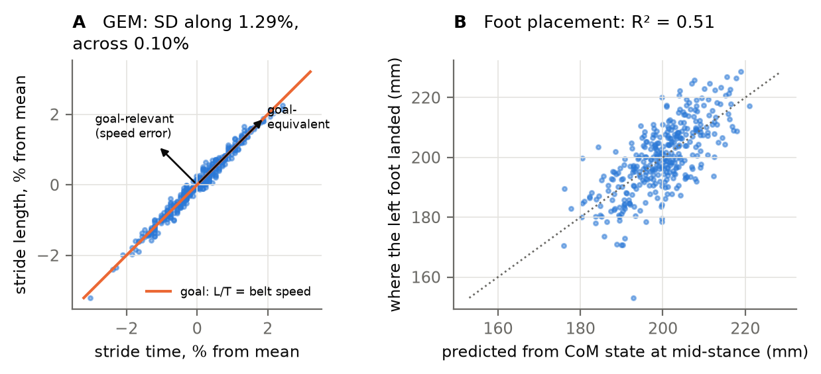
Figure 23. A: the GEM. Each dot is one stride’s time and length in % from the mean; the orange line is the goal (stride speed = belt speed). Deviations along the line are goal-equivalent, and across it a speed error. The synthetic walker’s strides lie close to the line: across-line SD 0.10%, along-line 1.29%. B: foot placement. Where the left foot landed against where the CoM state at the right foot’s mid-stance predicts it.
Why foot placement — lateral balance in walking is controlled mainly by where the next foot is placed. A walker who controls it well places the foot where the CoM’s position and velocity call for, so $R^{2}$ is high. Why mid-stance — the CoM state at mid-stance already predicts most of the next foot placement in healthy walkers (Wang & Srinivasan 2014). Using an earlier point asks whether control has started; using a later one mixes in the swing itself. Why the system CoM and the fused velocity — the load is part of what has to be balanced (§5.6), and the velocity must be clean (§5.7).
In the code — §17: lag1(), gem_decompose(), foot_placement_model(), foot_placement_rows(), series_for(), variability_rows(). Results: gem_parallel_sd_pct, gem_perpendicular_sd_pct, gem_*_lag1, gem_*_dfa_alpha (each _L/_R), foot_placement_r2_L/_R (the gains are in the note of the long table).
Table 17.1. Healthy ranges for the GEM and foot placement (treadmill walking).
Results column | What it is | Healthy range | Population | Source | Checked
gem_perpendicular_dfa_alpha | GEM goal-relevant DFA alpha | 0.2 to 0.5 | healthy young adults, treadmill | Dingwell et al. 2010 | verify
gem_parallel_dfa_alpha | GEM goal-equivalent DFA alpha | 0.7 to 1 | healthy young adults, treadmill, UNCUED (paced by a metronome) | Dingwell et al. 2010 | verify
foot_placement_r2 | ML foot placement explained by CoM state (R2) | 0.6 to 0.9 | healthy adults, ML, mid-stance (> 0.8 with pelvis state) | Wang & Srinivasan 2014 | yes

18. Local dynamic stability
What. How fast two nearly identical states of the walker drift apart: the local divergence exponent, or maximal Lyapunov exponent λ (Rosenstein, Collins & De Luca 1993; implemented as in Bruijn’s LocalDynamicStability toolbox; review: Bruijn et al. 2013). A larger λ means faster divergence: the walker is less locally stable.
Steps (lds_state_space(), divergence(), fit_lambdas(), window_lambda(), lds_rows()):
- A window of 150 consecutive strides of the right foot (LDS_N_STRIDES). The whole window is resampled by cubic spline to exactly 100 samples per stride (LDS_SAMPLES_PER_STRIDE), 15 000 samples in total.
- Delay embedding. From one signal $x$, build the state
$$X(i)=\left[x(i), x(i+τ), x(i+2τ), x(i+3τ), x(i+4τ)\right], τ=10 \text{samples}, d_{E}=5.$$
- Nearest neighbours. For every point $j$, find its nearest neighbour $\hat{j}$ that is more than half a stride (50 samples) away in time. This is the Theiler window, which stops the neighbour from being the same moment of the same stride.
- Divergence. Follow each pair for 10 strides (LDS_WS), and average the log distance over all pairs:
$$y(i)={\left\langle ln\left\|X(j+i)−X(\hat{j}+i)\right\|\right\rangle }_{j}.$$
- Exponents. λ is the slope of $y$ against time in strides: over 0–0.5 stride for the short-term exponent $λ_{S}$, and over 4–10 strides for the long-term exponent $λ_{L}$ (LDS_FIT).
- Windows. A long trial gives up to 4 non-overlapping windows of 150 strides (LDS_MAX_WINDOWS); the trial value is their mean. The interval is the stride bootstrap of §12.6.
State spaces (LDS_STATE_SPACES): Theia’s trunk linear velocity in the walker’s axes. ML, AP and VT are each delay-embedded with $d_{E}=5$, and the 3-D velocity is embedded with $d_{E}=2$ (6 dimensions). The primary result is the AP trunk velocity (LDS_PRIMARY).
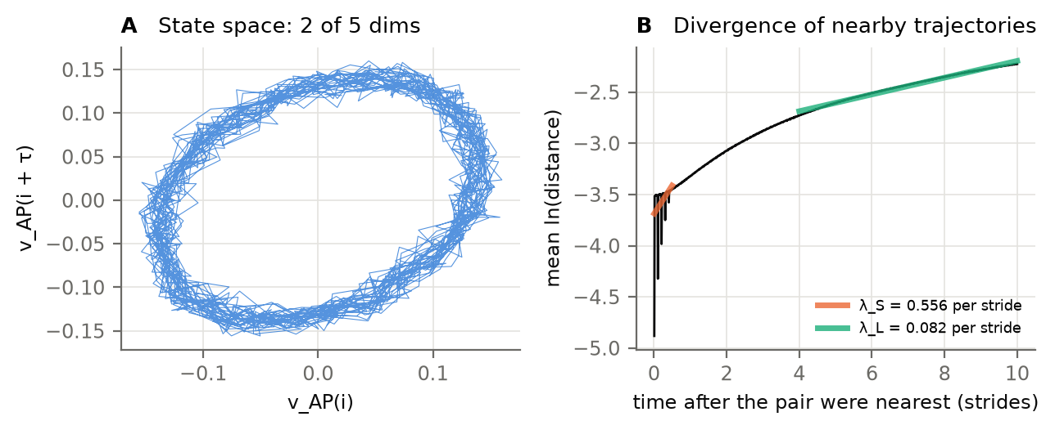
Figure 24. A: two of the five dimensions of the state space (AP trunk velocity against itself 10 samples later) over 15 strides. The trajectory is a loop that repeats every stride. B: the mean log divergence of nearest neighbours, with the short-term (orange, 0–0.5 stride) and long-term (green, 4–10 strides) fits. The saw-tooth in the first half-stride comes from the synthetic signal: its unfiltered white noise repeats in the embedding every τ = 10 samples. Theia’s filtered output should not show it.
Why the same number of strides in every window — λ depends on the length of the series, so every window is exactly 150 strides, in every trial, and the trial value is a mean over windows rather than one estimate from a longer series. Why normalise to 100 samples per stride — it removes differences in stride time between trials and conditions, and it expresses λ per stride, the natural unit of walking. Why fixed τ and $d_{E}$ — choosing them per trial (by mutual information and false nearest neighbours) would make λ incomparable between trials. τ = 10% of a stride and $d_{E}$ = 5 are common fixed choices for gait. lds_validation.py (part 2) estimates τ and $d_{E}$ by average mutual information and false nearest neighbours over the whole dataset, so one fixed value can be chosen from the data before the final run. Why the trunk velocity — the trunk carries most of the body’s mass and the load, Theia estimates its velocity smoothly, and trunk kinematics is the most studied state space for gait stability (Dingwell & Cusumano 2000; Bruijn et al. 2013). Why two exponents — $λ_{S}$ (within a stride) is the one most related to fall risk and to perturbations. $λ_{L}$ is small and less consistent, and it is reported for completeness.
Caution — λ values depend strongly on the method: the signal, the normalisation, τ, $d_{E}$, the series length and the fit windows (Bruijn et al. 2013). Published values differ several-fold between methods, and none used this state space, so no healthy range is given. On D05 the 1-D trunk velocity gave $λ_{S}≈2.3$ per stride. Compare conditions within this study, with the same settings and the same number of strides.
In the code — §18: lds_state_space(), divergence(), fit_lambdas(), window_lambda(), lds_rows(). Settings: LDS_N_STRIDES = 150, LDS_SAMPLES_PER_STRIDE = 100, LDS_TAU = 10, LDS_DE = 5, LDS_WS = 10, LDS_FIT, LDS_MAX_WINDOWS = 4, LDS_N_BOOT = 500, LDS_STATE_SPACES, LDS_PRIMARY, RUN_LDS. Results: lds_lambda_S_<space>, lds_lambda_L_<space>; each window is in {trial}_lds_windows.csv. lds_validation.py (part 1) checks that the shipped divergence() recovers known exponents.

19. Results tables and figures

19.1 What is written
Everything goes to OUTPUT_FOLDER (gait_analysis_outputs/, next to the event outputs).
File | Shape | Use
all_trials_metrics.xlsx | one row per trial, one column per metric | the file to read (sheets below)
all_trials_metrics.csv | the same values as CSV | for R, SPSS, Python
all_trials_metrics_ci.csv | the 95% limits of every value that has one (_lo, _hi) | error bars
metric_dictionary.csv | every column: family, description, unit, document section, healthy range and source | look up a column
all_trials_summary.csv | long form: one row per number, with its interval, N, block length and a note | mixed models (participant random, condition fixed)
{trial}_steps.csv | one row per step, every per-step value | checking, per-step statistics
{trial}_waveforms.npz | force and angle curves (101 points), LDS and MSE curves | plotting
{trial}_lds_windows.csv | every LDS window | checking λ
{trial}_qa.png, {trial}_variability.png | per-trial figures (§19.3) | a first look at every trial
The workbook’s sheets:
- Key metrics: about 35 columns that answer the main questions.
- One sheet per family: Trial, Spatiotemporal, Stability, Kinetics, CoM work, Posture, Symmetry, DFA, Entropy, Trunk, Control, LDS.
- Healthy ranges: every column that has a range, with each trial’s cell green inside the range and orange outside it; the range is in the header.
- 95% CI: the interval limits.
- Dictionary: the meaning of every column.
In every sheet, row 1 describes the column in words with its unit, row 2 gives the column name, and the first three columns (participant, condition, trial) stay frozen.
Column names. A metric’s name alone (step_width_m) is the mean over all steady steps of both feet. _sd and _cv are its SD and CV. _L and _R are each foot’s mean or, for DFA, entropy, GEM and foot placement, the value from that foot’s own series.
In the code — §19: summarise(), CATALOG (the meaning, unit and section of every column), FAMILIES, KEY_METRICS, describe(), wide_column(), reference_for(), wide_tables(), build_tables(), write_workbook(). python gait_analysis.py --tables rebuilds the tables from the per-trial summaries without re-running any trial.

19.2 The healthy reference ranges
The ranges in Table 19.1 are the ones used throughout this document and in the workbook’s “Healthy ranges” sheet. They are stored once, in REFERENCE_RANGES (§19 of the code). Per-foot columns (_L, _R) share their metric’s range.
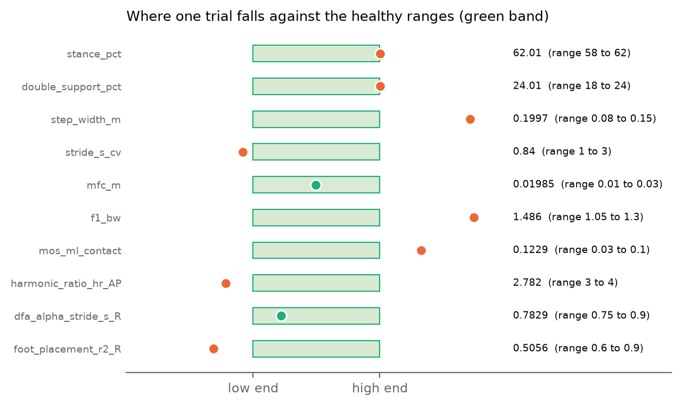
Figure 25. How a trial is compared with the healthy ranges (synthetic trial, 20 kg load). The green band is each metric’s healthy range, scaled so that it runs from its low to its high end. The dot is the trial’s value: green inside, orange outside. The workbook colours each trial’s cell in the same way.
How to read an orange cell — first ask whether the difference is expected: from the load (Appendix B), from the treadmill, from the metronome (§2.5, §14), or from a different boundary definition (§10). Then check the trial’s quality columns (§13.4). A value outside the range is a prompt to look, not a verdict.
Table 19.1. Every healthy reference range (healthy adults without load, about 1.2–1.4 m/s, unless stated). “Checked” = verified against the source’s abstract or a review; “verify” = check against the full paper before publication.
Results column | What it is | Healthy range | Population | Source | Checked
stride_s | Stride time | 1 to 1.15 s | healthy adults ~1.3 m/s (fixed at 1.11 s by the 108-bpm metronome here) | Perry & Burnfield 2010; Oberg et al. 1993 | verify
cadence_spm | Cadence | 104 to 120 steps/min | healthy adults ~1.3 m/s | Oberg et al. 1993 | verify
stance_pct | Stance, % of stride | 58 to 62 % | healthy adults, % of gait cycle | Perry & Burnfield 2010 | verify
double_support_pct | Double support, % of stride | 18 to 24 % | healthy adults, both periods, % of gait cycle | Perry & Burnfield 2010 | verify
single_support_pct | Single support, % of stride | 38 to 42 % | healthy adults, % of gait cycle | Perry & Burnfield 2010 | verify
step_length_m | Step length (heel to heel, along the belt) | 0.65 to 0.8 m | healthy adults ~1.3 m/s (scales with stature) | Oberg et al. 1993 | verify
step_width_m | Step width (heel to heel, across the belt) | 0.08 to 0.15 m | healthy young adults, treadmill, heel to heel | Owings & Grabiner 2004 | verify
stride_s_cv | Stride time: CV over steps | 1 to 3 % | healthy young adults | Hausdorff 2005 | verify
stride_length_m_cv | Stride length over the belt: CV over steps | 1 to 3 % | healthy young adults | Hausdorff 2005 | verify
step_width_m_sd | Step width (heel to heel, across the belt): SD over steps | 0.01 to 0.03 m | healthy young adults, treadmill | Owings & Grabiner 2004 | verify
walk_ratio | Walk ratio: step length / cadence | 0.0055 to 0.0072 m/(steps/min) | healthy adults, preferred speed (0.0063 +- 0.0007) | Sekiya & Nagasaki 1998 | yes
hip_rom_deg | Hip sagittal range of motion | 38 to 50 deg | healthy adults, sagittal | Winter 2009; Kadaba et al. 1990 | verify
knee_rom_deg | Knee sagittal range of motion | 55 to 68 deg | healthy adults, sagittal | Winter 2009; Kadaba et al. 1990 | verify
ankle_rom_deg | Ankle sagittal range of motion | 22 to 35 deg | healthy adults, sagittal | Winter 2009; Kadaba et al. 1990 | verify
f1_bw | Vertical GRF first peak (weight acceptance) | 1.05 to 1.3 BW | healthy adults, treadmill (e.g. 1.19 BW) | Winter 2009; treadmill GRF studies | yes
trough_bw | Vertical GRF mid-stance trough | 0.6 to 0.85 BW | healthy adults ~1.3 m/s | Winter 2009 | verify
f2_bw | Vertical GRF second peak (push-off) | 1 to 1.25 BW | healthy adults, treadmill (e.g. 1.14 BW) | Winter 2009; treadmill GRF studies | yes
f1_tw | Vertical GRF first peak, per total weight | 1.05 to 1.3 TW | unloaded pattern (per total weight) | Birrell et al. 2007 | verify
f2_tw | Vertical GRF second peak, per total weight | 1 to 1.25 TW | unloaded pattern (per total weight) | Birrell et al. 2007 | verify
loading_rate_bw_per_s | Loading rate, 20-80% of F1 | 5 to 15 BW/s | shod walking, mean slope 20-80% of F1 | gait literature; method dependent | verify
peak_braking_bw | Peak braking force | 0.15 to 0.25 BW | healthy adults ~1.3 m/s | Winter 2009 | verify
peak_propulsive_bw | Peak propulsive force | 0.15 to 0.25 BW | healthy adults ~1.3 m/s | Winter 2009 | verify
propulsive_impulse_bw_s | Propulsive impulse | 0.02 to 0.04 BW s | healthy adults | Revi et al. 2020 | verify
braking_impulse_bw_s | Braking impulse (negative) | -0.04 to -0.02 BW s | healthy adults | Revi et al. 2020 | verify
vertical_impulse_bw_s | Vertical impulse | 0.5 to 0.6 BW s | physics: each limb carries ~half the weight over a stride of 1.0-1.2 s | Newton | yes
cop_ap_range_mm | CoP excursion along the belt | 150 to 220 mm | healthy adults (~60-75% of foot length) | gait literature | verify
cop_ml_range_mm | CoP excursion across the belt | 15 to 40 mm | healthy adults | gait literature | verify
free_moment_peak_nm | Peak |free moment| | 2 to 8 N m | healthy adults walking | Holden & Cavanagh 1991; Li et al. 2001 | verify
push_off_j_kg | Push-off: positive work, other heel strike to toe-off | 0.1 to 0.25 J/kg | healthy adults 1.25 m/s, per step | Donelan et al. 2002 | verify
collision_j_kg | Collision: negative work, heel strike to other toe-off | -0.25 to -0.08 J/kg | healthy adults 1.25 m/s, per step | Donelan et al. 2002 | verify
mos_ml_contact | ML margin of stability at heel strike | 0.03 to 0.1 m | healthy adults, ankle/malleolus boundary (boot edge adds ~0.03-0.05 m); treadmill > overground | Hof et al. 2005; Rosenblum et al. 2021 | verify
mos_ml_min | ML margin of stability, single-support minimum | 0.02 to 0.08 m | healthy adults, ankle boundary | Hof et al. 2005 | verify
mfc_m | Minimum foot clearance above the belt | 0.01 to 0.03 m | healthy young adults (1-2 cm overground; treadmill studies up to 3 cm) | Begg et al. 2007; Barrett et al. 2010 | yes
mfc_m_sd | Minimum foot clearance above the belt: SD over steps | 0.002 to 0.006 m | healthy young adults | Begg et al. 2007; Barrett et al. 2010 | verify
harmonic_ratio_hr_AP | Harmonic ratio AP (median over strides) | 3 to 4 | healthy young adults, trunk | Menz et al. 2003; Lowry et al. 2012 | yes
harmonic_ratio_hr_VT | Harmonic ratio vertical (median) | 3 to 4 | healthy young adults, trunk | Menz et al. 2003; Lowry et al. 2012 | yes
harmonic_ratio_hr_ML | Harmonic ratio ML (median) | 2 to 2.7 | healthy young adults, trunk | Menz et al. 2003; Lowry et al. 2012 | yes
harmonic_ratio_ihr_AP | Improved harmonic ratio AP (mean) | 85 to 97 % | healthy young adults, sacrum | Pasciuto et al. 2017 | verify
harmonic_ratio_ihr_VT | Improved harmonic ratio vertical (mean) | 85 to 97 % | healthy young adults, sacrum | Pasciuto et al. 2017 | verify
harmonic_ratio_ihr_ML | Improved harmonic ratio ML (mean) | 70 to 90 % | healthy young adults, sacrum | Pasciuto et al. 2017 | verify
step_regularity_VT | Step regularity vertical | 0.7 to 0.95 | healthy adults, trunk | Moe-Nilssen & Helbostad 2004; Kobsar et al. 2014 | verify
stride_regularity_VT | Stride regularity vertical | 0.75 to 0.95 | healthy adults, trunk | Moe-Nilssen & Helbostad 2004; Kobsar et al. 2014 | verify
step_regularity_AP | Step regularity AP | 0.6 to 0.9 | healthy adults, trunk | Moe-Nilssen & Helbostad 2004; Kobsar et al. 2014 | verify
stride_regularity_AP | Stride regularity AP | 0.65 to 0.9 | healthy adults, trunk | Moe-Nilssen & Helbostad 2004; Kobsar et al. 2014 | verify
dfa_alpha_stride_s | DFA alpha of stride time | 0.75 to 0.9 | healthy adults, uncued; METRONOME-PACED walking gives < 0.5 | Hausdorff et al. 1996; Terrier et al. 2005 | yes
dfa_alpha_stride_length_m | DFA alpha of stride length over the belt | 0.6 to 0.9 | healthy young adults, treadmill, UNCUED (a metronome paces it too: L = v T) | Dingwell et al. 2010 | yes
dfa_alpha_stride_speed_ms | DFA alpha of stride speed over the belt | 0.2 to 0.4 | healthy young adults, treadmill (anti-persistent) | Dingwell et al. 2010; Terrier 2012 | yes
dfa_alpha_step_width_m | DFA alpha of step width (heel to heel, across the belt) | 0.6 to 0.9 | healthy young adults, treadmill (persistent) | Dingwell & Cusumano 2015 | verify
gem_perpendicular_dfa_alpha | GEM goal-relevant DFA alpha | 0.2 to 0.5 | healthy young adults, treadmill | Dingwell et al. 2010 | verify
gem_parallel_dfa_alpha | GEM goal-equivalent DFA alpha | 0.7 to 1 | healthy young adults, treadmill, UNCUED (paced by a metronome) | Dingwell et al. 2010 | verify
foot_placement_r2 | ML foot placement explained by CoM state (R2) | 0.6 to 0.9 | healthy adults, ML, mid-stance (> 0.8 with pelvis state) | Wang & Srinivasan 2014 | yes
symmetry_angle_stance_s | Symmetry angle (0 = symmetric, + = right larger) of stance time | -3 to 3 % | healthy adults | Zifchock et al. 2008 | verify
symmetry_angle_step_length_m | Symmetry angle (0 = symmetric, + = right larger) of step length (heel to heel, along the belt) | -3 to 3 % | healthy adults | Zifchock et al. 2008 | verify
symmetry_angle_f1_bw | Symmetry angle (0 = symmetric, + = right larger) of vertical grf first peak (weight acceptance) | -3 to 3 % | healthy adults | Zifchock et al. 2008 | verify

19.3 The per-trial figures
With MAKE_FIGURES = True, each trial gets two figures:
- {trial}_qa.png: is the trial sound? It shows the quiet standing and the weight, where the events came from along the trial, the clearance over the belt, the margins through the trial, the force of the trusted stances and the velocity fusion.
- {trial}_variability.png: DFA with its interval, α for every series, the LDS divergence curves and the multiscale entropy curves.
With MAKE_VIDEO = True, a bird’s-eye video of one typical stride is also saved ({trial}_mos_stride.mp4). It shows the boots, the CoM, the xCoM and the margins in the belt frame. The typical stride is the one closest to the median in stride time, step width and both margins.
In the code — §19 FIGURES: qa_figure(), variability_figure(), typical_stride(), mos_video(). Settings: MAKE_FIGURES, MAKE_VIDEO.

20. Validation
Every method was checked on data whose answer is known, using the code exactly as shipped (not a copy of it). There are three checks, and they should be rerun after any change to the code.

20.1 The synthetic trial
synthetic_trial.py builds a complete trial in the exact file formats of the real data:
- an 80 kg walker carrying a 20 kg load 150 mm behind the trunk;
- a quiet standing at the start, then walking on a belt at 1.3 m/s on a treadmill pitched 0.84°;
- the participant’s real boot meshes, bending at the MTP;
- force plates whose forces are computed from where each sole touches, in the plate’s own frame (rotated 90° and shifted from Theia’s), with baselines, drift and noise;
- steps that cross onto the other belt, straddle the gap or hang over it;
- a slowly unloading belt, a tracking dropout, and swings with a known clearance.
The figures in this document were all drawn from a 7-minute version of it.

20.2 Event detection (test_detect_gait_events.py)
Check | Result
plate registration (rotation, translation) | 0.09°, 5.0 mm from the truth
belt pitch | 0.89° (true 0.84°)
deepest sole point in stance | bent boot −3/−4 mm; rigid boot −17/−16 mm (the reason for the toe hinge)
trusted force events | 184 of 200; worst 0.20 frames (2 ms) off
force events from crossed or straddled steps | none
the step hanging over the gap | keeps both force events
every true event recovered | 205 of 205, none missed, worst 0.33 frames
Zeni offsets | heel strike −22 ms, toe-off +19 ms; after correction 0.7–0.8 ms mean and 1.8 ms 95th-percentile error

20.3 The whole analysis (test_gait_analysis.py)
Check | Result
weight in quiet standing | 99.9 kg; load 19.9 kg (true 100 / 20)
load position | 152 mm behind the trunk (true 150)
system CoM | 1.9 mm from the truth (median); Theia’s body CoM alone is 82 mm off
fused CoM velocity | 4–8 mm/s RMS error; markers alone 25 mm/s
belt speed | 1.299 m/s (true 1.3)
stance time | −0.1 ± 0.4 ms from the truth
step width | 1.0 mm from the truth (median)
MFC | found in 334 of 337 swings, 1.0 mm from the built-in clearance
ML margin of stability | 0.8 mm from the margin computed with the true CoM and velocity
kinetics | each limb’s vertical impulse carries 50.2% of the weight over a stride (50%); braking and propulsion cancel (net −0.0001 BW·s); free moment 1.00 × the one built in; CoM work nets to zero (28.2 J in, 28.2 J out)
results | 373 metric columns, each in the dictionary with its section; DFA and LDS intervals present
The cell-by-cell script Gait_analysis_all_metrics.py (version 4) is checked the same way by test_gait_analysis_all_metrics.py, on a 5-minute synthetic trial laid out as the Box folders. Theia’s toe angle is corrupted with 25° of toe flexion through every swing, while the boot itself stays rigid. The toe-angle hinge of version 3 then puts swings through the belt, and its mid-swing clearance falls from about 19 mm to about 5 mm. The toe model of §3.3, which takes extension only and never goes below the belt, ignores the corruption: no swing goes through the belt, and the MFC stays within 2 mm of the built-in clearance. The same test checks the belt speed, load, stride and stance times, step width, the vertical impulse (50% of the weight over a stride), and a trip-risk window in every swing. It also checks that TRI agrees with Schulz’s (2017) regression at this speed, and that the outputs are written.

20.4 The metric methods (gait_metrics_validation.py, lds_validation.py)
Method | Test | Result
velocity fusion (§5.7) | 1, 2, 5 mm marker noise | fused 0.5–3, 2–8, 5–19 mm/s vs 25, 49, 124 mm/s for markers alone; no bias below 0.5 Hz
margin of stability (§10) | hand-computed case | exact to 0.01 mm
MFC, MoI, TRI (§11) | built swing with analytic speed and acceleration | MFC and MoI exact; TRI window on the analytic acceleration peaks either side of the speed peak, TRI exact; a swing without a minimum gives missing
DFA (§14) | fractional Gaussian noise, H = 0.5, 0.7, 0.9, N = 486 and 756 | unbiased within ±0.02; shuffled → 0.505
DFA interval (§12.5) | 60 trials, N = 486, α = 0.75 | covers the truth 93%, 0.33 wide
block bootstrap (§12.2) | AR(1), φ = 0.6, N = 400 | covers the true mean 93% (single strides: 66%)
sample entropy (§15.1) | white noise against the closed form | within 0.006
multiscale entropy (§15.2) | white vs 1/f noise | white 2.19 → 1.02 over scales; 1/f stays 1.53 → 1.50
harmonic ratio (§16.2) | two-tone signals | exact (HR 20, 4, 1); ML inverts; k-weighting from velocity exact
regularity (§16.3) | drifting stride time | peaks 0.999 where a fixed lag gives 0.937
GEM, foot placement (§17) | built components and gains | recovered exactly
Lyapunov exponents (§18) | systems with known exponents (lds_validation.py) | recovered by the shipped divergence()

20.5 What the synthetic data cannot check
The synthetic trial tests the calculations. It does not test:
- how accurate Theia’s skeleton is on real people in boots and loads (see Kanko et al. 2021 for unloaded gait);
- the load’s true height (it cannot be measured from standing, §5.6);
- whether a real participant’s quiet standing was truly still (the 2% walking-weight check, §5.5, is the safeguard).
The per-trial quality columns (§13.4) and the QA figure (§19.3) are there to catch problems with real data.

Appendix A. Every setting
Every number that shapes a result is a setting at the top of a script. The tables below are generated from the scripts themselves, so they always match the code.

A.1 detect_gait_events.py (CONFIG)
Table A.1. Settings of the event detection.
Setting | Value | What it does (section)
TRIALS | None | None = every .csv in FORCE_FOLDER, or a list
GRF_RATE | 1000 | force-plate sampling rate, Hz (§2.2)
KINEMATIC_RATE | 100 | Theia sampling rate, Hz (§2.1)
FORCE_SHIFT_MS | "auto" | The force file and the Theia export are taken to start together. They may not (D05: Theia’s events came 14 ms before the plates’), and then every force event is read at the wrong kinematic instant. “auto”: the offset is measured per trial, as the lag that best lines up the CoM’s vertical acceleration from the plates (sum of Fz) and from Theia (Whole_body_COG), and the force data are moved by it. A number: that many ms (+ = the force data are moved LATER). 0: left as recorded.
CLOCK_MIN_SHIFT_MS | 3 | a measured offset smaller than this is left alone
BELT | {"L": "Left belt", "R": "Right belt"} | Force channels, and the frame the CoP is in. “plate”: each belt’s own frame, origin at the plate centre (the DICE export: COP = (-My/Fz, Mx/Fz) - OFFSET exactly). “lab”: already in the frame of the plate corners.
COP_FRAME | "plate" | frame of the exported CoP: “plate” = each belt’s own frame, origin at its centre (§5.4)
LAB_TO_THEIA | None | Plate-corner lab frame (m) -> Theia (m), as [[a, b, tx], [c, d, ty]]. None: estimated per trial from single support and printed in this form, with its distance from the identity. “identity”: Theia uses the mocap lab frame.
FORCE_FILTER_HZ | 50.0 | Belt contacts from force
FORCE_THRESHOLD_N | 20.0 | above each belt’s own baseline
BASELINE_WINDOW_S | 10.0 | the baseline is re-measured this often
MERGE_GAP_S | 0.030 | dips shorter than this do not split a contact
EDGE_SEARCH_S | 0.015 | The zero-lag filter spreads a steep landing over a few ms, so the filtered force crosses the threshold ~1-2 ms before the foot lands (and after it leaves). Each edge is then placed where the RAW force crosses, searched within this of the filtered crossing and held for EDGE_HOLD samples so a noise spike cannot trigger it
EDGE_HOLD | 5 | samples the raw force must stay across the threshold at an edge (§4.1)
MIN_CONTACT_S | 0.080 | contacts shorter than this are dropped
SHAPE_LEVEL_N | 200.0 | a real landing reaches this within …
MAX_LOADING_S | 0.060 | … this (D05: 10-36 ms)
MAX_UNLOADING_S | 0.080 | and leaves it within this (D05: 34-45 ms; the left-belt tails run to 315 ms)
SOLE_CELL_MM | 10.0 | sole = lowest mesh vertex in each cell
SOLE_MAX_RISE_MM | 35.0 | … up to this far above the lowest one
CONTACT_HEIGHT_MM | 15.0 | a sole vertex this close to the belt touches
MIN_CONTACT_VERTICES | 3 | this many touching = the boot is down
TOE_HINGE | True | Bend each boot at the MTP by Theia’s toe angle (a hinge about the foot’s X axis through _Toes_Position). Without it the rigid toe cap swings 30-40 mm through the belt at every push-off. A positive angle is extension with TOE_SIGN = 1 (checked on D05: the toes then lie flat on the floor). Only EXTENSION is applied: the belt can lift a boot’s toe cap, nothing pushes it down through the belt. A toe flexion Theia reports in swing (its toe segment is fitted to a foot inside a stiff boot) would otherwise put the toe cap under the belt and count as a contact.
TOE_SIGN | 1 | sign of Theia’s toe angle for extension (§3.3)
TOE_REFERENCE_DEG | 0.0 | toe angle in the static scan (D05: +0.4/-1.4)
TOE_EXTENSION_ONLY | True | apply only extension of Theia’s toe angle: the belt can lift the toe cap, a flexion never turns it down through the belt (§3.3)
TRUST_WINDOW_S | 0.050 | checked over +/- this around each event
EXTRA_MARGIN_MM | 0.0 | A boot is on a plate when at least MIN_CONTACT_VERTICES of its touching sole vertices are inside the plate’s fitted outline, grown by the outline’s own uncertainty (the worst corner miss, 8 mm on DICE) plus this. Hanging over the gap or the outer edge is fine – it moves no force anywhere – so only a boot on the wrong plate costs an event.
SHARED_MIN_FRAMES | 2 | frames with the other boot on this belt that make a contact “shared” (§4.3)
STRADDLE_MIN_FRAMES | 2 | frames with this boot also on the other belt that make it a “straddle” (§4.3)
COP_TOLERANCE_MM | 30.0 | CoP this close to the contact patch = under it
COP_MIN_FORCE_N | 150.0 | the CoP is used only above this force (§4.3, §5.4)
COP_MIN_INSIDE | 0.90 | share of the contact the CoP must be under it
KINEMATIC_FILTER_HZ | 10.0 | Zeni
MAX_GAP_FILL_FRAMES | 10 | tracking gaps bridged before filtering
MIN_CALIBRATION_EVENTS | 10 | fewer on one limb: pool both limbs
ZENI_MIN_PROMINENCE_M | 0.05 | A Zeni event is a real swing of the foot past the pelvis, not a wobble of a foot standing still: its peak must stand this far above the lowest point within ZENI_WINDOW_S on each side (walking: ~0.3 m; the quiet standing that opens a trial: a few mm of tracking noise)
ZENI_WINDOW_S | 0.6 | window either side for the prominence test (§4.4)
INTERPOLATE_MISSING | True | last resort, between two trusted events only
TRIM_TO_COMPLETE_STANCES | True | each limb starts on HS and ends on TO
FLAG_RATIO | (0.75, 1.25) | stance / stride outside this x median

A.2 gait_analysis.py (§0 SETTINGS)
Table A.2. Settings of the gait analysis. TRUNK_SOURCES (§16) and LDS_STATE_SPACES (§18) are lists, and are described in their sections.
Setting | Value | What it does (section)
TRIALS | None | None = every trial detect_gait_events wrote
FS | dge.KINEMATIC_RATE | 100 Hz, Theia
FS_FORCE | dge.GRF_RATE | 1000 Hz, force plates
STEP | dge.STEP | force samples per kinematic frame (10)
WARMUP_S | 60.0 | §5.1 skip the belt ramp and settling
BELT_FLAT | (0.25, 0.55) | §5.2 foot-flat part of stance (heel rides belt)
FORCE_FILTER_HZ | 50.0 | §5.4 low-pass for force peaks
HANDRAIL_N | 15.0 | §5.4 handrail force that counts as contact
QS_SEARCH_S | 30.0 | §5.5 quiet standing looked for in first 30 s
QS_WINDOW_S | 2.0 | §5.5 … as the steadiest 2 s window
QS_MAX_CV | 0.02 | §5.5 total vertical force steady within 2%
QS_MIN_SHARE | 0.15 | §5.5 both belts loaded (each >= 15%)
QS_MAX_FOOT_TRAVEL | 0.02 | §5.5 heels still (moved < 20 mm)
LOAD_MIN_KG | 1.0 | §5.6 below 1 kg: no load
LOAD_HEIGHT_M | 0.0 | §5.6 load CoM height above Trunk_Position
LOAD_CENTRED | True | §5.6 load on the mid-line (left-right)
LOAD_MAX_OFFSET_M | 0.40 | §5.6 load placed further than this: not believed
LOAD_PLACE_MIN_KG | 10.0 | §5.6 lighter (boots, clothing): spread like the body
FORCE_ALIGN_GRAVITY | True | §5.4 turn the forces so their walking mean is vertical
FORCE_MAX_TILT_DEG | 3.0 | §5.4 a larger tilt is reported, not corrected
OUTLIER_ROBUST_Z | 5.0 | §6 steps this many robust SD off: event errors
CROSSOVER_HZ | 0.5 | §5.7 markers below, force plates above
MARKER_SAVGOL | (11, 3) | §5.7 Savitzky-Golay window, order (markers)
ANTIALIAS_HZ | 40.0 | §5.7 before taking force to 100 Hz
LOADING_BAND | (0.20, 0.80) | §8 loading rate between 20% and 80% of F1
COP_FILTER_HZ | 15.0 | §8 CoP and free moment low-pass
WAVE_POINTS | 101 | §7/8 points per time-normalised waveform
MFC_LOCAL_WINDOW | 2 | §11 frames either side a minimum must beat
MFC_SPEED_QUANTILE | 0.75 | §11 MFC must be in the fastest 25% of swing
SWING_TRIM | 0.02 | §11 trim 2% of the swing at each end
MIN_CLEARANCE_MM | 1.0 | §11 floor for the trip-risk division
TRI_DERIV_WINDOW | 7 | §11 Savitzky-Golay frames (order 3), MFC point
TOE_MAX_BEND_DEG | 60.0 | §5.3 the toe cap never bends further than this
TOE_BEND_STEP_DEG | 0.5 | §5.3 resolution of the contact-constrained bend
TOE_USE_THEIA_EXTENSION | True | §5.3 also lift the toe cap by Theia’s toe extension
SOLE_FLAT_IN_STANCE | True | §5.3 level each sole in foot-flat (turn about the ankle)
SOLE_FLAT_MAX_DEG | 6.0 | §5.3 a larger turn is reported, not applied
N_BOOT | 1000 | block-bootstrap resamples
N_BOOT_DFA | 200 | simulated series for the DFA interval
CI_LEVEL | 0.95 | confidence level of every interval (§12)
SEED | 0 | fixed, so intervals are reproducible
SERIES_LENGTH | "shortest" | §12.4 strides per series: “shortest”, int, None
LIMB_FOR_TRUNK | "R" | §16/§18 whose strides segment the trunk signal
DFA_MIN_BOX | 16 | §14 smallest box (Damouras et al. 2010)
DFA_MAX_BOX_FRAC | 1.0 / 9 | §14 largest box = N/9
DFA_N_BOXES | 20 | §14 box sizes, log-spaced
DFA_N_SURROGATE | 20 | §14 shuffled copies (must give alpha ~0.5)
GPH_POWER | 0.5 | §14 GPH bandwidth m = N^0.5
ENT_M | 2 | §15 template length
ENT_R | 0.2 | §15 tolerance, x SD
ENT_R_SWEEP | (0.10, 0.15, 0.20, 0.25, 0.30) | tolerances also reported, to show the dependence on r (§15.1)
MSE_SCALES | 30 | §15 coarse-graining scales (0.3 s)
MSE_MAX_S | 300.0 | §15 seconds of trunk signal for MSE
TRUNK_LOWPASS_HZ | 20.0 | §16
TRUNK_DERIV_WINDOW | 5 | §16 Savitzky-Golay: accurate to 18 Hz
HR_HARMONICS | 20 | §16.1
HR_MIN_SAMPLES | 40 | §16.1 a stride must hold 20 harmonics
REGULARITY_SEARCH | 0.25 | §16.2 peak searched +-25% around expected lag
LDS_N_STRIDES | 150 | §18 strides per window
LDS_SAMPLES_PER_STRIDE | 100 | §18 time normalisation
LDS_TAU | 10 | §18 delay (normalised samples)
LDS_DE | 5 | §18 embedding dimension
LDS_WS | 10 | §18 strides the divergence is followed
LDS_FIT | {"S": (0.0, 0.5), "L": (4.0, 10.0)} | §18 fit windows, strides
LDS_MAX_WINDOWS | 4 | §18 windows per trial
LDS_N_BOOT | 500 | §18 stride-bootstrap resamples
LDS_PRIMARY | "trunkVel_AP" | §18 state spaces: name -> ([(signal, axis)], dE, scaling). Axis 0/1/2 = ML/AP/vertical in the walker’s frame. dE None = no delay embedding.
RUN_LDS | True | compute §18 (the slowest step)
MAKE_FIGURES | True | write the per-trial figures (§19.3)
MAKE_VIDEO | False | birds-eye MoS video of one typical stride

Appendix B. What a load is expected to do
These are the directions reported in the load-carriage literature for healthy adults. They are expected directions, not ranges: use them to judge whether a value outside the healthy range is the effect of the load or a problem. Each participant’s own unloaded condition is the best reference.
Table B.1. Expected direction of the effect of load carriage.
Metric | Expected change with load | Source
F1, F2, impulses per body weight (_bw) | increase, roughly in proportion to the total weight | Birrell et al. 2007
the same per total weight (_tw) | little change | Birrell et al. 2007
loading rate | increases | Birrell et al. 2007
double support, stance % | increase | Kinoshita 1985; Knapik et al. 2004
cadence / stride length | cadence up and stride shorter, slightly (fixed here by the metronome and the belt) | Knapik et al. 2004
trunk forward lean | increases, most with backpacks | Kinoshita 1985; Attwells et al. 2006
knee flexion in weight acceptance, knee ROM | increases | Kinoshita 1985; Attwells et al. 2006
CoM work (collision, push-off) | expected to increase with the mass redirected at each step | Donelan et al. 2002 (model)
ML margin of stability, step width | mixed evidence; depends on load placement | –
MFC, variability, entropy, LDS | mixed evidence; fatigue under load may lower MFC | Qu & Yeo 2011

Appendix C. Where each section is in the code
Every section of gait_analysis.py, in order, with the functions it defines. The table is generated from the script. In Spyder, the outline pane (View → Panes → Outline) lists the same sections, so you can jump to one.
Table C.1. The sections and functions of gait_analysis.py.
Section | What | Functions
§0 | Settings | (settings only)
tools | small tools used throughout | read_export, foot_pose, at, fill_gaps, widen, Trial
§5.1 | Events -> steps | read_events, build_steps
§5.2 | The belt’s speed and direction of travel | belt_motion
§5.3 | Boots over the belt | contact_toe_pose, level_sole, foot_flat_surface, Boots
§5.4 | Forces into the motion-capture frame | align_gravity, read_forces
§5.5 | Quiet standing: weighing body + load | quiet_standing
§5.6 | The system (body + load) centre of mass | trunk_frame, system_com
§5.7 | CoM velocity: markers + force plates | complementary, fuse_velocity
§5 | Preparing a trial, in order | load_trial
§6 | Spatiotemporal metrics | spatiotemporal
§7 | Posture and joint motion | posture
§8 | Kinetics and §9 CoM work | trusted_stance, phase_work, kinetics
§10 | Margin of stability | margin_of_stability
§11 | Foot clearance and trip risk | swing_clearance, foot_clearance
§12 | Confidence intervals | rng_for, optimal_block_length, block_indices, percentile_ci, series_summary, bootstrap_rows, fractional_gaussian_noise, simulate_alpha, dfa_interval
§13 | Summary statistics, symmetry, walk ratio | row, steady_steps, trial_descriptors, step_summaries, symmetry_angle, symmetry_rows
§14 | Long-range correlations: DFA | dfa, dfa_alpha, gph_alpha
§15 | Entropy | match_counts, sample_entropy, rcmse, stride_series_metrics
§16 | Trunk: harmonic ratio, regularity | trunk_signal, harmonics, harmonic_ratio, unbiased_autocorr, regularity, trunk_rows
§17 | Control of stepping: GEM and foot placement | lag1, gem_decompose, foot_placement_model, foot_placement_rows, series_for, variability_rows
§18 | Local dynamic stability | lds_state_space, divergence, fit_lambdas, window_lambda, lds_rows
§19 | Results tables | summarise, describe, wide_column, reference_for, wide_tables, build_tables, write_workbook
§19 | Figures | qa_figure, variability_figure, typical_stride, mos_video
RUN | one trial, then every trial | read_participants, trial_stems, steady_strides, analyse_trial, main
The run, one trial (analyse_trial()):
- load_trial() carries out §5.1 → §5.7;
- spatiotemporal() (§6), posture() (§7), kinetics() (§8–9), margin_of_stability() (§10) and foot_clearance() (§11) add their columns to the per-step table;
- summarise() computes §12–18 and returns the trial’s long table;
- the files of §19 are written.
main() does this for every trial and then calls build_tables().

Appendix D. References
Attwells, R.L., Birrell, S.A., Hooper, R.H., Mansfield, N.J. (2006). Influence of carrying heavy loads on soldiers’ posture, movements and gait. Ergonomics 49, 1527–1537.
Barrett, R.S., Mills, P.M., Begg, R.K. (2010). A systematic review of the effect of ageing and falls history on minimum foot clearance characteristics during level walking. Gait & Posture 32, 429–435.
Begg, R., Best, R., Dell’Oro, L., Taylor, S. (2007). Minimum foot clearance during walking: reliability and variability in young and elderly. Gait & Posture 25, 191–198.
Birrell, S.A., Hooper, R.H., Haslam, R.A. (2007). The effect of military load carriage on ground reaction forces. Gait & Posture 26, 611–614.
Bruijn, S.M., Meijer, O.G., Beek, P.J., van Dieën, J.H. (2013). Assessing the stability of human locomotion: a review of current measures. Journal of the Royal Society Interface 10, 20120999.
Costa, M., Goldberger, A.L., Peng, C.-K. (2002). Multiscale entropy analysis of complex physiologic time series. Physical Review Letters 89, 068102.
Damouras, S., Chang, M.D., Sejdić, E., Chau, T. (2010). An empirical examination of detrended fluctuation analysis for gait data. Gait & Posture 31, 336–340.
Davies, R.B., Harte, D.S. (1987). Tests for Hurst effect. Biometrika 74, 95–101.
Dingwell, J.B., Cusumano, J.P. (2000). Nonlinear time series analysis of normal and pathological human walking. Chaos 10, 848–863.
Dingwell, J.B., Cusumano, J.P. (2015). Identifying stride-to-stride control strategies in human treadmill walking. PLoS ONE 10, e0124879.
Dingwell, J.B., John, J., Cusumano, J.P. (2010). Do humans optimally exploit redundancy to control step variability in walking? PLoS Computational Biology 6, e1000856.
Donelan, J.M., Kram, R., Kuo, A.D. (2002). Simultaneous positive and negative external mechanical work in human walking. Journal of Biomechanics 35, 117–124.
Geweke, J., Porter-Hudak, S. (1983). The estimation and application of long memory time series models. Journal of Time Series Analysis 4, 221–238.
Hausdorff, J.M. (2005). Gait variability: methods, modeling and meaning. Journal of NeuroEngineering and Rehabilitation 2, 19.
Hausdorff, J.M., Purdon, P.L., Peng, C.-K., Ladin, Z., Wei, J.Y., Goldberger, A.L. (1996). Fractal dynamics of human gait: stability of long-range correlations in stride interval fluctuations. Journal of Applied Physiology 80, 1448–1457.
Hof, A.L., Gazendam, M.G.J., Sinke, W.E. (2005). The condition for dynamic stability. Journal of Biomechanics 38, 1–8.
Holden, J.P., Cavanagh, P.R. (1991). The free moment of ground reaction in distance running and its changes with pronation. Journal of Biomechanics 24, 887–897.
Kadaba, M.P., Ramakrishnan, H.K., Wootten, M.E. (1990). Measurement of lower extremity kinematics during level walking. Journal of Orthopaedic Research 8, 383–392.
Kanko, R.M., Laende, E.K., Davis, E.M., Selbie, W.S., Deluzio, K.J. (2021). Concurrent assessment of gait kinematics using marker-based and markerless motion capture. Journal of Biomechanics 127, 110665.
Kinoshita, H. (1985). Effects of different loads and carrying systems on selected biomechanical parameters describing walking gait. Ergonomics 28, 1347–1362.
Knapik, J.J., Reynolds, K.L., Harman, E. (2004). Soldier load carriage: historical, physiological, biomechanical, and medical aspects. Military Medicine 169, 45–56.
Kobsar, D., Olson, C., Paranjape, R., Hadjistavropoulos, T., Barden, J.M. (2014). Evaluation of age-related differences in the stride-to-stride fluctuations, regularity and symmetry of gait using a waist-mounted tri-axial accelerometer. Gait & Posture 39, 553–557.
Li, Y., Wang, W., Crompton, R.H., Gunther, M.M. (2001). Free vertical moments and transverse forces in human walking and their role in relation to arm-swing. Journal of Experimental Biology 204, 47–58.
Lowry, K.A., Lokenvitz, N., Smiley-Oyen, A.L. (2012). Age- and speed-related differences in harmonic ratios during walking. Gait & Posture 35, 272–276.
Menz, H.B., Lord, S.R., Fitzpatrick, R.C. (2003). Acceleration patterns of the head and pelvis when walking on level and irregular surfaces. Gait & Posture 18, 35–46.
Moe-Nilssen, R., Helbostad, J.L. (2004). Estimation of gait cycle characteristics by trunk accelerometry. Journal of Biomechanics 37, 121–126.
Öberg, T., Karsznia, A., Öberg, K. (1993). Basic gait parameters: reference data for normal subjects, 10–79 years of age. Journal of Rehabilitation Research and Development 30, 210–223.
Owings, T.M., Grabiner, M.D. (2004). Step width variability, but not step length variability or step time variability, discriminates gait of healthy young and older adults during treadmill locomotion. Journal of Biomechanics 37, 935–938.
Pasciuto, I., Bergamini, E., Iosa, M., Vannozzi, G., Cappozzo, A. (2017). Overcoming the limitations of the Harmonic Ratio for the reliable assessment of gait symmetry. Journal of Biomechanics 53, 84–89.
Patton, A., Politis, D.N., White, H. (2009). Correction to “Automatic block-length selection for the dependent bootstrap”. Econometric Reviews 28, 372–375.
Peng, C.-K., Buldyrev, S.V., Havlin, S., Simons, M., Stanley, H.E., Goldberger, A.L. (1994). Mosaic organization of DNA nucleotides. Physical Review E 49, 1685–1689.
Perry, J., Burnfield, J.M. (2010). Gait Analysis: Normal and Pathological Function, 2nd ed. SLACK.
Politis, D.N., White, H. (2004). Automatic block-length selection for the dependent bootstrap. Econometric Reviews 23, 53–70.
Qu, X., Yeo, J.C. (2011). Effects of load carriage and fatigue on gait characteristics. Journal of Biomechanics 44, 1259–1263.
Revi, D.A., Alvarez, A.M., Walsh, C.J., De Rossi, S.M.M., Awad, L.N. (2020). Indirect measurement of anterior-posterior ground reaction forces using a minimal set of wearable inertial sensors: from healthy to hemiparetic walking. Journal of NeuroEngineering and Rehabilitation 17, 82.
Richman, J.S., Moorman, J.R. (2000). Physiological time-series analysis using approximate entropy and sample entropy. American Journal of Physiology – Heart and Circulatory Physiology 278, H2039–H2049.
Rosenstein, M.T., Collins, J.J., De Luca, C.J. (1993). A practical method for calculating largest Lyapunov exponents from small data sets. Physica D 65, 117–134.
Schulz, B.W. (2017). A new measure of trip risk integrating minimum foot clearance and dynamic stability across the swing phase of gait. Journal of Biomechanics 55, 107–112.
Sekiya, N., Nagasaki, H. (1998). Reproducibility of the walking patterns of normal young adults: test-retest reliability of the walk ratio (step-length/step-rate). Gait & Posture 7, 225–227.
Terrier, P., Turner, V., Schutz, Y. (2005). GPS analysis of human locomotion: further evidence for long-range correlations in stride-to-stride fluctuations of gait parameters. Human Movement Science 24, 97–115.
Terrier, P., Dériaz, O. (2012). Persistent and anti-persistent pattern in stride-to-stride variability of treadmill walking: influence of rhythmic auditory cueing. Human Movement Science 31, 1585–1597.
van Schooten, K.S., Sloot, L.H., Bruijn, S.M., Kingma, H., Meijer, O.G., Pijnappels, M., van Dieën, J.H. (2011). Sensitivity of trunk variability and stability measures to balance impairments induced by galvanic vestibular stimulation during gait. Gait & Posture 33, 656–660.
Wang, Y., Srinivasan, M. (2014). Stepping in the direction of the fall: the next foot placement can be predicted from current upper body state in steady-state walking. Biology Letters 10, 20140405.
Winter, D.A. (2009). Biomechanics and Motor Control of Human Movement, 4th ed. Wiley.
Wu, S.-D., Wu, C.-W., Lin, S.-G., Lee, K.-Y., Peng, C.-K. (2014). Analysis of complex time series using refined composite multiscale entropy. Physics Letters A 378, 1369–1374.
Yentes, J.M., Raffalt, P.C. (2021). Entropy analysis in gait research: methodological considerations and recommendations. Annals of Biomedical Engineering 49, 979–990.
Zeni, J.A., Richards, J.G., Higginson, J.S. (2008). Two simple methods for determining gait events during treadmill and overground walking using kinematic data. Gait & Posture 27, 710–714.
Zifchock, R.A., Davis, I., Higginson, J., Royer, T. (2008). The symmetry angle: a novel, robust method of quantifying asymmetry. Gait & Posture 27, 622–627.
Note on the references — the bibliographic details above were compiled without access to the publishers’ websites. Check volume and page numbers against the journal before citing. Rosenblum et al. (2021) is cited in REFERENCE_RANGES (treadmill vs overground margins of stability) and its details should be added once checked.

