Ortiz-Leon+2015 Table 6:

Name Spectral type SED classification Variability α X-ray
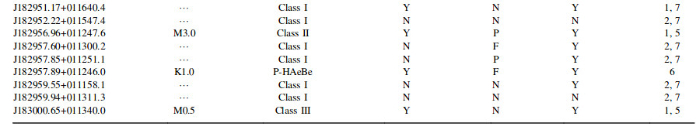
A
B
C
D
E
F
G
H
I

