Outflows parameters

CO J=6-5

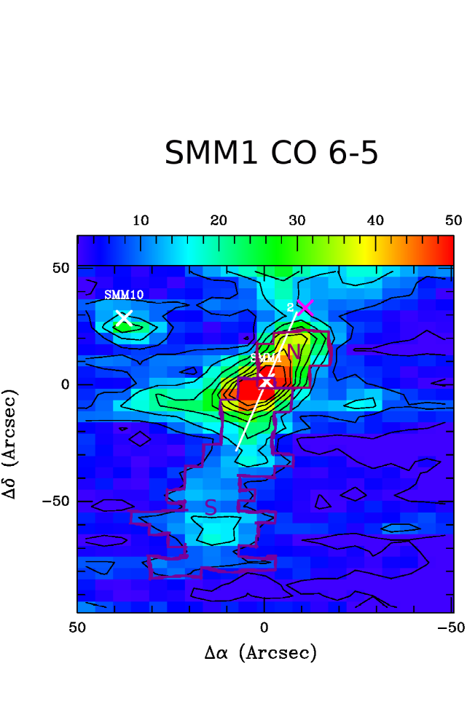

Fig. 1. Ser-SMM1 map in CO 6-5. Blue outflow was divided into two parts: Northern and Southern. Pixels used for outflow parameters calculation are marked with dark and bright purple respectively.

Region | SMM1 North | SMM1 South | Yildiz et al. 2015
Number of pixels | 17 | 27
M_outfllow [M_sun] | 2.79e-3 | 3.87e-3 | 1.6e-2
R [AU] | 4,503 | 21,442 | 34,000
t_dyn [yr] | 541,495 | 2,028,831 | 8,400
M_dot [M_sun/yr] | 5.15e-09 | 1.38e-09 | 8.2e-6
F_outflow [M_sun/yr km/s] | 1.31e-05 | 3.45e-06 | 1.5e-4
L_kin [L_sun] | 5.5e-2 | 1.4e-2 | 5.7e-2

There is an one order of magnitude difference between calculated outflow mass (M_outflow) and published by Yildiz et al. 2015. It may be caused by:
- different distance to the source: I assumed 260 pcs (Evans et al. 2009)
- different integration method: I used rectangular method. Currently I work on implementing Gaussian fit (and multigaussian fit for CN and HCN)
- different size (area) of the ouflow: I calculated the fluxes from pixels marked in Fig. 1. Probably, I should take a greater are into considaration. The difference in the outflow radius would confirm this.

I am not sure if I understand correctly, what the V_max parameter is. I applied the absolute value of the greater integration limit for flux calculation at 3sigma. In case of CO 6-5 it was roughly 50 km/s. It may be the reason of the enourmos dynamical time and differences in the further parameters.

HCN J=1-0

Region | SMM1 North | SMM1 South
Number of pixels | 5 | 8
M_outfllow [M_sun] | 175.54268 | 298.97825
R [AU] | 8,222 | 15,817
t_dyn [yr] | 8,120,089 | 15,621,285
M_dot [M_sun/yr] | 2.16e-05 | 1.12e-05
F_outflow [M_sun/yr km/s] | 5.2e-03 | 2.7e-03
L_kin [L_sun] | 2.05 | 1.07

For outflow mass calculation we need relative abudances [H2/HCN]. I applied 10e9 from Hirota et al. 1998 and it seems to be a resonable value. But this factor effects the outflow mass very much.

According to this equation (Yildiz et al. 2015, eq. 3):
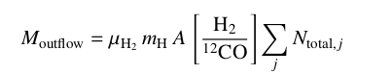

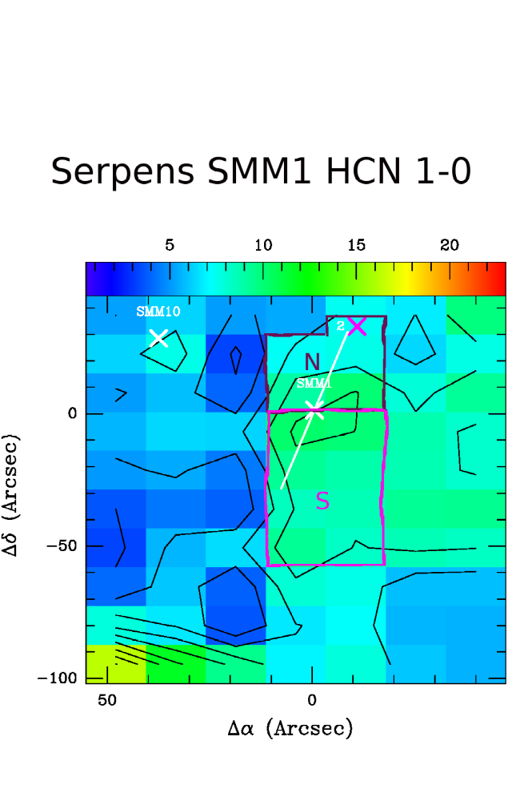
A few order of magnitudes higher H2/molecule ratio (comparing to 10e4 for H2/CO) gives suspiciously high ouflow mass in HCN (despite of lower column densities). Do you have any suggestions what could went wrong?

Fig. 1. Ser-SMM1 map in HCN 1-0. Blue outflow was divided into two parts: Northern and Southern. Pixels used for outflow parameters calculation are marked with dark and bright purple respectively.

