Outflows parameters

CO J=6-5

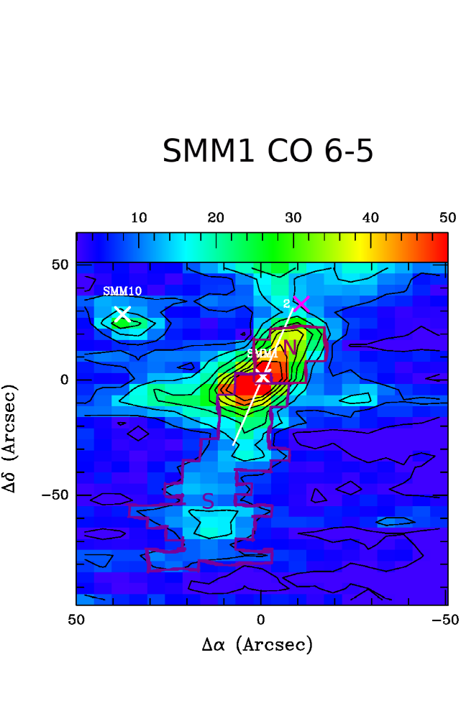

Fig. 1. Ser-SMM1 map in CO 6-5. Blue outflow was divided into two parts: Northern and Southern. Pixels used for outflow parameters calculation are marked with dark and bright purple respectively.

Region | SMM1 North | SMM1 South | Yildiz et al. 2015
Number of pixels | 23 | 74
M_outfllow [M_sun] | 2.89e-3 | 7.47e-3  sum: 1.04e-2 | 1.6e-2
R [AU] | 7,589 | 27,990 | 34,000
t_dyn [yr] | 718 | 2,648 | 8,400
M_dot [M_sun/yr] | 4.02e-06 | 2.82e-06 | 8.2e-06
F_outflow [M_sun/yr km/s] | 1.01e-02 | 7.07e-03 | 1.5e-04

There is one order of magnitude difference between calculated outflow mass (M_outflow) and published by Yildiz et al. 2015. It may be caused by:
- different distance to the source: I assumed 260 pcs (Evans et al. 2009)
- different integration method: I used rectangular method
- different size (area) of the outflow: I calculated the fluxes from pixels marked in Fig. 1.

HCN J=1-0

Region | SMM1 North | SMM1 South
Number of pixels | 5 | 8
M_outfllow [M_sun] | 175.54268 | 298.97825
R [AU] | 8,222 | 15,817
t_dyn [yr] | 9,506 | 18,288
M_dot [M_sun/yr] | 1.8e-02 | 1.6e-02
F_outflow [M_sun/yr km/s] | 3.7 | 3.4

For outflow mass calculation we need relative abundances [H2/HCN]. I applied 10e9 from Hirota et al. 1998 and it seems to be a reasonable value. But this factor effects the outflow mass very much.
According to this equation (Yildiz et al. 2015, eq. 3):
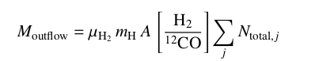
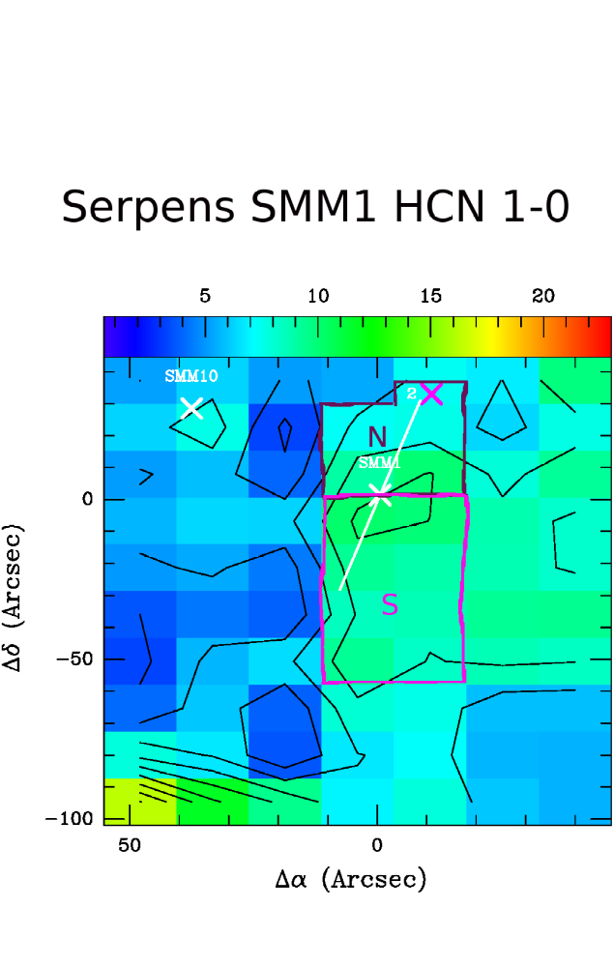
A few order of magnitudes higher H2/molecule ratio (comparing to 10e4 for H2/CO) gives suspiciously high outflow mass in HCN (despite of lower column densities). Do you have any suggestions what could went wrong?

Fig. 1. Ser-SMM1 map in HCN 1-0. Blue outflow was divided into two parts: Northern and Southern. Pixels used for outflow parameters calculation are marked with dark and bright purple respectively.

