Colloids and Surfaces A: Physicochem. Eng. Aspects 396 (2012) 63–73

Contents lists available at [SciVerse ScienceDirect](http://www.sciencedirect.com/science/journal/09277757)

Colloids and Surfaces A: Physicochemical and Engineering Aspects

jo ur nal homep a ge: [www.elsevier.com/locate/colsurfa](http://www.elsevier.com/locate/colsurfa)

Incorporating emulsion drop coalescence into population balance equation models of high pressure homogenization

Shashank N. Maindarkara, Neha B. Raikarb, Peter Bongersb, Michael A. Hensona*,*∗

a *Department of Chemical Engineering, University of Massachusetts, Amherst, MA 01003-9303, United States*

b *Unilever R&D, 3133 AT Vlaardingen, The Netherlands*

a r t i c l e i n f o a b s t r a c t

*Article history:*

Received 21 October 2011

Received in revised form 6 December 2011 Accepted 8 December 2011

Available online 17 December 2011

*Keywords:*

Emulsions

High pressure homogenization Drop breakage

Drop coalescence Drop size distributions

Population balance equation models

Population balance equation (PBE) models of emulsiﬁcation processes allow the prediction of the drop size distribution, a critical determinant of emulsion properties. While many PBE models that account only for drop breakage have been developed for model emulsion systems with relatively low oil-to- surfactant ratios, industrial practice is to minimize surfactant use to reduce manufacturing costs and establish process conditions under which drop coalescence is appreciable. In this study, we incorporated coalescence into our previously developed breakage-only PBE model of high pressure homogenization to allow the prediction of drop size distributions under high oil-to-surfactant ratios used industrially. Drop breakage under turbulent homogenization conditions was modeled with two distinct breakage rate functions and a distribution function that accounted for the formation of multiple daughter drops. Drop coalescence was incorporated through the addition of two functions for the drop collision rate and the coalescence efﬁciency of collisions. By utilizing nonlinear optimization to estimate six adjustable parameters in the breakage and coalescence functions from measured drop distributions, the com- bined breakage–coalescence model was shown to provide superior predictions as compared to the breakage-only model for emulsions with high oil-to-surfactant ratios. Because mechanistic breakage and coalescence functions that included emulsion properties and homogenization conditions were used, the model was able to satisfactorily predict drop size distributions at other surfactant concentrations and operating pressures without re-estimation of the parameters. The model was able to generate accept- able predictions for two other surfactants if the model parameters were re-estimated using data for each surfactant.

Published by Elsevier B.V.

## Introduction

Oil-in-water emulsions are ubiquitous dispersed phase sys- tems with diverse applications that include consumer products, processed foods, polishes, waxes, agricultural sprays and road sur- facing materials [1–3]. In the foods industry, emulsions constitute natural foods as well as numerous processed products such as milk, butter, margarine, ice cream, sauces and desserts. Food emul- sions contain edible oils, water and biocompatible surfactants as the major ingredients and vitamins, minerals and/or ﬂavors as minor ingredients [4]. These products exhibit a wide range of physicochemical and sensory characteristics based on the emulsion system formulation, which inﬂuence dispersed and continuous phase properties such as density, viscosity and dielectric constant. The surfactant plays a critical role in determining interfacial prop- erties and surface charge as well as emulsion stability. Process

∗ Corresponding author. Tel.: +1 413 545 3481; fax: +1 413 545 1647.

*E-mail address:* [henson@ecs.umass.edu](mailto:henson@ecs.umass.edu) (M.A. Henson).

operations such as mixing, homogenization and pasteurization also have a substantial effect on emulsiﬁed product properties, includ- ing appearance, taste, mouthfeel, odor and safety. Emulsion system formulation and processing operations both impact the drop size distribution, a key property that inﬂuences emulsion rheology, sta- bility, texture and appearance. A typical processed food requires the drop size distribution to be maintained within acceptable limits, which includes achieving a prescribed mean drop size, maintaining small variations about the mean and avoiding very small or large drops that adversely affect product properties such as texture and appearance.

Emulsiﬁcation can be achieved in a single step or a multistep process depending on the application, and the choice of equip- ment is based on the energy intensities required [4]. Oil-in-water emulsions are typically formed by ﬁrst preparing a coarse premix using a low shear stator-rotor type device that mixes the vari- ous ingredients into a stable form. This premix is then processed with a high shear device, such as a high pressure homogenizer or microﬂuidizer, where relatively large drops are broken into much smaller drops. In high pressure homogenization, a coarse emulsion

0927-7757/$ – see front matter. Published by Elsevier B.V.

doi:10.1016/j.colsurfa.2011.12.041

is passed through a small oriﬁce under very high pressure. The ﬂuid stream passes radially through the narrow gap formed between the piston and the valve seat at high velocity, creating a local environment of high turbulence and shear stress that causes drop deformation and breakage. The processed liquid exits the homog- enizer at atmospheric pressure, and the pressure drop across the device is called the homogenization pressure. Several phenomenon occurring simultaneously in the homogenizer determine the result- ing drop size distribution. Drop breakage leads to the creation of new interfacial area that must be stabilized by the surfactant. If newly formed drops are not sufﬁciently covered by surfactant, the drops will coalesce to form larger drops and produce corresponding increases in drop mean size and variability. Inability of the surfac- tant to achieve adequate drop coverage can be attributable to either insufﬁcient free surfactant in solution or slow surfactant adsorption kinetics [5,6]. Under typical industrial conditions where surfactant use is minimized to reduce manufacturing costs, drop coalescence is prevalent due to insufﬁcient surfactant regardless of the adsorp- tion kinetics. While drop breakage under laminar conditions has been extensively studied [7,8], the problem of turbulent breakage and coalescence is less understood.

Due to lack of quantitative understanding, new emulsiﬁed prod-

ucts are currently developed by combining a broad knowledge of previous product formulations with empirical scientiﬁc exper- imentation. Because this approach is intuitive and experimental, the progression of a formulation is generally unpredictable and a new product will often go through hundreds of prototype formula- tions in a laboratory or pilot plant before commercialization. Due to the very large number of possible formulation and processing com- binations that need to be explored, the traditional trial-and-error approach requires signiﬁcant time and resources. An alternative to brute force experimentation is to utilize a suitable mathematical model to predict the drop size distribution for different emulsion formulations and processing conditions. The population balance equation (PBE) modeling framework [9] is particularly well suited for this problem as functions describing single drop events such as breakage and coalescence can be incorporated within a funda- mental number balance equation to predict the evolution of the drop size distribution. PBE models have been developed for a wide variety of dispersed phase systems including continuously agitated liquid–liquid dispersions [10–16], liquid–liquid extractors [17–19], continuous ﬂow screw-loop reactors [20] and bubble columns [21]. More recently, several investigators have developed PBE models of high pressure homogenizers with application to small vesicle formation [22,23], intracellular product recovery [24] and food emulsion production [25–27]. With a only a few exceptions [22], these homogenizer models neglect drop coalescence under the assumption that newly formed drops are sufﬁciently covered by surfactant.

In our previous work on high pressure homogenization [28,29],

we developed breakage-only PBE models for prediction of the drop volume distribution. We showed that the system exhibited neg- ligible coalescence for the low oil to surfactant ratio (5% oil, 1% surfactant) used through experimental and computational stud- ies. The models included two mechanistic breakage rate functions that depended on the emulsion formulation through bulk physi- cal properties (dispersed phase volume fraction, continuous phase viscosity, interfacial tension) and on the homogenization pressure through the energy dissipation rate. The distribution function was chosen such that the breakage of a single mother drop produced a large number of daughter drops under the assumption that the tur- bulent homogenization conditions would produce results similar to laminar ﬂow experiments [30–32]. We used nonlinear opti- mization to ﬁt adjustable breakage rate parameters to measured drop volume distributions for a particular experimental condition, and then showed that the model produced reasonable predictions

**Table 1**

Base case emulsion formulation and homogenization conditions.

|  |  |
| --- | --- |
| Vegetable oil | 50 wt% |
| Pluronic F-68 surfactant | 1 wt% |
| Continuous phase density (*фc* ) | 997 g/l |
| Dispersed phase density (*фd*) | 917 g/l |
| Interfacial tension (*σ*) | 14.4 mN/m |
| Continuous phase viscosity (*щc* ) | 1 cP |
| Premix speed and time | 16,000 rpm, 15 min |
| Homogenizer pressure (*P*) | 800 bar |
| Number of passes | 5 |

for different homogenization pressures and different surfactant concentrations that maintained the same oil to surfactant ratio. In the present study, we incorporated mechanistic drop coales- cence functions into our most recent breakage-only PBE model

[29] to allow the drop volume distribution to be predicted over a much larger range of oil to surfactant ratios. In addition to examin- ing model extensibility for different surfactant concentrations and homogenization pressures, we investigated how the model could be adapted to different surfactants as a ﬁrst step towards emulsion formulation design.

## Experimental methods

* 1. *Materials*

Oil-in-water emulsions were prepared using vegetable oil (Fisher Scientiﬁc) as the dispersed phase and water as the contin- uous phase. The base case emulsion consisted of 50 wt% oil, 1 wt% Pluronic F-68 surfactant with the remainder water (Table 1). The high oil-to-surfactant ratio of 50 wt%/1 wt% was chosen to promote homogenization conditions leading to coalescence. Extensibility experiments were performed at three other Pluronic F-68 concen- trations (0.5, 2.0 and 5.0 wt%). To examine model extensibility to other nonionic surfactants, Pluronic F-127 (Sigma) and Tween 60 (Sigma) were also used as the emulsiﬁer.

* 1. *Emulsion preparation*

Emulsions were prepared using a two-step process. First approximately 400 ml of coarse pre-emulsion was prepared by mixing the ingredients in a stator-rotor device (Ultra-Turrax Model T25, Rose Scientiﬁc Ltd.) at 16,000 rpm for 15 min. About 100 ml of pre-emulsion was processed in a high-pressure homogenizer (Emulsiﬂex C-3, Avestin Inc.) to reduce the average drop size. The base case homogenization pressure was chosen as 800 bar to pro- duce small drops likely to undergo coalescence. Multiple passes were performed by reprocessing the emulsion obtained from the previous homogenizer pass. Five passes were performed for each experiment, and after each pass approximately 2 ml of emulsion was sampled to analyze the drop size distribution. Extensibility experiments were performed at three lower pressures (200, 400 and 600 bar).

* 1. *Emulsion characterization*

Drop size distributions were measured using a light scattering device (Mastersizer S, Malvern Instruments). Densities, viscosities and the interfacial tension were measured prior to each homog- enization experiment. Continuous and dispersed phase densities were measured using Bio-Rad 36XMX densitometer. Continuous and dispersed phase viscosities were measured using a Ubbelo- hde type capillary viscometer (Model CT-1000, Canon Instruments Company) at 25 ◦C. The oil–water interfacial tension *σo/w* was mea- sured by drop shape analysis (Model DSA-10 Tensiometer, KRUSS

Instruments) at 25 ◦C. The interfacial tension *σ* at surfactant con- where *Vtot* is the conserved total volume of the drops. The PBE (3) centration of *c* temperature *T* was calculated as, was reformulated in terms of *np*(*v, t*) to yield,

*σ* = *σ* − *RTГ* ln 1 + *c* (1)

∞

*o/w*

*c*1*/*2

*∂np*(*v, t*)

= −*g*(*v*)*n* (*v, t*) + *v*

∫ ∞ r r r

*v*

where *Г*∞

is maximum surface coverage and *c*1/2

*∂t*

is the surfac-

*p v*r

∫ ∞ *C*(*v, v*r)*n* (*v*r*, t*)*V*

*ˇ*(*v, v* )*g*(*v* )*np*(*v , t*) *dv*r

# 

−

tant concentration corresponding to half of the maximum surface

coverage. The constants *Г*∞ and *c*1/2 were found by plotting sur-

face coverage *Г* versus surfactant concentration *c* with *Г* values

*np*(*v, t*)

0

*p tot dv*r

*v*r

*v* ∫ *v C*(*v* − *v*r*, v*r)*np*(*v* − *v*r*, t*)*np*(*v*r*, t*)*Vtot*

1

*dσ*

0

calculated from the Gibb’s adsorption isotherm (Eq. (2)),

+ 2

*v* (*v*

*v* ) *dv*r (6)

r

−

r

*Г* = − *RT d*(ln(*c*)) (2)

## Theory

* 1. *Population balance equation model*

The PBE is formally derived from a number balance on parti- cles by accounting for the various rate processes such as breakage and coalescence that affect particle size [9]. In this study, a vol- ume structured PBE was used because light scattering most directly measures drop volume. Under the assumption that drops are spher- ical, drop volume is readily converted into drop diameter. Although homogenizers have distinct zones where local shear forces can change dramatically [33], we treated the homogenizer as a well- mixed batch system to avoid the complexities associated with including spatial variations. In this case, the PBE can be written

1 The measured volume percent distribution of the coarse pre- emulsion was used as initial condition *np*(*v,* 0) for the ﬁrst homogenizer pass. Each pass corresponded to one dimensionless time unit, and the initial condition for each subsequent pass was the predicted volume percent distribution from the previous pass.

* 1. *PBE functions*

The PBE (3) contains three functions (*g*(*v*)*, ˇ*(*v, v*r)*, C*(*v, v*r)) that must be speciﬁed to compute the drop size distribution. Follow- ing our previous work [28], the breakage rate *g*(*v*) was assumed to be determined by turbulent breakage of drops by both inertial and viscous forces such that *g*(*v*) = *g*1(*v*) + *g*2(*v*). The ﬁrst breakage function *g*1(*v*) was derived assuming drops break due to collision with turbulent eddies [13],

as [28,13],

*∂* (*v* ) ∫ ∞

*n*

*, t*

= −*g*(*v*)*n*(*v, t*) +

*ˇ*(*v, v*r)*g*(*v*r)*n*(*v*r*, t*)*dv*r

*g*1(*v*) = *K*1*v*−2*/*9*‹*1*/*3

exp −

*K*2*σ*(1 + *ф*)2

*pdv*5*/*9*‹*2*/*3

(7)

*∂t*

— *n*(*v, t*) ∫ ∞

*v*

*C*(*v, v*r)*n*(*v*r*, t*)*dv*r

exp

(8)

where *K*1 and *K*2 are adjustable constants. The second breakage rate function *g*2(*v*) wa s derived assumin g that drop breakage results from turbulent shear [28],

∫ 0 2 1*/*2 *‹pd* 1*/*2

# 

1

+ 2

*v*

*C*(*v* − *v*r*, v*r)*n*(*v* − *v*r*, t*)*n*(*v*r*, t*)*dv*r (3)

*g*2(*v*) = *K*3

*п*

*щd*

*K*4*σ*2*λ*

0

— *v*2*/*3*‹щc*

where *v* is the volume of the particle; *n*(*v, t*)*dv* is the number of drops with volume in the range [*v, v dv*] per unit volume of dis- persion at time *t*; *g*(*v*) is the breakage rate representing the fraction of drops of volume *v* breaking per unit time; *ˇ*(*v, v*r) is the daughter drop distribution function representing the probability of forming a daughter drop of size *v* from breakage of a mother drop of size *v*r; and *C*(*v, v*r) is coalescence frequency representing the rate at which drops of size *v* and drops of size *v*r coalesce. The ﬁrst and third terms on the right hand side of Eq. (3) account for disappearance of drops of size *v* due to breakage and coalescence, respectively, while the second and fourth terms account for the appearance of drops of size *v*. The model requires speciﬁcation of the functions

+

where *K*3 and *K*4 are the adjustable constants. The two breakage

rates depend on the homogenizer pressure *P* through the energy dissipation rate *‹* (see below) and bulk emulsion properties includ- ing the dispersed phase volume fraction *ф*, the interfacial tension *σ*, the dispersed phase density *pd*, the continuous phase viscosity *щc* and the dispersed phase viscosity *щd* through the ratio *λ* = *щd*/*щc*. We have shown that these dependencies are necessary for the PBE model to be predictive over a range of formulation and homoge- nization conditions with a single set of constants *K*1 *K*4 [28,29].

−

The breakage rate function was specialized to high-pressure homogenizers by using the following relation for the energy dis- sipation rate [26,27],

*∆PQ*

= *V*

that describe the breakage and coalescence processes, namely *g*(*v*), *ˇ*(*v, v*r) and *C*(*v, v*r). Our previous models [28,29] have been based

*‹*

*diss*

(9)

on the assumption of negligible coalescence, which is reasonable if the oil-to-surfactant ratio is sufﬁciently small that the emulsion is not surfactant limited. In this case, the PBE can be simpliﬁed as [13,20,34,28].

∫

where *∆P* is the applied pressure, *Q* is the volumetric ﬂow rate and *Vdiss* is the valve gap volume which depends on valve gap distance *hgap*. Equations for *Vdiss* and *hgap* can be found in our previous work [28]. As in our previous breakage-only PBE model [28], we used

*∂n*(*v, t*)

*∂t* = −*g*(*v*)*n*(*v, t*) +

∞

*ˇ*(*v, v*r)*g*(*v*r)*n*(*v*r*, t*)*dv*r (4)

*v*

the power law product form of the generalized Hill-Ng distribution [36–38] as the daughter drop distribution function *ˇ*(*v, v*r) to model the breakage of a mother drop into multiple daughter drops. The

The PBE (3) describes the evolution of the number density *n*(*v, t*), while the particle analyzer provided measurements of the volume percent distribution *np*(*v, t*). Under the standard assumption that

parameter *q* was chosen as unity to represent the uniform prob- ability of daughter drops of any size (*v < v*r) being formed due to

drops are spherical, the two distributions are related as follows,

*V totnp*(*v, t*)

=

*n*(*v, t*) *v*

(5)

1 The equation is discretized by ﬁxed pivot technique described in [35] which makes sure that the denominator in the last term does not go to zero as *v*r approaches *v*.

breakage of a mother drop of size *v*r. In this case, the daughter drop distribution function has the form [28],

signiﬁcantly. The least-squares objective function *ˇ* used for parameter estimation was,

*ˇ*(*v, v*r) = (*p* − 1)

*v p*−2

— *v*r

1

(10)

*n*

Σ[*n*ˆ*p*(*vj, i*) − *np*(*vj, i*)]2

*N*

where *p*

≥ 2 is the number of daughter drops formed from breakage

*ˇ* = Σ *j*=1

(13)

of a single mother drop. Based on preliminary simulation results (not shown), we determined that the best ﬁt of the base case drop volume distribution data was obtained for *p* = 80. While laminar

Σ

*i*=1

[*np*(*vj, i*)]2

*j*=1

*n*

ﬂow experiments have established that a mother drop can break into numerous daughter drops [30–32], the assumption that tur- bulent homogenization conditions could produce as many as 80 daughter drops from a single mother drop would require experi- mental testing beyond the scope of this study.

The coalescence frequency *C*(*v, v*r) of drops of size *v* and *v*r was

modeled as the product of the drop collision frequency *h*(*v, v*r) and the coalescence efﬁciency *λ*(*v, v*r): *C*(*v, v*r) *h*(*v, v*r)*λ*(*v, v*r). While certainly not mechanistically correct, we followed the common practice of modeling the collision frequency assuming that drops in turbulent ﬂow behave like gas molecules [13],

=

where *np*(*vj, i*) is the measured value of the drop volume distri-

bution at drop volume *vj* and homogenizer pass *i*, *n*ˆ*p*(*vj, i*) is the corresponding predicted value from the discretized PBE model, *n* is the total number of spatial node points, and *N* is the number of passes. The objective function was minimized subject to the large number of equality constraints representing the discretized model equations as well as continuity conditions across the ﬁnite ele- ments. The optimization problem was formulated in AMPL [39] and solved using the nonlinear program solver CONOPT [40]. We found that the solution was relatively insensitive to the initial guess of the

parameter values, so an acceptable solution could be found with only a small number of guesses. Values of the objective function *ˇ*

r *K*5*‹*1*/*3

2*/*3

r2*/*3

2*/*9

r2*/*9 1*/*2

were used to judge the quality of model predictions for different

*h*(*v, v* ) =

1 + *ф* (*v*

+ *v* )(*v*

+ *v* )

(11)

experiments.

where *K*5 is an adjustable constant. The coalescence efﬁciency was modeled to depend on the contact time of droplets, with coales- cence occurring if the contact time is greater than the time required for the liquid ﬁlm between two drops to drain [13],

## Results and discussion

* 1. *Parameter estimation for base case conditions*

−*K щ p ‹*  *v*1*/*3*v*r1*/*3

*λ*(*v, v*r) = exp

6

*c*

*c*

4

The PBE models, Eqs. (4) and (3), contained adjustable param-

(12)

eters that were estimated from experimental data collected at

*σ*2(1 + *ф*)3

*v*1*/*3 + *v*r1*/*3

the base case conditions (Table 1) to allow predictions for other emulsion formulations and homogenization conditions. More

where *K*6 is an adjustable constant. Similar to the breakage rate,

the coalescence frequency depends on the homogenizer pressure *P* through the energy dissipation rate *‹* and bulk emulsion properties including the continuous phase density *pc* and *ф*, *σ* and *щc*.

*3.3. Dynamic simulation and parameter estimation*

The PBE model (3) was solved numerically by approximating the integral expression using the ﬁxed pivot technique [35] with 100 equally spaced node points. Increasing the number of node points produced very small changes in the solution but substantially increased the computational cost for simulation and optimization (see below). The discretized PBE model consisted of 100 nonlinear ordinary differential equations in which the independent variable was time and the dependent variables represented the volume per- cent distribution at each node point. The ODE system was solved with the Matlab integration code ode45 using the measured premix distribution as the initial condition *np*(*v,* 0).

The constants *K*1 *K*4 in the breakage rate function and *K*5 *K*6 in the coalescence frequency function were estimated from base case homogenization experiments. The data used for parameter estimation were the bulk emulsion properties (*ф*, *σ*, *pc*, *pd*, *щc*, *щd*), the premix volume distribution *np*(*v,* 0) and measured drop

— −

volume distributions *np*(*v, t*) for ﬁve homogenization passes. The

100 ODEs obtained from spatial discretization of the PBE model were temporally discretized using orthogonal collocation with 15 ﬁnite elements and 2 internal collocation points per element to produce a large set of nonlinear algebraic equations. Each homoge- nizer pass corresponded to 3 ﬁnite elements. The algebraic equation system was posed as a set of equality constraints in the nonlin- ear optimization problem. We found that additional spatial node points, ﬁnite elements, and/or collocation points had little effect on the parameter estimates but increased the computational effort

speciﬁcally, the constants *K*1 − *K*4 in the breakage rate function and *K*5 − *K*6 in the coalescence frequency function were estimated from bulk emulsion properties (*ф*, *σ*, *pc*, *pd*, *щc*, *щd*), the premix volume distribution *np*(*v,* 0) and drop volume distributions *np*(*v, t*) for ﬁve

homogenization passes. Parameter estimation was performed for both the breakage-only PBE model (4) and the full PBE model (3) to access the value of including drop coalescence. The breakage-only model produced noticeable errors in predicted volume distribu- tions (Fig. 1a) and Sauter mean diameters (Fig. 1b) despite explicit ﬁtting of the parameters for these conditions. By comparison, the full PBE model produced very accurate predictions (Fig. 1c and d). The overall quality of prediction was quantiﬁed with the objec- tive function value, which was *ˇ* = 0.1348 for the breakage-only model and decreased by a factor of 5 for the full model (*ˇ* = 0.0254). The full model generated much more accurate predictions because the base case conditions of a 50/1 oil–surfactant ratio and 800 bar homogenization pressure favored coalescence because inadequate surfactant was available to stabilize the small drops produced.

* 1. *Parameter estimation for different pressures and surfactant concentrations*

The model parameters were re-estimated for different homog- enization pressures and surfactant concentrations than the base case values to further access the impact of including coalescence in the model description. For each case, drop volume distribu- tions measured following ﬁve homogenization passes were used to estimate the parameters in the breakage-only PBE model (4) and the full PBE model (3). The homogenization pressure was incorpo- rated into the models through the energy dissipation rate. While the full model produced more accurate predictions for all four pressures considered, the relative improvement over the breakage- only model decreased as the pressure decreased (Table 2). These

**(a)**

14

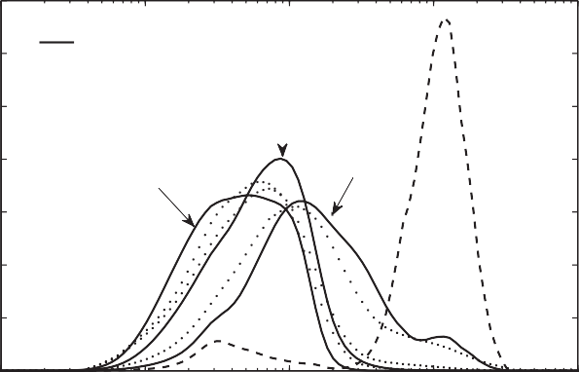

Experimental

Premix

Predicted

  

3rd pass

5th pass

1st pass

12

10

8

Vol%

6

**(b)**

1

0.9

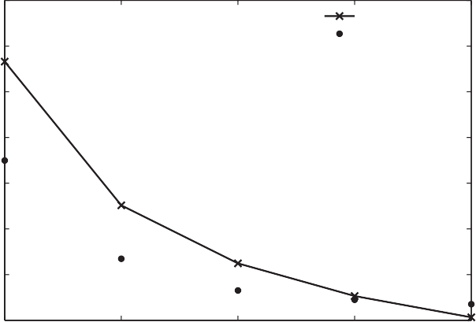

Model predicted Experimental

0.8

Mean diameter d32 m

0.7

0.6

4

2

0 −2

10

10−1

100

101

102

0.5

0.4

1

2 3 4 5

Diameter (m)

Number of passes

**(c)** 14

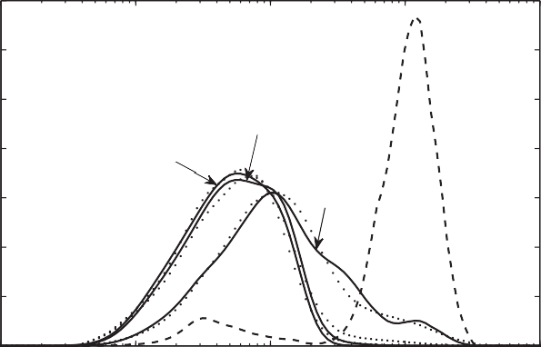

Experimental Predicted

Premix

  

3rd pass

5th pass

1st pass

12

10

8

Vol%

6

4

2

0 −2

10

10−1

100

101

102

**(d)**

0.7

0.65

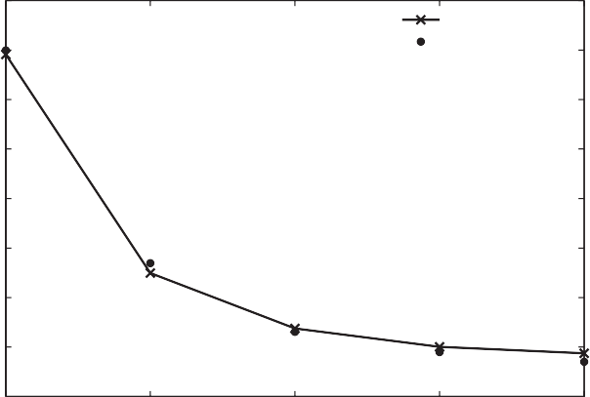

Model predicted Experimental

0.6

Mean diameter d32 m

0.55

0.5

0.45

0.4

0.35

1 2 3 4 5

Diameter (m) Number of passes

**Fig. 1.** Experimental and model predicted results for the emulsion formulation with 50 wt% oil, 1 wt% PF-68 homogenized at 800 bar: (a) drop size distributions using PBE model with breakage function only (*ˇ* = 0.1348); (b) Sauter mean diameter using PBE model with breakage function only; (c) drop size distribution using PBE model with breakage and coalescence functions (*ˇ* = 0.0254); (d) Sauter mean diameter using PBE model with breakage and coalescence functions.

**Table 2**

Minimized objective function values for emulsions consisting of 50 wt% oil and 1 wt% Pluronic F-68 homogenized at different pressures.

full model produced approximately equal improvement over the breakage-only model for the range of surfactant concentrations considered (Table 3). The full model even generated substantially

Pressure (bar) Model with breakage

function only

|  |  |  |  |
| --- | --- | --- | --- |
| 200 | 0.117 | 0.0769 | (Fig. 2), conditions under which minimal coalescence was expected. |
| 400 | 0.1303 | 0.0744 | Therefore, we concluded that the full model with coalescence was |
| 600  800 | 0.1028  0.1348 | 0.0315  0.0254 | superior over a wide range of conditions and did not consider the breakage-only model further in this study. |

Model with breakage and coalescence functions

improved volume distribution and Sauter mean diameter predic- tions as compared to the breakage-only model at 5% surfactant

results can be attributed to the production of increasingly small drops, insufﬁcient surfactant coverage and increased coalescence at higher pressures. The surfactant concentration was incorporated into the models by adjusting the interfacial tension *σ* (Fig. 5) in breakage and coalescence rate functions. Unlike the pressure, the

* 1. *Model extensibility*

Parameter estimation at the base case conditions yielded a set of model parameters *K*1 *K*6 that provided excellent prediction of the measured drop volume distributions used for estimation (Fig. 1c

−

**Table 3**

Minimized objective function values for emulsions homogenized at 800 bar with different oil to surfactant ratios.

|  |  |  |  |
| --- | --- | --- | --- |
| Oil concentration (wt%) | Pluronic F68 concentration (wt%) | Model with breakage function only | Model with breakage and coalescence functions |
| 50 | 0.5 | 0.1782 | 0.0454 |
| 50 | 1 | 0.1348 | 0.0254 |
| 50 | 2 | 0.1248 | 0.0376 |
| 50 | 5 | 0.1354 | 0.0325 |

**(a)** 14

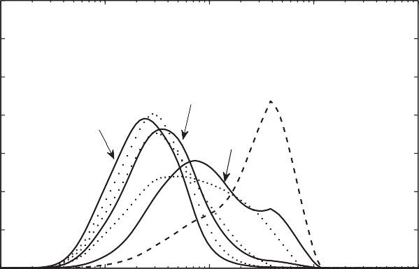

Experimental

Predicted

Premix

  

3rd pass

5th pass

1st pass

12

10

8

Vol%

6

**(b)** 0.55

0.5

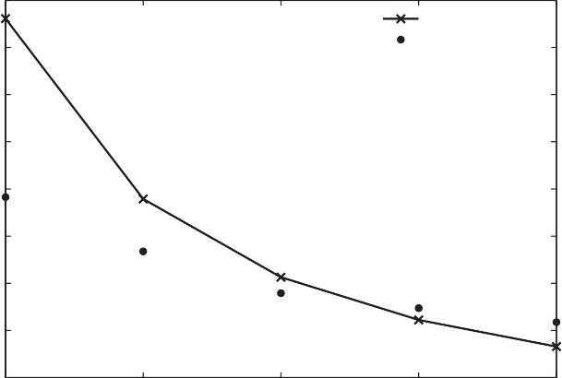

Model predicted Experimental

0.45

Mean diameter d32 m

0.4

0.35

0.3

4 0.25

2 0.2

0 −2

10

10−1

100

101

102

1 2 3 4 5

Diameter (m)

Number of passes

**(c)** 14

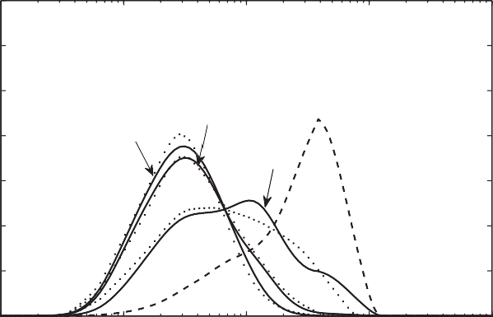

Experimental

Predicted

Premix

  

3rd pass

5th pass

1st pass

12

**(d)**

0.45

0.4

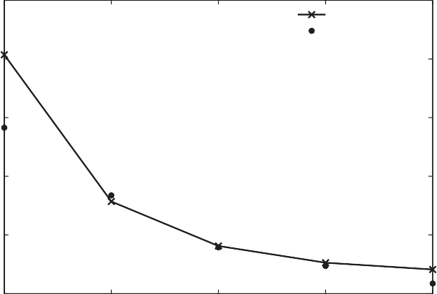

Model predicted Experimental

10

Mean diameter d32 m

0.35

8

Vol%

6 0.3

4

2

0 −2

10

10−1

100

101

102

0.25

0.21 2 3 4 5

Diameter (m) Number of passes

**Fig. 2.** Experimental and model predicted results for the emulsion formulation with 50 wt% oil, 5 wt% PF-68 homogenized at 800 bar: (a) drop size distributions using PBE model with breakage function only (*ˇ* = 0.1354); (b) Sauter mean diameter using PBE model with breakage function only; (c) drop size distribution using PBE model with breakage and coalescence functions (*ˇ* = 0.0325); (d) Sauter mean diameter using PBE model with breakage and coalescence functions.

−

and d). To examine model extensibility to other emulsiﬁcation con- ditions, we investigated the ability of the PBE model to predict drop volume distributions over a range of homogenization pressures and surfactant concentrations with a single set of parameters. These predictions were generated by changing the pressure in the energy dissipation rate and the interfacial tension in breakage and coales- cence rate functions. As a ﬁrst step towards formulation design, we attempted to adapt the PBE model to two other nonionic surfactants by ﬁrst adjusting the interfacial tension and then by re-estimating the model parameters for each surfactant.

* + 1. *Homogenization pressure*

Homogenization experiments were performed at 50% oil, 1% surfactant and four pressures (200, 400, 600 and 800 bar). Drop volume distributions were measured for ﬁve passes at each

pressure, and these data were used to estimate a different set of model parameters *K*1 *K*6 for each pressure. Then the model parameters found at each pressure were used to predict drop vol- ume distributions at all four pressures, with the objective function *ˇ* providing a measure of prediction accuracy for each case. The results obtained show that parameters estimated at either pressure extreme (200 and 800 bar) generated relatively poor predictions at the other pressures (Table 4). Predictions with parameter esti- mated at 200 bar were particularly poor, most likely due to the large drops produced and limited coalescence occurring at this low pressure. Parameters estimated at intermediate pressures (400 and 600 bar) generated better predictions over the pressure range. The lowest total objective function value was obtained with the 600 bar parameters, which produced reasonable drop volume distribu- tion predictions except at 200 bar where the breakage–coalescence

**Table 4**

Objective function values at different pressures using optimal parameters *K*1 − *K*6 obtained at one pressure for emulsions consisting of 50 wt% oil and 1 wt% Pluronic F-68.

|  |  |  |  |  |
| --- | --- | --- | --- | --- |
| Pressure (bar) | Using parameters at 200 bar | Using parameters at 400 bar | Using parameters at 600 bar | Using parameters at 800 bar |
| 200 | 0.07699 | 0.4987 | 1.2835 | 1.8954 |
| 400 | 0.7843 | 0.0485 | 0.3828 | 0.9771 |
| 600 | 3.1223 | 0.5011 | 0.0318 | 0.2421 |
| 800 | 5.2689 | 1.2484 | 0.2358 | 0.0255 |
| Total | 9.2525 | 2.2967 | 1.9339 | 3.1401 |

**Table 5**

Objective function values at different pressures using optimal parameters *K*1 − *K*6 obtained at two pressures for emulsions consisting of 50 wt% oil and 1 wt% Pluronic F-68.

|  |  |  |  |
| --- | --- | --- | --- |
| Pressure (bar) | Using parameters at 200 and 400 bar | Using parameters at 400 and 600 bar | Using parameters at 200 and 800 bar |
| 200 | 0.2084 | 0.9397 | 0.3229 |
| 400 | 0.1424 | 0.5308 | 0.4078 |
| 600 | 0.7554 | 0.2570 | 0.8131 |
| 800 | 1.5209 | 0.4301 | 1.4176 |
| Total | 2.6271 | 2.1576 | 2.9614 |

balance was signiﬁcantly underpredicted (Fig. 3). We also investi- gated the possible advantage of using drop volume distributions collected at multiple pressures for parameter estimation. Due to limitations on optimization problem size, the computations were restricted to two pressures per dataset. The results obtained show that the two pressures chosen for estimation had little effect on prediction accuracy (Table 5) and that the inclusion of multiple pressures did not improve predictive capability relative to a sin- gle pressure (Table 4). Hence, we concluded that homogenization experiments performed at a single, intermediate pressure provided the best drop distribution data for parameter estimation.

* + 1. *Surfactant concentration*

Homogenization experiments were performed at 50% oil, 800 bar and four surfactant concentrations (0.5, 1, 2 and 5%). Drop

* + - 1. 14

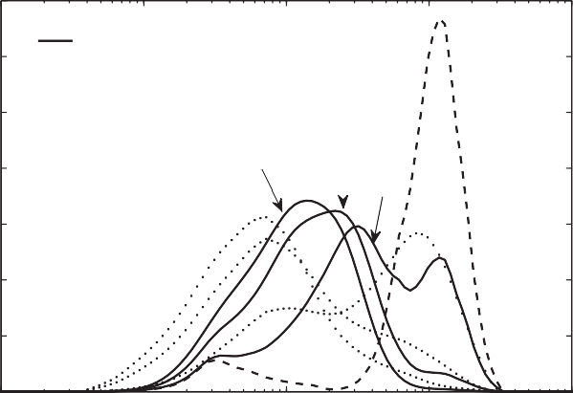

Experimental Predicted

Premix

200 bar

  

5th pass 3rd pass

1st pass

12

10

8

Vol%

volume distributions were measured for ﬁve passes at each surfac- tant concentration, and these data were used to estimate a different set of model parameters *K*1 *K*6 for each concentration. Then the model parameters found at each concentration were used to predict drop volume distributions at all four concentrations. The results obtained show that parameters estimated at the lowest surfac- tant concentration (0.5%) generated relatively poor predictions at the other concentrations (Table 6), as the breakage–coalescence balance was generally underpredicted. By contrast, parameters estimated at the other three concentrations (1, 2 and 5%) gener- ated acceptable predictions over the surfactant range investigated. The lowest total objective function value was obtained with the 1% concentration parameters, which produced reasonable drop vol- ume distribution predictions for all four surfactant concentrations (Fig. 4). Therefore, we concluded that homogenization experiments

* + - 1. 14 12

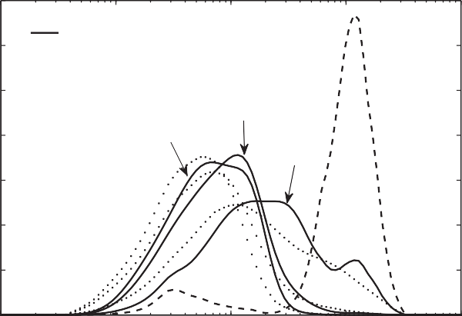

Experimental Predicted

Premix

400 bar

  

3rd pass

5th pass

1st pass

−

10

8

Vol%

6 6

4 4

2 2

0 −2

10

10−1

100

Diameter (m)

101

102

0 −2

10

10−1

100

Diameter (m)

101

102

* + - 1. 14 12

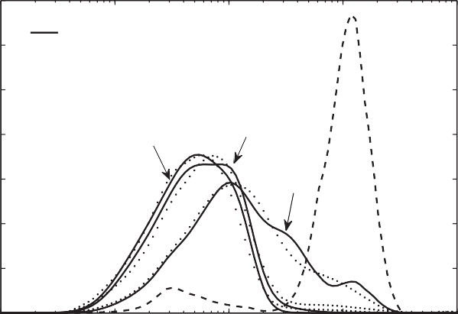

Experimental Predicted

Premix

600 bar

  

5th pass

3rd pass

1st pass

10

8

Vol%

6

* + - 1. 14

12

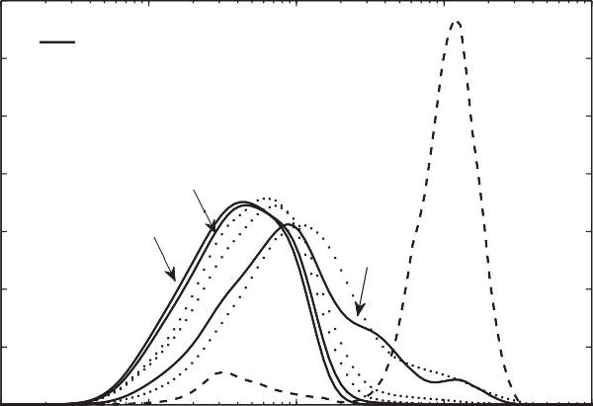

Experimental Predicted

Premix

800 bar

  

3rd pass

5th pass

1st pass

10

8

Vol%

6

4 4

2 2

0 −2

10

10−1

100

Diameter (m)

101

102

0 −2

10

10−1

100

Diameter (m)

101

102

**Fig. 3.** Experimental and model predicted drop size distributions, obtained using optimized parameters for the case of 50 wt% oil, 1 wt% Pluronic F-68 homogenized at 600 bar using PBE model with breakage and coalescence functions, at different pressures: (a) 200 bar (*ˇ* = 1.284), (b) 400 bar (*ˇ* = 0.383), (c) 600 bar (*ˇ* = 0.032), (d) 800 bar (*ˇ* = 0.236).

**Table 6**

Objective function values at different oil to surfactant ratios using optimal parameters *K*1 − *K*6 obtained at one oil to surfactant ratio for emulsions homogenized at 800 bar.

|  |  |  |  |  |
| --- | --- | --- | --- | --- |
| Oil–surfactant concentrations (wt%) | Using parameters at 50–0.5 (wt%) | Using parameters at 50–1 (wt%) | Using parameters at 50–2 (wt%) | Using parameters at 50–5 (wt%) |
| 50–0.5 | 0.0456 | 0.4575 | 1.1376 | 0.9605 |
| 50–1 | 0.6213 | 0.0254 | 0.4193 | 0.4056 |
| 50–2 | 1.9941 | 0.4834 | 0.0376 | 0.1165 |
| 50–5 | 1.6255 | 0.2051 | 0.2268 | 0.0325 |
| Total | 4.2665 | 1.1714 | 1.8213 | 1.5151 |

**Table 7**

Objective function values at different oil to surfactant ratios using optimal parameters *K*1 − *K*6 obtained for one surfactant at 50 wt% oil and 1 wt% surfactant for emulsions homogenized at 800 bar.

|  |  |  |  |  |  |
| --- | --- | --- | --- | --- | --- |
| Oil–surfactant concentrations (wt%) | PF-68 with PF-68  parameters | PF-127 with PF-68  parameters | PF-127 with  PF-127 parameters | Tween60 with  PF-68 parameters | Tween60 with Tween 60 parameters |
| 50–0.5 | 0.4575 | 2.2807 | 0.2283 | 2.7315 | 0.7497 |
| 50–1 | 0.0254 | 2.4369 | 0.0127 | 0.8322 | 0.0308 |
| 50–2 | 0.4834 | 3.7747 | 0.0530 | 0.2978 | 0.2539 |
| 50–5 | 0.2051 | 7.2886 | 0.5387 | 0.1479 | 0.2550 |
| Total | 1.1714 | 15.7809 | 0.8327 | 4.0094 | 1.2894 |

1. 14

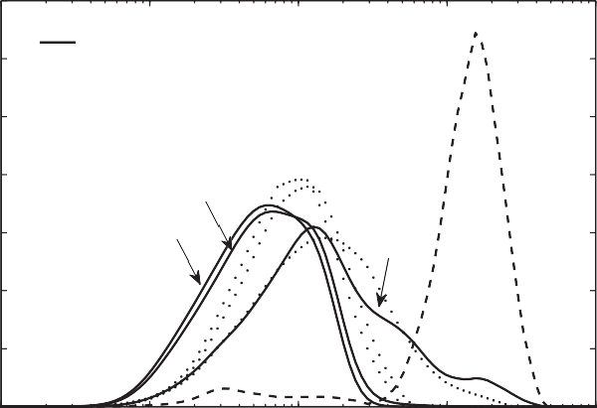

Experimental Predicted

Premix

50wt% oil−0.5 wt%PF68

  

3rd pass

5th pass

1st pass

12

10

1. 14

12

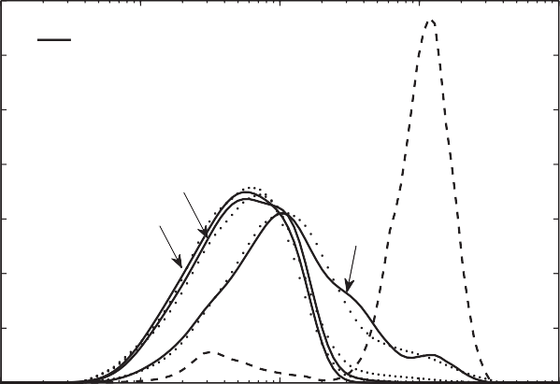

Experimental Predicted

Premix

50wt% oil−1 wt%PF68

  

3rd pass

5th pass

1st pass

10

8 8

Vol%

Vol%

6 6

4 4

2 2

0 −2

10

10−1

100

Diameter (m)

101

102

0 −2

10

10−1

100

Diameter (m)

101

102

1. 14

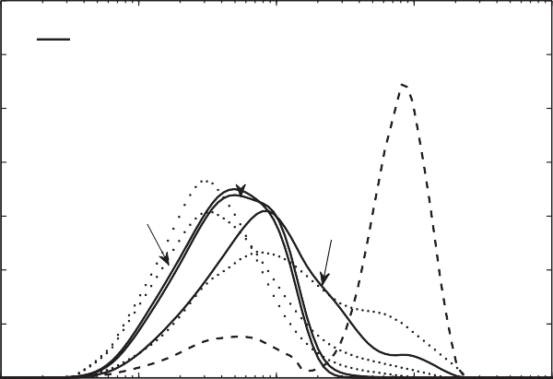

Experimental Predicted

Premix

50wt% oil−2 wt%PF68

  

3rd pass

5th pass

1st pass

12

10

1. 14

12

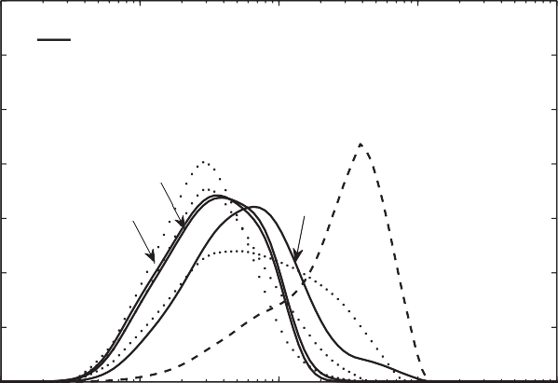

Experimental Predicted

Premix

50wt% oil−5 wt%PF68

  

3rd pass 5th pass

1st pass

10

8 8

Vol%

Vol%

6 6

4 4

2 2

0 −2

10

10−1

100

Diameter (m)

101

102

0 −2

10

10−1

100

Diameter (m)

101

102

**Fig. 4.** Experimental and model predicted drop size distributions, obtained using optimized parameters for the base case formulation using PBE model with breakage and coalescence functions, at different oil–surfactant ratios: (a) 50–0.5 wt% (*ˇ* = 0.4575), (b) 50–1 wt% (*ˇ* = 0.0254), (c) 50–2 wt% (*ˇ* = 0.4834), (d) 50–5 wt% (*ˇ* = 0.2051).

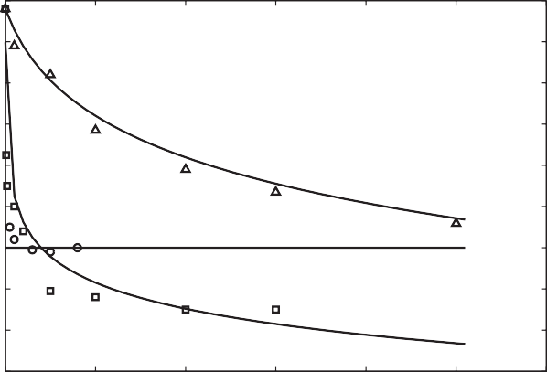performed at a single, sufﬁciently large surfactant concentration 20

provided satisfactory drop distribution data for parameter estima-

tion. 18

16

Interfacial tension (mN/m)

* + 1. *Surfactant type* 14

As a ﬁrst step towards emulsion formulation design, we inves-

tigated the ability of the PBE model to predict drop volume 12

distributions for two other nonionic surfactants (Pluronic F-127 and 10

Tween 60) at different oil–surfactant ratios. First the model param-

eters *K*1 *K*6 were ﬁxed at the values estimated from Pluronic F-68 8

−

base case data, the interfacial tension for each surfactant was cal-

culated from (1) according to the surfactant concentration, and the 6

PBE model was simulated with the calculated interfacial tension 4

used in the breakage and coalescence rate functions. Comparisons

of interfacial tension data and predictions obtained from (1) for 2

Pluronic F68 Tween 60

Pluronic F127

Pluronic F-127 and Tween 60 are shown in Fig. 5. The Pluronic F- 127 predictions were generally less accurate than those obtained for Pluronic F-68. As the critical micelle concentration of Tween 60 is very low (0.0026 wt%), the interfacial tension value was assumed to be independent of the surfactant concentration. When the model parameters were ﬁxed at the Pluronic F-68 values, the PBE model generated inaccurate predictions of drop volume distributions for both Pluronic F-127 and Tween 60 as measured by objective func- tion values (Table 7). The predictions were particularly poor for

* + - 1. 14

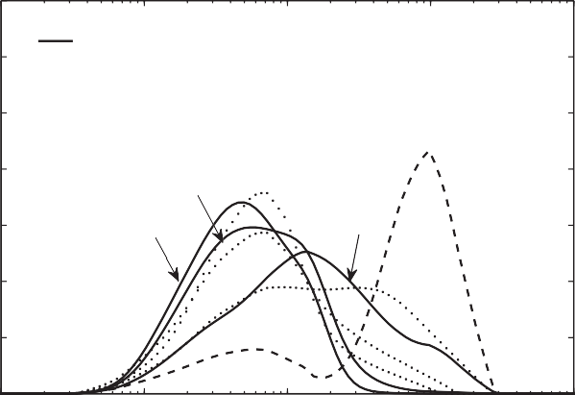

Experimental Predicted

Premix

50wt% oil−0.5 wt%PF127

  

3rd pass 5th pass

1st pass

12

10

0 1 2 3 4 5 6

Surfactant concentration (mN/m)

**Fig. 5.** Interfacial tension values for different surfactants.

Pluronic F-127, demonstrating that one set of model parameters was not sufﬁcient to describe multiple surfactants.

Consequently, we re-estimated the model parameters for each surfactant using bulk emulsion properties, the premix volume

* + - 1. 14

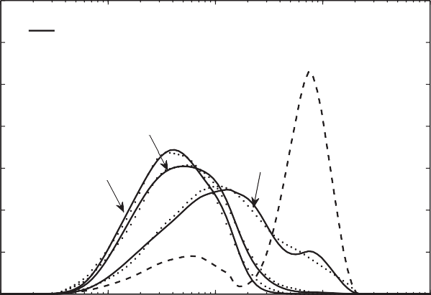

Experimental Predicted

Premix

50wt% oil−1 wt%PF127

  

3rd pass

5th pass

1st pass

12

10

8 8

Vol%

Vol%

6 6

4 4

2 2

0 −2

10

10−1

100

Diameter (m)

101

102

0 −2

10

10−1

100

Diameter (m)

101

102

* + - 1. 14

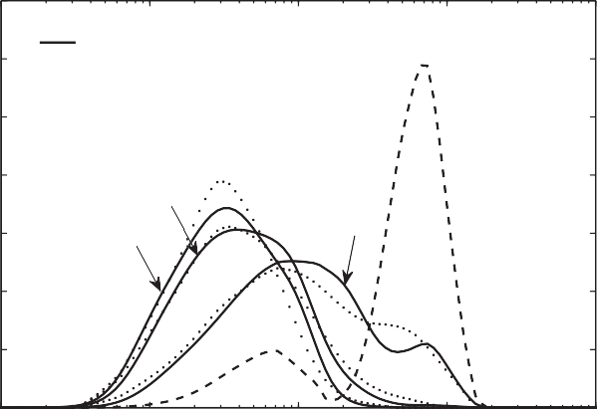

Experimental Predicted

Premix

50wt% oil−2 wt%PF127

  

3rd pass 5th pass

1st pass

12

10

8

Vol%

6

* + - 1. 14

12

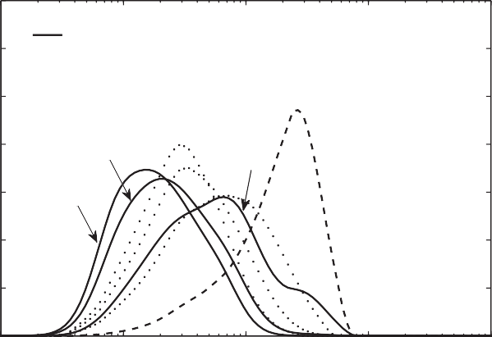

Experimental Predicted

Premix

50wt% oil−5 wt%PF127

  

3rd pass

1st pass

5th pass

10

8

Vol%

6

4 4

2 2

0 −2

10

10−1

100

Diameter (m)

101

102

0 −2

10

10−1

100

Diameter (m)

101

102

**Fig. 6.** Experimental and model predicted drop size distributions, obtained using optimized parameters for the case of 50 wt% oil, 1 wt% Pluronic F127 homogenized at 800 bar using PBE model with breakage and coalescence functions, at different oil–surfactant ratios: (a) 50–0.5 wt% (*ˇ* = 0.2283), (b) 50–1 wt% (*ˇ* = 0.0127), (c) 50–2 wt% (*ˇ* = 0.0530), (d) 50–5 wt% (*ˇ* = 0.5387).

1. 14 12

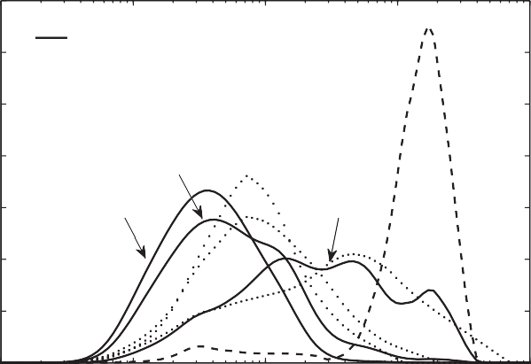

Experimental Predicted

Premix

50wt% oil−0.5 wt%Tween60

  

3rd pass

5th pass

1st pass

10

1. 14

12

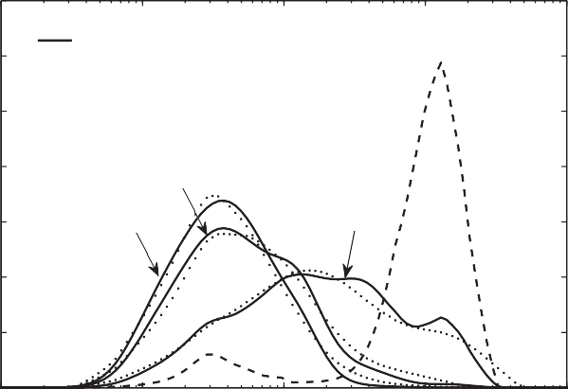

Experimental Predicted

Premix

50wt% oil−1 wt%Tween60

  

3rd pass 5th pass

1st pass

10

8 8

Vol%

Vol%

6 6

4 4

2 2

0 −2

10

10−1

100

Diameter (m)

101

102

0 −2

10

10−1

100

Diameter (m)

101

102

1. 14

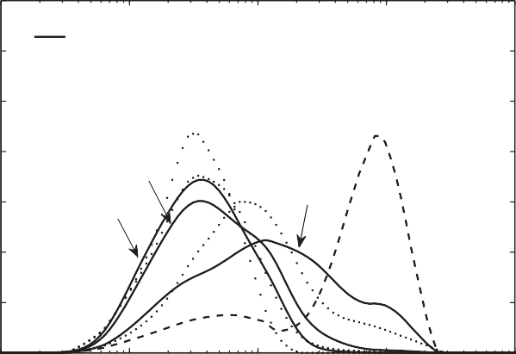

Experimental Predicted

Premix

50wt% oil−2 wt%Tween60

  

3rd pass

1st pass

5th pass

12

10

1. 14

12

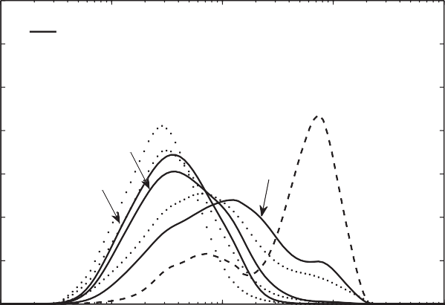

Experimental Predicted

Premix

50wt% oil−5 wt%Tween60

  

3rd pass

1st pass

5th pass

10

8 8

Vol%

Vol%

6 6

4 4

2 2

0 −2

10

10−1

100

Diameter (m)

101

102

0 −2

10

10−1

100

Diameter (m)

101

102

**Fig. 7.** Experimental and model predicted drop size distributions, obtained using optimized parameters for the case of 50 wt% oil, 1 wt% Tween 60 homogenized at 800 bar using PBE model with breakage and coalescence functions, at different oil–surfactant ratios: (a) 50–0.5 wt% (*ˇ* = 0.7497), (b) 50–1 wt% (*ˇ* = 0.0308), (c) 50–2 wt% (*ˇ* = 0.2539), (d) 50–5 wt% (*ˇ* = 0.2550).

distribution and drop volume distributions for 50% oil, 1% sur- factant and ﬁve homogenization passes following the procedure used for Pluronic F-68. With surfactant speciﬁc parameters, the PBE model was able to generate satisfactory predictions over the range of surfactant concentrations investigated (Table 7). The Pluronic F-127 PBE model produced reasonable drop volume dis- tribution predictions for all four surfactant concentrations, with the largest errors observed at 0.5% and 5% surfactant where the breakage–coalescence balance was overestimated and the model generated smaller drops than observed experimentally (Fig. 6). Similar results were obtained with the Tween 60 PBE model except that the breakage–coalescence balance was underestimated at higher surfactant concentrations and the model generated larger drops than observed experimentally (Fig. 7). Therefore, we con- cluded that the PBE model was extensible to other surfactants if the adjustable model parameters were estimated for each surfactant using suitably chosen base case data.

## Conclusions

We developed a population balance equation (PBE) model of high pressure homogenization that accounts for emulsion drop breakage and coalescence under high oil-to-surfactant ratios com- monly encountered in industry. Drop coalescence was incorporated

into our previously developed breakage-only PBE model through the addition of two functions for the drop collision rate and the coalescence efﬁciency of collisions. Mechanistic breakage and coa- lescence functions were used to allow the PBE model to have predictive capability over a range of emulsion compositions and homogenization conditions. The model contained six adjustable parameters that were estimated by nonlinear optimization from drop volume distribution measurements obtained at a speci- ﬁed base case condition. The PBE model with coalescence was shown to produce vastly superior distribution predictions over a range of homogenization pressures and surfactant concentra- tions compared to the breakage-only PBE model. The base case condition chosen for parameter estimation was shown to have a substantial impact on predictive capability, with conditions at the low and high extremes of the prediction range being gen- erally unfavorable. While satisfactory predictions were obtained with a single set of model parameters for Pluronic F-68 surfactant, the parameters had to re-estimated for the other two non-ionic surfactants (Pluronic F-127 and Tween 60) investigated to gener- ate acceptable drop volume distribution predictions. These results suggested that limited homogenization data must be collected for each surfactant of interest for the PBE model to generate suf- ﬁciently accurate predictions to be used for emulsiﬁed product design.

## Acknowledgements

We would like to acknowledge ﬁnancial support from the National Science Foundation (Grants CBET-0730795 and DMI- 0531171) and Unilever Foods. We would also like to thank Prof. Julian McClements (UMass Food Science) for providing access to the Malvern Mastersizer and the KRUSS Instruments Tensiometer.

## References

1. P. Becher, Emulsions: Theory and Practice, Oxford University Press, New York, NY, 2001.
2. M. Chappat, Some applications of emulsions, Colloid Surf. A 91 (1994) 57–77.
3. J. Israelachvili, The science and applications of emulsions – an overview, Colloid Surf. A 91 (1994) 1–8.
4. D.J. McClements, Food Emulsions: Principles, Practice, and Techniques, CRC Press, Boca Raton, FL, 2005.
5. P. Becher, Encyclopedia of Emulsion Technology, vol. I, Marcel Dekker, New York, NY, 1983.
6. P. Walstra, Principles of emulsion formation, Chem. Eng. Sci. 48 (2) (1993) 333–349.
7. D. Dhingra, Feasible Drop Sizes in Laminar Emulsiﬁcation Systems, Master’s Thesis, University of Massachusetts Amherst, 2001.
8. S. Gupta, Structured Liquid Products: Emulsiﬁcation Process Design for Vis- coelastic Liquids, Master’s Thesis, University of Massachusetts Amherst, 2004.
9. D. Ramkrishna, Population Balances: Theory and Applications to Particulate Processes in Engineering, Academic Press, New York, NY, 2000.
10. V. Alopaeus, J. Koskinen, K. Keskinen, Simulation of the population balances for liquid–liquid systems in a nonideal stirred tank. Part 1: description and qualitative validation of the model, Chem. Eng. Sci. 54 (24) (1999) 5887–5899.
11. V. Alopaeus, J. Koskinen, K. Keskinen, J. Majander, Simulation of the population balances for liquid–liquid systems in a nonideal stirred tank. Part 2 – parameter ﬁtting and the use of the multiblock model for dense dispersions, Chem. Eng. Sci. 57 (10) (2002) 1815–1825.
12. V. Alopaeus, J. Koskinen, K. Keskinen, Utilization of population balances in sim- ulation of liquid–liquid systems in mixed tanks, Chem. Eng. Sci. 190 (11) (2003) 1468–1484.
13. C. Coulaloglou, L. Tavlarides, Description of interaction processes in agitated liquid–liquid dispersions, Chem. Eng. Sci. 32 (11) (1977) 1289–1297.
14. M. Kostoglou, A. Karabelas, A contribution towards predicting the evolution of droplet size distribution in ﬂowing dilute liquid/liquid dispersions, Chem. Eng. Sci. 56 (14) (2001) 4283–4292.
15. H. Sovova, Breakage and coalescence of drops in a batch stirred vessel. 2. Com- parison of model and experiments, Chem. Eng. Sci. 36 (9) (1981) 1567–1573.
16. H. Sovova, J. Prochazka, Breakage and coalescence of drops in a batch stirred vessel. 1. Comparison of continuous and discrete models, Chem. Eng. Sci. 36 (1) (1981) 163–171.
17. M. Ruiz, P. Lermanda, R. Padilla, Drop size distribution in a batch mixer under breakage conditions, Hydrometallurgy 63 (1) (2002) 65–74.
18. M. Ruiz, R. Padilla, Analysis of breakage functions for liquid–liquid dispersions, Hydrometallurgy 72 (3-4) (2004) 245–258.
19. M. Simon, S. Schmidt, H. Bart, The droplet population balance model – estima- tion of breakage and coalescence, Chem. Eng. Technol. 26 (7) (2003) 745–750.
20. Z. Chen, J. Pruss, H. Warnecke, A population balance model for disperse systems: drop size distribution in emulsion, Chem. Eng. Sci. 53 (5) (1998) 1059–1066.
21. T. Wang, J. Wang, Y. Jin, A CFD-PBM coupled model for gas–liquid ﬂows, AIChE J. 52 (1) (2006) 125–140.
22. L. Maguire, H. Zhang, P. Shamlou, Preparation of small unilamellar vesicles (SUV) and biophysical characterization of their complexes with poly- l-lysine-condensed plasmid DNA, Biotechnol. Appl. Biochem. 37 (2003) 73–81.
23. S. Soon, J. Harbidge, N. Titchener-Hooker, P. Shamlou, Prediction of drop break- age in an ultra high velocity jet homogenizer, J. Chem. Eng. Jpn. 34 (5) (2001) 640–646.
24. W. Kelly, K. Muske, Optimal operation of high-pressure homogenization for intracellular product recovery, Bioproc. Biosyst. Eng. 27 (1) (2004) 25–37.
25. S. Tcholakova, N. Vankova, N. Denkov, T. Danner, Emulsiﬁcation in turbulent ﬂow: 3. Daughter drop-size distribution, J. Colloid Interface Sci. 310 (2) (2007) 570–589.
26. N. Vankova, S. Tcholakova, N. Denkov, V. Vulchev, T. Danner, Emulsiﬁcation in turbulent ﬂow 2. Breakage rate constants, J. Colloid Interface Sci. 313 (2) (2007) 612–629.
27. N. Vankova, S. Tcholakova, N. Denkov, I. Ivanov, V. Vulchev, T. Danner, Emulsi- ﬁcation in turbulent ﬂow – 1. Mean and maximum drop diameters in inertial and viscous regimes, J. Colloid Interface Sci. 312 (2) (2007) 363–380.
28. N. Raikar, S. Bhatia, M. Malone, M. Henson, Experimental studies and popula- tion balance equation models for breakage prediction of emulsion drop size distributions, Chem. Eng. Sci. 64 (10) (2009) 2433–2447.
29. N. Raikar, S. Bhatia, M. Malone, C. Almeida-Rivera, P. Bongers, D. McClements, M. Henson, Prediction of emulsion drop size distributions with population balance equation models of multiple drop breakage, Colloid Surf. A 361 (1-3) (2010) 96–108.
30. J. Rallison, The deformation of small viscous drops and bubbles in shear ﬂows, Annu. Rev. Fluid Mech. 16 (1984) 45–66.
31. H. Stone, Dynamics of drop deformation and breakup in viscous ﬂuids, Annu. Rev. Fluid Mech. 26 (1994) 65–102.
32. X. Zhao, J. Goveas, Size selection in viscoelastic emulsions under shear, Lang- muir 17 (13) (2001) 3788–3791.
33. A. Hakansson, C. Tragardh, B. Bergenstahl, Dynamic simulation of emulsion formation in a high pressure homogenizer, Chem. Eng. Sci. 64 (12) (2009) 2915–2925.
34. P. Canu, Prediction of multimodal distributions in breakage processes, Ind. Eng. Chem. Res. 44 (8) (2005) 2649–2658.
35. S. Kumar, D. Ramkrishna, On the solution of population balance equations by discretization 1. A ﬁxed pivot technique, Chem. Eng. Sci. 51 (8) (1996) 1311–1332.
36. P. Hill, K. Ng, Statistics of multiple particle breakage, AIChE J. 42 (6) (1996) 1600–1611.
37. R. Diemer, J. Olson, A moment methodology for coagulation and breakage prob- lems. Part 3: generalized daughter distribution functions, Chem. Eng. Sci. 57 (19) (2002) 4187–4198.
38. A. Zaccone, A. Gabler, S. Maass, D. Marchisio, M. Kraume, Drop breakage in liquid–liquid stirred dispersions: modelling of single drop breakage, Chem. Eng. Sci. 62 (22) (2007) 6297–6307.
39. R. Fourer, D.M. Gay, B.W. Kernighan, AMPL: A Modeling Language for Math- ematical Programming, Brooks/Cole Publishing Company, Paciﬁc Grove, CA, 2003.
40. A. Drud, Conopt – a large-scale grg code, INFORMS J. Comput. 6 (1994) 207–216.