In the name of God

1-a: 0.2%

1-b: YES

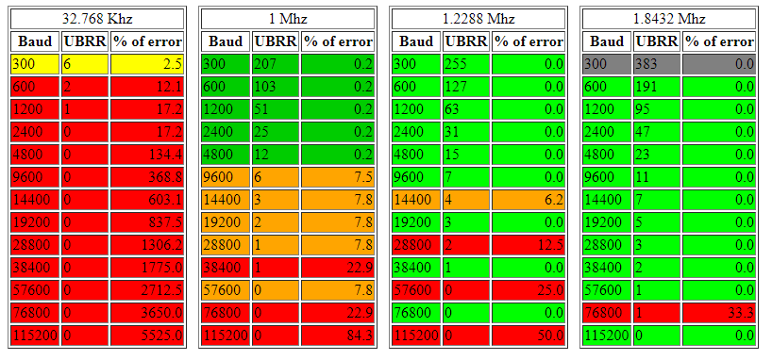

reference: https://cache.amobbs.com/bbs_upload782111/files_22/ourdev_508497.html