به نام خدا

تمرین 9 ریز

امیرمحمد پیرحسین لو

9531014

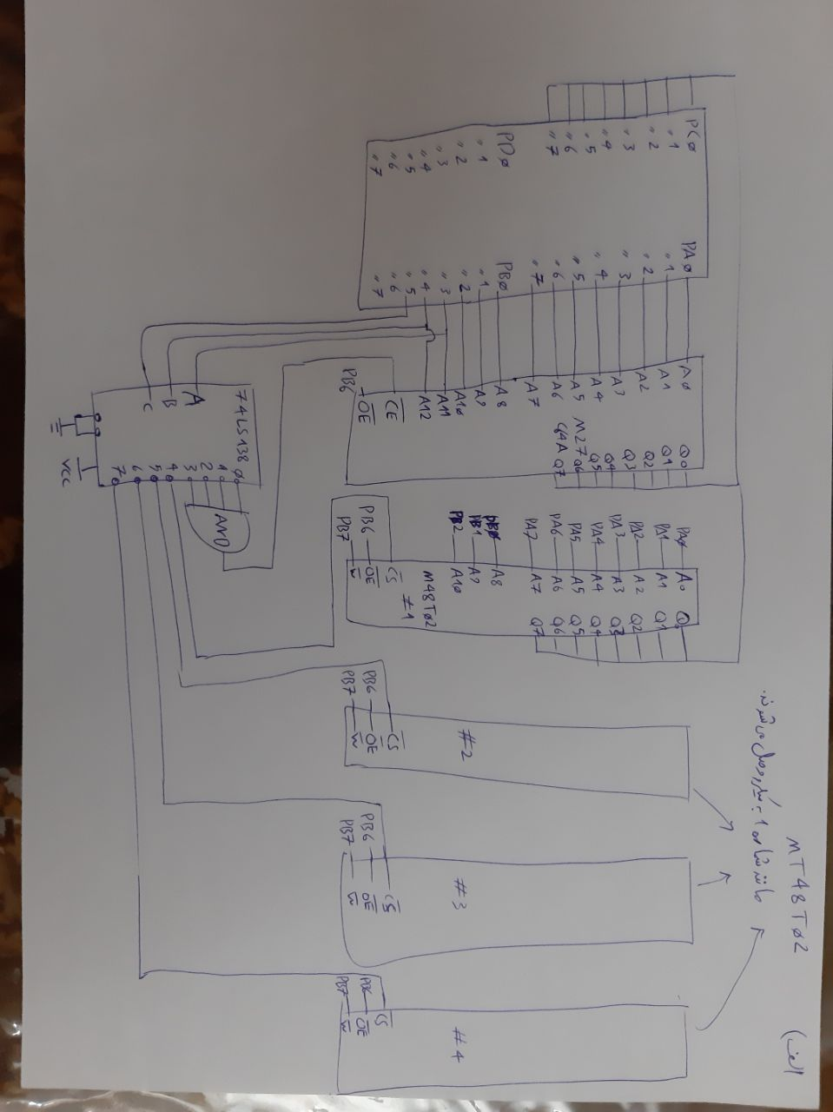

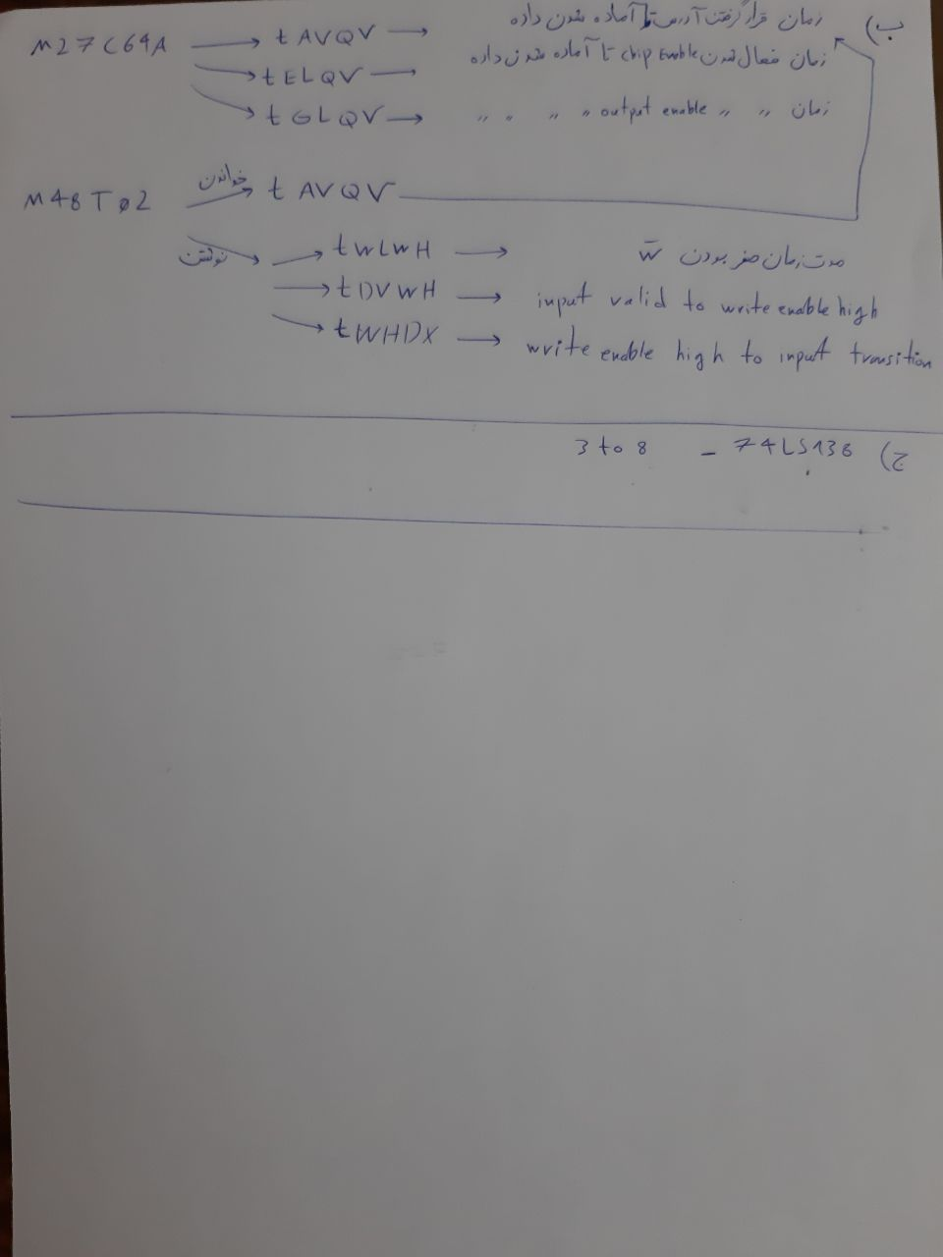

; Reset Vector

rjmp Start

;====================================================================

; CODE SEGMENT

;====================================================================

Start:

; Write your code here

Loop:

call READ

call WRITE

rjmp Loop

READ:

ldi r16,0x00 ;Address: Low Byte

ldi r17,0x15 ;Address: High Byte

ldi r18,0xFF

out DDRA,r18 ;PORTA is output

out DDRB,r18 ;PORTB is output

ldi r18,0x00

out DDRC,r18 ;PORTC is input

out PORTA,r16

andi r17,0x1F

out PORTB,r17

nop ;7 nop = 7 clocks = 7 \* 62.5ns > tAVQV + 1.5 clocks = 300 + 1.5 \* 62.5ns

nop

nop

nop

nop

nop

nop

in r0,PINC

ret

WRITE:

ldi r16,0x00 ;Address: Low Byte

ldi r17,0x25 ;Address: High Byte

ldi r20,0x90 ;Data

ldi r18,0xFF

out DDRA,r18 ;PORTA is output

out DDRB,r18 ;PORTB is output

out DDRC,r18 ;PORTC is output

out PORTC,r20

out PORTA,r16

andi r17,0x7F

ori r17,0x40 ;output diabled

out PORTB,r17

nop ;1 nop = 1 clock = 62.5ns > tWLWH = 20ns

sbi PORTB,7

nop ;1 nop = 1 clock = 62.5ns > tDVWH = 12ns

ret

;====================================================================

RM48L952 16- and 32-Bit RISC Flash Microcontroller

3MB of Program Flash with ECC

256KB of RAM with ECC

64KB of Flash with ECC for Emulated

EEPROM

16-Bit External Memory Interface