**In the name of God**

**Multicore Programming Course**

**homework 3**

**Amir M Pirhosseinloo**

**9531014**

1. Elapsed time: 2.573088 seconds program: 1.cu
2. Miss prediction: 21.5 % program: 2-a.cpp

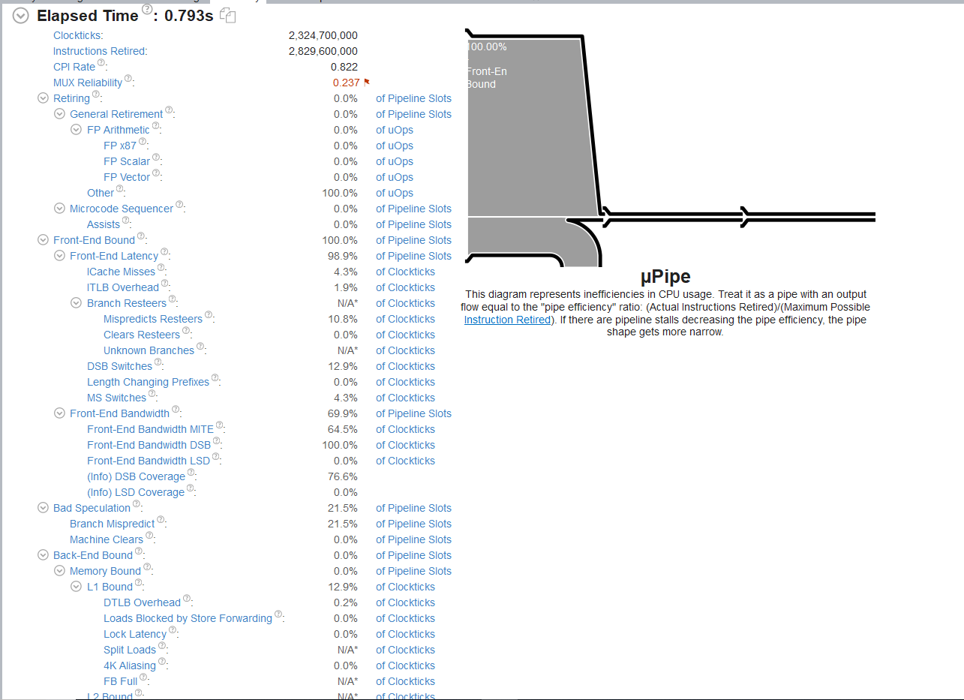

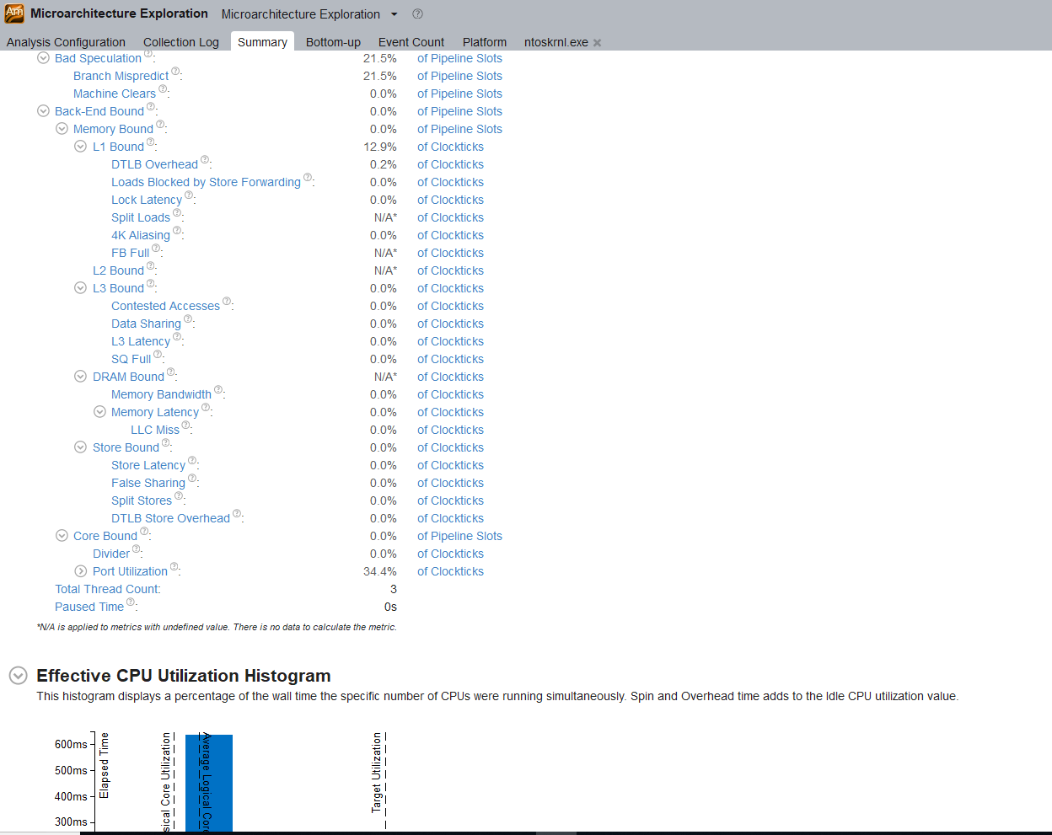

1. Elapsed time: 0.583 seconds program: 2-b.cpp

Miss prediction: 0.0 %

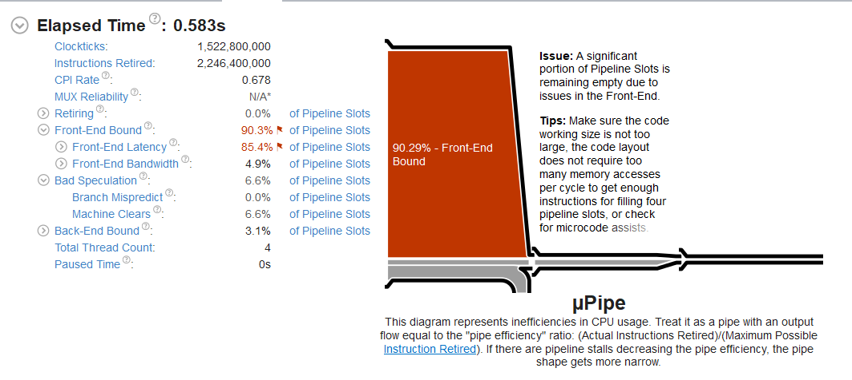

1. Elapsed time: 3.741 seconds

Miss prediction: 10.5 % program: 2-c.cpp

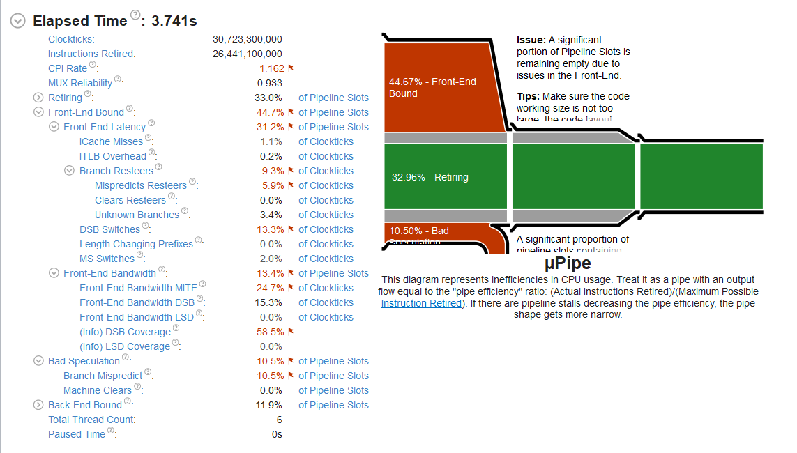

1. Elapsed time: 2.112 seconds

Miss prediction: 6.1 % program: 2-d.cpp

