**In the name of GOD**

**signals and systems homework 2**

**report**

**Amir H Pirhosseinloo**

**9531014**

1. Question 1
   1. part a

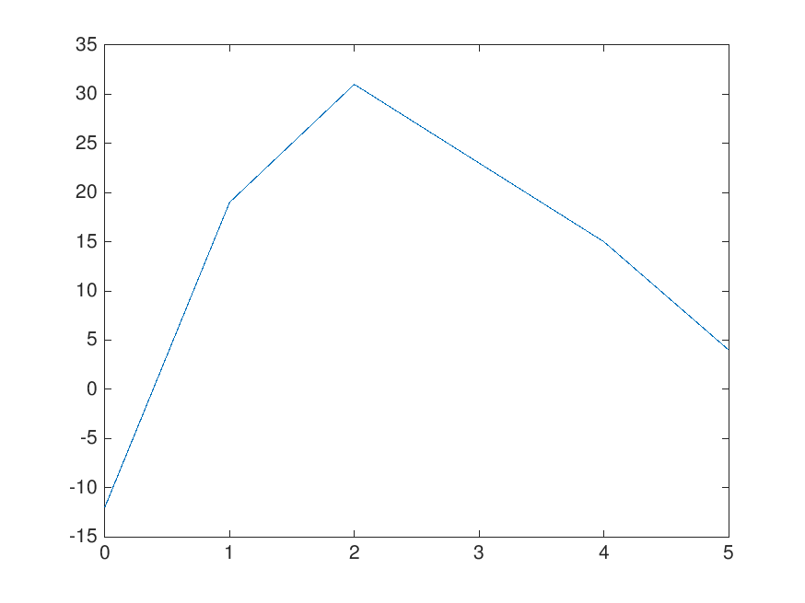

* 1. part b

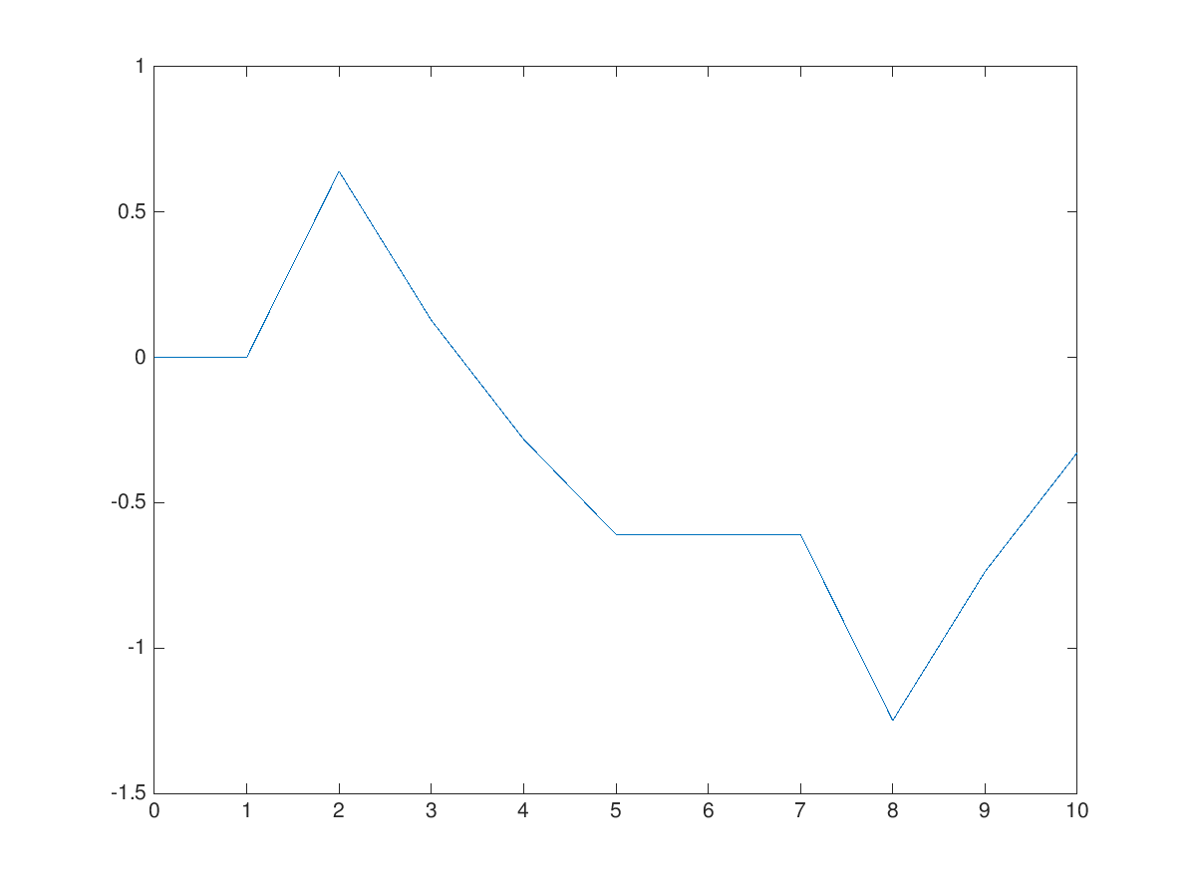

1. Question 2
   1. part a
      1. median blur w = 5

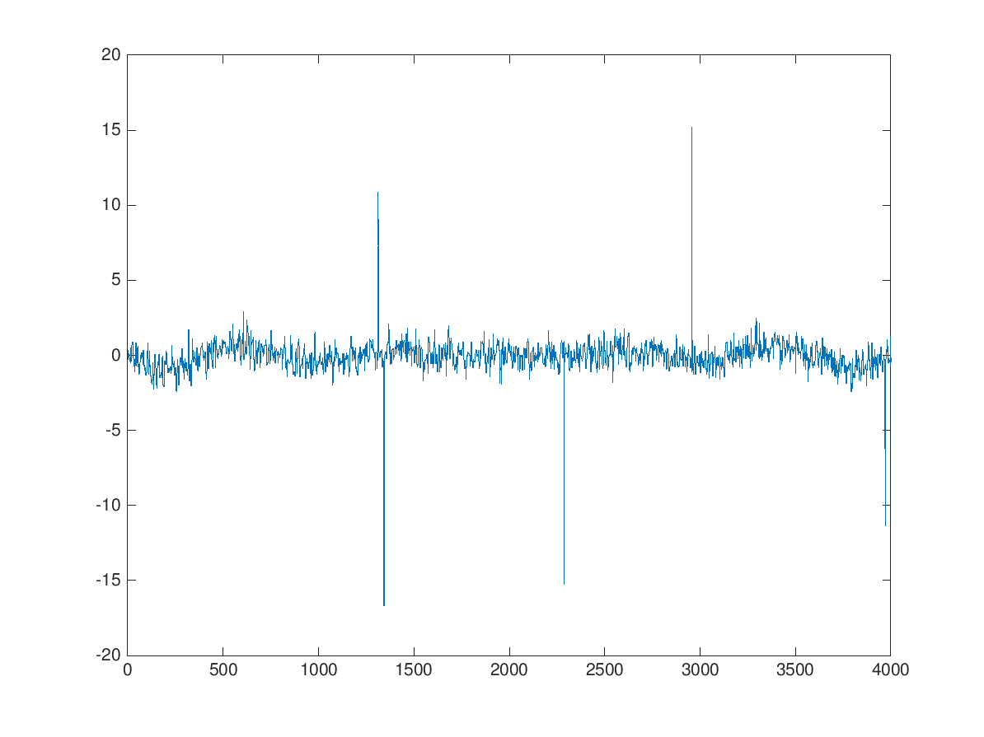

* + 1. median blur w = 10

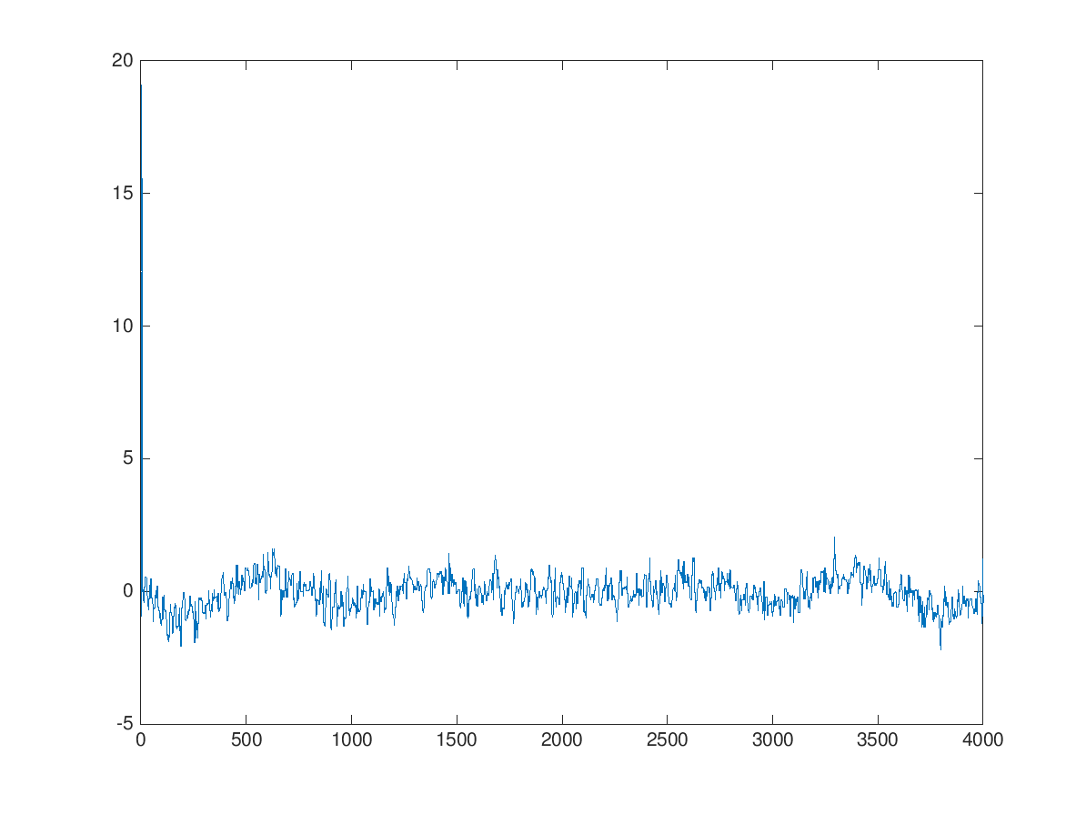

* + 1. median blur w = 100

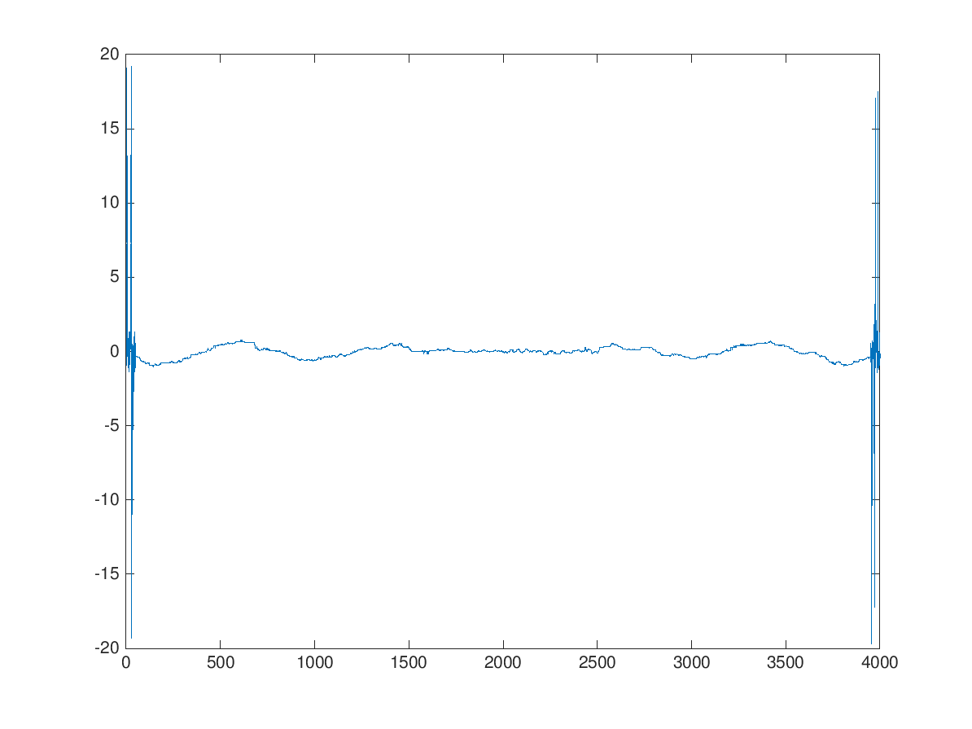

* + 1. Gaussian blur w = 5

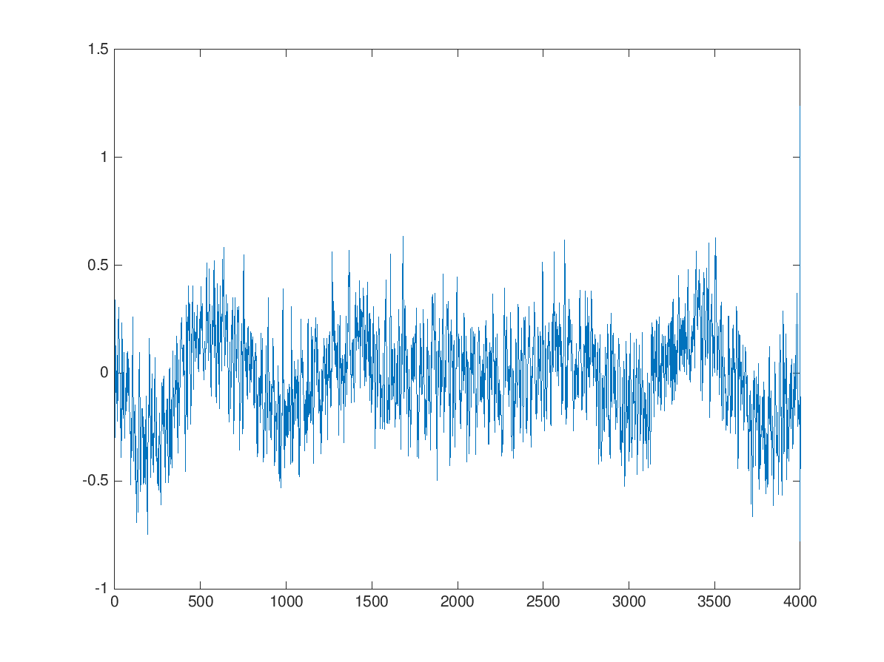

* + 1. Gaussian blur w = 10

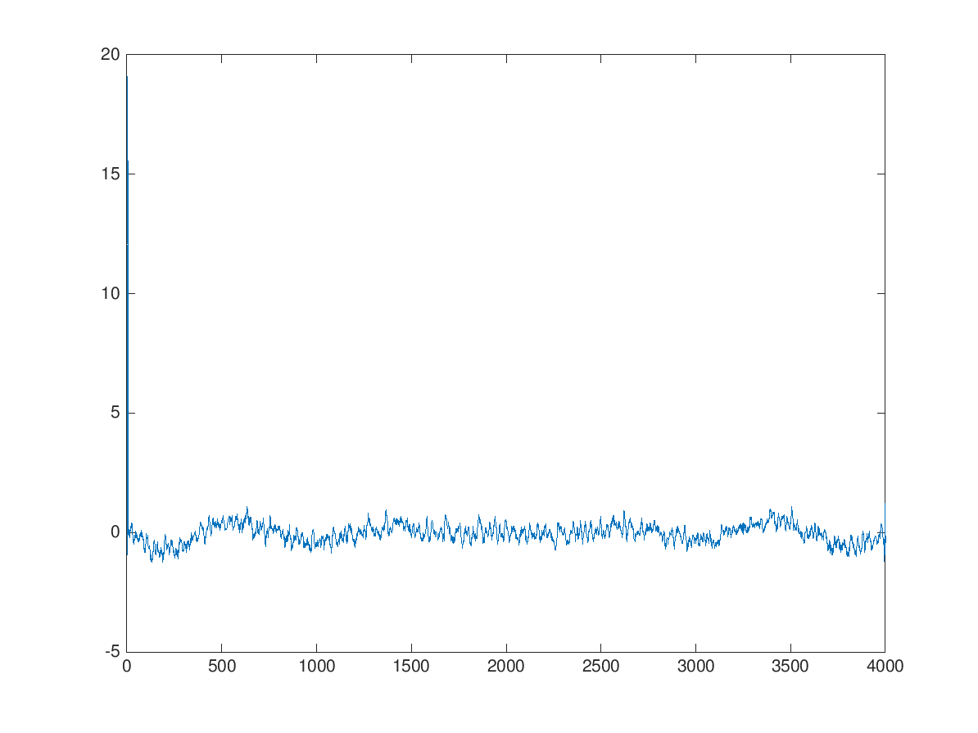

* + 1. Gaussian blur w = 100

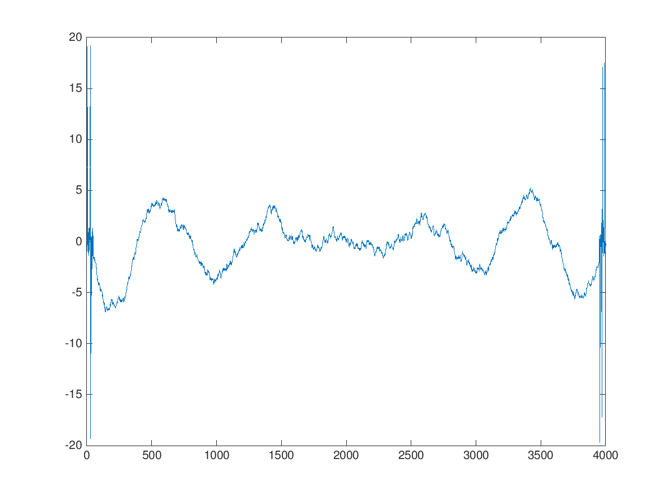

* 1. part b: Yes

* 1. part c: No

1. Question 3
   1. box blur w = 3



* 1. box blur w = 5



* 1. Gaussian blur w = 3



* 1. Gaussian blur w = 5

