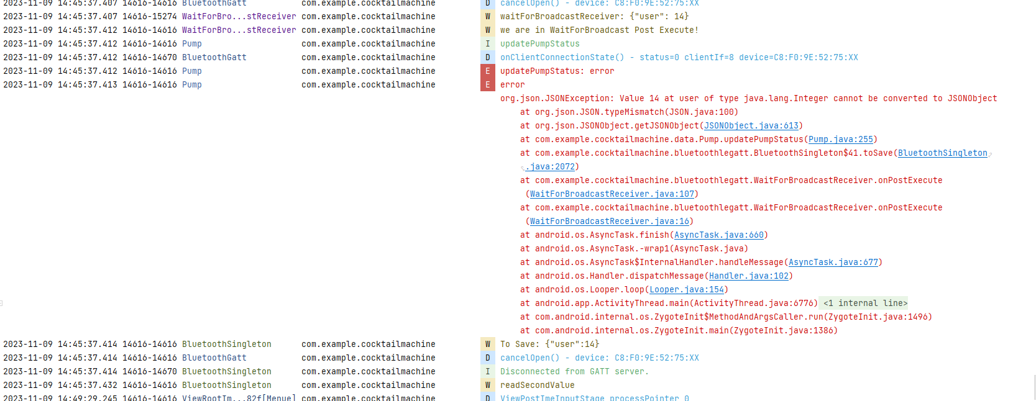

2023-11-09 14:45:37.406 14616-15239 WaitForBro...stReceiver com.example.cocktailmachine W waitForBroadcastReceiver: {"user": 14}

2023-11-09 14:45:37.406 14616-14616 WaitForBro...stReceiver com.example.cocktailmachine W we are in WaitForBroadcast Post Execute!

2023-11-09 14:45:37.406 14616-14616 AdminRights com.example.cocktailmachine I setUser

2023-11-09 14:45:37.406 14616-14616 AdminRights com.example.cocktailmachine I setUserId

2023-11-09 14:45:37.406 14616-14616 AdminRights com.example.cocktailmachine I getSingleton

2023-11-09 14:45:37.406 14616-14616 AdminRights com.example.cocktailmachine I setUserId: userId

2023-11-09 14:45:37.406 14616-14616 AdminRights com.example.cocktailmachine I setUser: done

2023-11-09 14:45:37.407 14616-14616 BluetoothSingleton com.example.cocktailmachine W To Save: {"user":14}

2023-11-09 14:45:37.407 14616-14616 BluetoothGatt com.example.cocktailmachine D cancelOpen() - device: C8:F0:9E:52:75:XX

2023-11-09 14:45:37.407 14616-15274 WaitForBro...stReceiver com.example.cocktailmachine W waitForBroadcastReceiver: {"user": 14}

2023-11-09 14:45:37.412 14616-14616 WaitForBro...stReceiver com.example.cocktailmachine W we are in WaitForBroadcast Post Execute!

2023-11-09 14:45:37.412 14616-14616 Pump com.example.cocktailmachine I updatePumpStatus

2023-11-09 14:45:37.412 14616-14670 BluetoothGatt com.example.cocktailmachine D onClientConnectionState() - status=0 clientIf=8 device=C8:F0:9E:52:75:XX

2023-11-09 14:45:37.412 14616-14616 Pump com.example.cocktailmachine E updatePumpStatus: error

2023-11-09 14:45:37.413 14616-14616 Pump com.example.cocktailmachine E error

org.json.JSONException: Value 14 at user of type java.lang.Integer cannot be converted to JSONObject

at org.json.JSON.typeMismatch(JSON.java:100)

at org.json.JSONObject.getJSONObject(JSONObject.java:613)

at com.example.cocktailmachine.data.Pump.updatePumpStatus(Pump.java:255)

at com.example.cocktailmachine.bluetoothlegatt.BluetoothSingleton$41.toSave(BluetoothSingleton.java:2072)

at com.example.cocktailmachine.bluetoothlegatt.WaitForBroadcastReceiver.onPostExecute(WaitForBroadcastReceiver.java:107)

at com.example.cocktailmachine.bluetoothlegatt.WaitForBroadcastReceiver.onPostExecute(WaitForBroadcastReceiver.java:16)

at android.os.AsyncTask.finish(AsyncTask.java:660)

at android.os.AsyncTask.-wrap1(AsyncTask.java)

at android.os.AsyncTask$InternalHandler.handleMessage(AsyncTask.java:677)

at android.os.Handler.dispatchMessage(Handler.java:102)

at android.os.Looper.loop(Looper.java:154)

at android.app.ActivityThread.main(ActivityThread.java:6776)

at java.lang.reflect.Method.invoke(Native Method)

at com.android.internal.os.ZygoteInit$MethodAndArgsCaller.run(ZygoteInit.java:1496)

at com.android.internal.os.ZygoteInit.main(ZygoteInit.java:1386)

2023-11-09 14:45:37.414 14616-14616 BluetoothSingleton com.example.cocktailmachine W To Save: {"user":14}

2023-11-09 14:45:37.414 14616-14616 BluetoothGatt com.example.cocktailmachine D cancelOpen() - device: C8:F0:9E:52:75:XX

2023-11-09 14:45:37.414 14616-14670 BluetoothSingleton com.example.cocktailmachine I Disconnected from GATT server.

2023-11-09 14:45:37.432 14616-14616 BluetoothSingleton com.example.cocktailmachine W readSecondValue

2023-11-09 14:49:29.245 14616-14616 ViewRootIm...82f[Menue] com.example.cocktailmachine D ViewPostImeInputStage processPointer 0

2023-11-09 14:49:29.313 14616-14616 ViewRootIm...82f[Menue] com.example.cocktailmachine D ViewPostImeInputStage processPointer 1

2023-11-09 14:49:29.314 14616-14616 InputMethodManager com.example.cocktailmachine D ISS - flag : 0Pid : 14616 view : com.example.cocktailmachine

2023-11-09 14:49:29.640 14616-14616 ViewRootIm...0da[Menue] com.example.cocktailmachine D MSG_RESIZED: frame=Rect(0, 0 - 1080, 1920) ci=Rect(0, 72 - 0, 750) vi=Rect(0, 72 - 0, 750) or=1

2023-11-09 14:49:29.655 14616-14616 ViewRootIm...0da[Menue] com.example.cocktailmachine D Relayout returned: oldFrame=[0,0][1080,1920] newFrame=[0,0][1080,1920] result=0x1 surface={isValid=true -867522560} surfaceGenerationChanged=false

2023-11-09 14:49:29.658 14616-14616 ScrollView com.example.cocktailmachine D onsize change changed