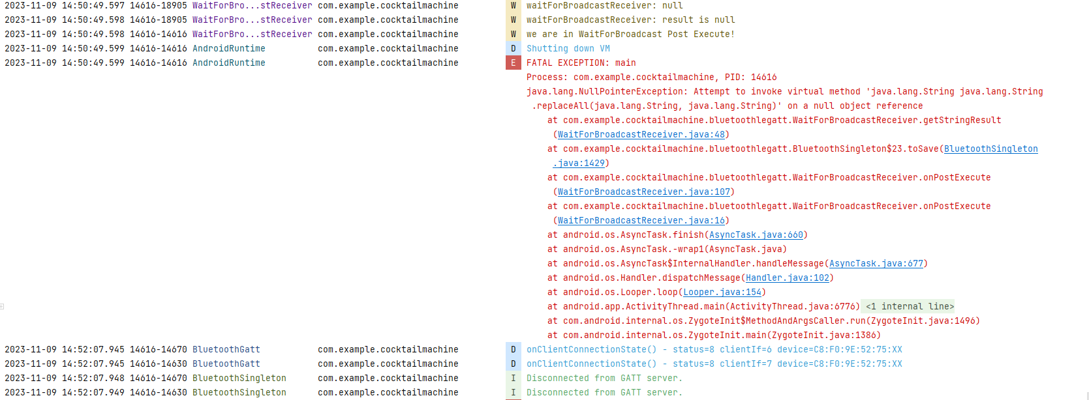

2023-11-09 14:50:48.596 14616-18978 BluetoothSingleton com.example.cocktailmachine W run2: read Characteristic: Reading from ESP is in Process!500

2023-11-09 14:50:48.596 14616-18905 WaitForBro...stReceiver com.example.cocktailmachine W we are in WaitForBroadcast doInBackground after try-catch!

2023-11-09 14:50:48.597 14616-18905 WaitForBro...stReceiver com.example.cocktailmachine W we are in WaitForBroadcast doInBackground before try-catch!

2023-11-09 14:50:48.597 14616-18905 WaitForBro...stReceiver com.example.cocktailmachine W waitForBroadcastReceiverAsyncTask: Waiting for target value..null

2023-11-09 14:50:49.096 14616-18978 BluetoothSingleton com.example.cocktailmachine W run2: Is reading Characteristic in Process!

2023-11-09 14:50:49.096 14616-18978 BluetoothSingleton com.example.cocktailmachine W run2: read Characteristic: Reading from ESP is in Process!500

2023-11-09 14:50:49.097 14616-18905 WaitForBro...stReceiver com.example.cocktailmachine W we are in WaitForBroadcast doInBackground after try-catch!

2023-11-09 14:50:49.097 14616-18905 WaitForBro...stReceiver com.example.cocktailmachine W we are in WaitForBroadcast doInBackground before try-catch!

2023-11-09 14:50:49.097 14616-18905 WaitForBro...stReceiver com.example.cocktailmachine W waitForBroadcastReceiverAsyncTask: Waiting for target value..null

2023-11-09 14:50:49.596 14616-18978 BluetoothSingleton com.example.cocktailmachine W run: read Characteristic: Timeout, unable to read value from ESP

2023-11-09 14:50:49.597 14616-14616 BluetoothSingleton com.example.cocktailmachine W readSecondValue

2023-11-09 14:50:49.597 14616-18905 WaitForBro...stReceiver com.example.cocktailmachine W waitforBraodcastReceiver: timeout...

2023-11-09 14:50:49.597 14616-18905 WaitForBro...stReceiver com.example.cocktailmachine W waitForBroadcastReceiver: null

2023-11-09 14:50:49.598 14616-18905 WaitForBro...stReceiver com.example.cocktailmachine W waitForBroadcastReceiver: result is null

2023-11-09 14:50:49.598 14616-14616 WaitForBro...stReceiver com.example.cocktailmachine W we are in WaitForBroadcast Post Execute!

2023-11-09 14:50:49.599 14616-14616 AndroidRuntime com.example.cocktailmachine D Shutting down VM

2023-11-09 14:50:49.599 14616-14616 AndroidRuntime com.example.cocktailmachine E FATAL EXCEPTION: main

Process: com.example.cocktailmachine, PID: 14616

java.lang.NullPointerException: Attempt to invoke virtual method 'java.lang.String java.lang.String.replaceAll(java.lang.String, java.lang.String)' on a null object reference

at com.example.cocktailmachine.bluetoothlegatt.WaitForBroadcastReceiver.getStringResult(WaitForBroadcastReceiver.java:48)

at com.example.cocktailmachine.bluetoothlegatt.BluetoothSingleton$23.toSave(BluetoothSingleton.java:1429)

at com.example.cocktailmachine.bluetoothlegatt.WaitForBroadcastReceiver.onPostExecute(WaitForBroadcastReceiver.java:107)

at com.example.cocktailmachine.bluetoothlegatt.WaitForBroadcastReceiver.onPostExecute(WaitForBroadcastReceiver.java:16)

at android.os.AsyncTask.finish(AsyncTask.java:660)

at android.os.AsyncTask.-wrap1(AsyncTask.java)

at android.os.AsyncTask$InternalHandler.handleMessage(AsyncTask.java:677)

at android.os.Handler.dispatchMessage(Handler.java:102)

at android.os.Looper.loop(Looper.java:154)

at android.app.ActivityThread.main(ActivityThread.java:6776)

at java.lang.reflect.Method.invoke(Native Method)

at com.android.internal.os.ZygoteInit$MethodAndArgsCaller.run(ZygoteInit.java:1496)

at com.android.internal.os.ZygoteInit.main(ZygoteInit.java:1386)

2023-11-09 14:52:07.945 14616-14670 BluetoothGatt com.example.cocktailmachine D onClientConnectionState() - status=8 clientIf=6 device=C8:F0:9E:52:75:XX

2023-11-09 14:52:07.945 14616-14630 BluetoothGatt com.example.cocktailmachine D onClientConnectionState() - status=8 clientIf=7 device=C8:F0:9E:52:75:XX

2023-11-09 14:52:07.948 14616-14670 BluetoothSingleton com.example.cocktailmachine I Disconnected from GATT server.

2023-11-09 14:52:07.949 14616-14630 BluetoothSingleton com.example.cocktailmachine I Disconnected from GATT server.

2023-11-09 14:55:49.746 2837-2991 ActivityManager system_server E Found activity ActivityRecord{77d300fd0 u0 com.example.cocktailmachine/.bluetoothlegatt.DeviceScanActivity t3579 f} in proc activity list using null instead of expected ProcessRecord{6103aff 14616:com.example.cocktailmachine/u0a265}

---------------------------- PROCESS ENDED (14616) for package com.example.cocktailmachine ----------------------------

2023-11-09 14:55:50.004 3091-3657 BtGatt.GattService com.android.bluetooth E [GSIM LOG]: gsimLogHandler: com.example.cocktailmachine, msg: MESSAGE_STOP_ADV

2023-11-09 14:55:50.004 3091-3657 BtGatt.GattService com.android.bluetooth E [GSIM LOG]: gsimLogHandler: com.example.cocktailmachine, msg: MESSAGE_STOP_ADV

2023-11-09 14:55:50.004 3091-3657 BtGatt.GattService com.android.bluetooth E [GSIM LOG]: gsimLogHandler: com.example.cocktailmachine, msg: MESSAGE_STOP_ADV