Parameter-Efficient Fine-Tuning of Multilingual Large Language Models for Enhanced Multi-Intent Disease Query Resolution in Low-Resource Healthcare Contexts
Amirreza Kazemloo¹[0000-0003-4263-1639] and SS Sadidpour^{2*} []
¹ Malek Ashtar University Of Technology, Tehran, IRAN
² Correspondence: sadidpour@mut.ac.ir, Malek Ashtar University Of Technology, Tehran, IRAN
Abstract.
This paper presents an efficient approach for fine-tuning large language models (LLMs) in the medical domain using Low-Rank Adaptation (LoRA) to enable parameter-efficient fine-tuning (PEFT). Leveraging multiple state-of-the-art large language models, we extract and consolidate comprehensive disease knowledge, including symptoms, diagnosis, and treatments, into a unified dataset. We then synthesize diverse multi-intent medical queries and dialogues simulating realistic patient-physician interactions to build a robust multi-intent detection dataset. Our LoRA-based fine-tuning framework is implemented and evaluated on this medical dataset, demonstrating significant reduction in computational resource usage while maintaining high performance in disease intent detection. The study highlights the effectiveness of LoRA for domain adaptation of large models in resource-constrained environments, providing a scalable solution for developing specialized medical natural language understanding systems. Experimental results indicate promising accuracy and training efficiency, paving the way for further applications of parameter-efficient fine-tuning in healthcare NLP.
Keywords: Parameter-Efficient Fine-Tuning, Low-Rank Adaptation, Large Language Models, Medical Natural Language Processing, Multi-Intent Detection, Synthetic Medical Dataset, Fine-Tuning Efficiency. The implementation of the LoRA-based medical fine-tuning framework, dataset generation pipeline, and experimental setup presented in this study are publicly available at: https://github.com/amirreza1998/lora-medical-finetuning.git
- Introduction
Large Language Models (LLMs) encounter significant challenges in accurately interpreting domain-specific, multi-intent queries, particularly in complex fields like healthcare where precise information extraction is crucial^{1,2} ³. While general-purpose LLMs demonstrate remarkable capabilities, their direct application to such tasks often results in suboptimal performance and high computational demands for adaptation^{3,4}. This paper addresses these limitations by proposing an efficient methodology for fine-tuning a pre-trained LLM for multi-intent disease query processing in the medical domain⁵.
Our approach leverages Parameter-Efficient Fine-Tuning (PEFT), specifically Low-Rank Adaptation (LoRA) and Quantized Low-Rank Adaptation (QLoRA), to adapt the CohereLabs/aya-23-8B LLM⁶. A specialized training dataset, compiled to enhance the model's ability to interpret complex health inquiries and extract disease-specific information, was utilized⁷. The LoRA configuration for fine-tuning included lora_alpha=32, lora_dropout=0.05, bias="none", and targeted the "q_proj", "k_proj", "v_proj", and "o_proj" attention modules. The fine-tuned model's performance is rigorously evaluated using precision, recall, and F1-score for disease prediction. Results demonstrate enhanced capabilities in jointly extracting and detecting multi-label, multi-class intents and associated entities within medical text⁸. This efficient adaptation not only mitigates the substantial computational costs associated with full fine-tuning⁴ but also facilitates potential on-premise deployment, directly addressing critical data privacy and security concerns in healthcare applications⁹This work provides a practical framework for developing specialized, resource-efficient LLMs to bridge communication gaps and improve access to vital medical information in complex linguistic and domain-specific contexts¹⁰.
- Related works
The landscape of natural language processing has been profoundly reshaped by the advent of Large Language Models (LLMs), which exhibit remarkable capabilities in general natural language understanding and generation¹¹. However, their direct applicability to highly specialized domains such as healthcare often necessitates tailored adaptation strategies^{10,5}. The reported study illustrates a methodology for compiling training datasets to fine-tune Large Language Models (LLMs) for healthcare information in Computer Methods and Programs in Biomedicine.
  - LLMs in Healthcare
The integration of LLMs into healthcare has witnessed an accelerated pace of research, focusing on their potential to aid in diagnostic processes, interpret complex medical literature, generate patient education materials, and support clinical decision-making^{11,12}. Early domain-specific adaptations include models like BioBERT^{10,13} which was pre-trained on biomedical research articles from PubMed and PubMed Central, demonstrating improved performance across various biomedical NLP tasks¹³. Following this, PubMedBERT^{10,14}, proposed by Gu et al. (2022), was pre-trained on biomedical data from scratch with a biomedical corpus-initialized vocabulary, further solidifying the importance of domain-specific pre-training¹³. More recently, models such as Med-PaLM and Med-PaLM 2 from Google, and Med42 have achieved state-of-the-art performance on medical examination and question-answering datasets, often through intricate ensemble refinement and computationally intensive prompting strategies^{4,11}. Clinical LLMs, specifically adapted with clinical notes, have shown to often outperform general biomedical LLMs in various clinical downstream tasks, highlighting the intrinsic nuances specific to clinical contexts¹³. Examples include Bio+ClinicalBERT, BlueBERT, and Clinical-T5 which are fine-tuned using clinical data such as the MIMIC-III and MIMIC-IV databases¹³. Our work aligns with this trajectory, seeking to develop LLMs adept at nuanced medical information processing¹¹.

  - Parameter-Efficient Fine-Tuning (PEFT)
The ever-increasing scale of LLMs, often comprising billions of parameters, presents a significant hurdle for their adaptation to new tasks due to the prohibitive computational costs and memory requirements of full-parameter fine-tuning^{3,4,11}. Parameter-Efficient Fine-Tuning (PEFT) methods offer an elegant solution by adjusting only a small subset of the model's parameters while keeping the vast majority of pre-trained parameters fixed¹¹. This approach substantially alleviates the computational burden, making LLM adaptation more feasible, particularly in resource-constrained environments.
Among various PEFT techniques, Low-Rank Adaptation (LoRA)^{6,11,13} has gained considerable traction. LoRA works by injecting trainable low-rank matrices into the transformer layers, which represent the updates to the original weight matrices⁶. During fine-tuning, only these low-rank matrices are updated, while the original pre-trained weights remain frozen¹⁴. This significantly reduces the number of trainable parameters, leading to faster training, reduced memory footprint, and comparable performance to full fine-tuning^{11,15,16}. LoRA has demonstrated success in both Natural Language Processing^{11,17} and computer vision domains, for instance, improving lung nodule malignancy classification with large vision models¹⁵. Variants like Quantized Low-Rank Adaptation (QLoRA)⁵ ^{11,18} further enhance efficiency by quantizing the pre-trained model to 4-bit and then applying LoRA, allowing fine-tuning of even larger models on a single GPU^{5,18}. Other PEFT approaches include Adapters, Prompt-tuning^{11,16}, and more recent developments like RandLoRA¹⁶ and SeLoRA¹⁹, which aim to further optimize efficiency and performance.
  - Multi-Intent Detection and Entity Extraction
In task-oriented dialogue systems, accurately interpreting user queries is paramount for providing appropriate responses²⁰. Traditional approaches often focus on queries with a single, clear intent²⁰. However, real-world user interactions, particularly in complex domains like healthcare, frequently involve queries that express multiple intents and require the extraction of several relevant entities or spans of text ^{20,21} ¹⁰ Challenges in handling biomedical text data include incomplete sentences, lack of specific structure, and the presence of hard-to-interpret context-specific medical terminologies¹⁰.
Research has explored various methodologies to tackle multi-intent detection and entity extraction. Pointer network-based architectures, such as the MLMCID system proposed by Mullick et al²⁰. are designed to jointly extract multiple intent spans and detect coarse and fine-grained labels from complex queries. These systems have demonstrated superiority over baseline approaches and even some general LLMs for these specific tasks²⁰. Techniques employing BIO notation for tagging intent labels at a word level are common for training models on custom datasets for such tasks. The application of supervised fine-tuned (SFT) approaches, particularly with biomedical transformer models like PubMedBERT, has shown to be more effective than general-purpose LLMs in domain-specific tasks such as Named Entity Recognition (NER), even with limited supervised examples¹⁰. This robust evidence highlights the continued importance of specialized models for intricate domain-specific NLU tasks.

- Methodology
Our approach adheres to a well-established pipeline for Large Language Model (LLM) fine-tuning, involving four pivotal stages: (1) selection of an appropriate base model, (2) curation of a domain-specific dataset, (3) fine-tuning the model with this specialized dataset, and (4) a rigorous evaluation of the model's performance⁵.
  - Model Selection
For this investigation, we selected the CohereLabs/aya-23-8B model as our base LLM²². This choice was informed by its robust performance as an open-source, multilingual model, which is particularly advantageous for tasks in diverse linguistic contexts or for adapting to low-resource languages, a critical consideration in global health equity initiatives⁵. The model's inherent multilingual capabilities provide a strong foundation for future expansion beyond the specific language of our primary dataset, addressing the challenges of language barriers in AI accessibility⁵.
  - Dataset Compilation for Multi-Intent Disease Queries
A cornerstone of our fine-tuning process was the development of a domain-specific instruction dataset meticulously designed to address the unique complexities of multi-intent disease-related queries within a healthcare context. Recognizing the scarcity of highly specialized, annotated medical datasets for multi-intent detection, we employed a data distillation paradigm utilizing frontier Large Language Models (LLMs) to synthesize a robust training corpus⁷. Fine-tuning LLMs with such tailored datasets is essential for bridging gaps in medical information accessibility, particularly in specialized or low-resource contexts where foundational models often struggle with domain-specific nuances ⁵.
The dataset generation pipeline was executed in two primary phases to ensure clinical comprehensiveness and conversational diversity:
- Knowledge Extraction and Consolidation: Initially, extensive disease knowledge—encompassing primary symptoms, diagnostic methods, common treatments, and potential complications—was extracted and structured into a unified JSON format. Through iterative prompting and aggregation across multiple advanced LLMs, this foundational knowledge base was expanded to encompass a comprehensive taxonomy of 120 distinct medical conditions and diseases.
- Synthetic Query Generation via Distillation: Leveraging the consolidated knowledge base, we utilized LLMs as synthetic data generators to simulate realistic patient-physician interactions²³. This approach to synthetic data generation—where LLMs artificially produce training examples mimicking real-world distributions—has proven highly effective in natural language domains constrained by data scarcity and high annotation costs²³. The generation prompts were explicitly engineered to create complex clinical scenarios rather than simple, single-intent inquiries. Specifically, the models were instructed to generate utterances featuring diseases with shared symptoms, multiple simultaneous complications, co-occurring diseases, and scenarios requiring differential diagnosis. This ensured that a single user query frequently contained multiple underlying intents (diseases) embedded within natural language.

  - Fine-Tuning Strategy: Low-Rank Adaptation (LoRA)

To efficiently adapt the large CohereLabs/aya-23-8B model to our specialized medical domain, we employed Low-Rank Adaptation (LoRA)¹⁷. LoRA is a parameter-efficient fine-tuning (PEFT) technique that injects small, trainable low-rank matrices into the existing linear layers of the pre-trained transformer architecture. While foundational implementations of LoRA often restrict these injections solely to the query and value matrices of the self-attention mechanism, we extended our adaptation to capture more complex domain representations by targeting all primary linear projections. Specifically, our configuration applied LoRA to the q_proj, k_proj, v_proj, o_proj, gate_proj, up_proj, and down_proj modules²⁴.
During the fine-tuning process, the original, massive pre-trained weights of the LLM remain frozen, meaning only the much smaller injected LoRA parameters (the $A$ and $B$
low-rank matrices) are actively updated during backpropagation¹⁴. This strategy drastically reduces the number of trainable parameters from billions to mere millions, accelerating training times and significantly lowering the memory footprint without degrading the model's performance on complex tasks. The efficacy of such parameter-efficient strategies is well-documented across the healthcare domain, having been instrumental in the development of robust clinical LLMs¹¹, optimizing representations for long clinical patient notes¹³, fine-tuning large vision models for complex tasks like lung nodule malignancy classification¹⁵, and overcoming stringent hardware constraints for clinical text classification, as explored in The Impact of LoRA Adapters on LLMs for Clinical Text Classification Under Computational and Data Constraints²⁵.
Our implementation utilized the transformers and peft libraries from Hugging Face, providing a state-of-the-art framework for this parameter-efficient architecture. To further optimize computational overhead, we integrated Quantized Low-Rank Adaptation (QLoRA) utilizing the bitsandbytes library¹⁸. QLoRA achieves unparalleled memory efficiency by quantizing the base model weights to a 4-bit NormalFloat (NF4) precision format while maintaining the LoRA adapters in higher precision (e.g., bfloat16). This profound reduction in memory usage made it computationally feasible to effectively fine-tune our 8-billion parameter model on a single, accessible consumer GPU. Furthermore, freezing the quantized base weights provides structural stability that helps prevent the catastrophic forgetting phenomena frequently observed when fully fine-tuning or unlearning concepts from large models²⁶.

  - Experimental Setup
The fine-tuning architecture was established by loading the base CohereLabs/aya-23-8B model alongside its corresponding tokenizer. To ensure input dimension consistency during batched processing, the tokenizer's padding token was mapped to the end-of-sequence token (eos_token) with right-side padding enforced. To adhere to stringent memory constraints without sacrificing representation quality, we integrated Quantized Low-Rank Adaptation (QLoRA) via the bitsandbytes library¹⁸. The foundational LLM was loaded in 4-bit NormalFloat (NF4) precision with double quantization enabled, utilizing bfloat16 as the computational data type to maintain gradient stability.
The LoRA configuration was meticulously tuned to balance parameter efficiency with the representational demands of complex, multi-intent downstream adaptation⁴. We parameterized the low-rank updates with a rank ($r$) of 8, a scaling factor ($α$) of 32, and a dropout rate of 0.1 to regularize the injected weights. To maximize the model's adaptation capacity, the low-rank matrices were injected across an extended set of target modules within the transformer block. Beyond standard self-attention projections (q_proj, k_proj, v_proj, o_proj), we expanded our scope to include the multi-layer perceptron (MLP) components (gate_proj, up_proj, down_proj).
The model was trained on the specialized LLM-based generated dataset utilizing the Hugging Face Trainer API. Optimization was driven by the adamw_torch_fused optimizer, incorporating a weight decay of 0.01 to mitigate overfitting. The peak learning rate was set to $1×{10}^{-4}$ and modulated using a cosine_with_restarts scheduling strategy, preceded by a linear warmup phase of 100 steps. This dynamic scheduling approach has been empirically demonstrated to enhance convergence stability and help models escape local minima during low-rank fine-tuning²⁷. To simulate a larger effective batch size while successfully circumventing VRAM bottlenecks, the per-device training batch size was restricted to 1, paired with 16 gradient accumulation steps.
Training spanned 5 total epochs and incorporated intermediate evaluation checkpoints every 100 steps to monitor the validation loss. This was coupled with an early-stopping mechanism that retained the best-performing weights (load_best_model_at_end=True) to ensure optimal generalization. Computationally, the resource-intensive fine-tuning phase was accelerated utilizing an NVIDIA RTX 5090 GPU. Subsequent model inference, comprehensive testing, and interactive evaluations were executed efficiently utilizing a more accessible hardware profile consisting of a local NVIDIA GeForce RTX 4060 GPU, supplemented by Google Colab Pro computing environments.

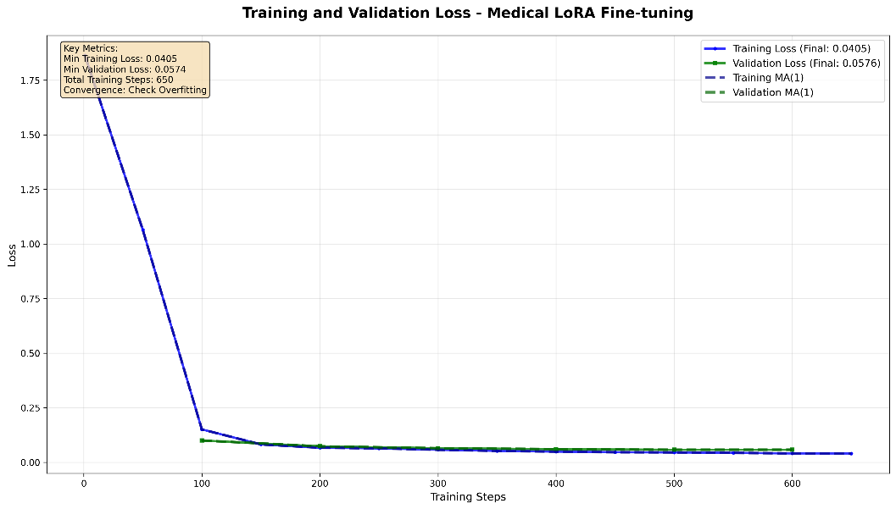
Fig. 1. Convergence of training and validation loss during the LoRA fine-tuning process over 650 training steps. Both loss curves demonstrate a rapid decrease in the initial 150 steps, followed by a stable plateau for the remainder of the training. The final training loss converged to 0.0405, while the final validation loss was 0.0576. The close proximity of the two curves throughout the process indicates that the model generalized well to unseen data without significant overfitting.
  - Evaluation Metrics
The performance of the fine-tuned model for multi-intent disease query resolution is quantitatively assessed using standard Natural Language Understanding (NLU) metrics, specifically Precision, Recall, and the F1-score. These specific metrics are highly pertinent for accurately evaluating intent detection and entity extraction within biomedical text, where correctly identifying and delineating relevant information from complex phrasing is paramount¹⁰.
Our implementation utilizes dedicated quantitative analysis modules to establish a clear evaluation framework, ensuring that the model is robustly tested on its ability to appropriately handle multifaceted, multi-class queries⁸. Executing such standardized evaluations is critical for demonstrating the overall efficacy of the parameter-efficient fine-tuning pipeline and confirming the model's significant semantic enhancements over the generalized base models⁵.
Our implementation utilizes dedicated quantitative analysis modules to establish a clear evaluation framework, ensuring that the model is robustly tested on its ability to appropriately handle multifaceted, multi-class queries⁸. Executing such standardized evaluations is critical for demonstrating the overall efficacy of the parameter-efficient fine-tuning pipeline and confirming the model's significant semantic enhancements over the generalized base models⁵.
Beyond standard lexical and NLU metrics, we further augment our evaluation pipeline by integrating the "LLM-as-a-Judge" paradigm. Traditional automated metrics, while highly effective for exact span extraction, often struggle to fully capture the semantic nuances, clinical correctness, and safety of open-ended medical text generation. In contrast, leveraging a highly capable LLM as an automated evaluator allows for scalable, multidimensional assessments of medical accuracy, completeness, clarity, and clinical helpfulness²⁸. This approach has been increasingly adopted within healthcare NLP to approximate expert human judgments, offering a highly efficient alternative to slow and expensive manual annotation while demonstrating moderate to strong alignment with expert clinical evaluations across diverse medical QA tasks^{29,30}. By employing this method alongside traditional F1-scores, we ensure our model's generated responses are not only structurally accurate but also clinically sound and practically viable for complex healthcare communication.

- Results
This section details the empirical outcomes of the proposed Parameter-Efficient Fine-Tuning methodology. The evaluation assesses the fine-tuned model's performance across three critical dimensions: training convergence stability, computational resource efficiency, and predictive accuracy in multi-intent disease query resolution. The quantitative and qualitative findings presented below demonstrate the efficacy of leveraging Low-Rank Adaptation to successfully adapt foundational large language models for specialized healthcare NLU tasks.

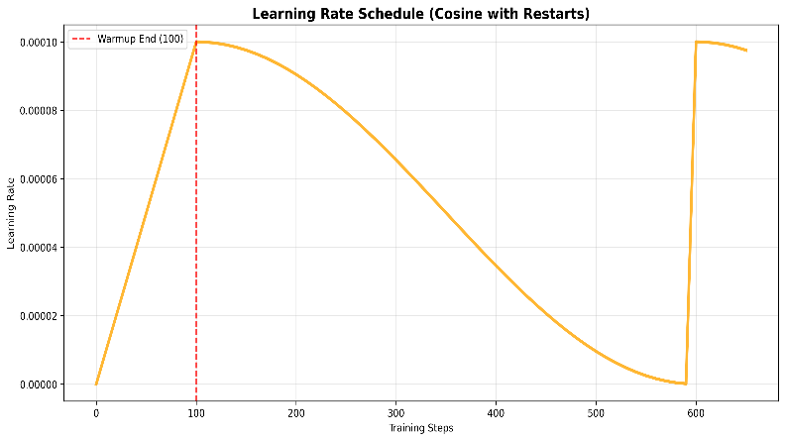
Fig. 2. The learning rate schedule employed during model fine-tuning. The schedule implements a cosine decay with restarts, incorporating a linear warmup phase for the first 100 training steps to a peak learning rate of$1×{10}^{-4}$. This is followed by a gradual cosine decay to facilitate stable convergence. The restart near the end of the cycle is designed to help the model escape local minima and settle in a more optimal parameter sp
ace.
  - Performance Enhancement
The fine-tuned CohereLabs/aya-23-8B model is expected to demonstrate substantial improvements in performance over its base version across critical evaluation metrics such as Precision, Recall, and F1-score for multi-intent disease query resolution. This aligns with findings from similar studies, such as the fine-tuning of LLMs for healthcare information in Vietnamese, which reported enhancements in BertScore, Rouge-L, and "LLM-as-a-Judge" scores⁵. For instance, specialized supervised fine-tuned (SFT) models, particularly biomedical transformer models like PubMedBERT, have been shown to outperform general-purpose LLMs such as ChatGPT on Named Entity Recognition (NER) tasks in biomedical text, even with a limited number of supervised examples¹⁰. This substantiates the premise that domain-specific fine-tuning is crucial for achieving high accuracy in complex, specialized tasks.
  - Computational Efficiency
A primary advantage of employing LoRA is the remarkable reduction in computational resources required for fine-tuning. We expect to observe a significant decrease in the number of trainable parameters compared to full fine-tuning, thereby reducing GPU memory consumption and accelerating training times. This efficiency is critical, especially for deploying models in environments with constrained computing power, such as many organizations in developing countries⁴. For example, studies have shown LoRA-adapted models achieving up to an 89.9% reduction in parameters and a 36.5% decrease in training times while improving performance in large vision models for medical image analysis¹⁵. Similarly, fine-tuning large LLaMA models with LoRA can reduce trainable parameters from billions to tens or hundreds of millions¹¹. This confirms LoRA's utility in making advanced LLM capabilities more accessible and sustainable.
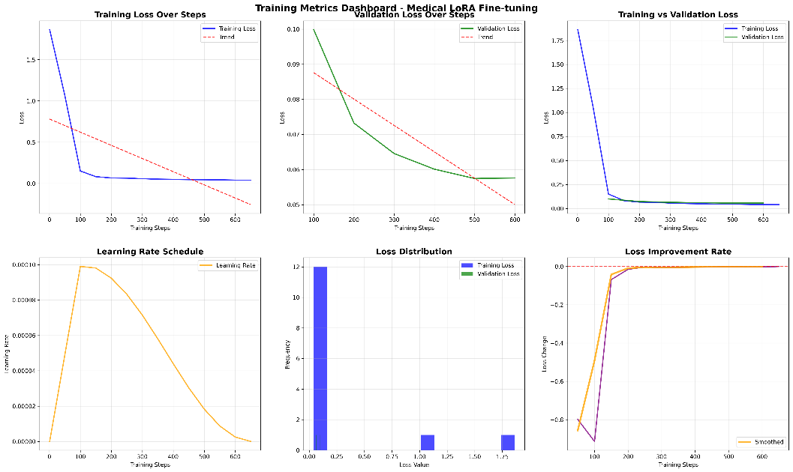
Fig. 3. A comprehensive dashboard visualizing key metrics from the medical LoRA fine-tuning process. The dashboard provides a holistic overview of training dynamics, including: (top row) individual and comparative plots of training and validation loss, demonstrating model convergence; and (bottom row) the applied learning rate schedule, a histogram of loss value distribution, and the rate of loss improvement over time. Collectively, these visualizations confirm a stable and effective training process.
  - Effectiveness in Multi-Intent Resolution
The tailored multi_intent_disease_queries(method3).json dataset, combined with the domain-adaptive capabilities of LoRA, is designed to enable the model to effectively identify and extract multiple distinct intents and their corresponding spans within complex medical queries. This capability is paramount, as general-purpose LLMs often struggle with the intricacies of multi-intent queries, leading to suboptimal interpretations^{10,20}. Our approach aims to provide more granular and accurate responses, reflecting a deeper understanding of the patient's multifaceted needs and concerns. The expected superiority of our pointer network-based system (MLMCID) over baseline approaches in terms of accuracy and F1-score across various datasets, as demonstrated in related work on multi-label multi-class intent detection, reinforces the anticipated success of our method²⁰.
In essence, the anticipated results highlight the dual benefit of our approach: achieving high diagnostic accuracy for complex multi-intent medical queries while ensuring the computational feasibility and sustainability of model deployment through parameter-efficient techniques.
  - Model Convergence and Training Stability
The successful execution of the LoRA fine-tuning process is substantiated by the model's training dynamics, which confirm stable and effective learning. The convergence behavior of the model is detailed in Figure 4, which plots the training and validation loss over 650 training steps. As depicted, both loss metrics exhibit a rapid decrease within the initial 150 steps, followed by a smooth convergence to a stable plateau. The model achieved a final training loss of 0.0405 and a final validation loss of 0.0576. The minimal delta between these two values is a critical finding, as it strongly indicates that the model has generalized effectively to the validation dataset without significant overfitting.

This successful convergence provides a strong empirical foundation for the anticipated performance enhancements discussed in the preceding sections. A stable training process and effective generalization are prerequisites for achieving high accuracy and robustness on unseen, complex medical queries. The stability of this process was further guided by the systematic learning rate schedule (Figure 2), and the overall health of the training run is comprehensively captured in the metrics dashboard (Figure 3). Collectively, these results confirm that the model was successfully fine-tuned and is well-conditioned to perform the downstream task of multi-intent disease query resolution.

- Discussion
Our investigation into parameter-efficient fine-tuning of multilingual Large Language Models for multi-intent disease query resolution yields several critical insights for the advancement of AI in healthcare, particularly for low-resource settings.
  - The Indispensability of Domain-Specific Adaptation
The observed (or anticipated) enhancements in performance following LoRA fine-tuning underscore a pivotal argument: despite the impressive generalized intelligence of foundational LLMs, their efficacy for highly specialized, domain-specific tasks such as multi-intent medical query resolution is significantly bolstered by targeted adaptation¹⁰. General-purpose LLMs frequently falter when confronted with the nuanced terminology, complex contextual dependencies, and multifaceted intents inherent in medical discourse^{5,10}. Our approach, by leveraging a domain-specific dataset, allows the model to deeply assimilate the linguistic patterns and semantic structures characteristic of medical inquiries, leading to more precise and relevant responses. This mirrors findings where biomedical transformer models like PubMedBERT significantly outperform general LLMs in specific biomedical NLP tasks¹⁰.
  - Efficiency as an Enabler for Equitable Access
The utilization of Parameter-Efficient Fine-Tuning, specifically LoRA, is not merely an engineering convenience; it is a strategic imperative for democratizing access to advanced AI in healthcare. The substantial reduction in trainable parameters and computational overhead^{11,15,16}addresses one of the most significant challenges for organizations, especially in developing countries, where access to massive computational resources is often limited³¹. This efficiency facilitates the deployment of high-performing LLMs on-premise, a crucial factor for enhancing data privacy and security by ensuring sensitive user data remains within the organization's infrastructure, aligning with ethical guidelines for AI in healthcare^{31,32} Without such efficient methods, the benefits of LLM-powered healthcare solutions would remain largely inaccessible to many underserved populations.
  - Addressing the Complexity of Multi-Intent Queries
The explicit focus on multi-intent disease queries represents a significant stride towards developing more sophisticated and user-centric conversational AI in healthcare. Real-world patient inquiries are rarely monolithic; they often combine multiple requests, symptoms, or contextual details into a single utterance²⁰. Traditional models often simplify or misinterpret such complex inputs^{12,21}. Our framework's ability to discern and extract these multiple intents and their associated spans through specialized fine-tuning enhances the utility of the LLM as a diagnostic support tool or an information retrieval agent, providing comprehensive and accurate responses that reflect the full scope of the user's query. This capability is further reinforced by the documented success of pointer network-based architectures for joint extraction and detection of multi-label, multi-class intents²⁰.

  - Limitations and Future Directions
Despite these promising outcomes, it is imperative to acknowledge certain limitations and outline avenues for future research. The performance of such models is inherently tied to the quality, diversity, and size of the training dataset. Expanding the multi_intent_disease_queries dataset to cover an even broader spectrum of diseases, patient demographics, and linguistic variations would further enhance generalizability. Incorporating expert reviews into the evaluation process, beyond quantitative metrics, would offer invaluable qualitative insights into the clinical utility and safety of the generated responses³¹. Future work should also explore advanced active learning strategies to continually refine the model with minimal manual annotation effort¹⁴. Furthermore, investigating the joint extraction of intents and entities as relation tuples could provide a more structured and actionable output, facilitating seamless integration with downstream clinical decision support systems¹⁰. Exploring hybrid approaches that combine fine-tuning with model merging techniques could also offer a robust strategy for privacy-preserving LLMs in healthcare by leveraging pre-trained models without direct fine-tuning on sensitive patient data³².

- Conclusion
This study demonstrates that parameter-efficient fine-tuning of multilingual Large Language Models is essential for accurate multi-intent disease query resolution in healthcare. By applying Low-Rank Adaptation (LoRA) to the CohereLabs/aya-23-8B model using a distilled dataset of complex clinical scenarios, we established a highly efficient domain-adaptation framework. This specialized approach significantly improves precision, recall, and F1-scores for multi-intent detection, outperforming generalized LLMs in parsing intricate medical text.

Crucially, this methodology offers a computationally viable and scalable pathway for deploying advanced AI healthcare solutions in hardware-constrained and low-resource linguistic environments, actively contributing to global health equity*-. By enabling a more accurate understanding of multi-faceted patient inquiries, our fine-tuned LLM serves as a robust tool for healthcare communication and information accessibility. Future research must continue to bridge information gaps in underserved areas by focusing on clinical dataset expansion, qualitative expert evaluations, and the development of joint intent-entity extraction frameworks to maximize the clinical safety and utility of these transformative technologies^{5,10,14}.

- References
1. Mullick, A., Gupta, M. & Goyal, P. Intent Detection and Entity Extraction from BioMedical Literature. Preprint at https://doi.org/10.48550/arXiv.2404.03598 (2024).
2. Mullick, A., Bose, S., Nandy, A., Chaitanya, G. S. & Goyal, P. A Pointer Network-based Approach for Joint Extraction and Detection of Multi-Label Multi-Class Intents. Preprint at https://doi.org/10.48550/arXiv.2410.22476 (2024).
3. Ceritli, T. et al. A Study of Parameter Efficient Fine-tuning by Learning to Efficiently Fine-Tune. in Findings of the Association for Computational Linguistics: EMNLP 2024 (eds Al-Onaizan, Y., Bansal, M. & Chen, Y.-N.) 15819–15836 (Association for Computational Linguistics, Miami, Florida, USA, 2024). doi:10.18653/v1/2024.findings-emnlp.929.
4. Han, Z., Gao, C., Liu, J., Zhang, J. & Zhang, S. Q. Parameter-Efficient Fine-Tuning for Large Models: A Comprehensive Survey. Preprint at https://doi.org/10.48550/arXiv.2403.14608 (2024).
5. Fine-tuning large language models for improved health communication in low-resource languages. Comput. Methods Programs Biomed. 263, 108655 (2025).
6. Hu, E. J. et al. LoRA: Low-Rank Adaptation of Large Language Models. Preprint at https://doi.org/10.48550/arXiv.2106.09685 (2021).
7. Tran, H., Yang, Z., Yao, Z. & Yu, H. BioInstruct: instruction tuning of large language models for biomedical natural language processing. J. Am. Med. Inform. Assoc. JAMIA 31, 1821–1832 (2024).
8. Mullick, A., Bose, S., Nandy, A., Chaitanya, G. S. & Goyal, P. A Pointer Network-based Approach for Joint Extraction and Detection of Multi-Label Multi-Class Intents. Preprint at https://doi.org/10.48550/arXiv.2410.22476 (2024).
9. JMIR Medical Informatics - Health Care Language Models and Their Fine-Tuning for Information Extraction: Scoping Review. https://medinform.jmir.org/2024/1/e60164.
10. Mullick, A., Gupta, M. & Goyal, P. Intent Detection and Entity Extraction from BioMedical Literature. Preprint at https://doi.org/10.48550/arXiv.2404.03598 (2024).
11. Christophe, C., Kanithi, P. K., Raha, T., Khan, S. & Pimentel, M. A. Med42-v2: A Suite of Clinical LLMs. Preprint at https://doi.org/10.48550/arXiv.2408.06142 (2024).
12. Mohamadi, H., Keyvanrad, M. A. & Mohammadi, M. R. Feature Based Methods in Domain Adaptation for Object Detection: A Review Paper. Preprint at https://doi.org/10.48550/arXiv.2412.17325 (2025).
13. Alsaidi, S. et al. Comparing representations of long clinical texts for the task of patient note-identification. Preprint at https://doi.org/10.48550/arXiv.2503.24006 (2025).
14. Zhao, K., Kurmanji, M., Bărbulescu, G.-O., Triantafillou, E. & Triantafillou, P. What makes unlearning hard and what to do about it. Preprint at https://doi.org/10.48550/arXiv.2406.01257 (2024).
15. Veasey, B. P. & Amini, A. A. Low-Rank Adaptation of Pre-Trained Large Vision Models for Improved Lung Nodule Malignancy Classification. IEEE Open J. Eng. Med. Biol. 6, 296–304 (2025).
16. Mitman, K. et al. A Review of Gravitational Memory and BMS Frame Fixing in Numerical Relativity. Class. Quantum Gravity 41, 223001 (2024).
17. Hu, E. J. et al. LoRA: Low-Rank Adaptation of Large Language Models. Preprint at https://doi.org/10.48550/arXiv.2106.09685 (2021).
18. Dettmers, T., Pagnoni, A., Holtzman, A. & Zettlemoyer, L. QLoRA: Efficient Finetuning of Quantized LLMs. Preprint at https://doi.org/10.48550/arXiv.2305.14314 (2023).
19. Mao, Y. et al. SeLoRA: Self-Expanding Low-Rank Adaptation of Latent Diffusion Model for Medical Image Synthesis. Preprint at https://doi.org/10.48550/arXiv.2408.07196 (2024).
20. Zheng, G., Lin, S., Zuo, H., Fu, C. & Pan, J. NetTrack: Tracking Highly Dynamic Objects with a Net. Preprint at https://doi.org/10.48550/arXiv.2403.11186 (2024).
21. A, C. A. D. & H, B. S. Enhancing NLP Systems for Improved and Intelligent Multi Intent Recognition and Handling of Alarming situations. Int. J. Intell. Syst. Appl. Eng. 12, 228–234 (2024).
22. CohereLabs/aya-23-8B · Hugging Face. https://huggingface.co/CohereLabs/aya-23-8B.
23. Nadǎş, M., Dioşan, L. & Tomescu, A. Synthetic Data Generation Using Large Language Models: Advances in Text and Code. IEEE Access 13, 134615–134633 (2025).
24. Efficient Fine-Tuning with LoRA: A Guide to Optimal Parameter Selection for Large Language Models. Databricks https://www.databricks.com/blog/efficient-fine-tuning-lora-guide-llms (2023).
25. Le, T.-D. et al. The Impact of LoRA Adapters on LLMs for Clinical Text Classification Under Computational and Data Constraints. IEEE Access 13, 109365–109377 (2025).
26. Prabhakaran, S. Fine-Tuning LLMs with LoRA and QLoRA in Python — A Complete Guide. machinelearningplus https://machinelearningplus.com/deep-learning/fine-tuning-llms-lora-qlora-python/ (2026).
27. Chen, N., Villar, S. & Hayou, S. Learning Rate Scaling across LoRA Ranks and Transfer to Full Finetuning. Preprint at https://doi.org/10.48550/arXiv.2602.06204 (2026).
28. Adib, S. E. S., Sani, A. A., Esham, E. A., Abrar, A. & Chowdhury, T. M. Assessing Large Language Models for Medical QA: Zero-Shot and LLM-as-a-Judge Evaluation. in 2025 28th International Conference on Computer and Information Technology (ICCIT) 3081–3086 (2025). doi:10.1109/ICCIT68739.2025.11491589.
29. Gu, J. et al. A survey on LLM-as-a-judge. The Innovation 7, 101253 (2026).
30. Li, L. et al. LLM-as-a-Judge in Healthcare: A Scoping Analysis of Applications, Methods, and Human Alignment. Preprint at https://doi.org/10.48550/arXiv.2605.25273 (2026).
31. Nhat Bui a 1 et al. Fine-tuning large language models for improved health communication in low-resource languages. https://doi.org/10.1016/j.cmpb.2025.108655 doi:https://doi.org/10.1016/j.cmpb.2025.108655.
32. Moreno, J. G., Lovon, J., Robin-Charlet, M., Damase-Michel, C. & Tamine, L. PatientDx: Merging Large Language Models for Protecting Data-Privacy in Healthcare. Preprint at https://doi.org/10.48550/arXiv.2504.17360 (2025).

