به نام خداوند مهربان

امیررضا رجبی 983126

گزارش آزمایش میانترم

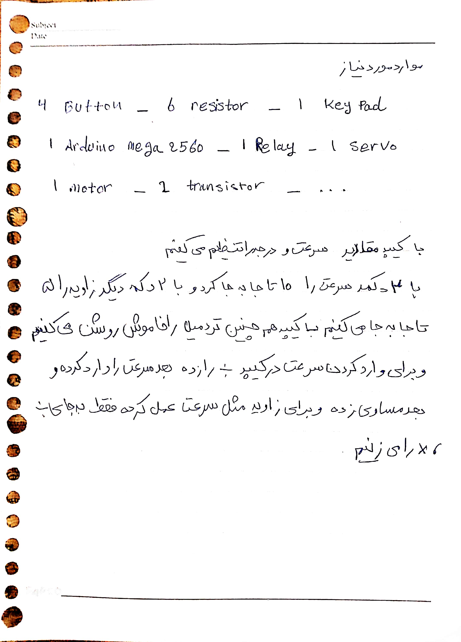

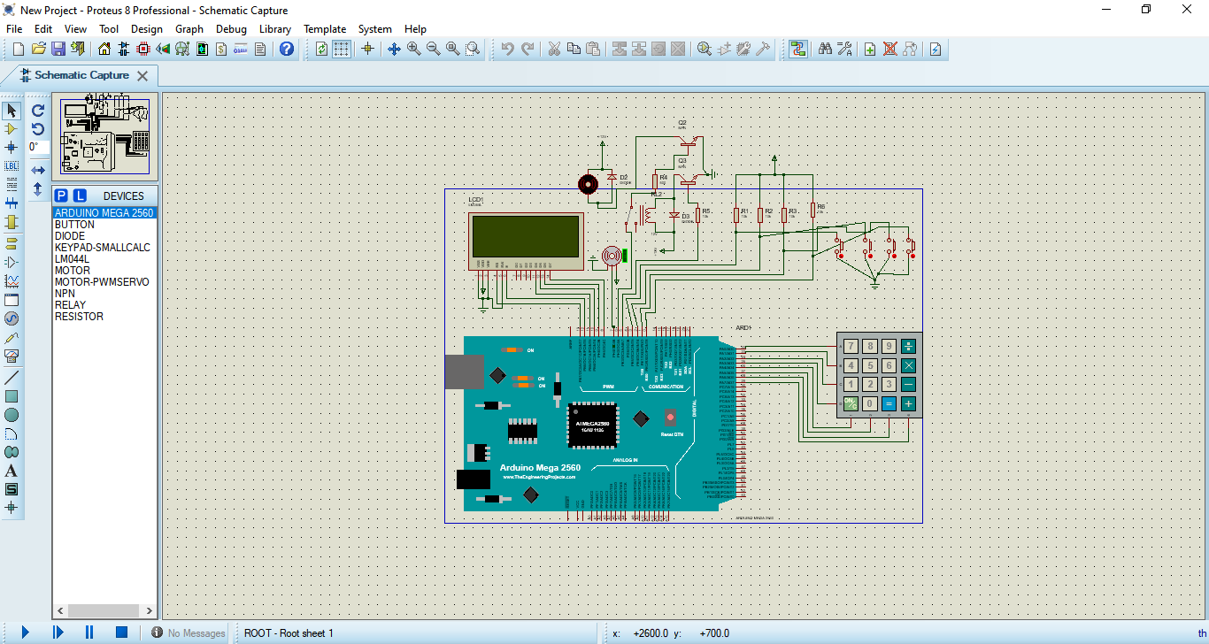

#include <LiquidCrystal.h>

#include <Keypad.h>

#include <Servo.h>

#define RS 13

#define E 12

#define D4 11

#define D5 10

#define D6 9

#define D7 8

const byte ROWS = 4;

const byte COLS = 4;

char keys[ROWS][COLS] = {

{'7','8','9', 'S'},

{'4','5','6', 'D'},

{'1','2','3', '-'},

{'O','0','=', '+'}

};

byte rowPins[ROWS] = {22, 23, 24, 25};

byte colPins[COLS] = {26, 27, 28, 29};

#define SERVO 7

Keypad keypad = Keypad(makeKeymap(keys), rowPins, colPins, ROWS, COLS);

LiquidCrystal lcd( RS, E, D4, D5, D6, D7 );

Servo servo;

#define MOTOR 6

#define ENABLE 5

#define SP_UP 3

#define SP_DOWN 2

#define SL_UP 1

#define SL_DOWN 0

boolean IS_ON = false;

int T_SP=0;

String S_SP = "";

int T_SL=0;

String S_SL = "";

int STATE = 0;

int P_U = 0;

int P_D = 0;

int L_U = 0;

int L_D = 0;

void setup() {

// put your setup code here, to run once:

pinMode(MOTOR, OUTPUT);

pinMode(ENABLE, OUTPUT);

pinMode(SP_UP, INPUT);

pinMode(SP_DOWN, INPUT);

pinMode(SL_UP, INPUT);

pinMode(SL_DOWN, INPUT);

lcd.begin(20, 4);

lcd.clear();

servo.attach(SERVO);

}

void loop() {

// put your main code here, to run repeatedly:

char key=keypad.getKey();

if(key){

if(key == 'O'){

if(IS_ON){

IS_ON = false;

analogWrite(MOTOR, 0);

digitalWrite(ENABLE, HIGH);

WRITE_LCD_OFF();

}else{

IS_ON = true;

digitalWrite(ENABLE, LOW);

delay(100);

analogWrite(MOTOR, T_SP);

WRITE_LCD();

}

}

else if(key == 'S' && IS_ON){

S_SP = "";

STATE = 0;

}

else if(key == 'D' && IS_ON){

S_SL = "";

STATE = 1;

}

else if(key == '=' && IS_ON){

if(STATE == 0){

int sp = S_SP.toInt();

S_SP = "";

WRITE_LCD();

if(sp >= 0 && sp <= 255){

T_SP = sp;

}

analogWrite(MOTOR, T_SP);

WRITE_LCD();

delay(200);

}else{

int sl = S_SL.toInt();

S_SL = "";

if(sl >= 0 && sl <= 90){

T_SL = sl;

}

WRITE_LCD();

servo.writeMicroseconds(int(1500+((500*float(T_SL))/90)));

delay(200);

}

}

else if(IS_ON){

if(key != '-' || key != '+'){

if(STATE == 1){

S_SL = S_SL + key;

}else{

S_SP = S_SP + key;

}

}

}

}

if (digitalRead(SL_DOWN) == LOW && IS_ON) {

T_SL -= 5;

WRITE_LCD();

servo.writeMicroseconds(int(1500+((500*float(T_SL))/90)));

delay(200);

}

if (digitalRead(SL_UP) == LOW && IS_ON) {

T_SL += 5;

WRITE_LCD();

servo.writeMicroseconds(int(1500+((500*float(T_SL))/90)));

delay(200);

}

if (digitalRead(SP_DOWN) == LOW && IS_ON) {

T_SP -= 10;

if(T_SP < 0){

T_SP = 0;

}

WRITE_LCD();

analogWrite(MOTOR, T_SP);

delay(200);

}

if (digitalRead(SP_UP) == LOW && IS_ON) {

T_SP += 10;

WRITE_LCD();

analogWrite(MOTOR, T_SP);

delay(200);

}

}

void WRITE_LCD() {

lcd.clear();

lcd.setCursor(0, 0);

lcd.print("SPEED:");

lcd.setCursor(0, 1);

lcd.print(T_SP);

lcd.setCursor(0, 2);

lcd.print("DEGREE:");

lcd.setCursor(0, 3);

lcd.print(T_SL);

}

void WRITE_LCD_OFF() {

lcd.clear();

lcd.setCursor(0, 0);

lcd.print("OFF");

}