## 6 Locations – 1

**Total nodes**: 270

**Total ways to travel**: 90

**Shortest distance order of travel**: [3, 1, 6, 2, 4, 5] ----> distance: 65 + 10

**Total size**: 72256.0 KB

**Total time**: 0:00:00.111007

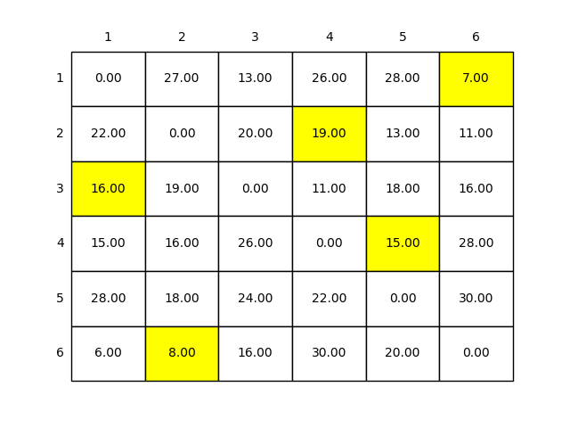

## 6 Locations – 2

**Total nodes**: 270

**Total ways to travel**: 90

**Shortest distance order of travel**: [1, 4, 2, 3, 6, 5] ----> distance: 50 + 10

**Total size**: 72220.0 KB

**Total time**: 0:00:00.117007

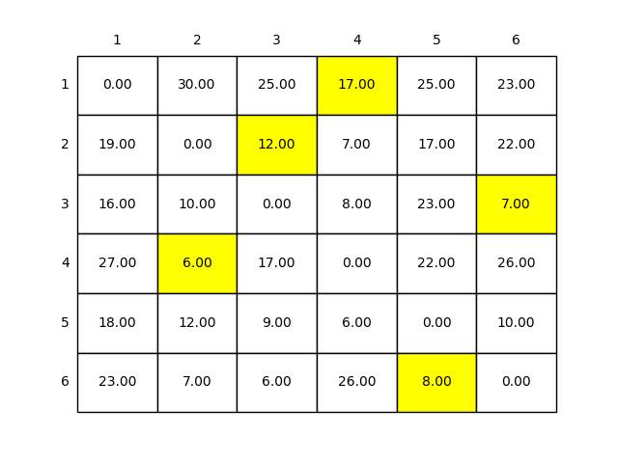

## 6 Locations – 3

**Total nodes**: 270

**Total ways to travel**: 90

**Shortest distance order of travel**: [1, 2, 3, 6, 4, 5] ----> distance: 50 + 10

**Total size**: 72208.0 KB

**Total time**: 0:00:00.124007

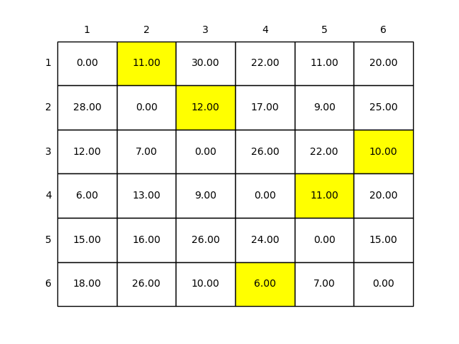

## 8 Locations – 1

**Total nodes**: 7364

**Total ways to travel**: 2520

**Shortest distance order of travel**: [2, 3, 1, 7, 4, 5, 6, 8] ----> distance: 53 + 10

**Total size**: 74492.0

**Total time**: 0:00:00.168010

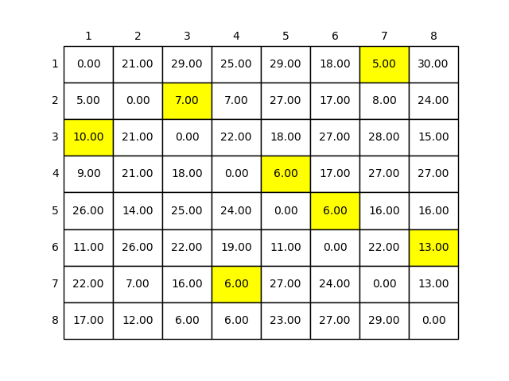

## 8 Locations – 2

**Total nodes**: 7364

**Total ways to travel**: 2520

**Shortest distance order of travel**: [4, 1, 8, 3, 5, 2, 6, 7] ----> distance: 58 + 10

**Total size**: 74324.0 KB

**Total time**: 0:00:00.180010

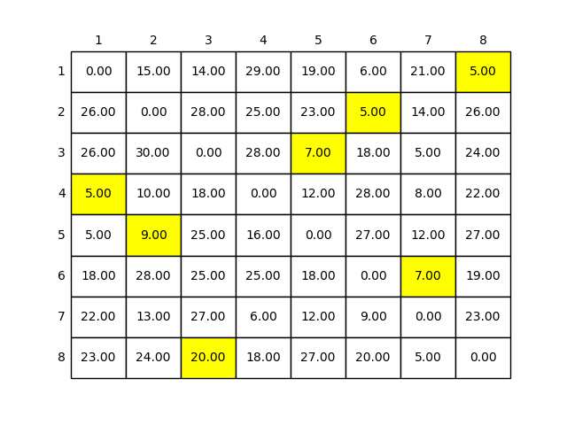

## 8 Locations – 3

**Total nodes**: 7364

**Total ways to travel**: 2520

**Shortest distance order of travel**: [2, 4, 8, 3, 6, 1, 7, 5] ----> distance: 71 + 10

**Total size**: 74380.0 KB

**Total time**: 0:00:00.167009

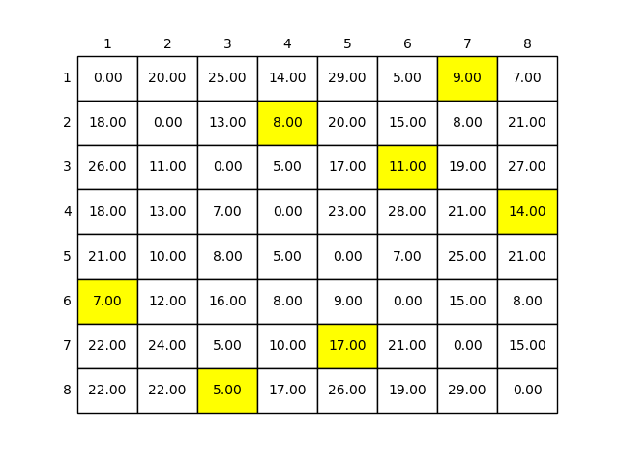

## 10 Locations – 1

**Total nodes**: 326010

**Total ways to travel**: 113400

**Shortest distance order of travel**: [2, 3, 5, 4, 8, 1, 9, 6, 7, 10] ----> distance: 68 + 10

**Total size**: 172228.0 KB

**Total time**: 0:00:06.525373

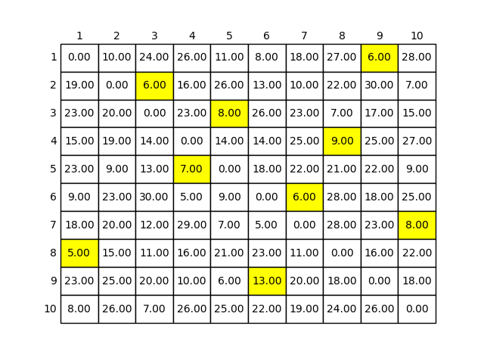

## 10 Locations – 2

**Total nodes**: 326010

**Total ways to travel**: 113400

**Shortest distance order of travel**: [2, 4, 3, 7, 5, 9, 8, 1, 6, 10] ----> distance: 88 + 10

**Total size**: 172104.0 KB

**Total time**: 0:00:06.480371

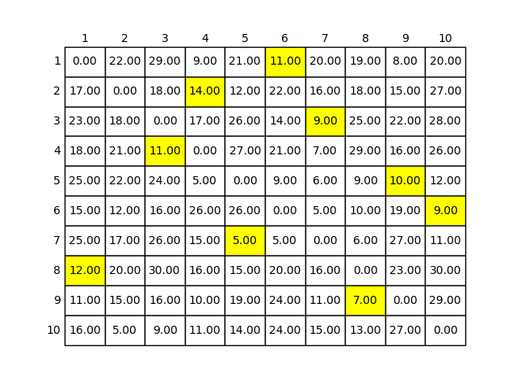

## 10 Locations – 3

**Total nodes**: 326010

**Total ways to travel**: 113400

**Shortest distance order of travel**: [4, 2, 1, 5, 9, 6, 3, 10, 7, 8] ----> distance: 78 + 10

**Total size:** 172076.0 KB

**Total time**: 0:00:06.555375

